Hindalco Industries Ltd.
(Unit : Birla Copper)
PO : Dahej
Dist. : Bharuch - 392001
Gujarat
Your Ref : J-UK-2510951
Our Ref : ALS-2509-0085-B
Date : October 06, 2025

Below you will find the details of a material described as “Cerro Verde Copper Concentrates”, which was weighed, loaded, and sampled in the presence of our representative.

General Details:

Material | Copper concentrates
Advised Weight | 10,500.00 WMT
Vessel | FW FIRMAMENT
Stowed | Holds Nr. 3 & 5
Supplier | SM Cerro Verde S.A.A.
Buyer | Hindalco Industries Ltd.
Load Port | Matarani, Peru
Discharge Port | Dahej, India
Vessel arrival | 13:42 Hrs. // 26-09-2025
Vessel berthed, Pier F | 23:00 Hrs. // 03-10-2025
Loading commenced | 01:35 Hrs. // 04-10-2025
Loading completed | 08:05 Hrs. // 04-10-2025

Outturn Weights:

Net Wet Weight (Scale) | 10,500.700 WMT
Moisture (%) | 7.59143 %
Net Dry Weight (Scale) | 9,703.547 DMT

1.- Cargo Condition:

Prior to loading operations commenced, our surveyor attended at the shipper’s stockpile “Cerro Verde” which is a sheltered warehouse owned by SMCV, with a full capacity of 150,000.000 MT. approx., located in TISUR terminal, approximately 700 meters away from the berth, and observed that the cargo consisting of copper concentrates was in bulk form and ready for loading, presented in a trapezium form pile of 10,550.000 WMT. approx., directly over the warehouse concrete floor. No apparent contamination or impurities were observed as far as visually accessible. Neither lumps nor agglomeration were observed in the cargo during loading operations. Also, our surveyor visited the mentioned stockpile during loading operations to check that there was no mixing of material. The color of the material was grey and consisted of fine material.

The date of stockpile material was from October 02nd, 2025 to October 04th, 2025 (information verbally received from Mrs. SM Cerro Verde S.A.A., in Matarani port).

It is worth to mention that even though we were authorized by the Shipper to enter to the stockpile, we were not authorized to take photographs.

2.- Loading of the Vessel:

2.1 Vessel’s Particulars:

Flag & Register Port | Singapore / Singapore
Owners | Zhe Yin Shan Zhou No. 7 (Tianjin) Leasing Co., Ltd.
Year Built | 2025
NRT | 13,740 T
GRT | 25,175 T
Type of ship | Bulk Carrier
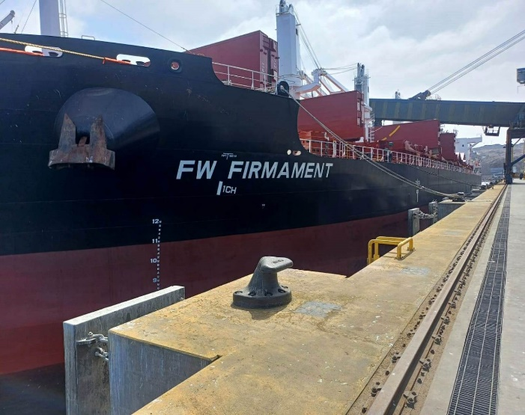

2.2 Dates & Times:
Date | Time | Description
October 01, 2025 | 00:00 to 22:00 | Vessel at anchorage awaiting 2nd berthing instructions
 | 22:00 | Pier “F” closed due to heavy swell
October 03, 2025 | 00:00 to 20:00 | Vessel at anchorage awaiting Pier “F” reopening
 | 20:00 | Pier “F” reopened
 | 20:48 | POB for berthing maneuver
 | 22:00 | First Line
 | 23:00 | All lines made fast to pier “F”
 | 23:20 | ALS Surveyor on board vessel
 | 23:30 to 23:40 | Opening of vessel’s holds Nr. 3 & 5
October 04, 2025 | 01:28 | Commenced loading at stockpile (Hindalco)
 | 01:30 | Commenced automatic sampling operations
 | 01:32 | Commenced weighing in electronic scale
 | 01:35 | Commenced loading operations in hold Nr. 5 (Hindalco)
 | 02:20 | Commenced samples reduction
 | 05:40 | Commenced samples moisture determination
 | 06:15 | Completed cargo loading operations in hold Nr. 5,  Total 9,000.250 WMT by Shore scale
 | 07:05 | Resumed loading operations in hold Nr. 3 (2nd parcel)
 | 07:58 | Completed loading at stockpile
 | 08:00 | Completed automatic sampling operations
 | 08:02 | Completed weighing in electronic scale
 | 08:05 | Completed cargo loading operations in hold Nr. 3, (2nd parcel)  Total 1,500.450 WMT by Shore scale
 | 08:10 to 10:00 | Final Draft survey
 | 09:30 to 09:50 | Cargo holds sealing
 | 09:30 | Completed samples reduction
 | 09:42 | POB for unberthing maneuver
 | 10:45 | Vessel sailed
 | 15:30 | Commenced preparation of quality samples
 | 18:00 | Completed samples moisture determination
October 05, 2025 | 00:20 | Completed preparation of quality samples
 | 00:30 | Commenced sealing and labeling of quality samples
 | 01:40 | Completed sealing and labeling of quality samples

2.3 Hold and Hatch condition:

Our surveyor, jointly with shipper’s surveyor, inspected hold N° 5, before loading:
HOLD N° 5 | GOOD | FAIR | POOR
Hatch covers
Hatch coatings
Rubber packing, draining holes
Acting cleats, compression bars
Non-return valves
Hydraulic Systems
Forward and aft bulkhead
Side/shell plating (port and stb)
Frames, brackets and bracket connection
Tank top plating
Hopper tank plating
Ventilation, void spaces
Bilges, suctions
Air vents Sounding pipes
Cleaning Condition
Observation: The cargo hold was found dry, clean and suitable to receive cargo.

Previous cargo:
- Fertilizers in bulk

2.4 Cargo Plan:
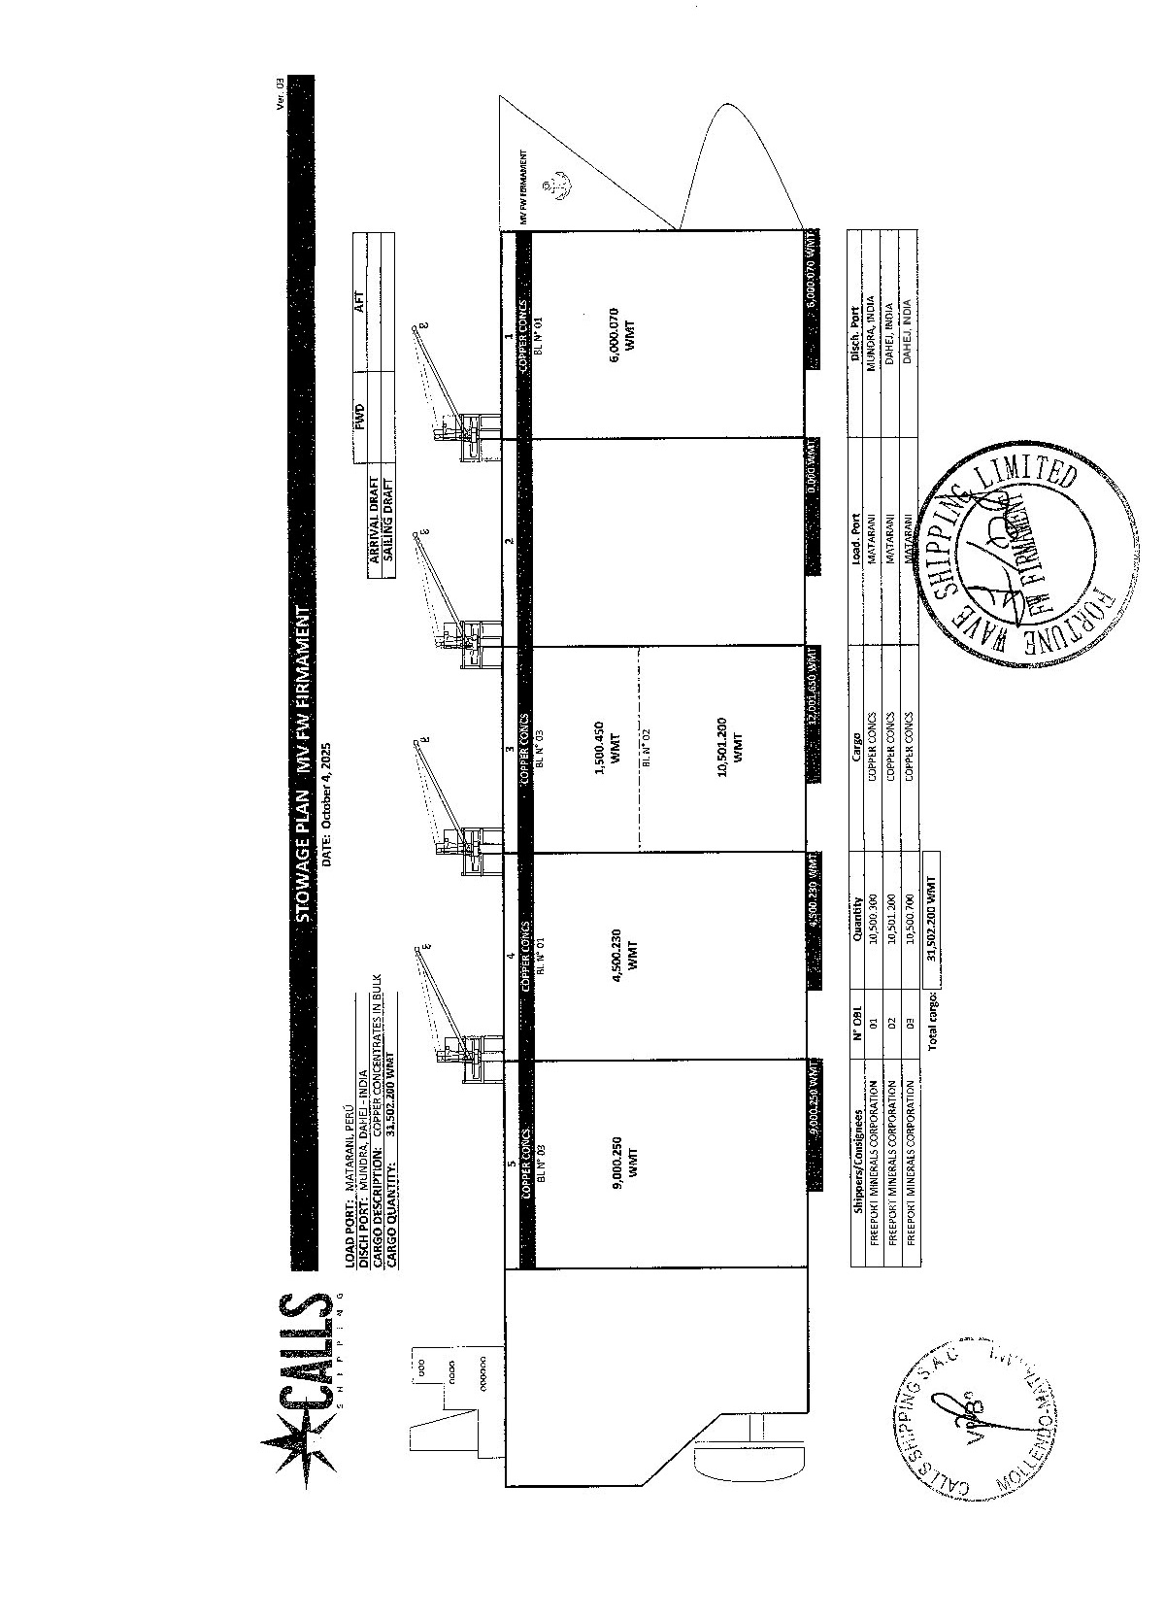
- Shore Scale Weighing and Loading:

  - Brief description of weighing system to be used:

The weighing system to be used during loading operation corresponded to weight scale belonged to TISUR (Matarani Port), according to following details:
SHORE SCALE BRAND | THERMO FISHER SCIENTIFIC
TYPE & S/N | ELECTRONIC MODEL 2301 // 14030837
CAPACITY | 2,200 T/H
MINIMUM DIVISION | 0.01 TM
TESTING COMPANY | LO JUSTO S.A.C.
CERTIFICATION N° | 128703
LAST TESTING | February 14, 2025
CONDITION | OPERATIVE

Prior to loading operations was performed Zero check for 10 to 20 minutes, such result was positive (no increased in the shore scale during idle running).

  - Loading operation and conveyor details:

The material was transported from the warehouse (Stockpile) to steel hoppers by means of two (2) front loaders that fed the conveyor belt Nº 17, and this to conveyor belt Nº 19 (where the automatic sampler is located), then to conveyor belt Nº 20, up to the transference tower where the material is transferred to an encapsulated belt conveyor up to the system named “Ship Loader”, which loads the material directly into the vessel´s holds at a speed of 2,000 to 2,100 WMT / Hour. The loading operations, as well as trimming operation inside cargo holds was carried out by Tramarsa staff.

During loading operations in holds Nr. 3 & 5, weather conditions were good, 17º C approx., there were not registered stoppages due to bad weather, rain or swell.

With the purpose of obtaining the information requested in regard to length, width of conveyor belt, ALS Surveyor, on behalf of Hindalco Industries Ltd., contacted Messrs. SMCV, who informed (verbally) the following:

Belt Capacity | Belt Length | Belt Speed
2200 T/H | 400 m | 2000/2100 T/H

In regards to procedures of calibration, calibration reports, error rates on starting-up and possible spilling observed, personnel of quality control company “AHK Lab” informed that they have all information requested but it could be issued to us only with the authorization of the shipper, Messrs. “SMCV”.

- Sampling for moisture determination and quality preparation:

4.1.- Sampling:
In order to determine the moisture content of the cargo loaded, the samples per sub-lot (500 wmt) were taken automatically in rotatory way into 8 metallic cylinders, with two cutters (Primary and Secondary) in conveyor belt Nº 19, as follows:
Each 500 wmt sub-lot, the primary sampler takes 01 increment sample, every 40 seconds approx., for about 15 minutes (in Total 22 increments of 22.70 Kg approx.), These increments are transferred to the secondary sampler where it takes 01 increment sample every 40 seconds approx., for about 15 minutes (in Total 22 increments of 1.70 Kg approx.), distributing them in equal quantity into 4 metallic cylinders (with plastic bag inside, in order to avoid any contamination and moisture variation).
It was obtained 36 kg to 40 kg approx. per each 500 wmt sub-lot, divided in four (4) plastic bags properly identified (A; B; C & D), with a weight of 9 kg to 10 kg each, being transported on a pick-up truck to the laboratory of AHK, which is distant approx. 250 meters from the sampling site.
The four (4) plastic bags per each sub lot of 500 wmt, were homogenized and reduced, forming a square bed and divided in 20 parts using a steel trowel named JIS 5 and then taking parallel samples and poured in 2 trays with 1.450 Kg to 1.570 Kg gross approx., of samples, each one, for moisture determination as per laboratory procedure.

4.2 Moisture determination:

The two (2) steel trays from each lot sample were dried in an oven at a controlled temperature of 105º C +/- 5° C, in two steps: after 4 hours in the oven, the samples were taken out and weighed, then put back in the oven for 4 hours more. In total the samples are dried for a period of 8 hours, until a constant weight was achieved. Then the final hot dried samples were let cool for one (1) hour app., after that they were weighed in order to find the moisture %, as per laboratory procedure.
After completion of drying process, the final moisture of 500 WMT lot-sample was calculated by the average of wet weight and dry weight loss each one.
There was no repetition of any sample moisture operations, all the sample moistures were performed at once.

Trays dimensions are:
- Length: 31.5 cm.
- Width: 18 cm.
- Height: 3 cm.
- Sample bed thickness on the tray: 2.5 cm.

Equipment for Moisture Determination:
Oven Dry / Model | E&H / EURF-2000 EXC
S/N | 001-2015
Temperature | 105° C +/- 5° C
Testing Company | CADENT S.A.C.
Last Testing / Certificate Nr. | October 21, 2024 / 0908-LT-2024
Digital Scale / Model S/N | OHAUS PX12001ZH/E / C44120813
Testing Company | CADENT S.A.C.
Min – Max Capacity | 0.1 gr – 12,000 gr
Last Testing / Certificate Nr. | July 22, 2025 / 2043-IMP-2024
Lamp | JIS 5
Mesh | SIEVE Nª 100-150 Microns – 99.20% Efficient
Grinding Machine | ESSA

4.3 Weighing details:

Shipper Contract Nº 202510CV115
Lot No. | Hold | Lot Weight | Moisture | Water Weight | Dry Weight
Lot No. | No. | (MT) | (%) | (MT) | (MT)
001 | 5 | 500.000 | 7.35 | 36.750 | 463.250
002 | 5 | 500.000 | 7.48 | 37.400 | 462.600
003 | 5 | 500.000 | 7.52 | 37.600 | 462.400
004 | 5 | 500.000 | 7.56 | 37.800 | 462.200
005 | 5 | 500.000 | 7.59 | 37.950 | 462.050
006 | 5 | 500.000 | 7.61 | 38.050 | 461.950
007 | 5 | 500.000 | 7.55 | 37.750 | 462.250
008 | 5 | 500.000 | 7.57 | 37.850 | 462.150
009 | 5 | 500.000 | 7.60 | 38.000 | 462.000
010 | 5 | 500.000 | 7.62 | 38.100 | 461.900
011 | 5 | 500.000 | 7.63 | 38.150 | 461.850
012 | 5 | 500.000 | 7.63 | 38.150 | 461.850
013 | 5 | 500.000 | 7.71 | 38.550 | 461.450
014 | 5 | 500.000 | 7.74 | 38.700 | 461.300
015 | 5 | 500.000 | 7.64 | 38.200 | 461.800
016 | 5 | 500.000 | 7.65 | 38.250 | 461.750
017 | 5 | 500.000 | 7.63 | 38.150 | 461.850
018 | 5 | 500.250 | 7.68 | 38.419 | 461.831
019 | 3 | 500.000 | 7.54 | 37.700 | 462.300
020 | 3 | 500.000 | 7.52 | 37.600 | 462.400
021 | 3 | 500.450 | 7.60 | 38.034 | 462.416
TOTAL |  | 10,500.700 | 7.59143 | 797.153 | 9,703.547

Total average moisture content calculation:
Total H2O MT/ Total wet weight x 100 = 797.153 / 10,500.700 X 100 = 7.59143 %
Total dry net weight: Nine thousand seven hundred three point five hundred and forty seven.

4.4 Quality sample preparation:
After drying, each sample is pulverized for 90 seconds, and finally got through grinder manually for 10 minutes, then the material was passed under a mesh of 120 micrometers for every 5 sub-lots (i.e lot 5, 10, 15, 20) to verify the pulverising efficiency, then the homogenized sample is put into a rotating divisor of 10 sets capacity, according to procedures of laboratory under our supervision, packed into aluminum envelopes of approx. 200 grs each, and then identified and sealed a total of 21 sub lots + 01 general composite. These are prepared as quality samples according to international practice.

Each lot sample was distributed in 08 sets as follows:

04 sets of samples for the seller, Cerro Verde (Mine)
02 sets of samples for Umpire Purposes, AHK surveyors
02 sets of samples for the buyer Hindalco Industries Ltd., ALS Surveyors

08 Composites were distributed as follows:

04 envelopes of composites for the seller, Cerro Verde (Mine)
02 envelopes of composites for Umpire Purposes, AHK surveyors
02 envelopes of composites for the buyer Hindalco Industries Ltd., ALS Surveyors

4.5 Sealing of samples:

A total of 08 sets x 21 lots of quality samples and 08 general quality composites envelopes were packed into aluminum bags, labeled with relevant information of the loading.

5.- Draft Survey:

ALS surveyor performed Draft Survey jointly with vessel’s Chief Officer for cargo to Dahej destination, the vessel was gauged twice by draft survey, at the beginning and at the end of the whole shipment.

Draft survey conducted in normal swell conditions (initial 1.00 to 1.50 meters / final 1.00 to 1.50 meters swell about).

The drafts conducted at this port are only referential, as official figures of cargo loaded are obtained from the shore weight meter.

5.1 Draft survey report for cargo hold Nr. 5:

Vessel : MV “FW FIRMAMENT”
Cargo : Copper Concentrates
Weight Hold Nr. 5 : 9,000.250 WMT. by shore scale
ALS Draft Survey Hold Nr. 5 : 8,990.591 WMT. by prorate (only referential)
Total cargo loaded in vessel : 31,502.200 WMT. by shore scale
Total cargo loaded according to ALS Draft survey: 31,468.459 WMT. (only referential)
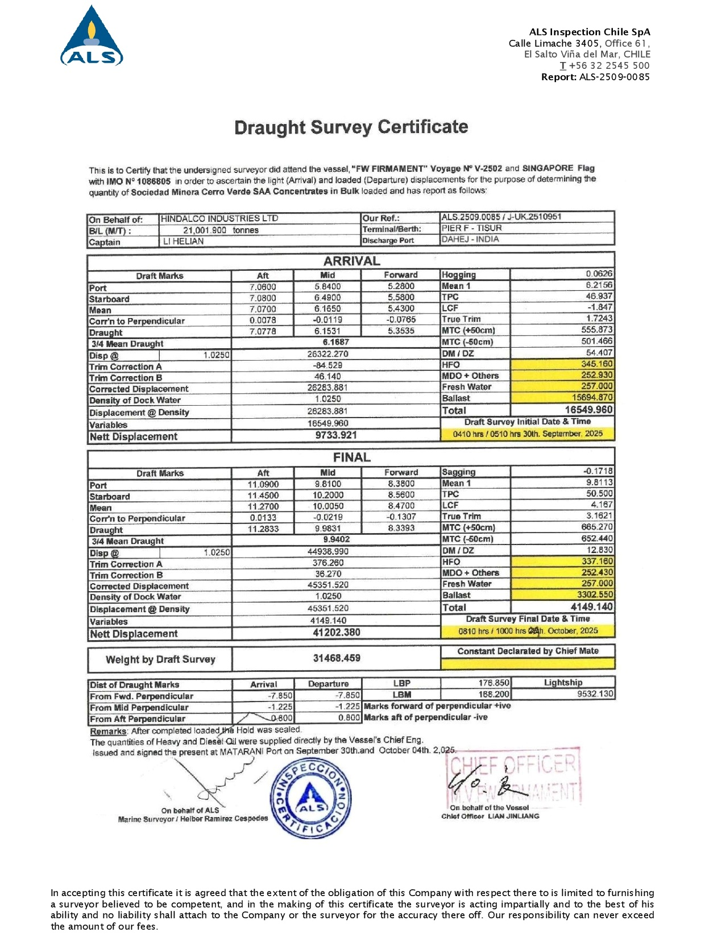
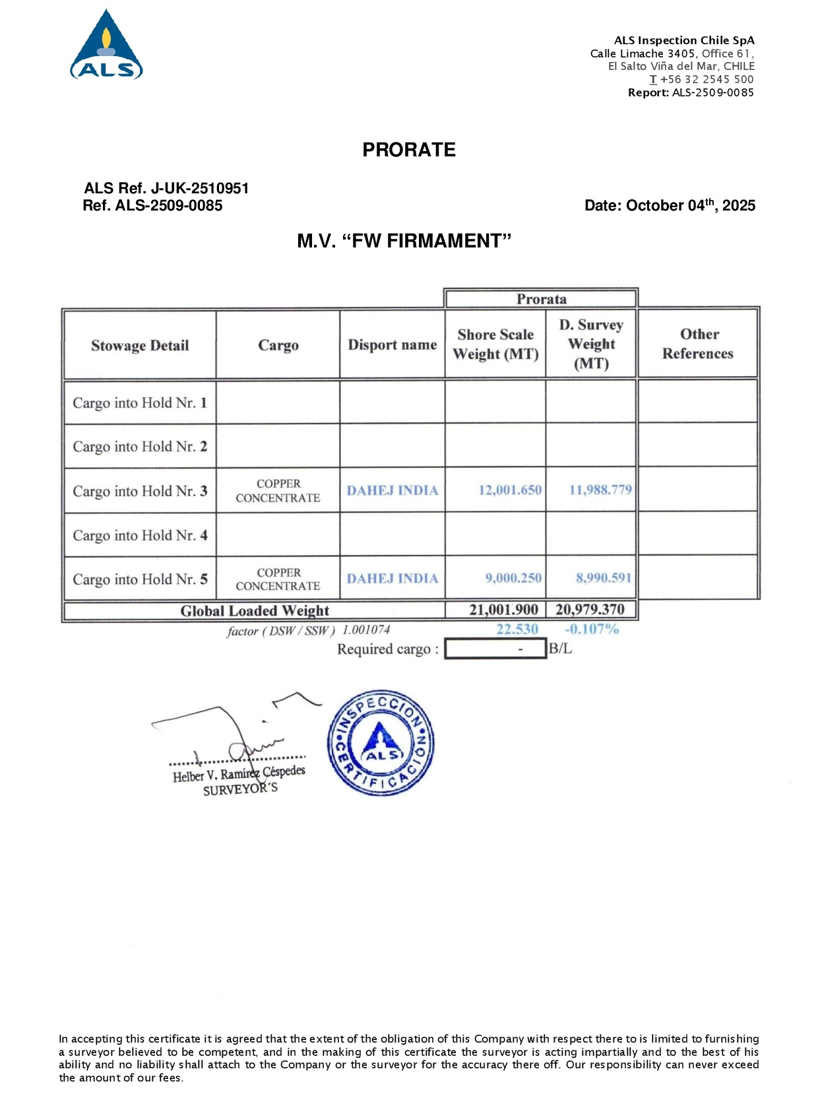

6.- Conclusion:
The present report reflects our findings at the time and place of the inspection only and does not refer to any other matters.
The inspection has been performed to the best of our knowledge and ability within the scope of the instructions we have received.
This report does not relieve buyers and sellers from their contractual obligations.
- Cargo did not present contamination.
- Sampling and moisture determination of cargo were conducted according to AHK / SM Cerro Verde standards.
- Official quantity of cargo loaded is according to Shore scale. Draft survey in Matarani port is only referential.
- Loading operation was carried out under good weather, 17º C.
- Upon completion of loading operations in vessel’s cargo hold Nr. 5, it was sealed by ALS & A.H.Knight surveyors, with the following seals, respectively:
ALS - Hold 5: Manhole F, 0027666 // Hatch cover, 0027617 // Manhole A, 0027632.
AHK - Hold 5: Manhole F, 1283378 // Hatch cover, 0000818 - 0000842 // Manhole A, 1283377.

7.-Attending parties:
Name | Position | On behalf of
Mr. LI Hejian | Vessel’s Master | Owners
Mr. LIAN Jinliang | Vessel’s Chief Officer | Owners
Mr. Mike Collado | AHK Supervisor | SMCV
Mr. Julio Herrada | AHK Supervisor | SMCV
Mr. Romario Huamachuco | AHK Supervisor | SMCV
Mr. Oscar Mallma | AHK Quality Surveyor | SMCV
Mr. Augusto Begazo | AHK Quality Surveyor | SMCV
Mr. Helber Ramirez | ALS Surveyor | Hindalco Industries Ltd.
Ms. Ana Vargas | ALS Surveyor | Hindalco Industries Ltd.

8.-Attachments:
- Mate’s Receipt
- Moisture Certificate
- Stowage Plan
- Statement of Facts
- Holds Inspection Certificate
- AHK Report of Seal Placed
- ALS Holds Sealing Certificate
- ALS Draft Survey

This survey was carried out without prejudice and in the interest of whom it may concern.



Helber Ramírez C.
Surveyor
On behalf of ALS

Reviewed by: R. Guillén
Approved by: C. Franco

