PHOTOGRAPHIC SET

M/V STAR JAPAN V.2505

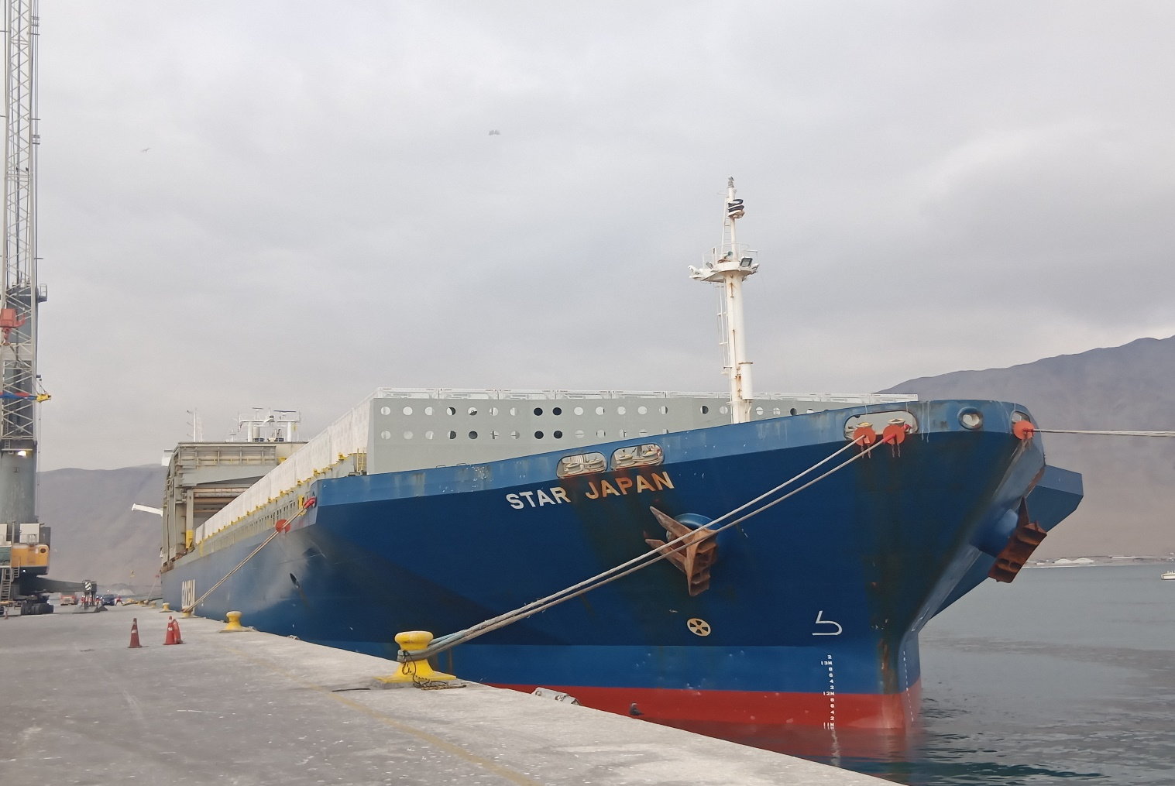
Empresa Portuaria Iquique - Pier Nr. 2

Voyage : 2505
Port of Discharge : Iquique - Chile
Stevedores Co. : ECOS Muellaje o/b of EPI (Iquique - Chile)
Surveyor : Mr. Gonzalo Bacian V.
Operations Agent : Mss. Maria Jose Palma C.

1. ARRIVAL CONDITION OF BATTERY ENERGY STORAGE SYSTEM STOWED ON DECK #1, 2, 3, 4, 5, 6, 7, 8, 9, 10 & 11:

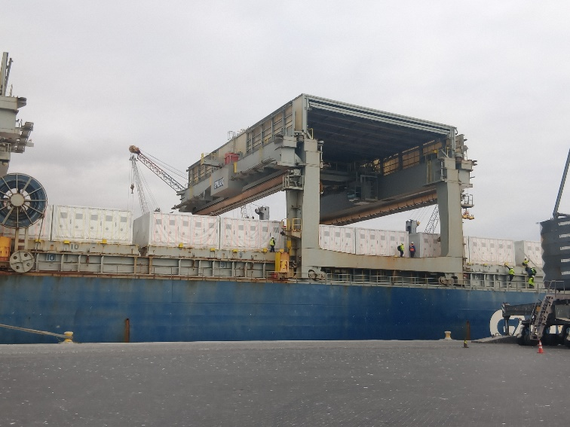 | 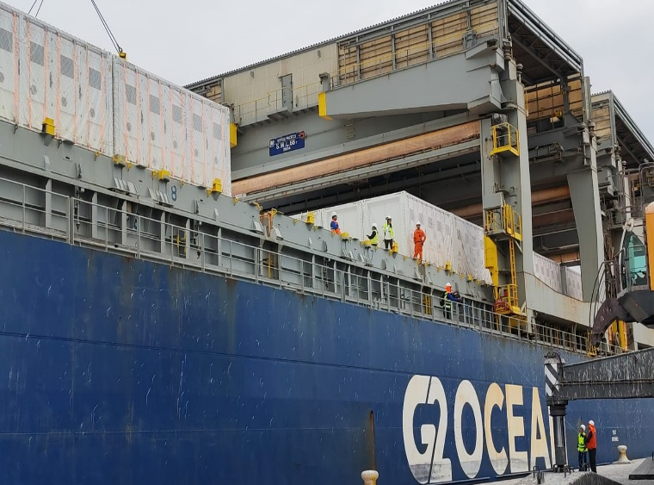
- General view of batteries on deck of MV MN STAR JAPAN. | - Batteries on deck.
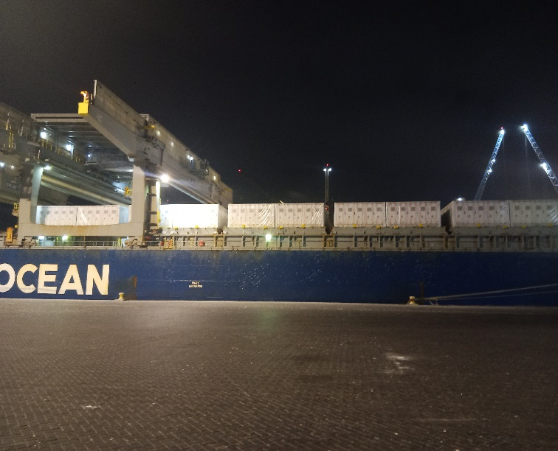 | 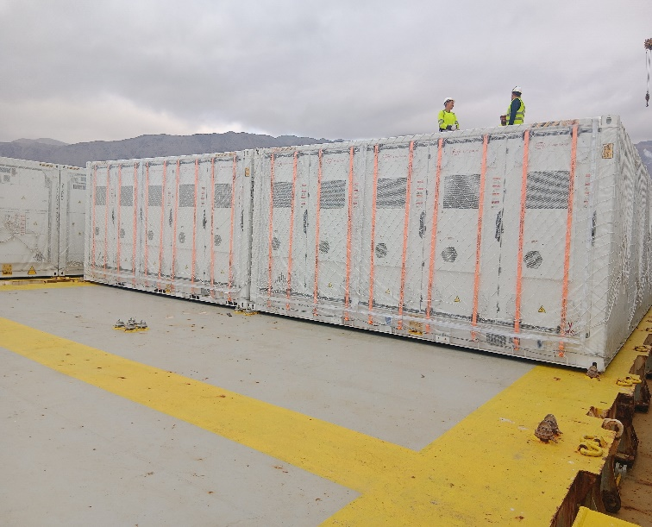
- General view of batteries on board Vessel. | - Batteries on deck N° 7.
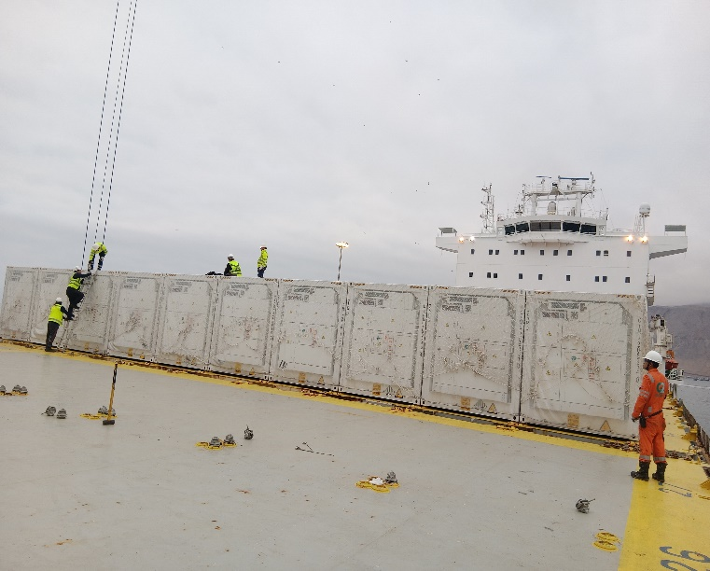 | 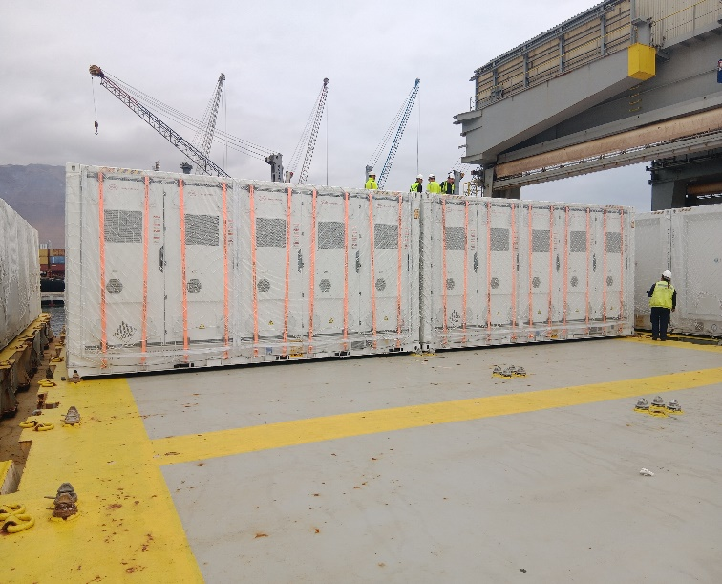
- Batteries on deck N° 8. | - Batteries on deck N° 9.
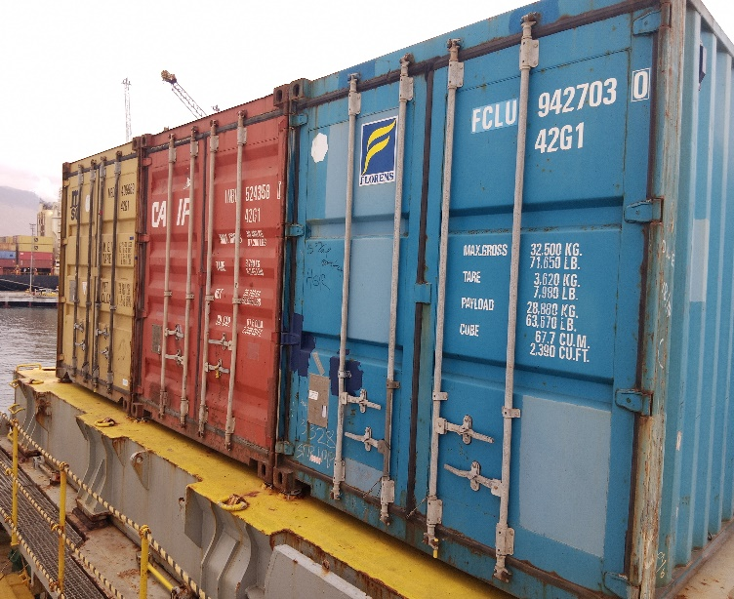 | 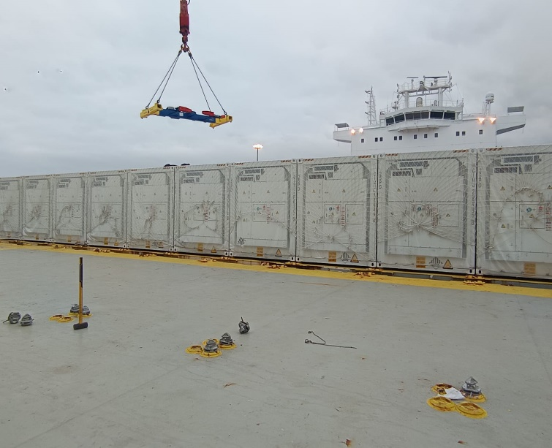
- View of 03x40 GP SOC, on deck N° 11. | - Batteries on deck N°10.
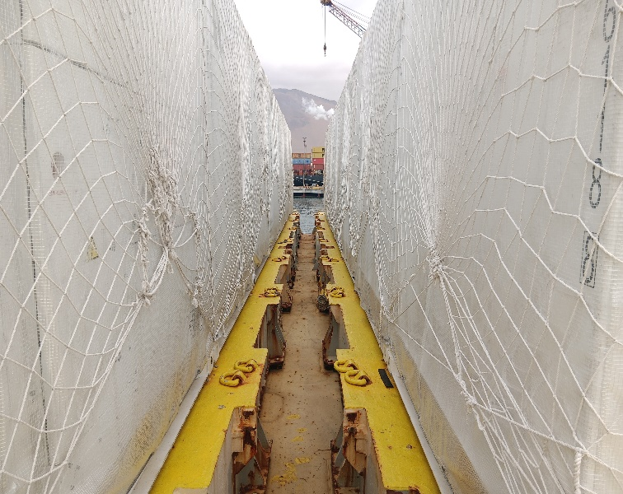 | 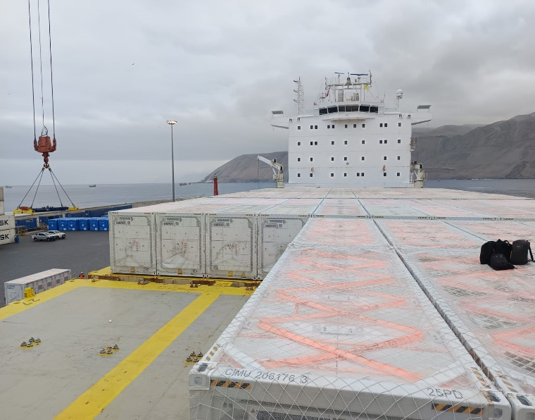
- Space between cargo. | - Roof of batteries.
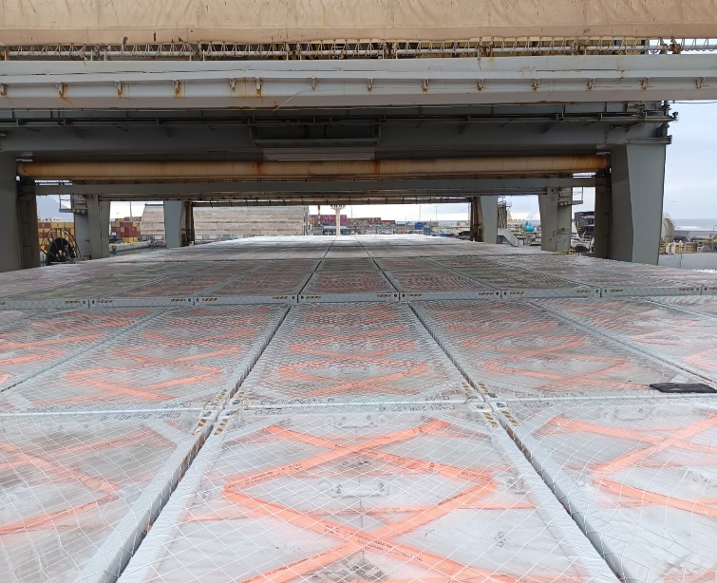 | 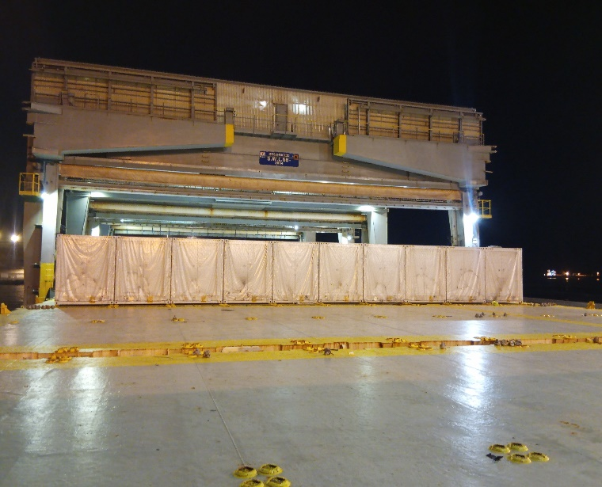
- Roof of batteries. | - Batteries on deck.
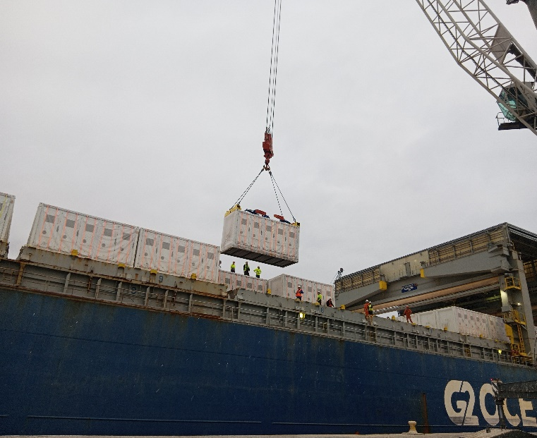 | 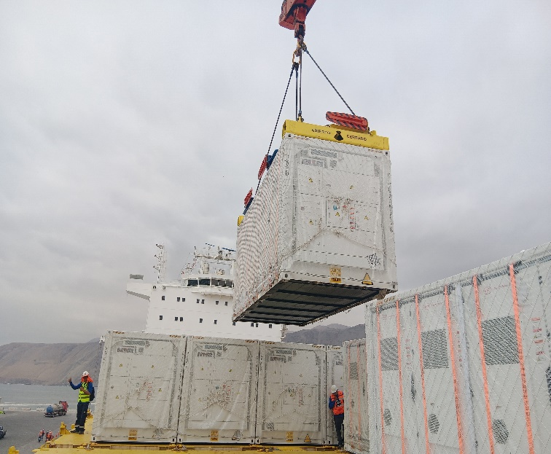
- Discharge Operation of battery stowed on deck N° 7 | - Discharge Operation of battery stowed on deck N° 7.
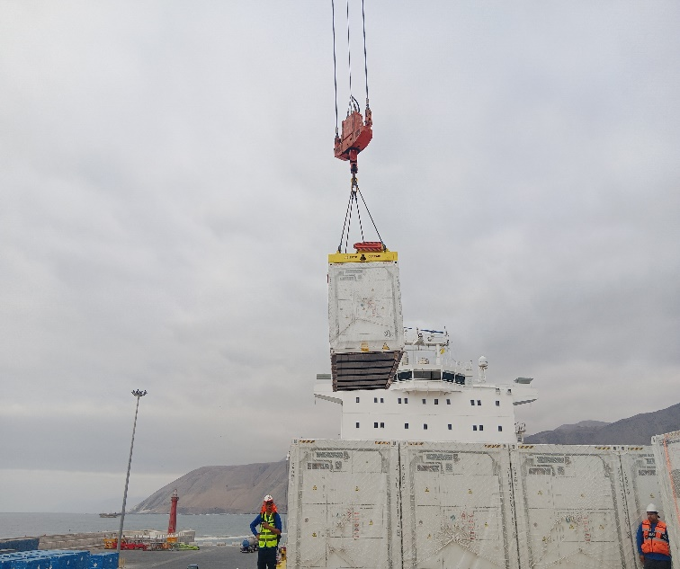 | 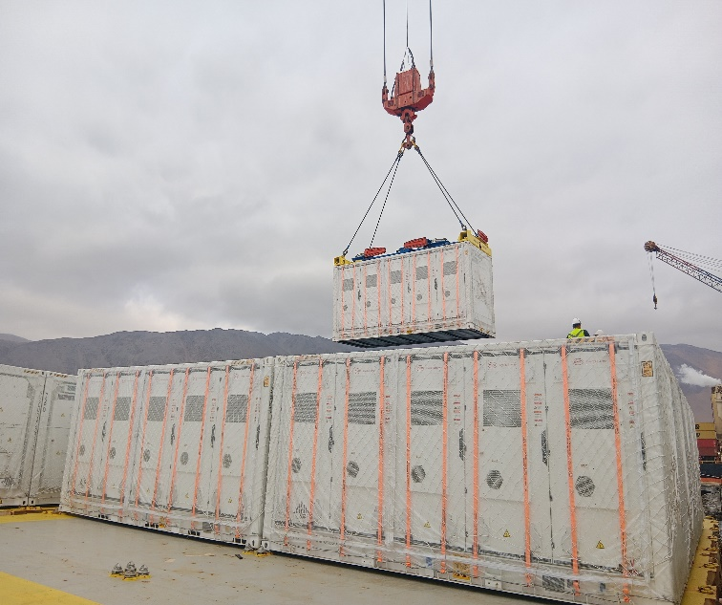
- Discharge operation of battery. | - Discharge Operation of battery.
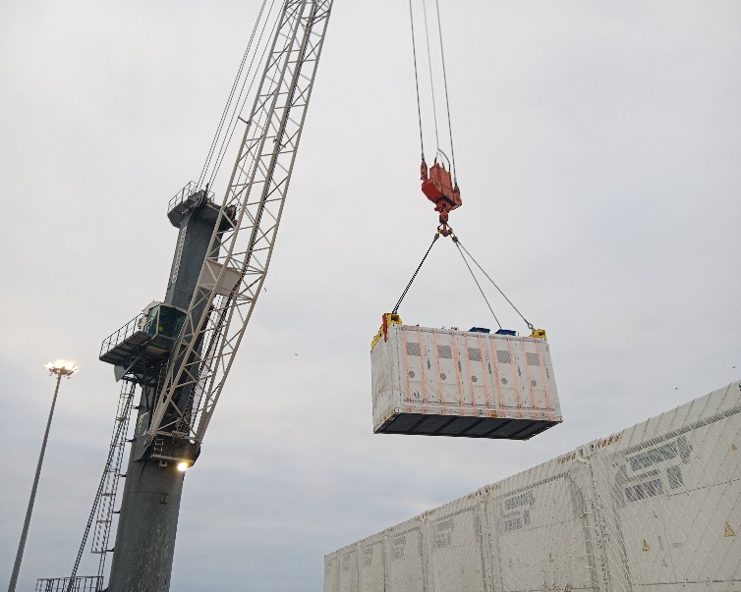 | 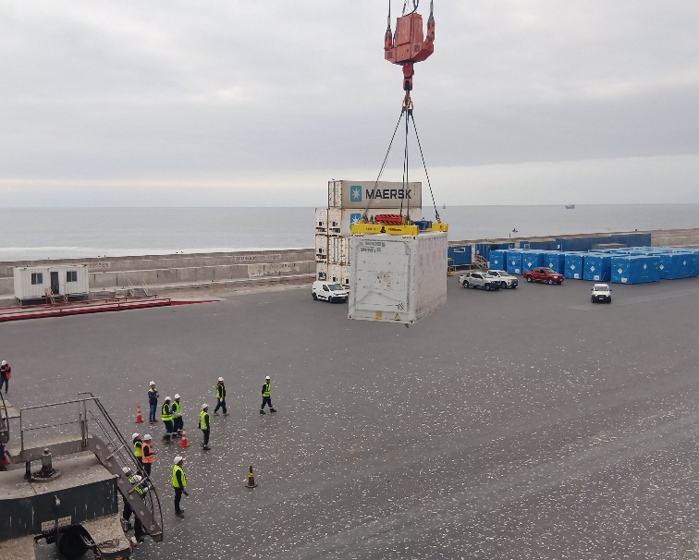
- Battery being discharged. | - Battery being discharged.
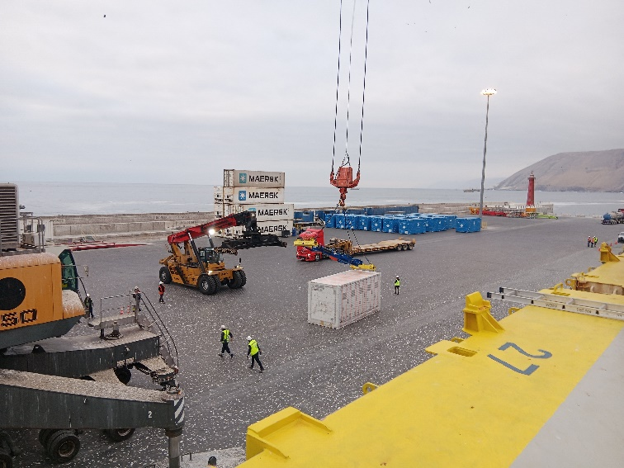 | 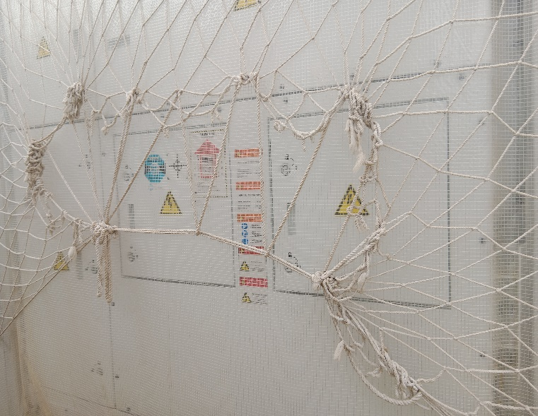
- Battery discharged directly on ground alongside Vessel. | - Sensors of battery.
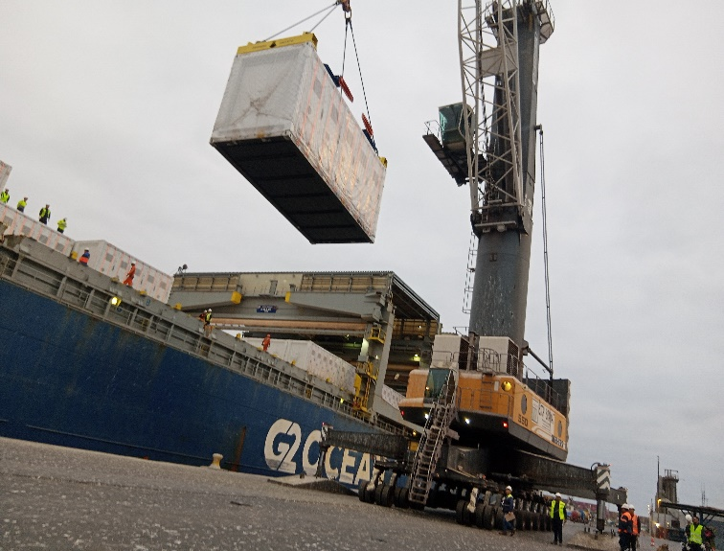 | 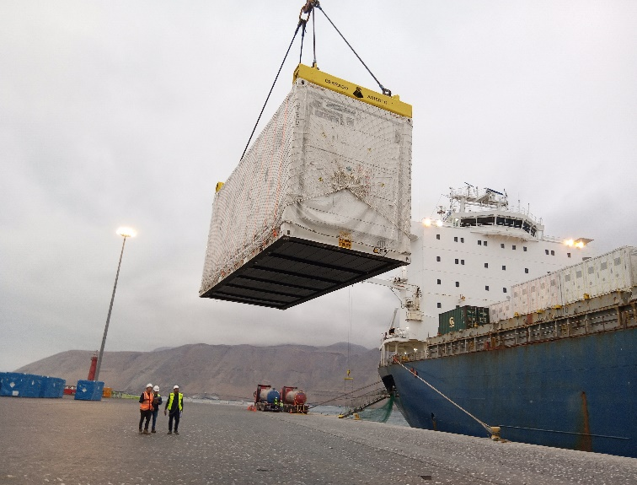
- Discharge Operation of battery. | - Battery being discharged.
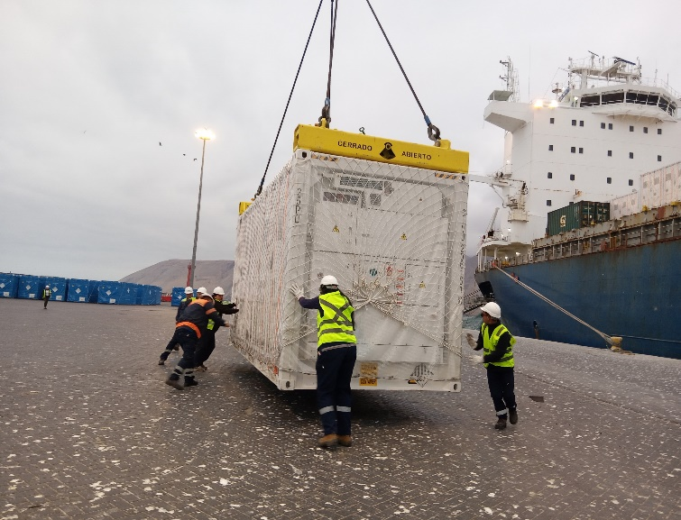 | 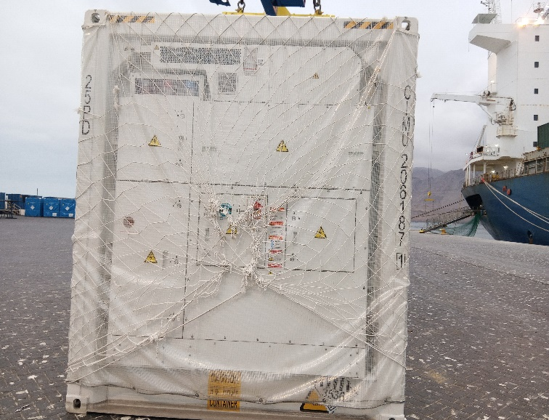
- Battery being discharged on ground alongside Vessel. | - Battery discharged alongside Vessel.
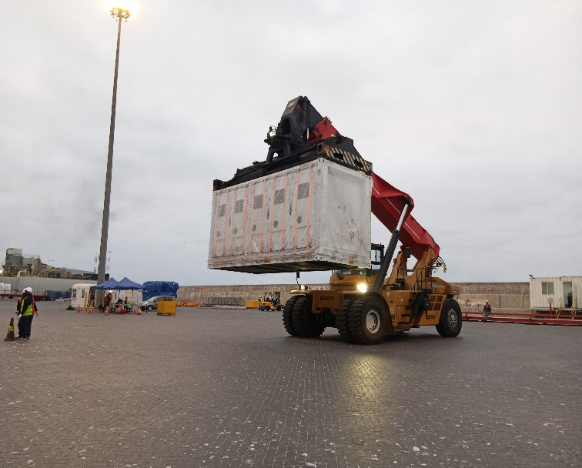 | 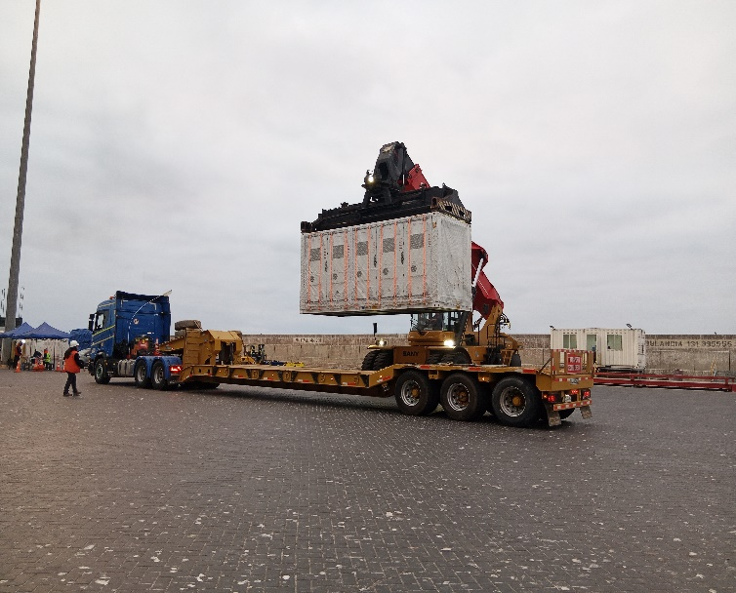
- Battery being taken by reach stacker to be loaded onto truck. | - Battery being taken by reach stacker to be loaded onto truck.
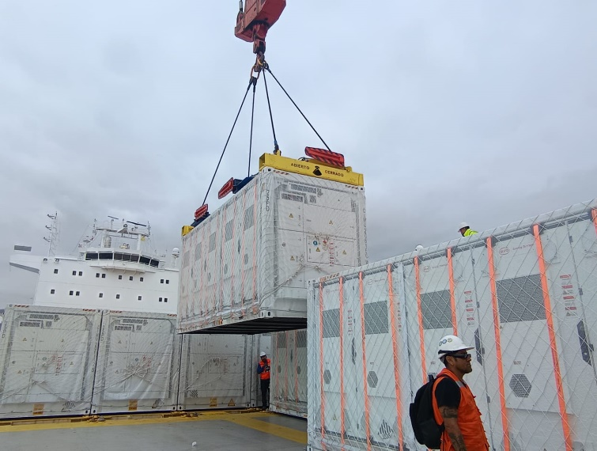 | 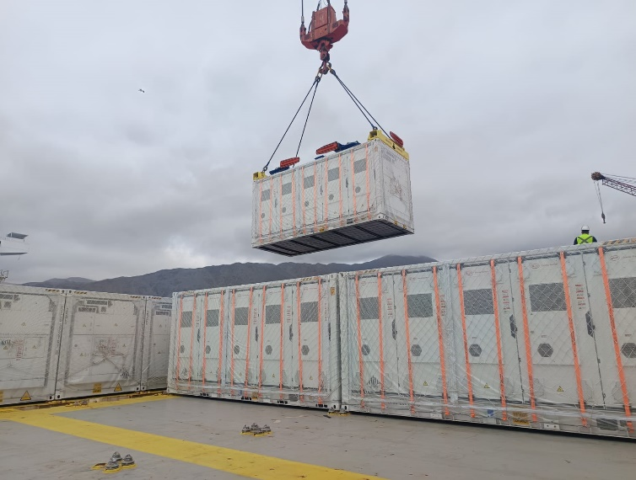
- Discharge Operation of battery. | - Battery being discharged.
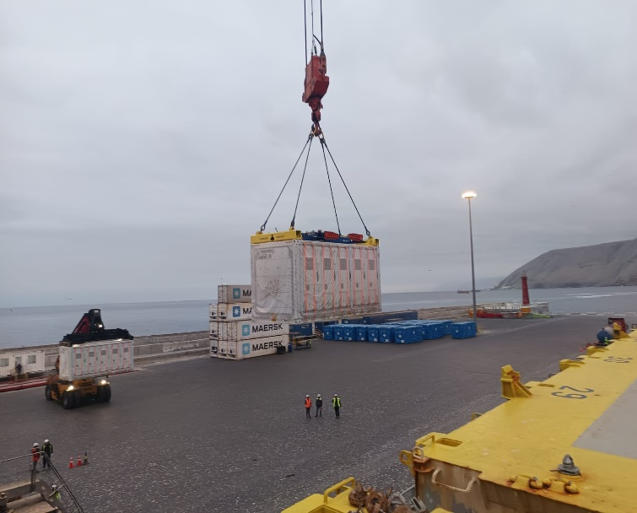 | 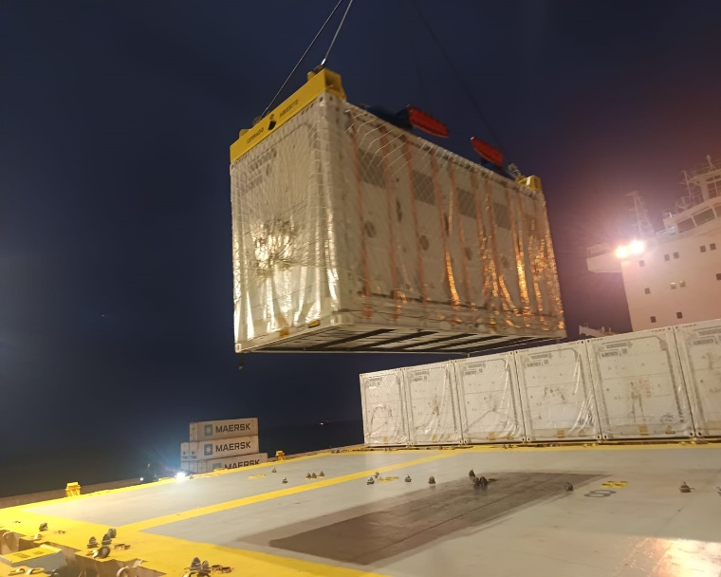
- Battery being discharged. | - Battery being discharged.
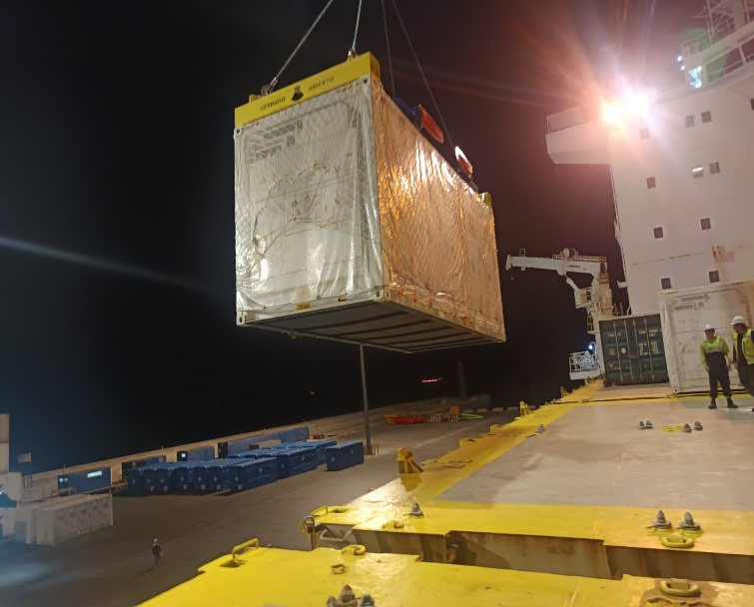 | 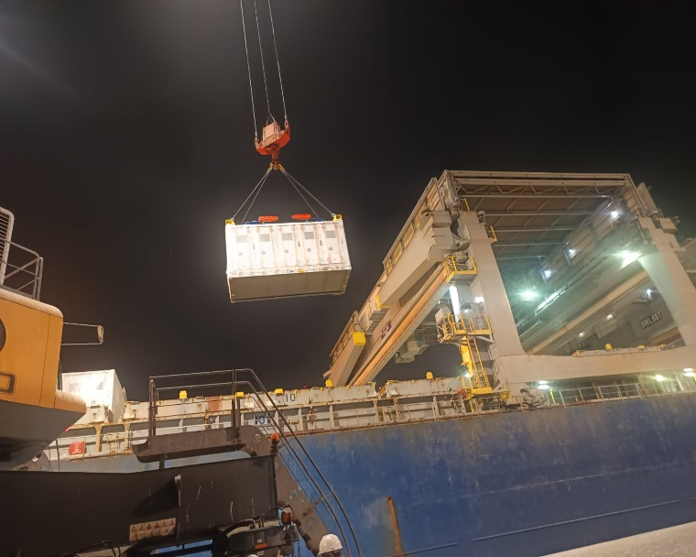
- Discharge operation of battery. | - Discharge operation of battery. Stowed on deck N° 5.
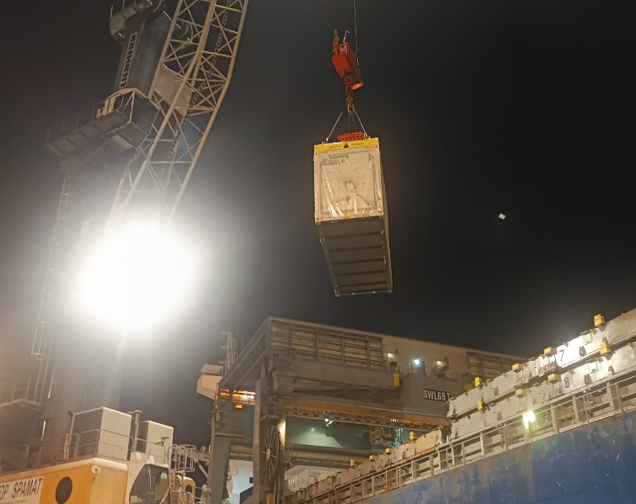 | 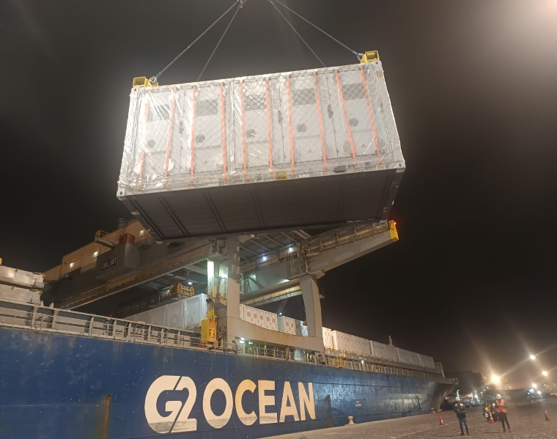
- Discharge Operation of battery. | - Battery being discharged.
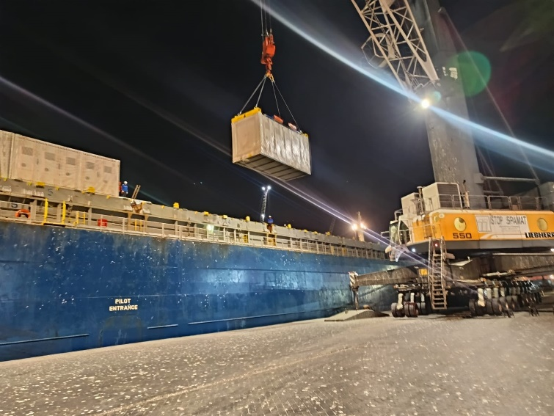 | 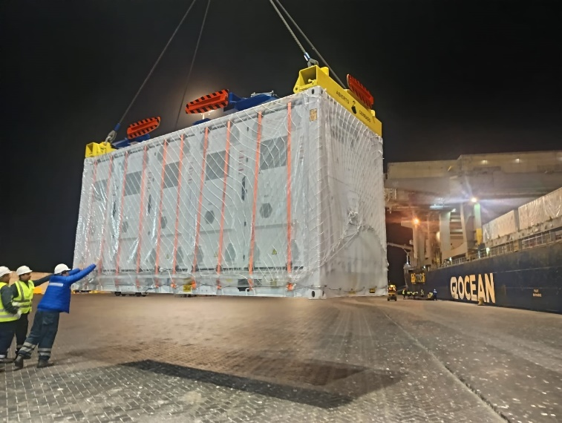
- Battery being discharged. | - Battery being discharged alongside vessel.
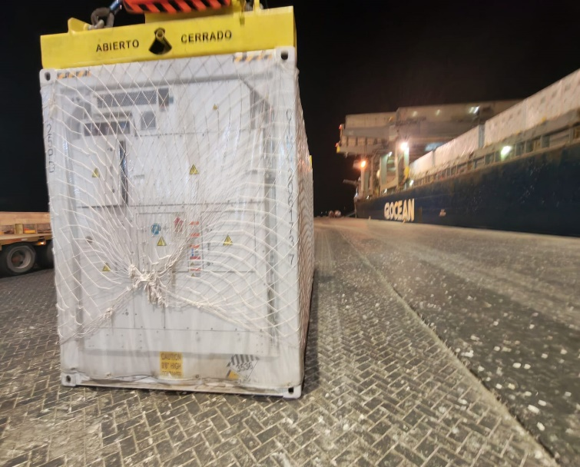 | 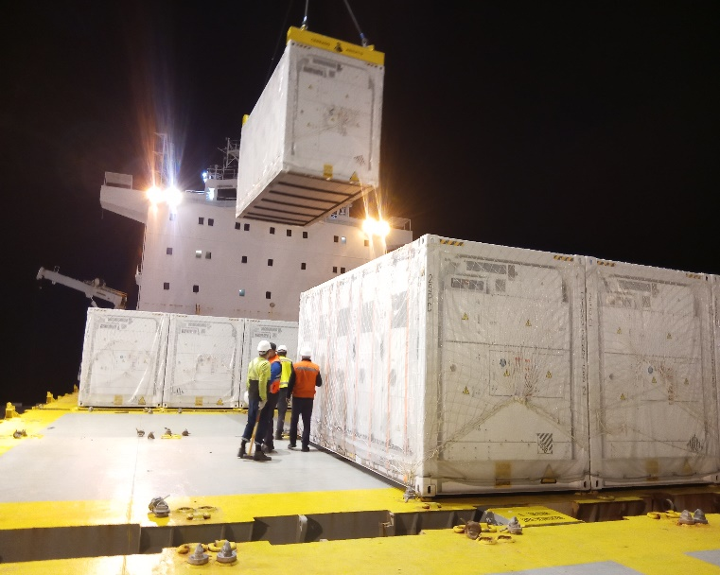
- Battery alongside Vessel. | - Battery being discharged.
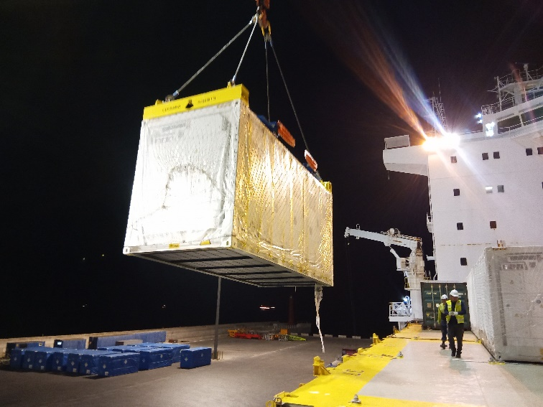 | 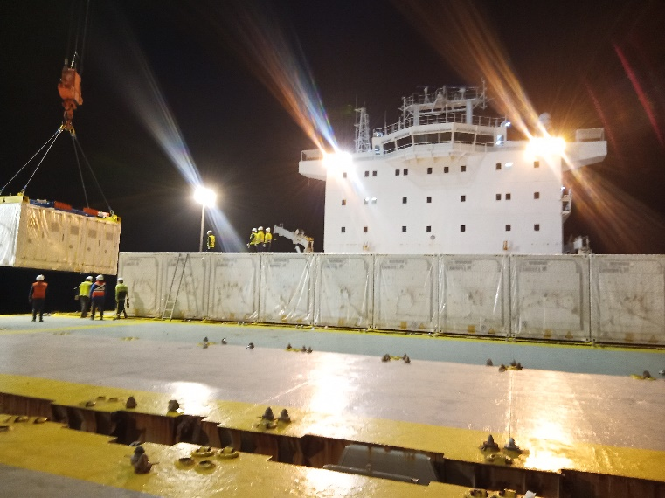
- Discharge operation of battery. | - Batteries on deck.

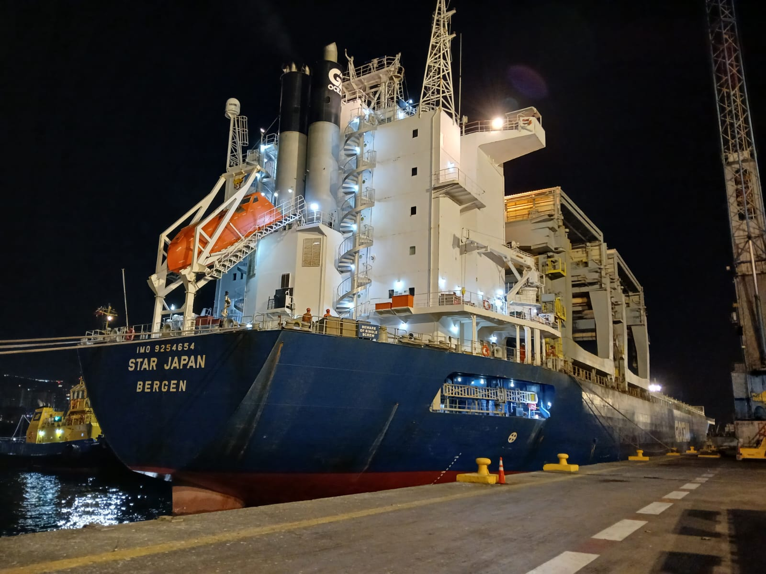
IQUIQUE TERMINAL INTERNATIONAL - Pier Nr. 4

Voyage : 2505
Port of Discharge : Iquique - Chile
Stevedores Co. : Iquique Terminal International o/b of ITI (Iquique - Chile)
Surveyor : Mss. Maria Jose Palma C.
Operations Agent : Mss. Maria Jose Palma C.

1. ARRIVAL CONDITION OF TRANSFORMER AND ACCESORIES DECK # 4

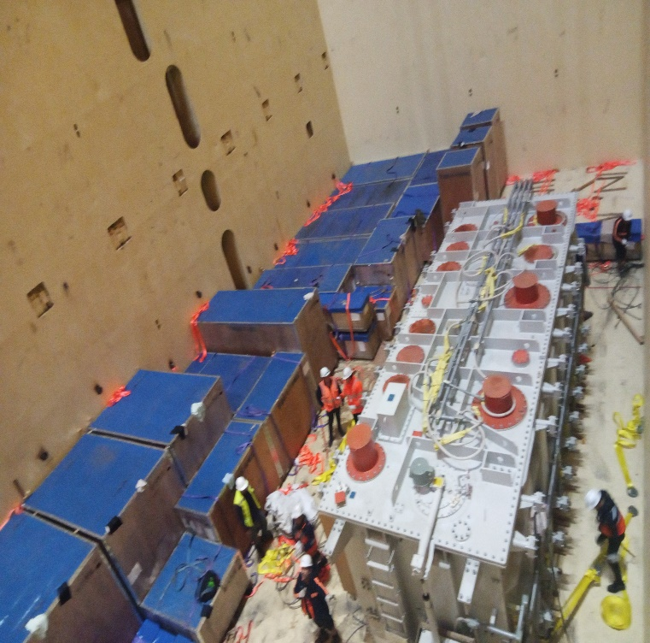 | 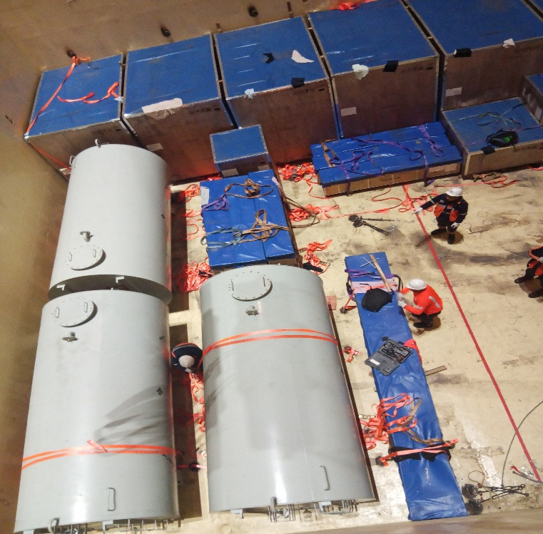
- Transformer and wooden crates, Hold N° 4. | - Wooden crates and tanks.
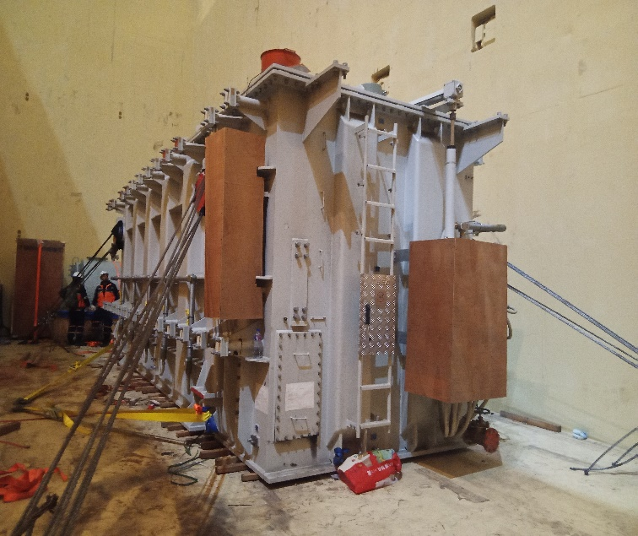 | 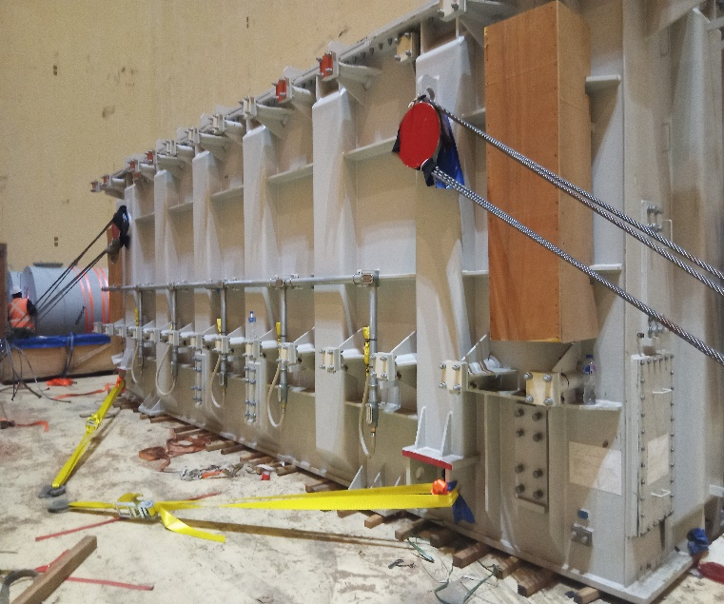
- Transformer stowed in hold N° 4 lashed with ¿???. | - Transformer stowed in hold N° 4 lashed with ¿???.

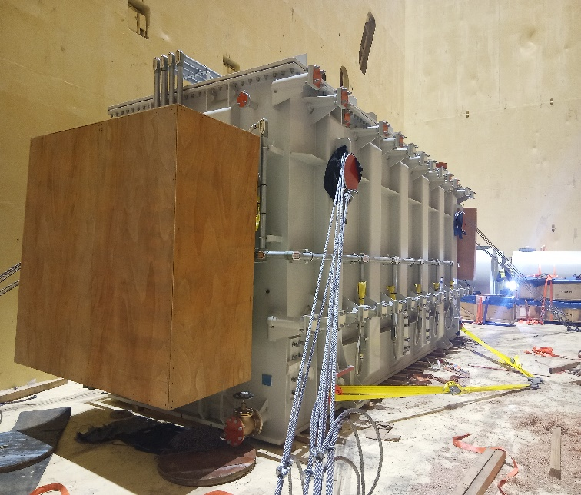 | 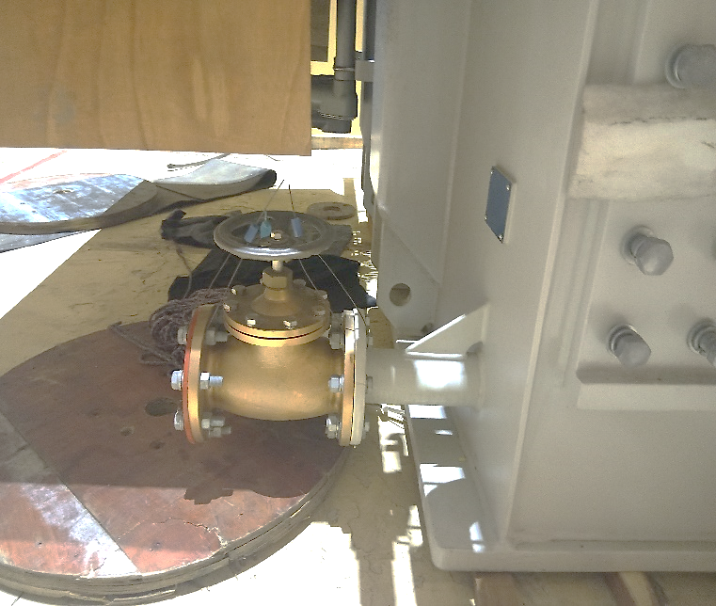
- Transformer stowed in hold N° 4 lashed with ¿???. | - Taps of transformer.
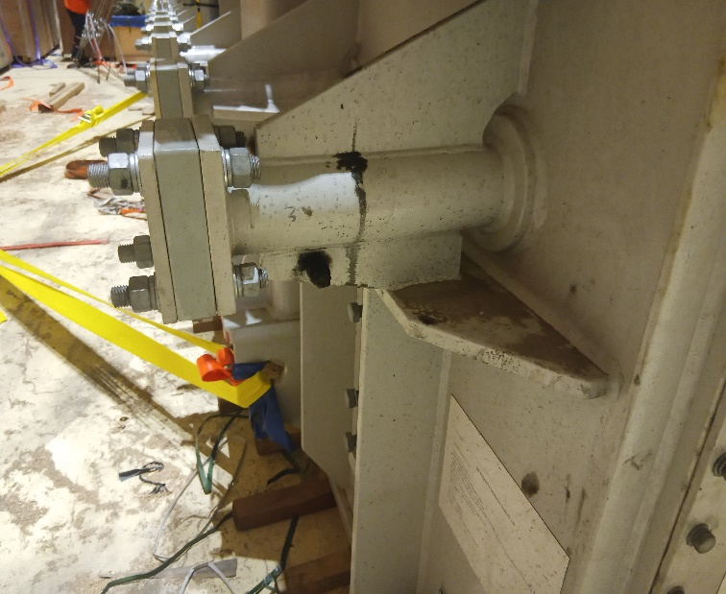 | 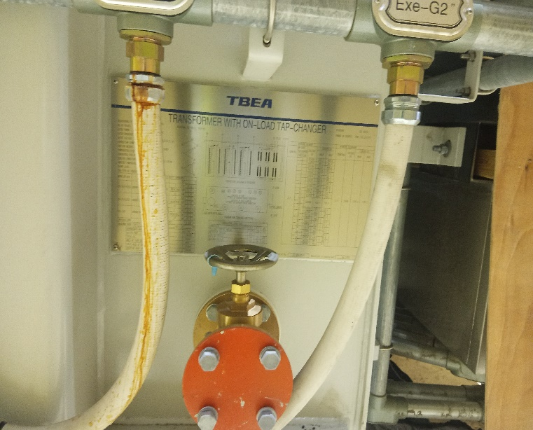
- Parts of transformer. | - Tap and pipes of transformer.

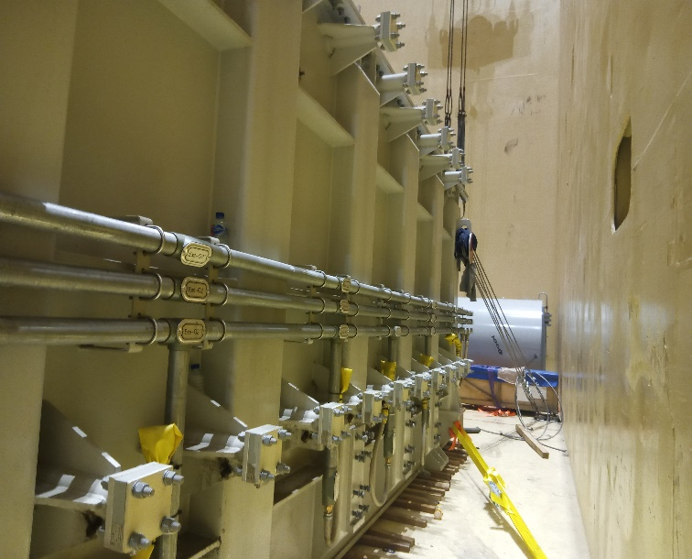 | 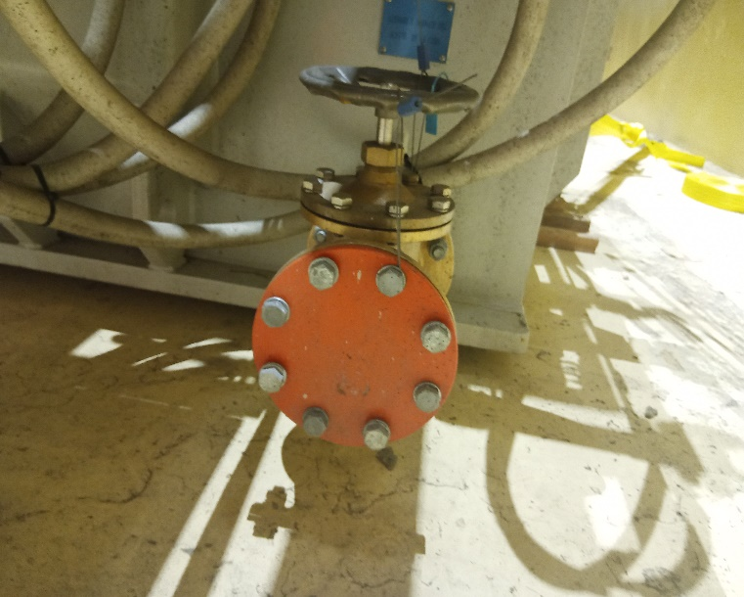
- Lateral side of transformer. | - Tap of transformer.
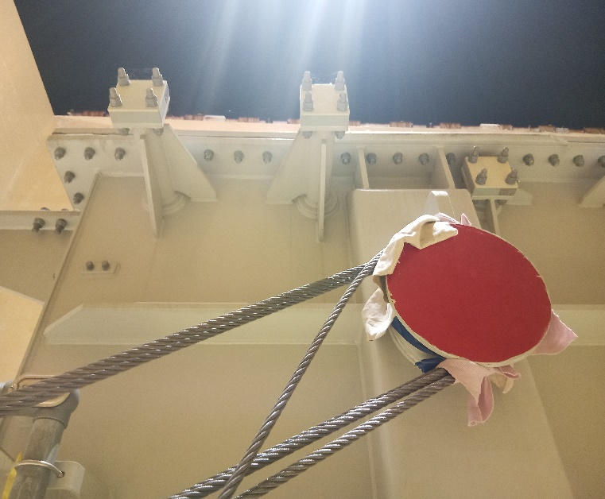 | 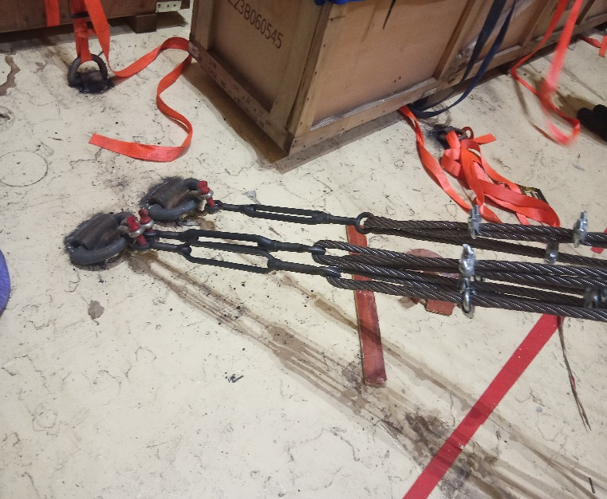
- Lashing of transformer with wires. | - Another view of lashing of transformer.

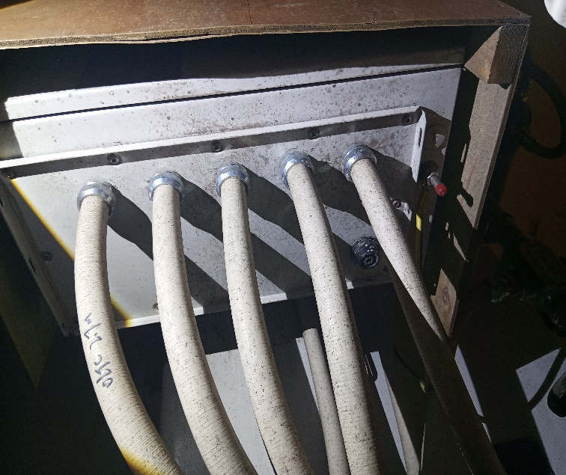 | 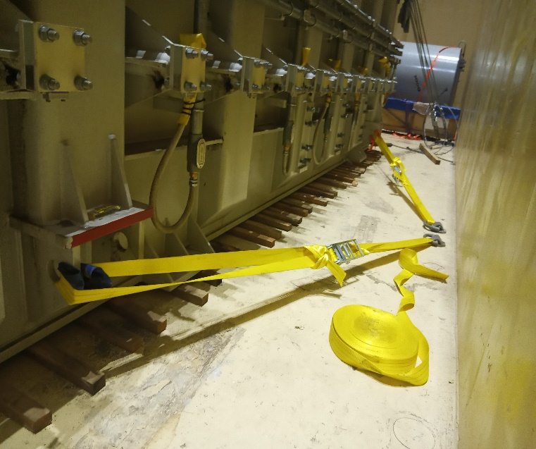
- Hoses of transformer. | - Lashing of transformer with marine bands.
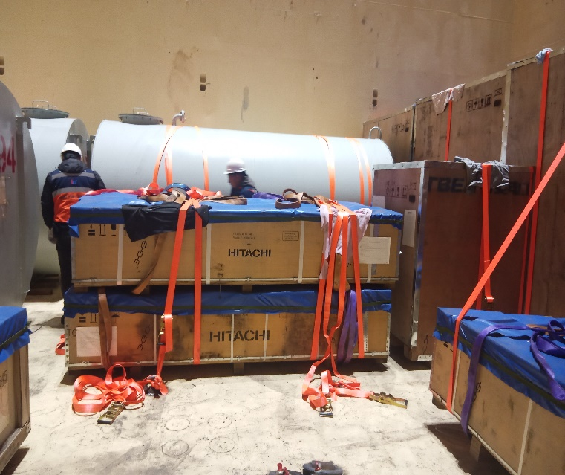 | 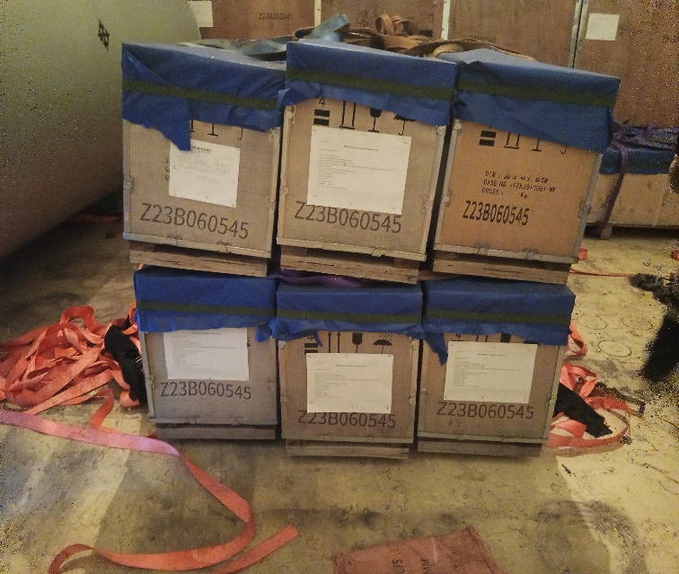
- Wooden crates stowed in hold N° 4. | - Wooden crates stowed in hold N° 4.

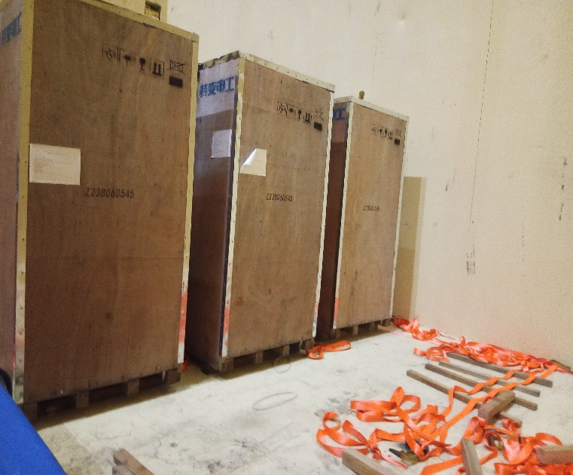 | 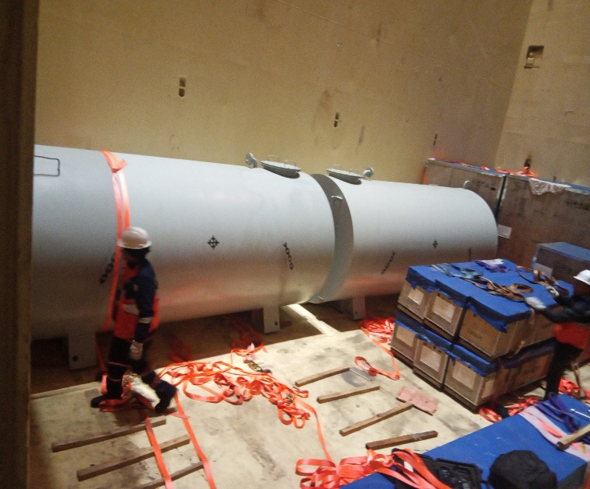
- Crates stowed in hold N° 4. | - Tanks stowed in hold N° 4.
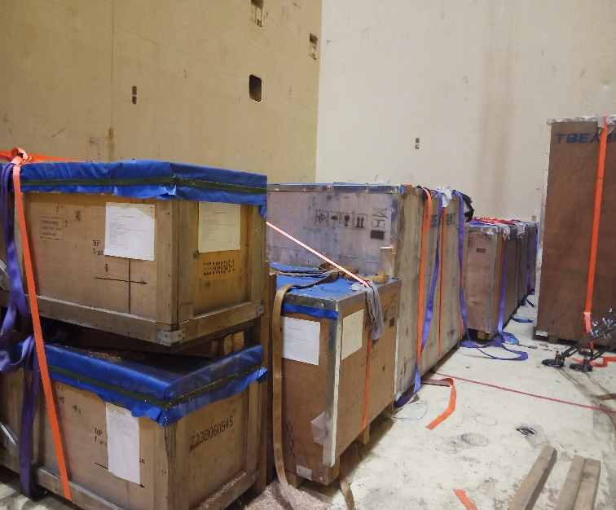 | 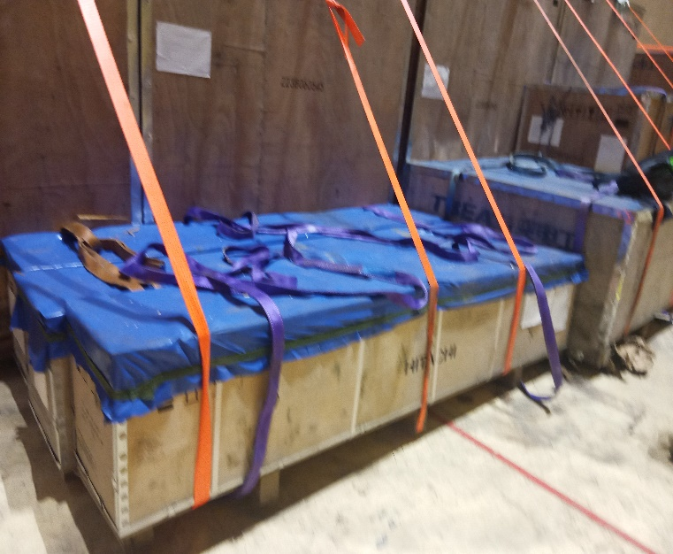
- General view of wooden crates stowed in hold N° 4. | - Lashing of crates with marine bands.

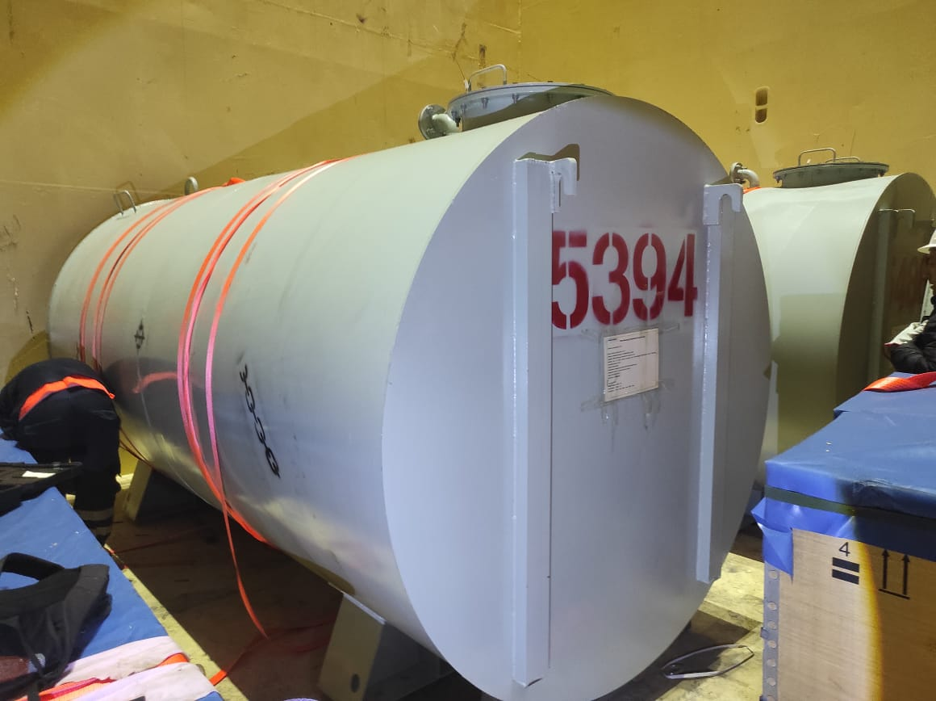 | 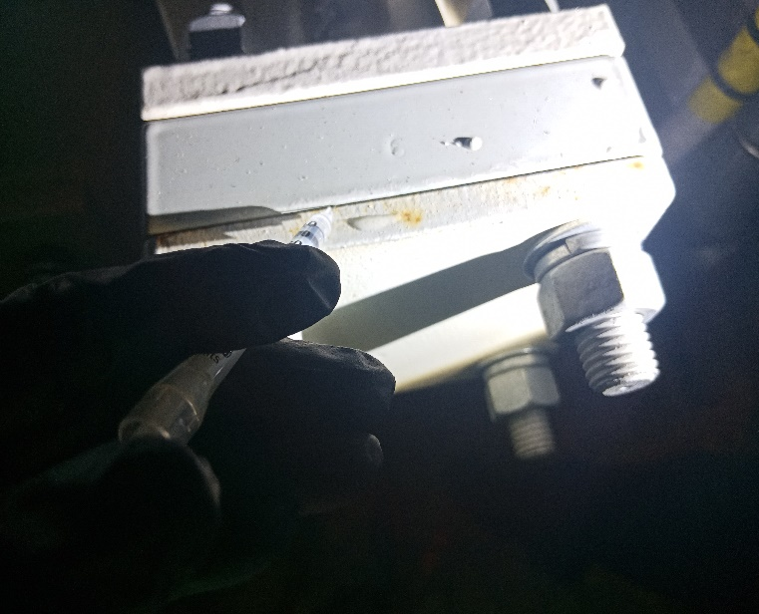
- Lashing of tank with marine bands. | - Salinity test on transformer, negative result.
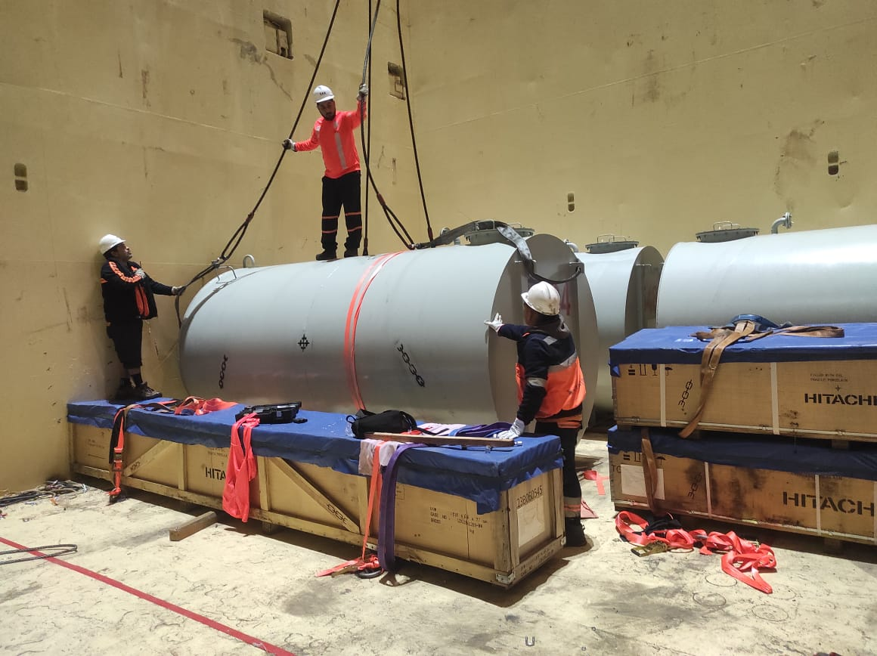 | 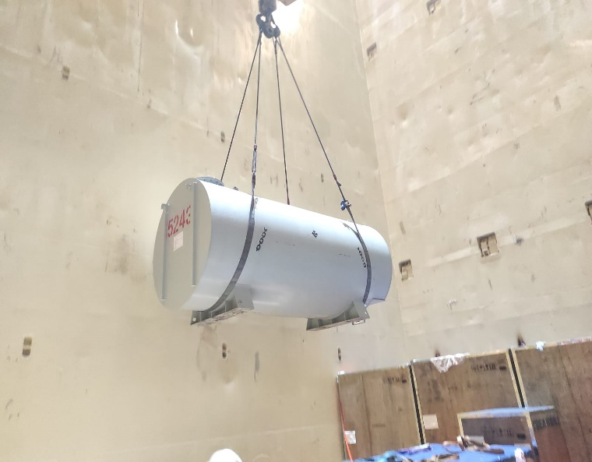
- Tank being prepared for discharging. | - Tank being discharged.

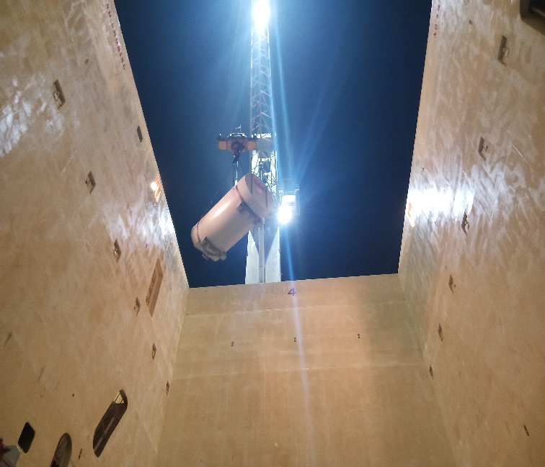 | 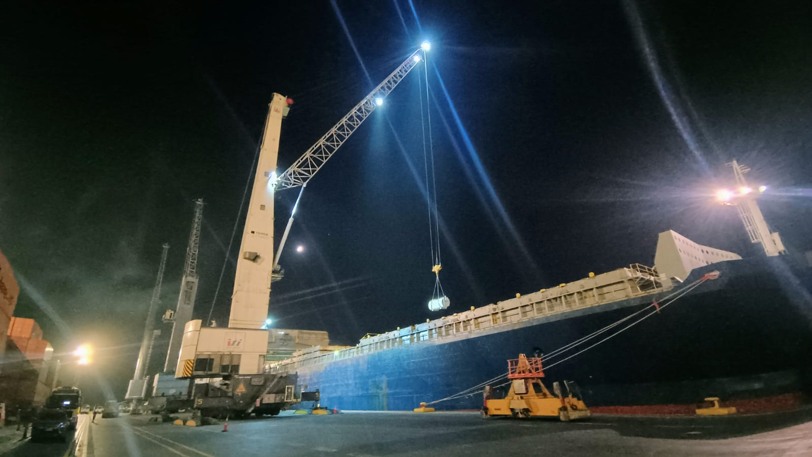
- Another view of tank being discharged. | - General view of discharging Operation of cargo.
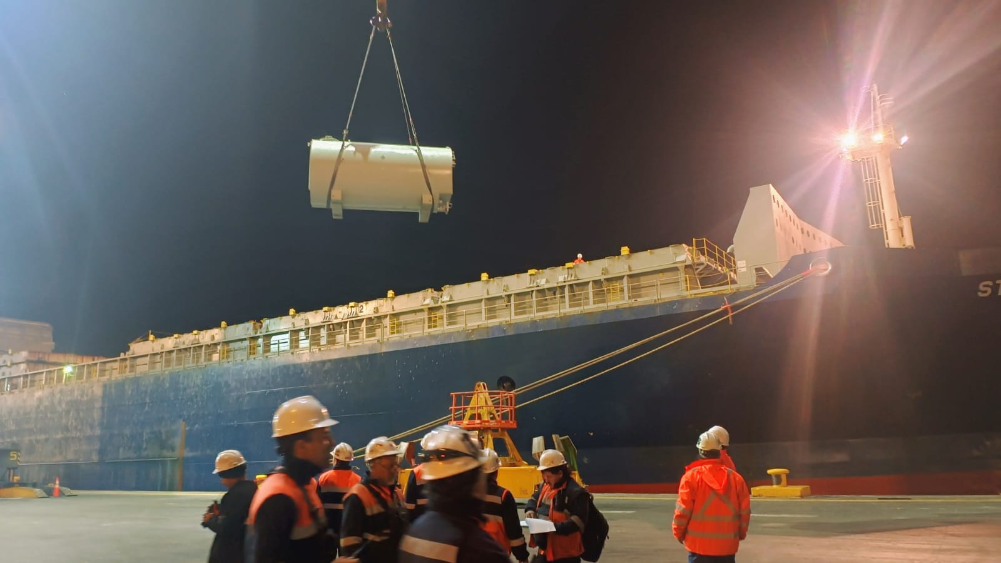 | 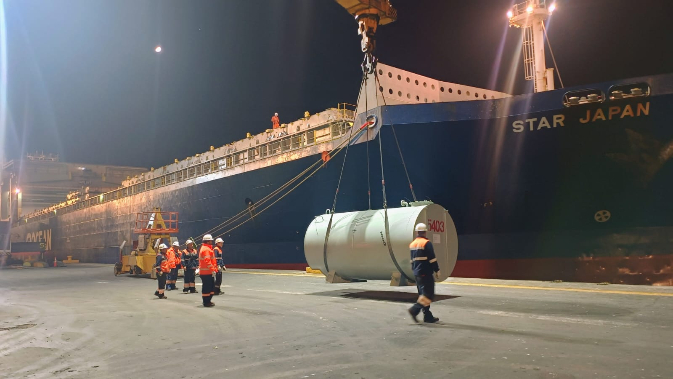
- Tank being discharged alongside vessel. | - Tank being discharged alongside vessel.

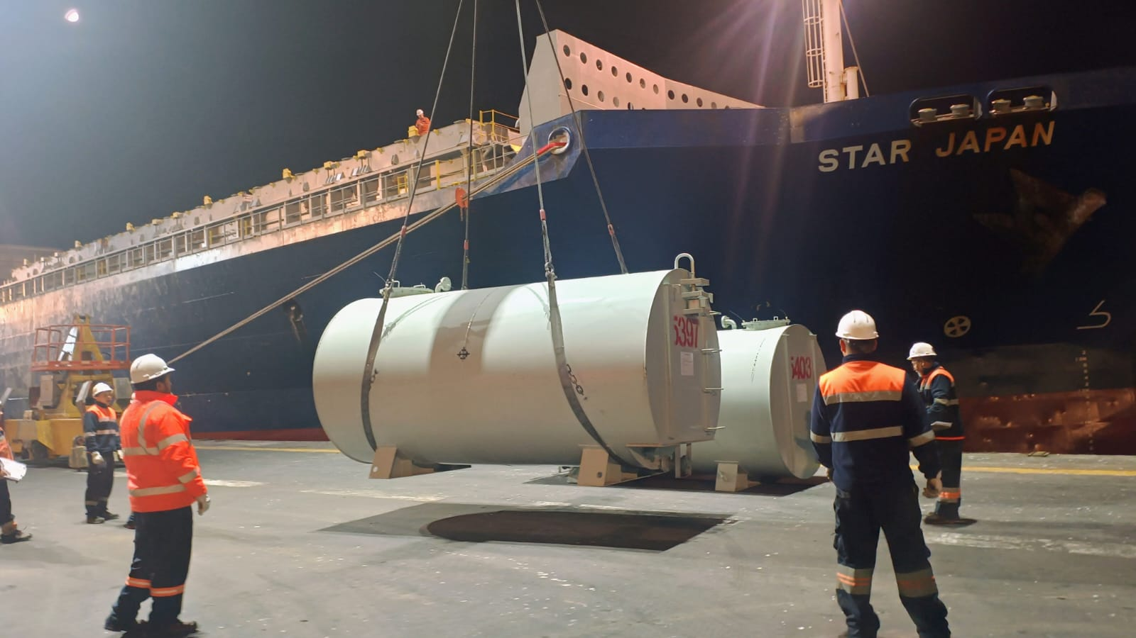 | 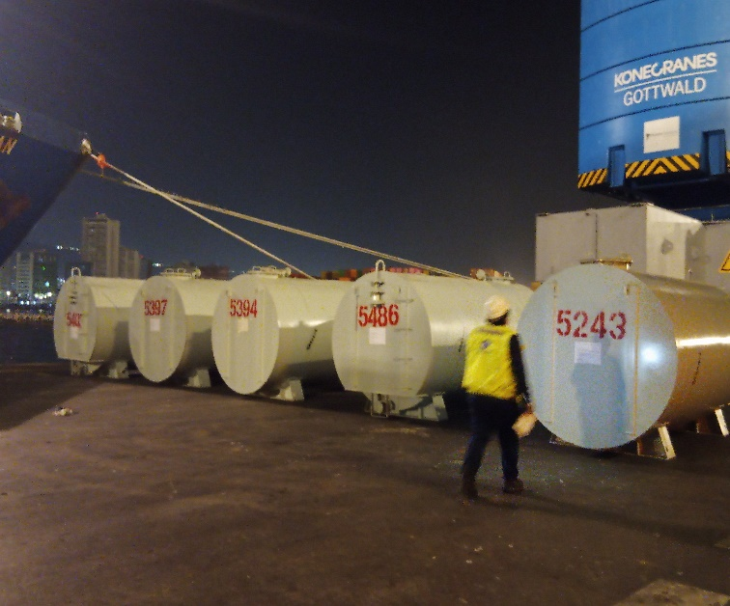
- Tank being discharged alongside vessel. | - Tanks alongside Vessel.
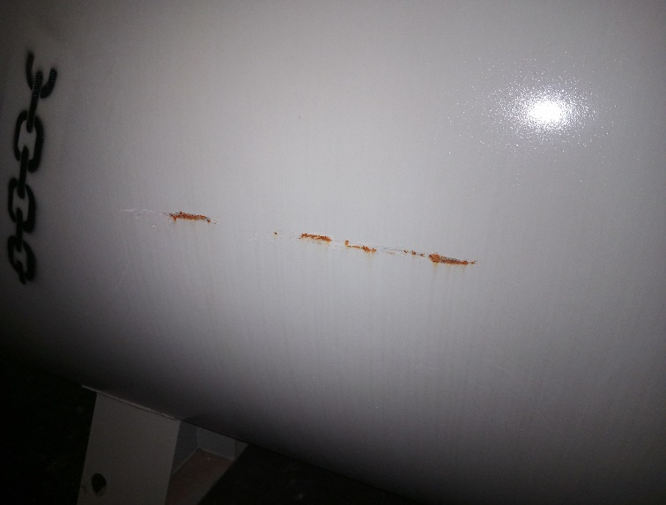 | 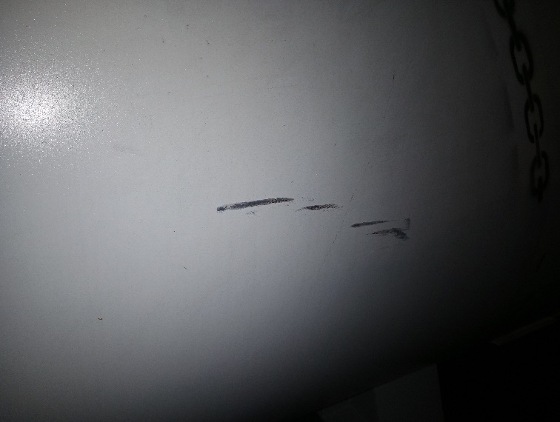
- Tank with rust signs. | - Tank scratched.

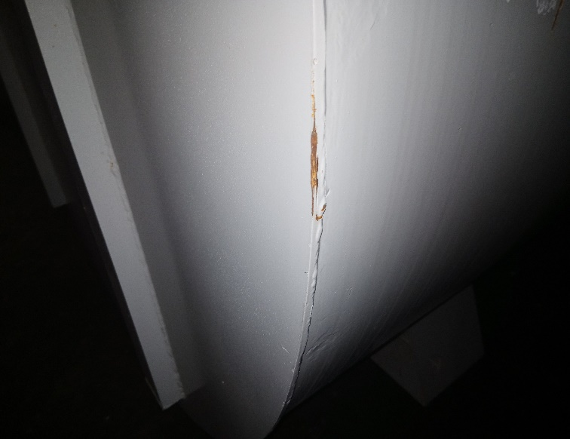 | 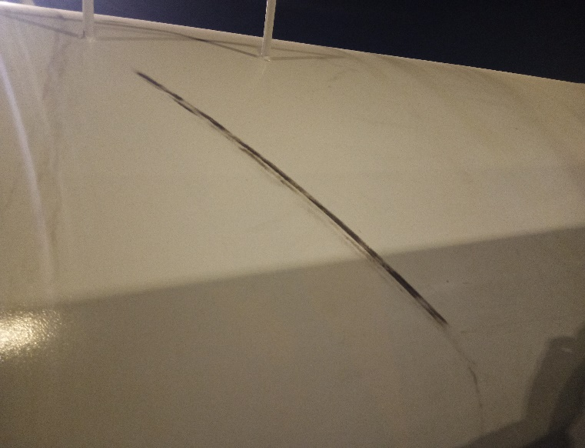
- Tank with rust. | - Tank scratched.
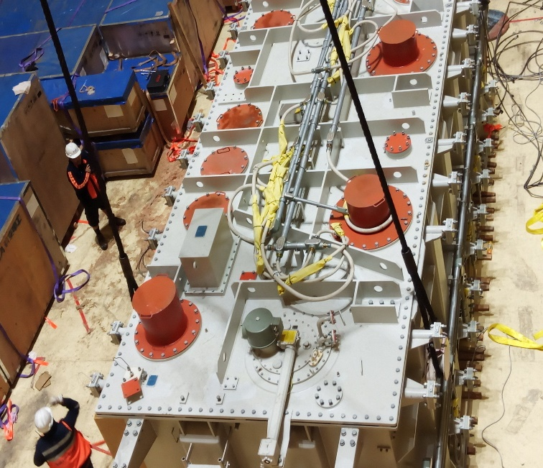 | 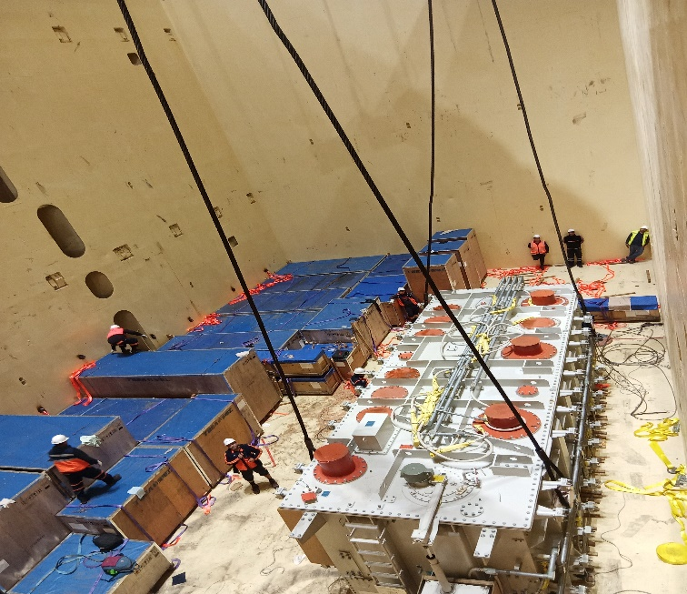
- Upper view of transformer. | - Transformer being ready for discharging.

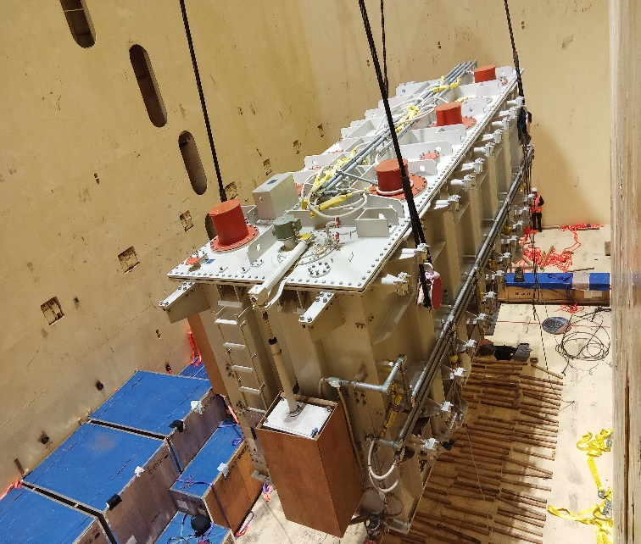 | 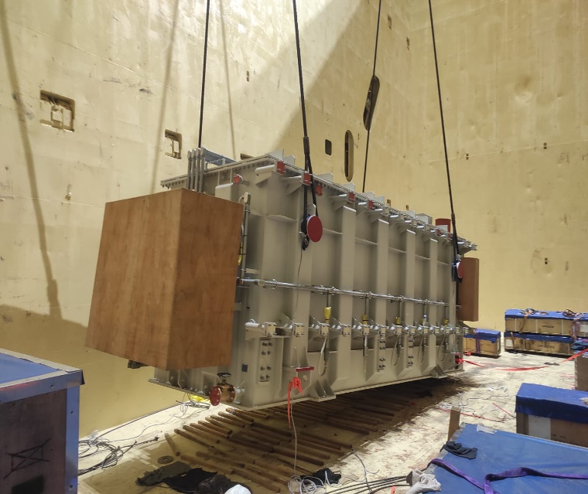
- Transformer being discharged. | - Transformer being discharged.
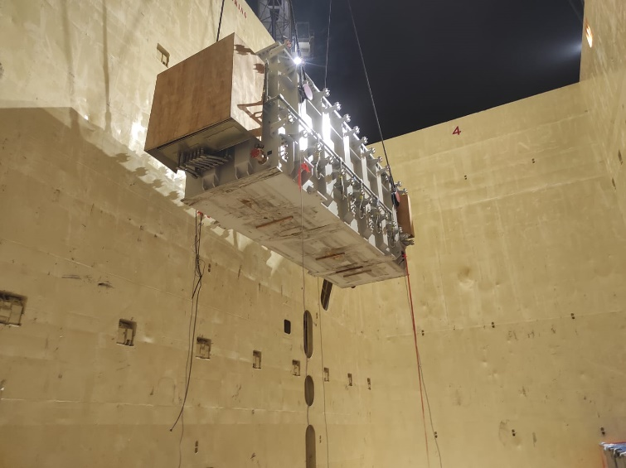 | 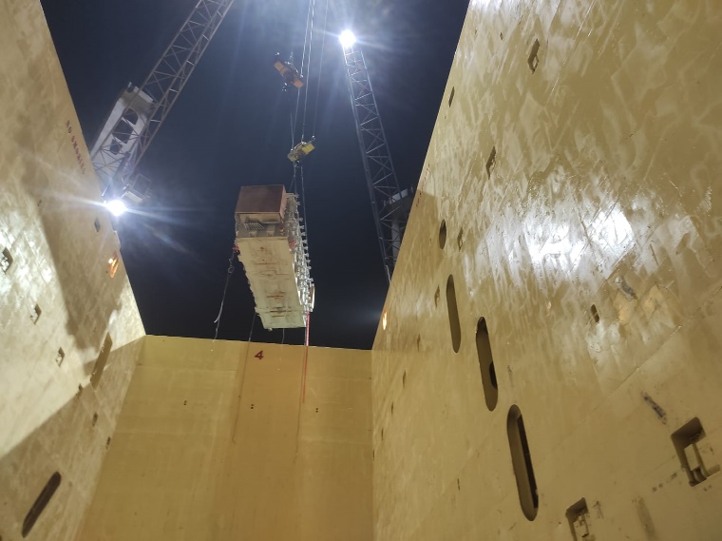
- General view of transformer being discharged. | - Transformer being discharged.

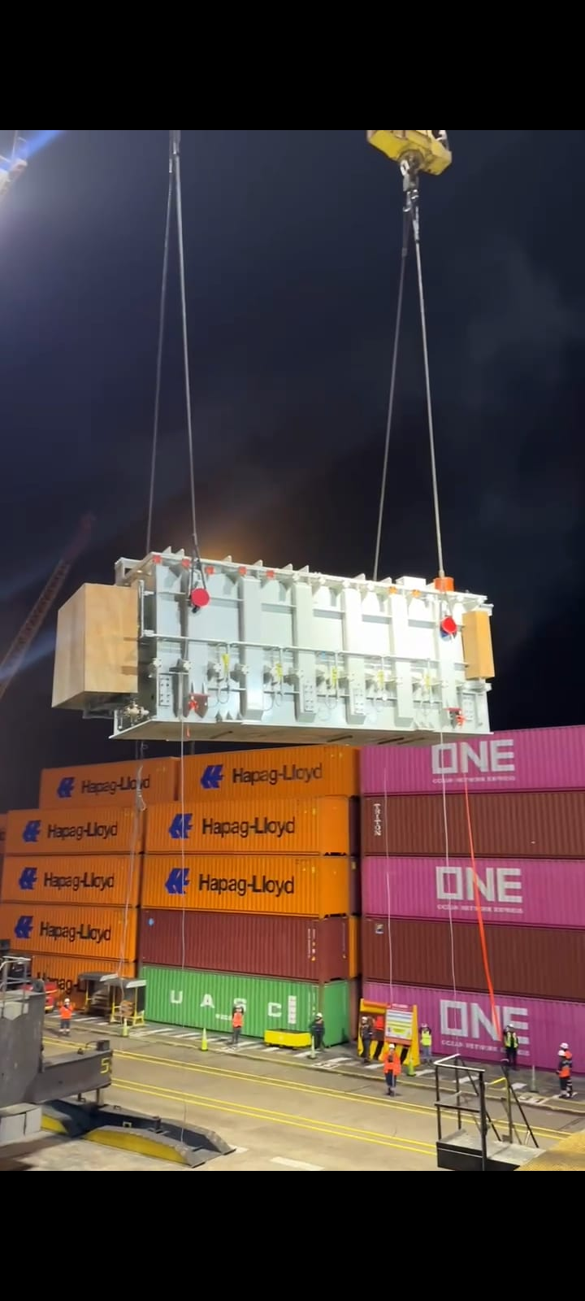 | 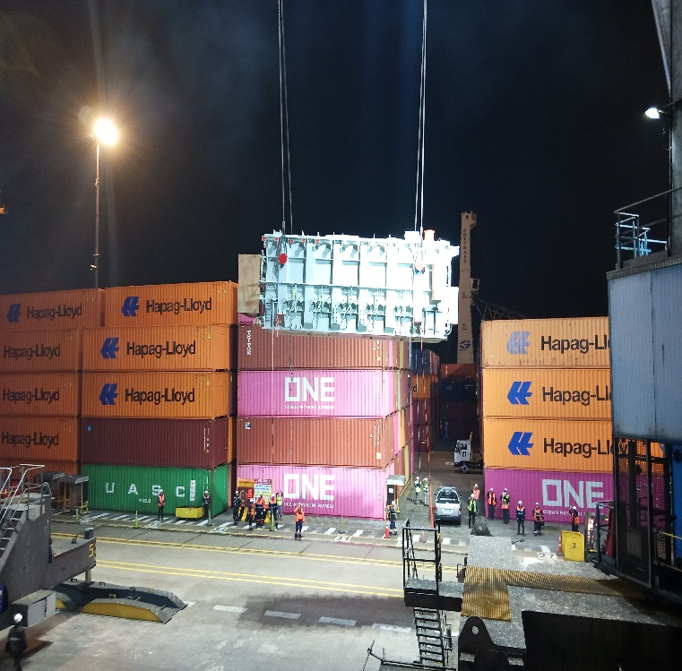
- Discharge operation of transformer. | - Discharge operation of transformer.
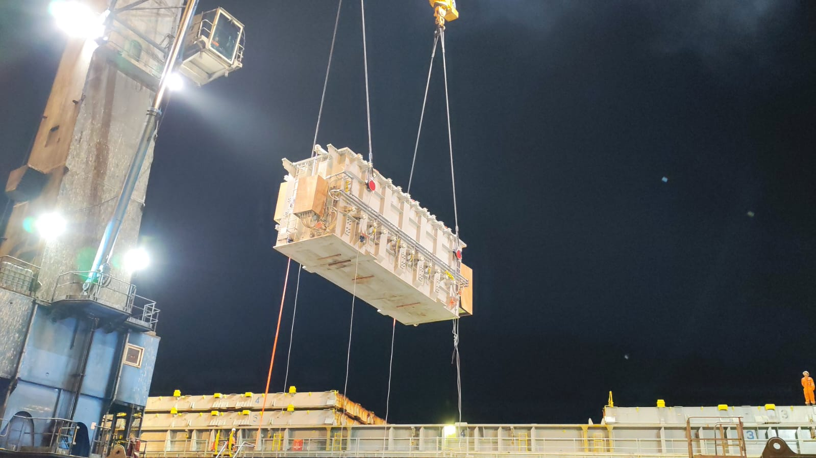 | 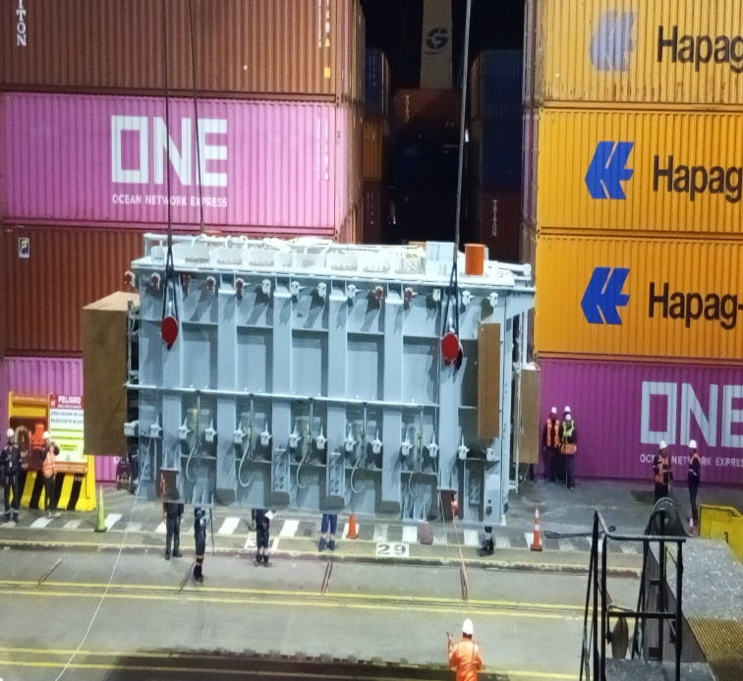
- Discharge operation of transformer. | - Discharge operation of transformer.

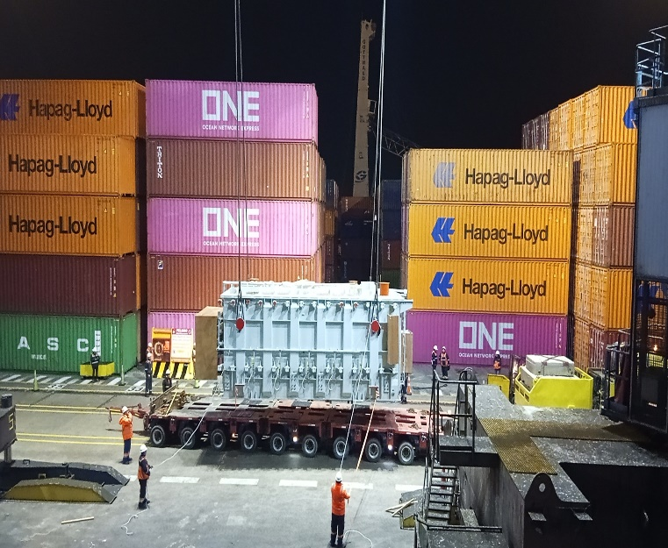 | 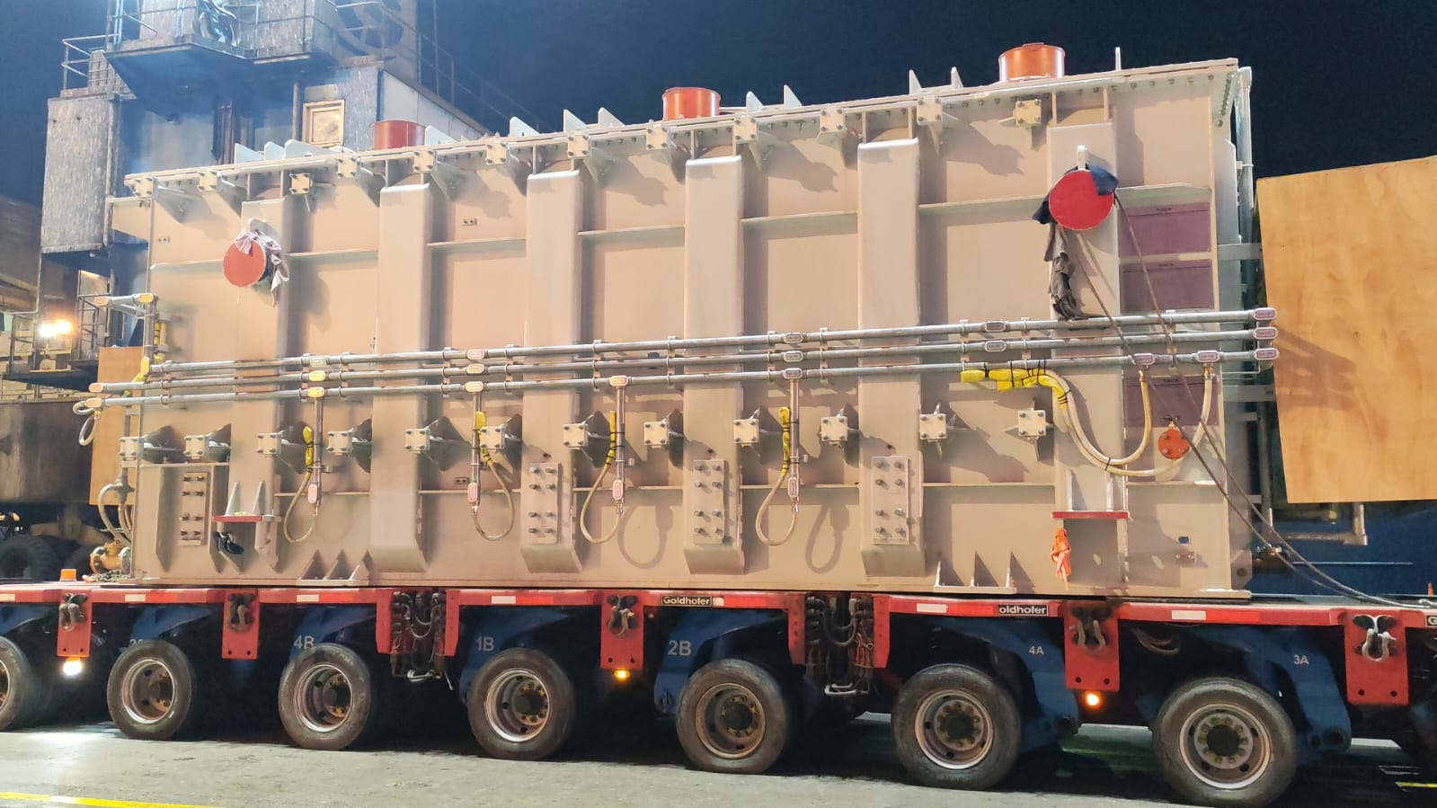
- Transformer discharged directly onto truck. | - Transformer discharged directly onto truck.
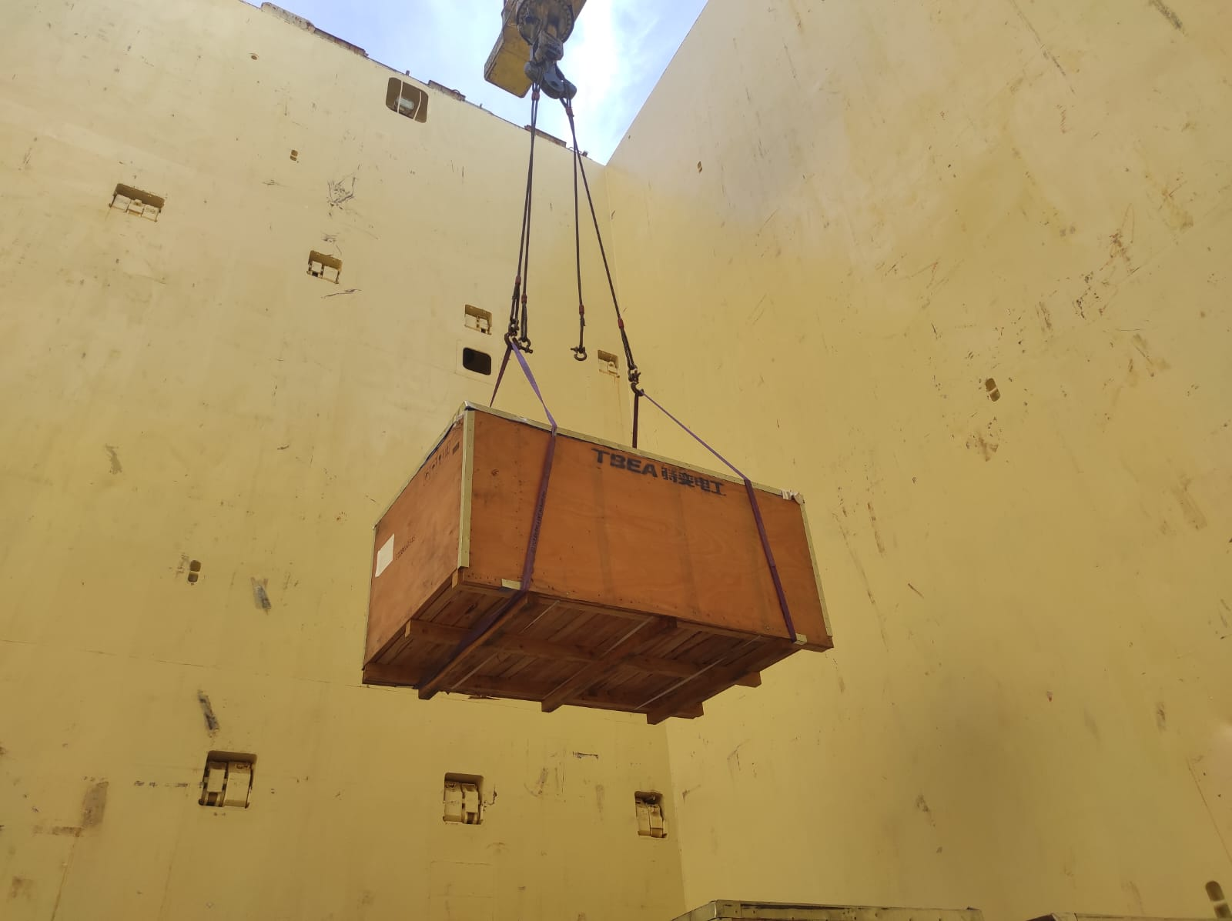 | 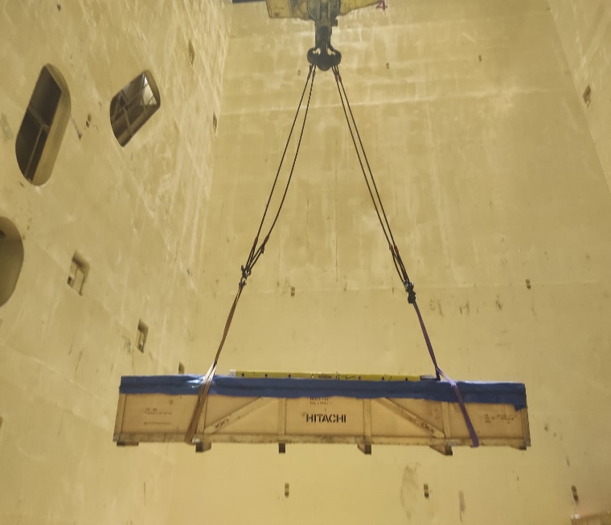
- Discharge operation of wooden crate. | - Discharge operation of wooden crate.

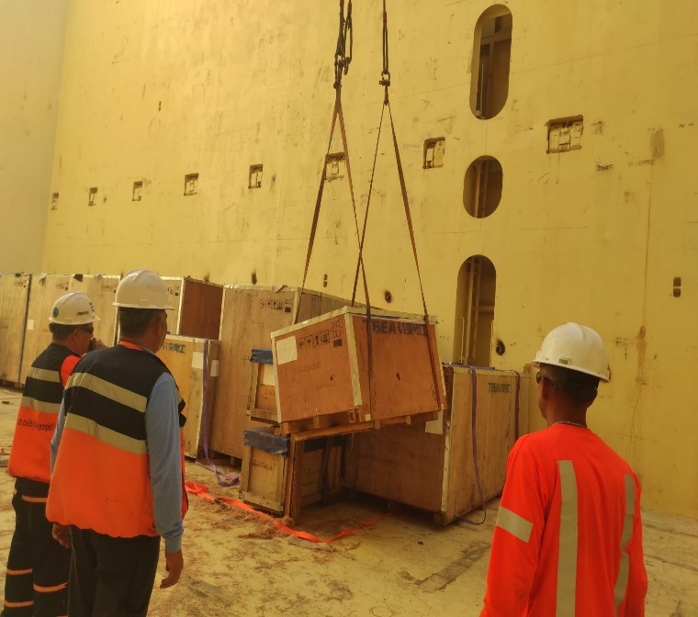 | 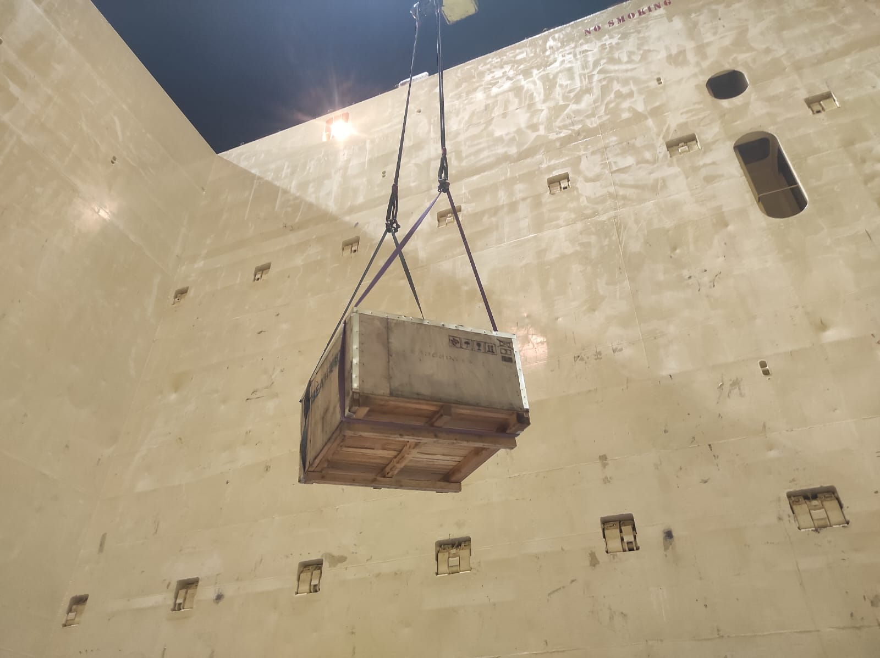
- Discharge operation of wooden crate. | - Wooden crate being discharged.
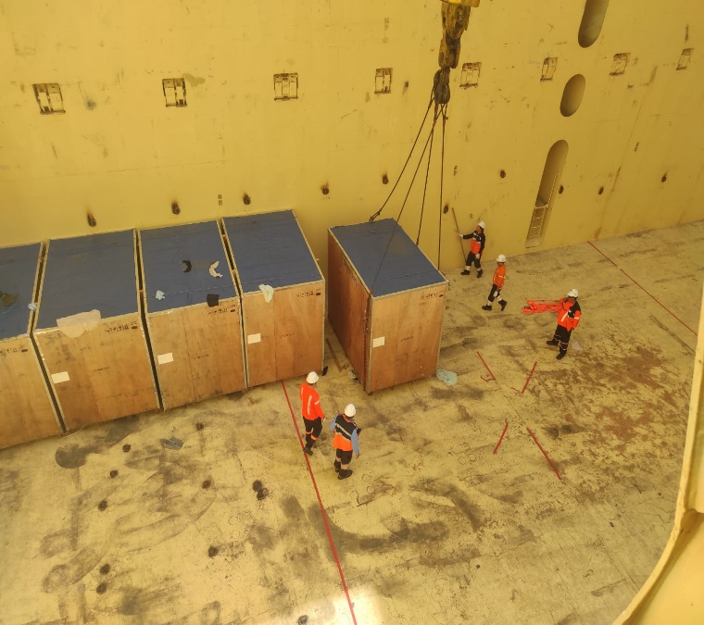 | 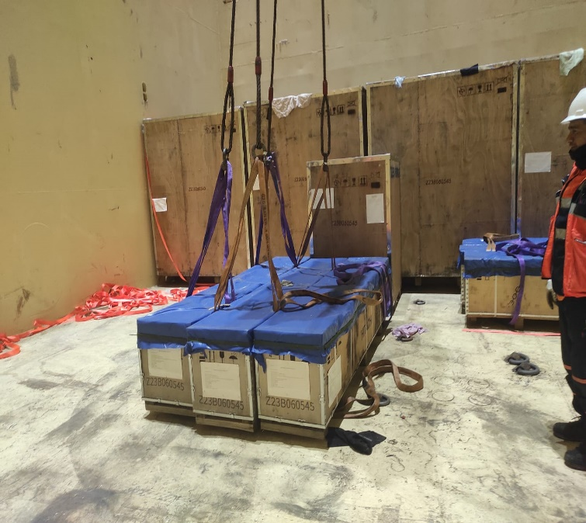
- Wooden crate being prepared for discharging. | - Wooden crates ready for discharging.

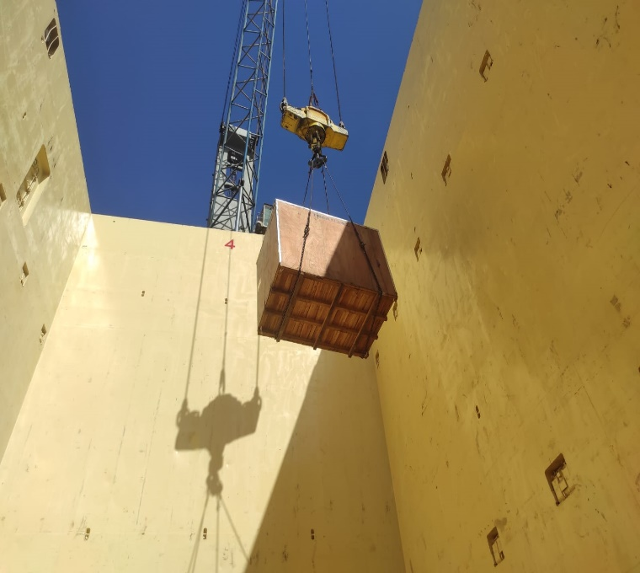 | 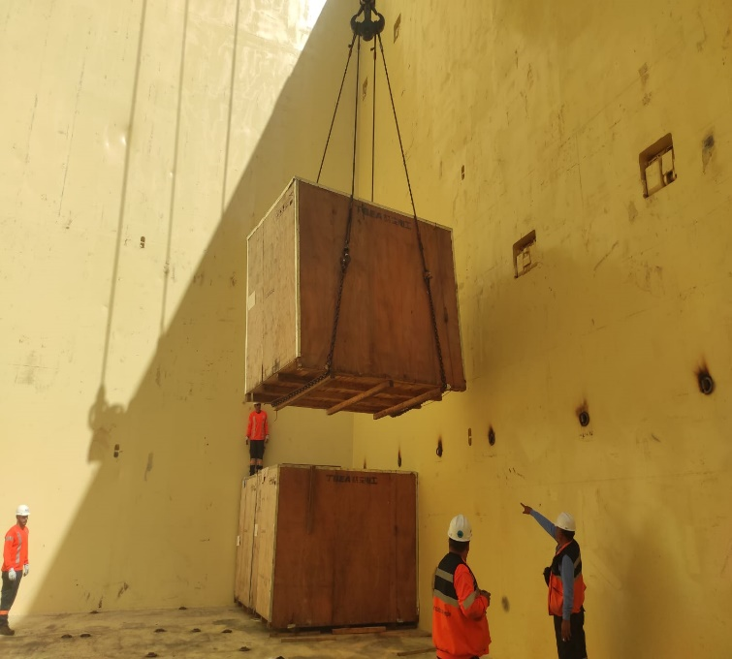
- Discharge operation of wooden crate. | - Discharge operation of wooden crate.
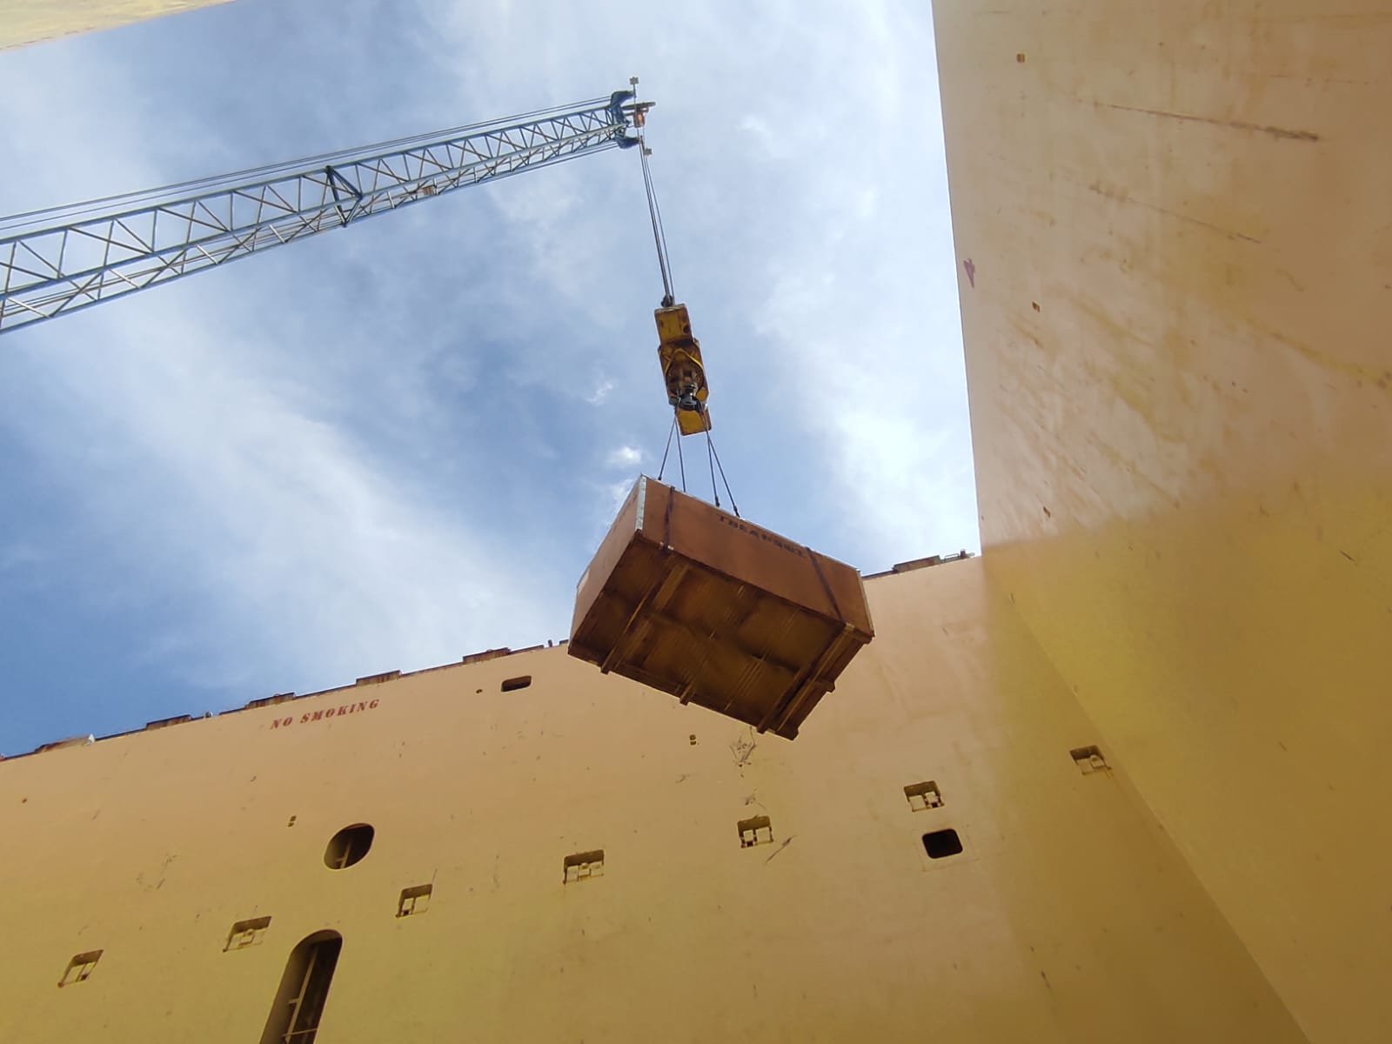 | 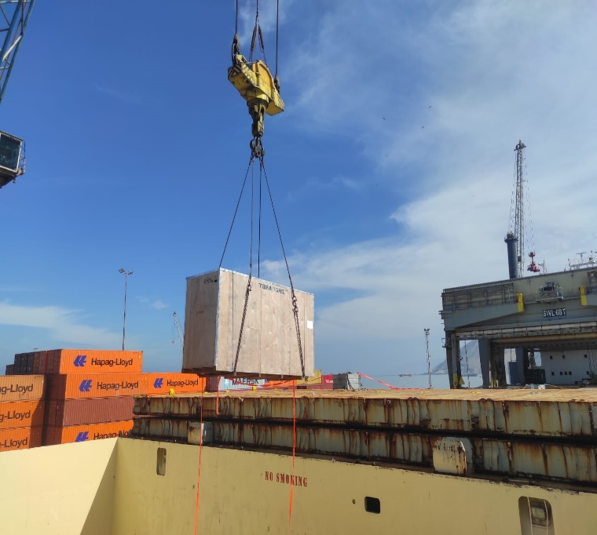
- Discharge operation of wooden crate. | - Discharge operation of wooden crate.

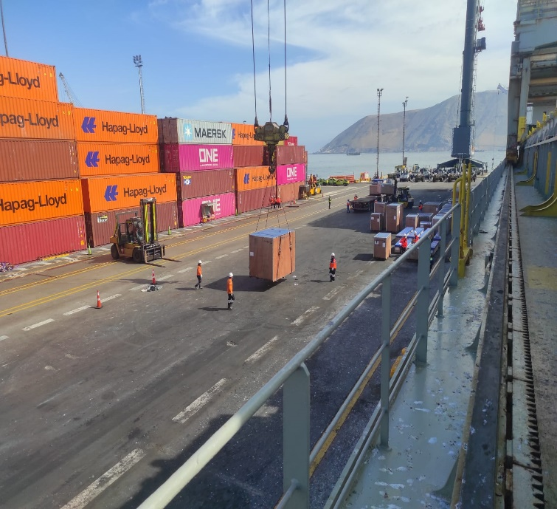 | 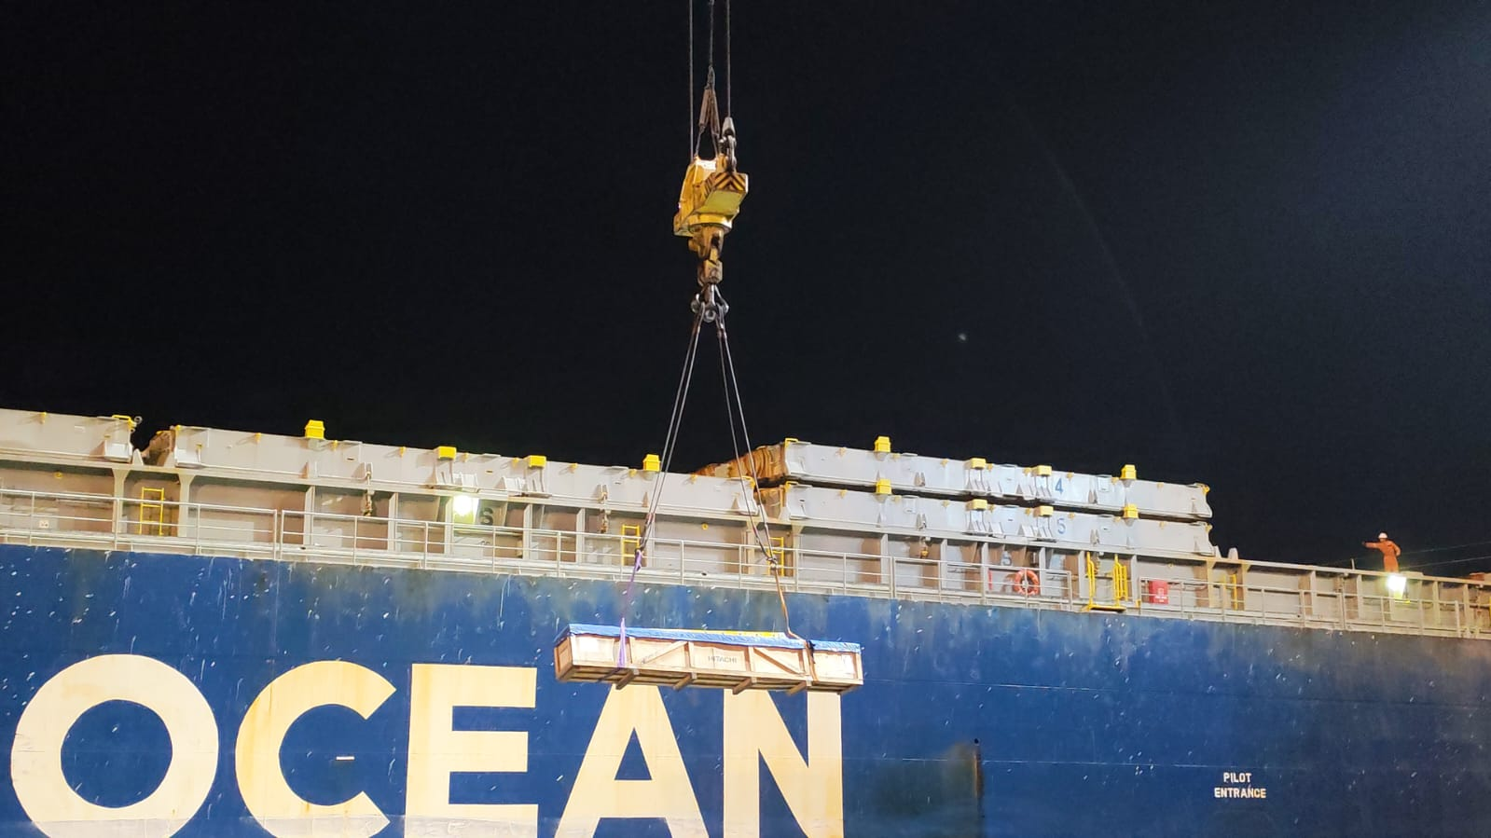
- Wooden crate discharged alongside Vessel. | - Discharge operation of crate.
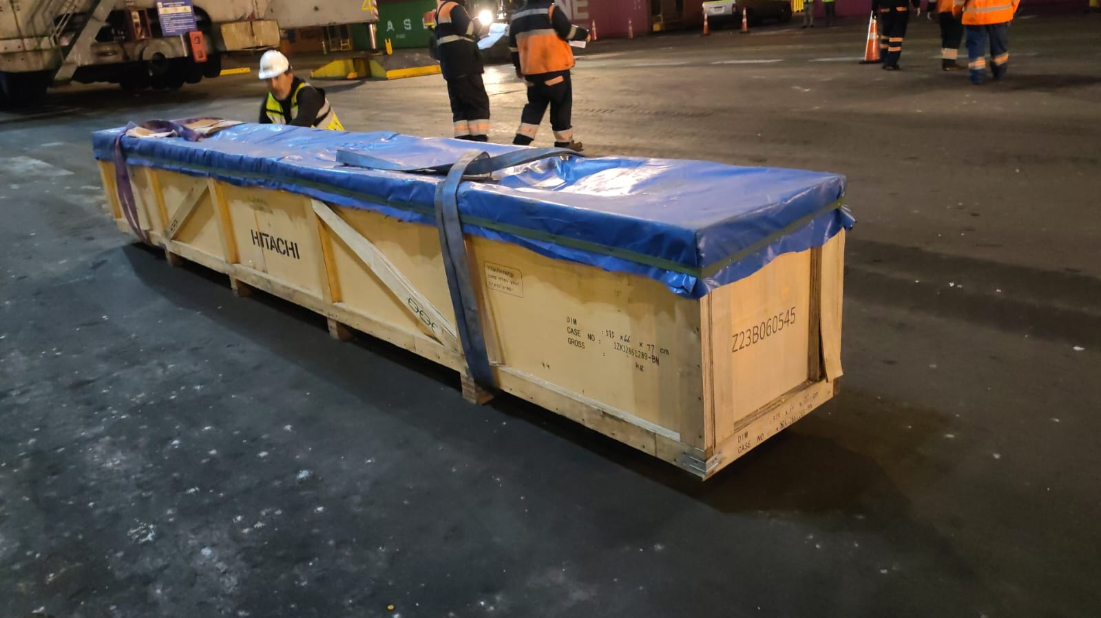 | 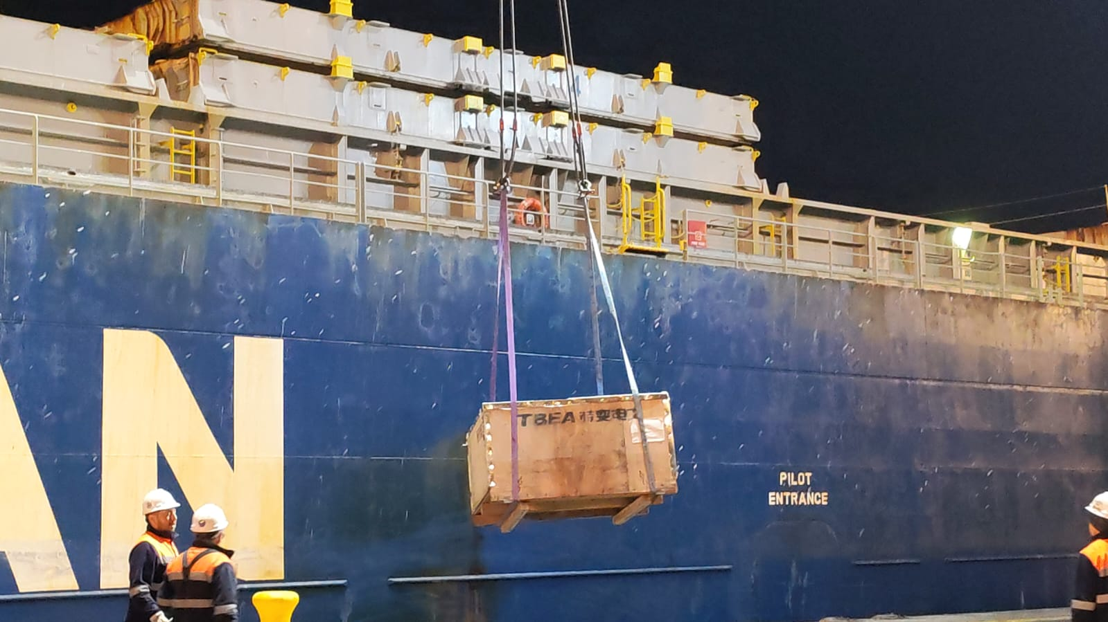
- Wooden crate discharged alongside Vessel. | - Discharge operation of crate.

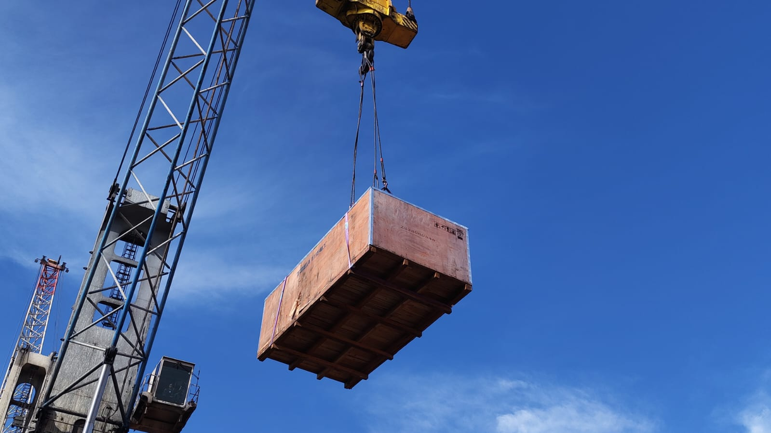 | 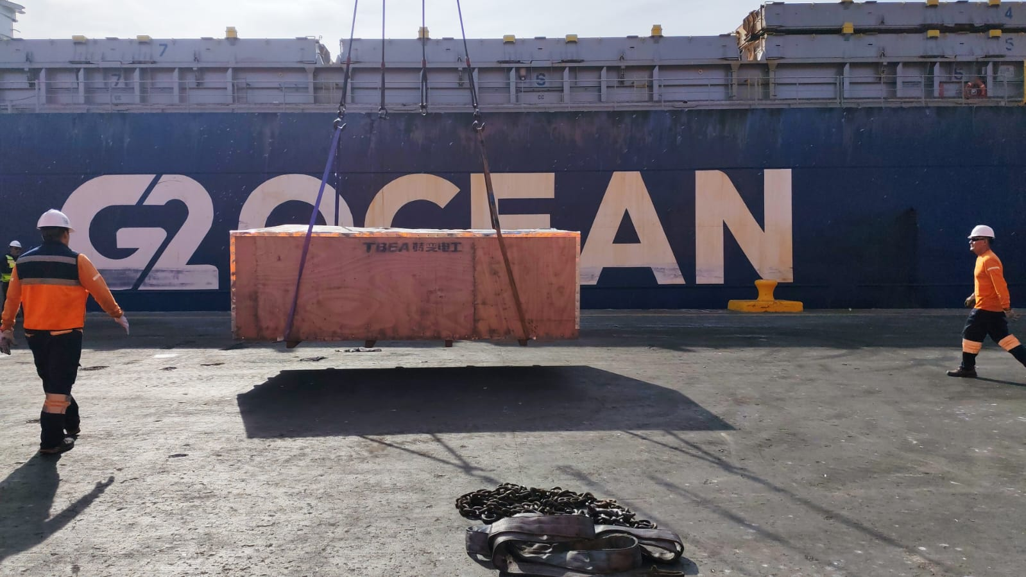
- Wooden crate being discharged. | - Wooden crate discharged alongside Vessel.
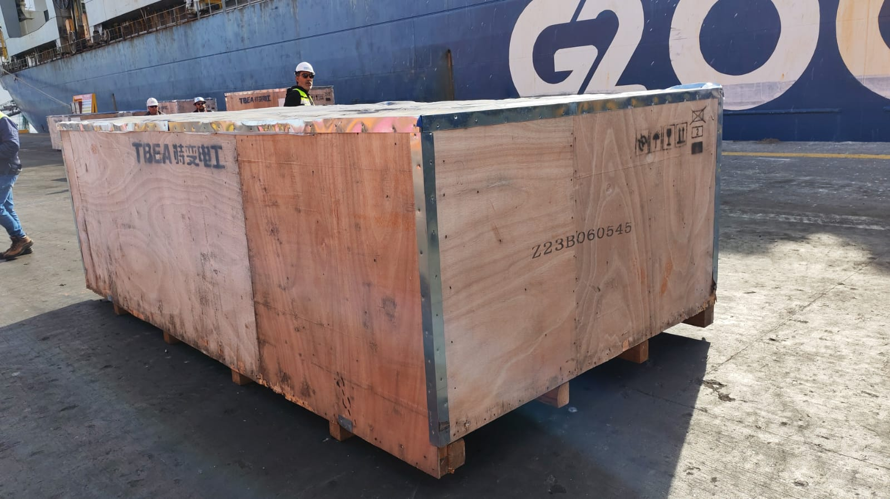 | 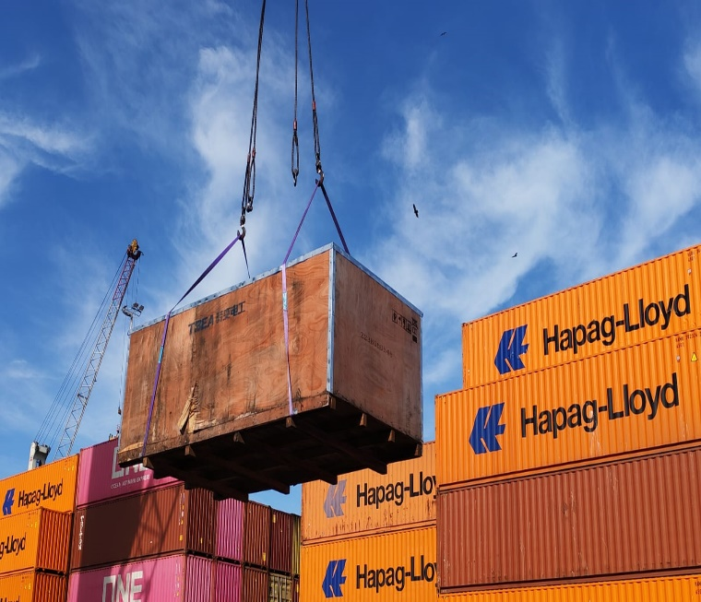
- Crate alongside vessel. | - Discharge operation of crate.

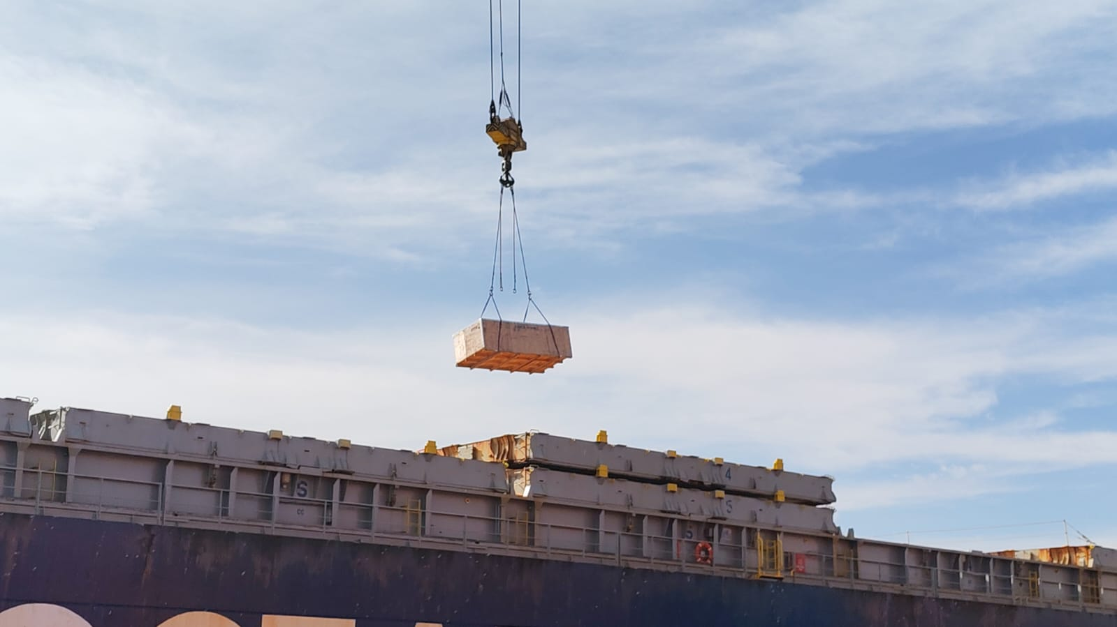 | 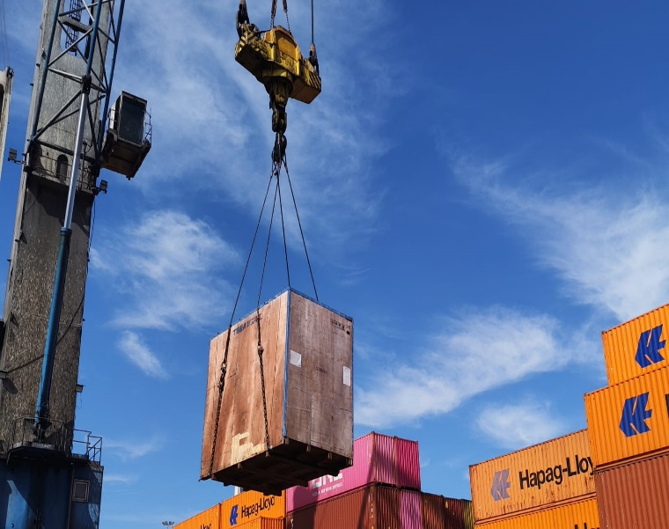
- Discharge operation of crate. | - Wooden crate being discharged.
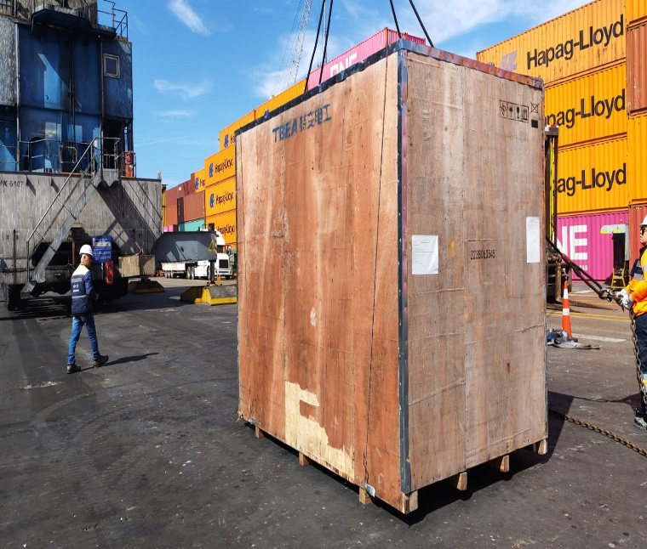 | 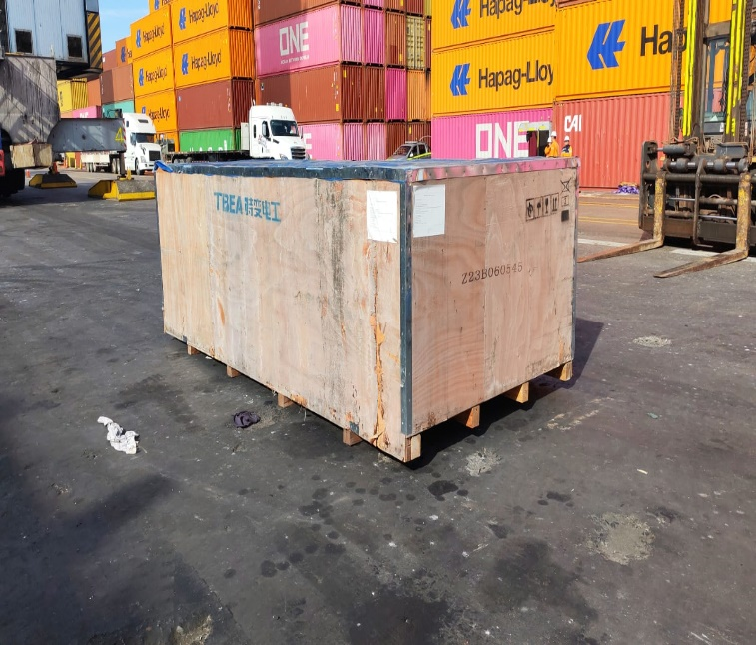
- Wooden crate chipped. | - Wooden crate chipped.

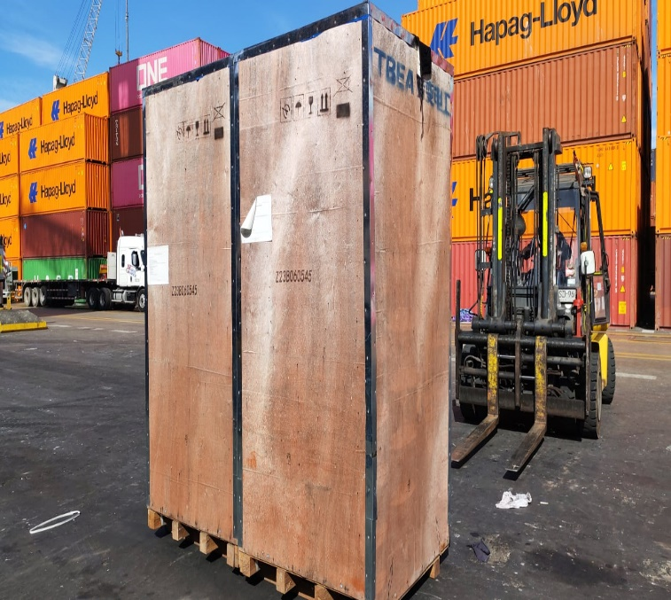 | 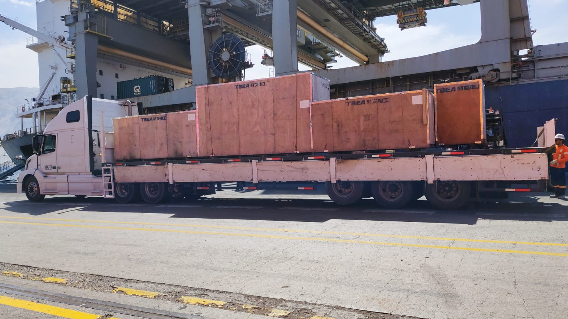
- Wooden crate ready for being loaded onto truck. | - Wooden crates onto truck to be dispatched to final destination.

