This is to certificate that we, ALS INSPECTION CHILE SpA, Independent Surveyors, at the request of LOTA PROTEIN S.A., we have attended we go to your facilities to supply dynamometer.
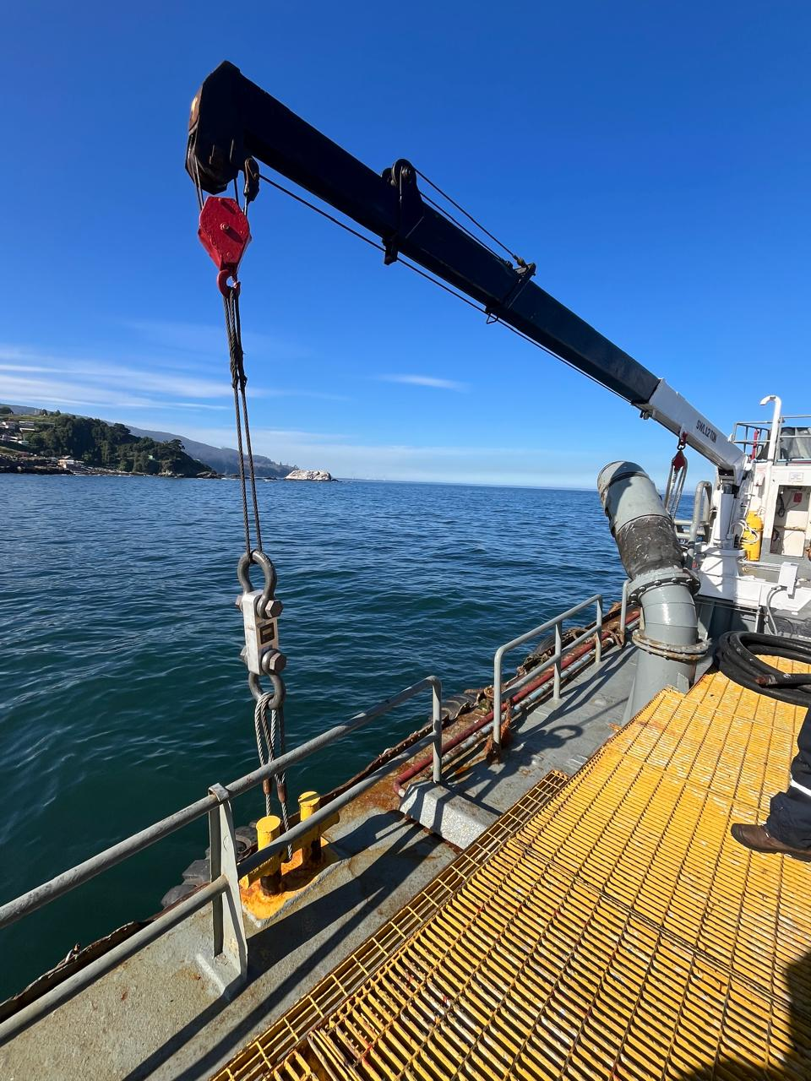

On October 27, 2025; in facilities of the Lota Protein company, Coronel / CHILE, in order to carry out a:

“SUPPLY OF DYNAMOMETER”

For the test of a boat crane. ALS only supplies the dynamometer equipment and is not involved in the load testing of the vessel's crane.

Dynamometer characteristics:

1. The test was carried out with a dynamometer mark Ningbo, model YB-C5-W6, serial Nr. 201903102, for 30 MT duly calibrated and certificated.

2. Operation and efficiency found to be satisfactory.

Load test photos provided by Lota Protein
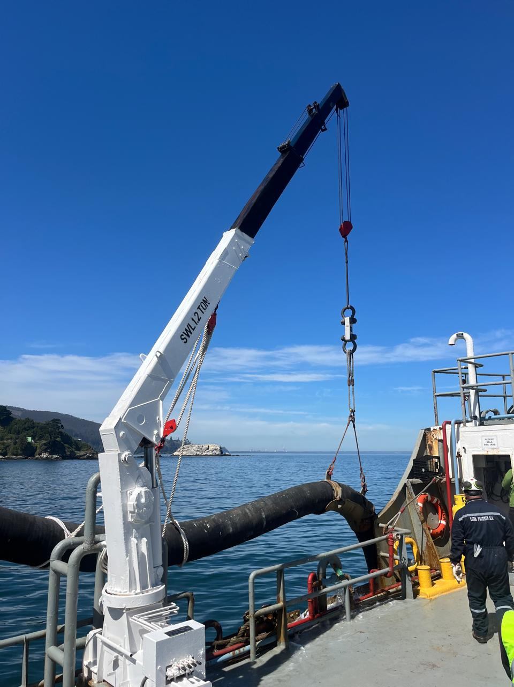
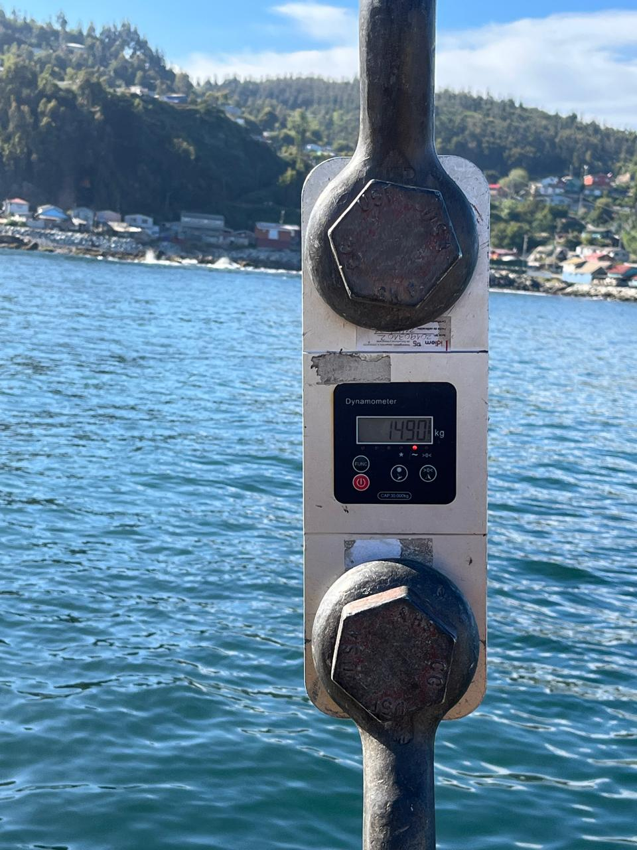 | 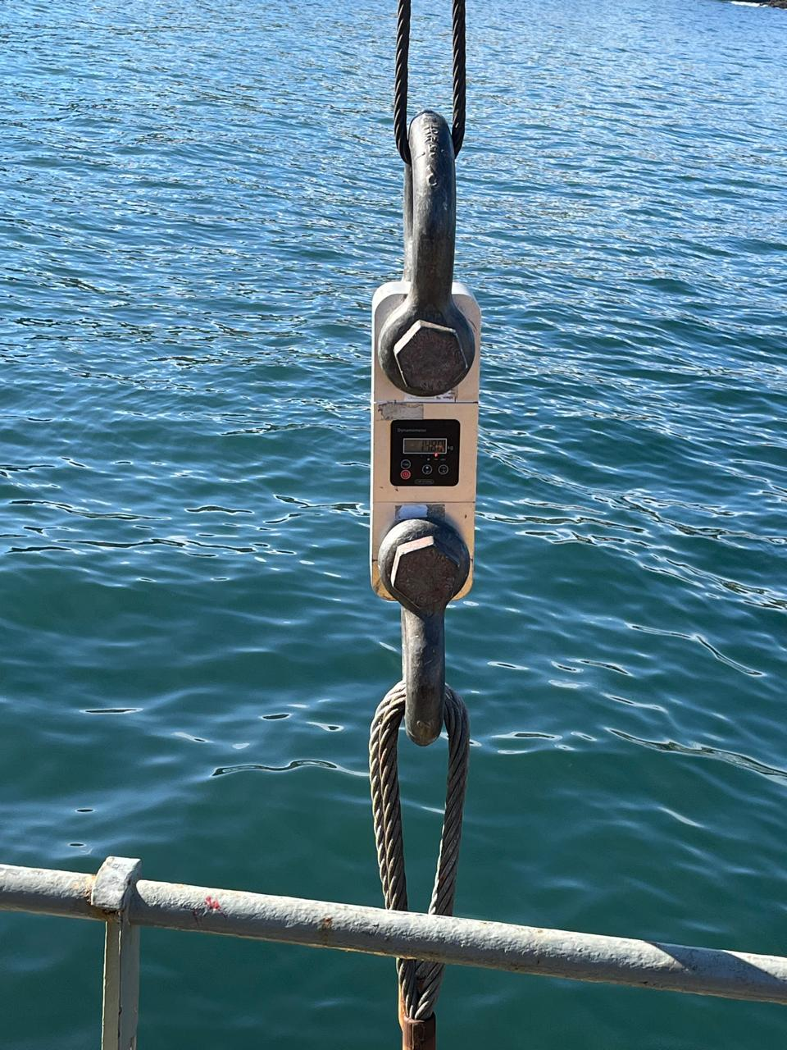

This survey was made without prejudice and in the interest of whom it may concern.

Surveyor
ALS Inspection Chile Spa.

Prepared by : R. Hernandez
Reviewed by : H.Campos
Validated by : J. López.

