This is to certify that we, ALS Inspection Chile SpA, at the request of Ms. Angelica Regla attended at:

MV “CONDOR VALPARAISO”

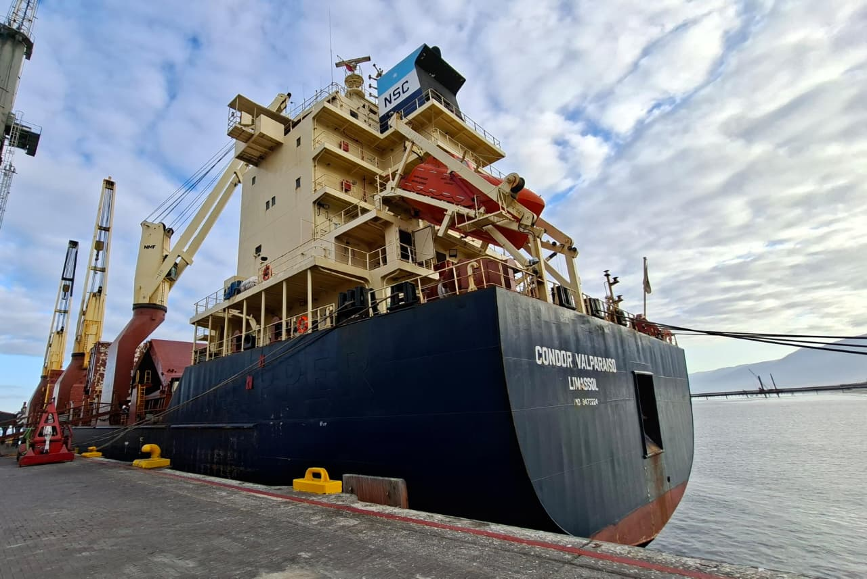
From February 20 to 22, 2026, with the purpose of carrying out an:

“ARRIVAL INSPECTION AND DISCHARGING SUPERVISION”

And report as follows,

1. -SCOPE OF SURVEY:

The inspection was carried out according to instructions received by Ms. Angelica Regla from BLUE WATERS SHIPPINGS, to carry out an arrival and discharge supervision of 40 pieces and 3 containers

Cargo inspected alongside of MV CONDOR VALPARAISO

2.- ANTECEDENTS:

2.1.- Ship´s Particulars:

Vessel | “CONDOR VALPARAISO”
Owners | CONDOR VALPARAISO Two Shipping Company Ltd.
IMO number | 9473224
Call Sign | 5BAQ5
Flag | CYPRUS
Port of Registry | LIMASSOL
Year of built | 2011
Vessel type | GENERAL CARGO
Builder | CHINA TONGFANG JIANGXIN
Length overall | 144.85 M
Breadth | 22.8
Gross tonnage | 12795
Net tonnage | 5486
Master name | Mr. LURJE WLODZIMIERZ
Chief Officer name | Mr. SAMARDZIC ZDRAVKO

3.- TIMES:

DATE | SHIFT | HOUR | DESCRIPTION
February 20, 2026 | 3° | 23:00 | ALS inspection Chile attended at Angamos Port
February 20, 2026 | 3° | 23:18 | Safety meeting
February 20, 2026 | 3° | 02:30 | Discharge operation commenced from cargo in TD Nr. 2
February 20, 2026 | 3° | 05:50 | Discharge completed from cargo in TD Nr. 2
February 20, 2026 | 3° | 06:00 | Legal rest
February 21, 2026 | 1° | 08.30 | Safety meeting
February 21, 2026 | 1° | 10:22 | Discharge operation commenced from cargo in TD Nr. 3
February 21, 2026 | 1° | 12:12 | Discharge completed from cargo in TD Nr. 3
February 21, 2026 | 1° | 13:15 | Discharge operation commenced from cargo in TD Nr. 1
February 21, 2026 | 1° | 15:00 | Legal rest
February 21, 2026 | 2° | 15:30 | Second shift commenced
February 21, 2026 | 2° | 16:00 | Discharge from another receiver
February 21, 2026 | 2° | 22:30 | Legal rest
February 21, 2026 | 3° | 23:00 | Discharge from another receiver
February 21, 2026 | 3° | 05:30 | Discharge resume from cargo in LH Nr. 3
February 21, 2026 | 3° | 06:00 | Legal rest
February 22, 2026 | 1° | 08:00 | ALS inspection Chile attended at Angamos Port
February 22, 2026 | 1° | 08:30 | Safety meeting
February 22, 2026 | 1° | 09:00 | Discharge resume from cargo in LH Nr. 3
February 22, 2026 | 1° | 11:50 | Discharge from another receiver
February 22, 2026 | 1° | 14:15 | Discharge operation commenced from cargo in LH Nr. 1
February 22, 2026 | 1° | 15:00 | Legal rest
February 22, 2026 | 2° | 15.30 | Safety meeting
February 22, 2026 | 2° | 16:00 | Discharge commenced from cargo in LH Nr. 1
February 22, 2026 | 2° | 17:35 | Discharge completed from cargo in TD Nr. 1
February 22, 2026 | 2° | 20:00 | Discharge resume from cargo in LH Nr. 3
February 22, 2026 | 2° | 21:00 | Discharge completed from cargo in LH Nr. 3
February 22, 2026 | 2° | 22:30 | ALS Personel left Angamos port

4.- CARGO DETAILS ACCORDING TO BL:

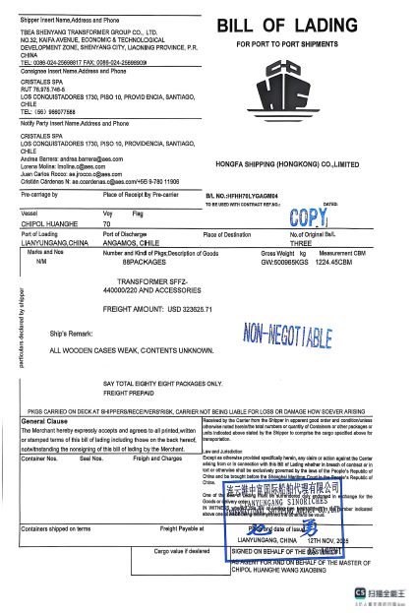

4.1- ARRIVAL CONDITIONS

Prior to the vessel’s arrival, a request was made for permission to conduct on-board inspections. However, Cosco Shipping denied the request, granting access only for general photography from the deck. No authorization was received to carry out inspections inside the holds.

The cargo was found distributed in several areas of the vessel, TD Nr. 1, LH Nr. 1, TD Nr.2, TD Nr. 3 & LH Nr.3

The cargo was secured with chains made fast to deck and hold eyebolts and was also fitted with twist locks for fastening between units.

No cargo displacement or shifting was observed.

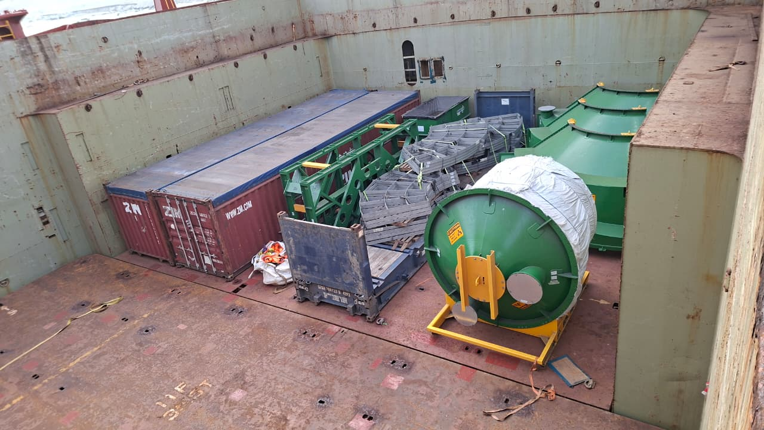 | 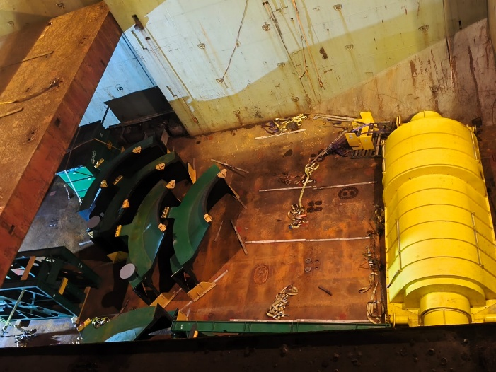
- Cargo stowage on TD Hold Nr. 3. | - Cargo stowage in LH Hold Nr. 3

The following details correspond to observations as arrival conditions:

N° | IDENTIFICATION | OBSERVATION
1 | TANK QUADRANT 04  Drawing 3250-6-00140 | Paint scratches
2 | ERM TANK 01  Drawing 3250-6-00100 | Chipped and paint scratches
3 | CENTRAL LAUNDER 06  Drawing 3250-6-00140 | Tarpaulin torn, rust stains, small scratches
4 | TANK QUADRANT 02  Drawing 3250-6-00140 | Paint scuffed upper part
5 | CENTRAL LAUNDER  Drawing 3250-6-00140 | Bisel scratches
6 | TANK QUADRANT 03  Drawing 3250-6-00140 | Tarpaulin torn, rust stains, small scratches
7 | TANK QUADRANT 04  Drawing 0320-Sep-0001 | Paint scratches
8 | TANK QUADRANT 04  Drawing 3250-6-00140 | Tarpaulin torn, rust stains, small scratches
9 | EXTENSION COLUMN  DRAWING 3250-6-00350 | Pallets pieces broken
10 | EXTENSION COLUMN  DRAWING 3250-6-00350 | Pallets pieces broken
11 | EXTENSION COLUMN  DRAWING 3250-6-00350 | Pallets pieces broken
12 | EXTENSION COLUMN  DRAWING 3250-6-00350 | Pallets pieces broken
13 | EXTENSION COLUMN  DRAWING 3250-6-00350 | Pallets pieces broken

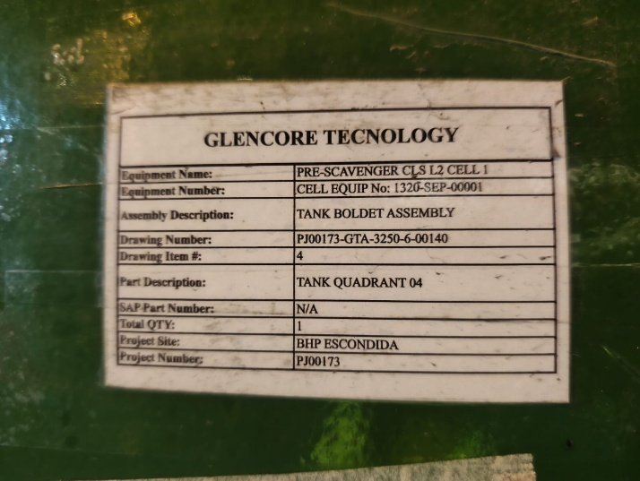 | 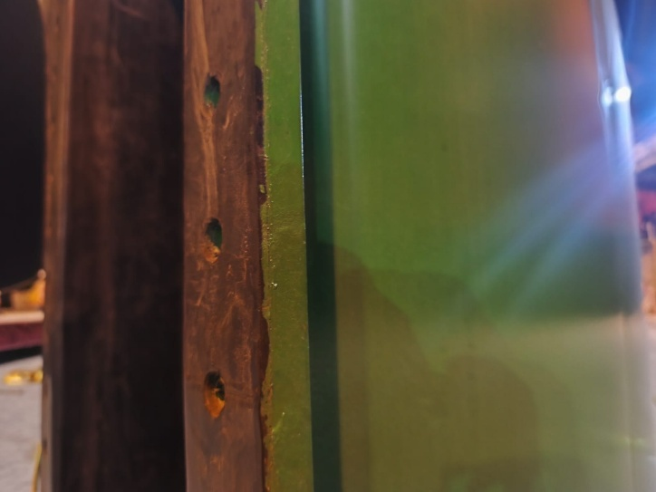
- TANK QUADRANT 04 | - Paint scratches

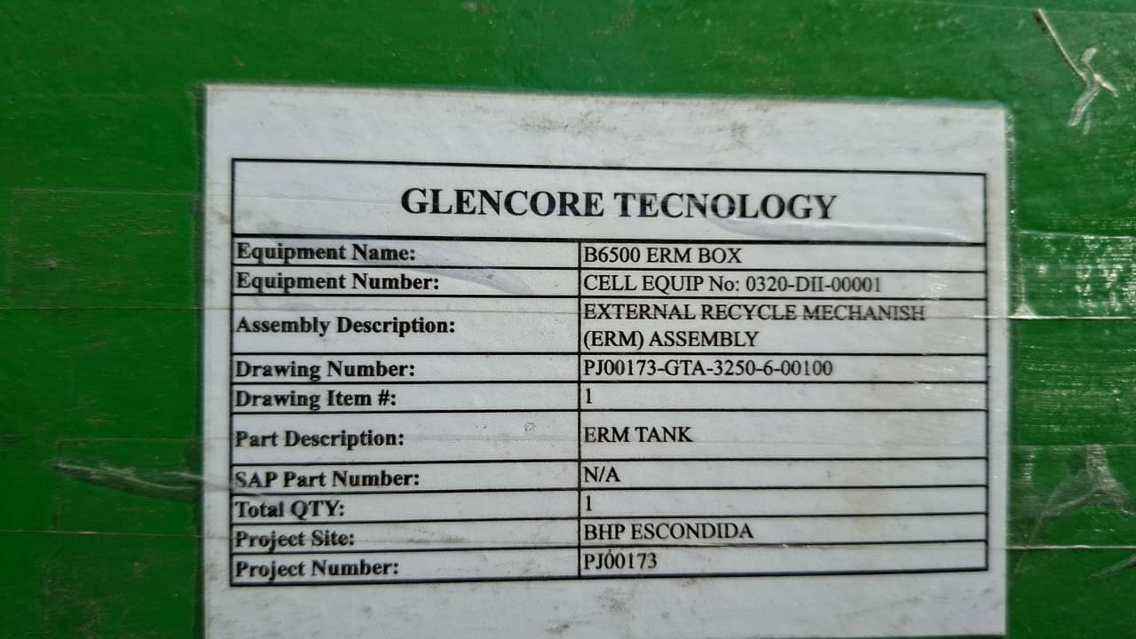 | 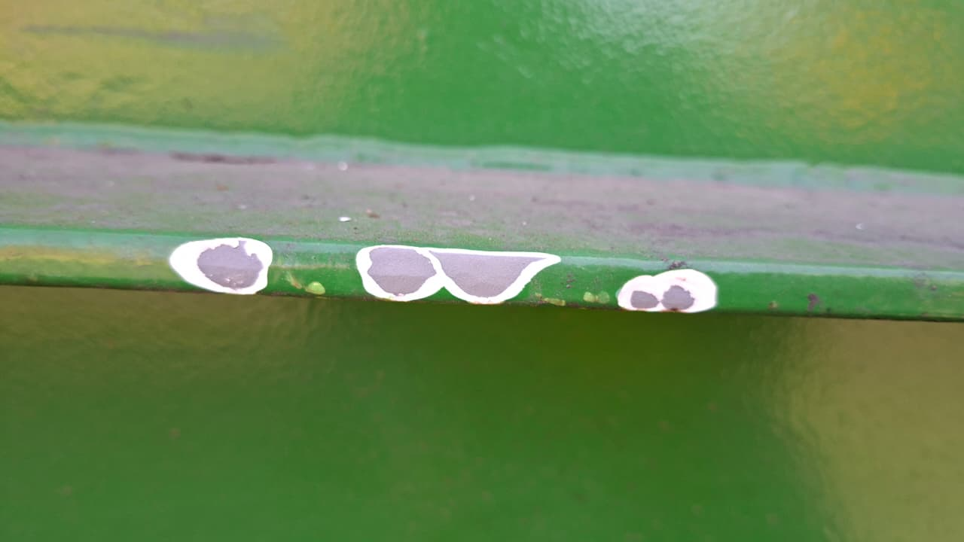
- ERM TANK ID | - Bisel chipped and scratches

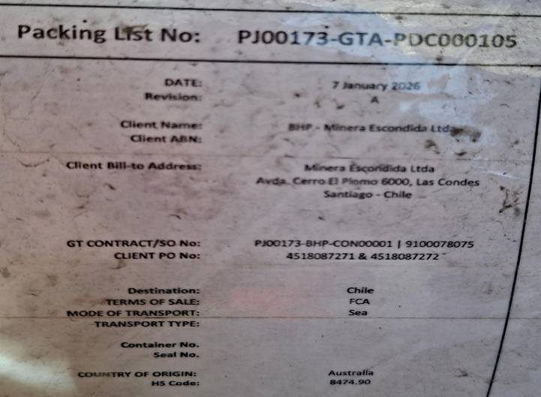 | 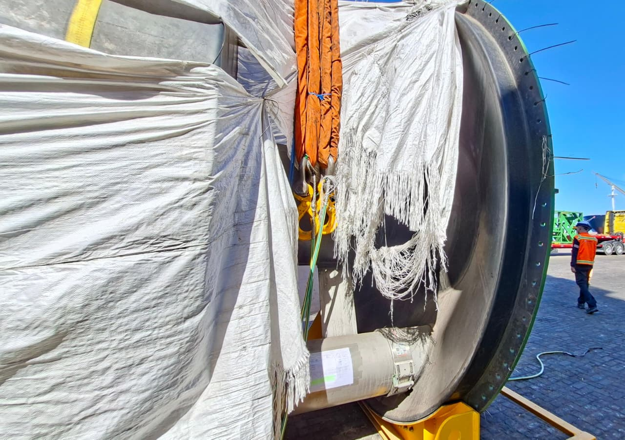
- PACKING NO: PJ00173-GTA-PDC000105 | - Tarpaulin torn and rust stains

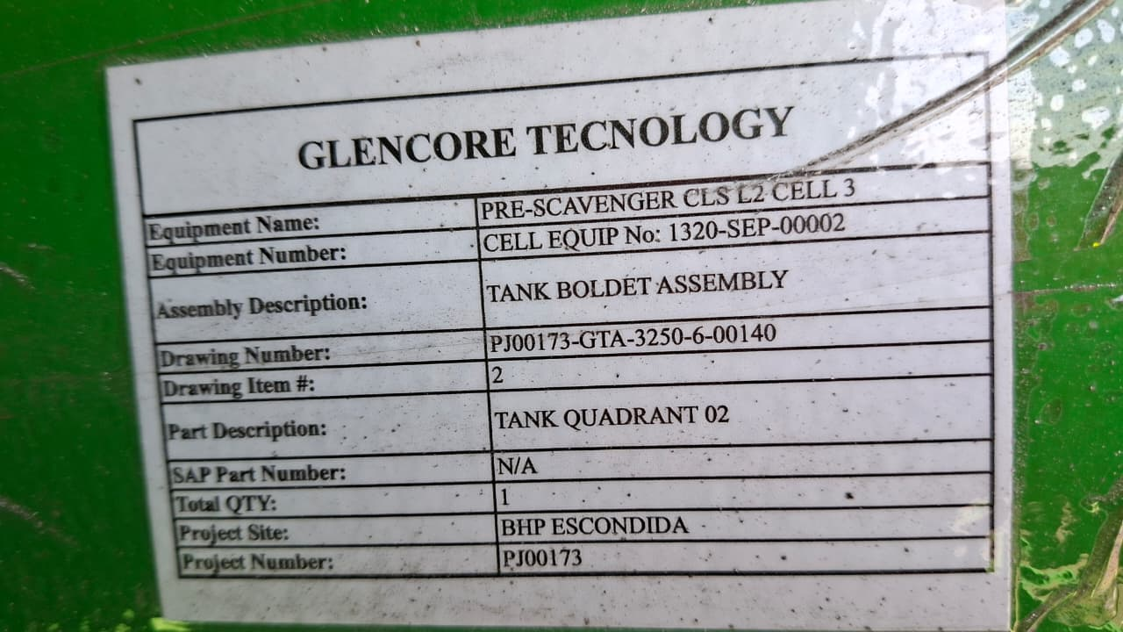 | 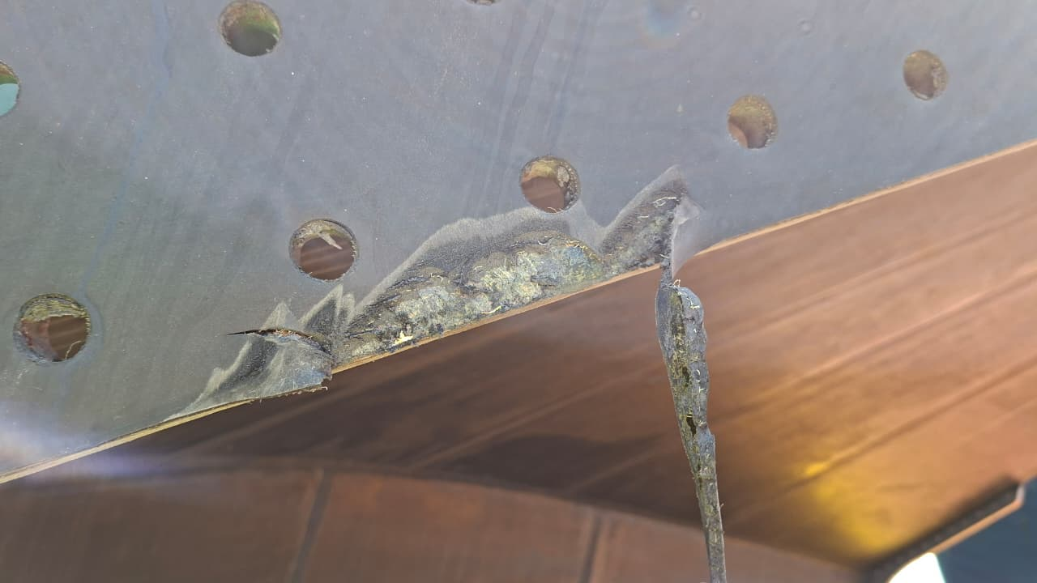
- TANK QUADRANT 02 | - Paint scratches upper part

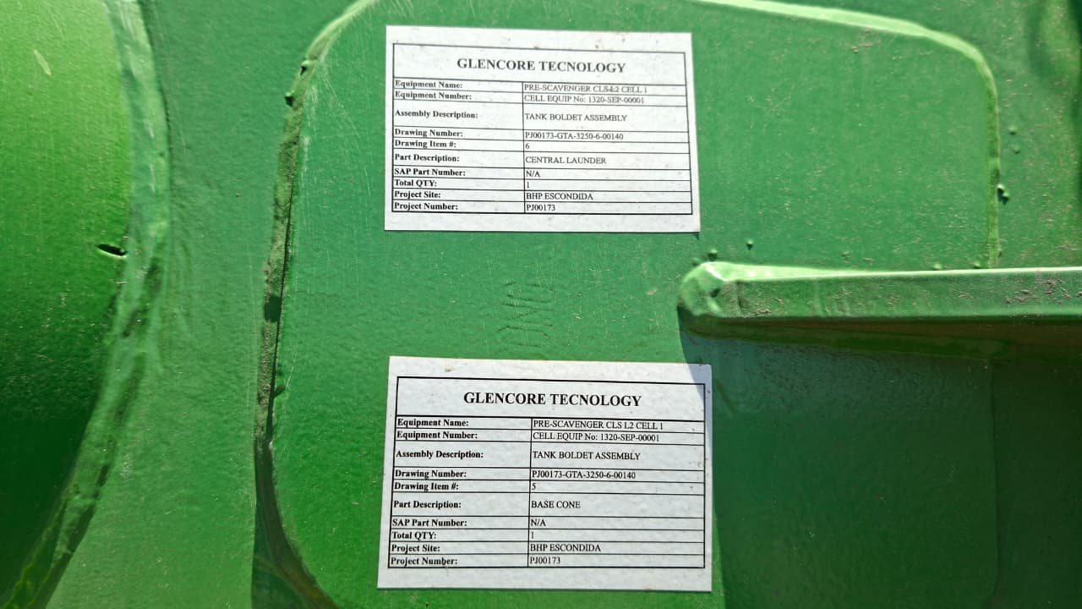 | 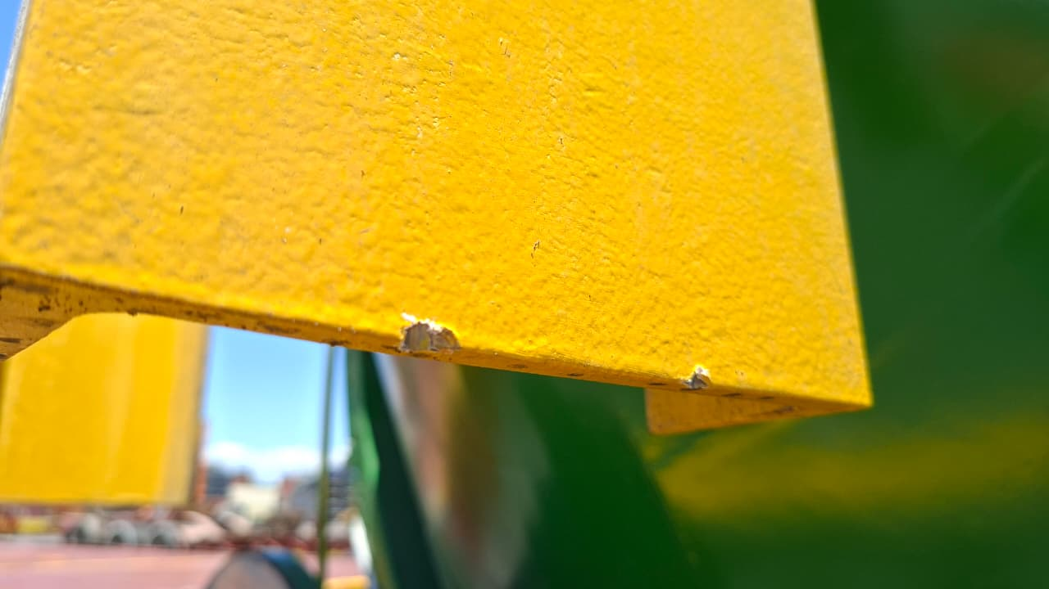
- CENTRAL LAUNDER identifictaion | - Paint scuffed

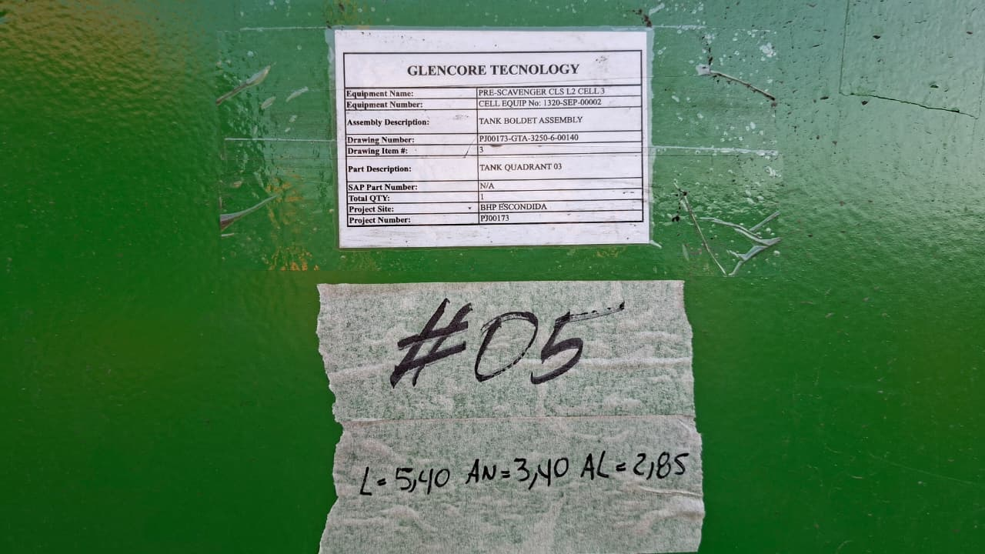 | 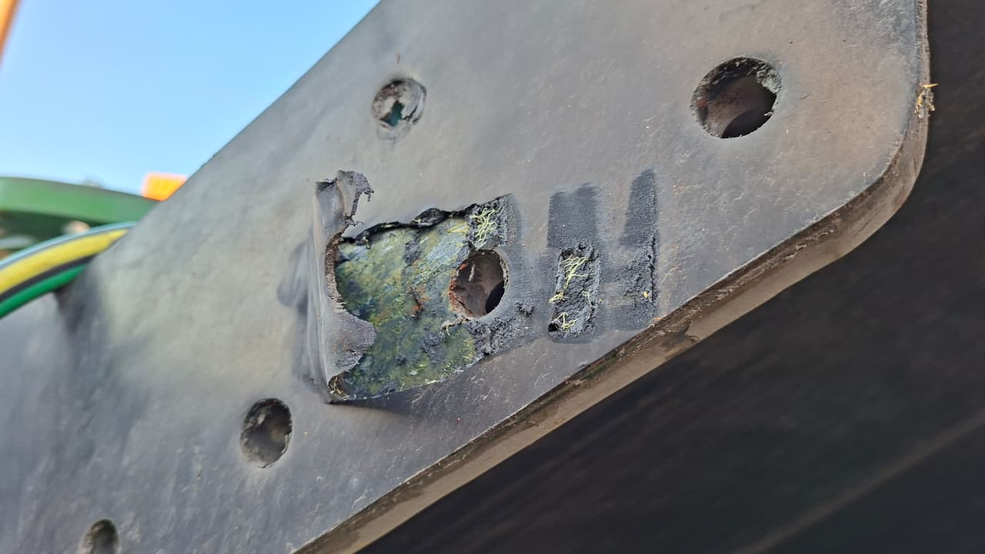
- TANK QUADRANT 03 | - Paint scratches and scuffed

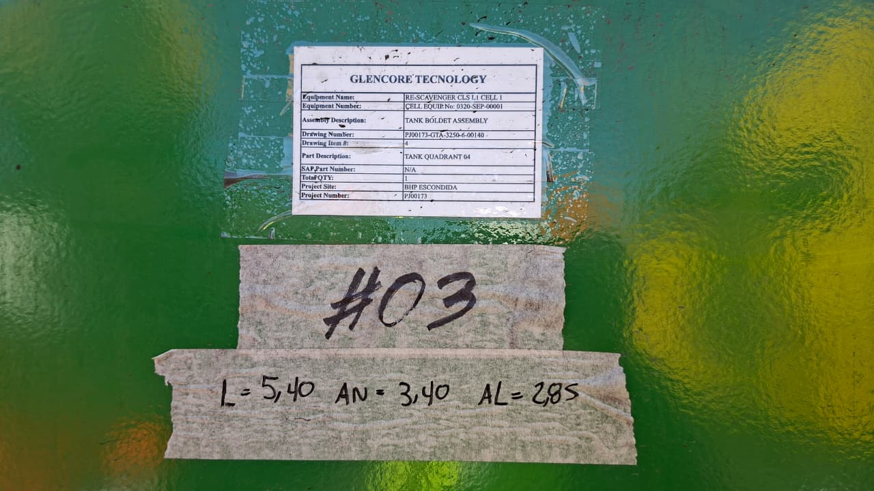 | 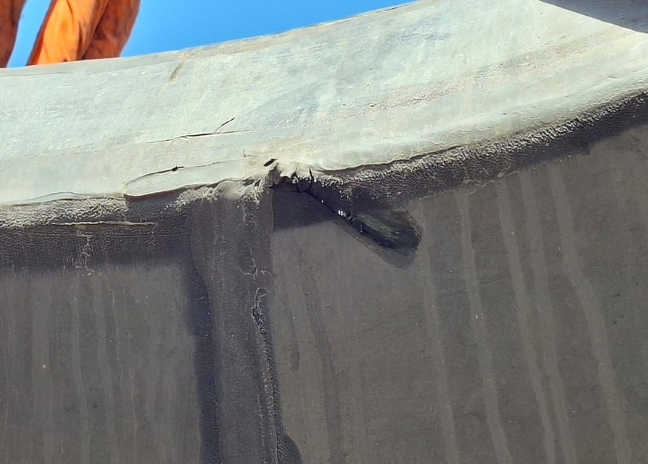
- TANK QUADRANT 03 | - Tarpaulin torn and scuffed paint

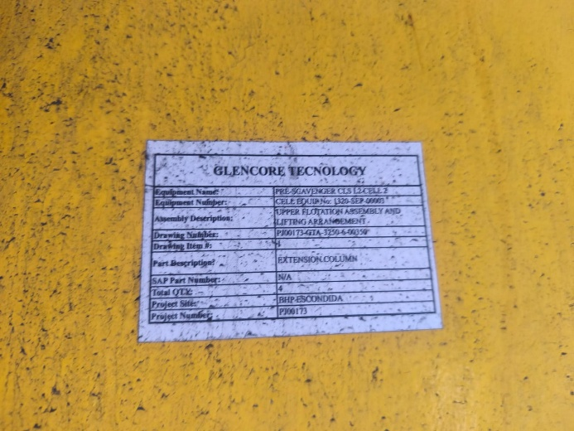 | 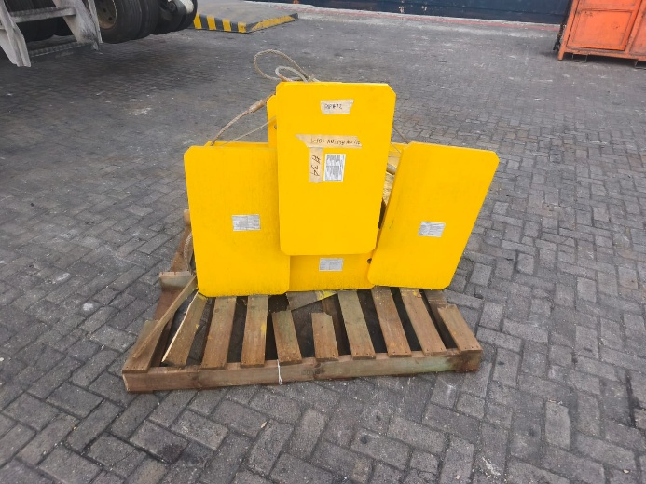
- EXTENCION COLUMN  Drawng 3250-6-00350 | - Pallets with broken pieces

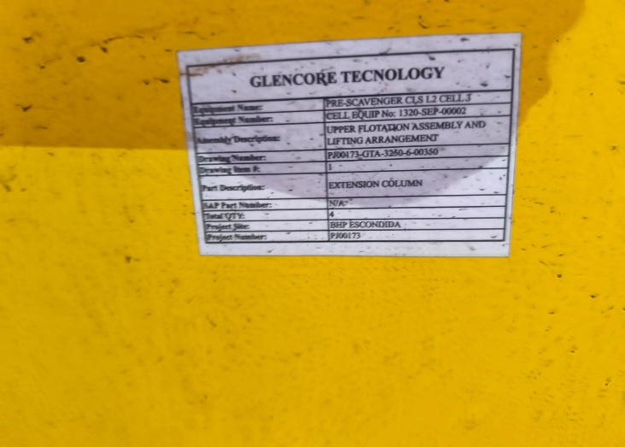 | 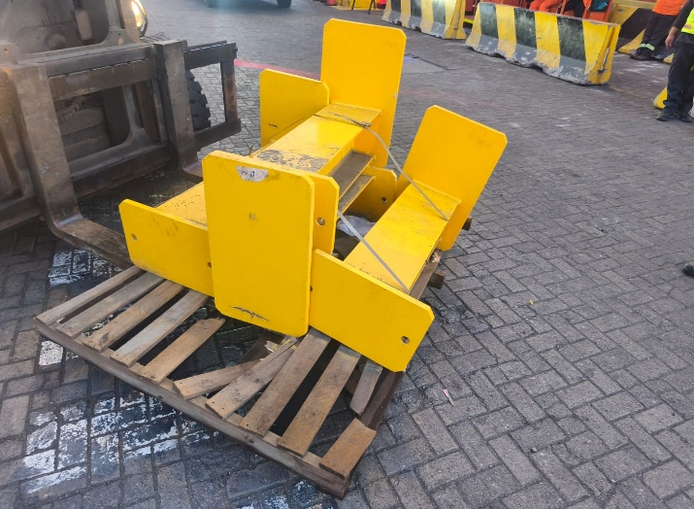
- EXTENCION COLUMN  Drawng 3250-6-00350 | - Pallets with broken pieces

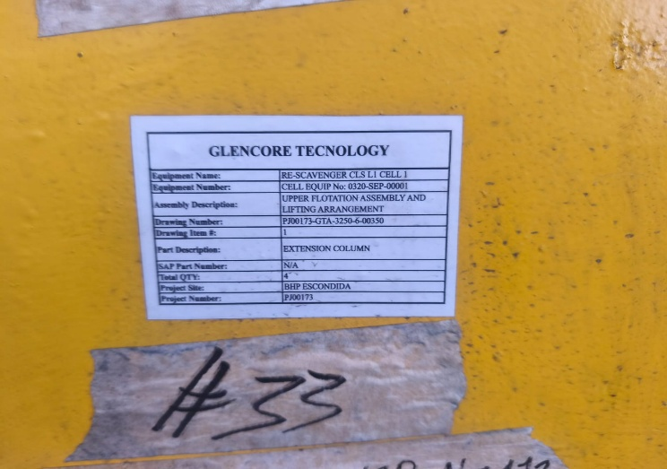 | 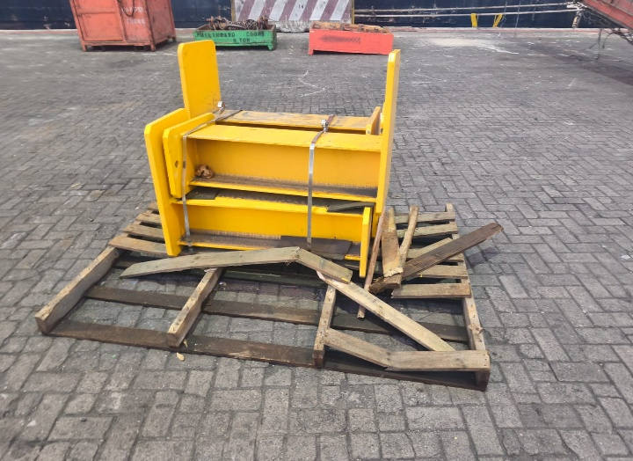
- EXTENCION COLUMN  Drawng 3250-6-00350 | - Pallets with broken pieces

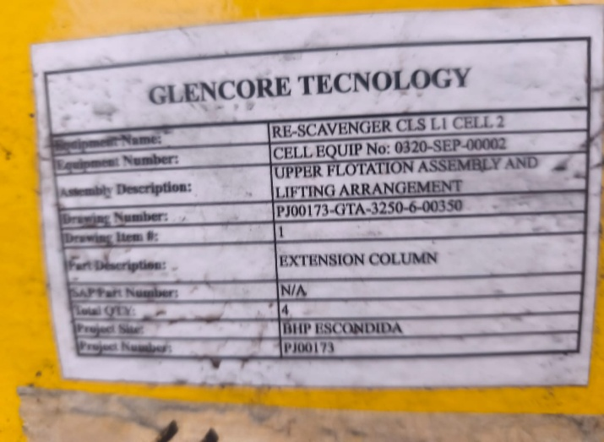 | 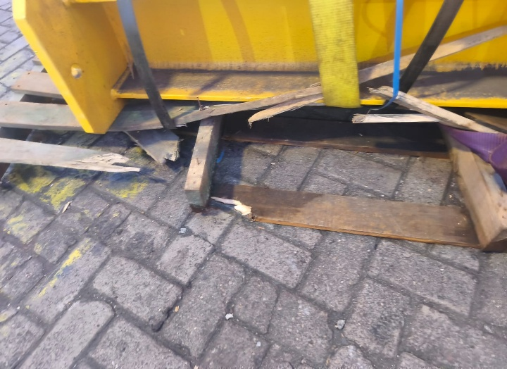
- EXTENCION COLUMN  Drawng 3250-6-00350 | - Pallets with broken pieces

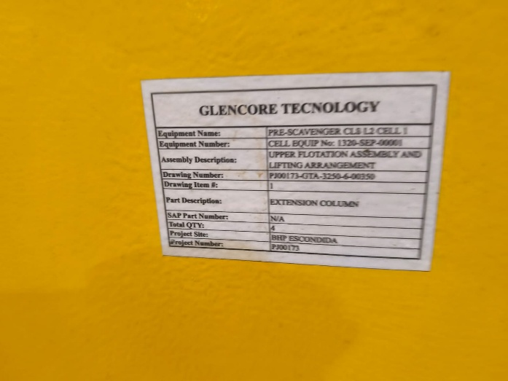 | 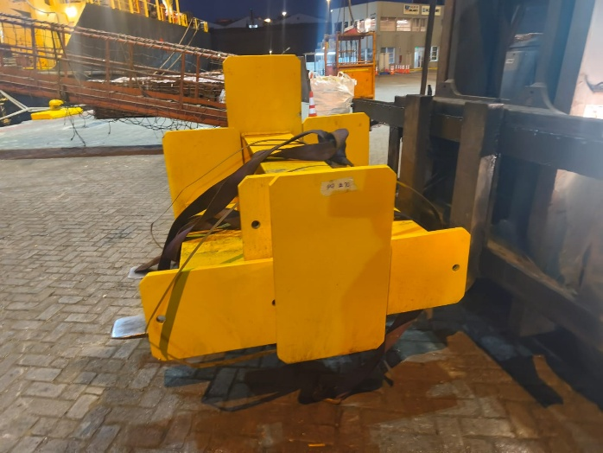
- EXTENCION COLUMN  Drawng 3250-6-00350 | - Pallets with broken pieces

4.2.- Discharge supervision:
The discharge operation of the containers were performed used a shore crane with a SWL of 100 Tons with semi automatic spreader.
The packages and accessories were discharged by Ultraport personnel (on behalf of terminal), using a shore crane with a SWL of 100 Tons. The lifting arrangement comprised four slings (10 m) with a SWL of 17 tons each, two slings (6 m) with a SWL of 13.8 tons each, four manual hooks with a SWL of 12.5 tons,
After discharge, several packages were placed on the pier and subsequently loaded onto trucks using a forklift.
No damage was observed during the operations.
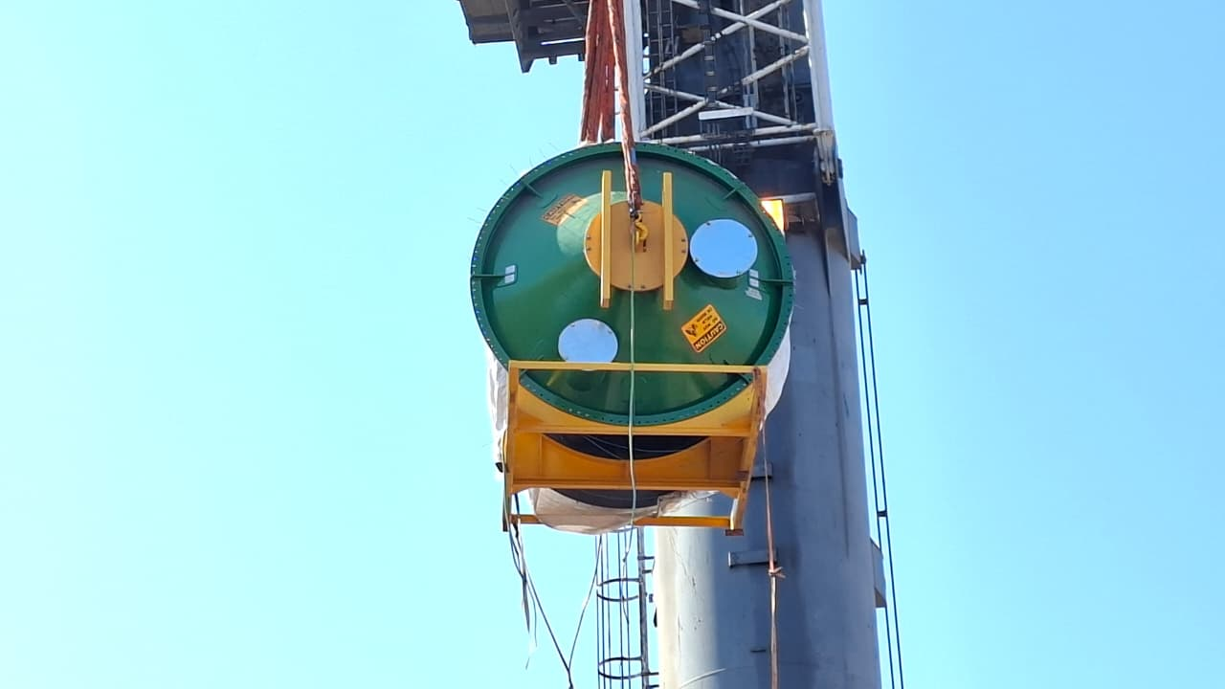 | 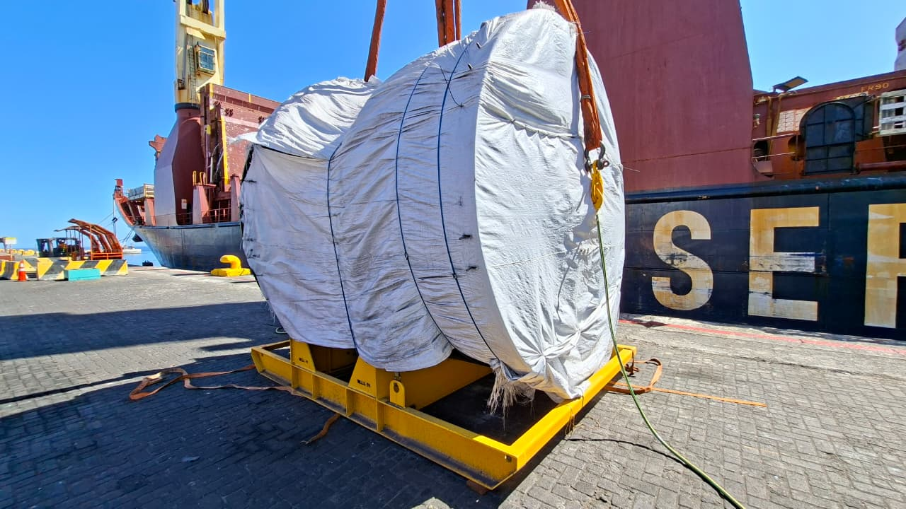
- Cargo being discharged from vessel Hold Nr.3. | - Another view of the cargo being discharged.

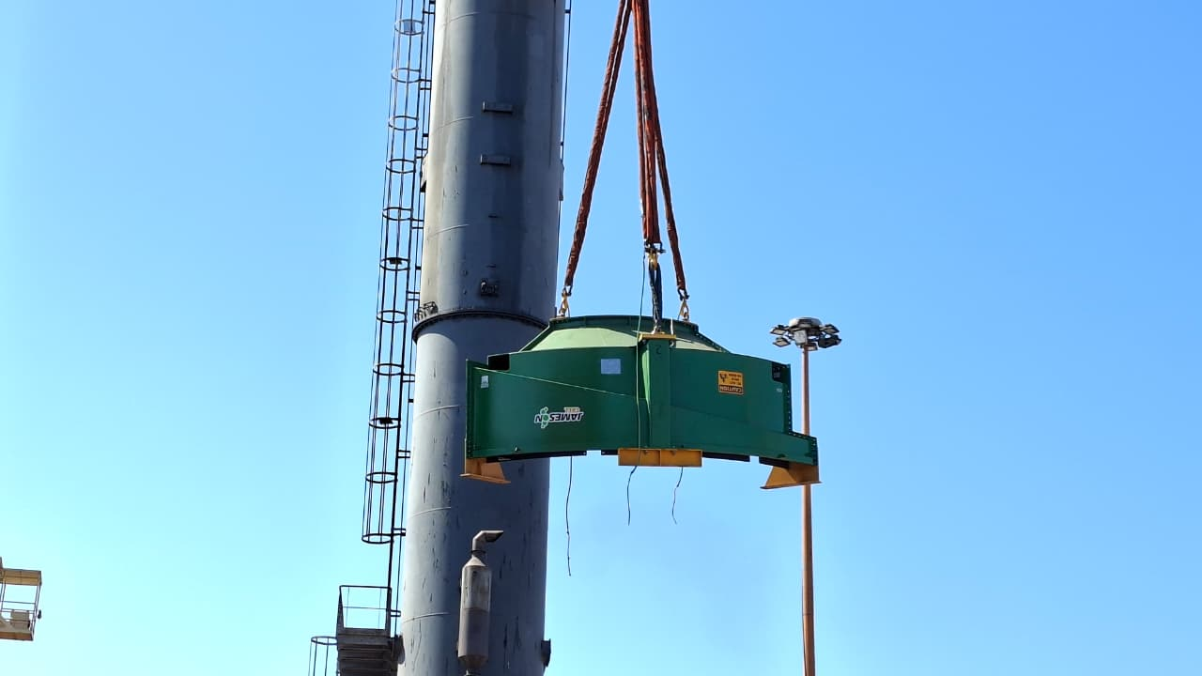 | 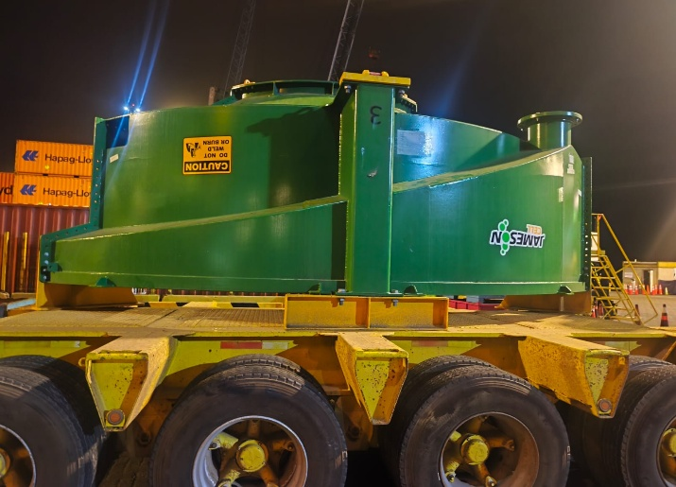
- Cargo being discharged | - Another piece being discharged

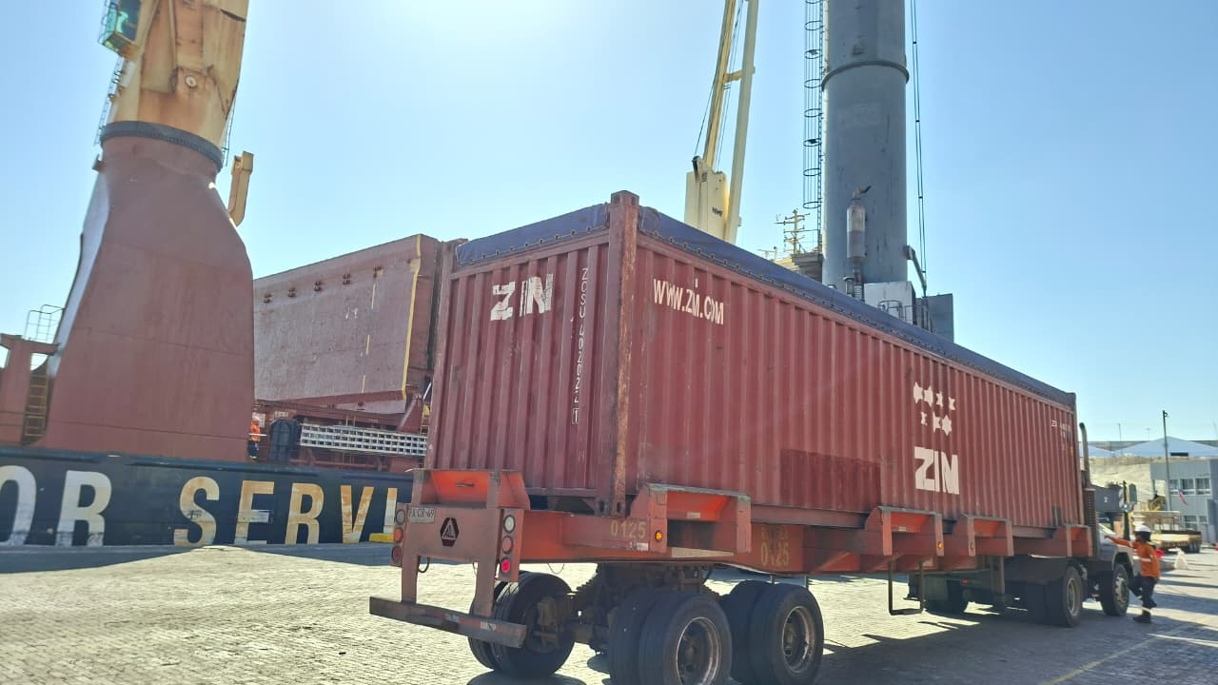 | 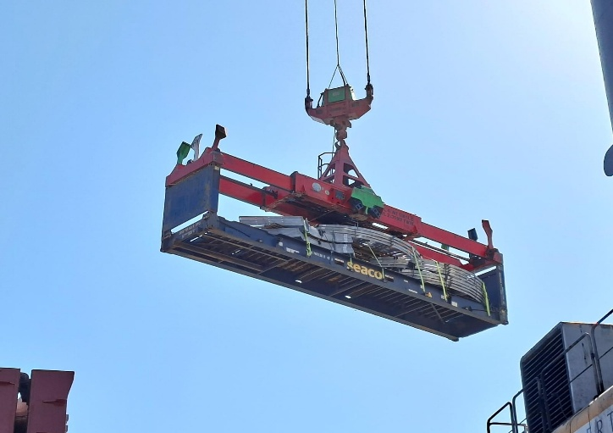
- General view of the discharge process. | - Container being discharged from vessel.

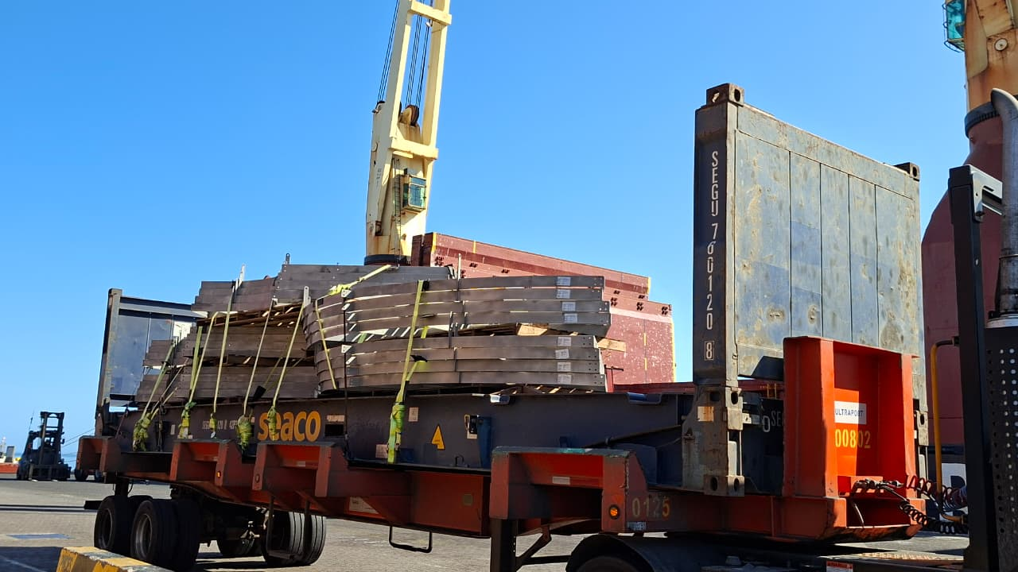 | 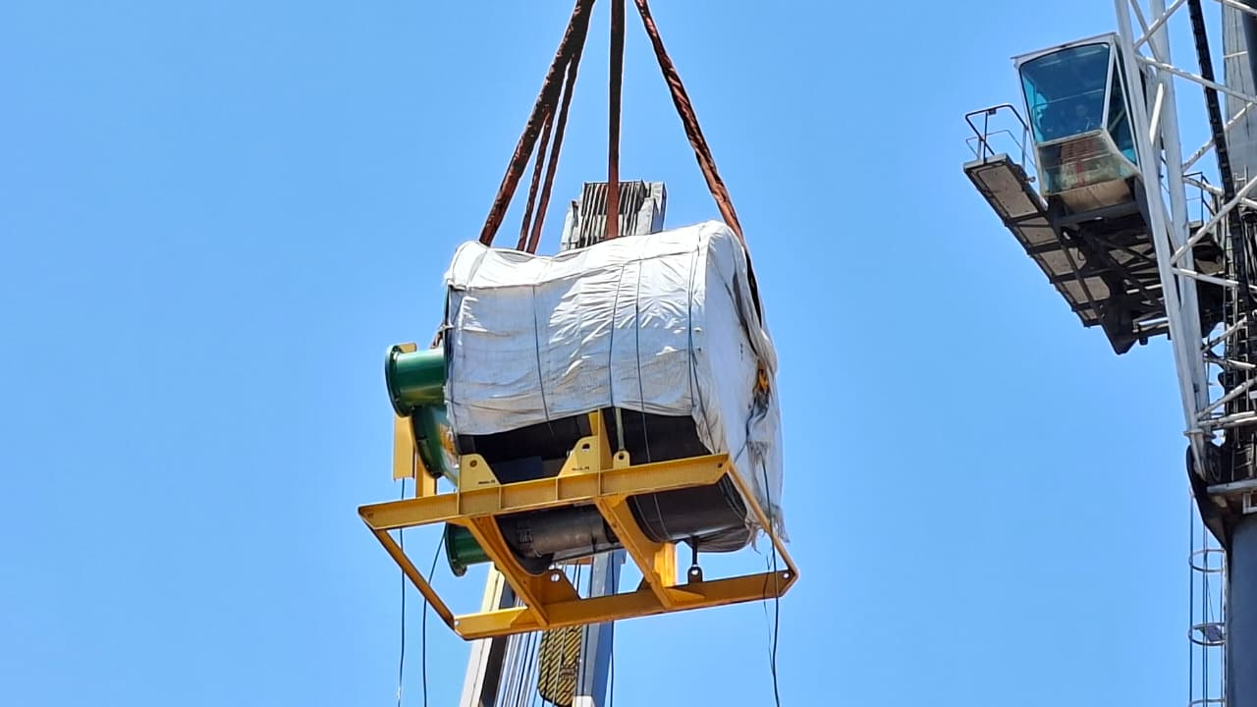
- Cargo being discharged. | - Cargo being discharged

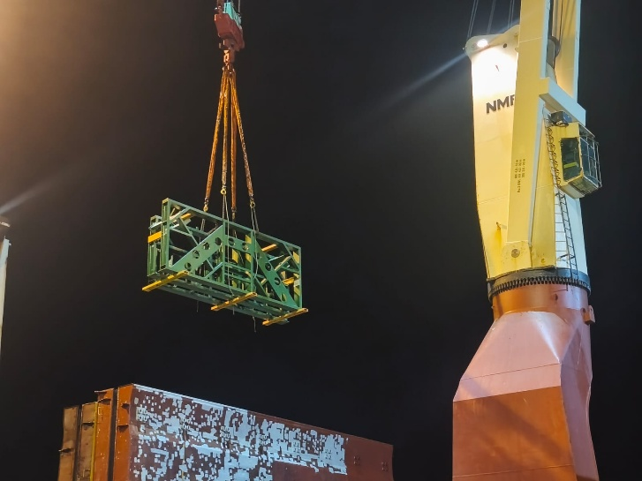 | 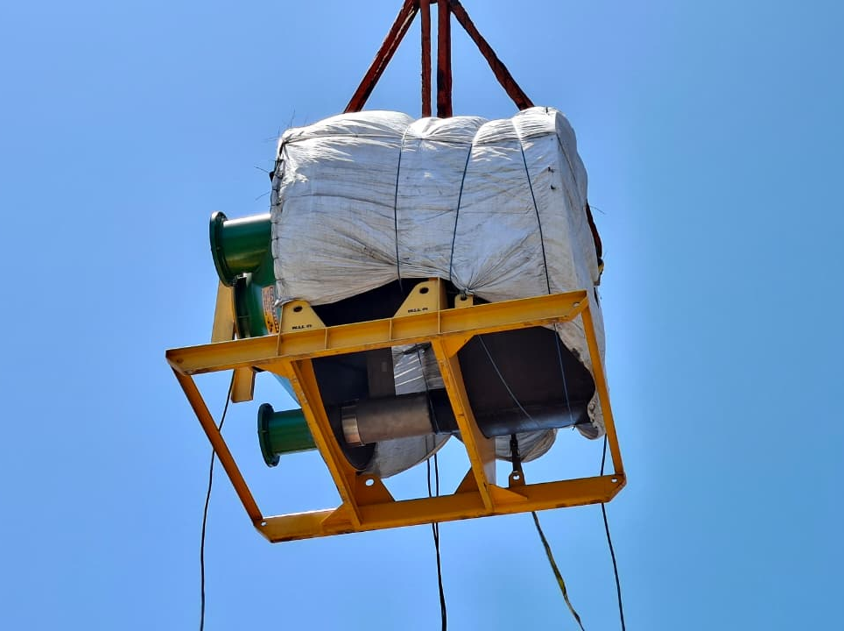
- Cargo being discharged | - Another view of cargo discharge operations.

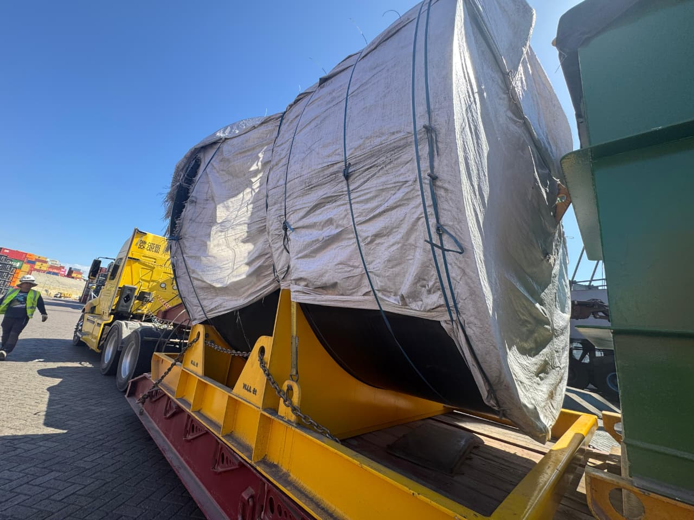 | 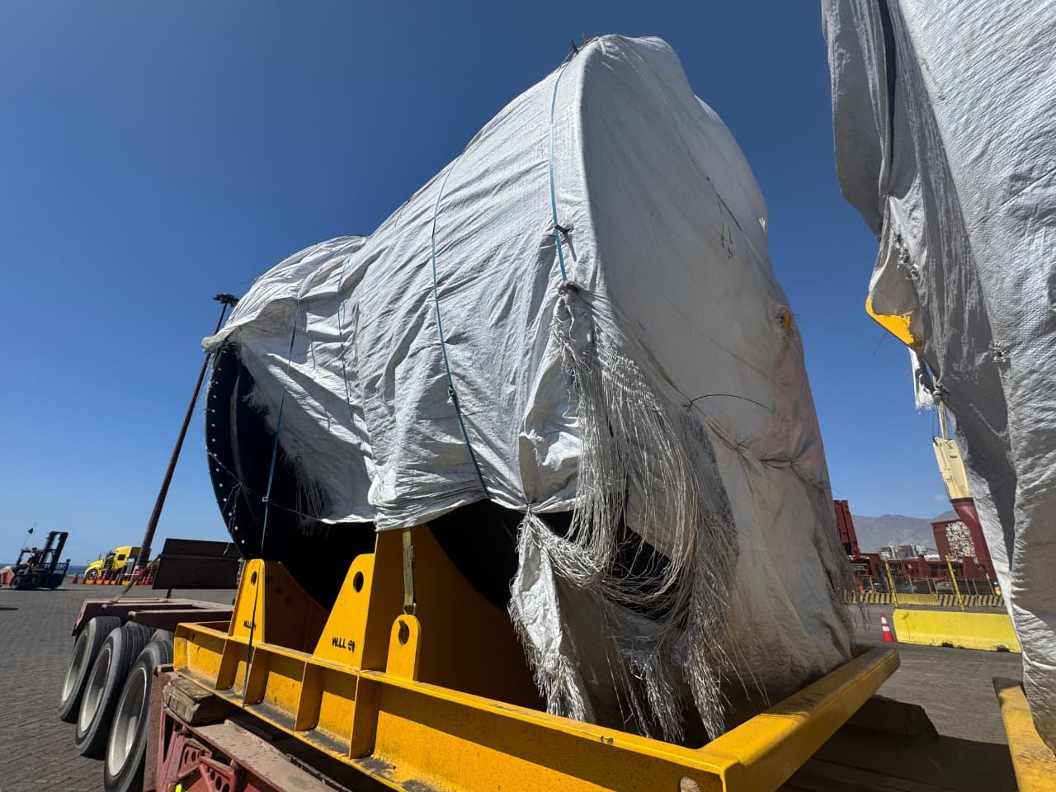
- General view of the discharge operation. | - Cargo being discharged and loaded onto truck

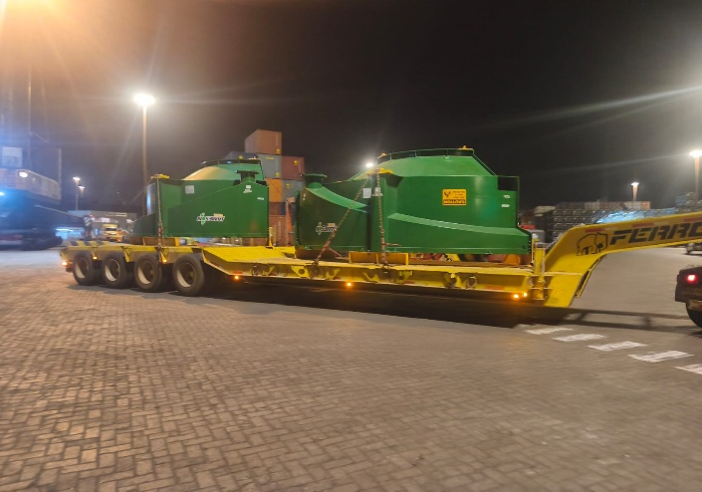 | 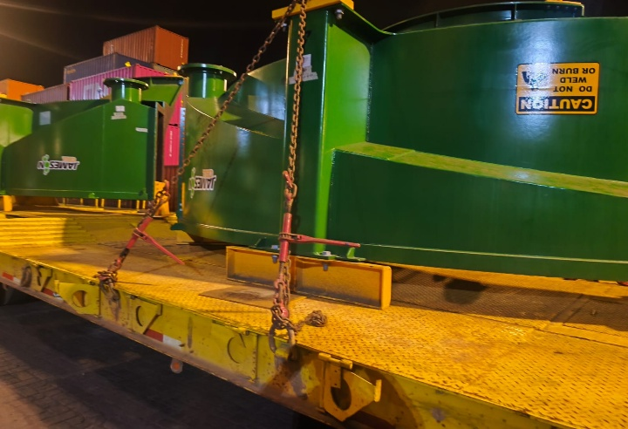
- Cargo being loaded onto truck. | - Another view of lashed onto truck

4.2.1.- Discharge operations:

No damages were observed during the discharge operation.

5. - SURVEYOR COMMENTS

- The discharge operation was carried out normally by stevedores.

- The maneuvers used during these operations were suitable and safe for this type of cargo.

- Each package and containers were inspected alongside the vessel. These were found to have environmental dust and several cosmetic scratches; the most significant findings are detailed in section 4.1 of this report

- All observations found are consistent with and stated in the loading report provided by Blue Water Shipping

- No damages were observed during discharge operations.

6. -ATTENDING PARTIES

NAME AND COMPANY | ON BEHALF OF
Mr. Yulier Betancourt / ALS Inspection Chile SpA | Blue Water Shipping
Mss Daniela Pedraza / ALS Inspection Chile SpA | Blue Water Shipping

This survey was carried out without prejudice and in the interest of whom it may concern.

ALS Inspection Chile Spa

Prepared by: Y. Betancourt
Revised by: M. Lopez
Valid by: J. Lopez.

