This is to certify that we, ALS Inspection Chile SpA, at the request of DSV Global Transport and Logistics attended at:

“CERRO PARANAL - ANTOFAGASTA”

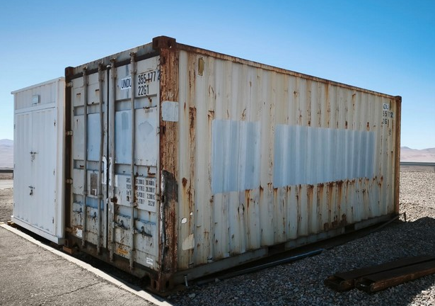
“Stacking area, Cerro Paranal”

March 18, 2026, with the purpose of carry out a:

“INSPECTION OF THE STOWAGE AND LASHING OF A 01X20’ HC CONTAINER”

And does report as follows:
1.- SCOPE OF SURVEY

The present inspection was carried out according to instructions received from Mr. Manuel Venegas (DSV Global Transport and Logistics), to:

- To verify cargo condition.

2.- TIMES

DATE | HOURS | DESCRIPTION
March 18, 2026 | 09:50 | ALS Inspection Chile SPA surveyor arrived at the inspection site
March 18, 2026 | 10:20 – 12:00 | Inspection of the stowage and lashing of a 01x20’ HC container
March 18, 2026 | 12:00 – 14:00 | Detention of the inspection due to lack of resources
March 18, 2026 | 14:10 | Inspector ALS left the place of inspection

3.- SURVEY

3.1. – Cargo description:

No. | BOX NO. | DESCRIPTION | NET WEIGHT (KG) | GROSS WEIGHT (KG)
1 | LRS-6 | Illumination Unit | 279,00 | 479,00
2 | FCS-01 | Workstation DELL (Computer without battery IWS), used | 32,00 | 47,00
3 | FCS-02 (T-5) | 4x heavy weight rolls, used | 29,00 | 44,00
4 | FCS-03 (Parcel 26) | Zarges box empty, used | 9,00 | 9,00
5 | FCS-04 (I-4) | 1x hand saw | 11,00 | 26,00
4
No. | BOX NO. | DESCRIPTION | NET WEIGHT (KG) | GROSS WEIGHT (KG)
6 | FCS-05 (I-7) | Zargesbox with  2x power strips | 24,00 | 39,00
7 | FCS-06 (I-5) | Zarges box empty, used | 13,00 | 13,00
8 | FCS-07 (I-3) | Zarges box empty, used | 14,00 | 14,00
9 | FCS-08 (PPE) | 1x fall arrest harnes  1x single lanyard  2x safety shoes  2x Petzl Torches with battery  1x helmet  2x jacket  1x working trousers | 8,00 | 17,00
10 | FCS-09 | 1x Brother label printer in black suitcase | 24,00 | 39,00
11 | FCS-10 | Alu box empty | 21,00 | 21,00
12 | AIP-01 (MetCam-05) | 1x hose cutter, used | 34,00 | 49,00
13 | AIP-02 (plastic box) | 4x safety shoes used | 2,00 | 8,00
14 | AIP-03 (Comm-01) | Alu box empty | 20,00 | 20,00
15 | AIP-04 | Laser Pencil beam Part 1 of 2 | 25,00 | 31,00
16 | AIP-05 | Laser Pencil beam Pat 2 of 2 | 28,00 | 34,00
17 | AIP-06 | Test setup for WFC transmission test | 8,00 | 14,00
18 | AIP-07 (FSTT Tools box) | Zarges box empty, used | 15,00 | 15,00
19 | AIP-08 | Load traverse, used | 219,00 | 219,00
20 | AIP-09 | Cable duct plastic yellow/black | 25,00 | 25,00
21 | AIP-10 | Workbenches zarges | 44,00 | 44,00
22 | HRS-6.1 | 8x lifting straps | 40,00 | 60,00
23 | HRS-6.2 | Alubox empty, used | 13,00 | 13,00
24 | HRS-LSW | Alubox empty, used | 12,00 | 12,00
25 | AESOP-01 | Zarges box "ELEC 26", used | 8,00 | 8,00

4.- INSPECTION
.-
Arrival condition

4.1.- Stowage and lashing

During the inspection, it was noted that the cargo consisted of metal boxes, plastic boxes, a wooden box and a metal ladder; the cargo was stowed in an orderly manner, with empty spaces at the sides and at the front. The cargo was secured with seven synthetic slings anchored to the container’s lashing points, which were positioned at the top of the cargo; however, a lack of tension was observed in some slings, causing the cargo to be loose.

Observations:

- Empty spaces were identified inside the container, with a lack of side and front blocks, which increases the risk of longitudinal and transverse movement.

- Synthetic slings do not cover the entire cargo nor secure all units independently, which could cause movement due to the acceleration and braking inherent in transport.

- Slings with insufficient tension, which prevents the cargo from being secured correctly.

- No anti-slip protection is observed on the base, which could facilitate movement across the container floor.

- No protection is observed on the sharp edges between the cargo and the slings.

Recommendations:

- It is recommended to use certified 3“x3“ timber nailed to the floor with 4'' nails to secure the cargo and prevent it from shifting.

- Incorporate filling and blocking materials such as timber, airbags or dunnage to eliminate empty spaces.

- Provide additional slings for securing the cargo, arranged in a cruzed pattern to improve stability and prevent the load from shifting.

- Check that the slings are properly tensioned to ensure the cargo is correctly secured.

- Consider using anti-slip material at the base of the cargo.

- Use protection on sharp edges between the cargo and the slings.

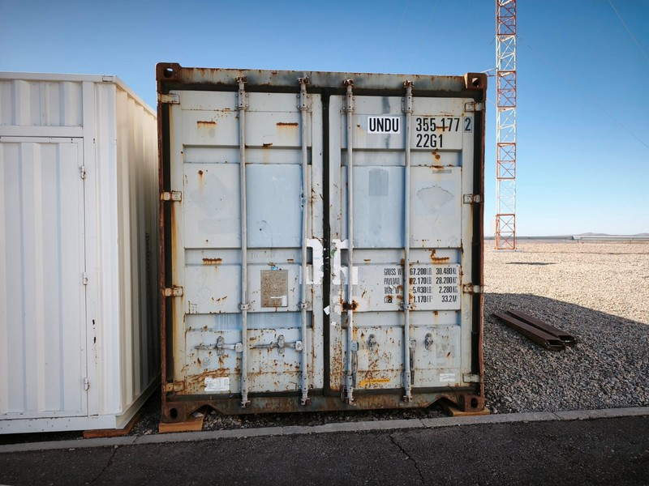 | 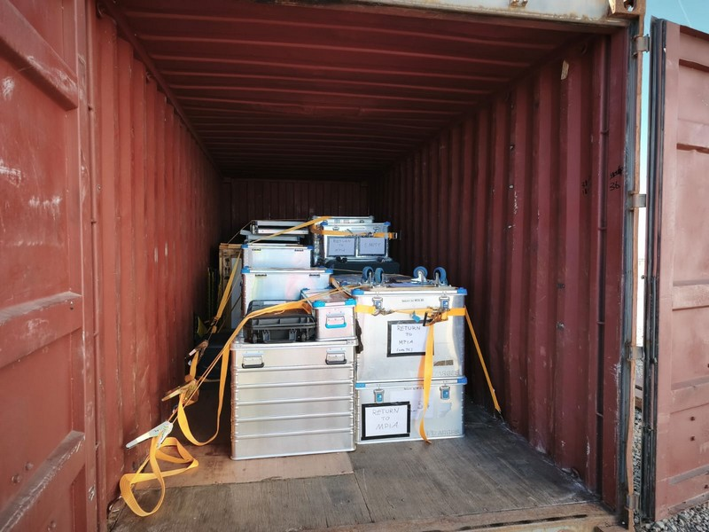
- Container UNDU 355177-2 | - Cargo condition inside the container upon door opened.

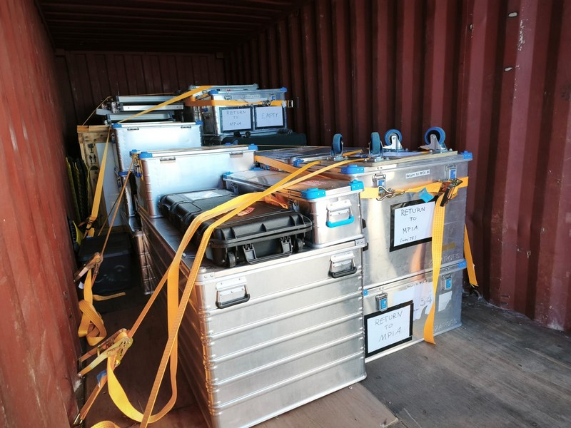 | 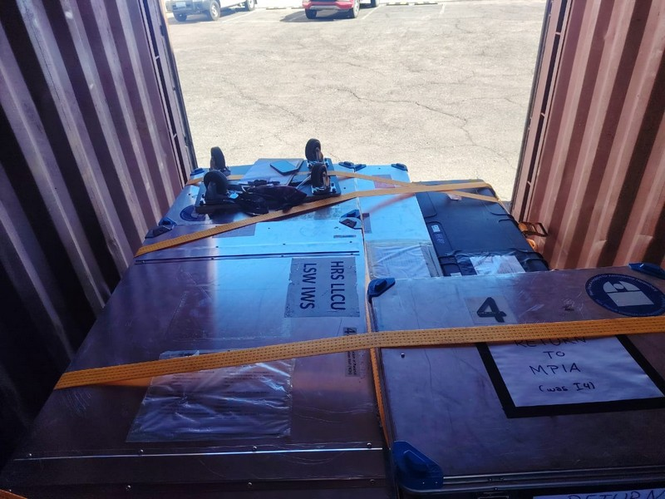
- Cargo condition inside the container upon door opened. | - Top view of the lashing condition.

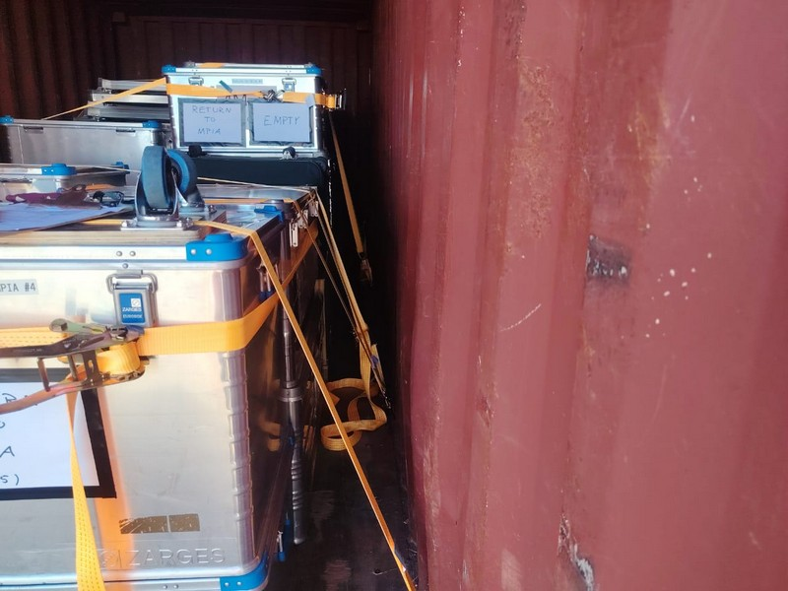 | 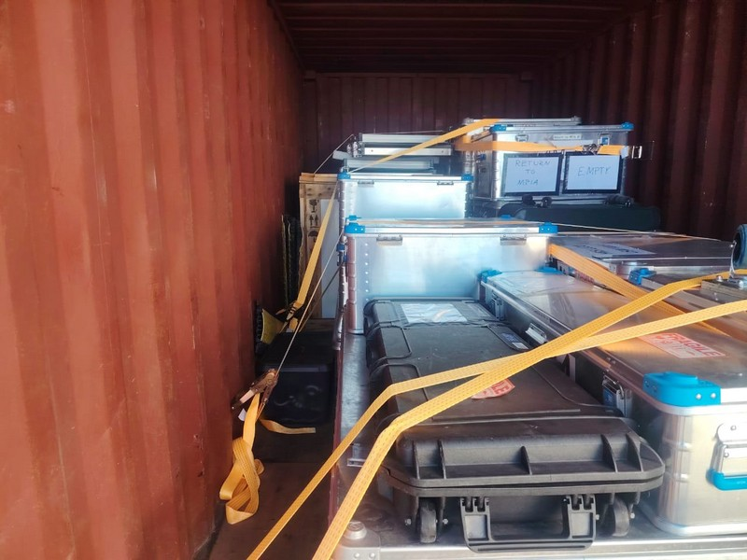
- View of the lashing condition. | - View of the lashing condition.

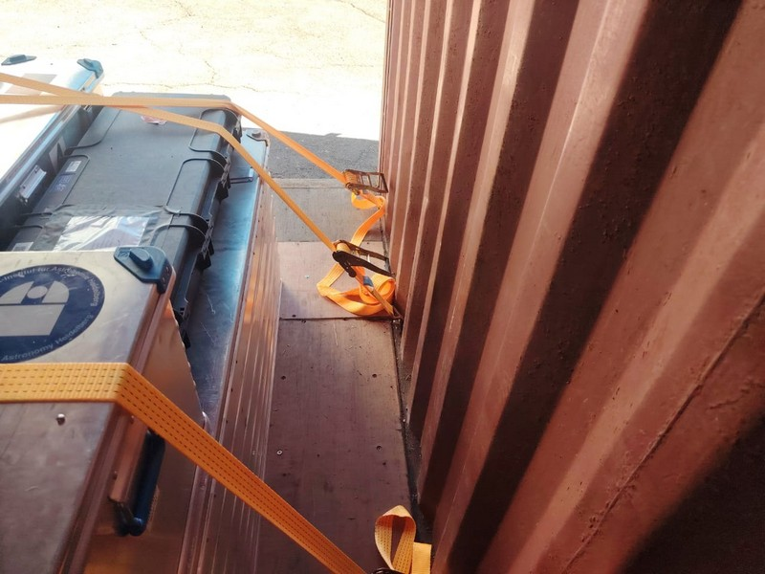 | 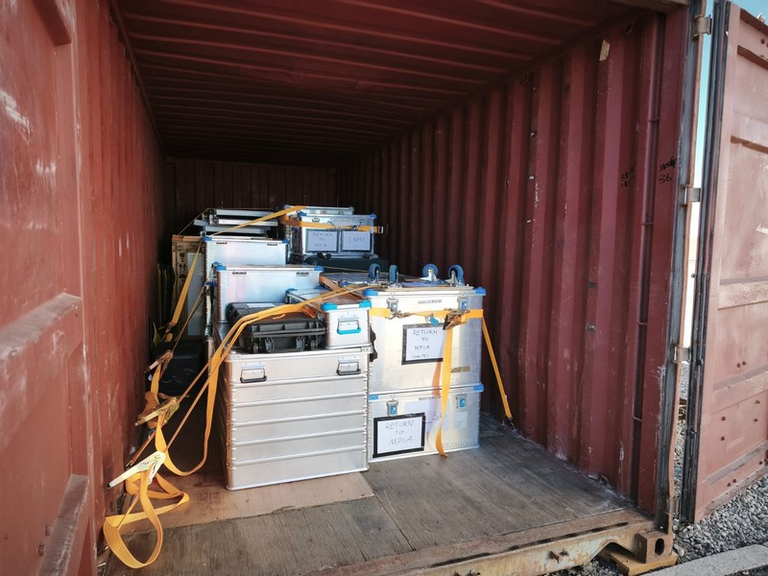
- Unprotected sharp edges | - Lack of timber secured to the floor and supports on the sides of the load to prevent it from shifting.

5.- CONCLUSION

In conclusion, although the cargo was initially stowed in an orderly manner and secured using synthetic slings to the container’s lashing points, there are significant shortcomings in the way it was secured. The presence of empty spaces, the absence of lateral and front blockages, the insufficient use of slings and the lack of adequate tension in them, together with the lack of anti-slip elements and protection on sharp edges, create a high risk of both longitudinal and transverse displacement during transport.

Therefore, it is essential to implement corrective measures that include the use of suitable blocking systems, the incorporation of dunnage, reinforcement and the correct arrangement of slings, as well as the application of anti-slip elements and protection at contact points. These actions will significantly improve the stability of the load and ensure safe conditions during its transport.

6.- ATTENDING PARTIES

NAME AND COMPANY | ON BEHALF OF
Mr. Deiber Cruz/ ALS Inspection Chile SpA | DSV Global Transport and Logistics
Ms. Selomit Morales /ALS Inspection Chile SpA | DSV Global Transport and Logistics

This survey was carried out without prejudice and in the interest of whom it may concern.

ALS Inspection Chile SpA

Prepared by: S. Morales
Revised by: M. López
Approved by: J. López

