ROUTE STUDY (ROUTE 5 NORTH) POWER EQUIPMENT TRANSPORT FROM ANGAMOS PORT TO INTERMEDIAL GATHERED PLACE INTERSEA (NODO URIBE) ANTOFAGASTA AND TO FINAL DESTINATION PFV MALGARIDA,DIEGO DE ALMAGRO

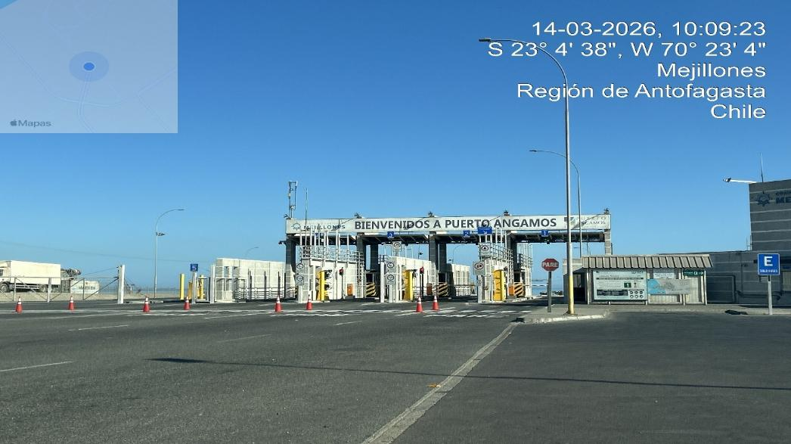
ANGAMOS PORT

Made for:


ISSUE DATE: April 2026

CONTENT

1. Introduction
2. Objectives
3. Brief Description
4. Field Inspection
4.1 Loading capacity of port cranes, daily port discharge rate and permissible storage time in port.
4.1.1. Loading capacity of port cranes.
4.1.2. Daily discharge rate at port.
  - 4.1.3. Allowable storage time at port.
  - 4.1.4. Availability of storage site.
  - 4.2. Define the distances in kilometers between the ports and the project facilities.
  - 4.3. Define estimated transportation times.
  - 4.4. Mark, the physical characteristics of the route.
  - 4.5. Identify the presence of low and medium voltage cables, indicating minimum permitted distances.
  - 4.6. Identify bridges on the route.
  - 4.7. Identify the presence of tunnels on the route and their technical capacities for traffic.
  - 4.8. Identify any other obstacles (traffic signs, advertising, private property, etc.) that are difficult of free transit.
  - 4.9. Establish a calendar of weather seasonality that affects safety transportation on the routes (rain season, intense heat, fog, snow, ice, as well as light times per season).
  - 4.10. Identify water crossings (dry or wet) on the route that could affect travel, nothing the following: maximum axle weight allowed, official strength specifications, physical attributes, and visual conditions, as well as by-pass or reinforcement alternatives if possible.
  - 4.11. Identify possible resting and Parking areas in safe conditions for the driver and cargo.
4.12. Current legislation.
5. Route evaluation (photographs)
6. Conclusions and recommendations.

1. INTRODUCTION

In response to the request made by Messrs. “DELFIN GROUP”, a route study is presented below for the transportation of POWER EQUIPMENT to Intermedial gathered place, Intersea, located at Nodo Uribe, Antofagasta, Chile (23°38'22.5"S 70°17'50.7"W ) and them completed to final destination at PFV Malgarida located at Diego de Almagro. Chañaral province, Chile (26°16'12.0"S 69°57'36.0"W)

2. OBJETIVES:

1. To have information regarding the loading capacity of port cranes, daily port discharge rate and admissible storage time in port, availability of storage facilities in port or close to it.
2. Allow us to identify the route involved in the transfer of components, and it will serve as a reference for a subsequent definition and assessment of the improvement in the existing road infrastructure, if necessary.
3. Define the distances in kilometers between the ports and the Project facilities.
4. Define estimated transportation times.
5. Indicate the physical characteristics of the route; pavement condition, type of surface, number of lanes, gradients, condition of the shoulder.
6. Presence of low, medium, and high voltage cables, indicating the minimum distance allowed by law to transit.
7. Identify the presence of bridges on the route.
8. Identify the presence of tunnels on the route and their technical capacities for transit.
9. Identify any other obstacles (traffic signs, advertising, private property, etc.) that are difficult of free transit
  - 10. Establish a calendar of weather seasonality that affects safety transportation on the routes (rain season, intense heat, fog, snow, ice, as well as light times per season).
11. Identify water crossings (dry or wet) on the route that could affect travel, nothing the following: maximum axle weight allowed, official strength specifications, physical attributes, and visual conditions, as well as bypass or reinforcement alternatives if possible.
12. Identify rest and Parking areas in safe conditions for the driver and cargo.
  - 13. Formulate relevant recommendations to the routes such as improvements, use of special equipment for transporting oversized and/or overweight cargo.

  - 3. BRIEF DESCRIPTION: Project to PFV Malgarida Norte including intermedial point

The Project presented in this route study corresponds to Two points, the first point corresponds to intermedial storage warehouse INTERSEA, will be located south of the Puerto Angamos, in the district of Antofagasta province, Antofagasta region, (23°38'22.5"S 70°17'50.7"W) approximately 88,5 kilometers away.

After that the second point correspond to intermedial storage warehouse INTERSEA, will be located south of the Puerto Angamos, in the district of Antofagasta province, Antofagasta region, (23°38'22.5"S 70°17'50.7"W) to final destination of project PFV Malgarida will be located at north of Diego de Almagro , Chañaral province, Atacama region (26°16'12.0"S 69°57'36.0"W) approximately 470.5 kilometers from de intermedial point to PFV Malgarida.

Total route includes the intermedial correspond to 559 Km from Puerto Angamos to final destination Malgarida project.

The project includes the construction and operation of a photovoltaic park consisting of 535 hectares of photovoltaic panels; The plant will connect and export its power through a resolute 654 GWh substation.

Main route from Angamos Port to the Project.

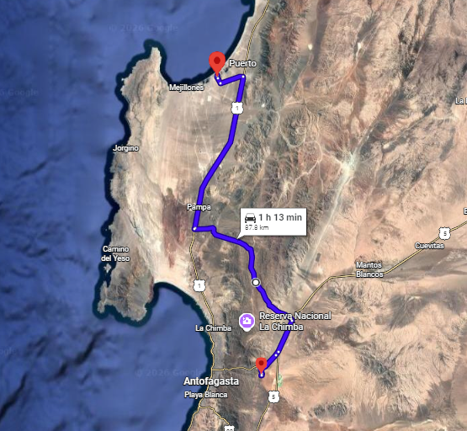
Main route from Angamos port to intermedial point: Google maps.

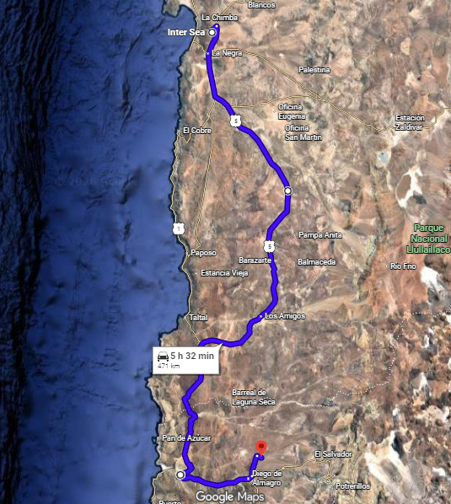
Main route from Intermedial point to destination: Google maps.

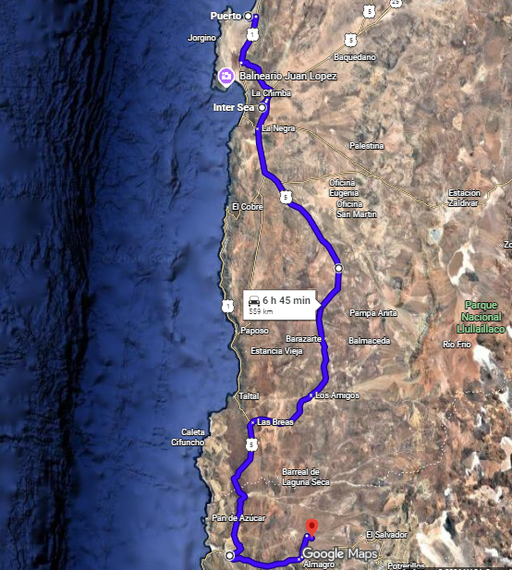
Main route from Angamos port to Final destination: Google maps.

4. FIELD INSPECTION:

Field inspections were conducted based on all defined routes, to carry out reference surveys of obstacles and singular points, photographic capture, clearance measurements, inspection of bridges and verification of general conditions of each route, critical points with insufficient maneuvering area, bridges with restrictions, among others, were photographed and inspected thoroughly.

Following our study, conducted in the field, we can define the following points:

4.1. LOADING CAPACITY OF PORT CRANES, DAILY PORT DISCHARGE RATE AND PERMISSIBLE STORAGE TIME IN PORT.

Through the following report we can inform you that the Angamos Port consists of 4 sites.
EQUIPMENT

6 mobile harbor cranes with a lifting capacity of 100 tons
12 Reach Stacker cranes for full containers
5 Top lifter cranes for empty containers
33 container trucks
37 forklift trucks

Main Area to Angamos international Terminal. (PAG)

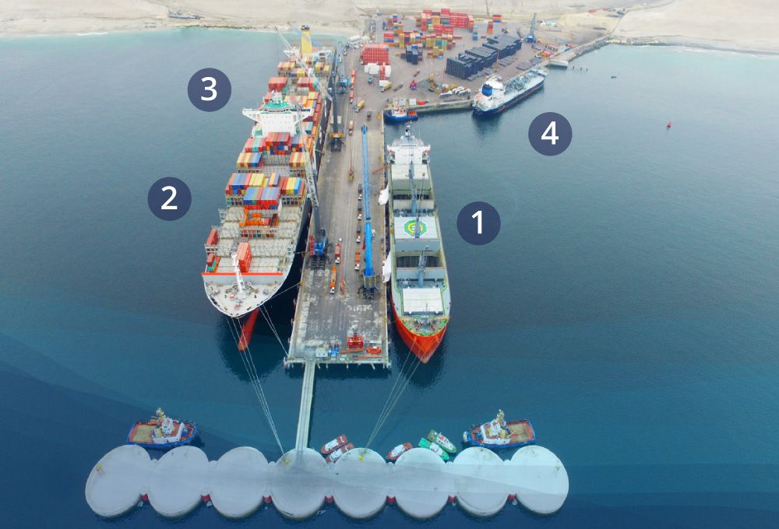

Satellite Image of ANGAMOS PORT

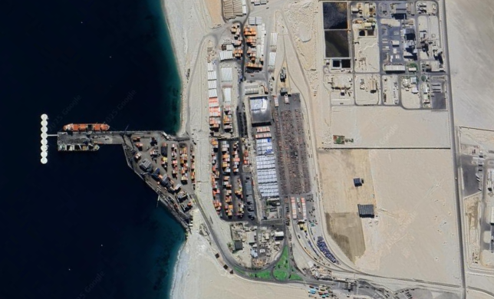
Souce: Google maps

4.1.1. LOADING CAPACITY OF PORT CRANES:

Angamos port has Dock Equipment with a safe working load of 100 tons and Yard Equipment with a working load of 45 tons.

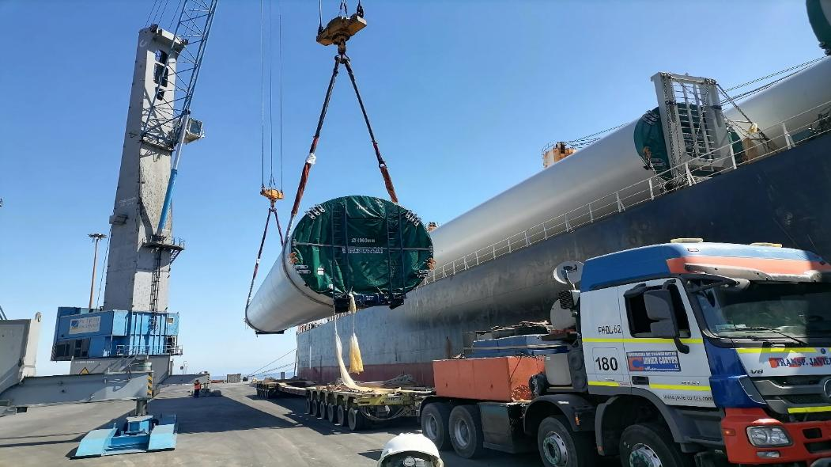
Source: Angamos Port.

4.1.2. DAILY DISCHARGE RATE AT ANGAMOS PORT.

At Angamos Port, cargo productivity is like handling 20' containers, from 80 to 100 units. per shift (3 shifts per day).

4.1.3. ALLOWABLE STORAGE TIME AT ANGAMOS PORT.

At Angamos Port, cargo such as power equipment is classified as IMO 9 / UN 3536, with a maximum stay in port of 72hrs, after this time, the units must be moved to the storage areas, where the spaces in m2 will be charged.

The values ​​were not provided; these were classified as reserved information. However, you can find prices on the terminal's website.

4.1.4 AVAILABILITY OF STORAGE ANGAMOS PORT

At Angamos port, cargoes such as power equipment, being classified as IMO 9, must be stored inside the controlled area for dangerous cargo.

Likewise, if the client has other warehouses outside the terminal, such as primary areas authorized by the National Customs Service as storage areas, in both cases the clients can choose that alternative.

It should be noted that the stay in Angamos port is subject to storage charges. For this, you can see the public tariff at the following link:

https://www.puertoangamos.cl/servicios-tarifas

4.2. DEFINE THE DISTANCES IN KILOMETERS BETWEEN THE PORTS AND THE PROJECT FACILITIES.

According to study realized, the access to PFV Malgarida and intermedial point, is via to main national roads that connect the cities,

The route was made from the port of discharge to its destination according to the coordinates provided（27°01'05.0"S 69°53'38.0"W）with a length of 559.,0 kilometers. Including intermedial point will be used as temporal storage located at Intersea Storage located at 23°38'22.5"S 70°17'50.7"W

Following our study, carried out in the field, we can define the following points:

Below are the distances in kilometers by sections:

START | FINAL DESTINATION | DISTANCE (km)
Puerto Angamos | Conection to Route B262 | 1.9
Conection to Route B262 | Route 1, Pampa, Antofagasta | 4.9
Route 1, Pampa, Antofagasta | Conection to B-400 route | 33.2
Conection to B-400 route | National route connection Nr. 5. | 32.2
National route connection Nr. 5. | Rute 26, Antofagasta | 7.4
Rute 26, Antofagasta | Alternative road no named | 5.1
Alternative road no named | Intersea Warehouse | 3.8
Intersea Warehouse | Alternative road no named | 3.8
Alternative road no named | Rute 26, Antofagasta | 5.1
Rute 26, Antofagasta | National route connection Nr. 5 | 4.7

START | FINAL DESTINATION | DISTANCE (km)
National route connection Nr. 5. | Conection to C-13, Chañaral province | 384.2
Conection to C-13, Chañaral province | Conection to C-115-B, Diego de Almagro province | 54.0
Conection to C-115-B, Diego de Almagro province | Conection to C-171, Diego de Almagro province | 15.0
Conection to C-171, Diego de Almagro province | Road desviation to entrance to PFV Malgarida | 3.0
Road desviation to entrance to PFV Malgarida | PFV Malgarida | 0.66

4.3. DEFINE ESTIMATED TRANSPORTATION TIMES.

According to the route study carried out, from the Port of Discharge to intermedial destination, the travel time of the route was 1 hour and 15 minutes, respecting the speed limits stipulated during the route, which were very well signposted.

Speed ​​limits:

Road : 70 to 120 Km/Hr.
Urban and rural areas : 30 to 50 Km/Hr.

Considering the speeds, determined by the land carrier, as a safety speed for the transport of cargo, we can consider a change in the number of hours considering that variable.

Speed ​​limits, for other projects with cargo up to 45 tons.

Road : 50 to 60 Km/Hr.
Urban and rural areas : 20 to 40 Km/Hr.

The route selected was found in good condition duly signed and all of the roads with pavement and asphalt. Last part of the route was found with dirty road from the deviation of route 26 to final destination. About 2 km.

In the route is necessary trespassing for two urban places, El Salado and Diego de Almagro

4.4. IDENTIFY THE PHYSICAL CHARACTERISTICS OF THE ROUTE, PAVEMENT CONDITION, TYPE OF SURFACE, NUMBER OF LANES, GRADIENTS, CONDITION OF THE SHOULDER.

According to the study carried out, from the Angamos Port to the FPV Malgarida Project, the physical characteristics of the routes traveled are detailed below:
ROUTE | ORIGIN | FINAL DESTINATION | TYPE OF SURFACE | NR. OF LANES | STATUS AND SIGNALING | TYPE OF ROUTE | CONDITION OF SHOULDER
S/R | PAUERTO ANGAMOS | ROUTE 1 | Pavement/  Asphalt | Bidirectional | Good | Straight | Good
1 | ROUTE 1 | PEAJE | Asphalt | Bidirectional | Good | Straight | Good
1 | PEAJE | Route B400 (paso Superior) | Asphalt | Bidirectional | Good | Straight | Good
B400 | Route B400 (paso Superior) | Route 5 | Asphalt | Bidirectional | Good | Straight | Good
5 | Route 5 | Route C-26 | Asphalt | Bidirectional | Good | Straight | Good
C-26 | Route C-26 | Desviatoion no named road | Asphalt | Bidirectional | Good | Straight | Good
First point | Desviation no named road | Intersea Warehouse | Dirty road | Bidirectional | No good | Straight | No good
First point | Intersea Warehouse | Desviation no named road | Dirty road | Bidirectional | No good | Straight | No good

ROUTE | ORIGIN | FINAL DESTINATION | TYPE OF SURFACE | NR. OF LANES | STATUS AND SIGNALING | TYPE OF ROUTE | CONDITION OF SHOULDER
C-26 | Desviatoion no named road | Route C-26 | Asphalt | Bidirectional | Good | Straight | Good
5 | Desviatoion no named road Route C-26 | Route 5 (national) | Asphalt | Bidirectional | Good | Straight | Good
5 | Route 5 (national) | Route C-13 | Asphalt | Bidirectional | Good | Straight | Good
C-13 | B Route C-13 | Route C-115-B | Asphalt | Bidirectional | Good | Straight | Good
C-115-B | Route C-115-B | Route C-171 | Asphalt | Bidirectional | Poor | Winding | Good
C-171 | Route C-171 | Conection to final road | Ground | Bidirectional | Poor | Winding | Good
na | Conection to final road | Final destination | Ground | Bidirectional | Poor | Winding | Poor

4.5. PRESENCE OF LOW, MEDIUM AND HIGH VOLTAGE CABLES, INDICATING THE MINIMUM DISTANCE ALLOWED BY LAW TO TRANSIT.

According to the study carried out, from Puerto Angamos to the Malgarida Park Project, high voltage cables were witnessed at different points along the route.

In Chile, the minimum height of telecommunications cables at street and avenue is 5,5 meters above the ground; this height applies to low voltages. For medium voltage 23Kv minimum 7 meters and high tension corresponds to minimum between 9 to 10 meters.

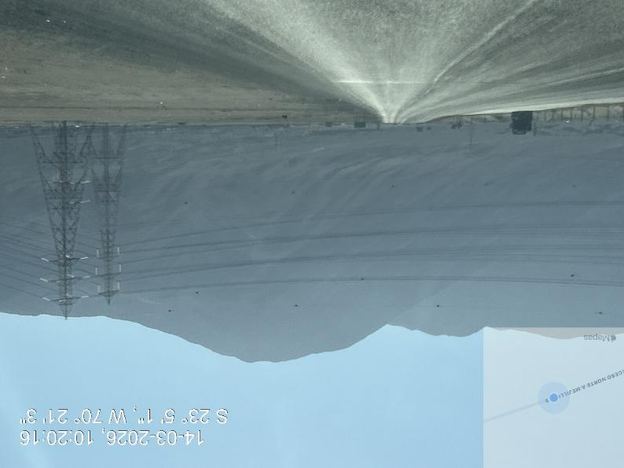
ROUTE 1. High voltage cables Route B 262

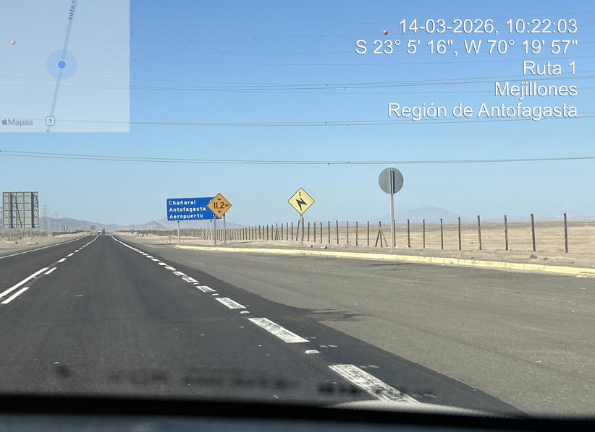
ROUTE 1 Cables de High tension

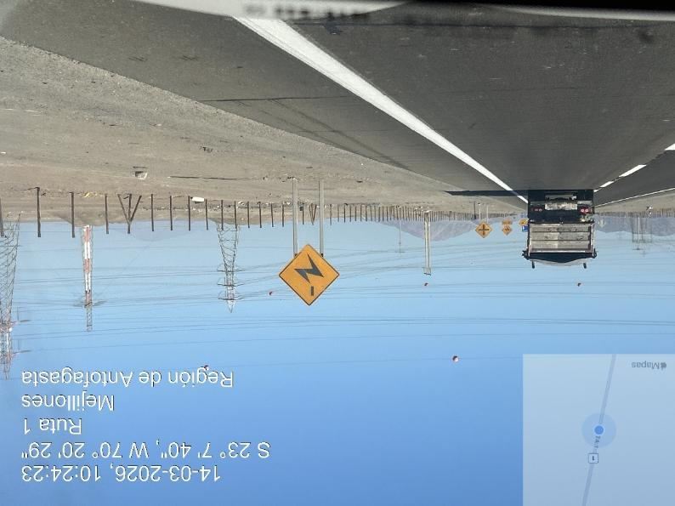
ROUTE 1 Cables de High tension
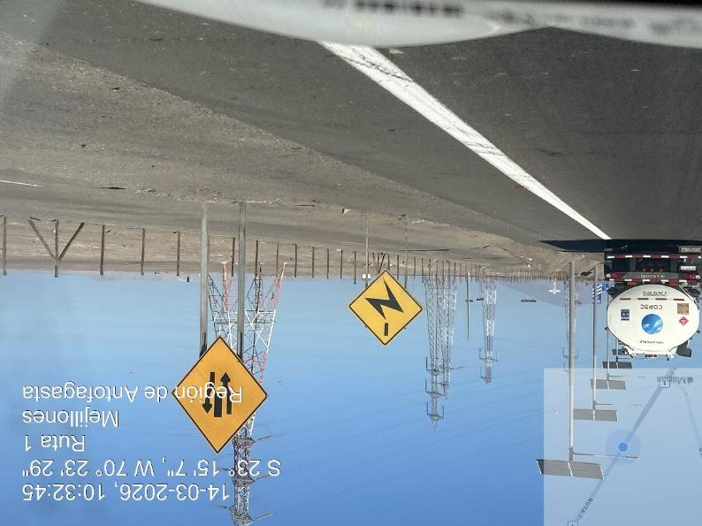
ROUTE 1 Cables de High tension

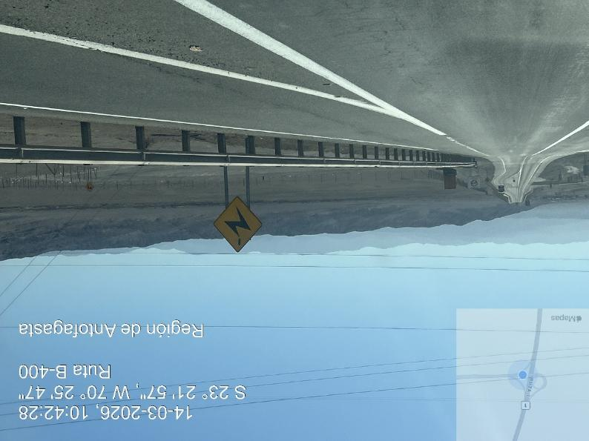
ROUTE 400 Cables de High tension

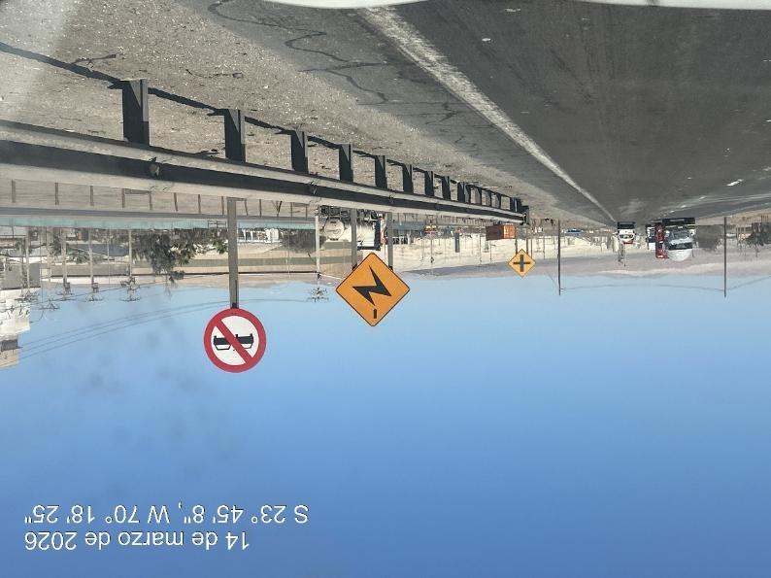
ROUTE 5, La Negra sector, Cables de High tension

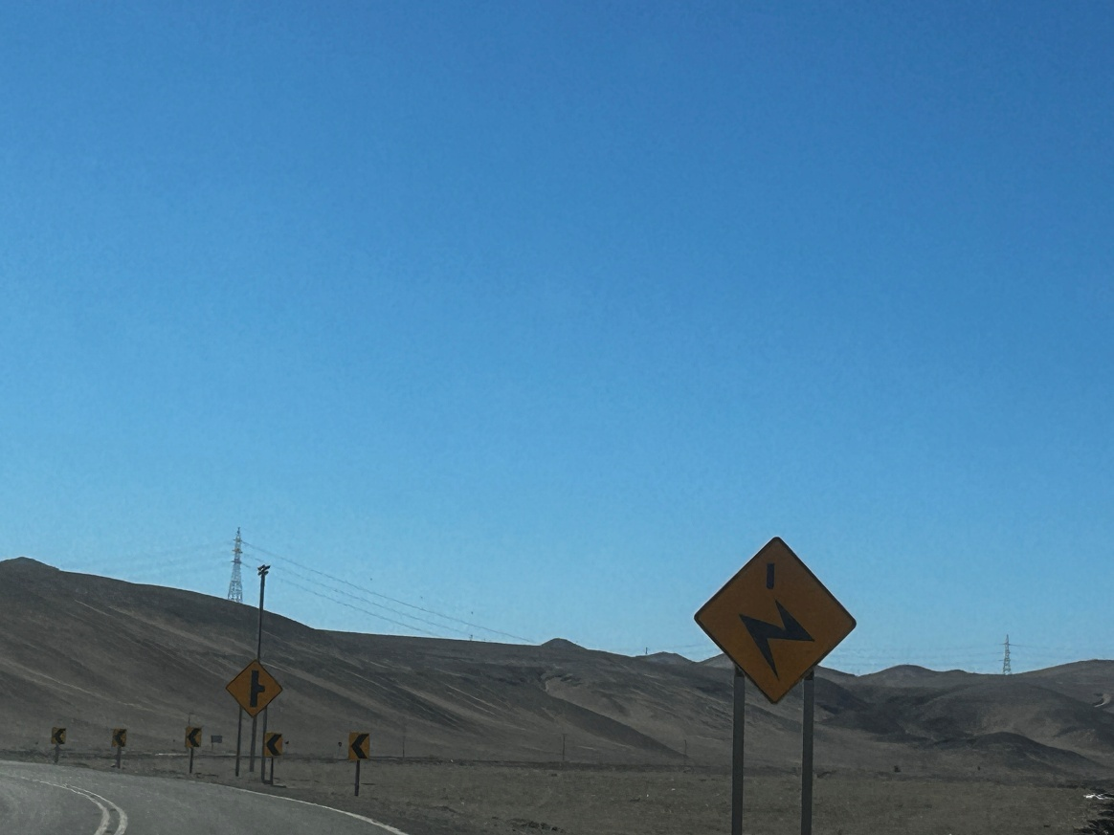
ROUTE C13,Previous to Diego de Almagro, Cables de High tensión
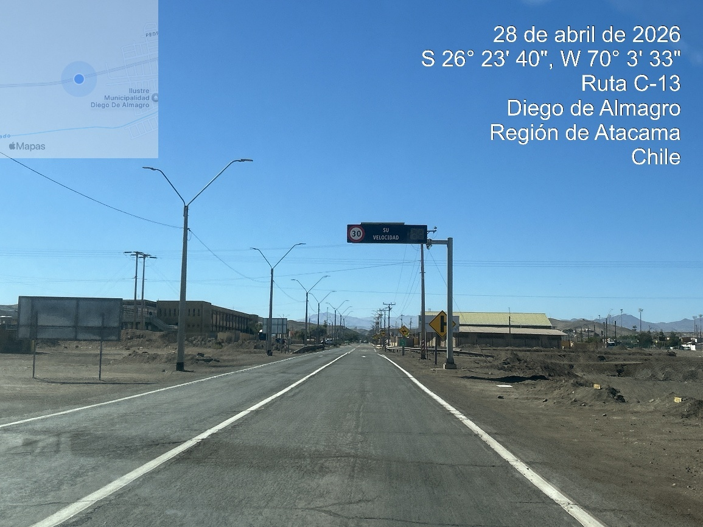
Entrance to Diego de Almagro, Cables de High tensión

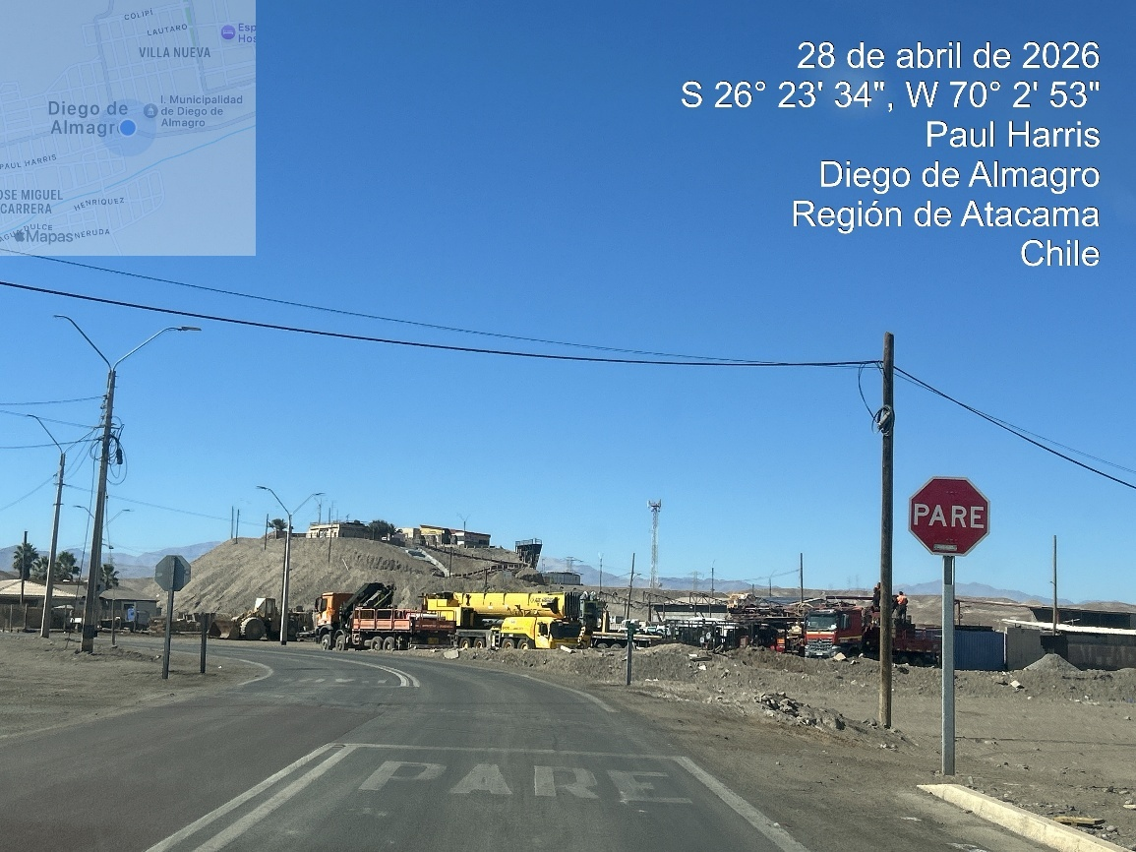
Diego de Almagro, Cables de High tensión

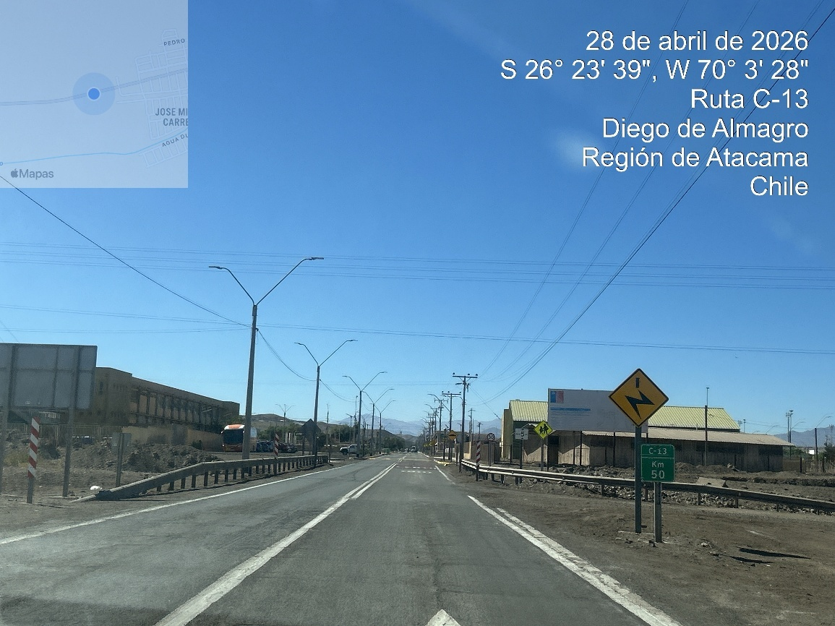
Diego de Almagro, Cables de High tensión

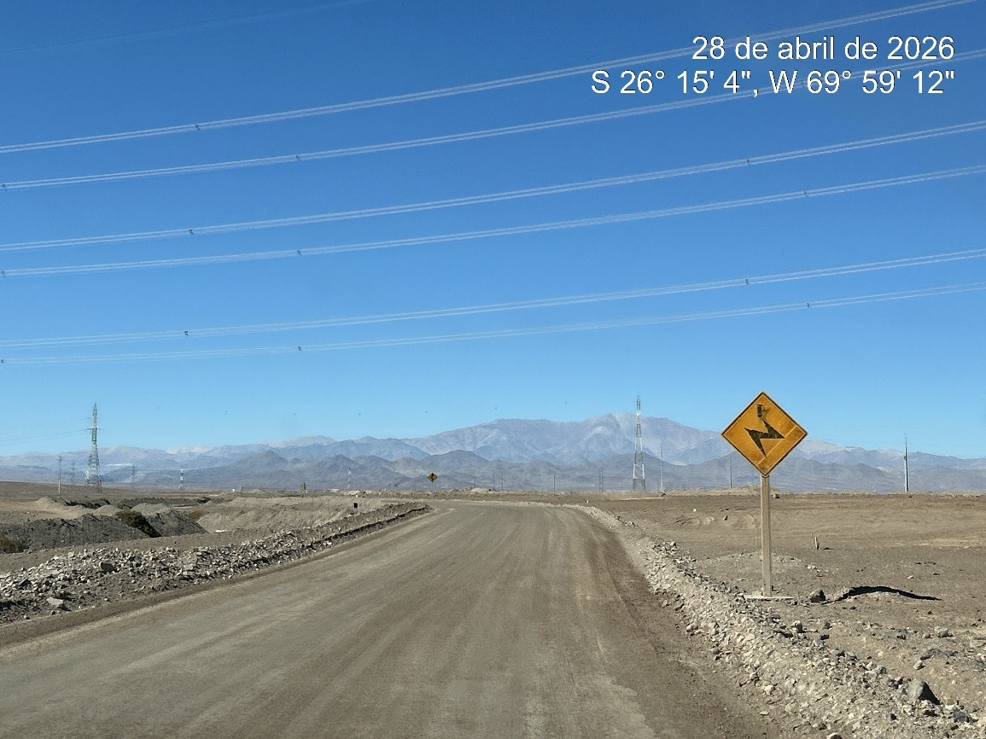
Route C-115-B Route , Cables de High tensión

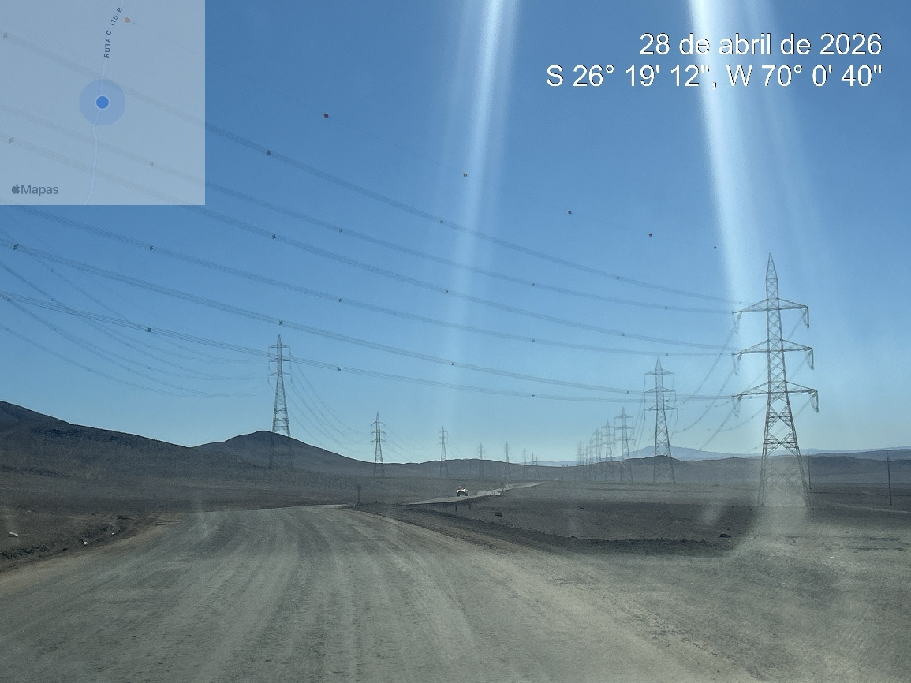
Route C-115-B Route , Cables de High tensión

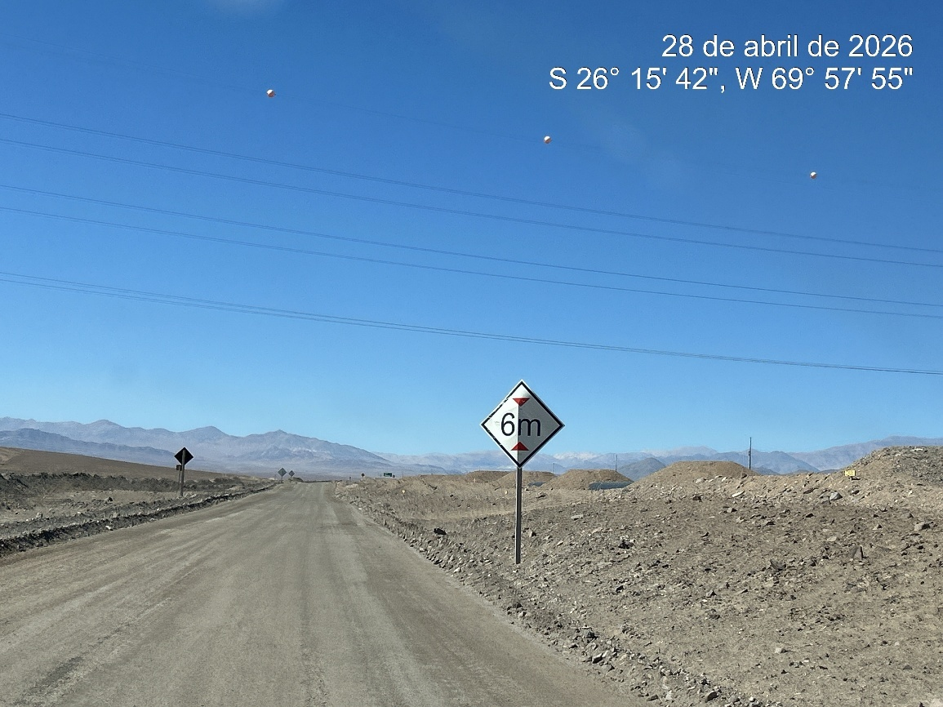
Route C-115-B Route , Cables de High tensión

4.6. IDENTIFY THE PRESENCE OF BRIDGES ON THE ROUTE.

According to the study carried out from Angamos Port, towards the Project, bridges and pedestrian walkways were identified on the route, which are detailed below.:

Summary table of dimensional restrictions on route to Malgarida Photovoltaic Park

ROUTE | DESCRIPTION | COORDINATES | LENGTH (M) | WIDTH (M) | HEIGHT (M)
1 | Walkways Mejillones Norte | 23°04'53.5"S 70°19'53.0"W | -- | -- | 4,2
1 | Walkways Mejillones Sur | 20°16'47.712''S, 70°6'4.254''W | -- | -- | 4,2
5 | La Negra Route | 23°46'28.062''S, 70°18'49.413''W |  | -- | 5.5

Photographs of bridges on route.
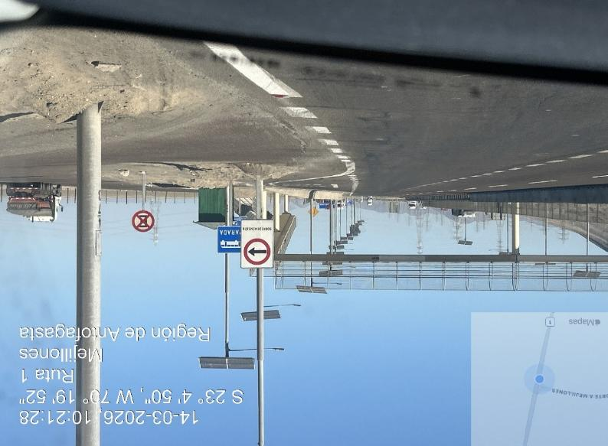
Walkways North Mejillones access
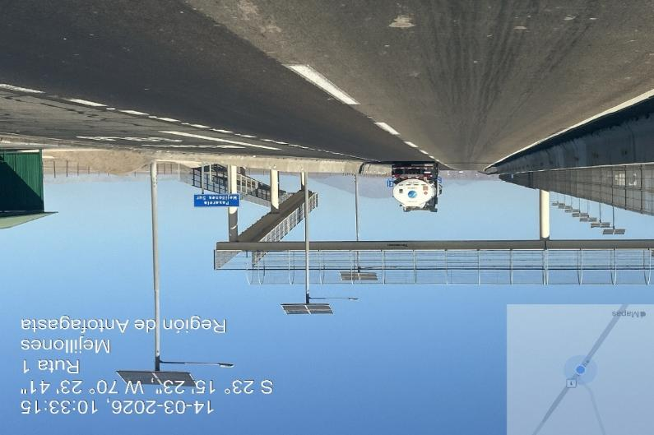
Walkways south Mejillones access
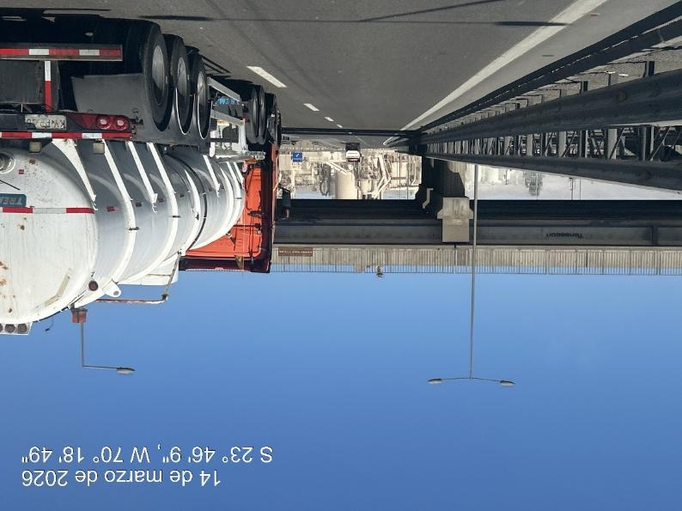
Bridge of La Negra sector

4.7. IDENTIFY THE PRESENCE OF TUNNELS ON THE ROUTE AND THEIR TECHNICAL CAPACITIES FOR TRANSIT

According to the route study carried out, from Angamos port to Final destination on PFV Malgarida , NO tunnels were observed.

4.8. IDENTIFY ANY OTHER OBSTACLE (TRAFFIC SIGNS, ADVERTISING, PRIVATE PROPERTY, ECT) THAT DIFFICULT OF FREE TRANSIT

According to the route study carried out from Angamos port to Intersea gathered place, the traffic signs were observed in good condition, in order and duly identified, such as: stopped, speed limits, bypass, detours and advertising, being easily access to the determined areas.

Last part of 2 km should be transit with low speed upto arrival to Intersea warehouse.

The same route should be used for second part, from intersea warehouse to final destination PFV Malgarida

First part of 2 km should be transit with low speed up to connection to C-13 route, is necessaries to transit thought El Salado, urban area and Diego de Almagro urban area.

Entrance to project corresponds to private property.

In the rural and urbanized places, the traffic is reduced according to speed limits established, since the route is found in the middle of urbanized areas, but this is not an obstacle to the free transportation.

In general, the route was observed without obstacles, without risk areas, which prevent free transit.

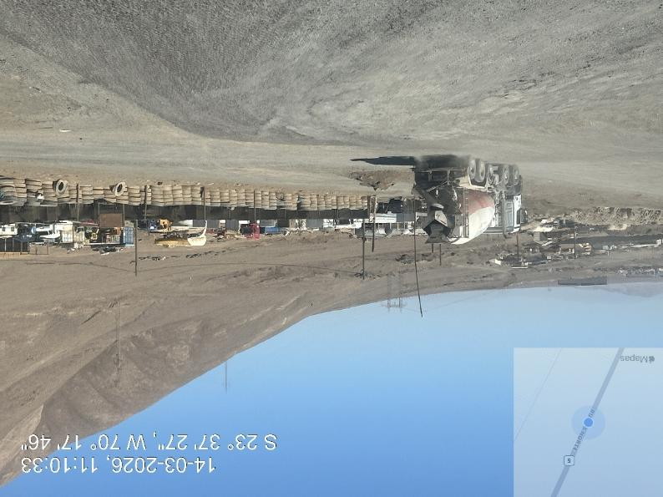
Road from route 26 to Intersea warehouse area
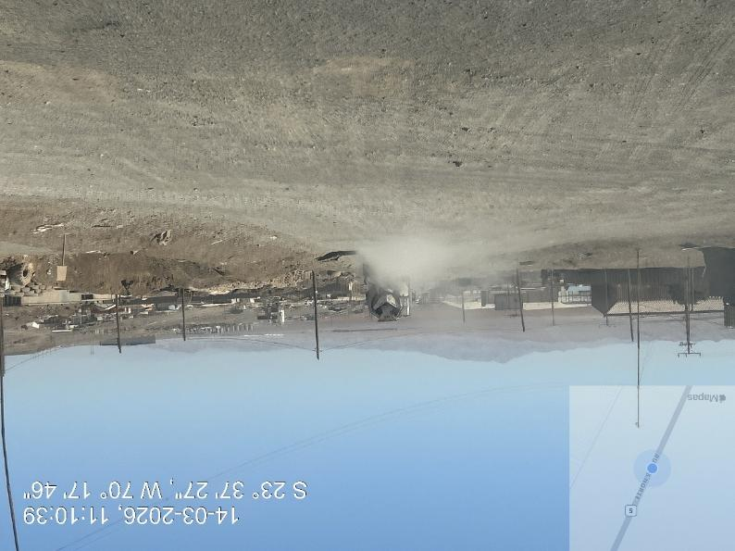
Road from route 26 to Intersea warehouse area
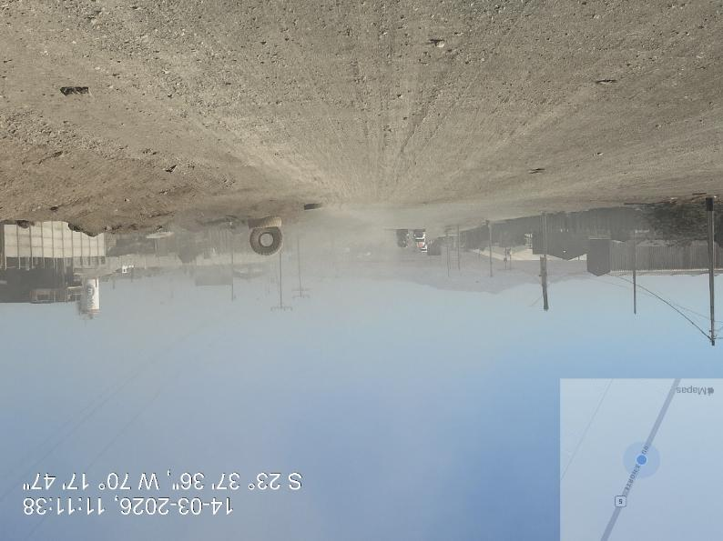
Route conditions

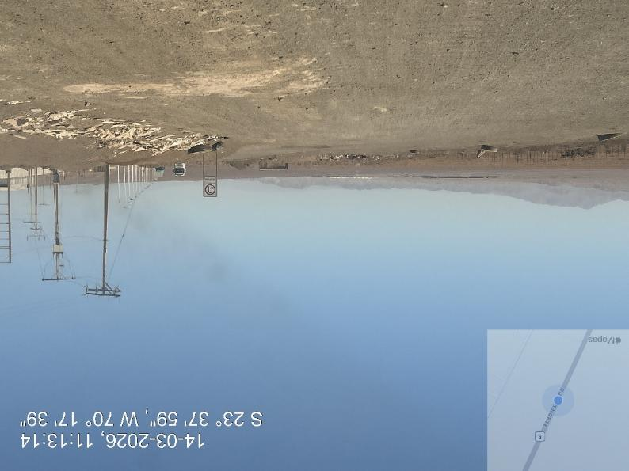
Route conditions
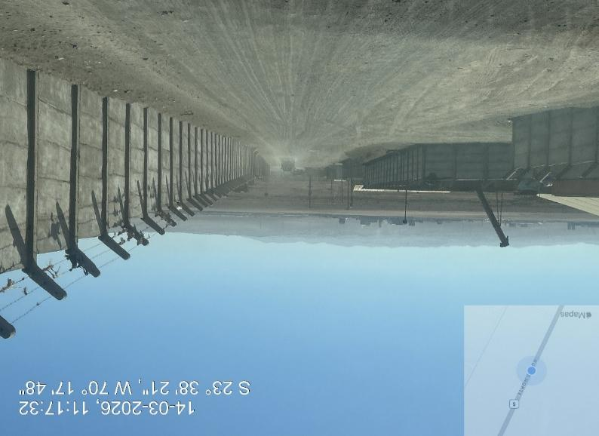
Final access road to Intersea Warehouse

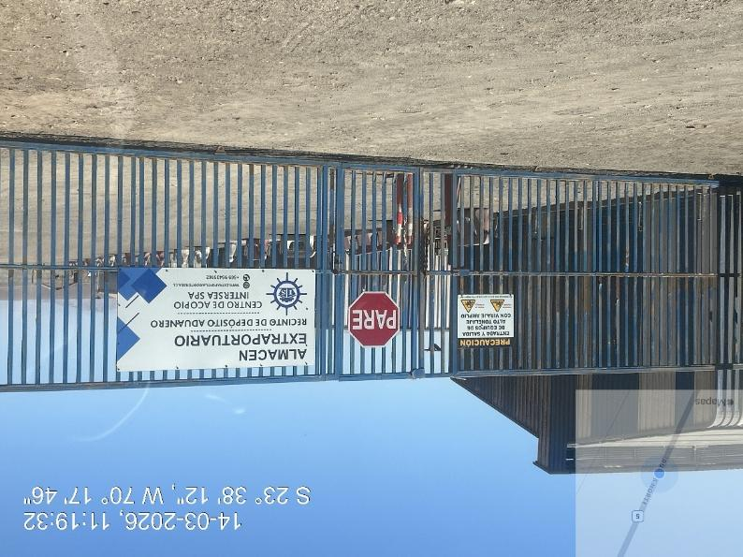
Acces to Intersea warehouse
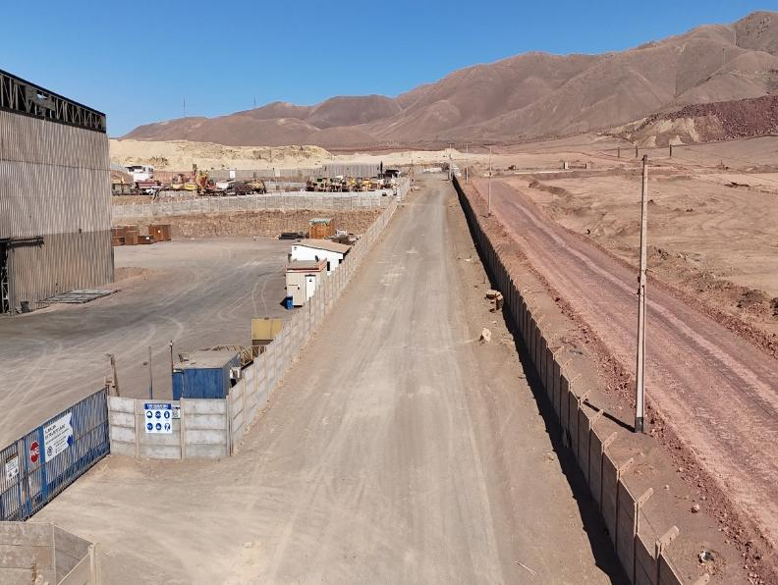
Main view of road for access to Intersea warehouse
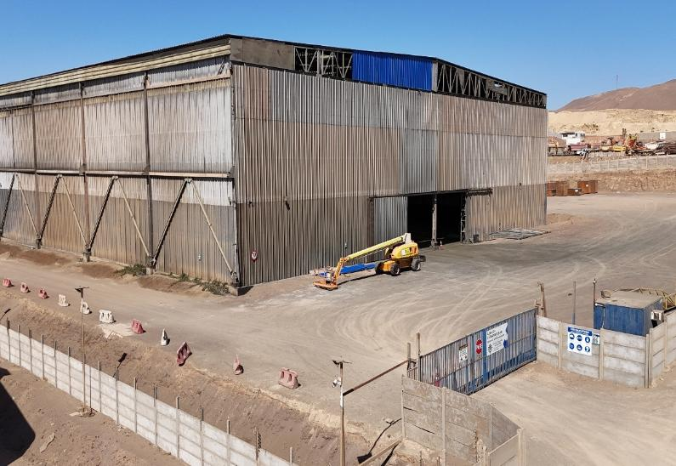
External view of warehouse
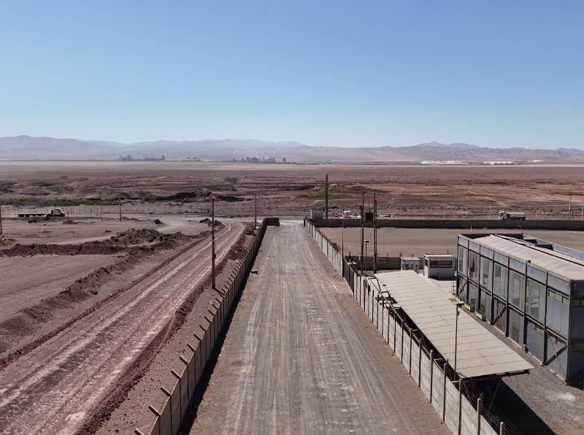
External view of access road to Intersea
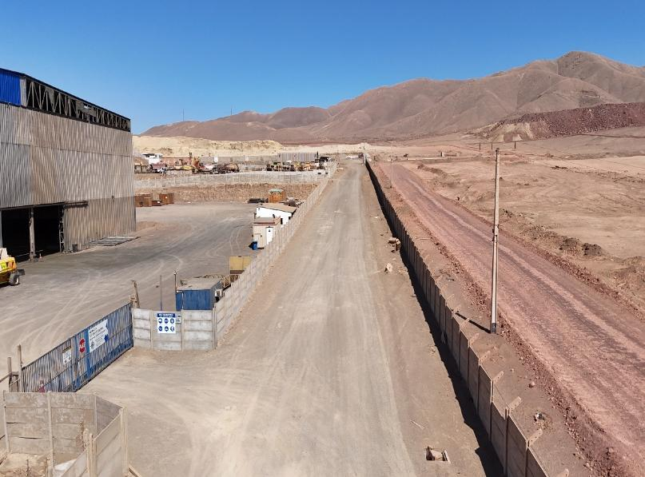
External view of access road to Intersea warehouse
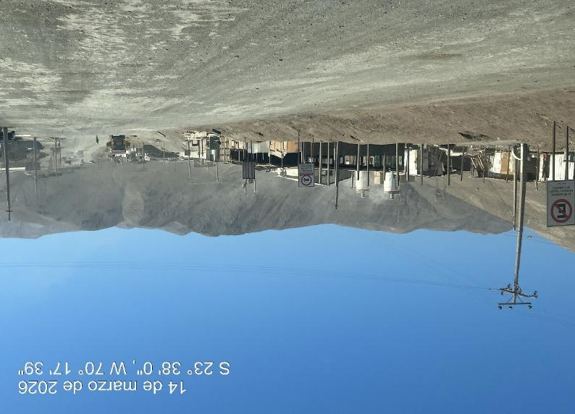
Route conditions from Intersea warehouse to route B-26
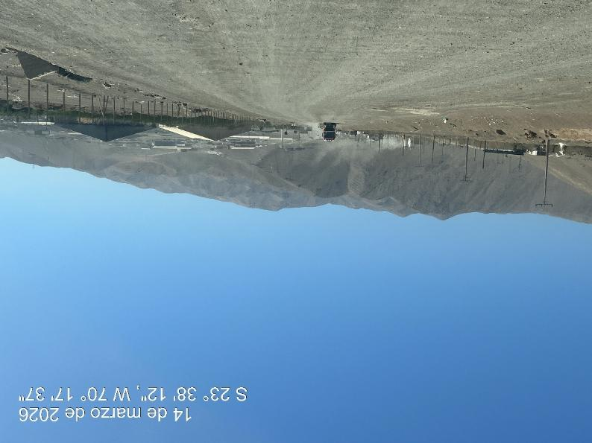
Route conditions from Intersea warehouse to route B-26
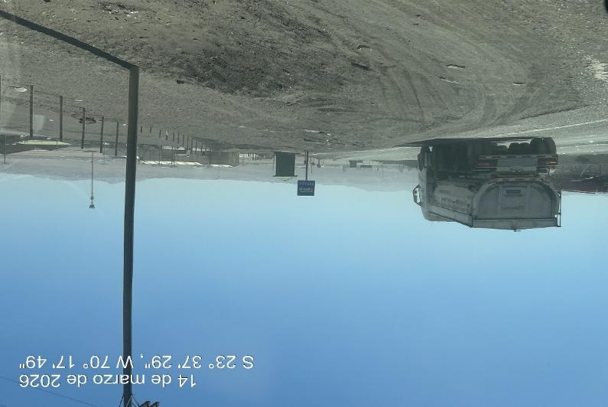
Route conditions from connection to Route 26
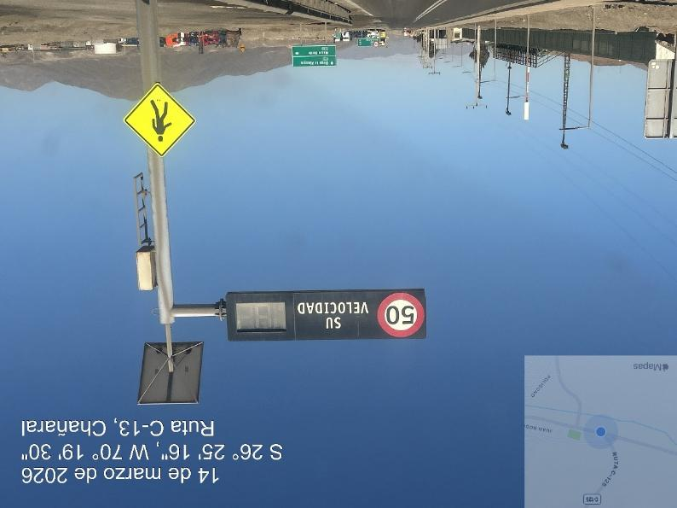
Route conditions entrance to El Salado urban area, max speed and traffic signal
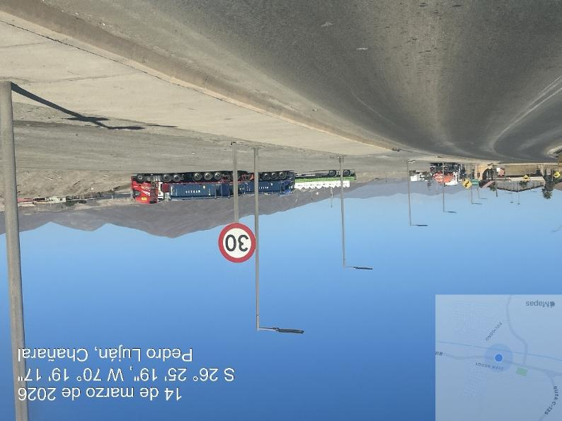
Route conditions max speed in El Salado urban area

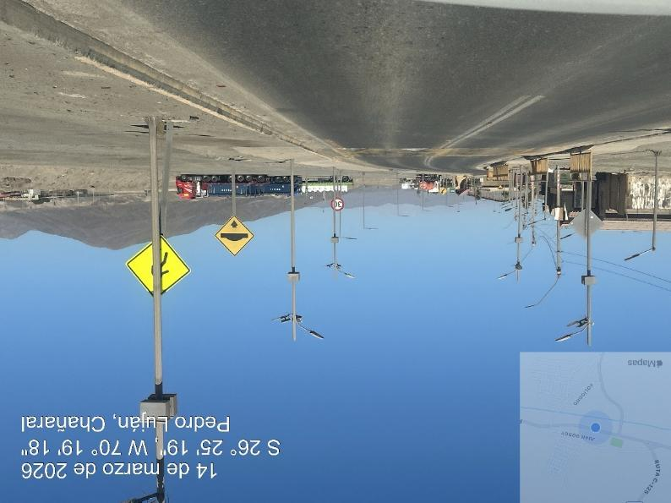
El Salado urban area, max speed and traffic signal
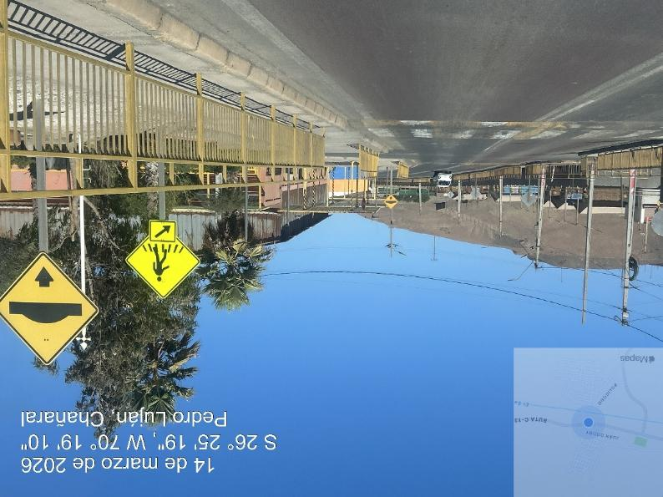
El Salado urban area, max speed and traffic signal

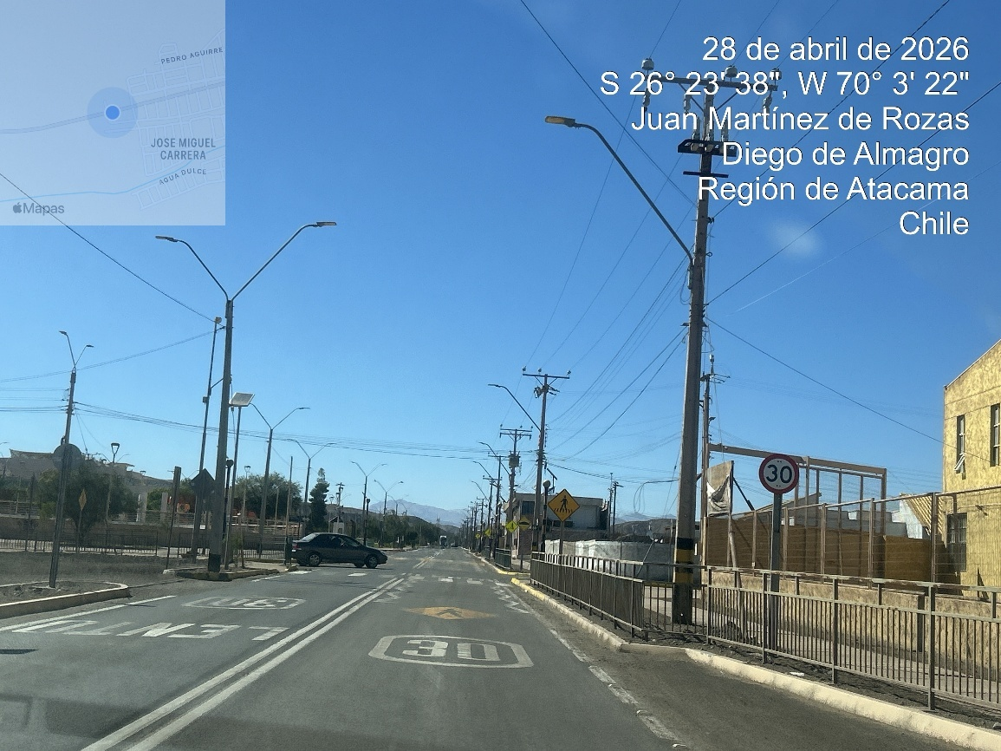
Diego de Almagro urban area, max speed and traffic signal

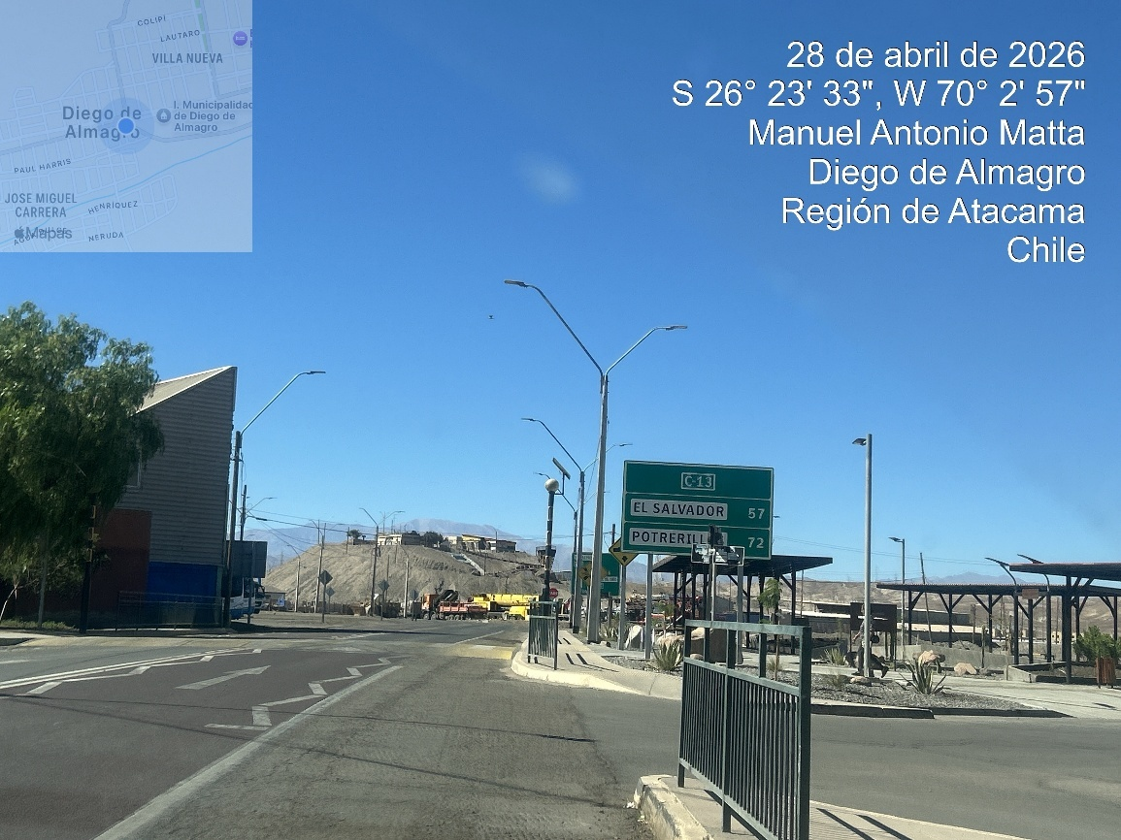
Diego de Almagro urban area, Street signal

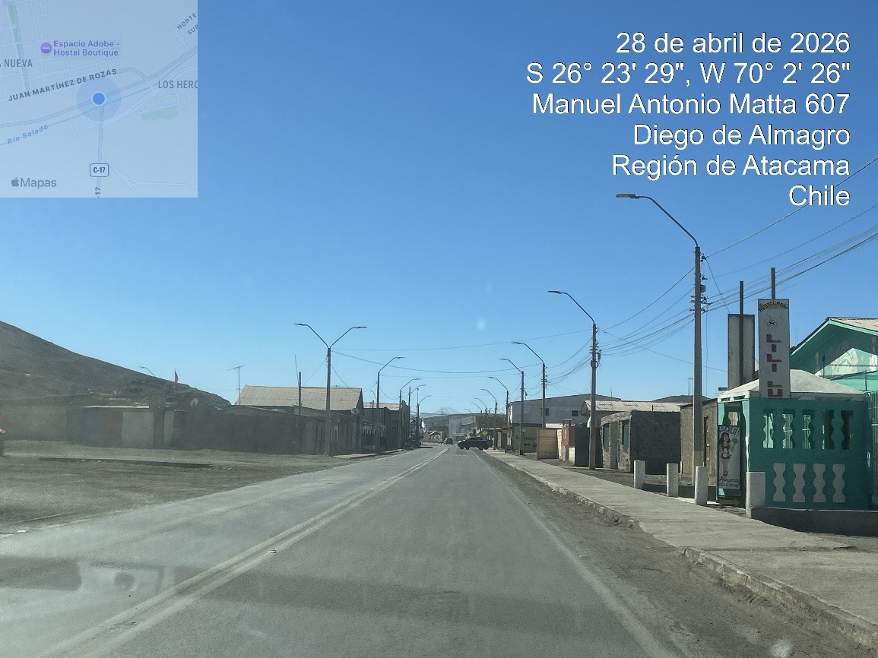
Diego de Almagro urban area, road conditions

4.9. ESTABLISH A CALENDAR OF WHEATHER SEASONALITY THAT AFFECTS A SAFETY TRANSPORTATION ON THE ROUTES (RAIN SEASON, INTENSE HEAT, FOG, SNOW, ICE, AS WELL AS LIGHT TIMES PER SEASON)
AD PRIVADA, ETC.) QUE DIFICULTE
The route study was developed during summer with an average temperature between 24° to 26 °C.
LIBRE TRÁNSITO
The weather condition noted from Puerto Angamos, Mejillones / destination, is a desert climate, which is characterized by high temperatures, low rainfalls, high humidity, and fog at night, during all seasons.

The weather conditions during the year, as per the following detail:

 | WEATHER
SUMMER |  | AUTUMN |  | WINTER | SPRING
Intense heat- Sunshine-  Humidity- Fog |  | Sunshine - Wind - Humidity - Fog |  | Humidity-wind-  Average rain - Fog | Sunshine - Wind - Humidity - Average rain - Fog

4.10. IDENTIFY WATER CROSSINGS (DRY OR WET) ON ROUTE THAT COULD AFFECT TRAVEL, NOTING THE FOLLOWING: MAXIMUM AXLE WEIGHT ALLOWED, OFFICIAL STRENGTH SPECIFICATIONS, PHYSICAL ATTRIBUTES AND VISUAL CONDITIONS, AS WELL AS BY-PASS OR REINFORCEMENT ALTERNATIVES IF POSSIBLE.

Being a desert area, the water crossings are not observed with water during the year, do not interfere with free transit, there are bridges over these flows, which does not hinder the movement of transport, being a route of free transit, safe and clear.

Regarding visibility, these areas do not have many constructions; on the route sides, few people, rather these areas correspond to routes of free transit.
.

4.11. IDENTIFY POSSIBLE RESTING AND PARKING AREAS IN SAFE CONDITIONS FOR THE DRIVER AND CARGO, FORMULATE RELEVANT RECOMMENDATIONS TO THE ROUTES SUCH AS POSSIBLE IMPROVEMENTS, USE OF SPECIAL EQUIPMENT FOR TRANSPORTING OVERSIZED AND/OR OVERWEIGHT CARGO.

According to the study, several places in route are available for rest, parking areas and two gas stations,

Resting areas:

Name | Location | City | Region
Gas Station | 23° 47'38" S, 70°19' 1 W | La Negra | Antofagasta
Gas Station | 25° 23'55''S, 69°57.51''W | Aguas Verdes | Antofagasta
Gas Station | 26° 23'25''S, 70°2.16''W | Diego de Almagro | Chañaral

Photographs of resting and Parking areas

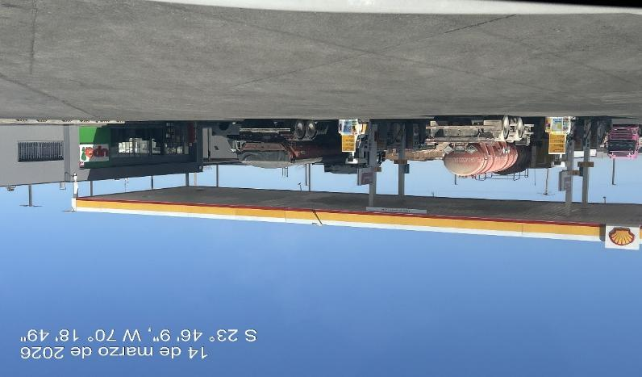
Gas station La Negra Antofagasta

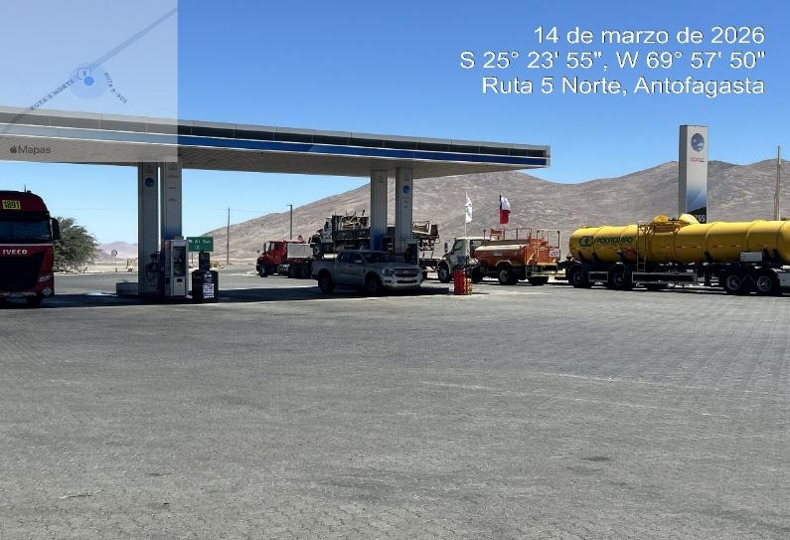
Gas station Agua Verde

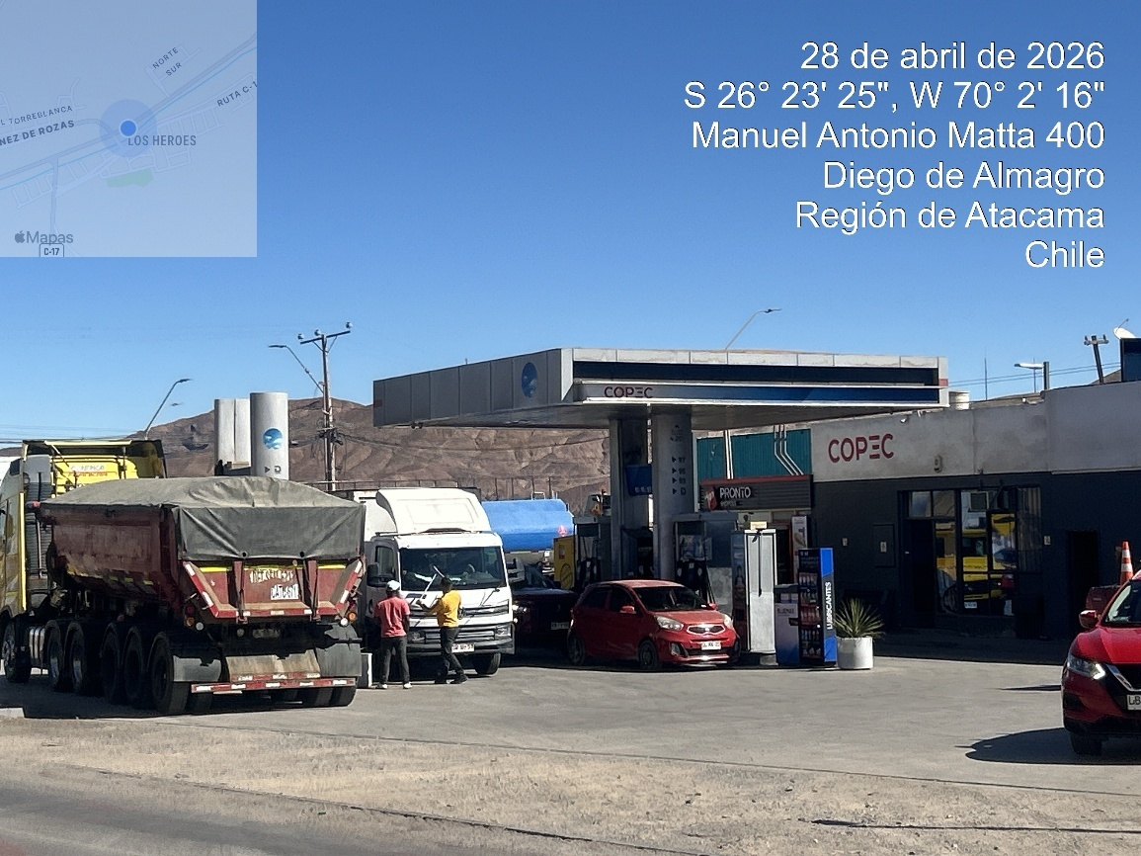
Gas station Diego de Almagro

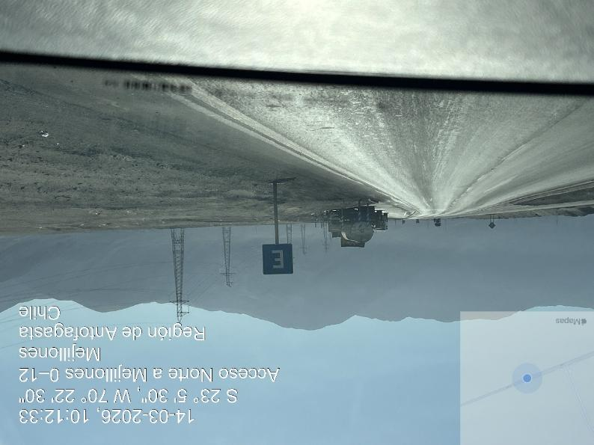
Parking areas into the route nr. 262

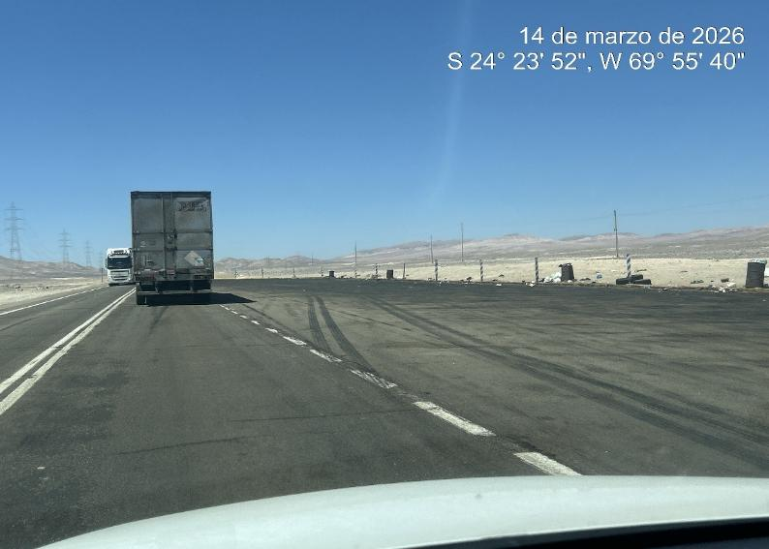
- Parking areas into the route nr. 5

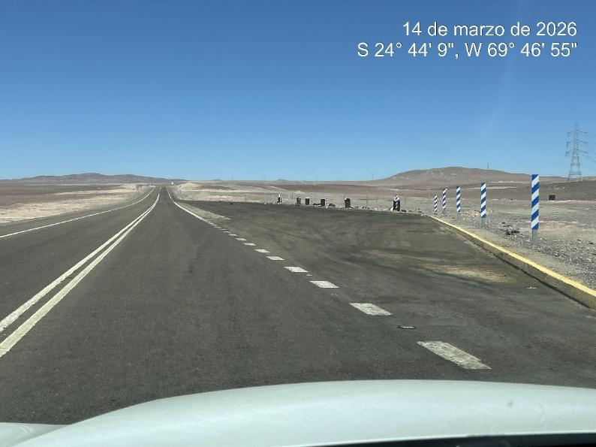
- Parking areas into the route nr. 5
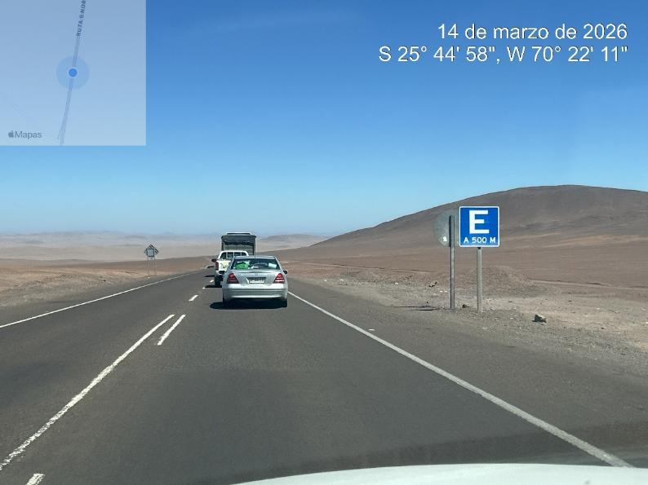
- Parking areas into the route nr. 5
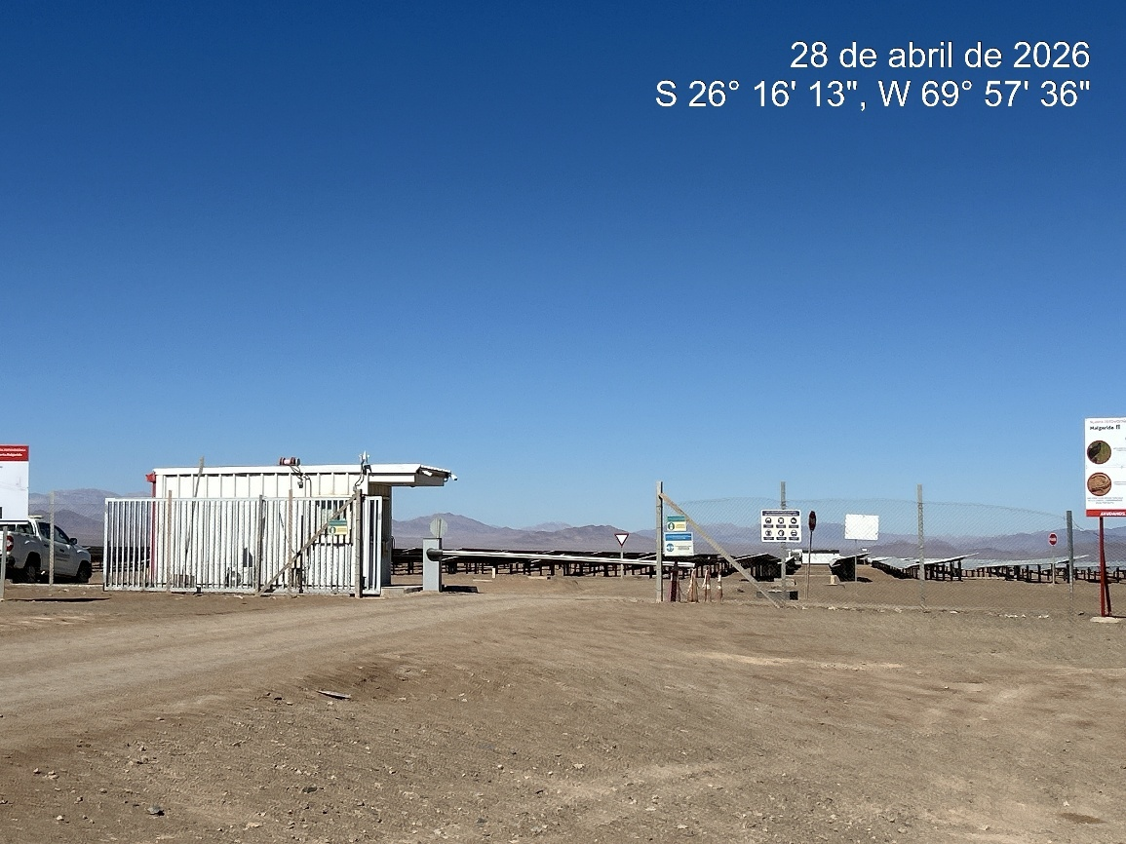
- View of entrance of PFV Malgarida

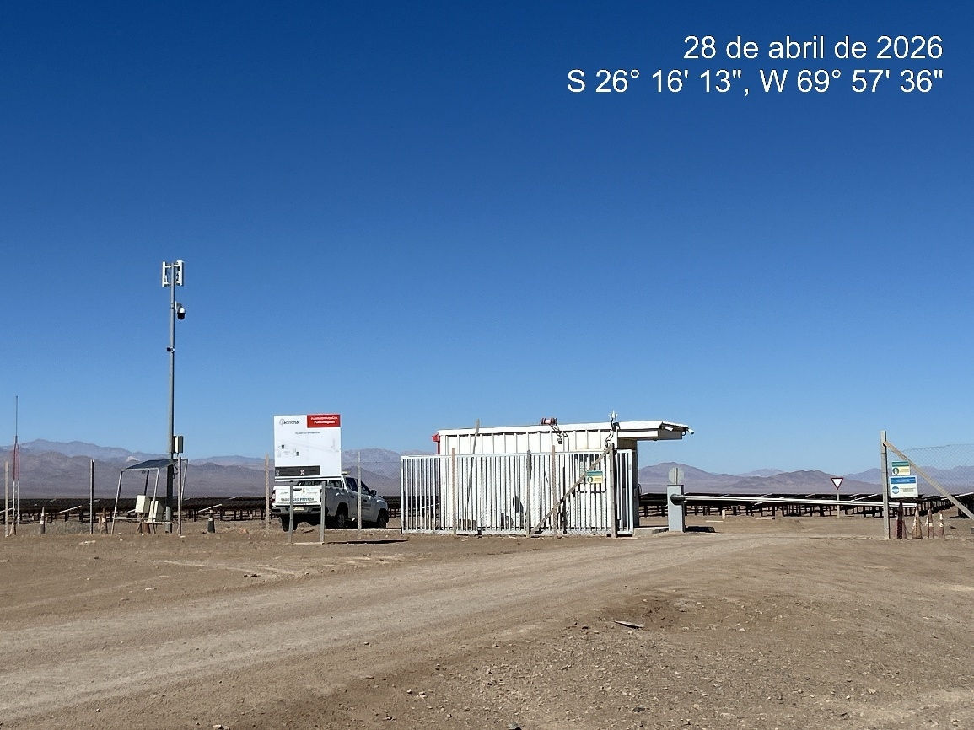
- View of entrance of PFV Malgarida
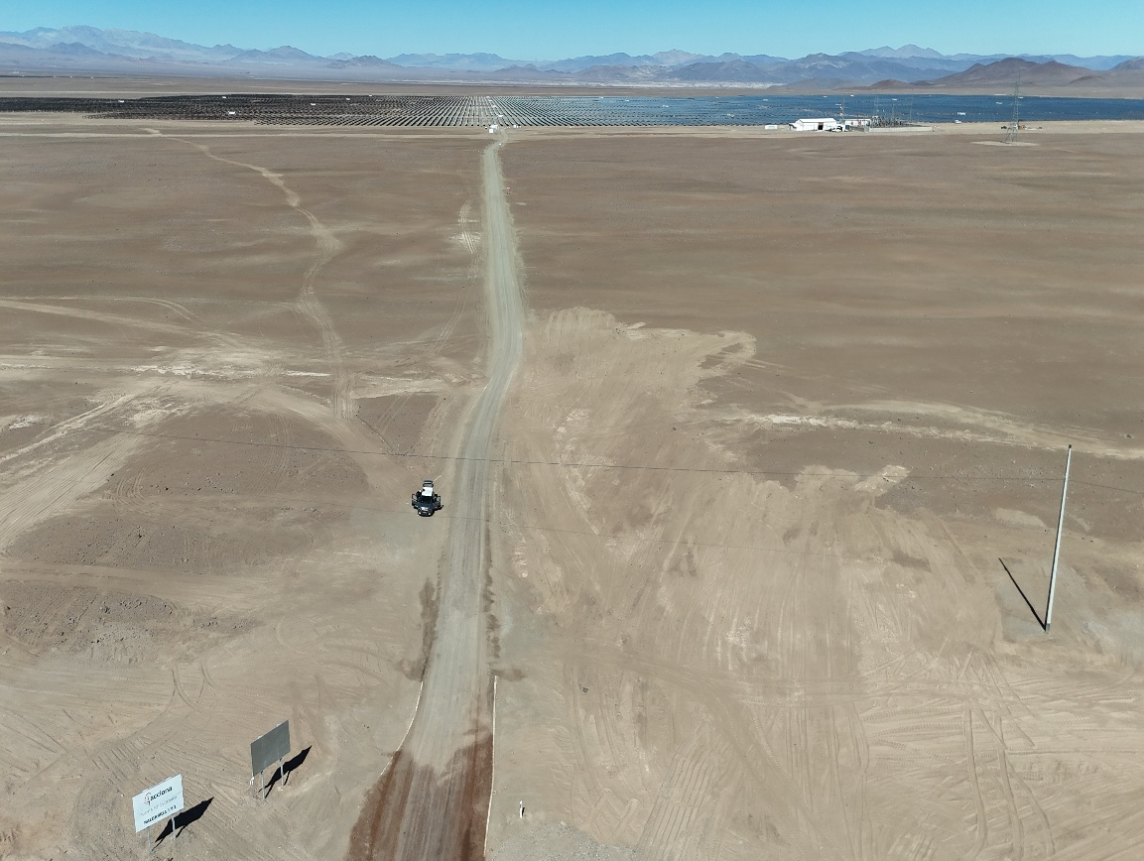
View of final connection to Malgarida Park access.

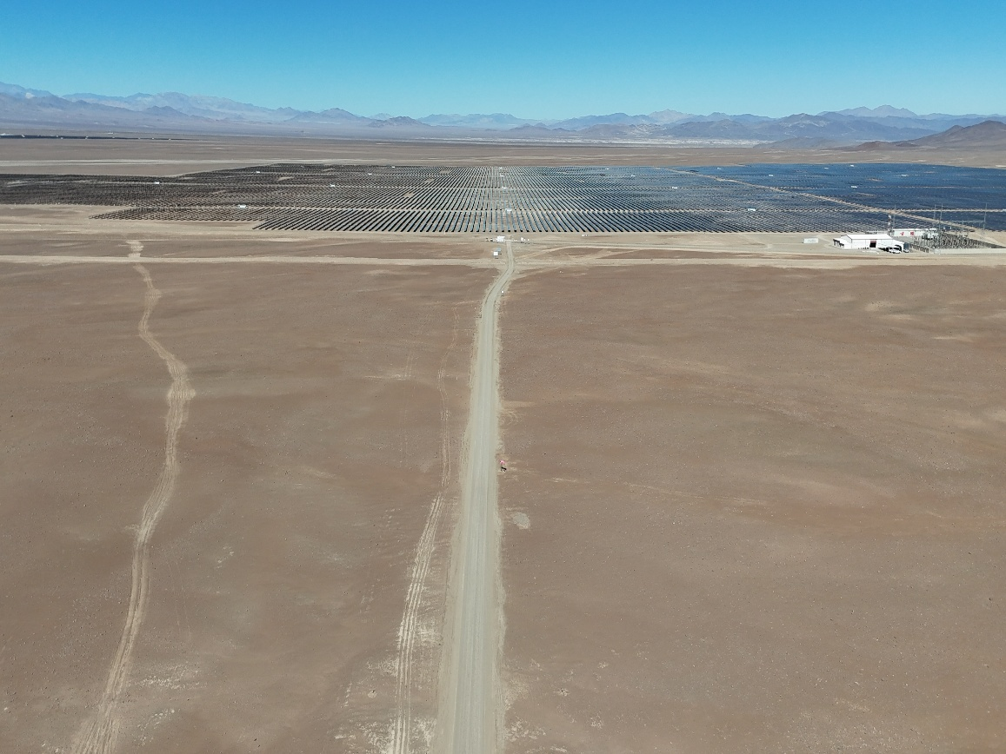
View of final route to Malgarida Park access.

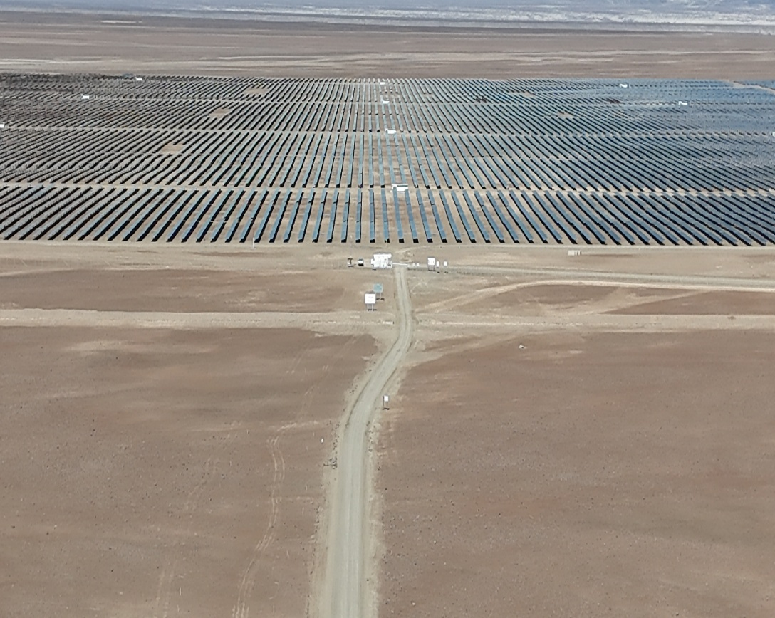
- View of access road to Malgarida park

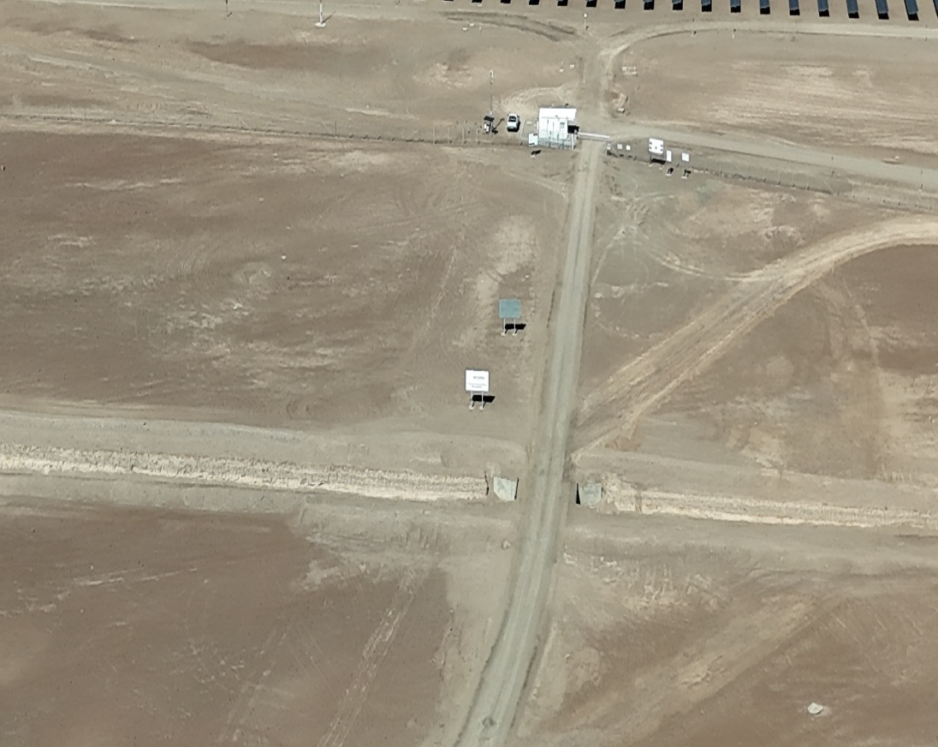
- Another view of access road to Malgarida park
4.12. CURRENT LEGISLATION:

4.13 ROAD PROCEDURES (Ministerio de Obras Públicas de Chile)

The authorization process for road procedures is in charge of “Ministerio de Obras Públicas de Chile”, through the “MANUAL OF AUTHORIZATIONS FOR SPECIAL TRANSPORTATION” of the “Ministerio de Obras Públicas” (M.O.P.), updated on September 21, 2023, and which, in turn, refers to the following regulatory framework:
    - Traffic Law 18.290
    - Law 19.171 de 1992
    - Supreme Decree MOP N° 158 / 1980
    - Supreme Decree MOP N° 19 / 1984
    - Supreme Decree MOP N° 414 / 2015
    - DFL N°1 de 2007 (Article 63)
    - DFL MOP N°850 de 1997
    - Resolution N°1 de 1995 / “Ministerio de Transportes y Telecomunicaciones”
    - Resolution N° 1600 de 2008 / “Contraloría General de la República”
    - Resolution D.V. (affect) N° 60 del 2018
    - Resolution D.V. (exempt) N° 5168 de 2018
    - Resolution D.V. (exempt) N° 2547 de 2020
    - Resolution D.V. (exempt) N°3995 de 2023
    - Resolution C.G.R. N°7 de 2019
    - Resolution C.G.R. N°14 de 2022

In accordance with the above, any truck, that meets at least one of the following conditions, must apply to the M.O.P. for a special authorization to travel with oversize cargo:
    - Total length bigger than 18.60 mts
    - Total width bigger than 2.60 mts
    - Total high bigger than 4.20 mts

Additionally, any truck exceeding 45 tons of Total Gross Weight must request to M.O.P. a special authorization for travelling with overweight cargo; M.O.P. may request complementary “Route Studies”, elaborated by engineers specialized in Road Safety, for those special transport requests that present the following minimum conditions:

    - Length equal to or bigger than 36 mts
    - Width bigger than 4,5 mts
    - High equal to or bigger than 5,5 mts
    - Total gross weight (TGW) equal to or bigger than 100 tons

Considering that the cargo to be transported comply with the established width, height and length indicated by the law, the information is only as reference.

5.- EVALUATION OF THE ROUTE.

The following route is considered from Mejillones Port to Final destination; all routes were found in good condition and available for the transit of truck with cargo

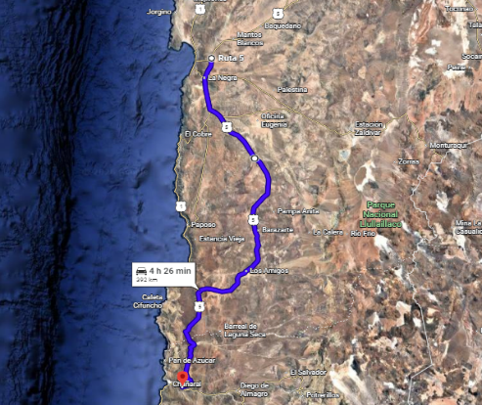
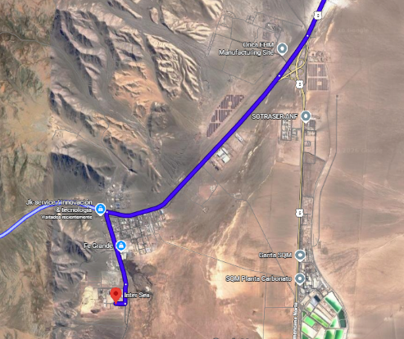
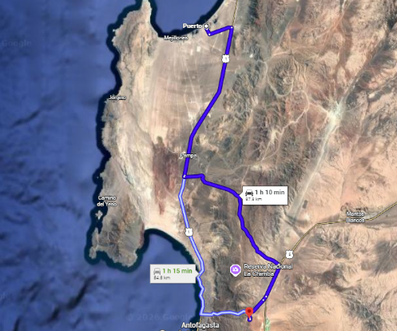
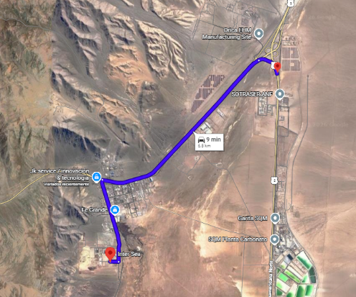

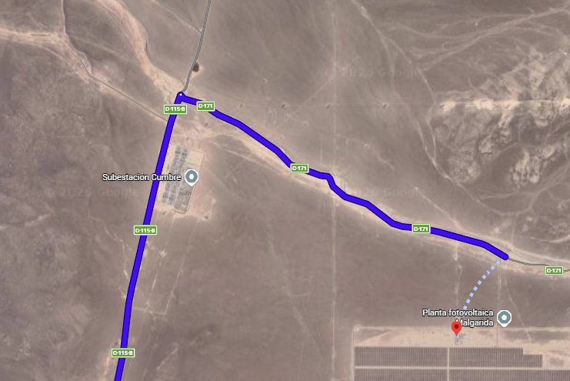
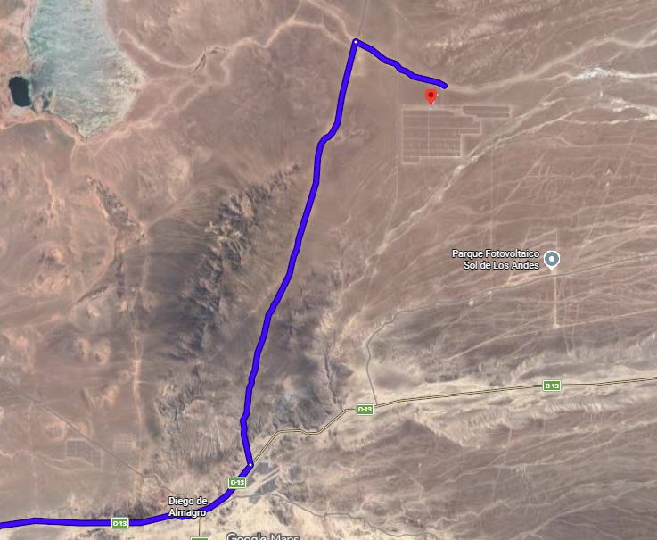
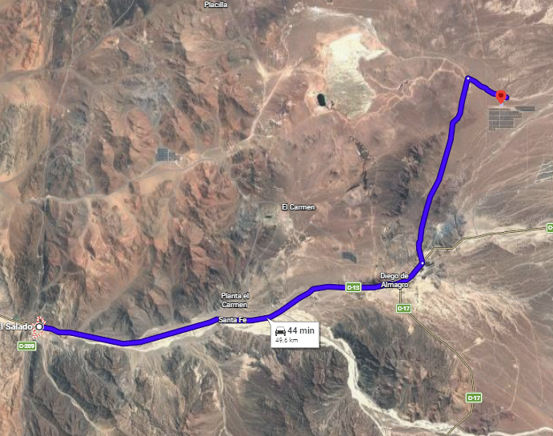
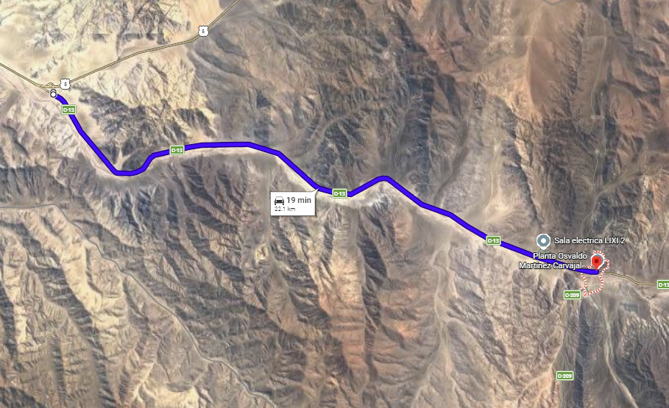

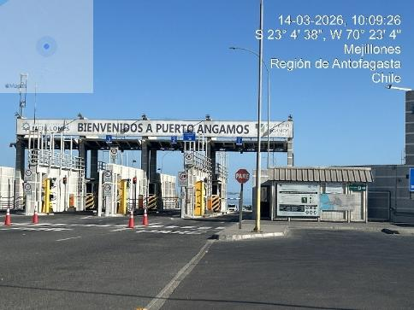 | 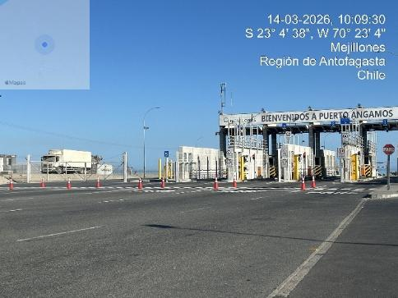
- Exit of Angamos port | - Exit of Port Angamos

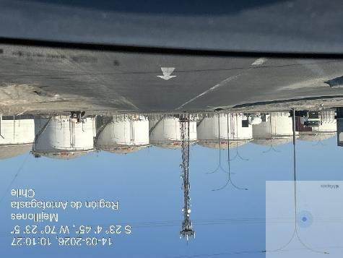 | 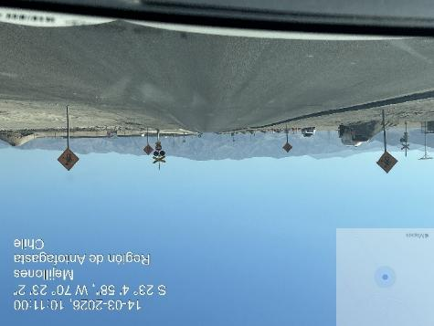
- Transit to Route B 262 | - Transit to Route B 262

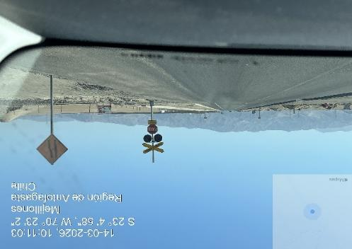 | 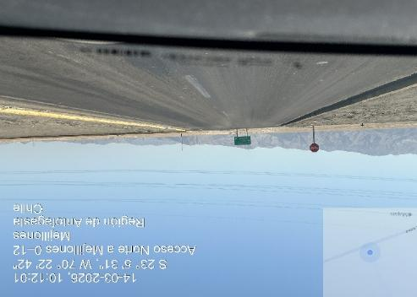
- Railing cross in route B 262 | - Access to route 262

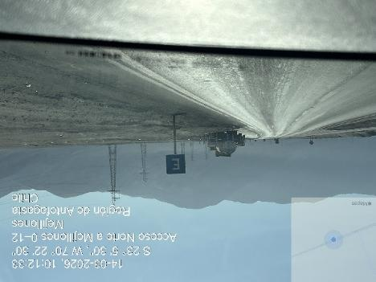 | 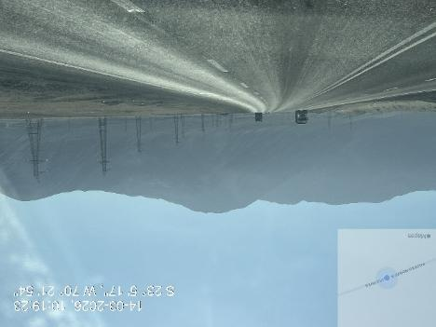
- Route 262 conditions | - Route 262 conditions

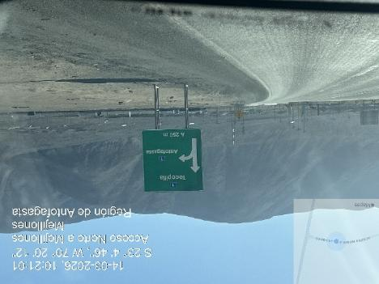 | 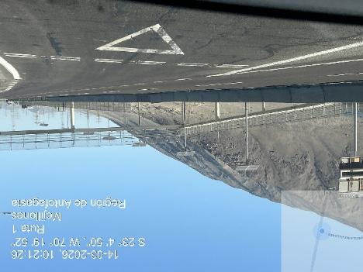
- Connection to Route 1 from route 262 | - Route 1 conditions

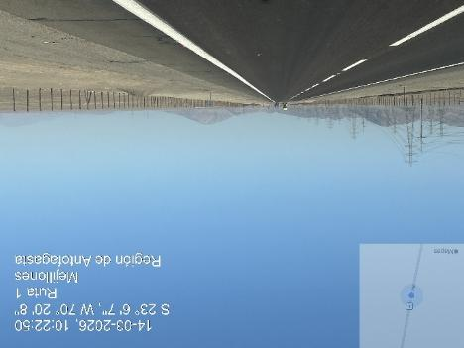 | 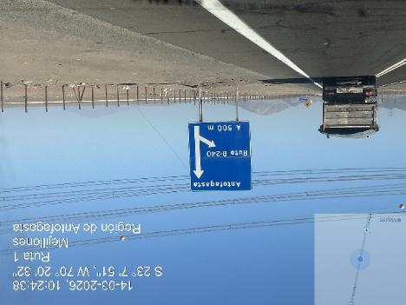
- Route 1 conditions | - Route 1 signals on road

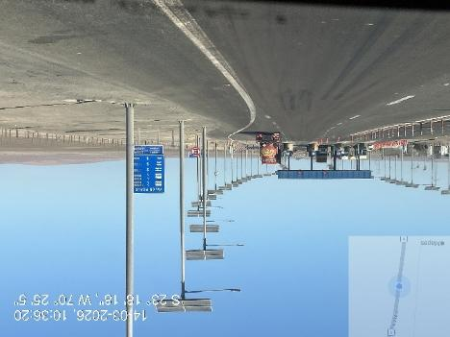 | 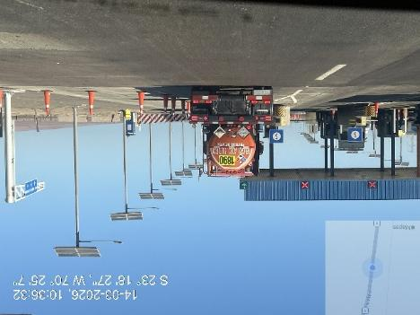
- Route 1 toll area | - Oversize transit in toll area

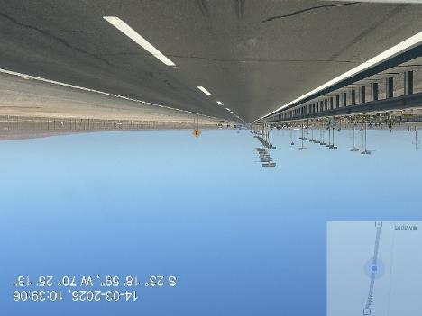 | 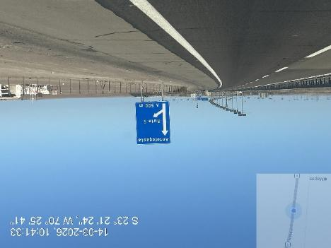
- Conditions of route 1 | - Another view conditions of route 1

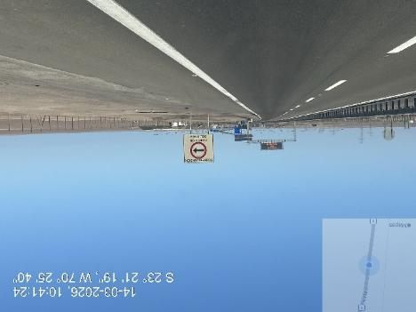 | 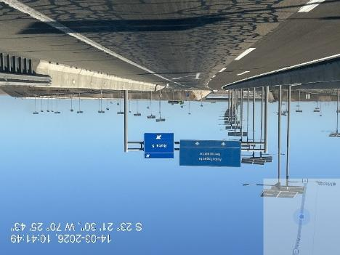
- Conditions of route 1 | - View of connection to B400

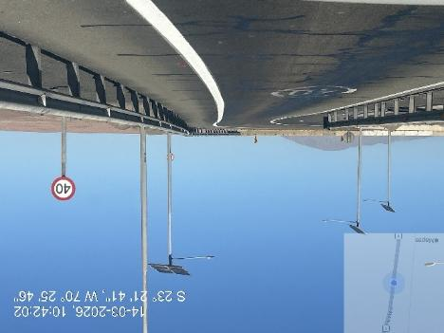 | 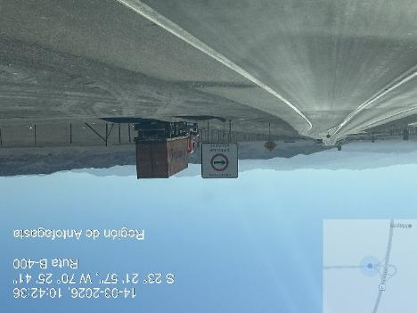
- View of connection to B400 | - View of condition of route B-400

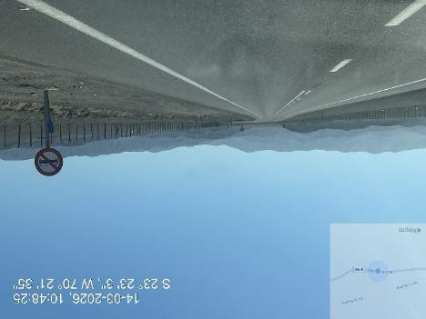 | 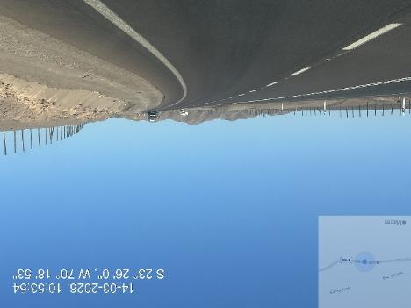
- View of conditions of route B-400 | - View of conditions of route B-400

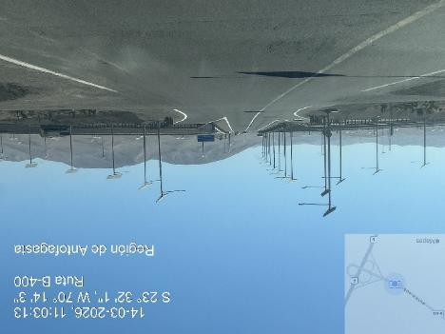 | 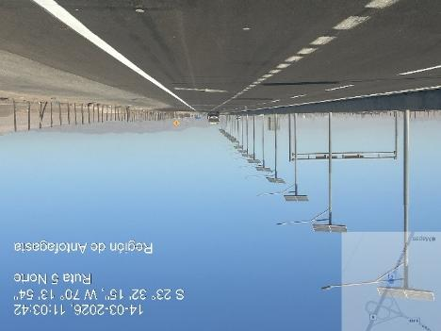
- View of connection from B-400 to national route Nr.5 | - View of access to national route nr. 5

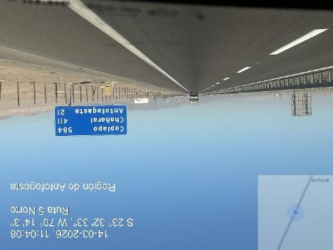 | 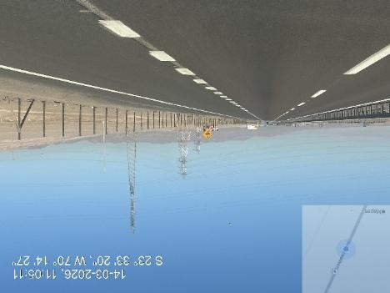
- View of condition of route Nr. 5 | - View of condition of route Nr. 5

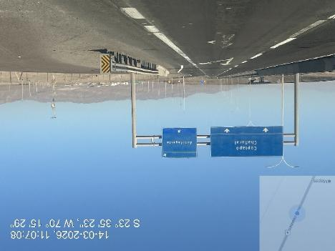 | 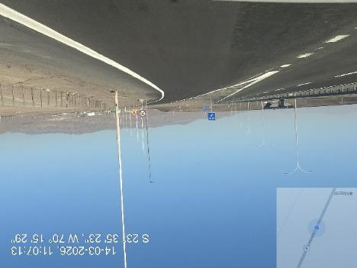
- View of connection from route 5 to Route 26 | - View of route 26 access

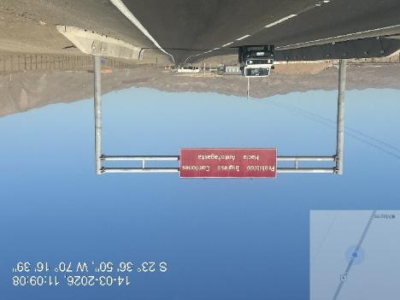 | 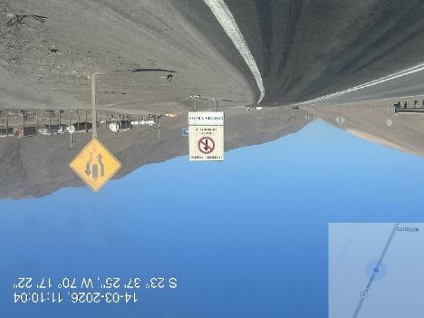
- Signal in the road 26 | - View of condition of route 26

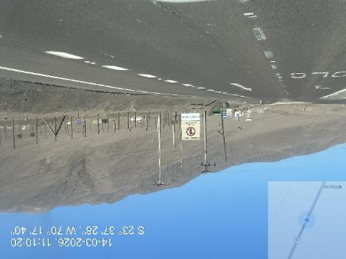 | 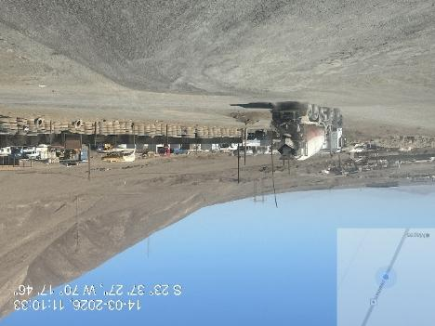
- Route 26 deviations to industrial zone no name route | - View of desviation

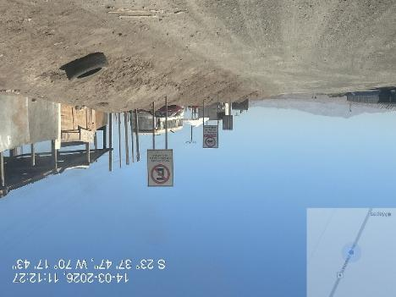 | 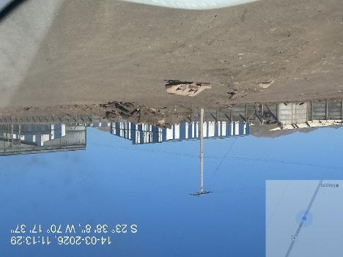
- Dirty road las 2 Kms | - Another view of road

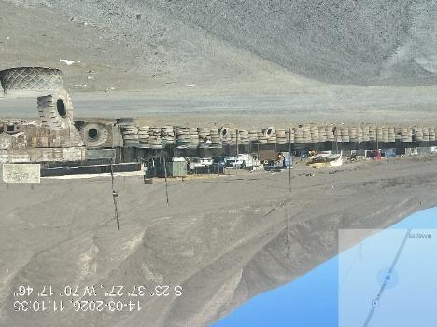 | 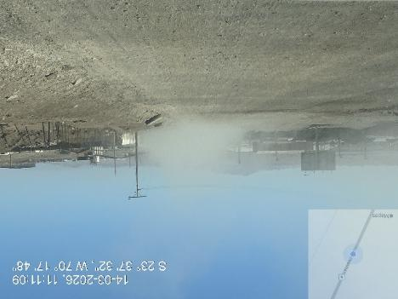
- View of dirty road | - Another view of final 2 kms

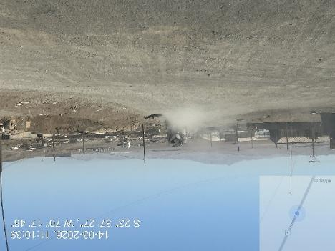 | 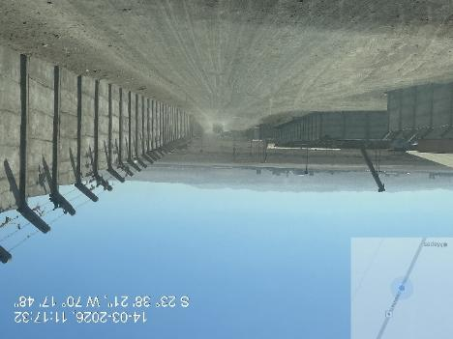
- Route without signal | - View of route transit by truck

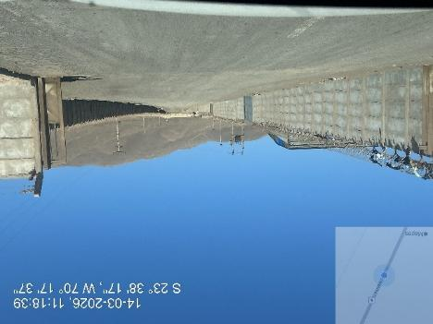 | 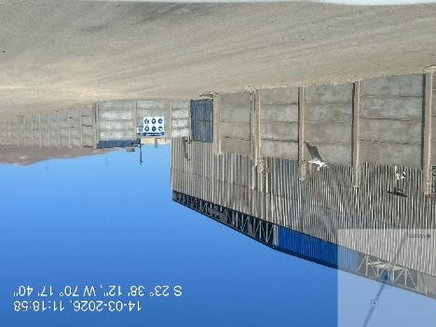
- View of route las 2 kms | - View of final access

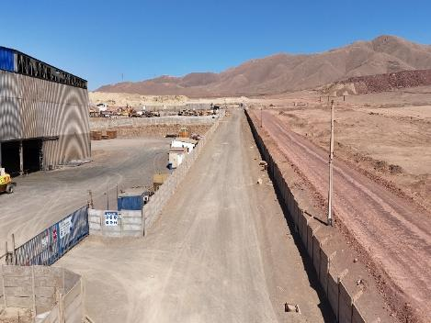 | 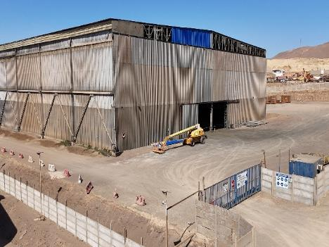
- View of final destination | - View of Intersea gathered place

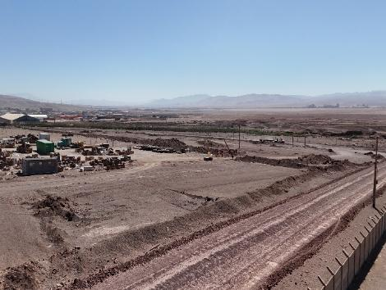 | 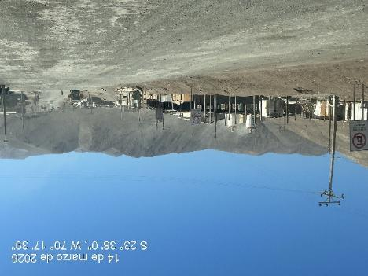
- View of route las 2 kms from Intersea to Route 26 | - View of road from intersea to route 26

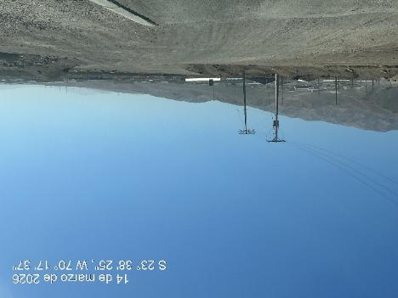 | 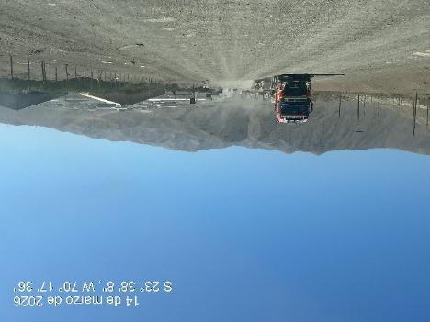
- Route without signal | - View of dirty road

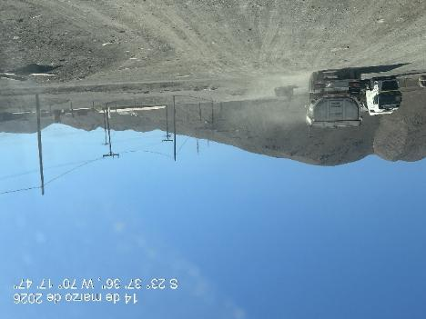 | 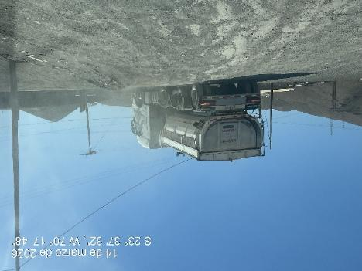
- View of road conditions | - View of connection to B-26 route

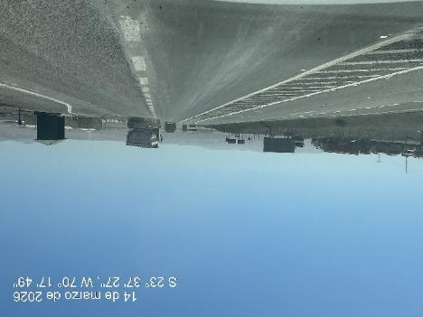 | 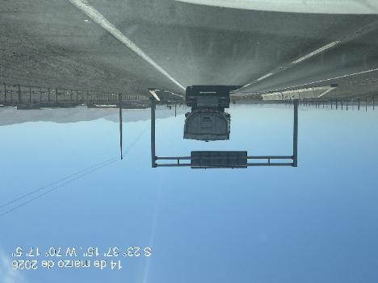
- View of route 26 conditions | - View of route 26 conditions

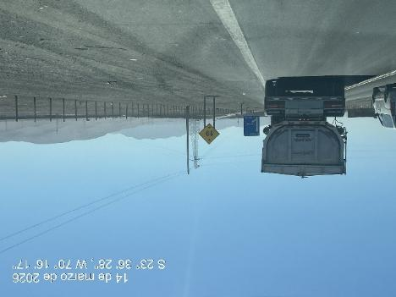 | 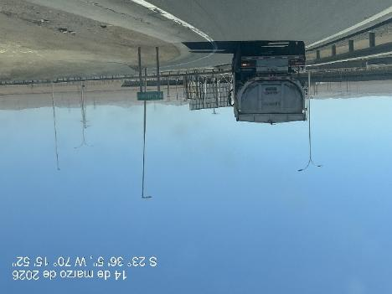
- Signal in the road 26 | - View of condition of route 26 connection to Route nr. 5

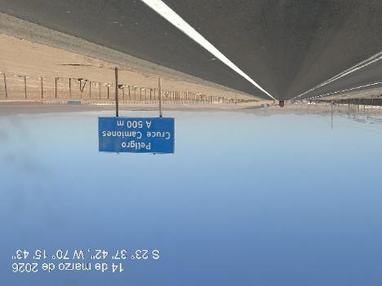 | 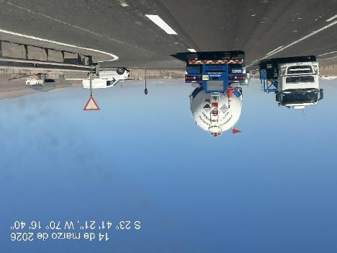
- View of road nr. 5 | - View of condition of Route nr. 5

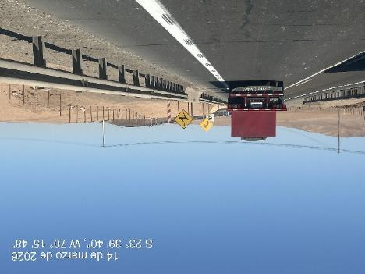 | 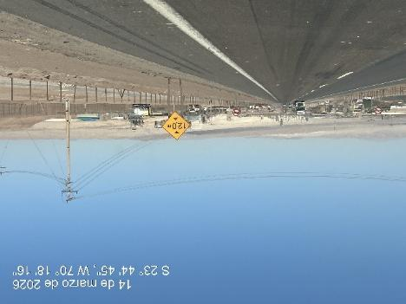
- View of road nr. 5 | - View of condition of Route nr. 5

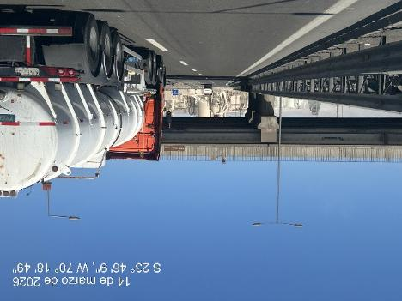 | 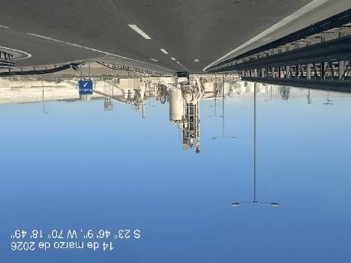
- Bridge of La Negra | - View of condition of route Nr. 5, industrial area La Negra Antofagasta

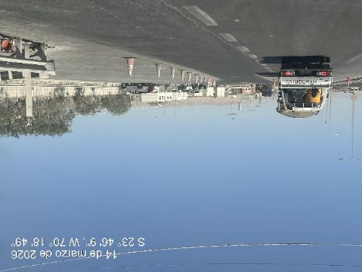 | 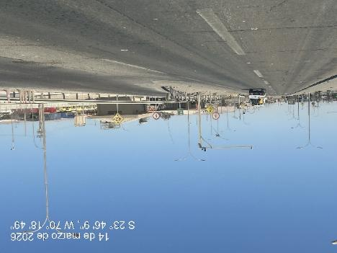
- Route nr. 5 police control La negra | - View of condition of route nr. 5

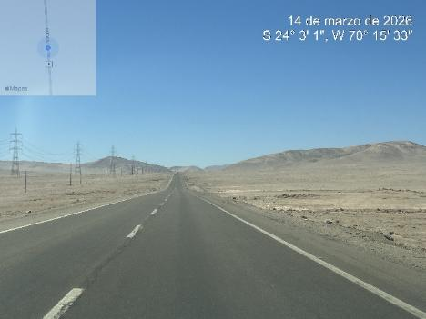 | 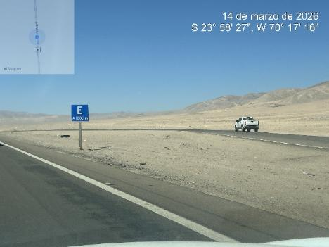
- Route nr. 5 bidirectional | - View of parking area into the route

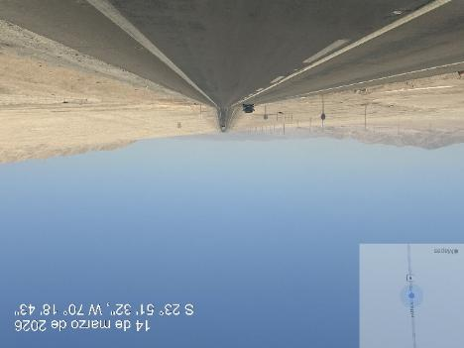 | 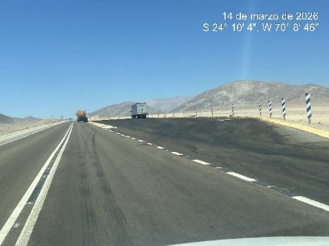
- Route nr. 5 bidirectional route | - View of route nr. 5 parking areas

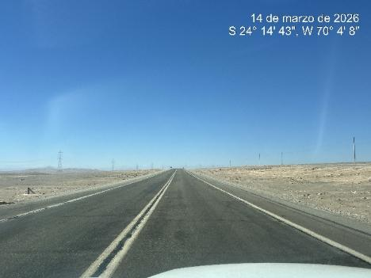 | 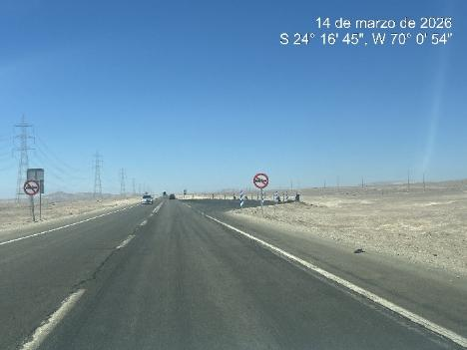
- Route nr. 5 bidirectional | - View of route nr. 5 parking areas

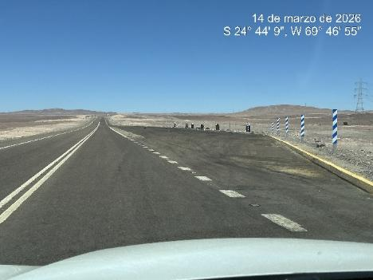 | 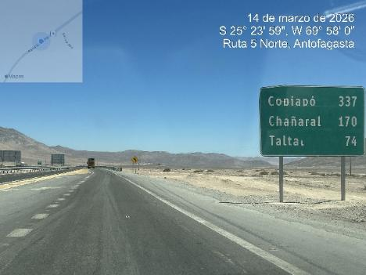
- View of route nr. 5 parking areas | - View of route nr. 5 duly signed

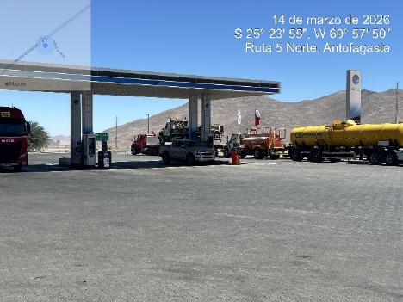 | 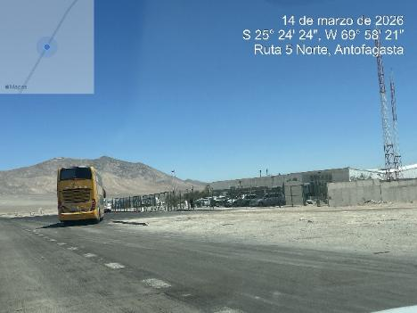
- View of gas station Aguas Verdes | - View of route nr. 5 Police control Aguas Verdes

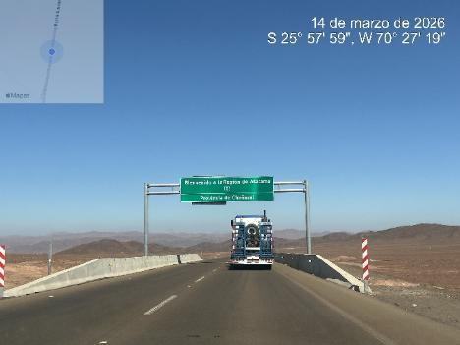 | 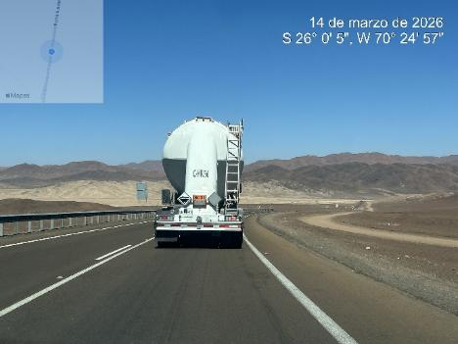
- View of route nr. 5 duly signed distance of cities | - View of route nr. 5 conditions

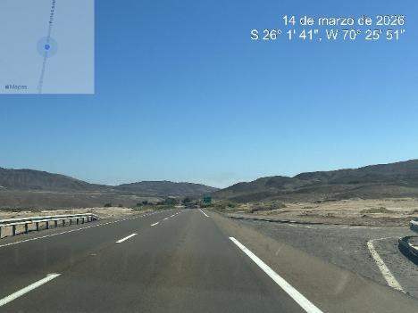 | 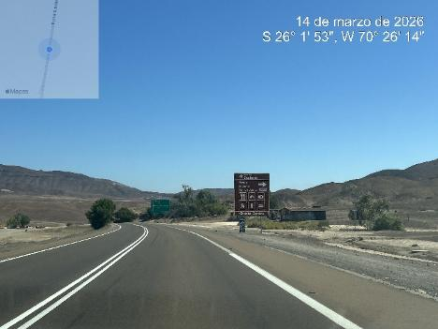
- View of route nr. 5, conditions | - View of route nr. 5 conditions parking areas

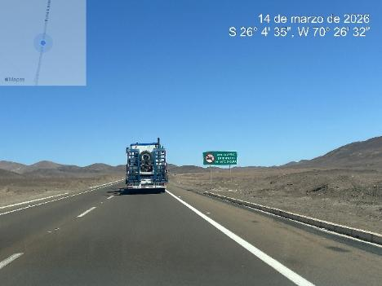 | 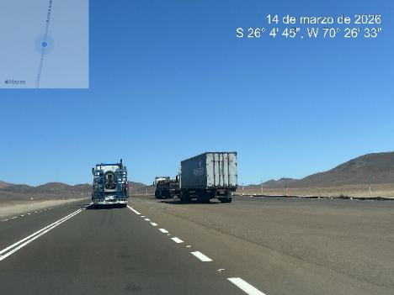
- View of route nr. 5 duly marked | - View of route nr. 5 conditions parking area

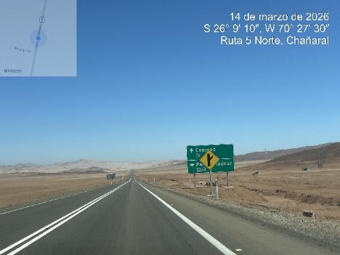 | 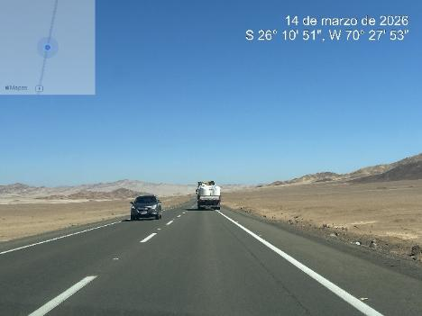
- View of route nr. 5 duly marked | - View of route nr. 5 transit for transport and trucks

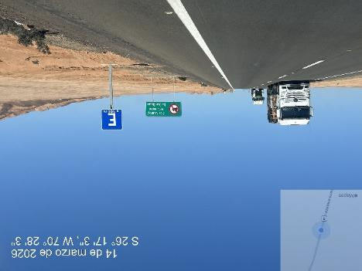 | 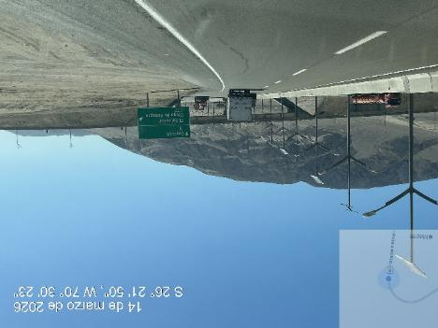
- View of route nr. 5 duly marked | - View of connection to Route C-13 to Diego de Almagro

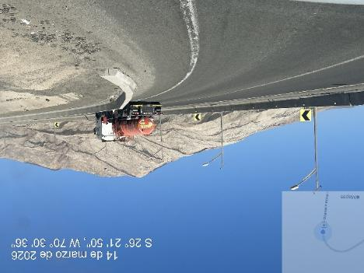 | 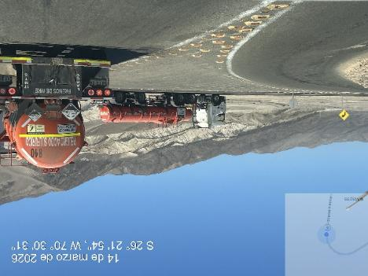
- Transit to C-13 | - View of connection to Route C-13 to Diego de Almagro

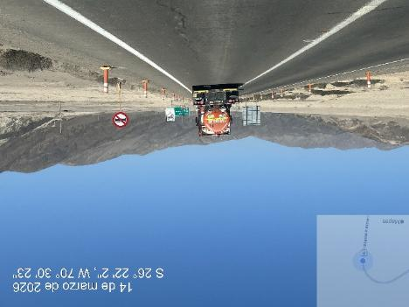 | 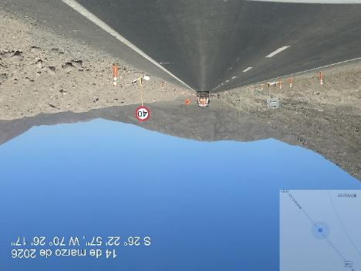
- Route C-13 conditions | - View of route conditions C-13

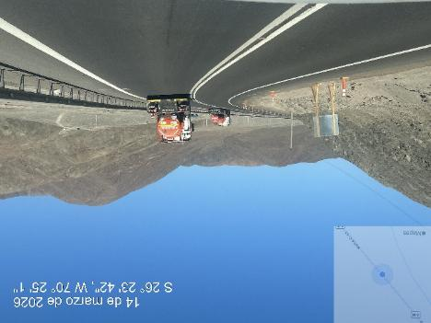 | 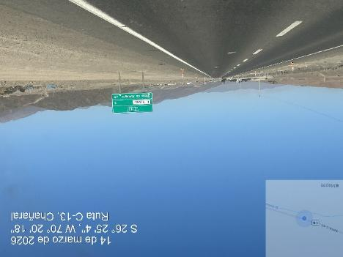
- View of route C-13 using by trucks | - Route C-13 conditions to Diego de Almagro

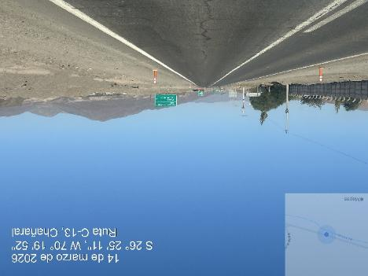 | 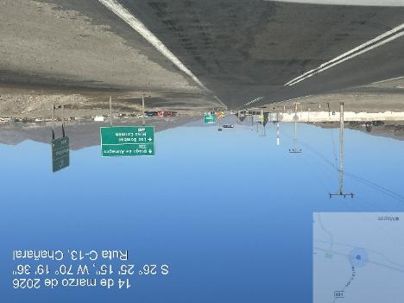
- Route C-13 conditions to Diego de Almagro | - View of conditions of route C-13

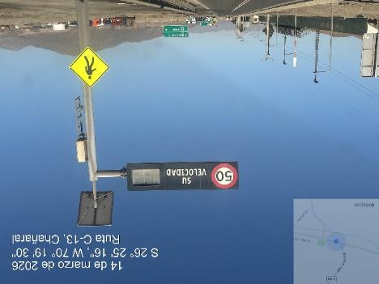 | 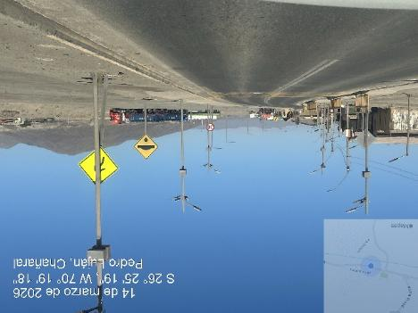
- Route C-13 entrance to El Salado | - View of El Salado Street

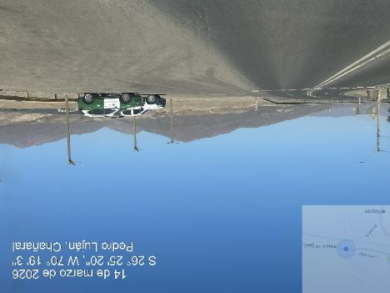 | 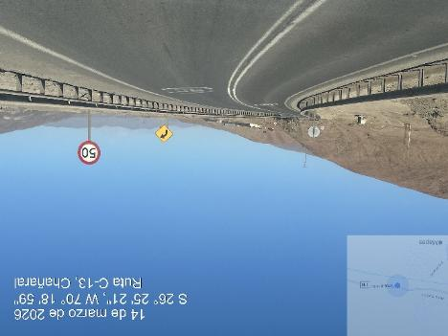
- Police control in El Salado urban area | - Route C-13 conditions for transit exit of El Salado

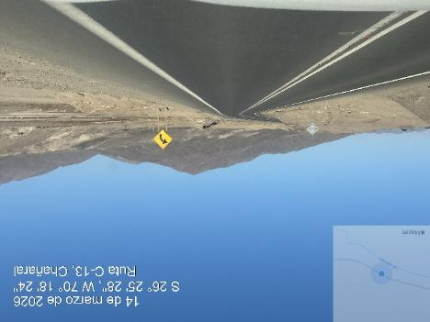 | 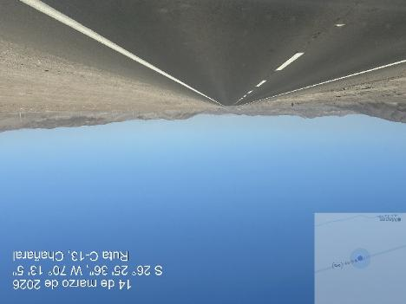
- Route from C-13 to Diego de Almagro | - View of C-13 route

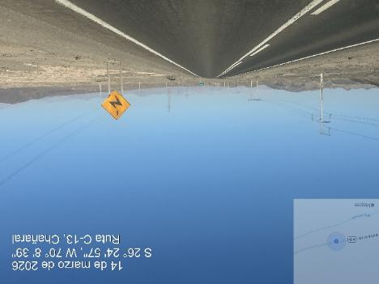 | 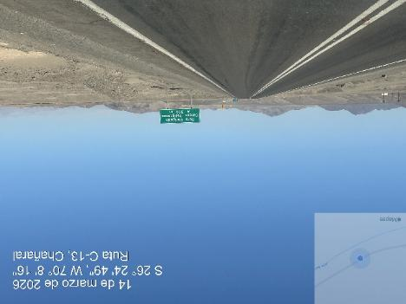
- Route C-13 high voltage cables over 9 meters | - C-13 route conditions

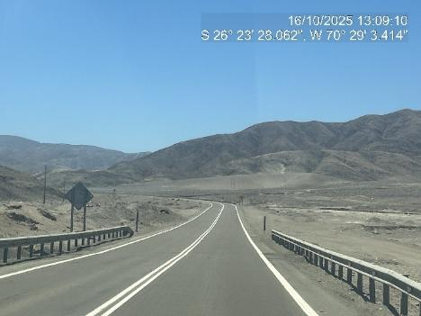 | 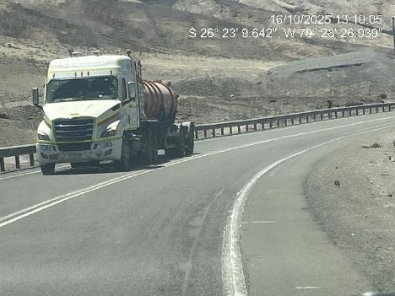
- Route C-13 conditions to Diego de Almagro | - View of route C-13 using by trucks

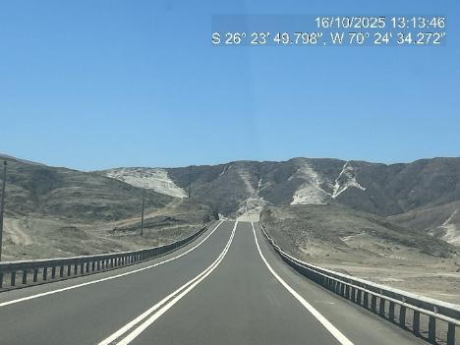 | 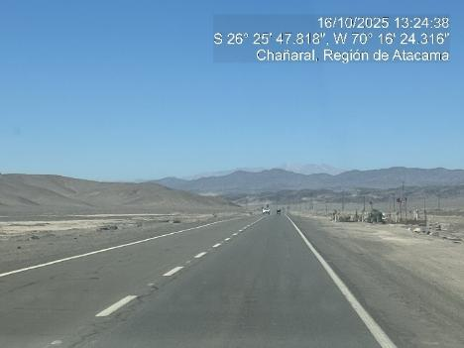
- Route C-13 conditions to Diego de Almagro | - View of conditions of route C-13

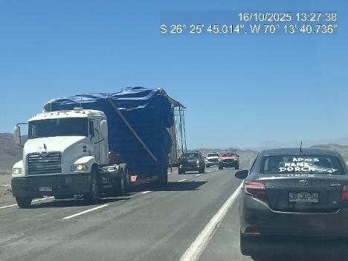 | 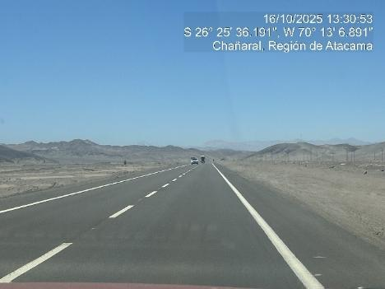
- Route C-13 used by oversize cargo | - View of conditions of route C-13

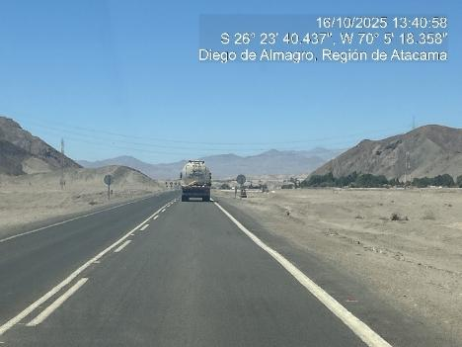 | 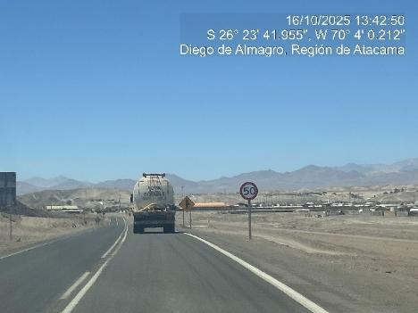
- Route C-13 conditions for transit | - View of max speed urban area Diego de Almagro

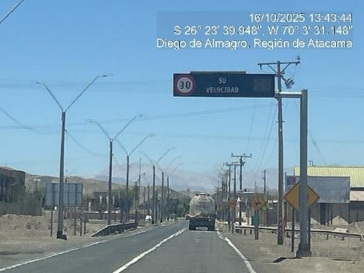 | 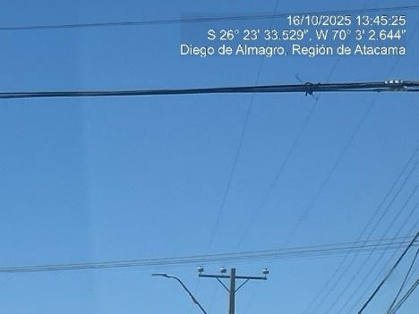
- Entrance to Diego de Almagro speed control max speed 30 Km/H | - View of electrical cables over 5 meters

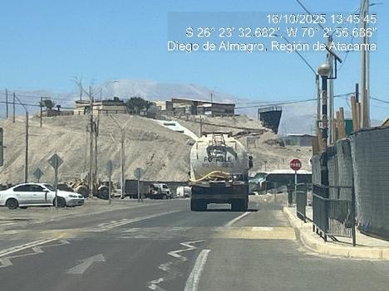 | 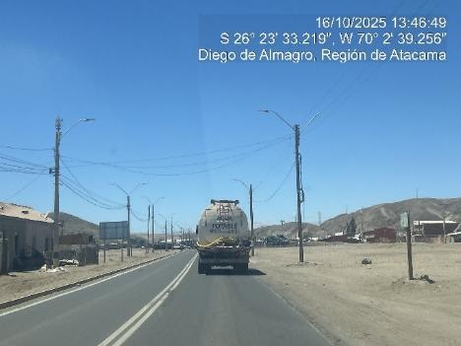
- Route C-13 passing trought Diego de Almagro city | - Finish urban area

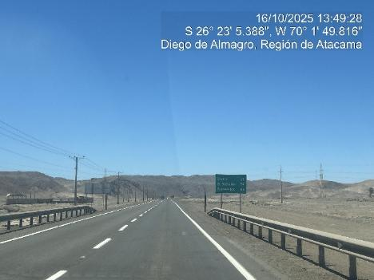 | 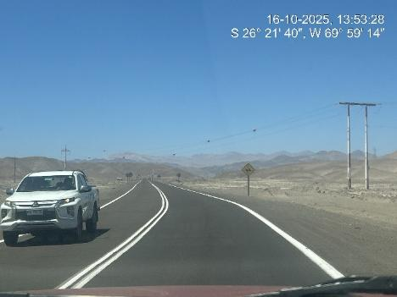
- Route C-13 conditions | - View of route conditions C-13

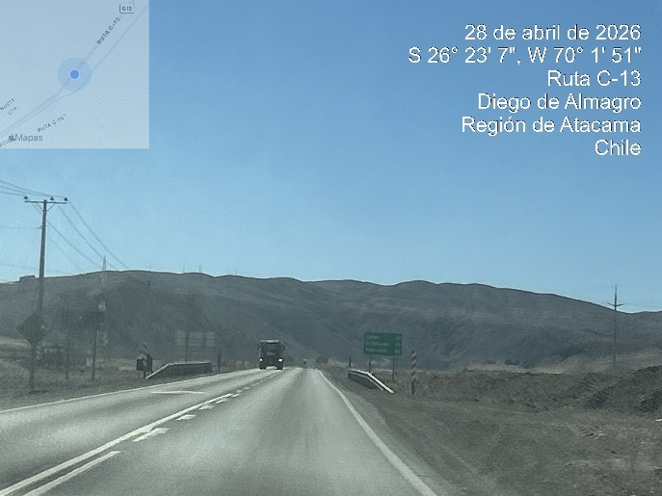 | 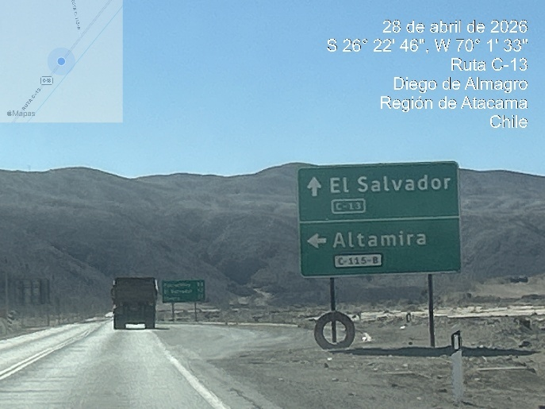
- Route C-13 conditions | - View of route conditions C-13, connection Altamira to Route C-115-B

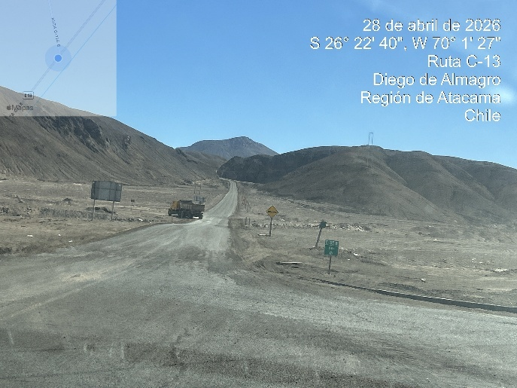 | 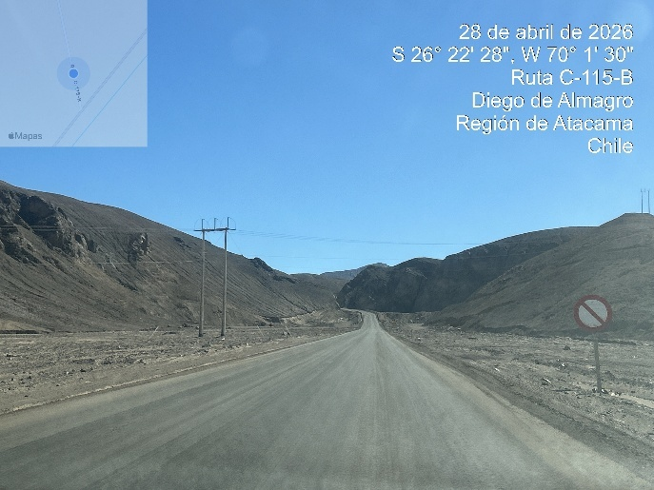
- Route C-115-B access | - View of route conditions C-115-B

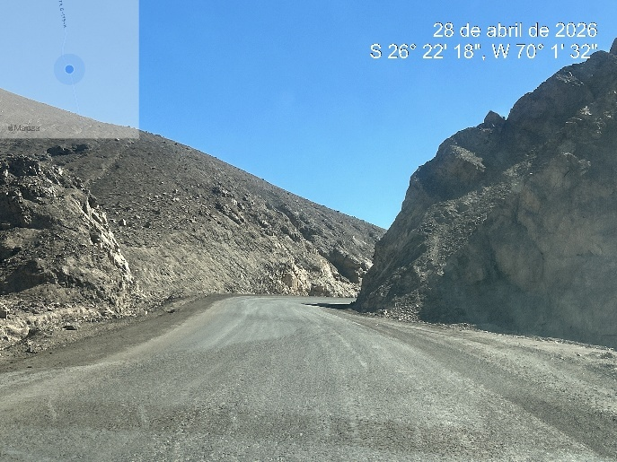 | 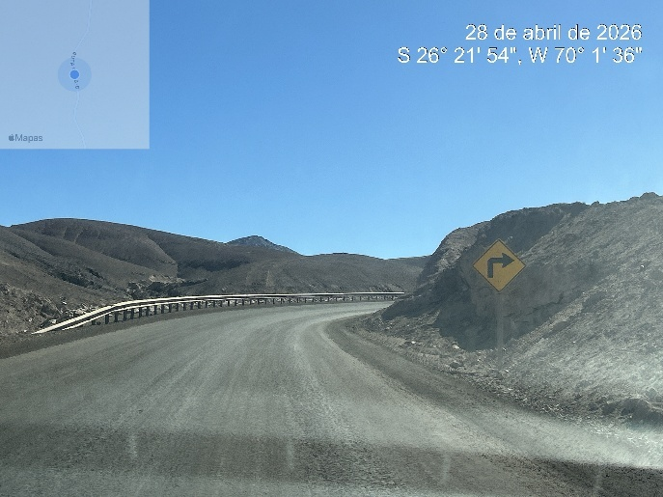
- Route C-115-B conditions | - View of route conditions C-115-B signal

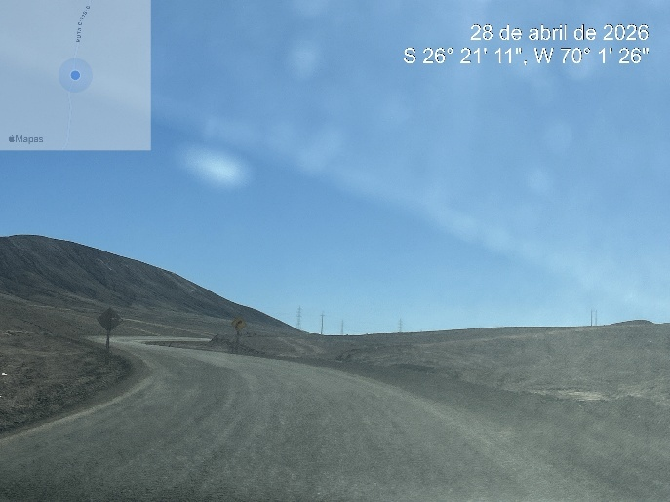 | 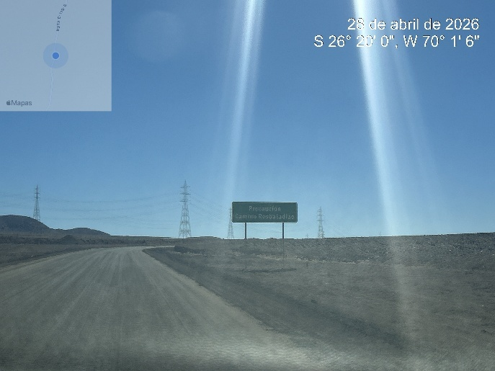
- Route C-115-B route conditions | - View of route conditions C-115-B, high tension cables

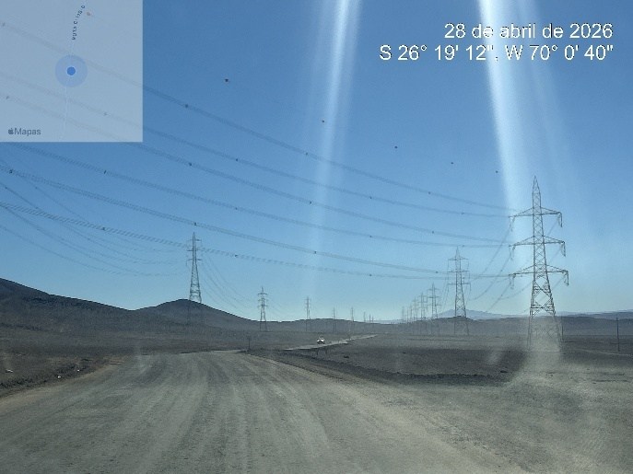 | 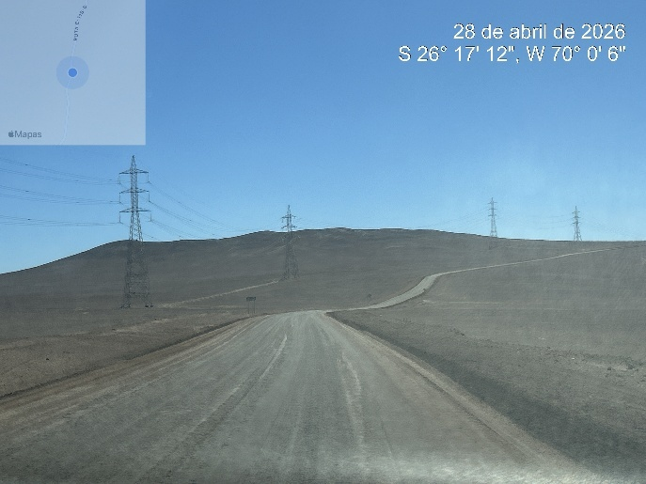
- Route C-115-B conditions, high voltages cables | - View of route conditions C-115-B curves on road

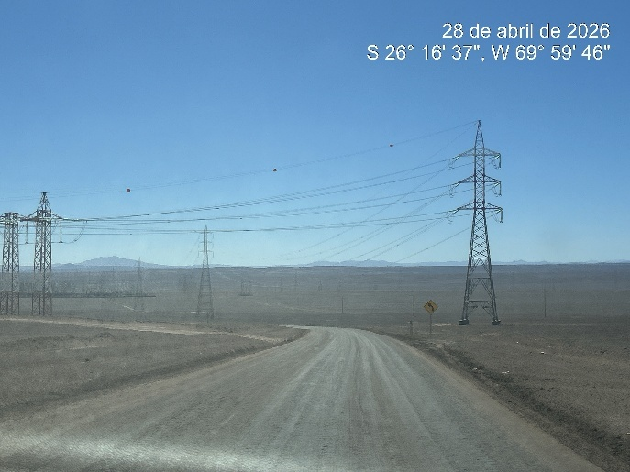 | 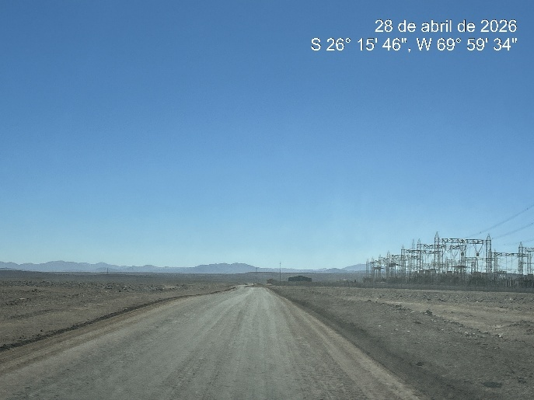
- View of route conditions C-115-B, high tension cables | - Route C-115-B route conditions

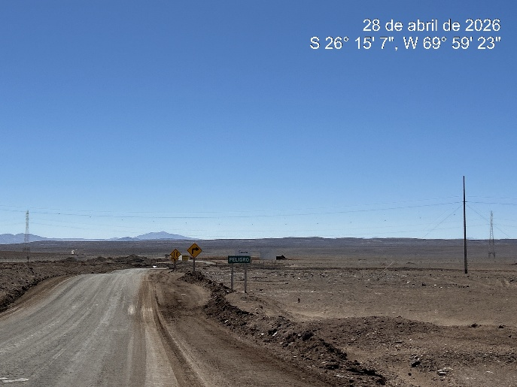 | 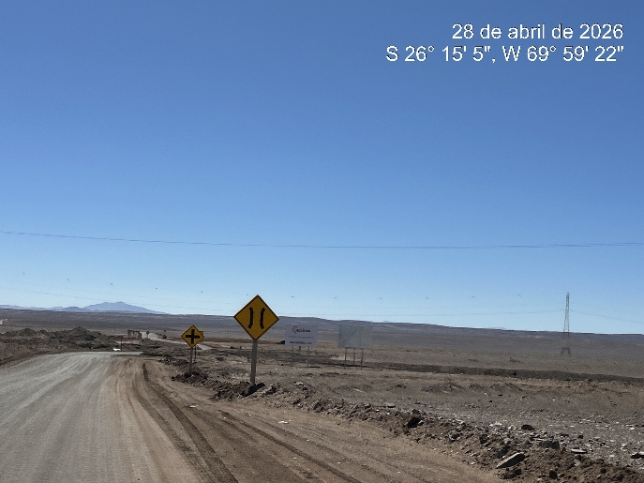
- Route C-115-B conditions, connection to C-171 route | - Route C-115-B conditions, near to connection to C-171 route

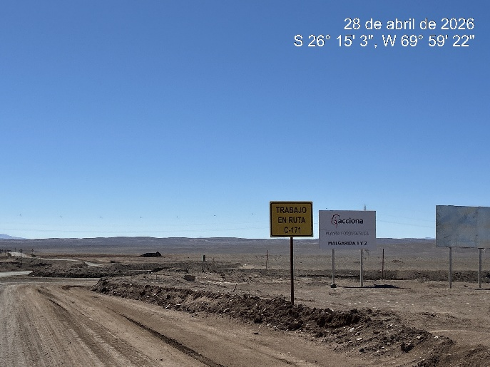 | 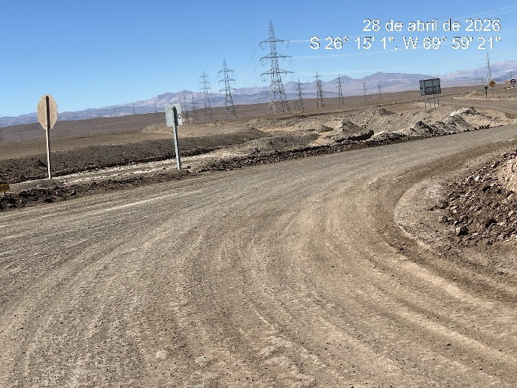
- View of connection to C-171 | - Route C-171 route conditions

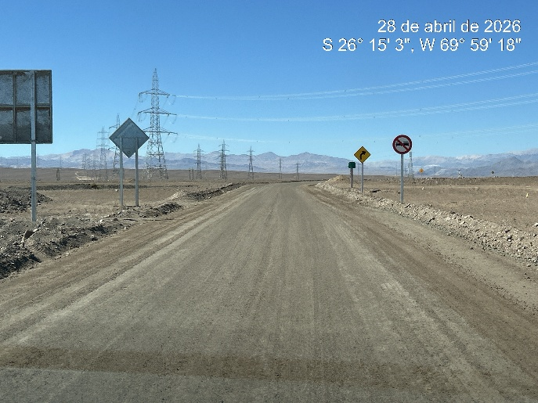 | 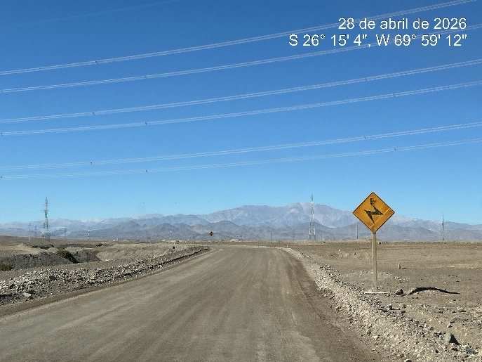
- View of road conditions | - View of connection to C-171 with high tension cables

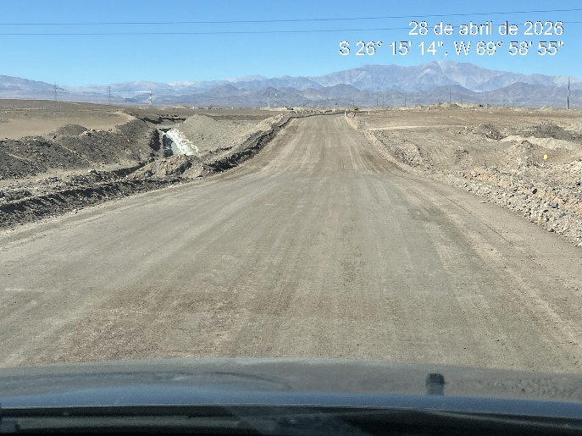 | 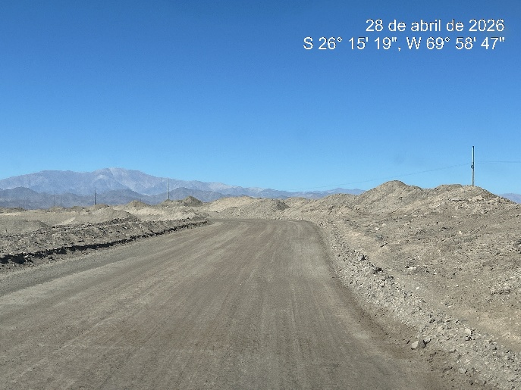
- View of conditions of road C-171 | - Route C-171 route conditions

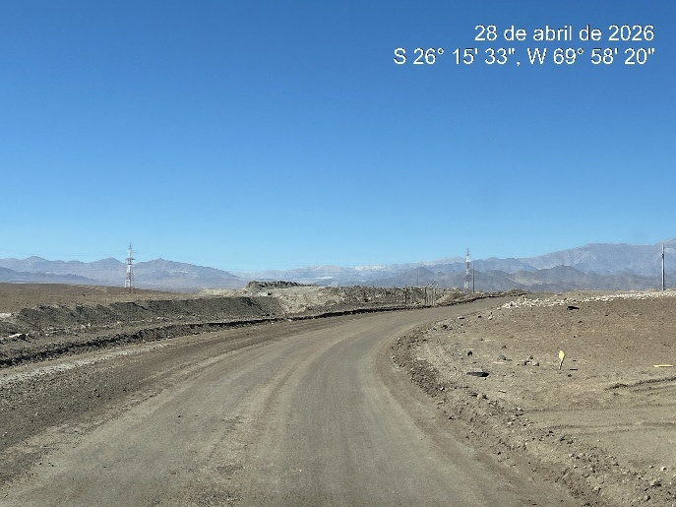 | 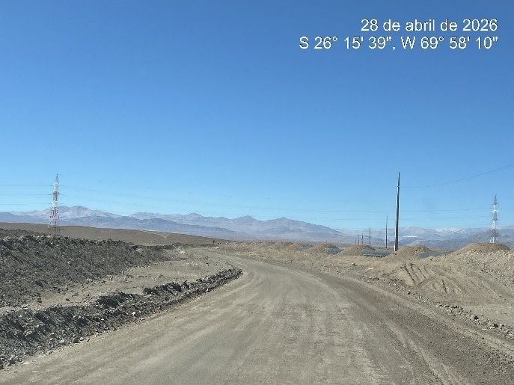
- View of road conditions | - C-171 road conditions

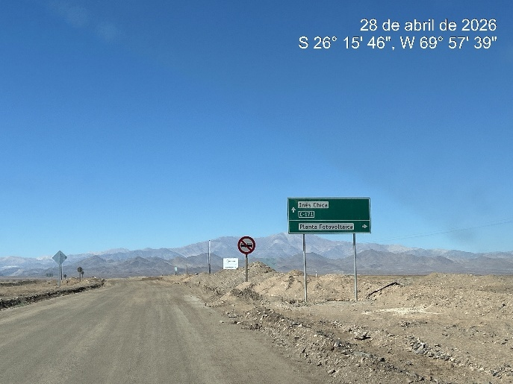 | 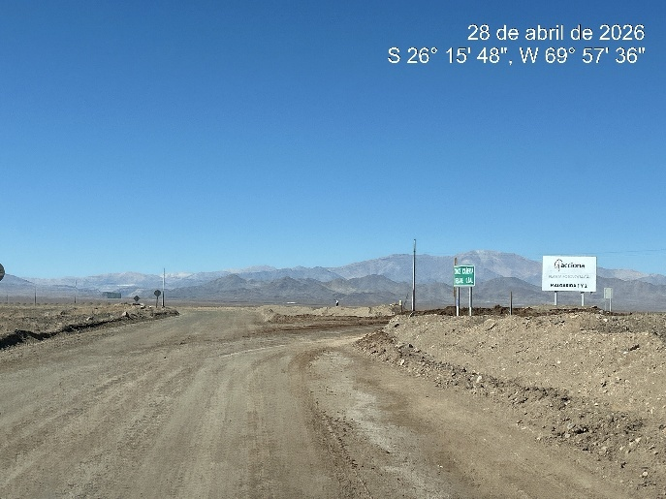
- View of conditions of road C-171 | - Route C-171 route conditions access to final destinations

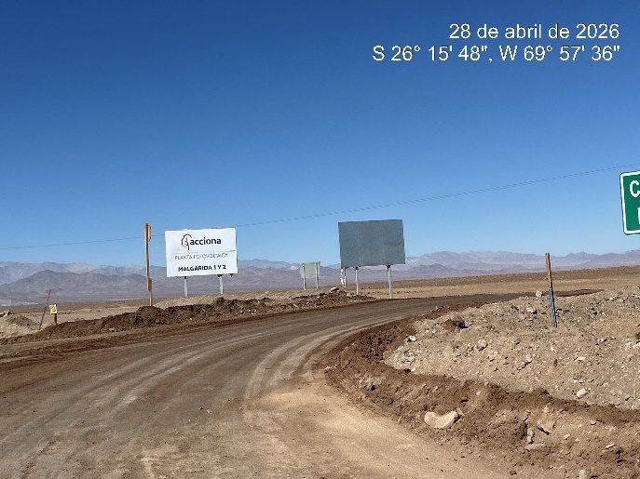 | 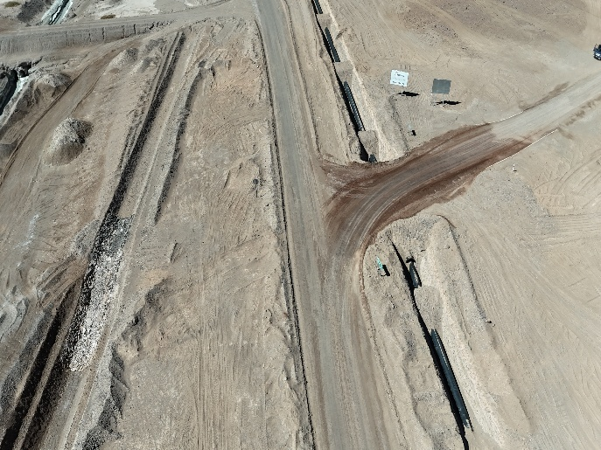
- View of access to final road to access PFV Malgarida | - Another view of the same

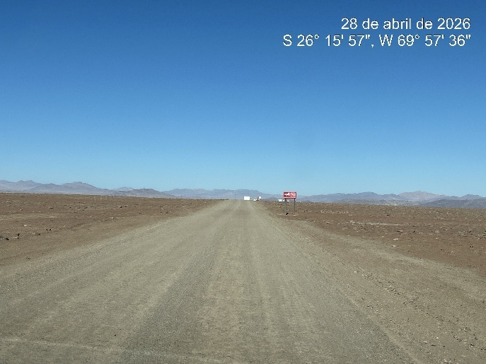 | 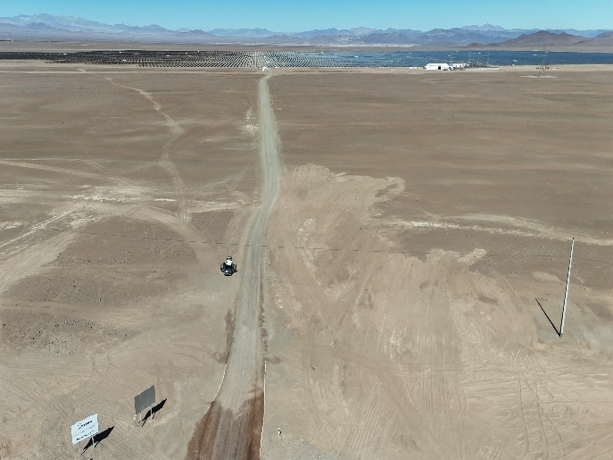
- View of road to access at Malgarida PFV | - Another view of the same

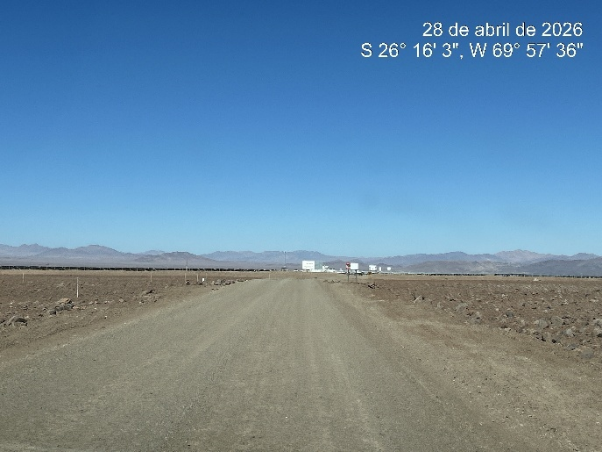 | 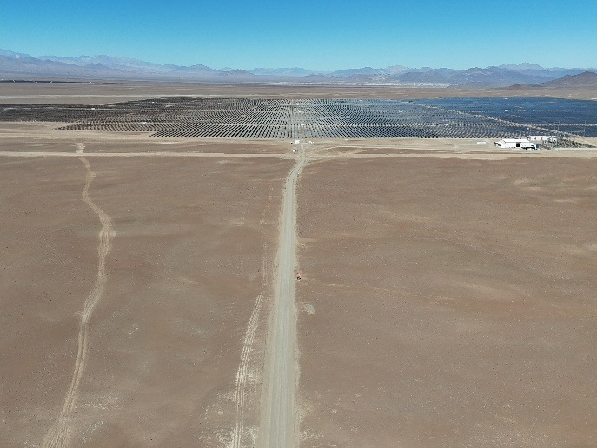
- View of access road conditions | - View of final road to access

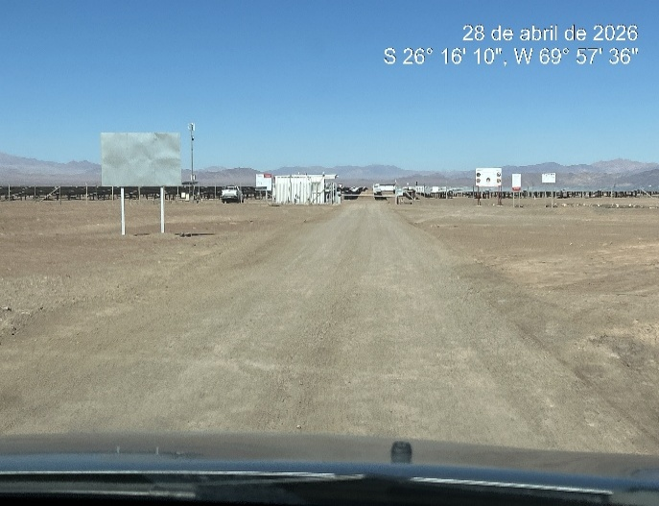 | 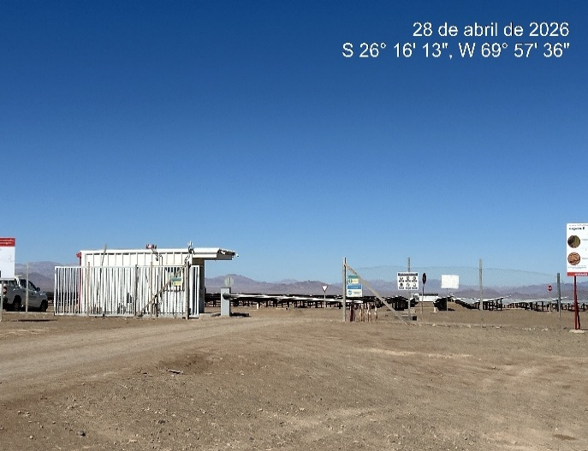
- View of access at Malgarida PFV | - Another view of access

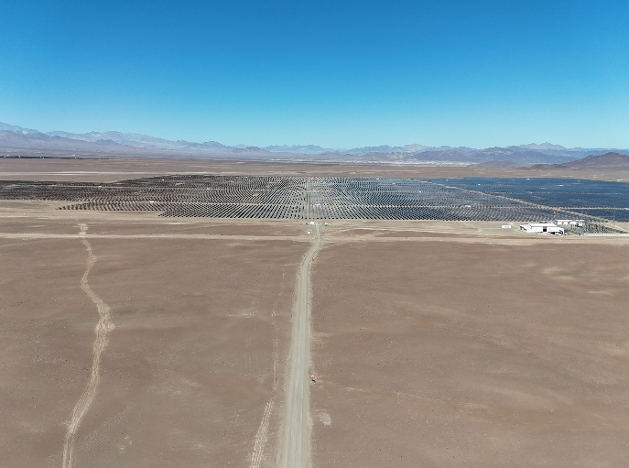 | 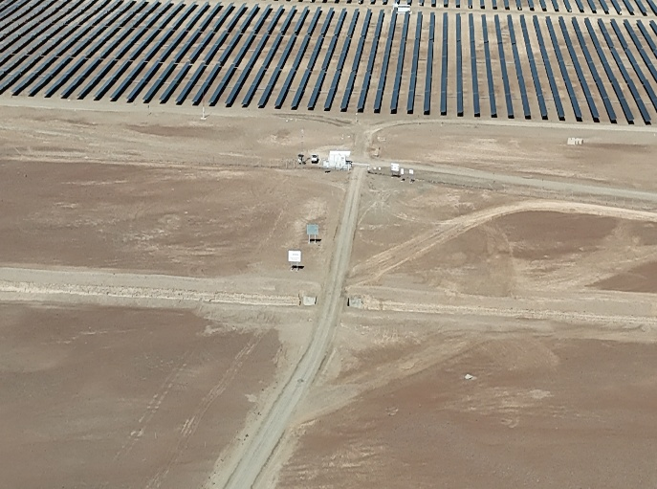
- View of access road conditions | - C-171 road conditions

6.- CONCLUSIONS AND RECOMMENDATIONS:

Based on the analysis carried out, the conclusions and recommendations of this report are presented below:
ALS conducted a route study from Port Angamos to FPV Malgarida considering the routes that connect to the destination.

- The route from the Port of Angamos to the final destination place comprises a total of 559. km of travel.
- Regarding the characteristics of the route from Angamos port to FPV Malgarida Norte, 98% of the route is paved and they are correctly signposted.
- The route from Angamos port intersea Gathered place has 5% U-turns or dangerous curves, so it is required to respect the speed limits according to the load being transported.
- Route 5 North does not present complications for transport in general, taking into consideration the observations that the MOP may have when processing road permits.
- The passage of the oversized load must be coordinated with the concessionaire of the route, so that, in the event of works on the route, they are coordinated correctly.
- Las part of tract corresponds to dirty road, no signal and no light was found in the tract of 0.6 kilometers.

Transport from Puerto Angamos to the destination is feasible, considering the adjustments proposed in this report and in accordance with the load and transport configuration considered.

