MV “AQUAMARINE”
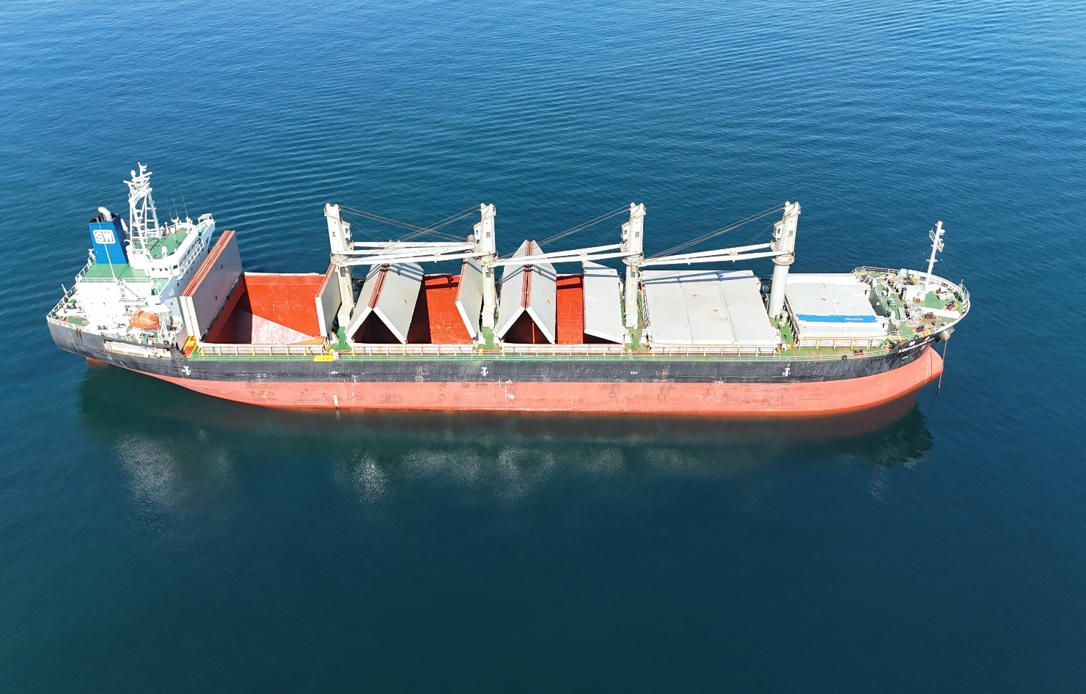
FULL ON HIRE & BUNKER SURVEY

This is to certify that the undersigned representative of ALS Inspection Chile did, at the request of Messrs. DAMPSKIBSSELSKABET NORDEN A/S attend on board motor vessel “AQUAMARINE SW” with Master consent on May 19th, 2026, while she was at anchorage in MEJILLONES BAY, Chile, in order to carry out an On Hire, general condition survey and bunker survey, as follows:

COMMENTS BY SURVEYOR
Vessel with certificates updated; hull was observed by Port side and starboard side and was observed with paint scratched, stained and with rust; hull dented port side after part superstructure in good condition, railing with several dented; cargo holds were observed clean and dry, with ladder and ladder step bent, shell plating with paint scratched; hatchcovers were in apparent good structural conditions, some hydraulic piston to opening the hatchcovers were noted with oil leakage; cargo cranes were observed in apparent good conditions.
INDEX

Content |  | Page Nr.
I. | Times
II. | Vessel’s particulars
III. | Capacities
IV. | Certificates Status
V. | External Hull Condition
VI. | General Statement of hull structure
VII. | Deck
VIII. | Holds & Hatches
IX. | Cargo Gear Conditions
X. | Bunker Survey
XI. | Attending Parties
XII. | Attachments

TERMS AND Definitions of Condition

Good | G | Unimpaired condition without significant wear or deviation from original strength and operating efficiency. No maintenance or repair required.
Fair | F | Condition in which wear and tear and other deficiencies of minor nature not requiring correction or repair.
Poor | P | Condition in which the adequacy of strength and/or operational efficiency is marginally below acceptable limits or is in doubt. Remedial action is required.
Unsatisfactory | U | Condition of undoubtedly inadequate strength, or operational efficiency. Immediate extensive repair/renewal, required to reinstate serviceability.
Observation | Obs Nr. | Indicate observation number (a special condition or important remark).

SCOPE OF SURVEY

- To verify capacities and general arrangement plans, load manuals and all certificates and to report upon them.

- To examine the weather deck and superstructures, cargo spaces including the cargo cranes, cargo gear and to record all defects.

- To examine the main hull/structures and fittings in each cargo space and to record all defects.

- To examine vessel's condition, cleanliness, and load readiness and to record all defects.

- To establish by sounding and calculation the quantity of fuel on board at the time of survey and to establish the fuel consumption from the time the vessel became On-Hire to the time of sounding.

- TIMES

Date | Time | Description
May 19, 2026 | 09:30 | ALS Surveyor on board MV “AQUAMARINE SW”
May 19, 2026 | 09:45 - 10:00 | Key meeting with C/E
May 19, 2026 | 10:00 – 11:00 | Vessel inspection holds and structures
May 19, 2026 | 11:00 | Bunker Survey commenced
May 19, 2026 | 13:00 | Bunker Survey completed
May 19, 2026 | 13:00 - 13:45 | Vessel certificates revison
May 19, 2026 | 13:45 – 14:00 | Documents signed
May 19, 2026 | 14:30 | ALS surveyor left the vessel

- VESSEL’S PARTICULARS

Master Name | Mr. Kang, Huaihong
Chief Officer Name | Mr. Ding , Jie
Chief Engineer | Mr. Li, Yongkang
Flag & Port of Register | Panama & Panama
Registered Owners | Brave Pescadores SA
Year Built | 2012
Length Overall | 177.8 Mts
Breath | 169.8 Mts
Summer. Draft | 10.869 Mt
GRT | 22, 855 Mt
NRT | 12.519 Mt
Classification Society | N.K.
Cargo gear | 4 x 30 T x 26 Mts Elect-Hyu

- CAPACITIES

Cargo Capacity | 45,790.76 m³ Grain // 45,294.41 m³ Bale
Summer. DWT | 37,119. Mt
IFO / MGO | 1,543.18 m³ // 170.14 m³
Lub Oil | 27.6 m³
Hydraulic Oil | 20.2 m³
Fresh Water | 219.28 m³
Ballast Water | 14,305.40 m³

- CERTIFICATES STATUS

Certificate / Document | Issue date | Expiry date | Endorsement
Certificate / Document | Issue place | Expiry date | Endorsement
Certificate of Registry | 12-07-2022 | 02-10-2027
Certificate of Registry | Panama, Panama | 02-10-2027
Certificate of Class | Shanghai, China | 05-07-2027
Certificate of Class | 02-07-2022 | 05-07-2027
International Tonnage | 06-09-2012
International Tonnage | Usuki, Japan
Suez Canal Tonnage | 06-09-2012
Suez Canal Tonnage | Usuki, Japan
Panama Tonnage | 06-09-2012
Panama Tonnage | Usuki, Japan
International load line | 02-07-2022 | 05-09-2027
International load line | Shanghai, China | 05-09-2027
Cargo ship safety construction | 02-07-2022 | 05-09-2027
Cargo ship safety construction | Shanghai, China | 05-09-2027
Cargo Ship Safety Equipment | 04-10-2024 | 05-09-2027
Cargo Ship Safety Equipment | Tokyo, Japan | 05-09-2027
Cargo Ship Safety Radio | 04-10-2024 | 05-09-2027
Cargo Ship Safety Radio | Tokyo, Japan | 05-09-2027
Annual Cargo Gear Examination | 09-01-26
Annual Cargo Gear Examination | Singapore, Singapore
International Oil Pollution Prevention | 02-07-2022 | 05-09-2027
International Oil Pollution Prevention | Shanghai, China | 05-09-2027
International Air Pollution Prevention | 02-07-2022 | 05-09-2027
International Air Pollution Prevention | Zhou Shan, China | 05-09-2027
International Ship Security | 14-11-2022 | 25-12-2027
International Ship Security | Panama, Panama | 25-12-2027
Last Port State Control | May 14, 20926
Last Port State Control | Paracas, Pisco, Peru
Last dry dock | July 20th, 2025
Last dry dock | Zhou Shan, China

V. EXTERNAL HULL CONDITION

 | G | F | P | U | Obs Nr
Structural condition |  |  |  |  | 1
Overall appearance

Coating condition

OBSERVATIONS: Nr. 1:
Hull Ps/Ss with paint scratched, stained and rusty

VI. GENERAL STATEMENT OF HULL STRUCTURE

Upon viewing vessel from various angles, were there any apparent or obvious signs of major longitudinal or transverse deformation or structural failure which might indicate earlier serious damage or poor repairs? | Y | N

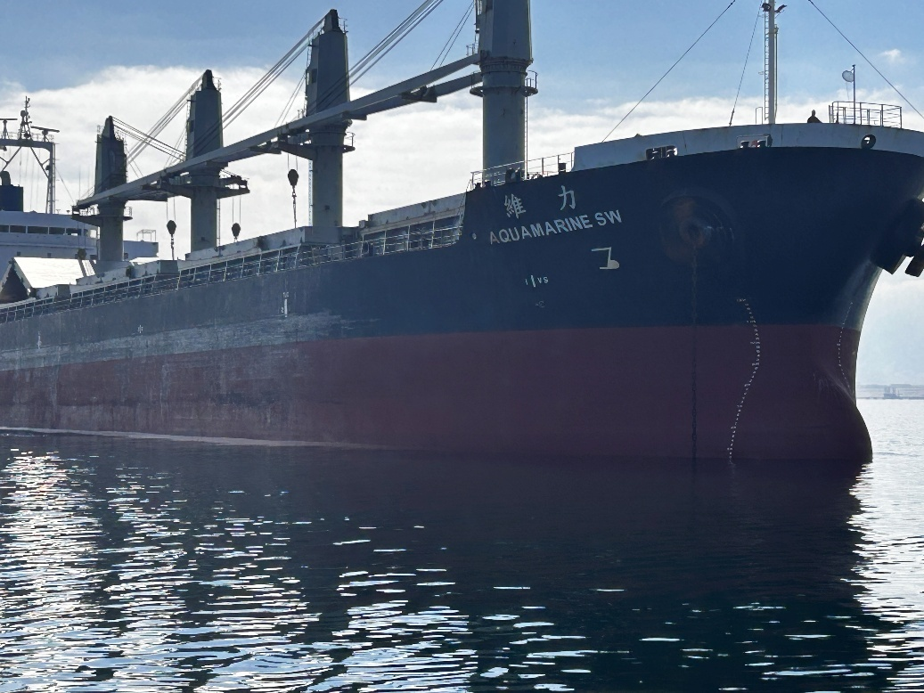
- General view of hull Fwd, paint scratched and rusty
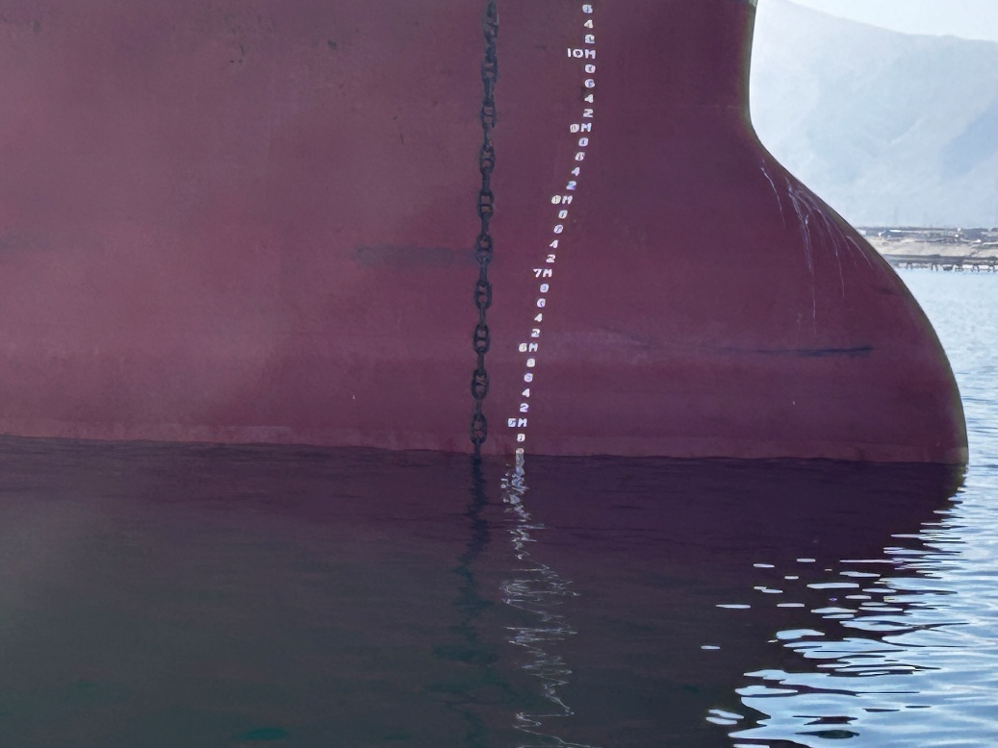
- Hull Fwd/Ss, paint scratched and rusty

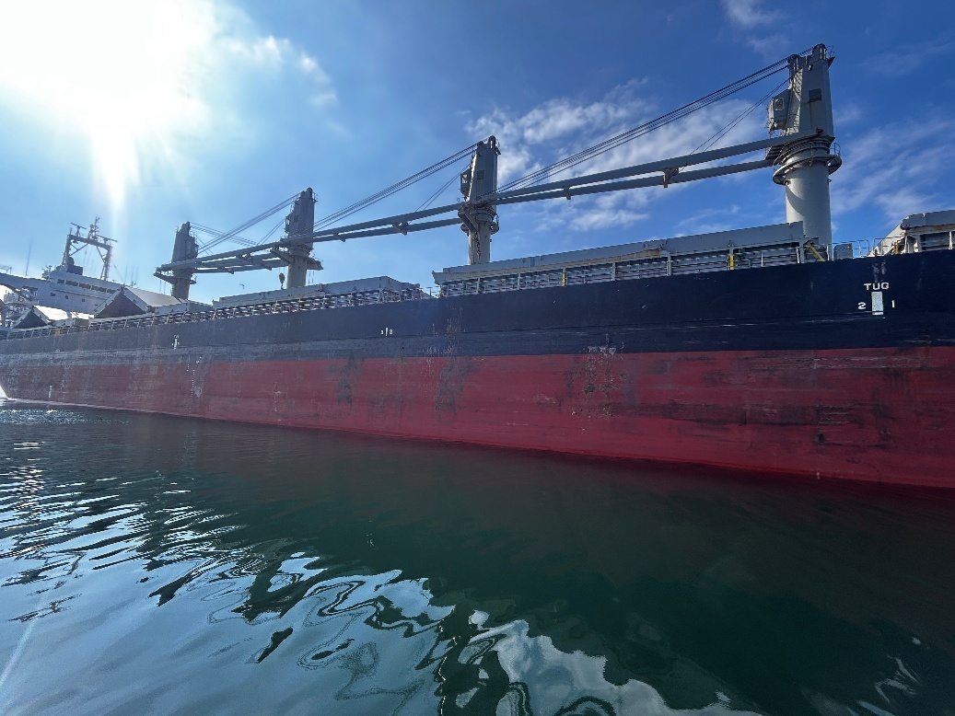
- Hull Ss, general conditions

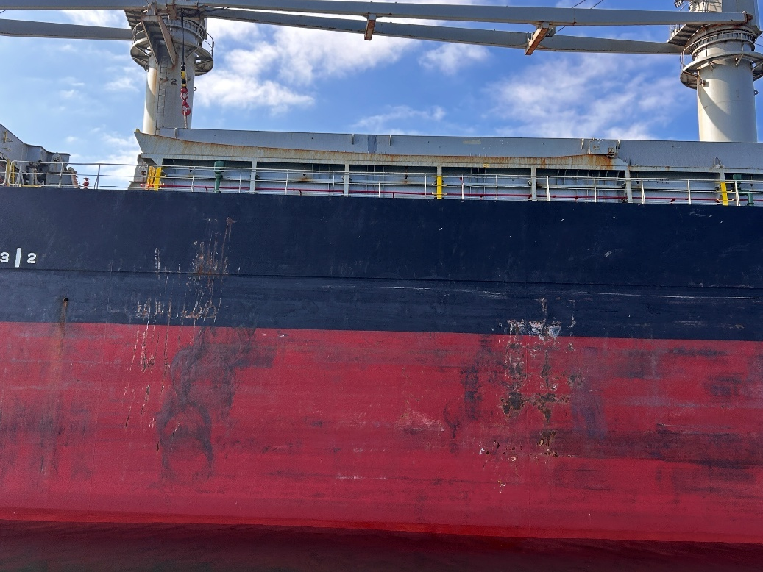
- Hull Ss, paint scratched and rusty

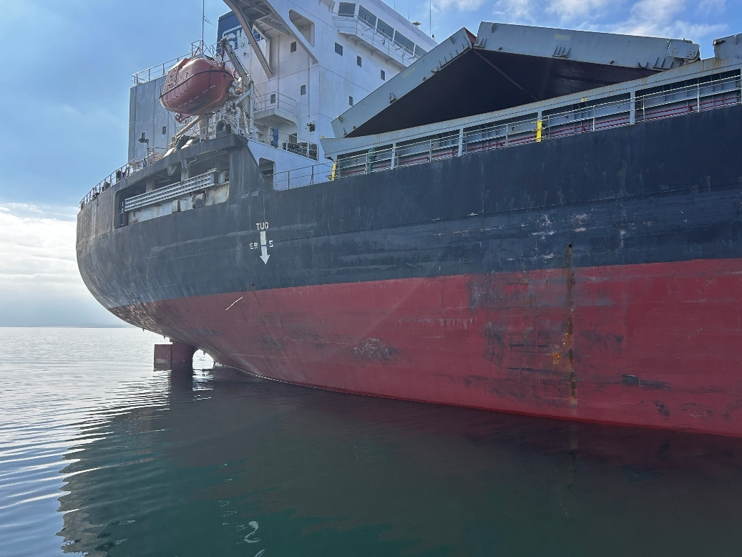
- Hull Aft/Ss, paint scratched and rusty

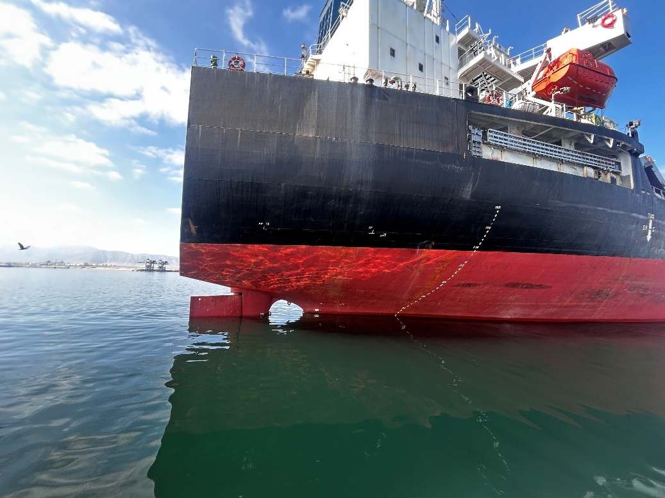
- Hull Aft/Ss, paint scratched and rusty

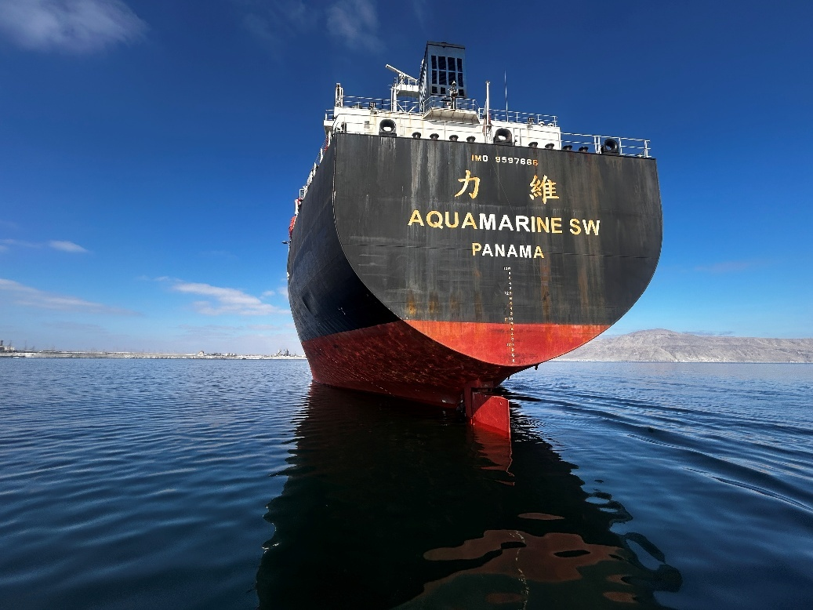
- Hull After part, paint scratched and rusty

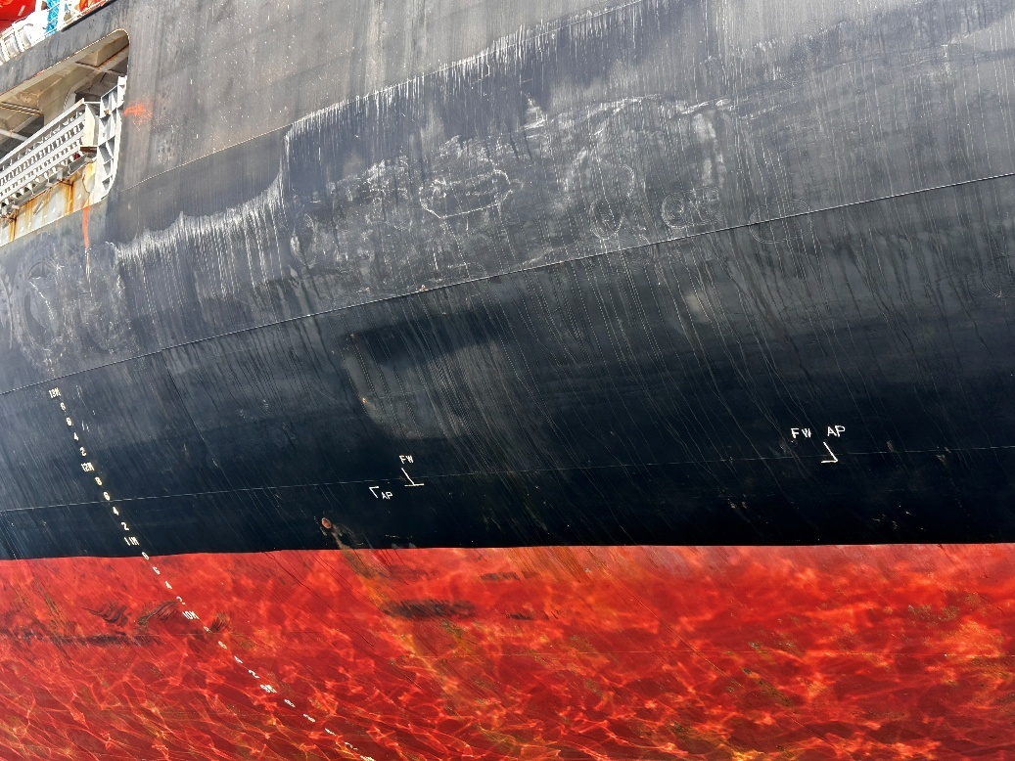
- Hull Aft/Ps, dented FW tank position

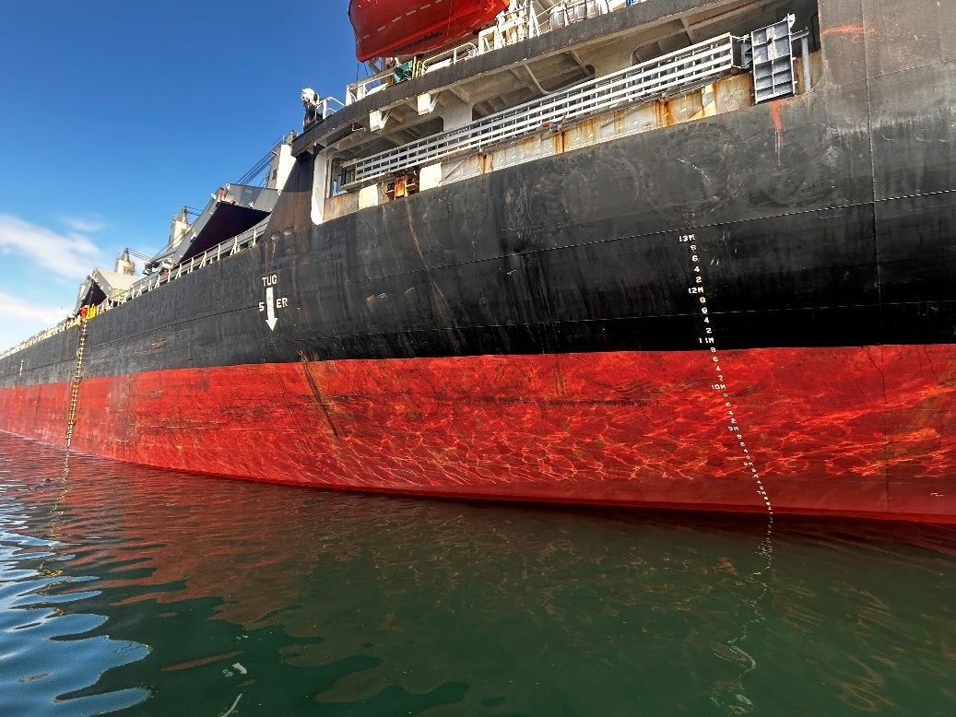
- Hull Aft/Ps, paint scratched and rusty

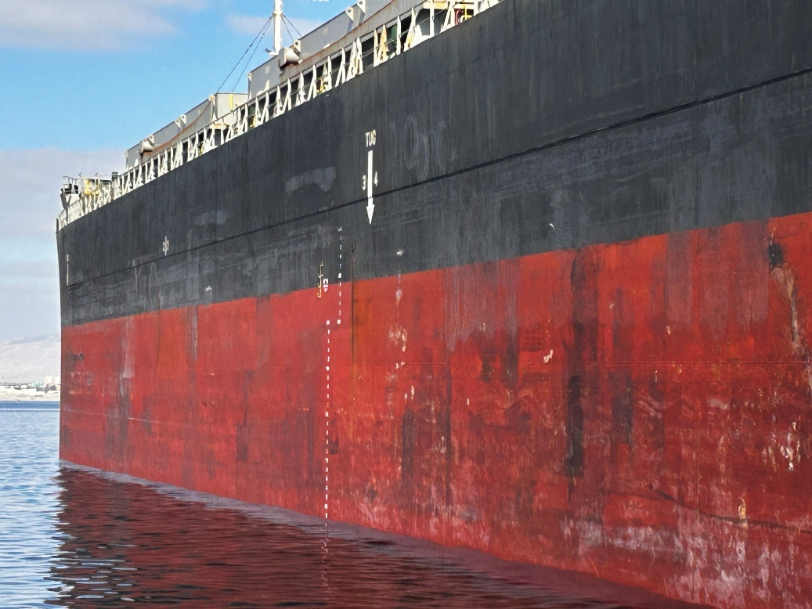
- Hull Mid part/Ps, paint scratched and rusty

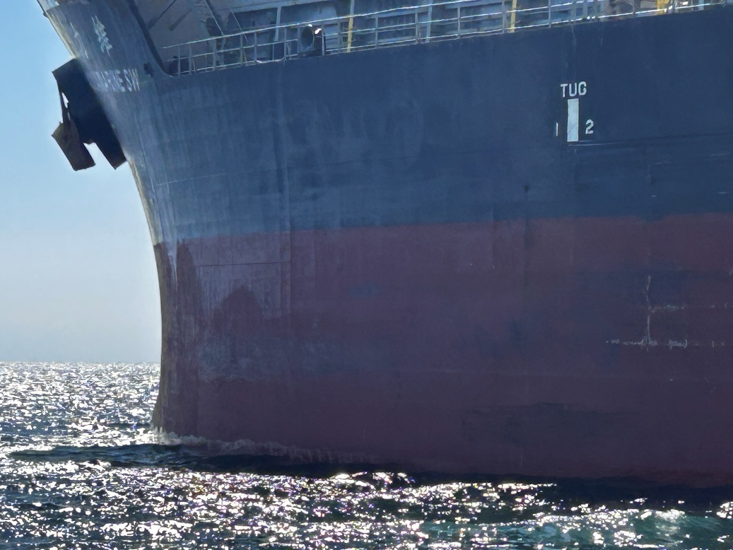
- Hull Fwd/Ps, paint scratched and rusty

VII. DECK

FORECASTLE DECK | G | F | P | U | Obs Nr |  | POOP DECK | G | F | P | U | Obs Nr
Anchor equipment |  |  |  |  |  |  | Winches
Railings and bulwark |  |  |  |  |  |  | Systems and bulkwark
Air and sounding pipes |  |  |  |  |  |  | Air and sounding pipes
Plating |  |  |  |  |  |  | Plating
Mooring lines |  |  |  |  |  |  | Mooring lines
Light mast |  |  |  |  |  |  | Access
Bollards |  |  |  |  |  |  | Bollards
Fair leaders |  |  |  |  |  |  | Fair leaders

PORT SIDE DECK | G | F | P | U | Obs Nr |  | STB SIDE DECK | G | F | P | U | Obs Nr
Hatchcoaming |  |  |  |  |  |  | Hatchcoaming
Deck plating |  |  |  |  |  |  | Deck plating
Railings / bulwark |  |  |  |  | 2 |  | Railings / bulwark
Piping in way |  |  |  |  |  |  | Piping in way
Air and  sounding pipes |  |  |  |  |  |  | Air and  sounding pipes
Stevedore’s access |  |  |  |  |  |  | Stevedore’s access

Observations:

Nr. 2: Railing several dented alongside vessel, port and star board side

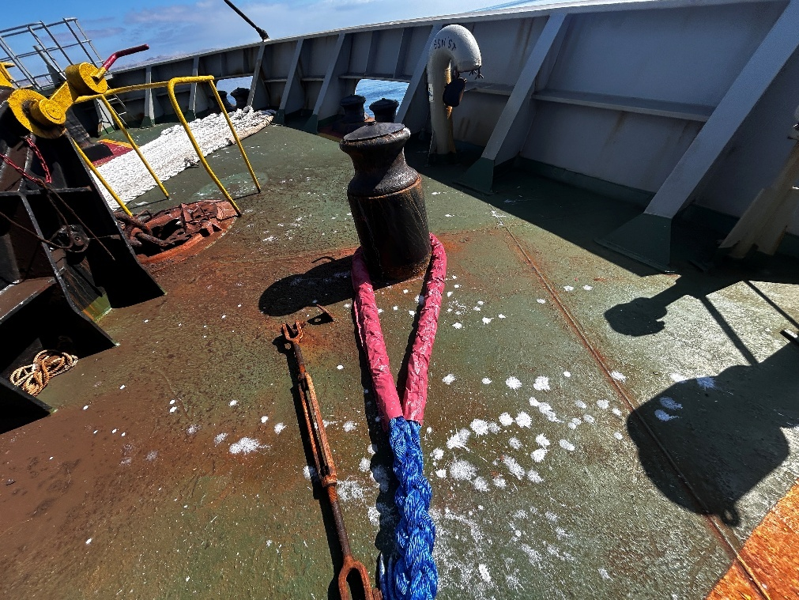
- Forward stations conditions pivot in good conditions

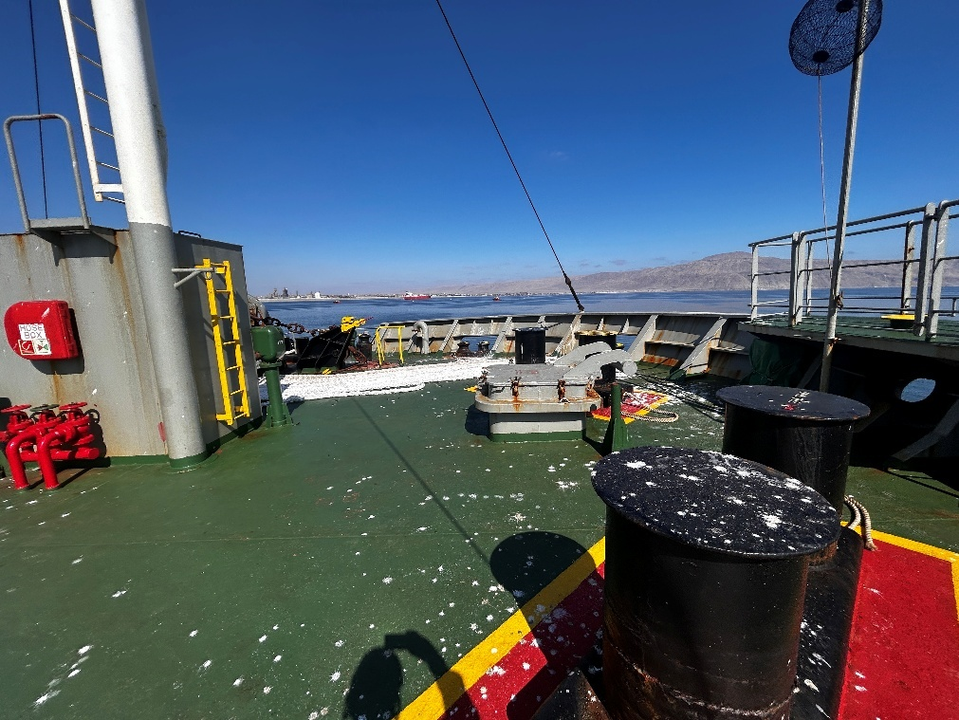
- Bitts and general conditions forward station

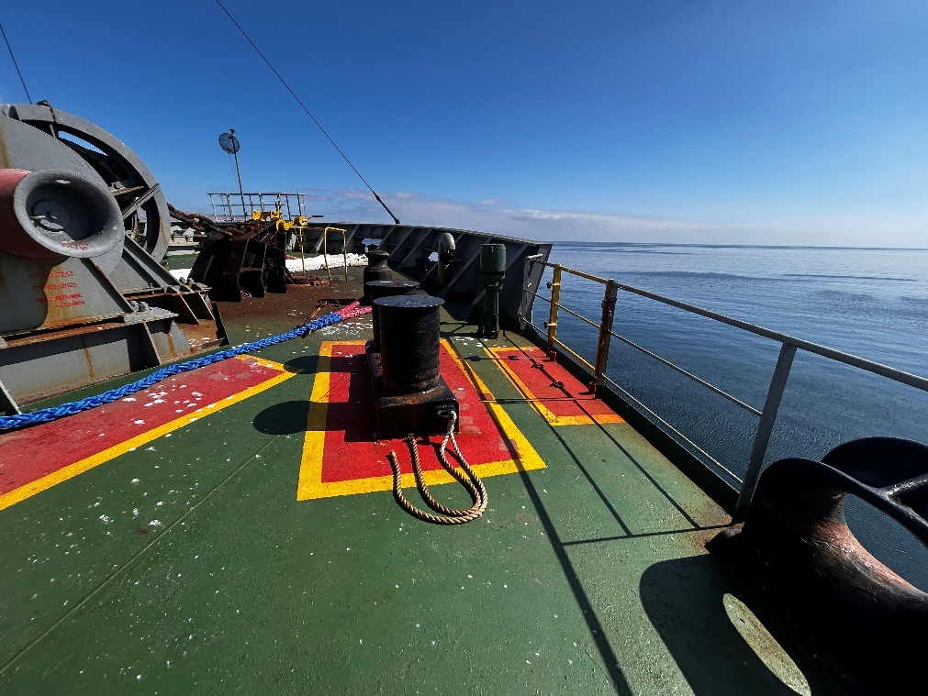
- Main view of railing and bitts conditions

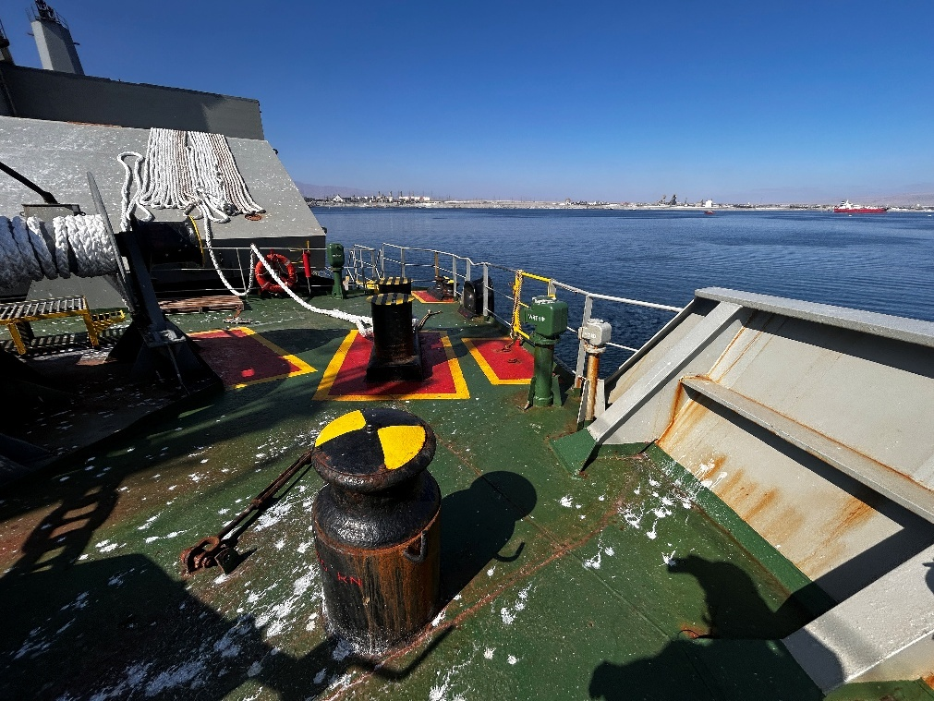
- Another view of pivot and bulk wards conditions

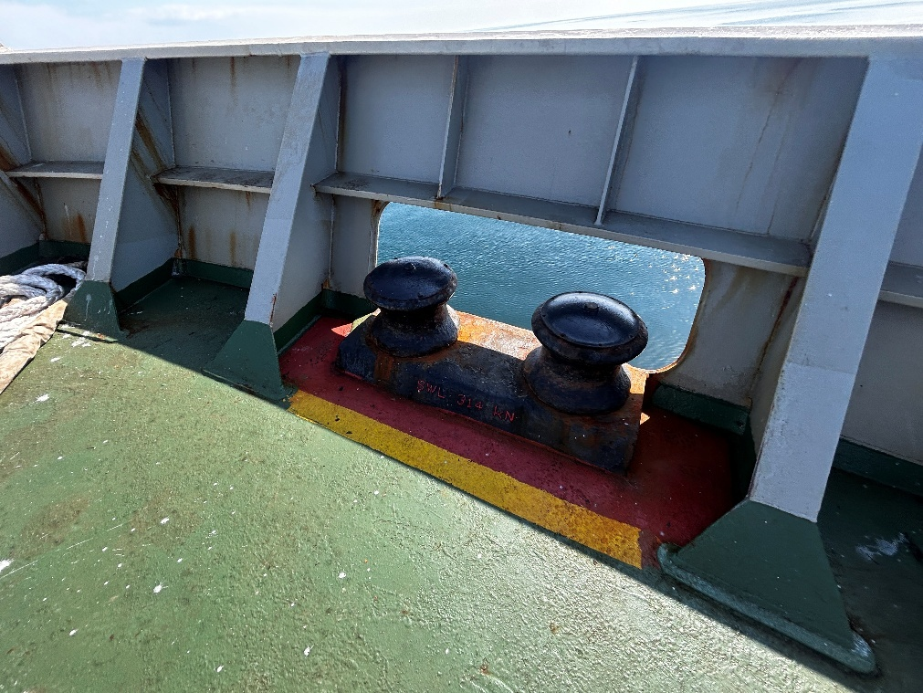
- Main view of roller conditions

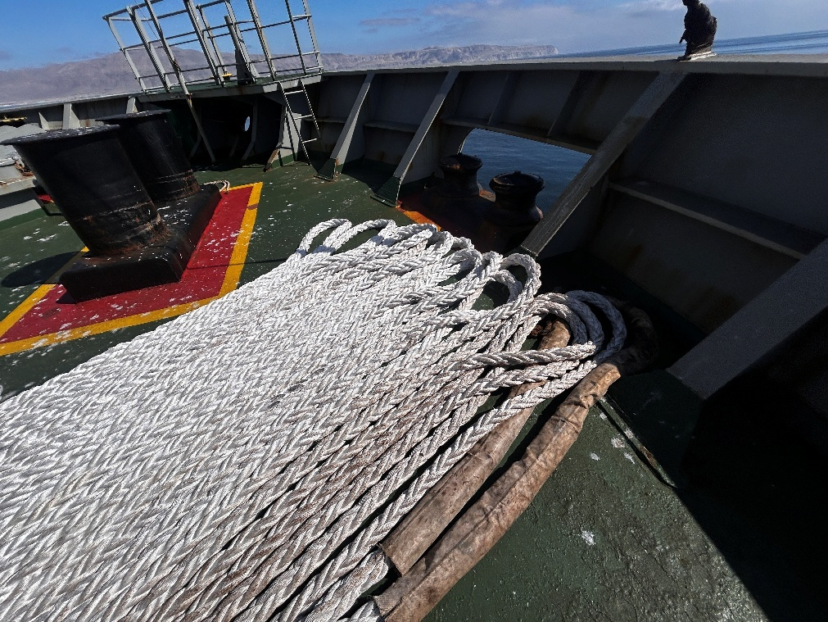
- Ropes conditions on forwards stations

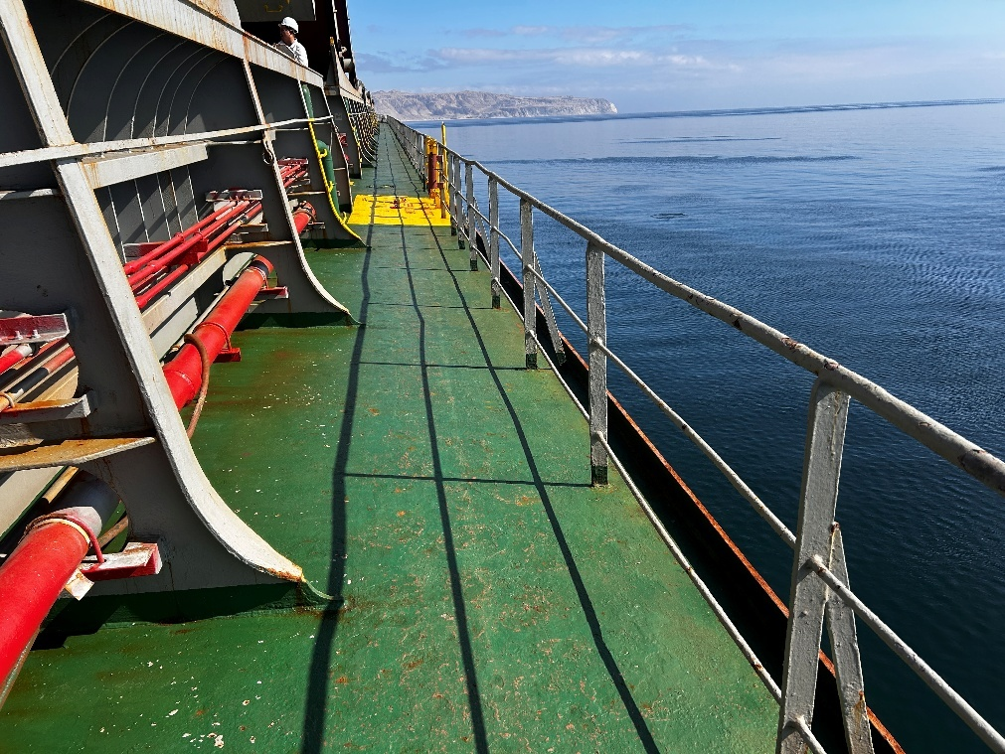
- Main deck Ss railing dented

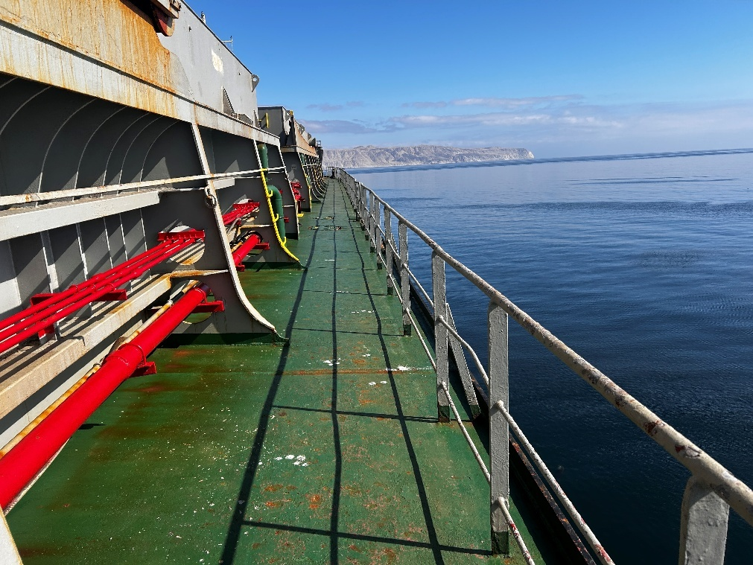
- Another view of main deck SS with railing dented

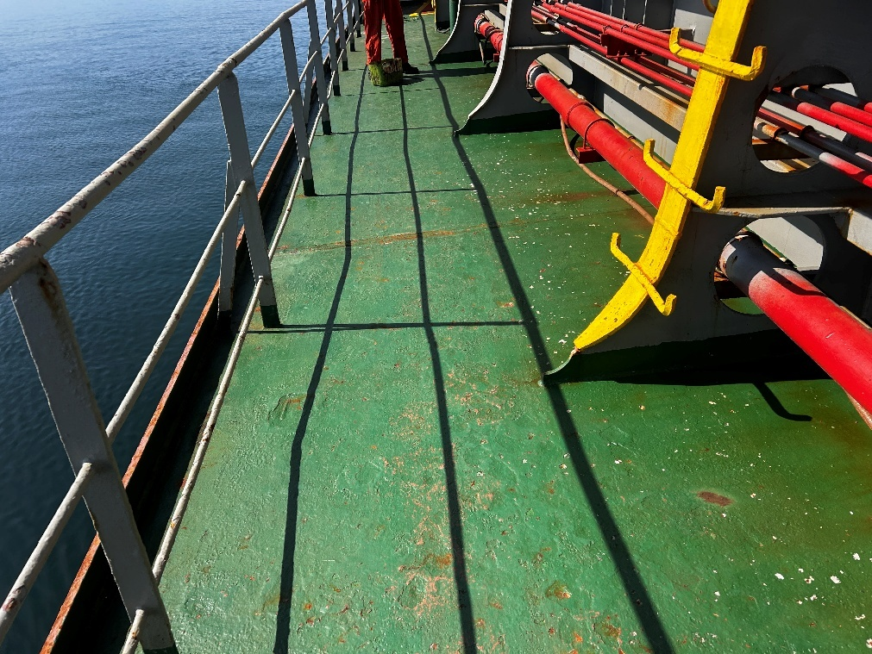
- Main deck SS condition and railing dented.

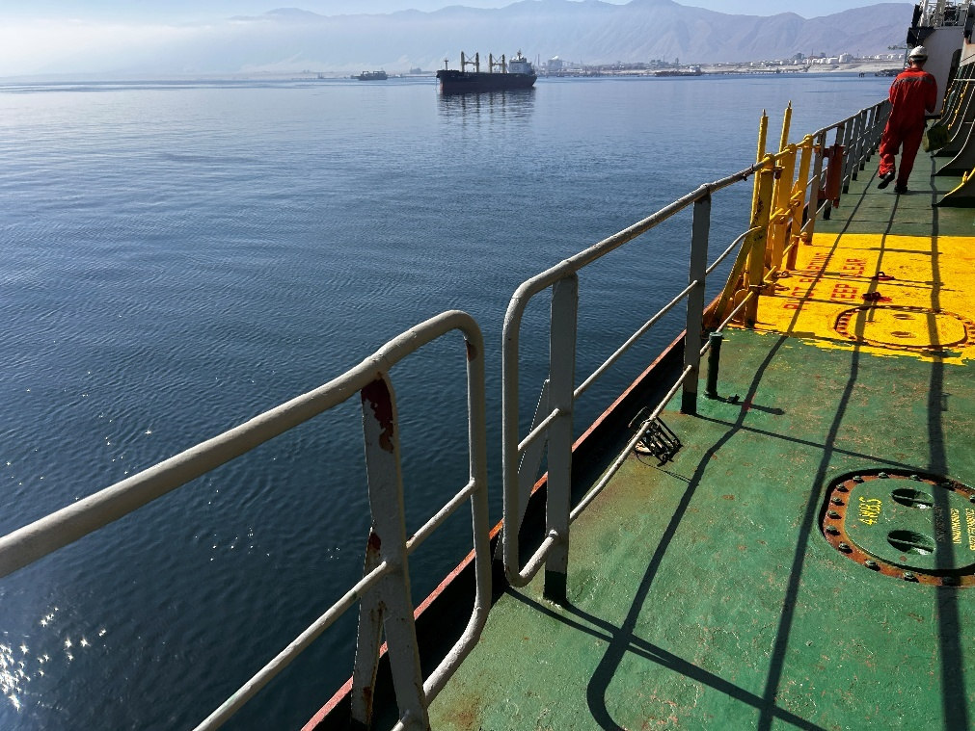
- Main deck Ss. railing several dented

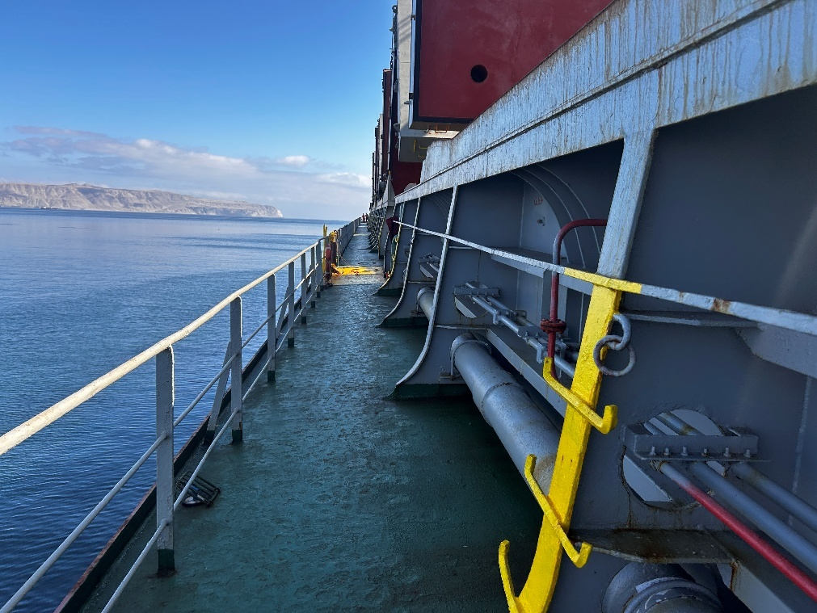
- Main deck Ps. Railing dented

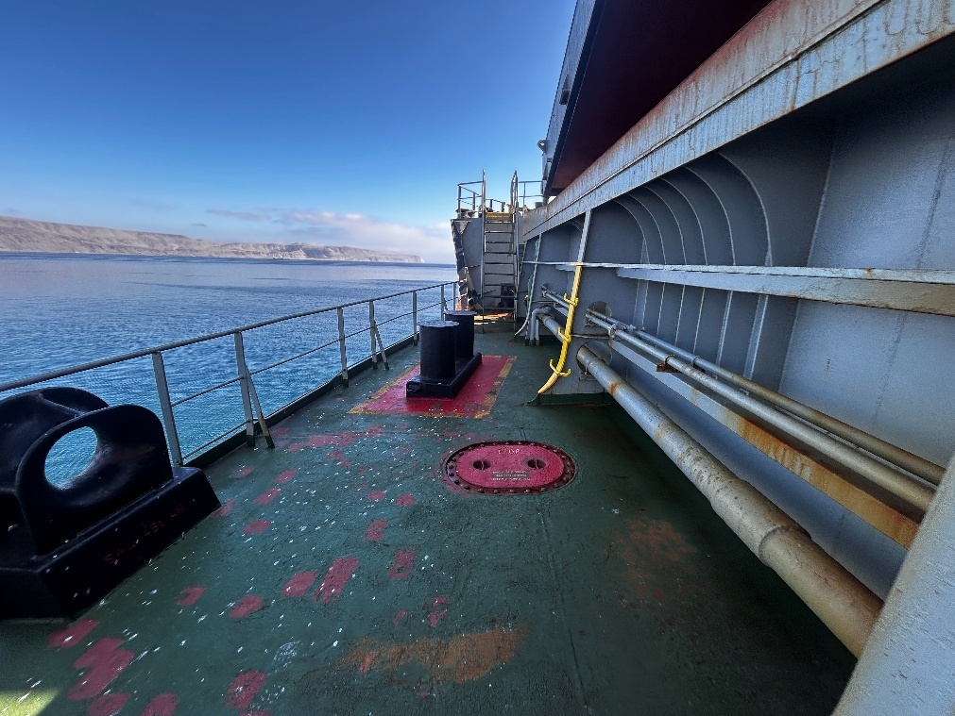
- Main deck Ps, general conditions

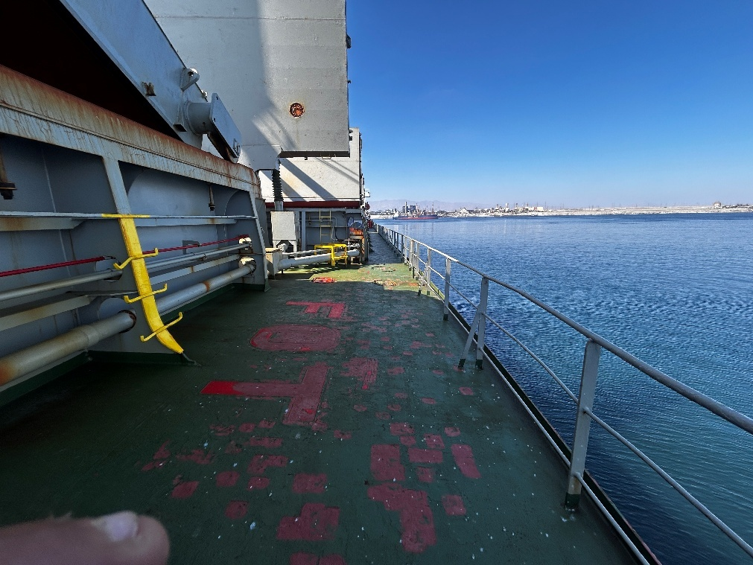
- Main deck Ps. Railing dented

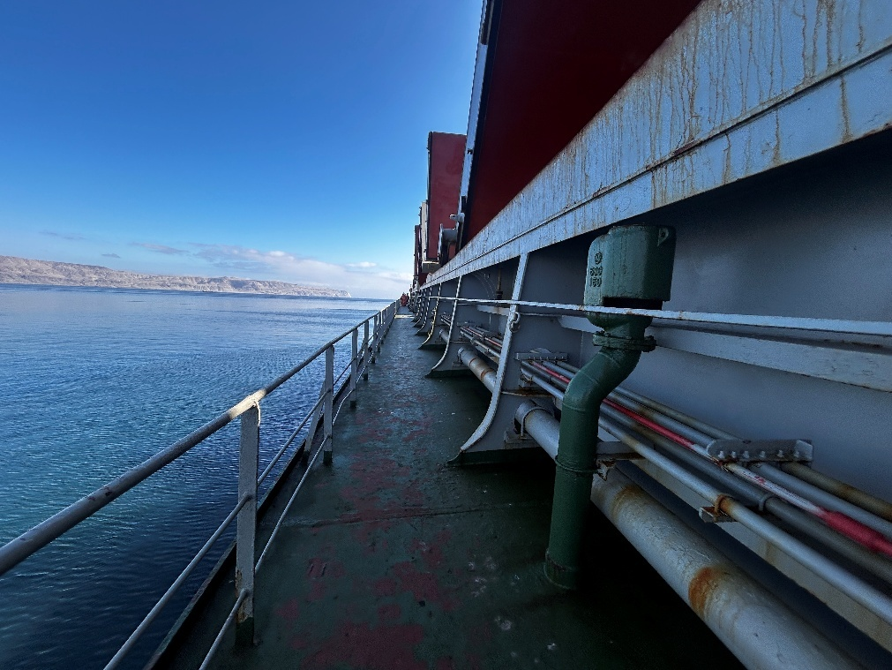
- Main deck Ps general conditions

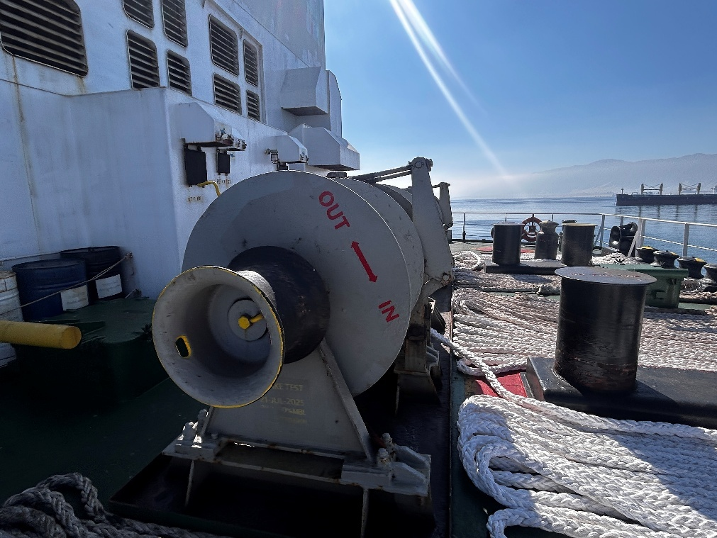
- After station in good conditions

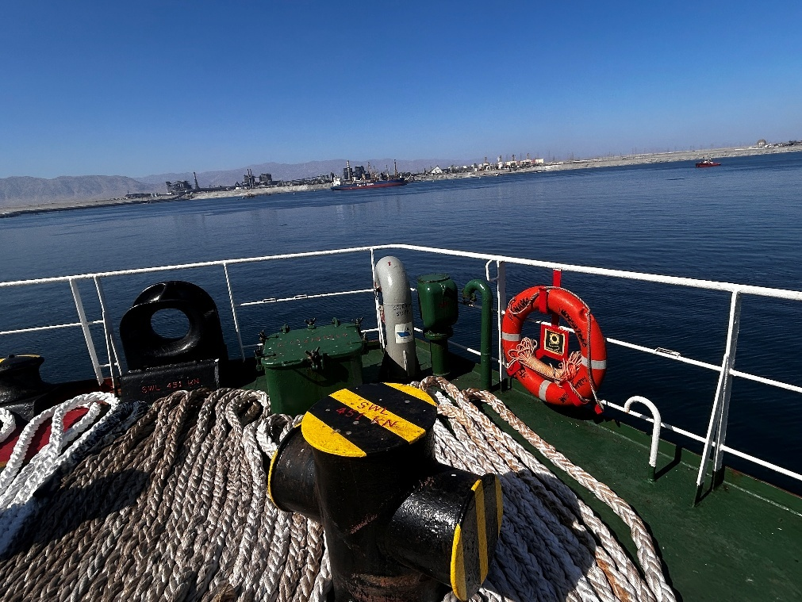
- After station bitts and railing in good conditions

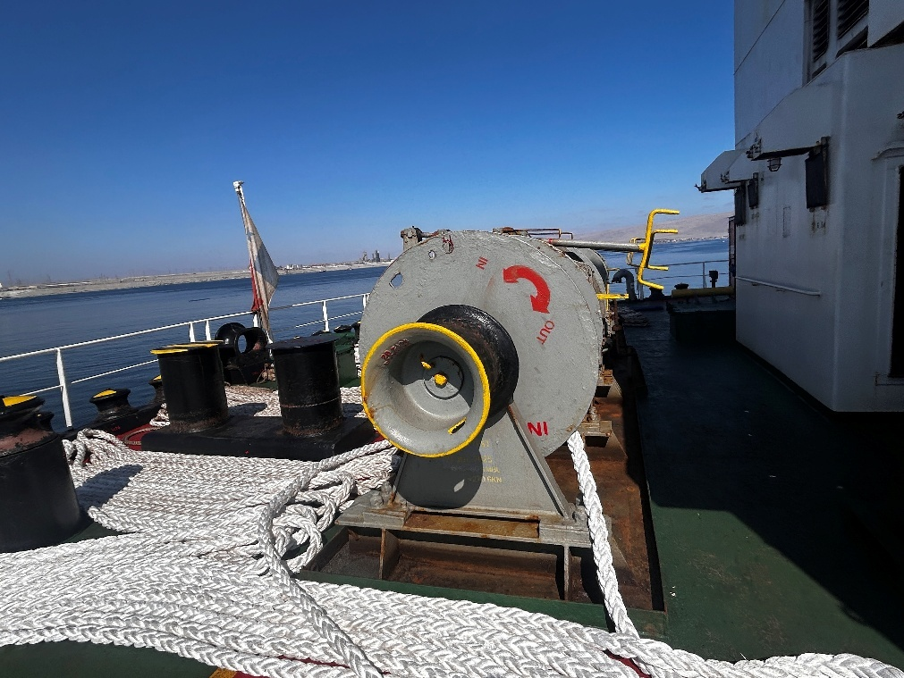
- Windlass in sound conditions

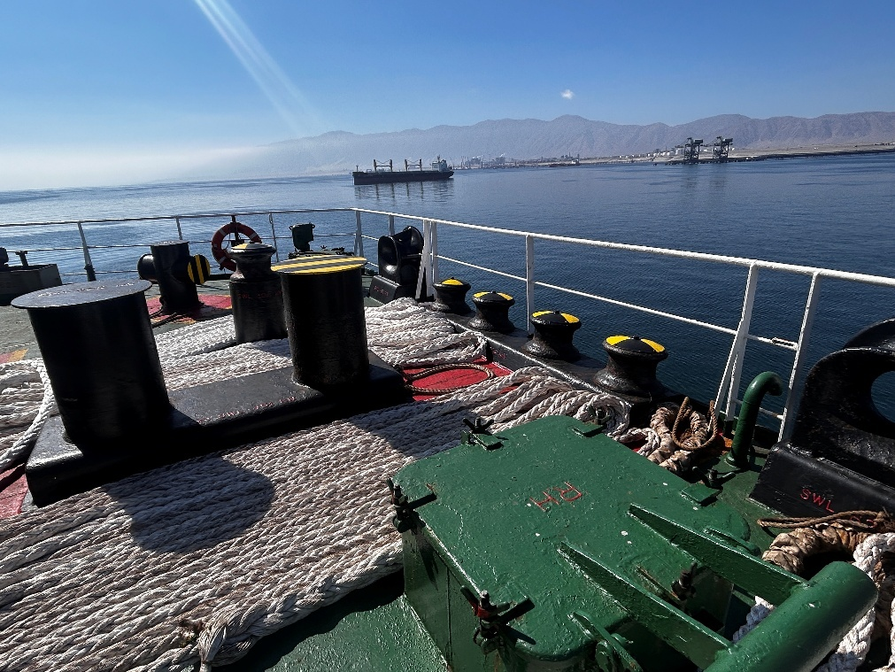
- View of railing rollers and bitts in good conditions

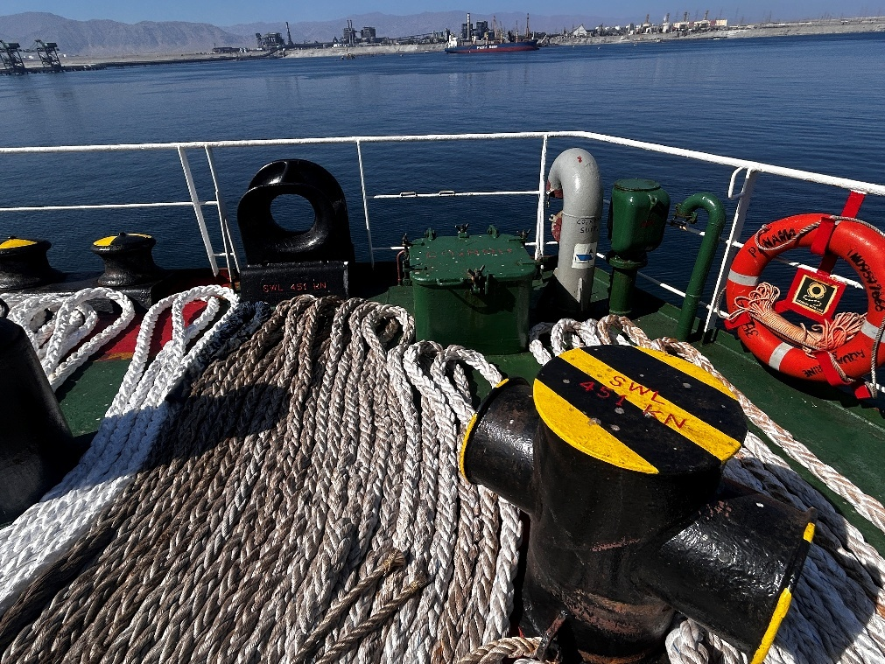
- Ropes conditions

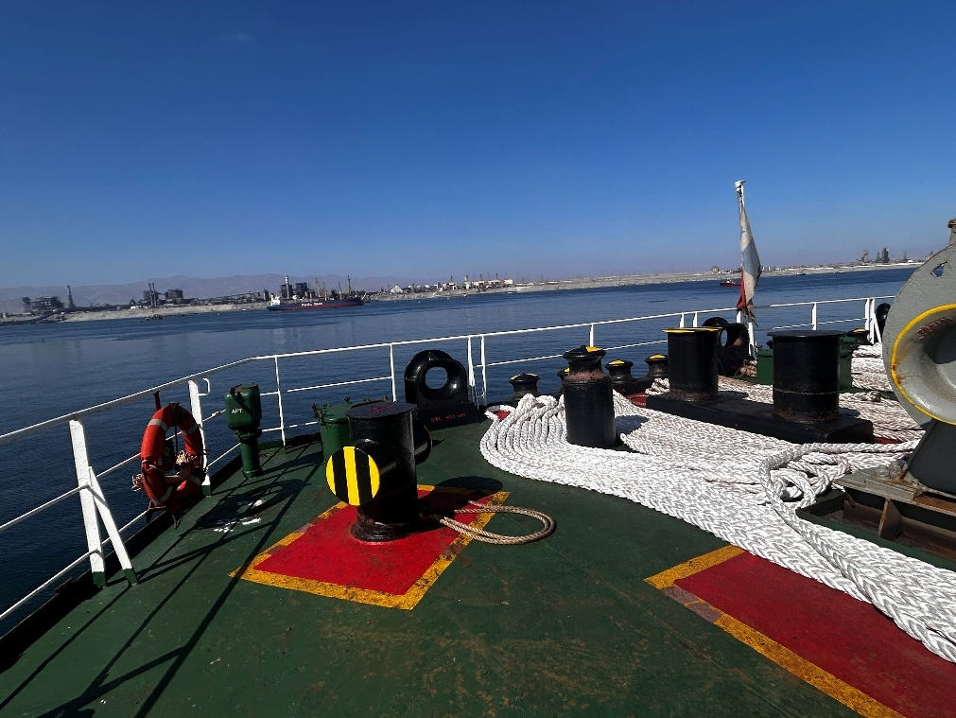
- Anotther view of ropes in good conditions

VIII. HOLDS & HATCHES

HATCH & HOLD  NR. 1 | G | F | P | U | Obs Nr
Hatch covers
Hatch coamings
Rubber packing
Draining holes
Acting cleats
Compression bars
Non return valves
Hydraulic Systems
Forward bulkhead |  |  |  |  | 4
After bulkhead |  |  |  |  | 4
Side/shell plating (port) |  |  |  |  | 4
Side/shell plating (stb) |  |  |  |  | 4
Frames, brackets and bracket connection
Tank top plating |  |  |  |  | 4
Hopper tank plating |  |  |  |  | 4
Under deck plating
Manholes and covers
Ventilation, void spaces
Bilges, suctions
Ladders
Air vents
Sounding pipes
Cleaning Condition

OBSERVATIONS:

Nr. 4: Bulkhead fwd, lower stool with paint scratched and rust.

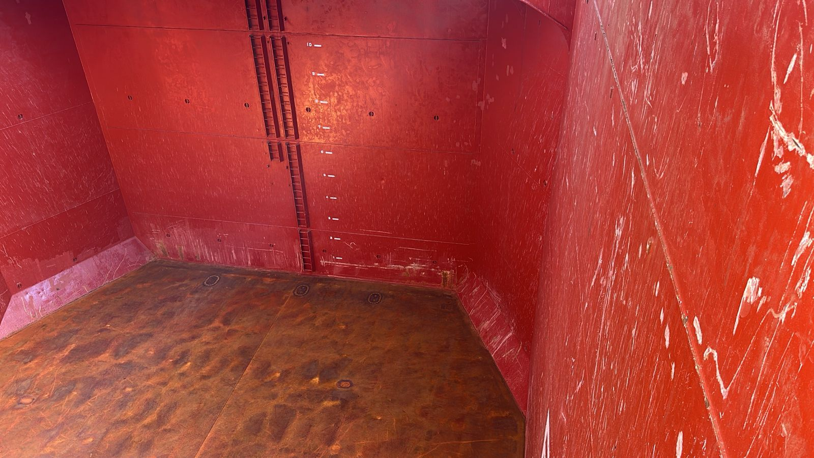
- Hold Nr. 1, bulkhead Fwd.

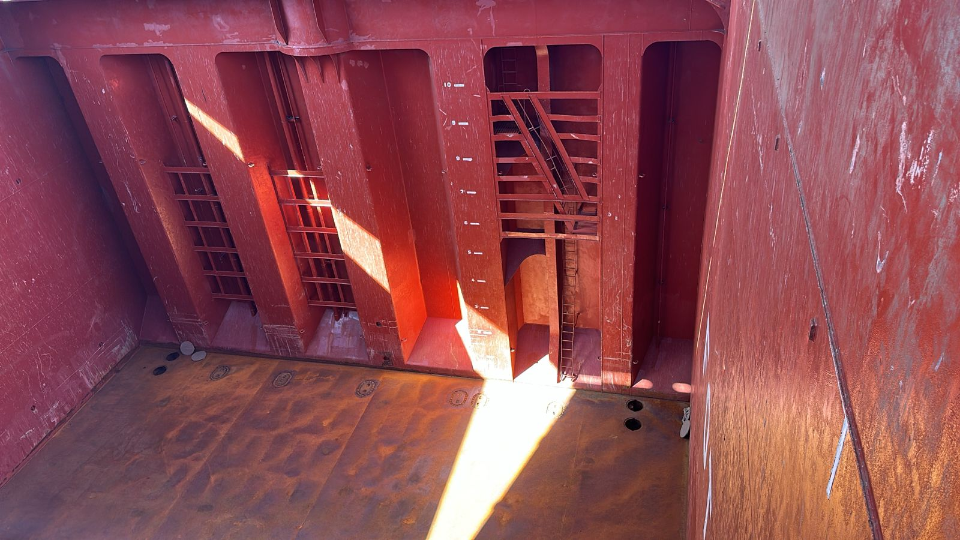
- Hold Nr. 1, after bulkhead

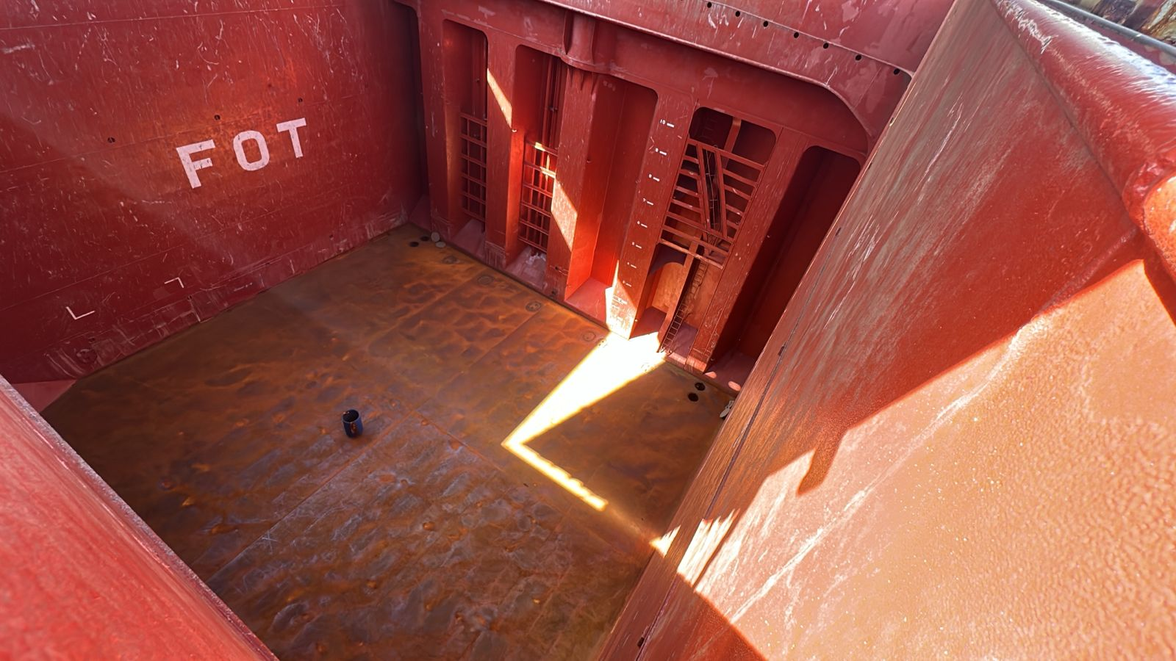
- Hold Nr. 1, star board side plate scratches and rusted

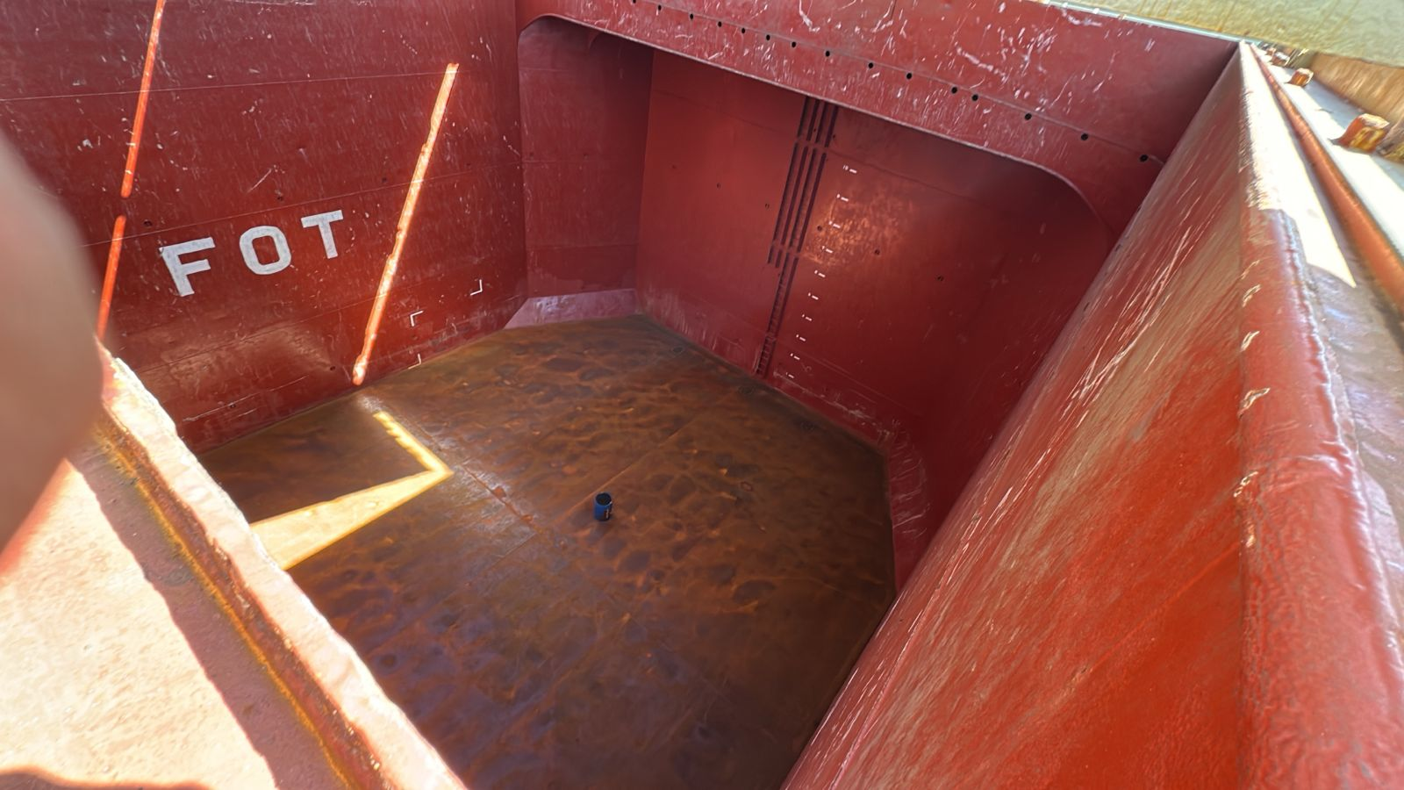
- Hold Nr. 1, Port side shell with scratches

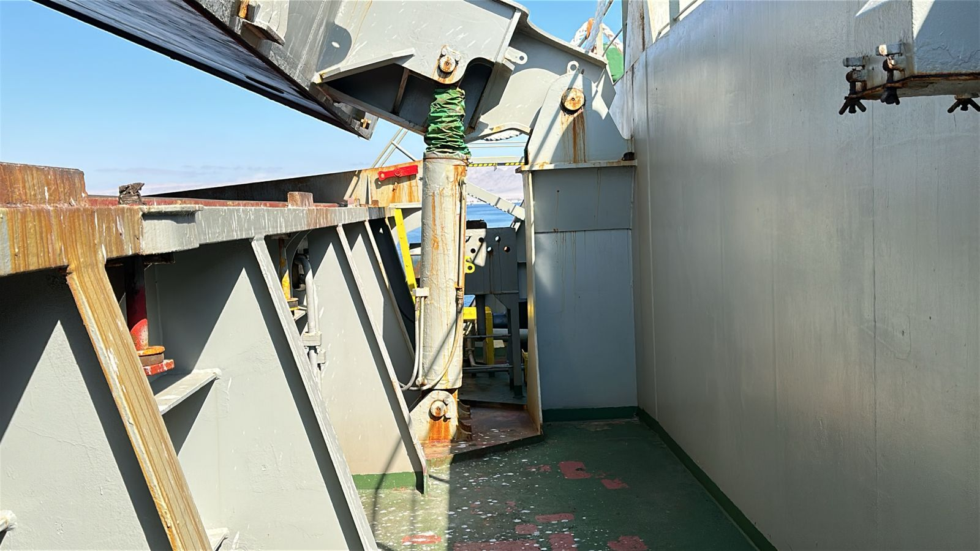
- Hold Nr. 1, hydraulic system in order

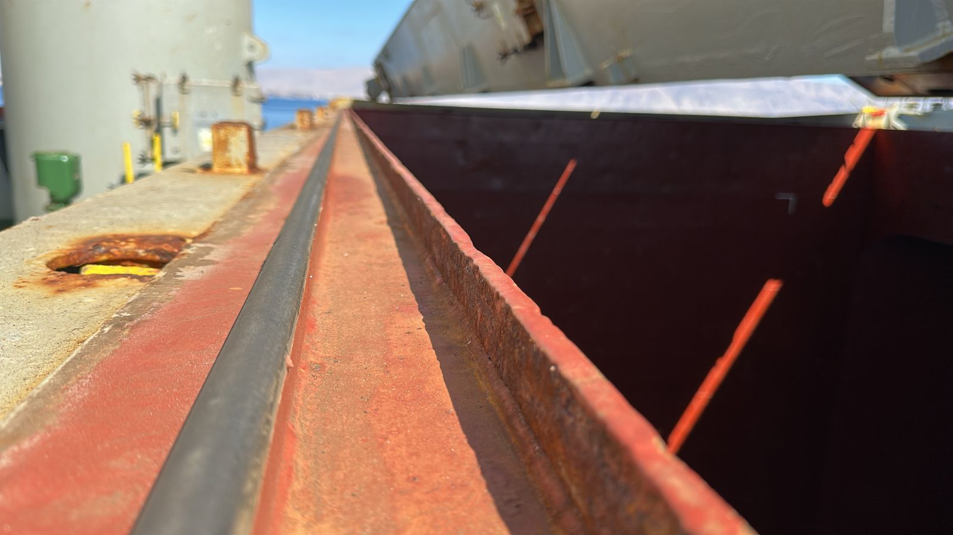
- Hold Nr. 1, rubber and compression bar in good conditions

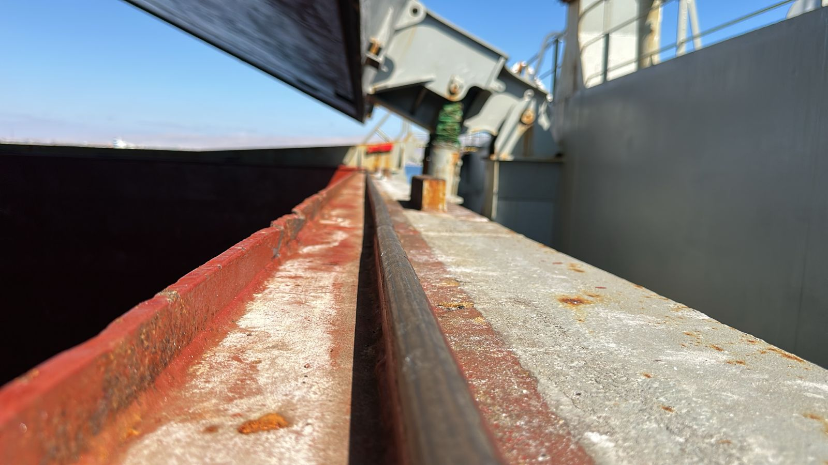
- Hold Nr. 1, drain channel and compression bar in good conditions

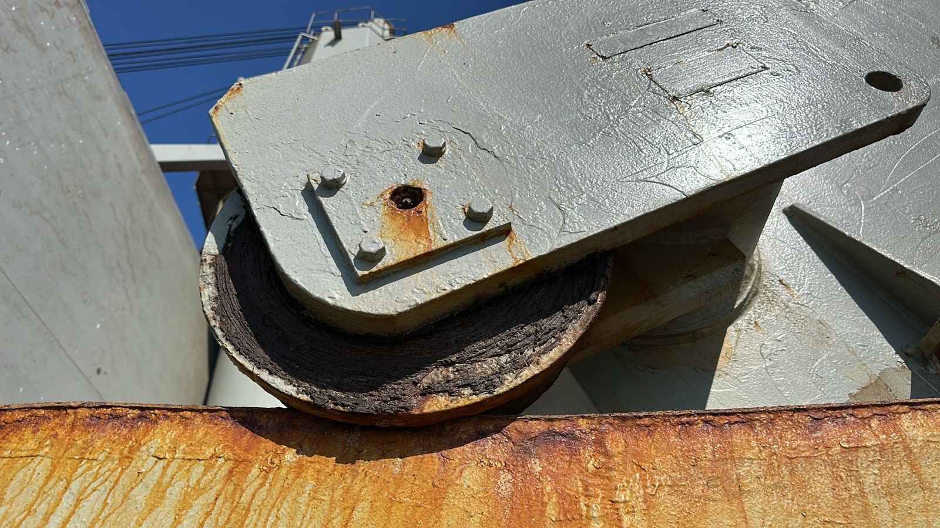
- Hold Nr. 1, roller rusted in good conditions

HATCH & HOLD  NR. 2 | G | F | P | U | Obs Nr
Hatch covers
Hatch coamings
Rubber packing
Draining holes
Acting cleats
Compression bars
Non return valves
Hydraulic Systems
Forward bulkhead |  |  |  |  | 4
After bulkhead |  |  |  |  | 4
Side/shell plating (port) |  |  |  |  | 4
Side/shell plating (stb) |  |  |  |  | 4
Frames, brackets and bracket connection
Tank top plating |  |  |  |  | 4
Hopper tank plating |  |  |  |  | 4
Under deck plating
Manholes and covers
Ventilation, void spaces
Bilges, suctions
Ladders
Air vents
Sounding pipes
Cleaning Condition

OBSERVATIONS:

Nr. 4: Bulkhead fwd, lower stool with paint scratched and rust.

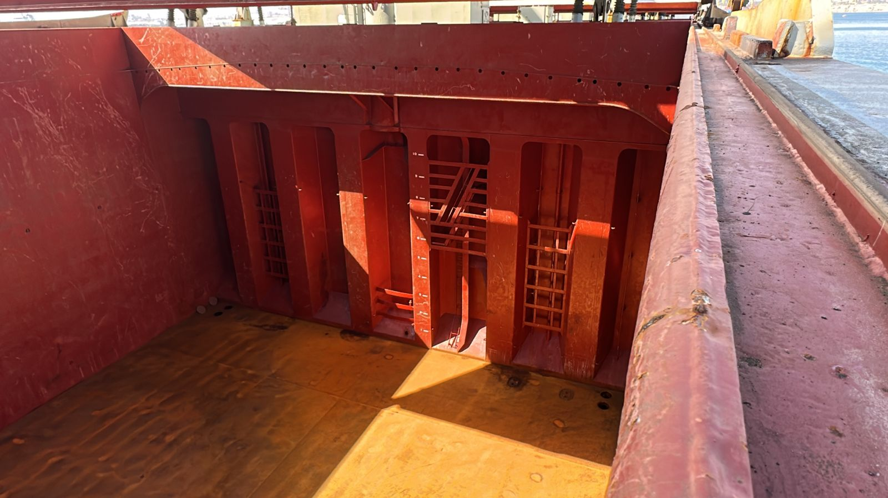
- Hold Nr. 2, bulkhead Fwd.

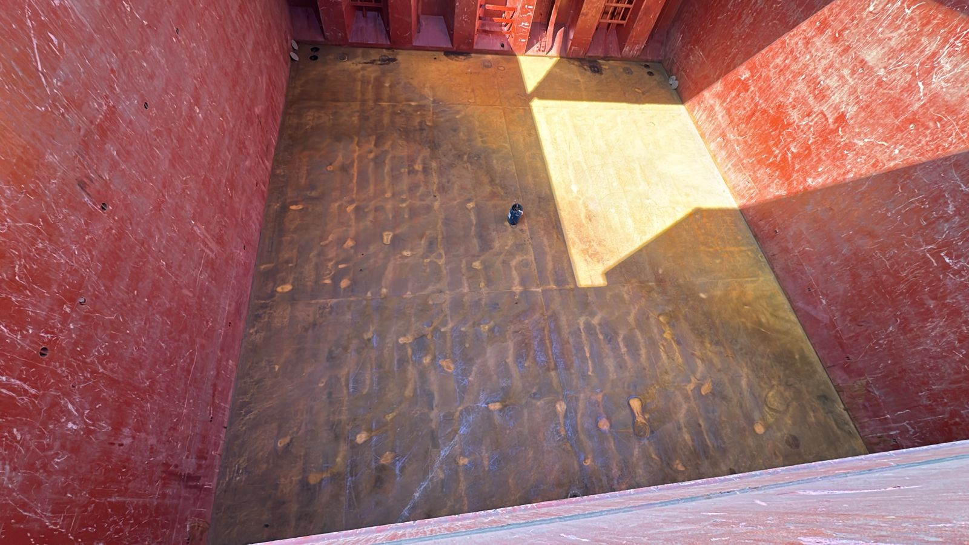
- Hold Nr. 2, after bulkhead

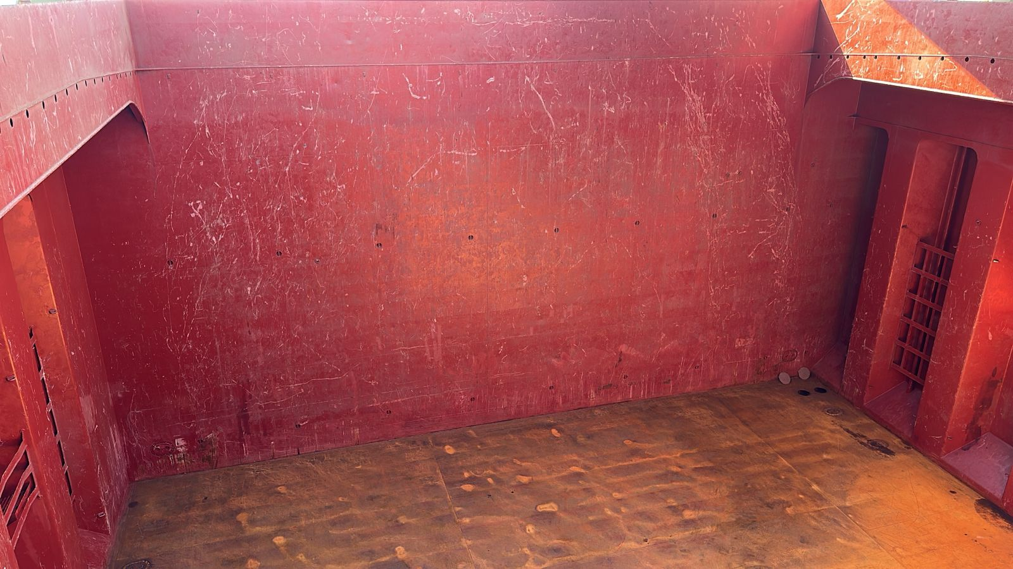
- Hold Nr. 2, star board side plate scratches and rusted

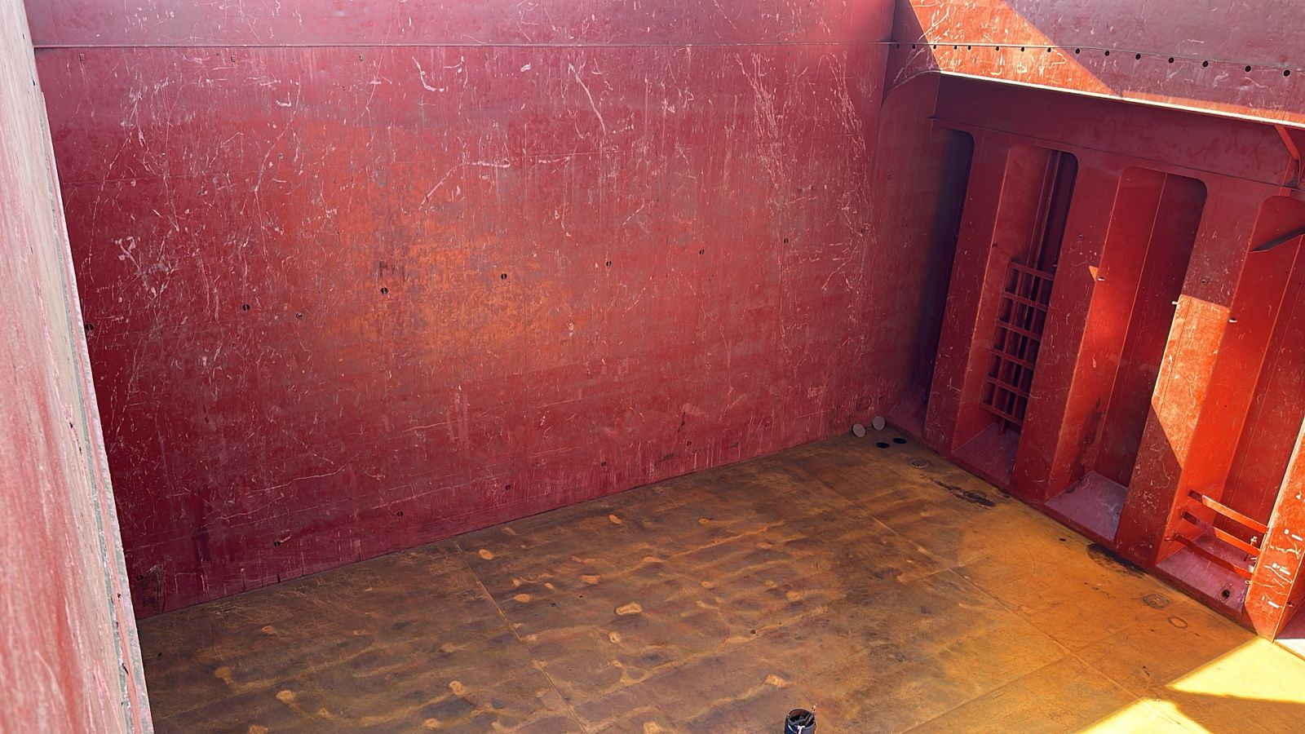
- Hold Nr. 2, Port side shell with scratches

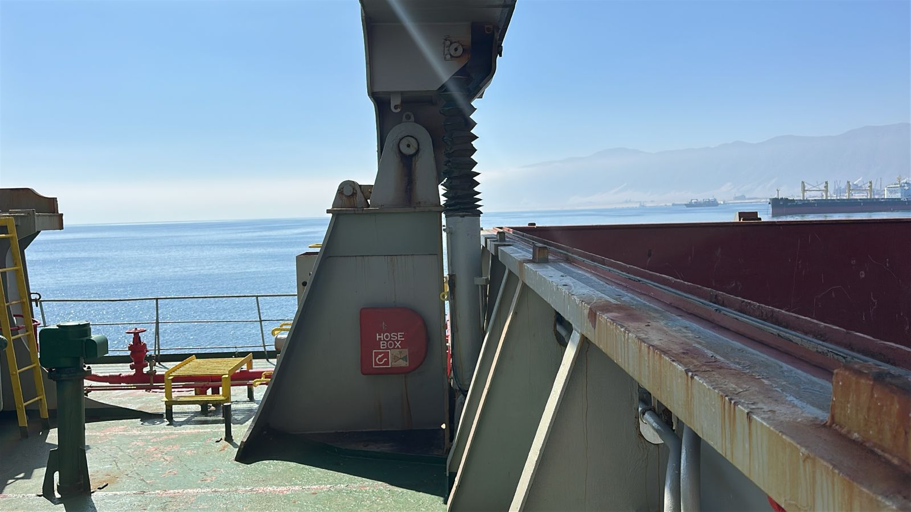
- Hold Nr. 2, hydraulic system in order

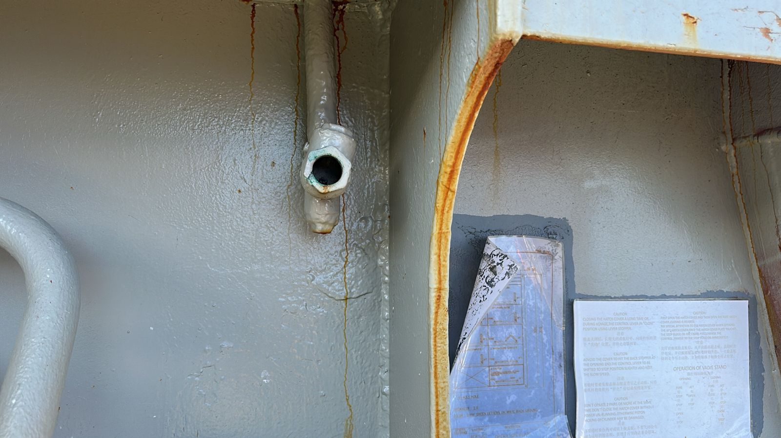
- Hold Nr. 2, non-return valve in good conditions

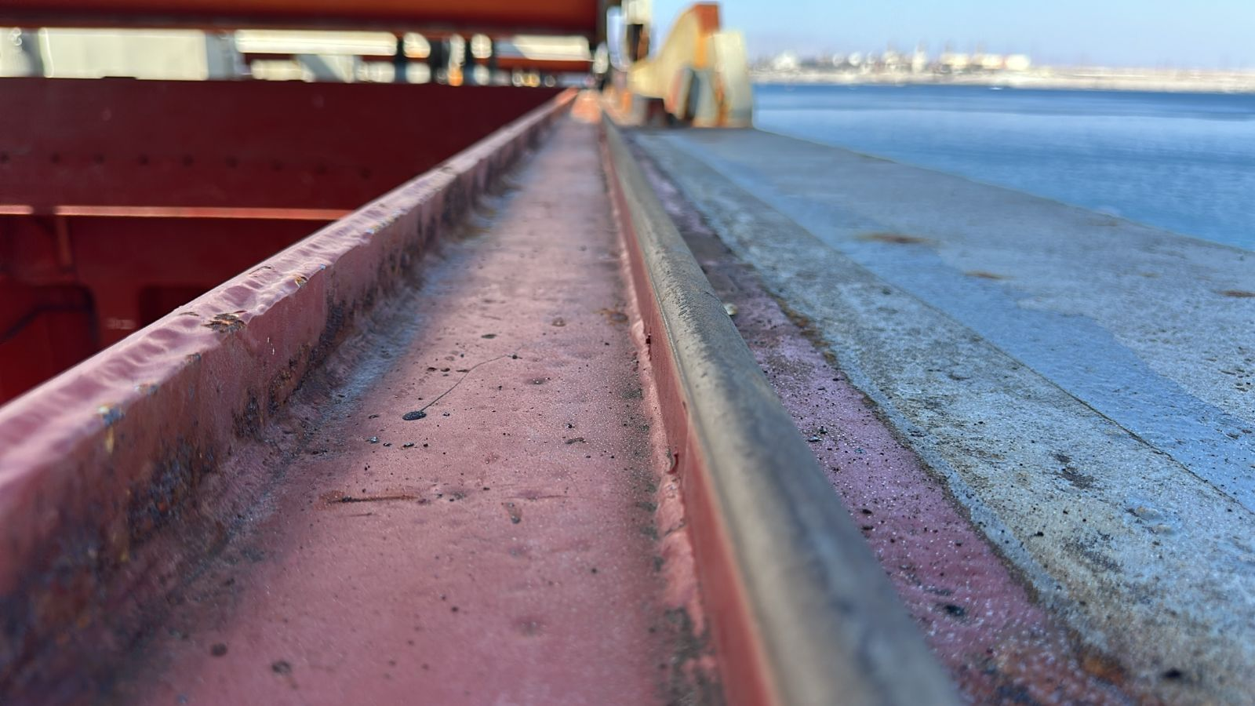
- Hold Nr. 2, drain channel and compression bar in good conditions

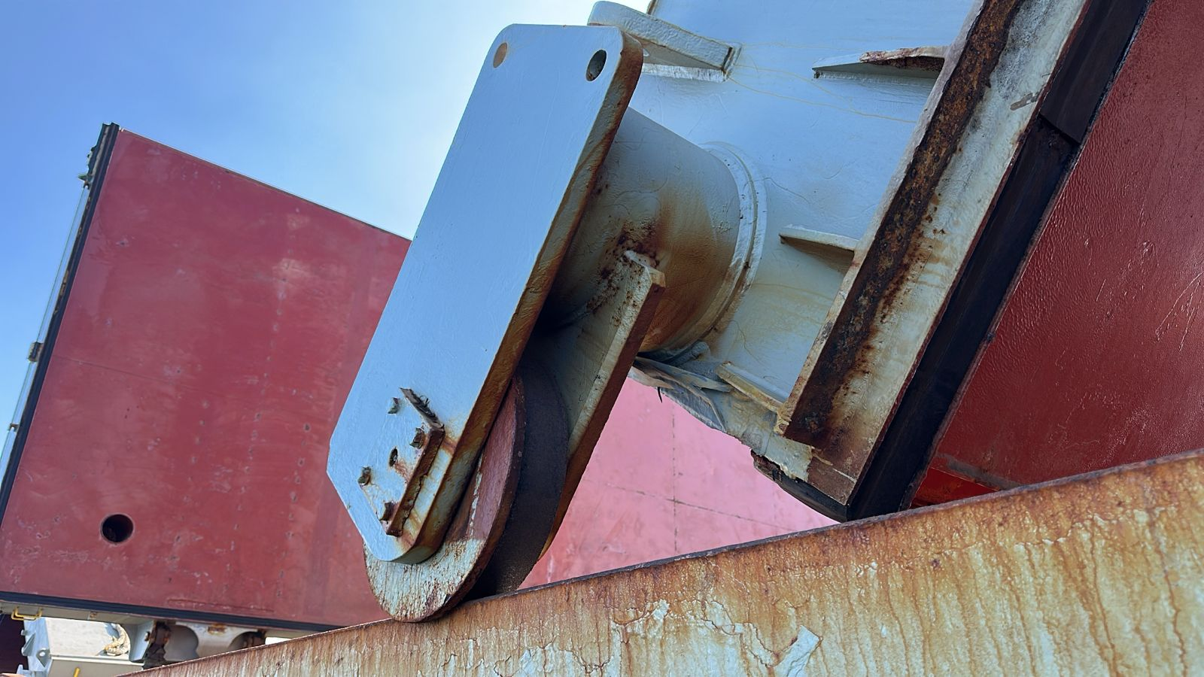
- Hold Nr. 2, roller rusted in good conditions

HATCH & HOLD  NR. 3 | G | F | P | U | Obs Nr
Hatch covers
Hatch coamings
Rubber packing
Draining holes
Acting cleats
Compression bars
Non return valves
Hydraulic Systems
Forward bulkhead |  |  |  |  | 4
After bulkhead |  |  |  |  | 4
Side/shell plating (port) |  |  |  |  | 4
Side/shell plating (stb) |  |  |  |  | 4
Frames, brackets and bracket connection
Tank top plating |  |  |  |  | 4
Hopper tank plating |  |  |  |  | 4
Under deck plating
Manholes and covers
Ventilation, void spaces
Bilges, suctions
Ladders
Air vents
Sounding pipes
Cleaning Condition

OBSERVATIONS:

Nr. 4: Bulkhead fwd, lower stool with paint scratched and rust.

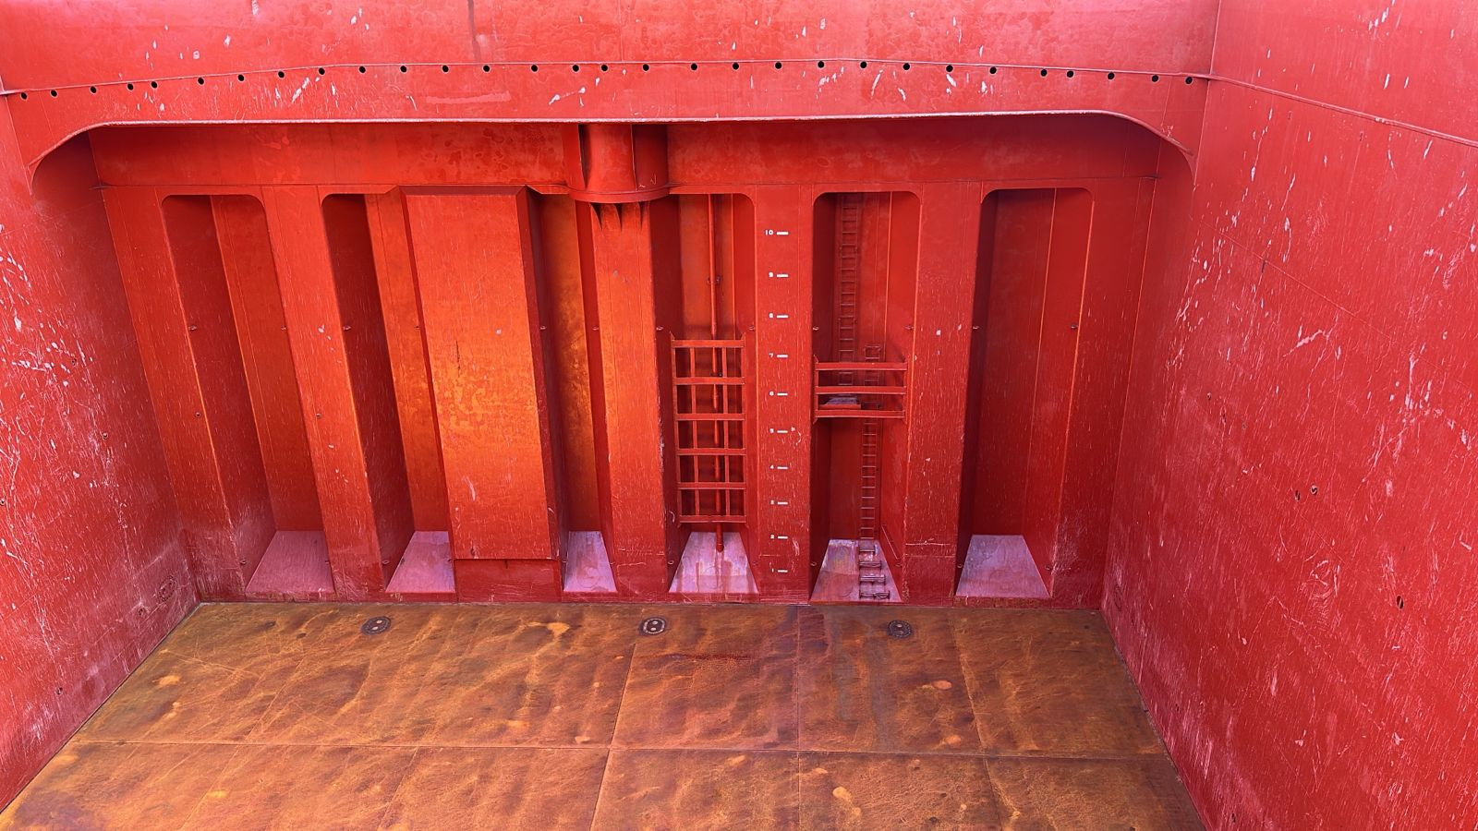
- Hold Nr. 3, bulkhead Fwd.

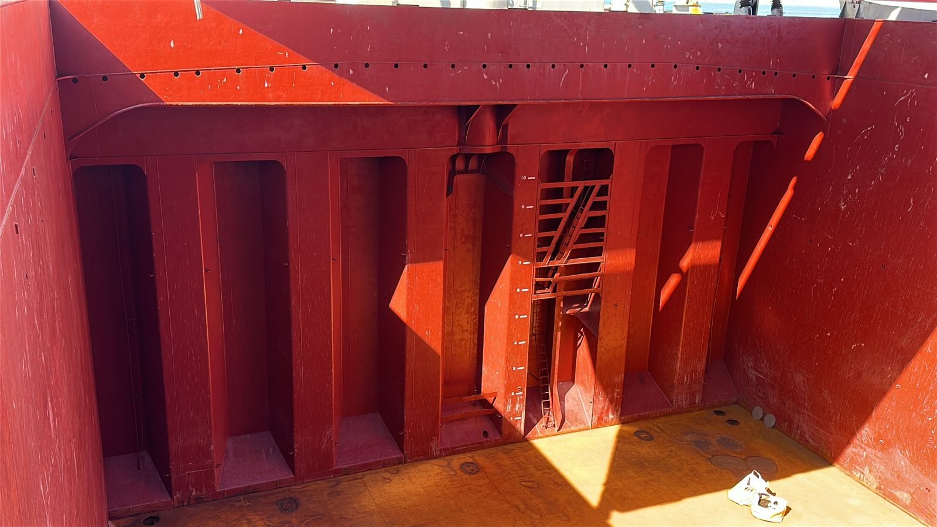
- Hold Nr. 3, after bulkhead

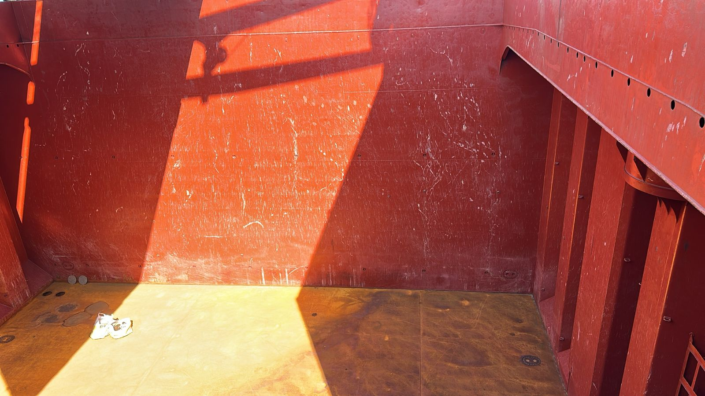
- Hold Nr. 3, star board side plate scratches and rusted

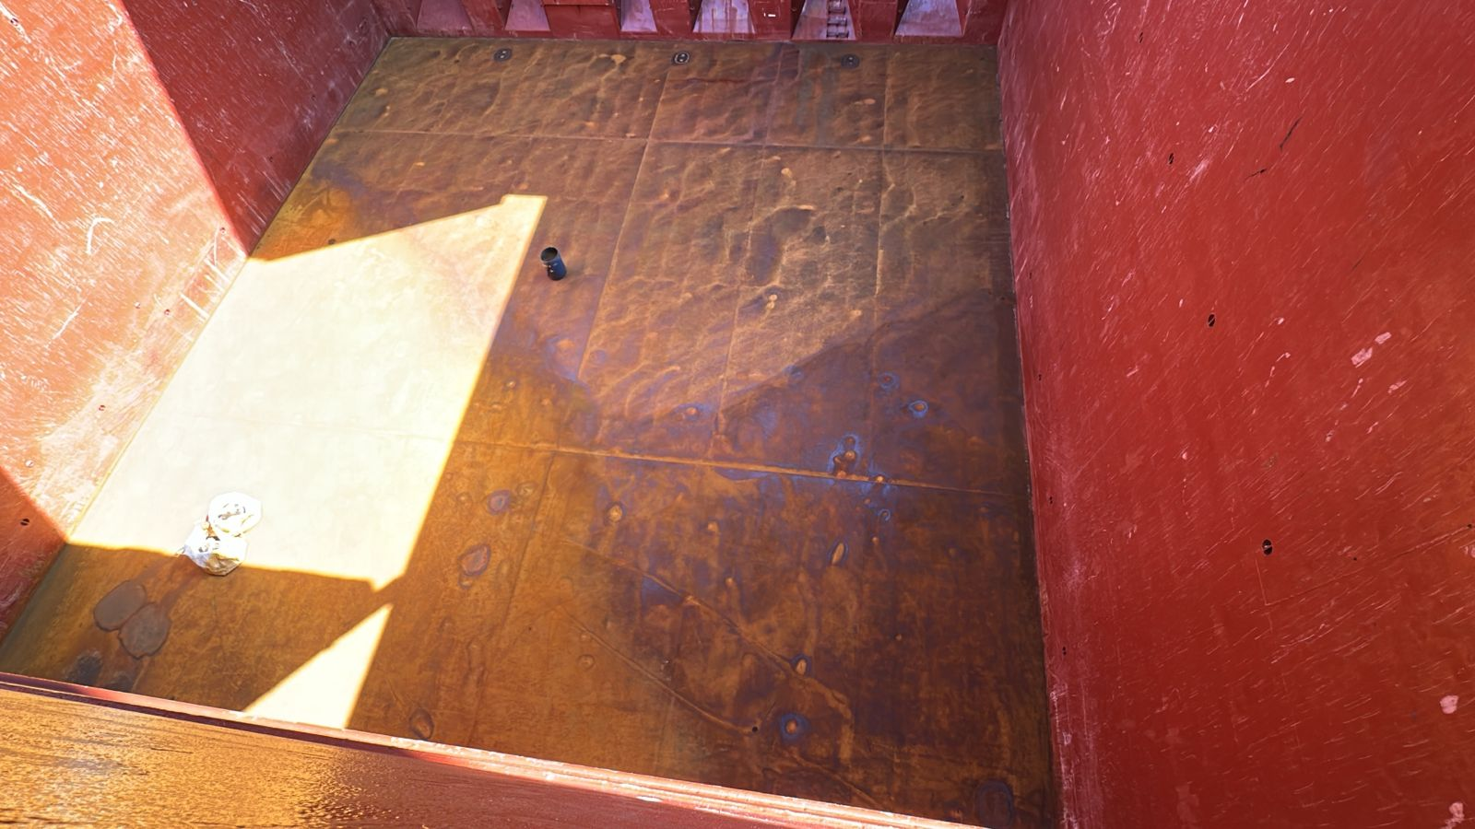
- Hold Nr. 3, Port side shell with scratches

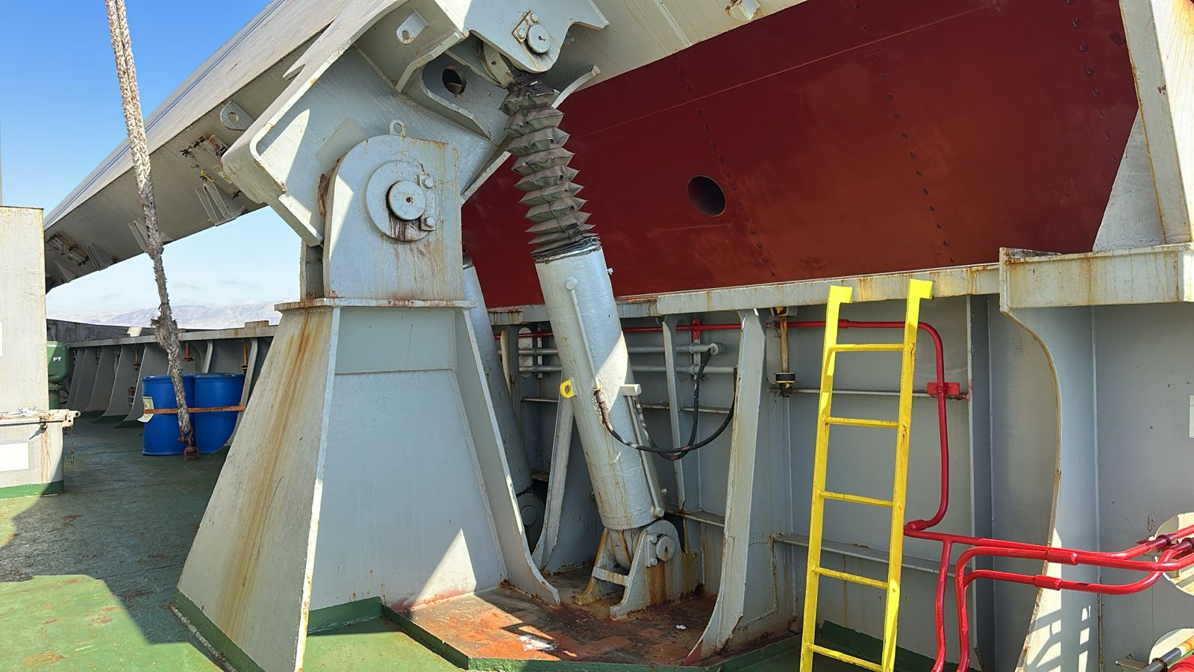
- Hold Nr. 3, hydraulic system in order

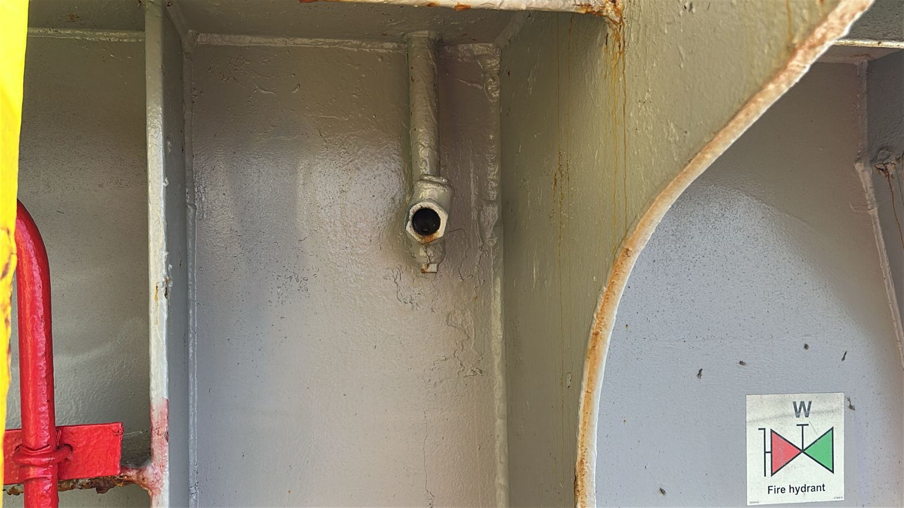
- Hold Nr. 3, non-return valve in good conditions

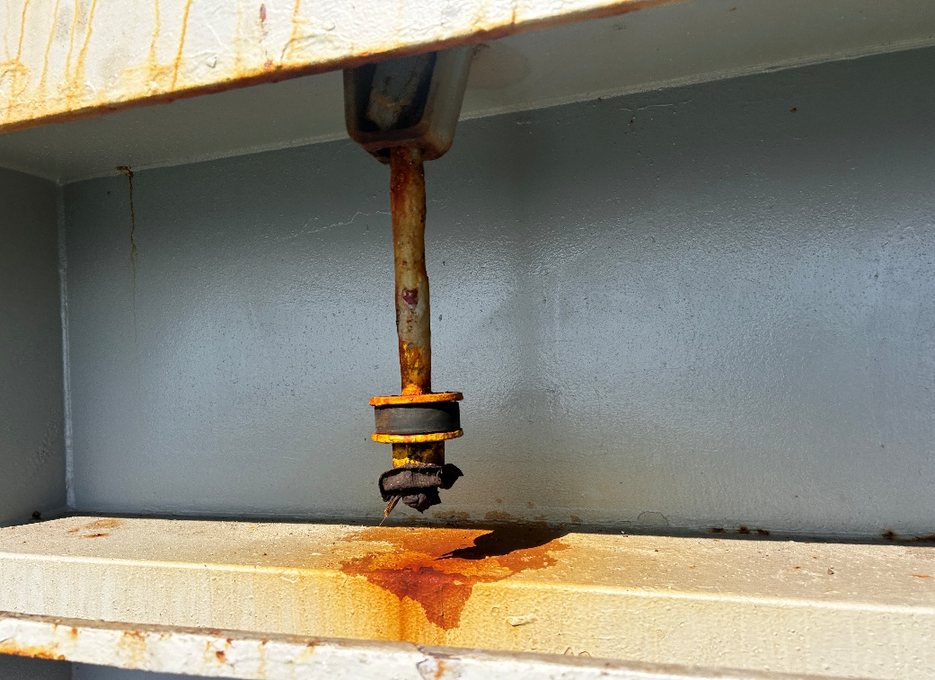
- Hold Nr. 3, actean cleats rusted, operative

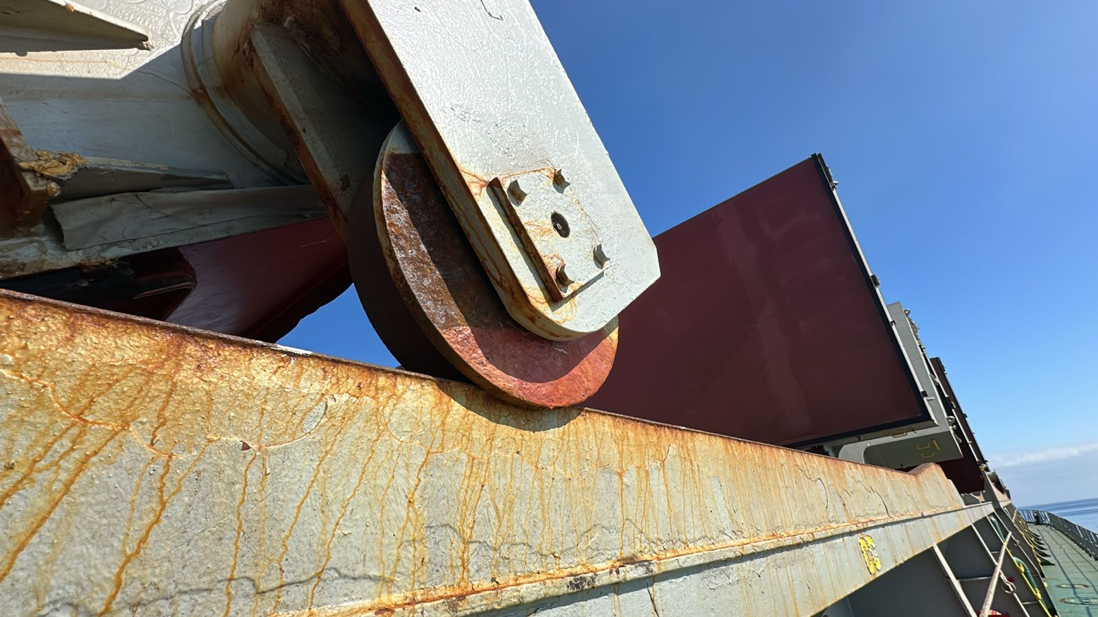
- Hold Nr. 3, roller rusted in good conditions

HATCH & HOLD  NR. 4 | G | F | P | U | Obs Nr
Hatch covers
Hatch coamings
Rubber packing
Draining holes
Acting cleats
Compression bars
Non return valves
Hydraulic Systems
Forward bulkhead |  |  |  |  | 4
After bulkhead |  |  |  |  | 4
Side/shell plating (port) |  |  |  |  | 4
Side/shell plating (stb) |  |  |  |  | 4
Frames, brackets and bracket connection
Tank top plating |  |  |  |  | 4
Hopper tank plating |  |  |  |  | 4
Under deck plating
Manholes and covers
Ventilation, void spaces
Bilges, suctions
Ladders
Air vents
Sounding pipes
Cleaning Condition

OBSERVATIONS:

Nr. 4: Bulkhead fwd, lower stool with paint scratched and rust.

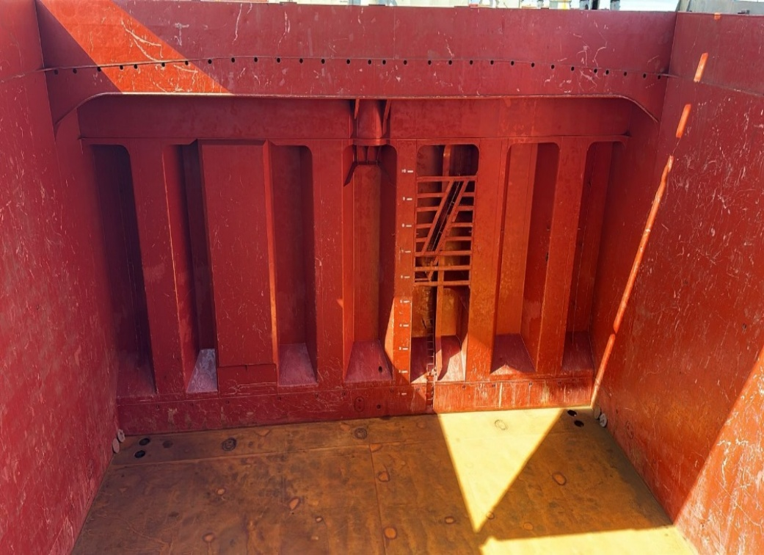
- Hold Nr. 4, bulkhead Fwd.

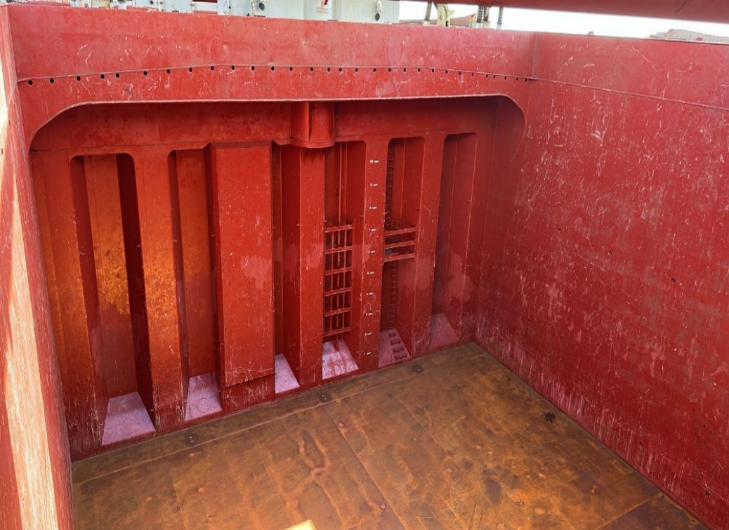
- Hold Nr. 4, after bulkhead

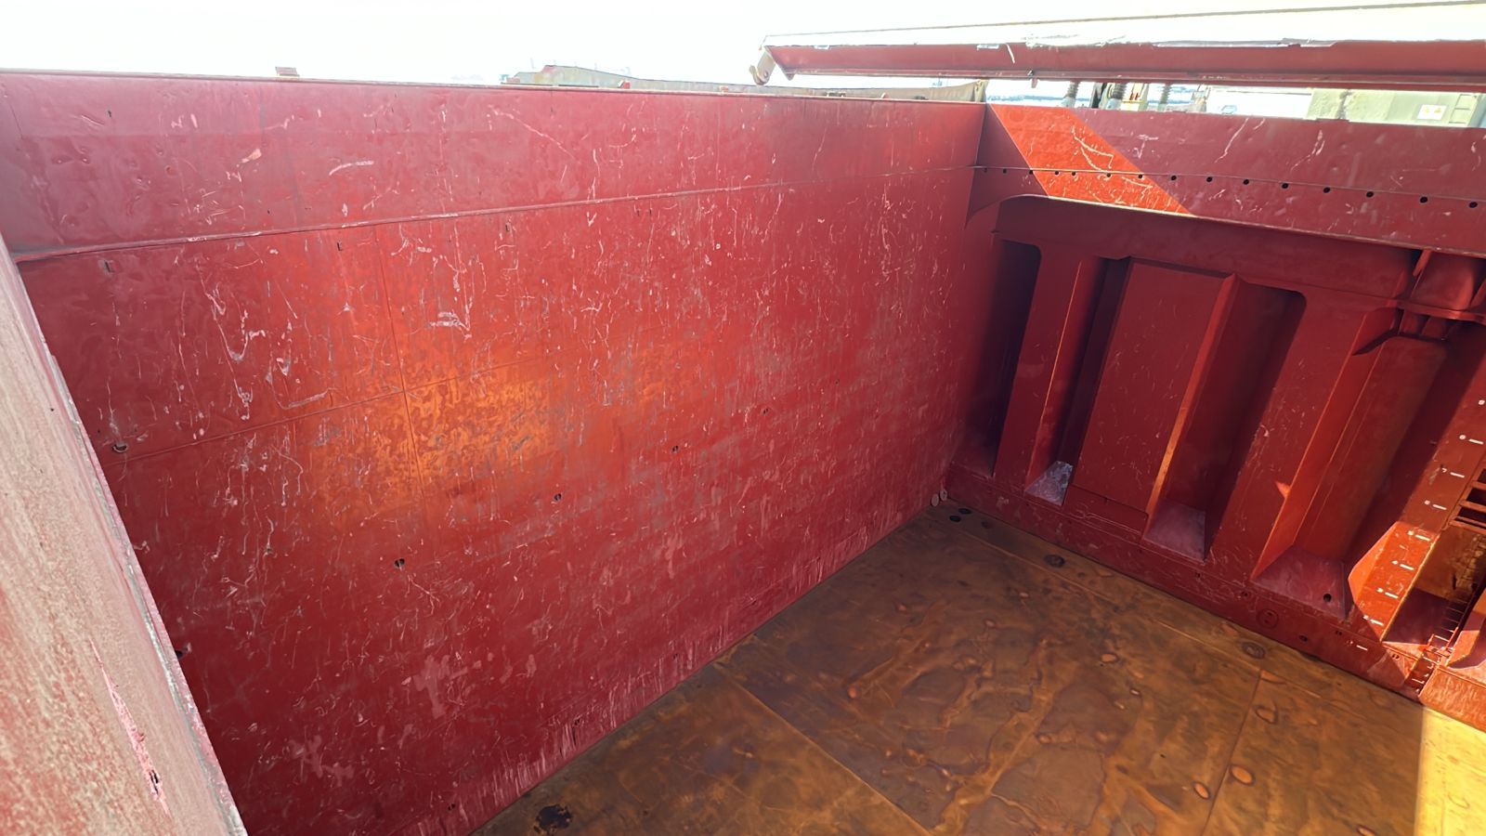
- Hold Nr. 4, star board side plate scratches and rusted

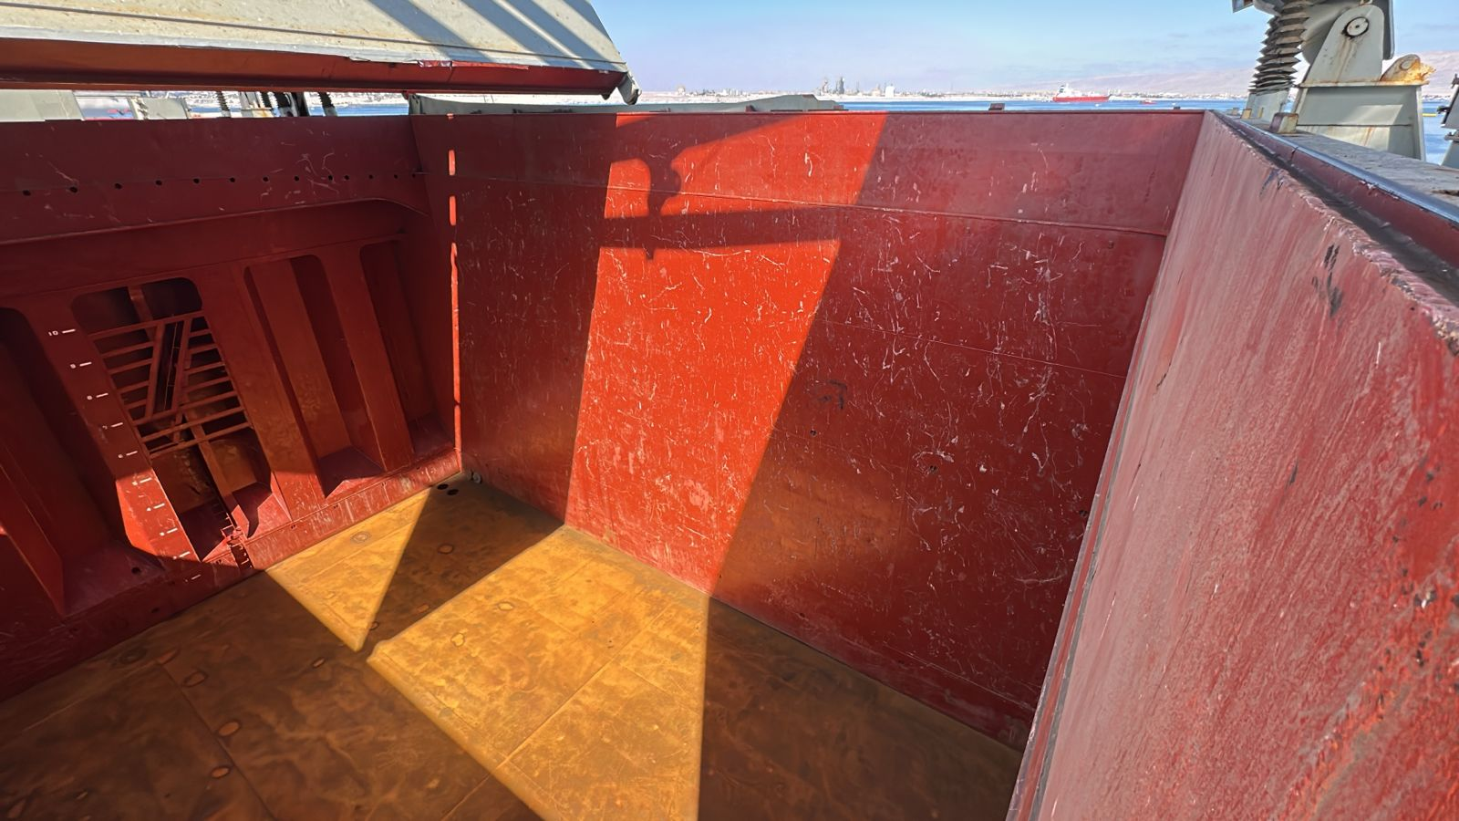
- Hold Nr. 4, Port side shell with scratches

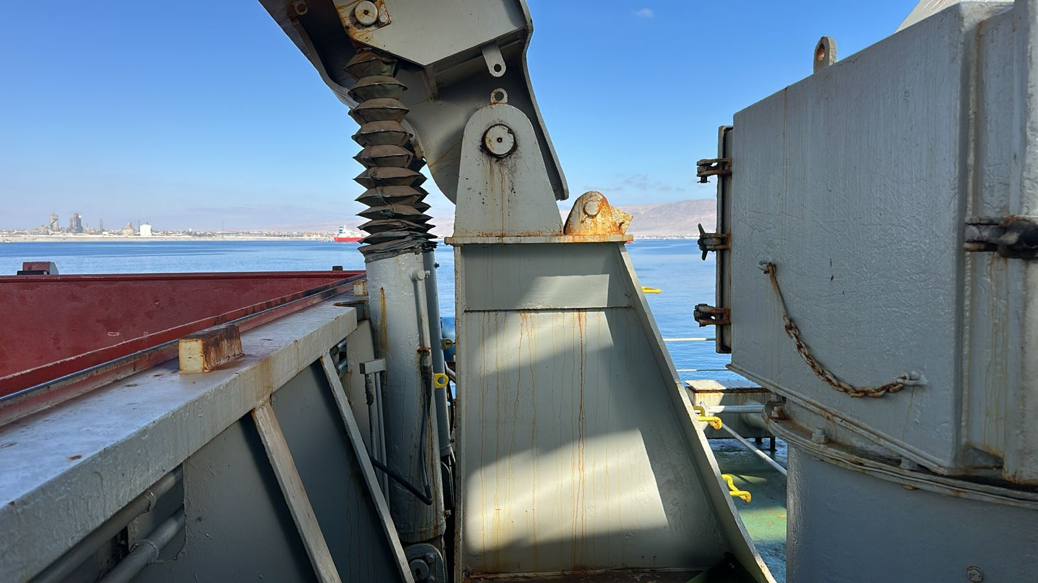
- Hold Nr. 4, hydraulic system in order

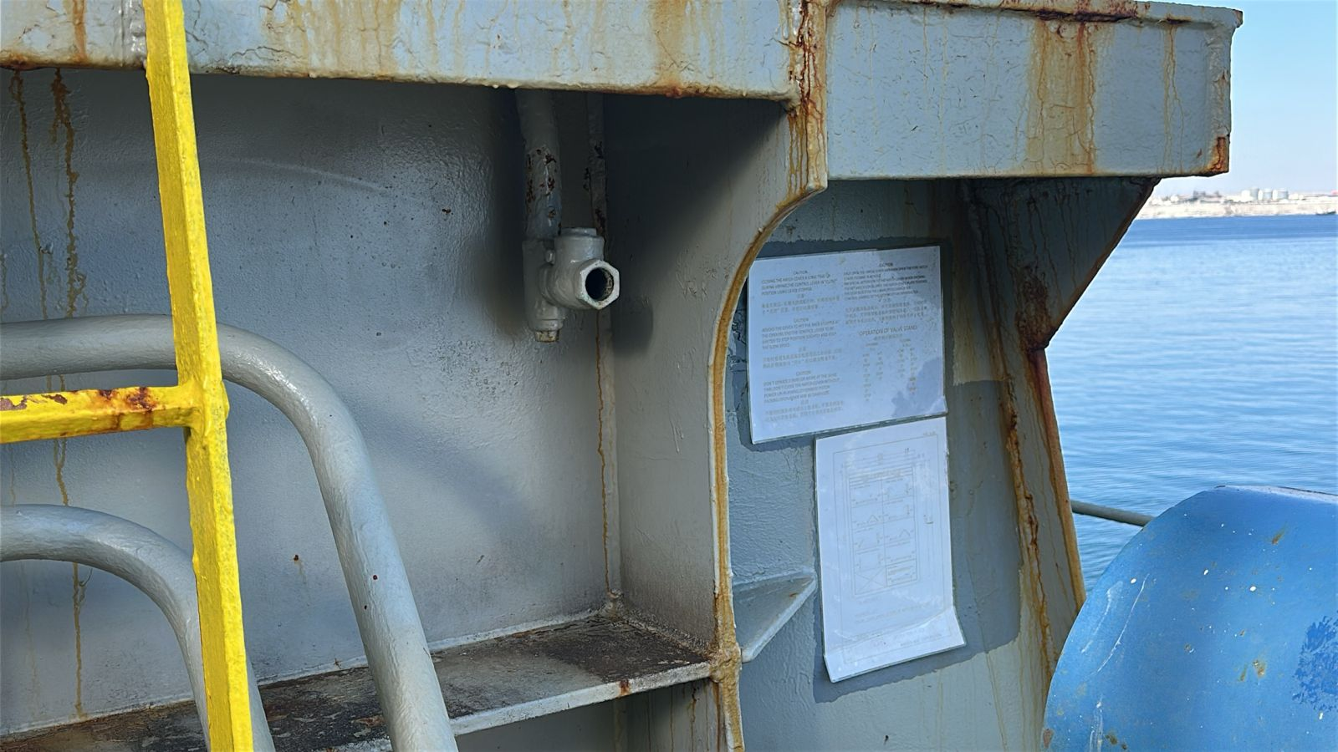
- Hold Nr. 4, non-return valve in good conditions

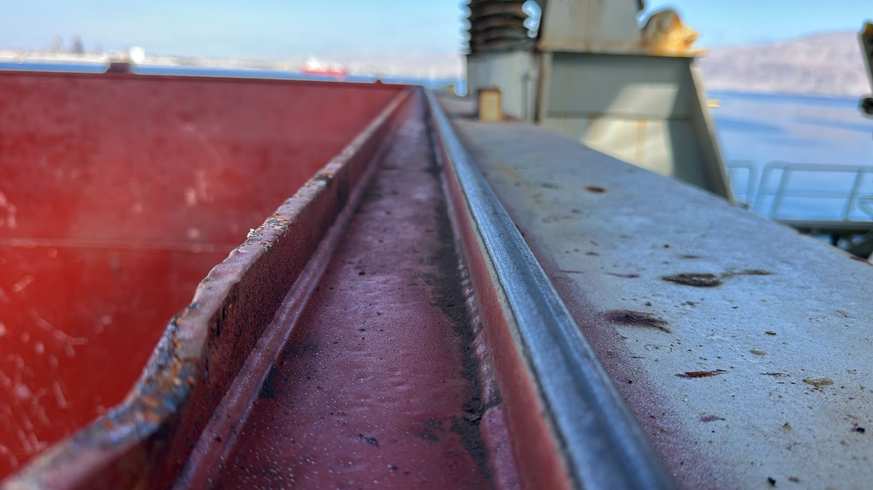
- Hold Nr. 4, compression bar in good conditions

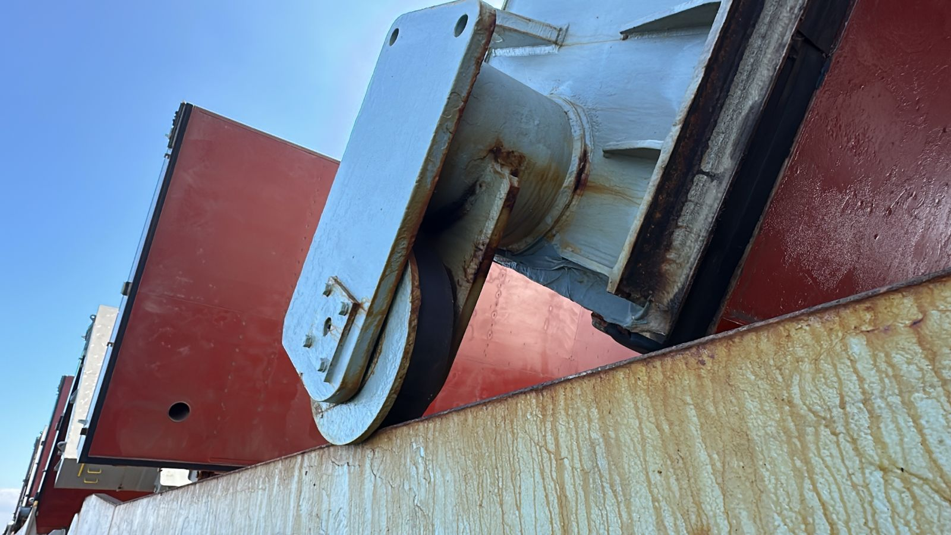
- Hold Nr. 4, roller rusted in good conditions

HATCH & HOLD  NR. 5 | G | F | P | U | Obs Nr
Hatch covers
Hatch coamings
Rubber packing
Draining holes
Acting cleats
Compression bars
Non return valves
Hydraulic Systems
Forward bulkhead |  |  |  |  | 4
After bulkhead |  |  |  |  | 4
Side/shell plating (port) |  |  |  |  | 4
Side/shell plating (stb) |  |  |  |  | 4
Frames, brackets and bracket connection
Tank top plating |  |  |  |  | 4
Hopper tank plating |  |  |  |  | 4
Under deck plating
Manholes and covers
Ventilation, void spaces
Bilges, suctions
Ladders
Air vents
Sounding pipes
Cleaning Condition

OBSERVATIONS:

Nr. 4: Bulkhead fwd, lower stool with paint scratched and rust.

- Hold Nr. 5, bulkhead Fwd.

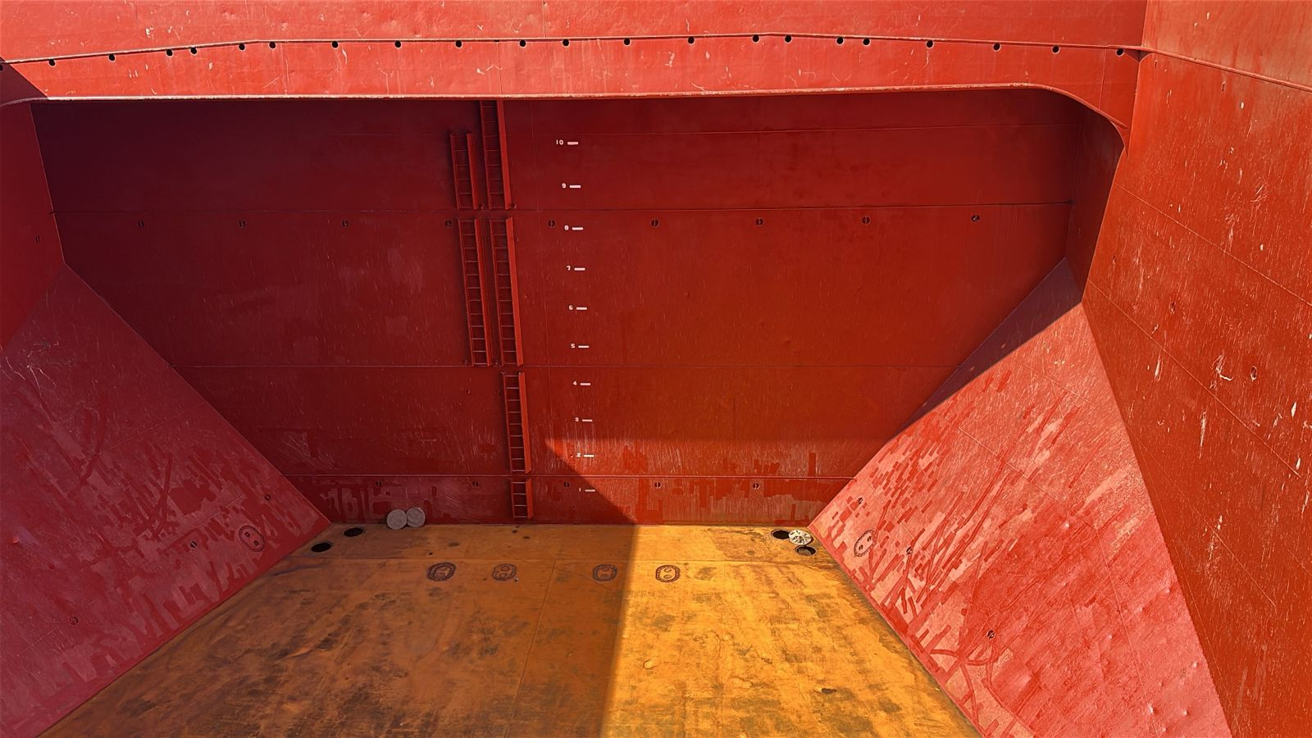
- Hold Nr. 5, after bulkhead

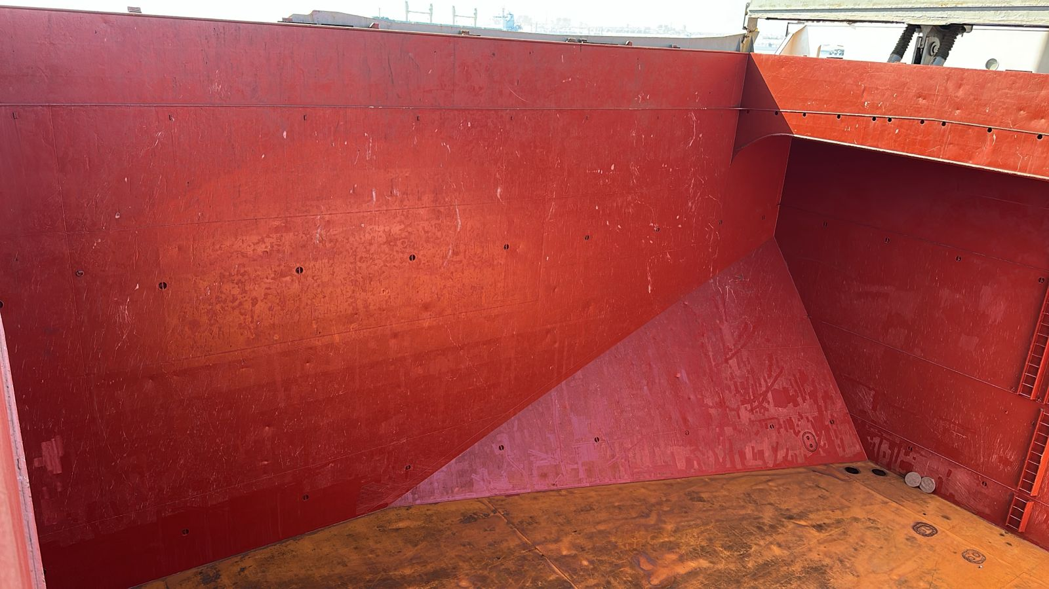
- Hold Nr. 5, star board side plate scratches and rusted

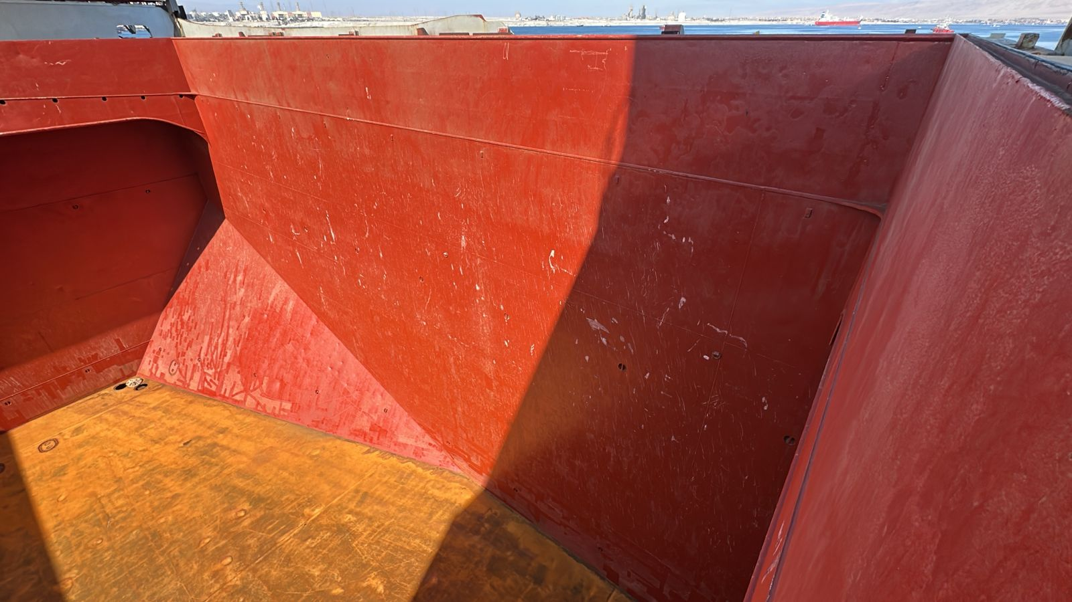
- Hold Nr. 5, Port side shell with scratches

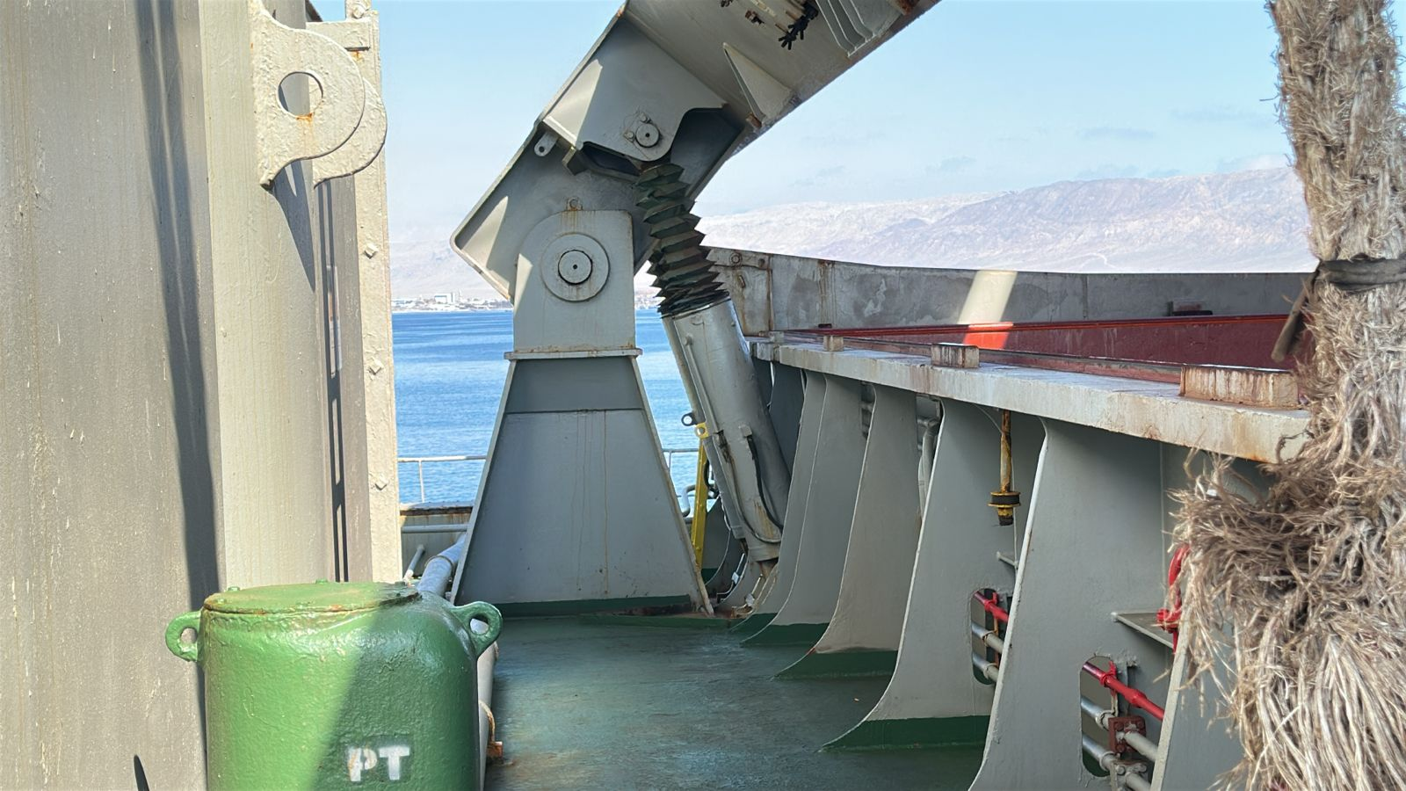
- Hold Nr. 5, hydraulic system in order

- Hold Nr. 5, non-return valve in good conditions

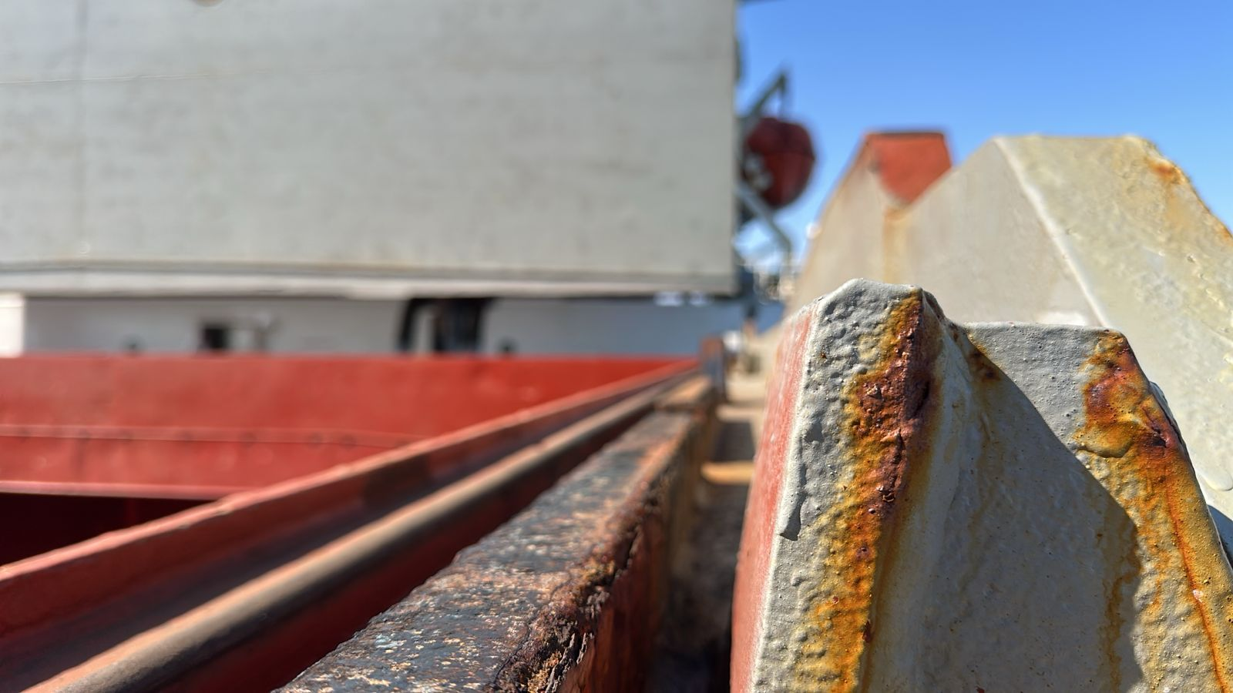
- Hold Nr. 5, compression bar in good conditions

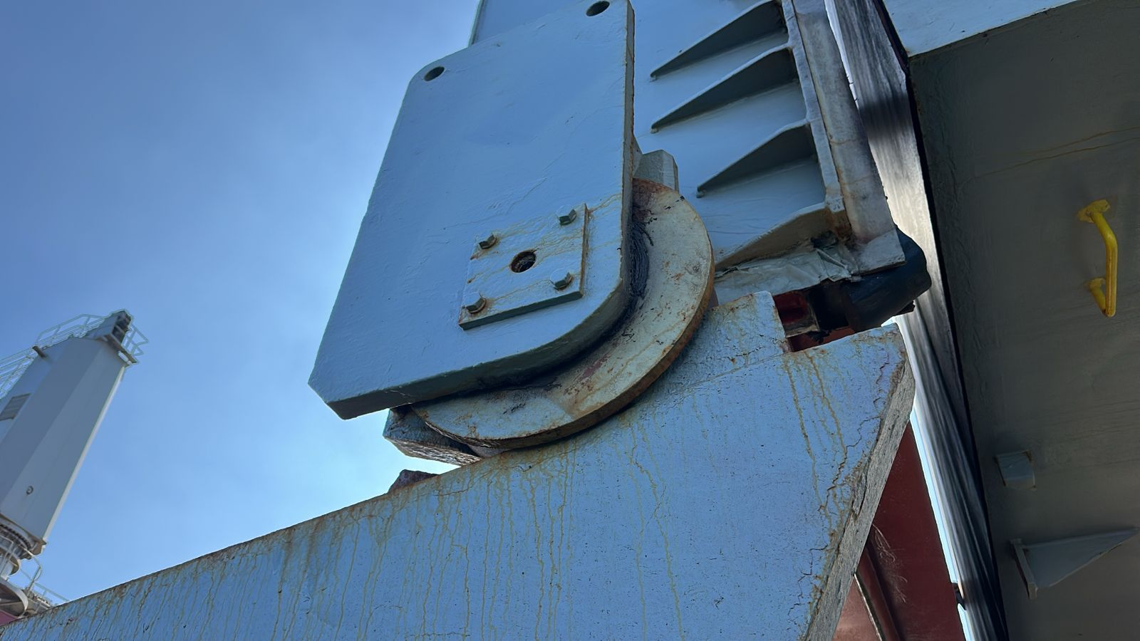
- Hold Nr. 5, roller rusted in good conditions

IX. CARGO GEAR CONDITION

Crane/DERRICK  Nr. 1 | G | F | P | U | Obs Nr |  | CRANE/DERRICK  NR. 2 | G | F | P | U | Obs Nr
Arm/Boom |  |  |  |  |  |  | Arm/Boom
Wires |  |  |  |  |  |  | Wires
Winches |  |  |  |  |  |  | Winches
Controls |  |  |  |  |  |  | Controls
Railings & Ladders |  |  |  |  |  |  | Railings & Ladders
Hydraulic pipes |  |  |  |  |  |  | Hydraulic pipes
Control Cabin Glass |  |  |  |  |  |  | Control Cabin Glass

Crane/DERRICK  Nr. 3 | G | F | P | U | Obs Nr |  | Crane/DERRICK  Nr. 4 | G | F | P | U | Obs Nr
Arm/Boom |  |  |  |  |  |  | Arm/Boom
Wires |  |  |  |  |  |  | Wires
Winches |  |  |  |  |  |  | Winches
Controls |  |  |  |  |  |  | Controls
Railings & Ladders |  |  |  |  |  |  | Railings & Ladders
Hydraulic pipes |  |  |  |  |  |  | Hydraulic pipes
Control Cabin Glass |  |  |  |  |  |  | Control Cabin Glass

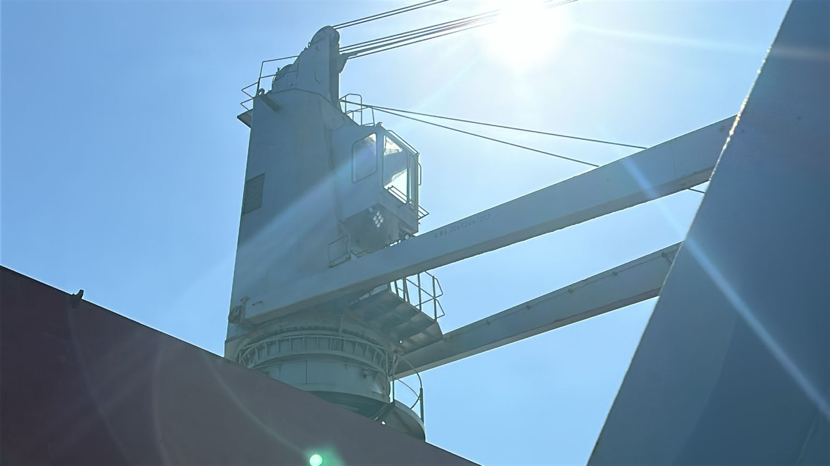
- Crane Nr. 1, external view of cabin

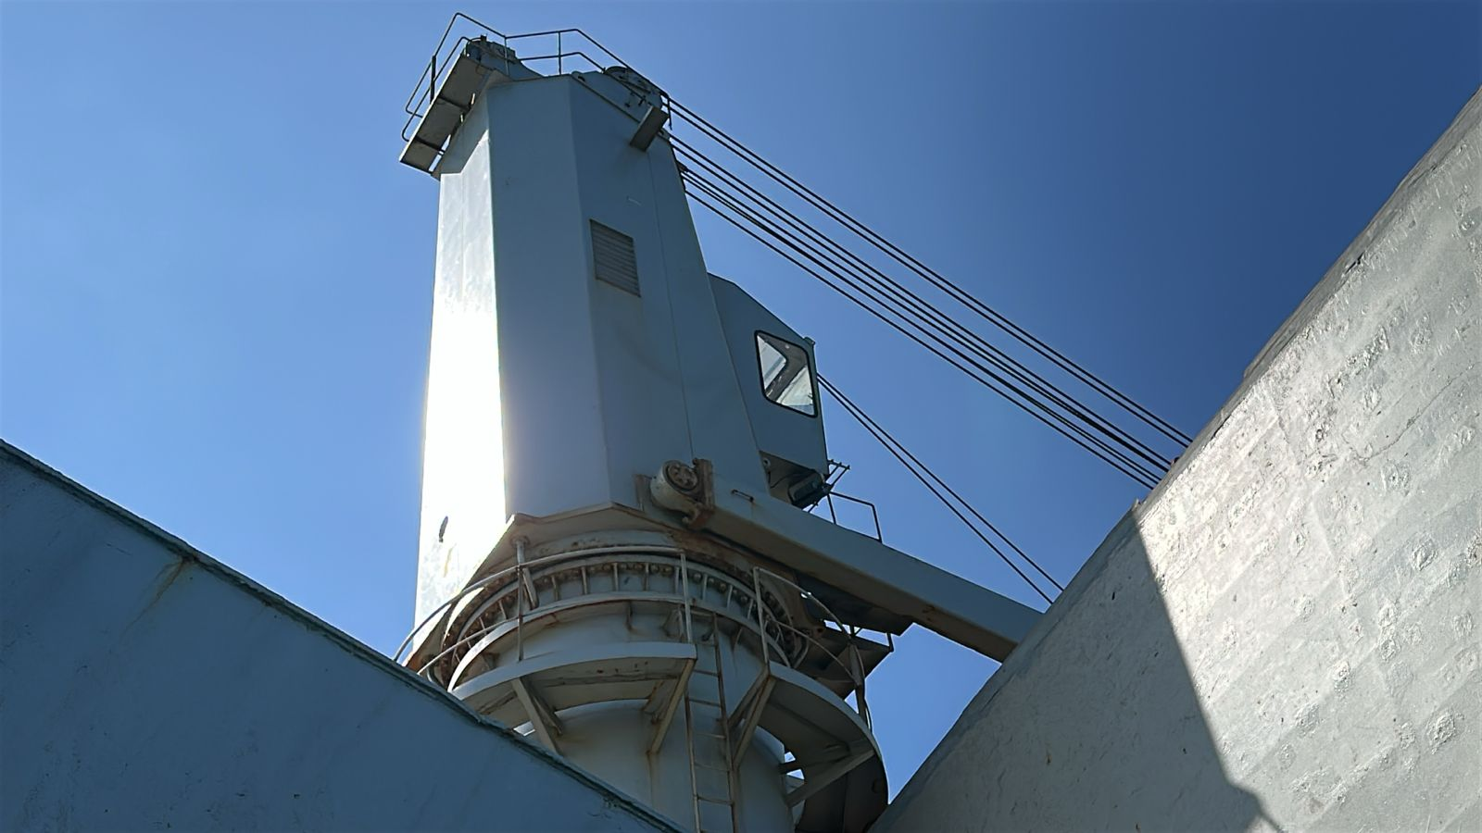
- Crane nr 1. General conditions

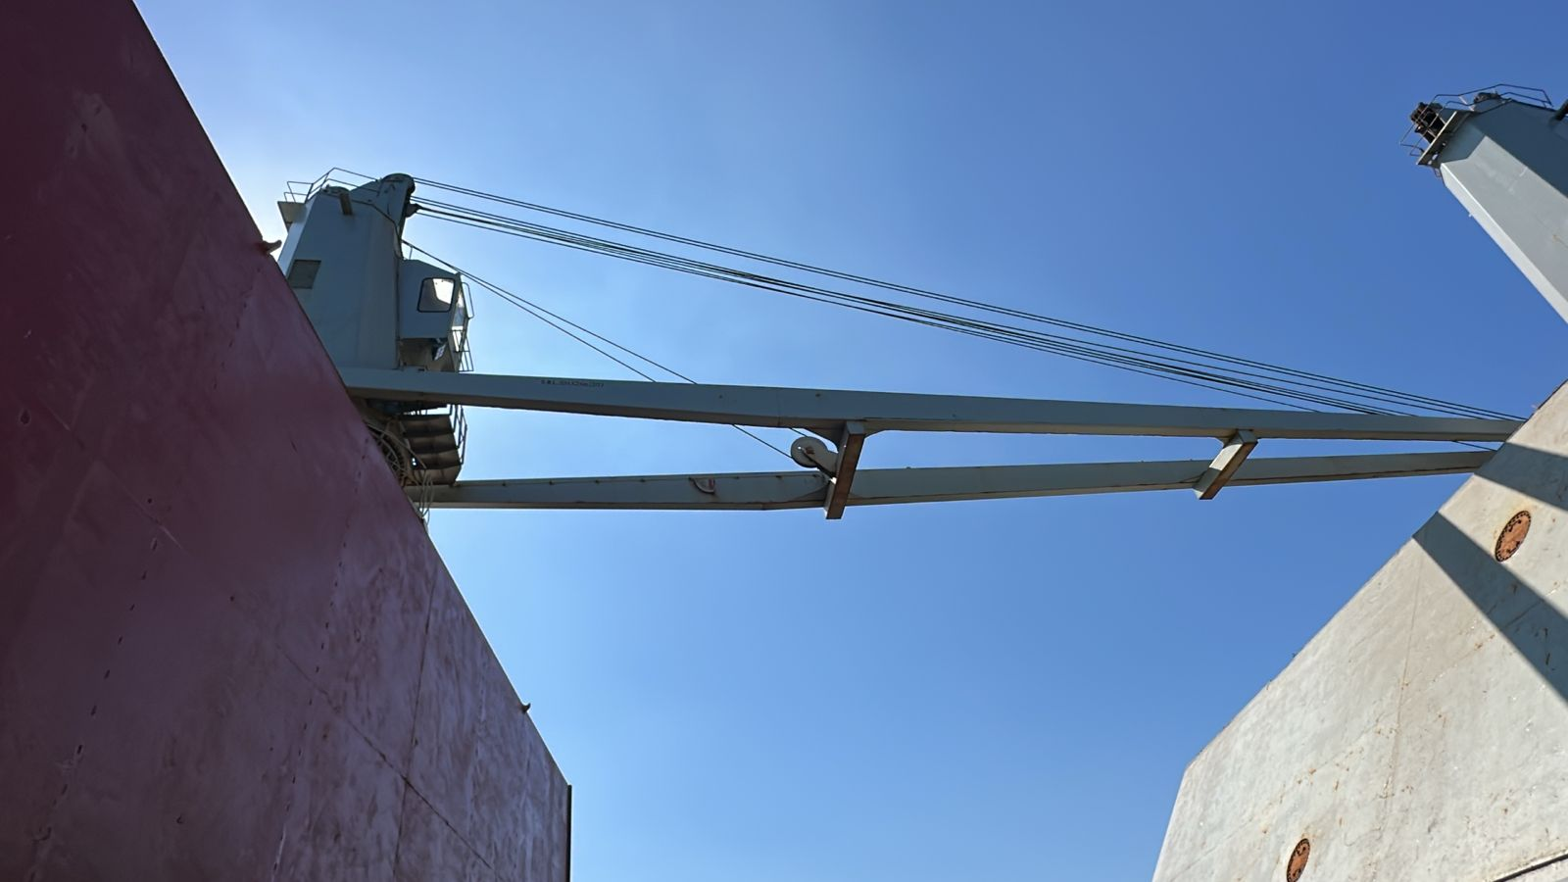
- Crane Nr. 1 arm in good conditions

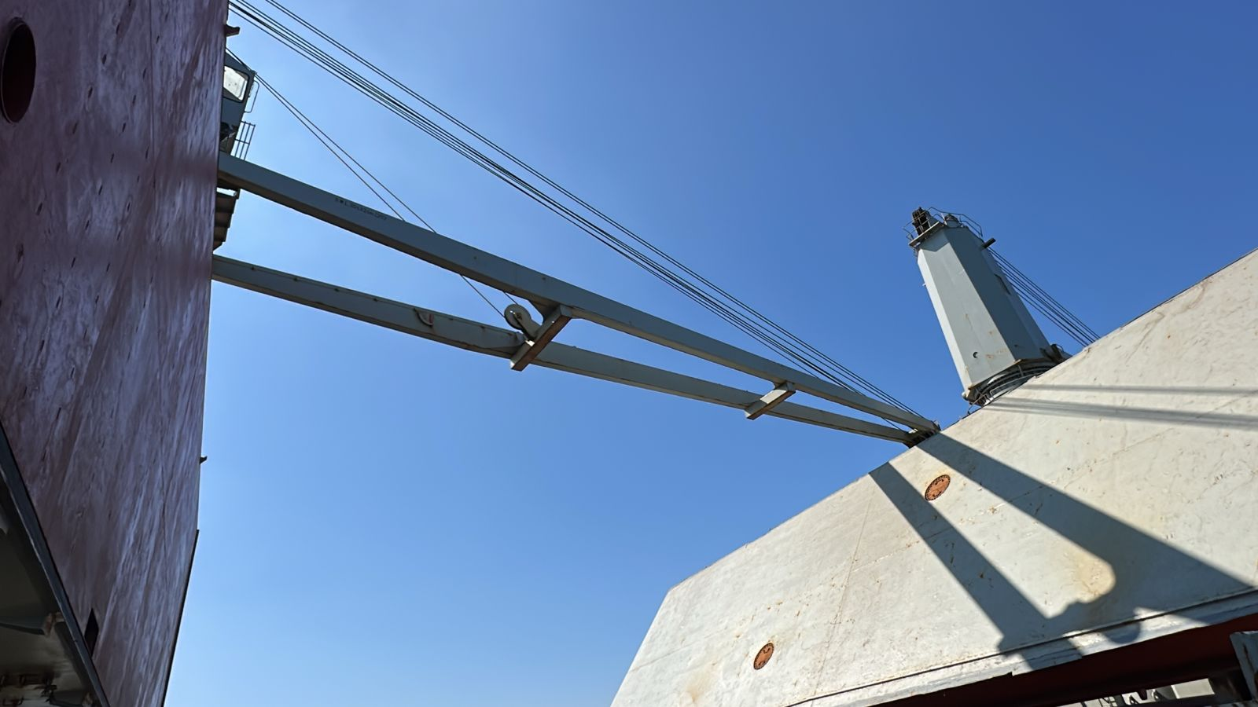
- Crane Nr. 1 general conditions

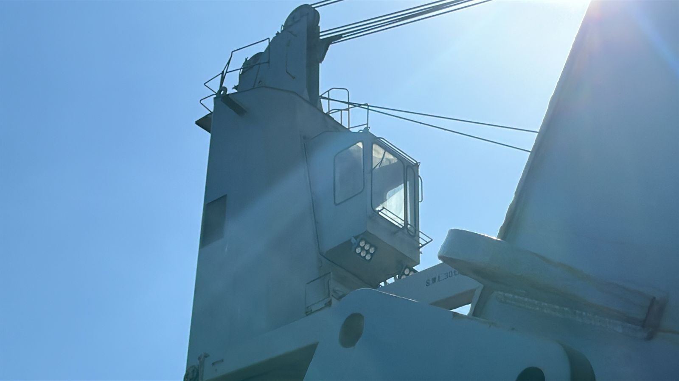
- Crane Nr. 2, external view of cabin

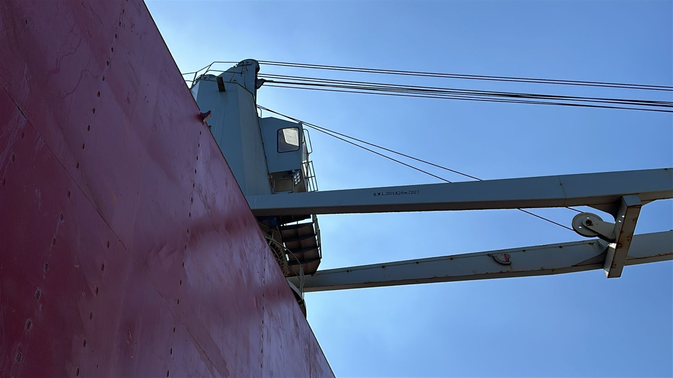
- Crane nr 2. General conditions

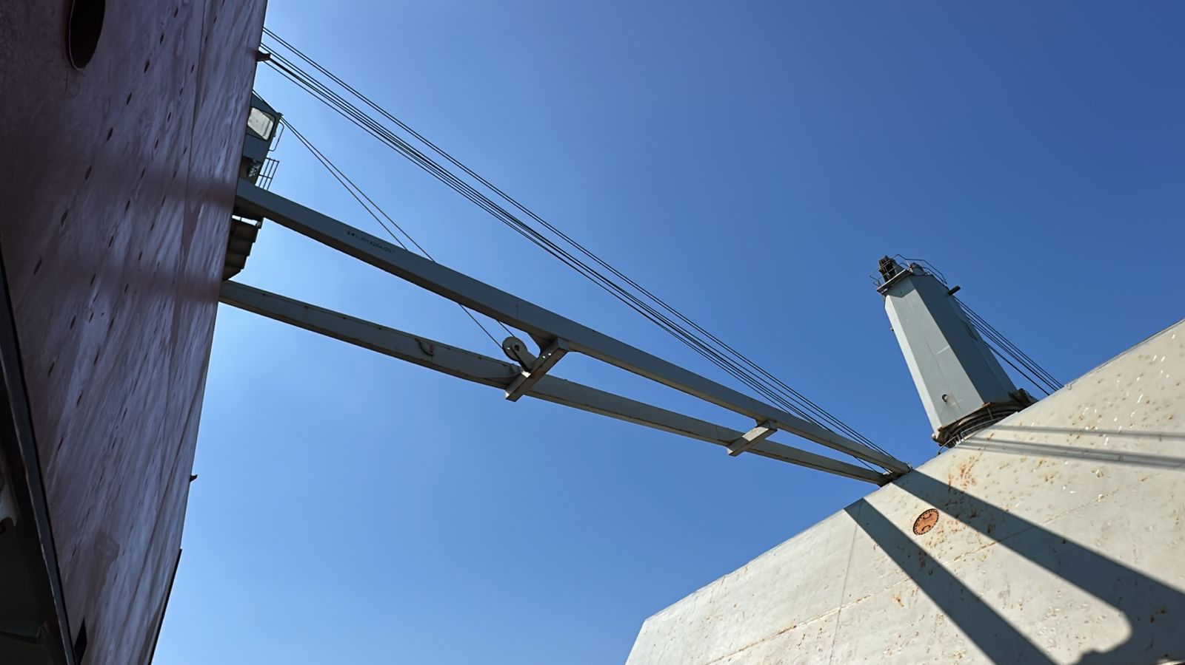
- Crane Nr. 2 arm in good conditions

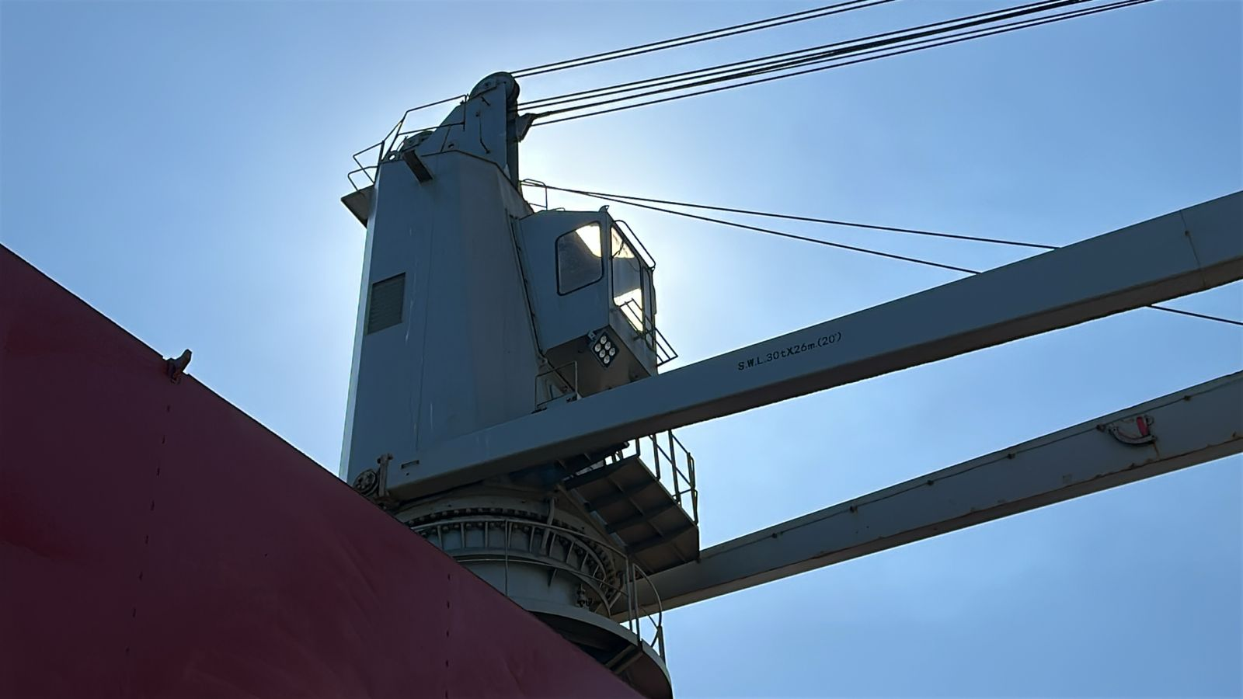
- Crane Nr. 2 SWL duly marked

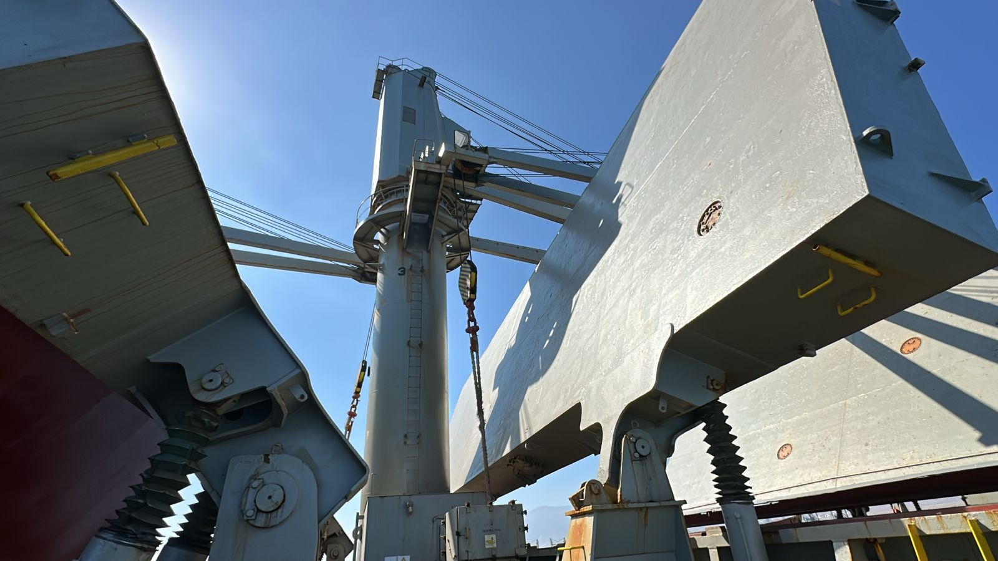
- Crane Nr. 3, external view of cabin

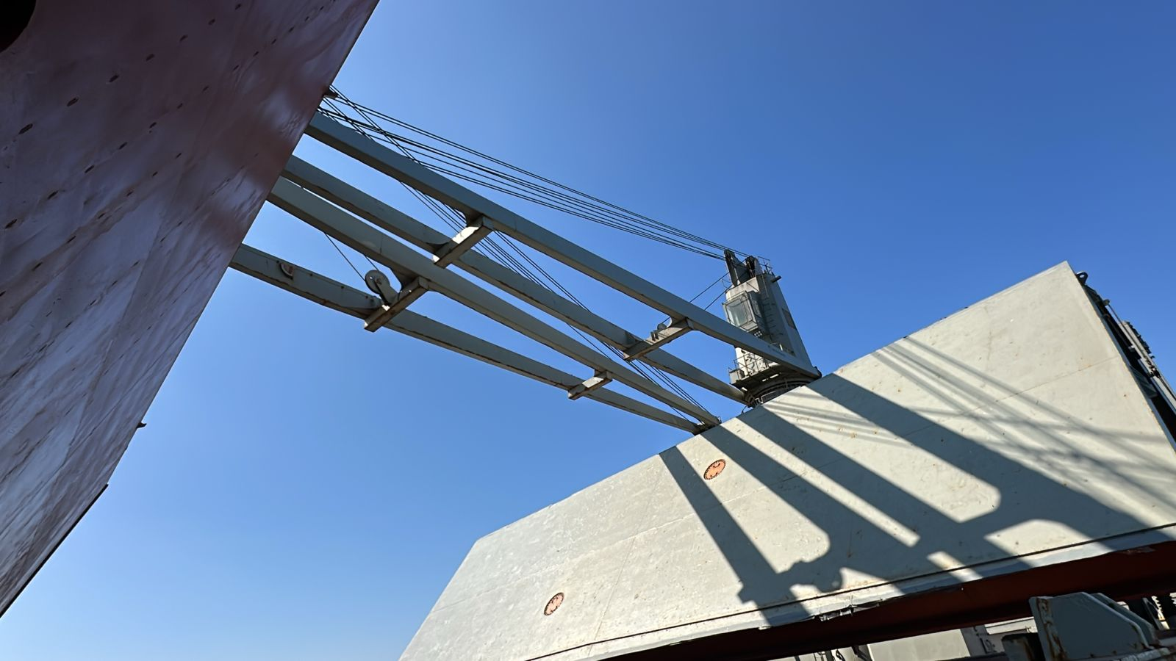
- Crane nr 3. General conditions

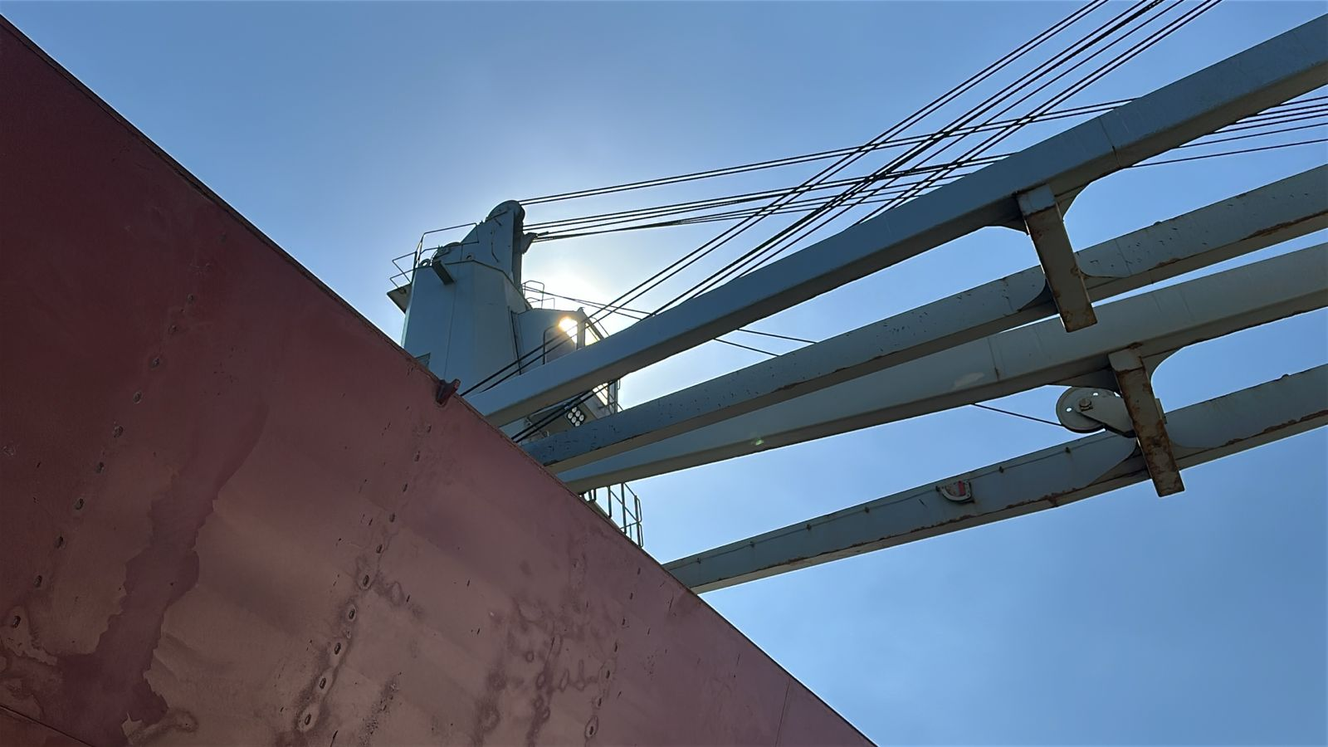
- Crane Nr. 3 arm in good conditions

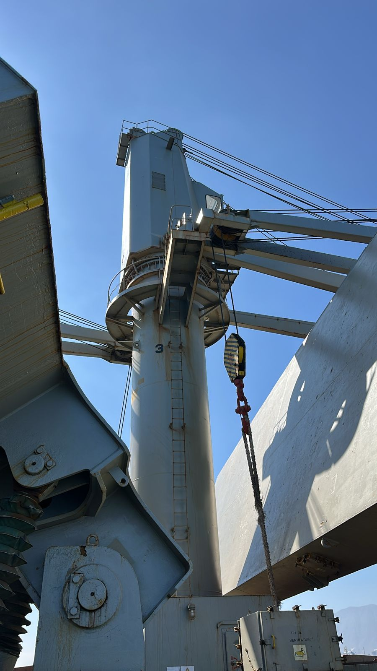
- Crane Nr. 3 external view of cabin

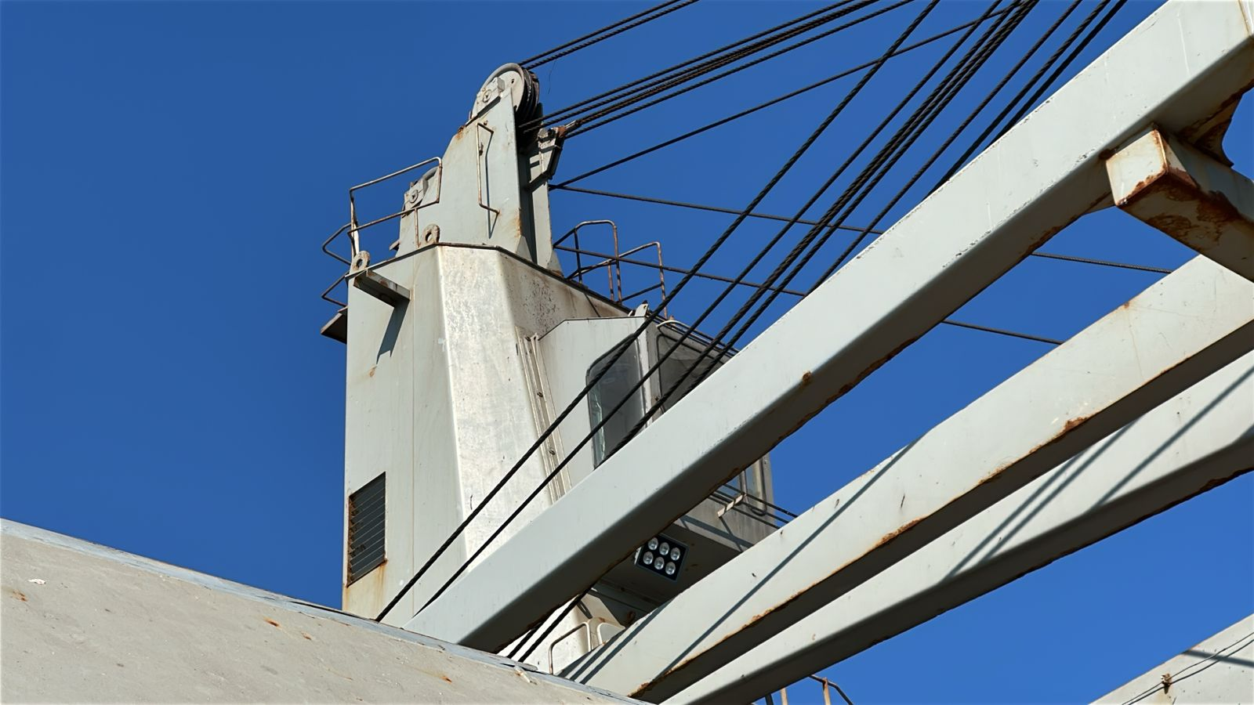
- Crane Nr. 4, external view of cabin

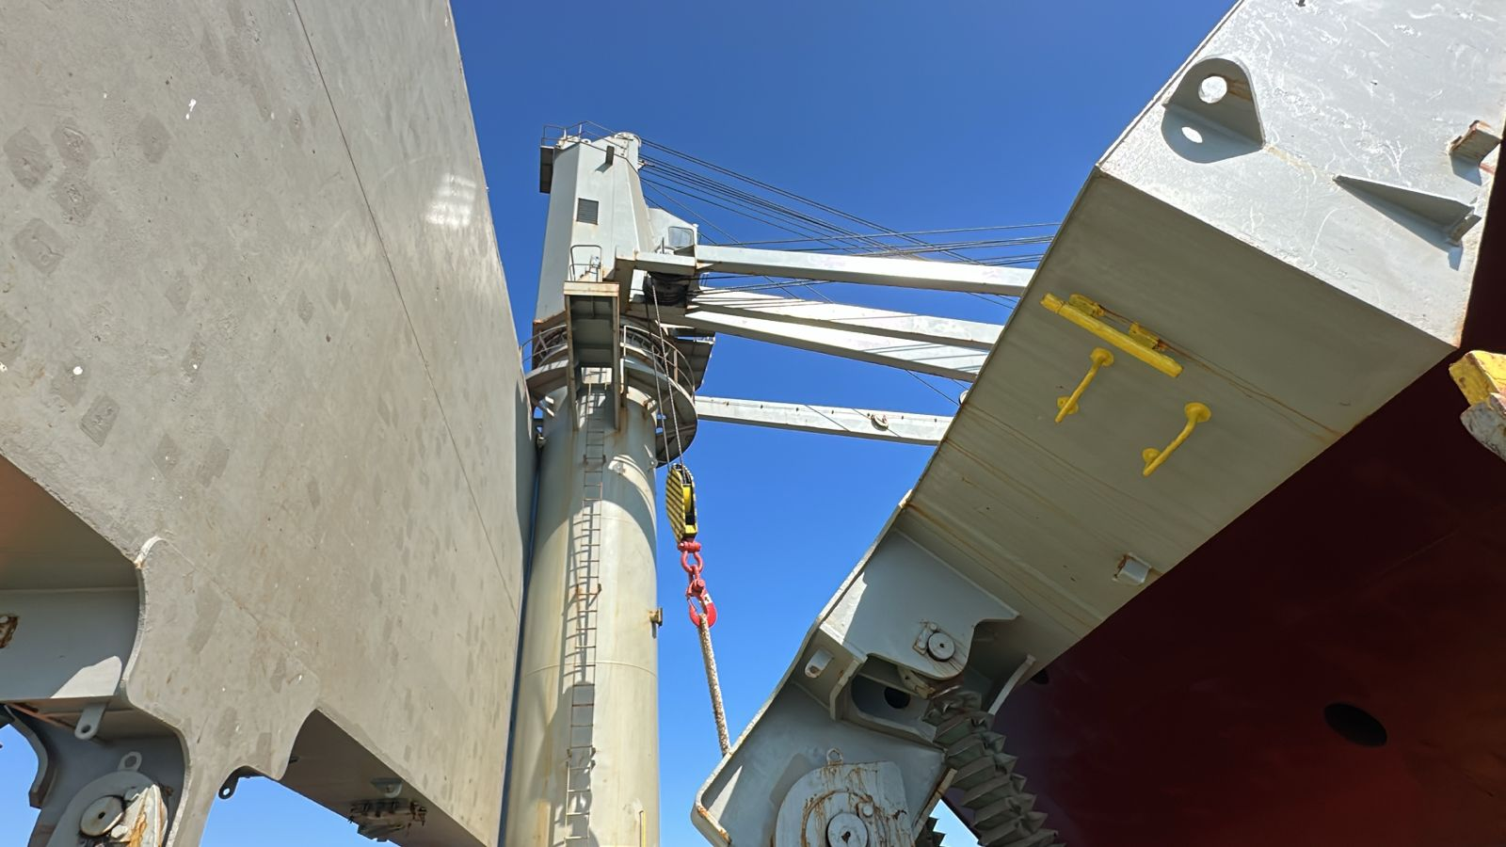
- Crane nr 4. General conditions

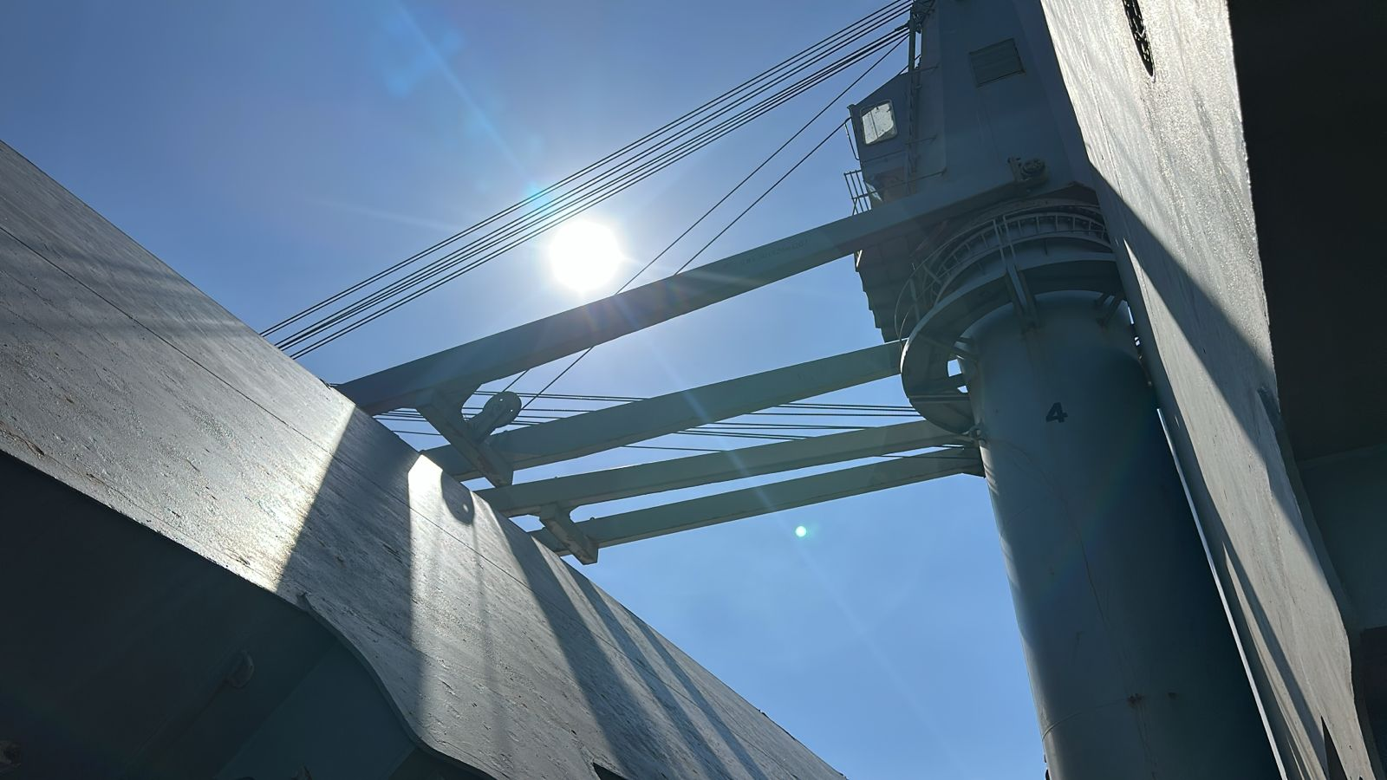
- Crane Nr. 4 arm in good conditions

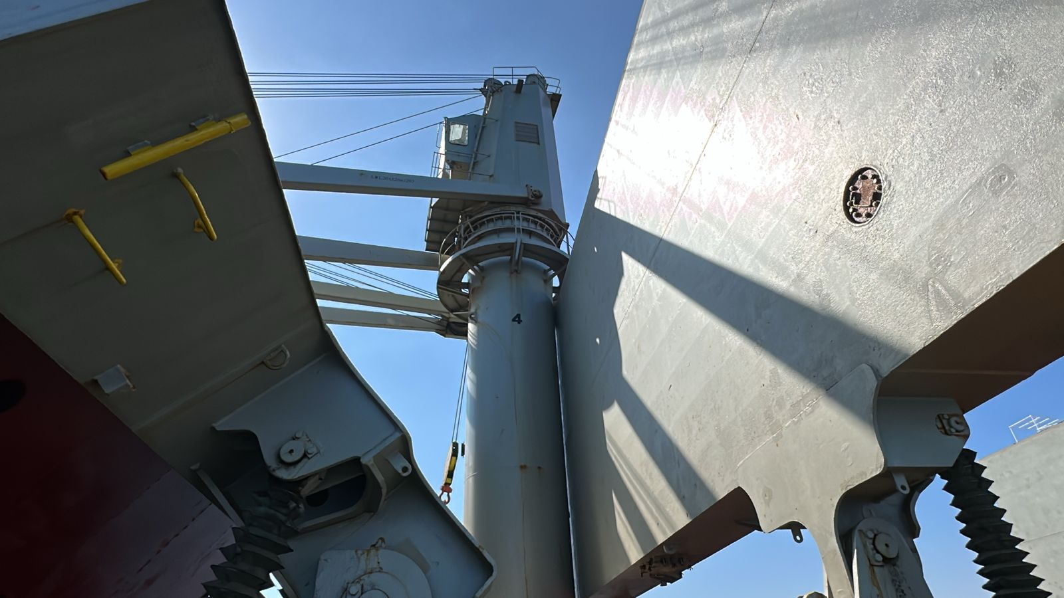
- Crane Nr. 4 externa view of cabin

X. BUNKER SURVEY

The following quantities were found onboard as calculated by Chief Engineer and the undersigned surveyor, from the ship’s calibration curves with due consideration to the trim of the vessel, temperature and specific gravity of oil:

Quantities found at Bunker Survey time on May 19,2026 at 11:00 hours LT (May 16, 2026 at 15:00 hours (UTC):

Consumption of Bunkers between Delivery time and Bunker survey:

Quantity of Bunkers at Delivery time on May 15, 2026 at 10:48 hours LT (May 15, 2026 at 15:48 hours UTC) at Pilot Station, Pisco, Peru:

XI. ATTENDING PARTIES

Name | Position | Company | On behalf of
Mr. Kang, Huaihong | Captain | MV Aquamarine SW | Owners
Mr. Ding , Jie | Chief Officer | MV Aquamarine SW | Owners
Mr. Li, Yongkang | Chief Engineer | MV Aquamarine SW | Owners
Mr. Ivan Meneses | Surveyor | ALS Inspection | Norden AS
Mr. Mauricio Lopez | Surveyor | ALS Inspection | Norden AS

XII. ATTACHMENTS

- Delivery Bunker Certificate

This survey was carried out without prejudice and in the interest of whom it may concern.

Surveyor
ALS Inspection Chile Spa

Prepared by : M. Lopez
Reviewed by : A. Paredes
Validated by : J. Lopez

