TRUCK CERTIFICATION FOR EXPLOSIVES TRANSPORTATION

ALS REFERENCE
ARI-2601-0347

INSPECTION ON BEHALF OF
ORICA Chile S.A.

REQUESTED BY
Mss. Maria Fernanda Poblete

TRUCK MODEL
VOLKSWAGEN

TRUCK PLATE
BEP5A04

ALS INSPECTION SURVEYOR
Gonzalo Bacian Valdivia

PLACE OF INSPECTION
Recinto STORAGE & SECURITY SOLUTIONS SPA
Pampa Chaca Km1, Ruta A-31, Arica

REFERENCE
CAPSULAS OP 4800075547 - 4800075302 BRASIL

ATTENDANCE DATE
January 29, 2026

1.-Truck certification for explosives transportation
Truck model: | Volkswagen
Carrier: | TLGA TRANSPORTES DO BRASIL
Name of driver: | Thiago Silva Marinho
License expiration date: | 17.01.2033

2.- General overview of unit subsystems
2.1.- Load ramp | Compliance
2.2.- Load gangway | Compliance
2.3.- Interior lining | Compliance
2.4.- Tires condition | Compliance
2.5.- Suspention condition | Compliance
2.6.- Wheeling system | Compliance
2.7.- Brake system | Compliance
2.8.- Electric system | Compliance
2.9.- King Pin | Compliance
2.10.- Chasis subsystems | Compliance
2.11.- Truck | Compliance
3.- General overview of safety accessories
3.1.- Extinguishers | Compliance
3.2.- Exhaust spark arrest | Compliance
3.3.- Exhaust thermal insulator | Compliance
3.4.- Battery cover | Compliance
3.5.- Ground Chains (2) | Compliance
3.6.- Elect. Handles Static | Compliance
3.7.- Flags | Compliance
3.8.- Signage | Compliance
3.9.- Rhomb class | Compliance
3.10.- Explosive’s sign | Compliance
3.11.- Safety cones | Compliance
Remark: This certificate will be considered only as reporting of the unit in particular
4.- Through this document ALS INSPECTION CHILE SPA certifies that
4.1.- The equipment for explosives transportation is SUITABLE to operate | YES
4.2.- The safety accessories of the equipment are adequate and sufficient | YES
5.- ALS INSPECTION CHILE S.P.A comments
- Exhaust thermal insulation was observed without coating, staff Storage Solution performs the complete coating.

Date & Time of Survey | January 29, 2026 / 08:30 to 14:35 hrs.

This survey was carried out without prejudice and in the interest of whom it may concern.
SURVEYOR ALS INSPECTION CHILE SPA. | Gonzalo Bacian V. | 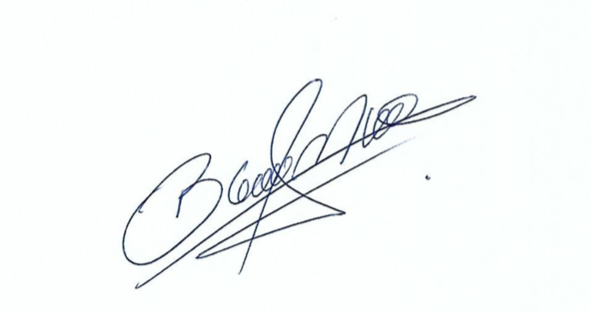

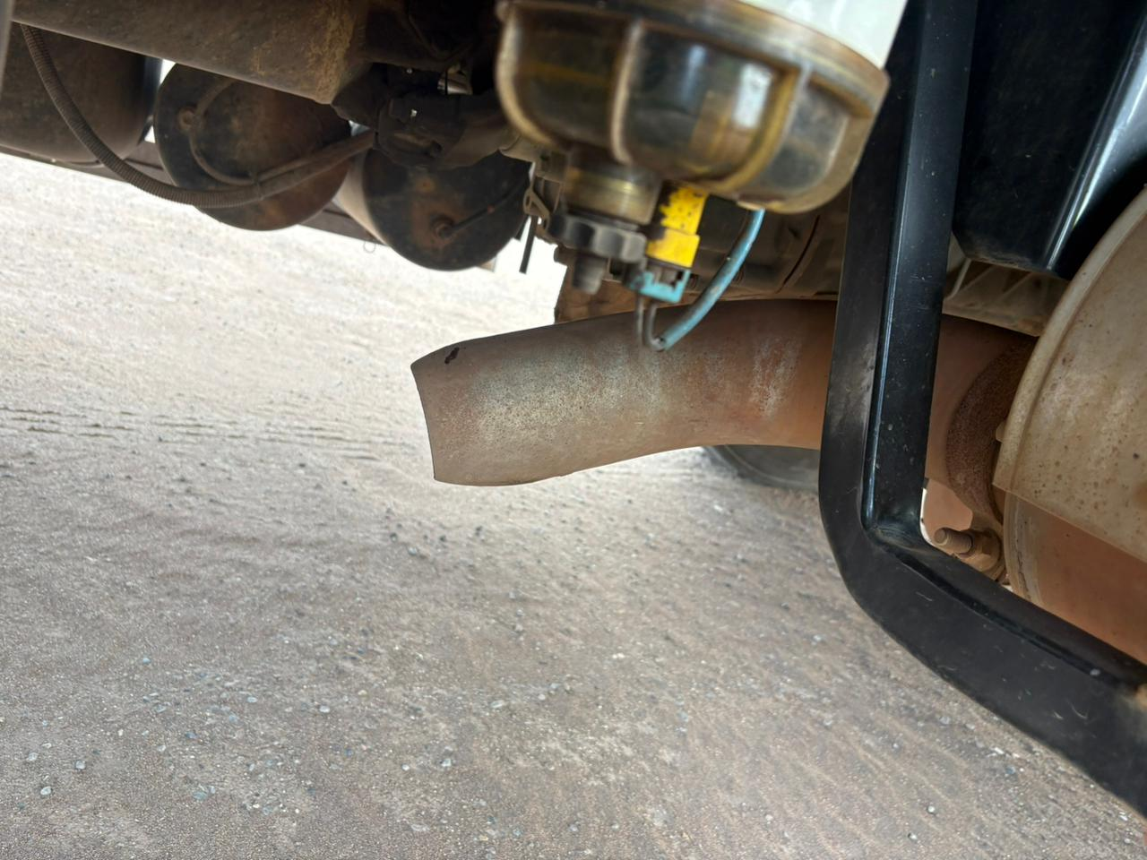 | 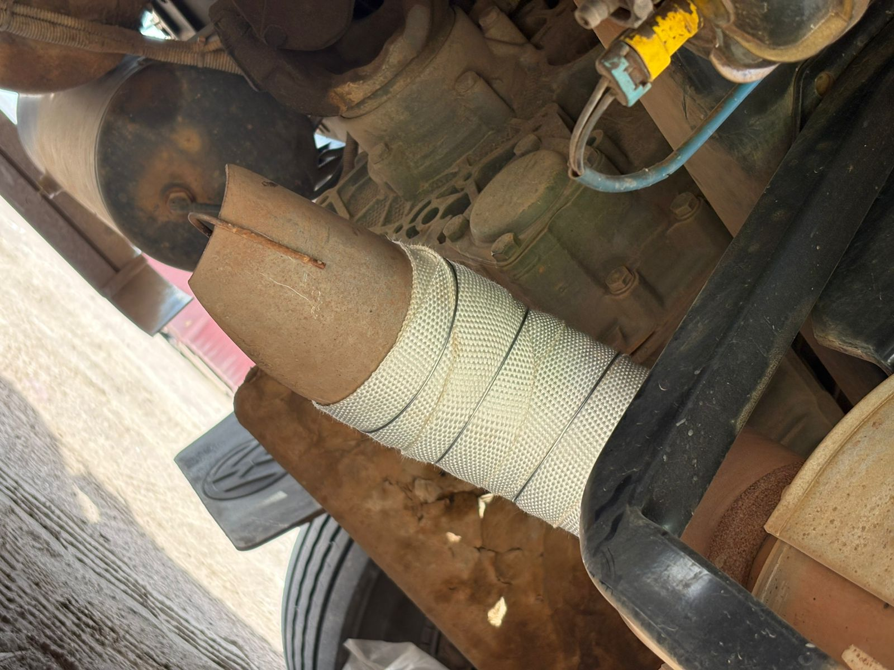
Exhaust thermal insulation was observed without coating, staff Storage Solution performs the complete coating.

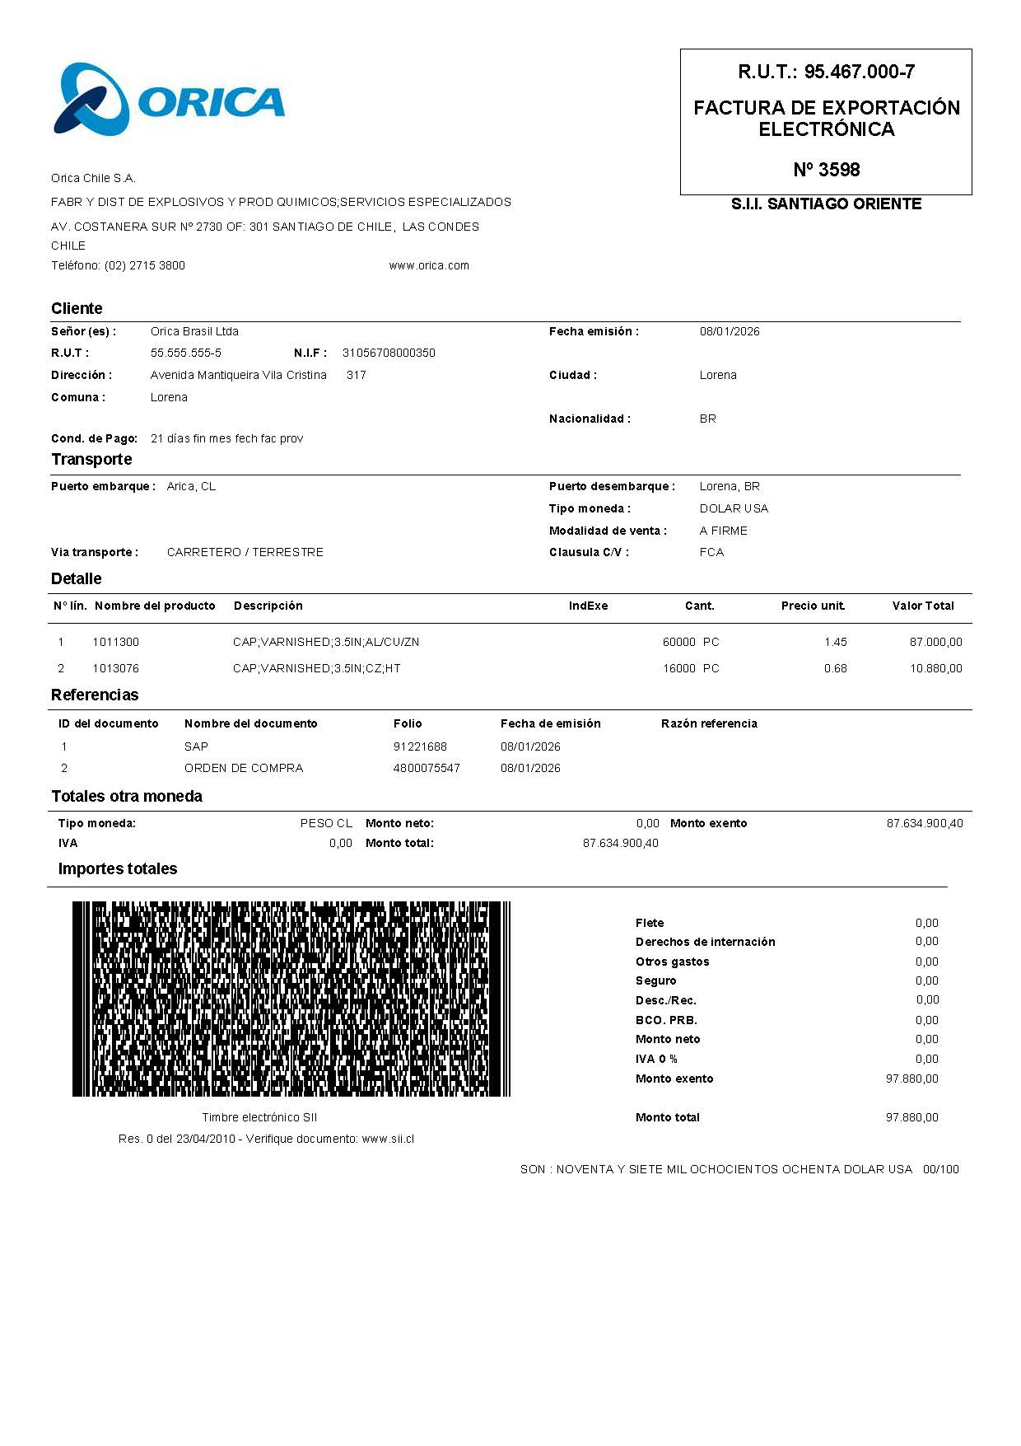

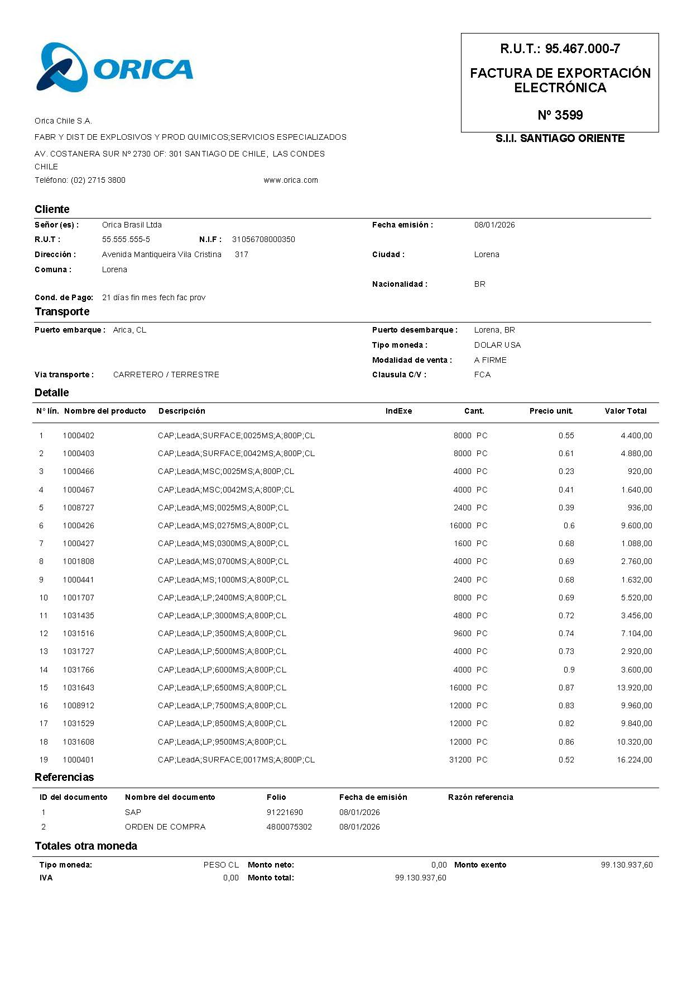

Photograph Set

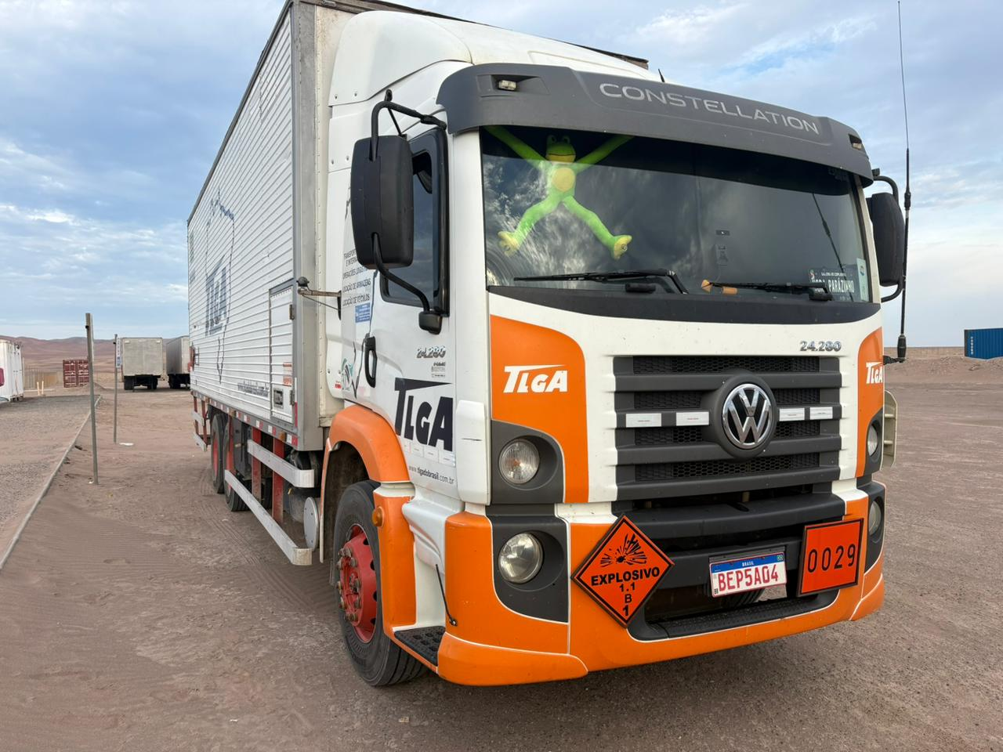 | 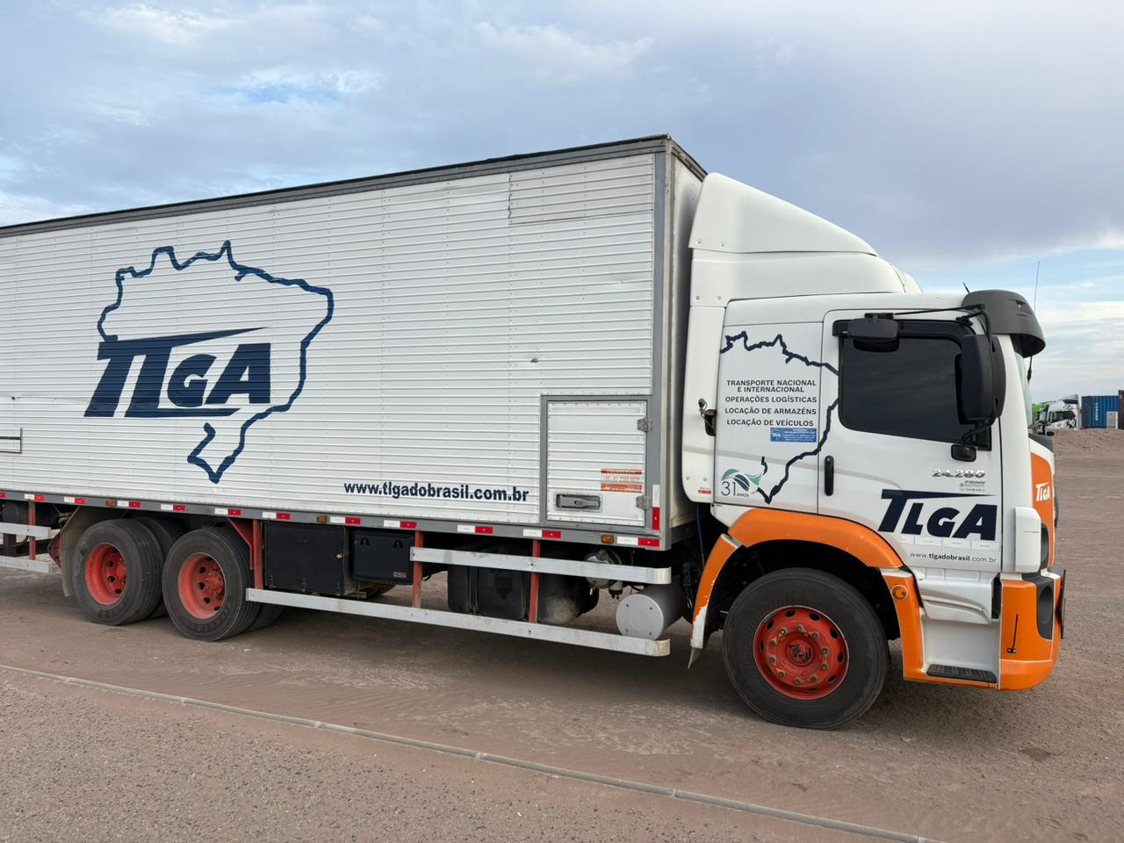
Principal view of truck prior to stripping operations.

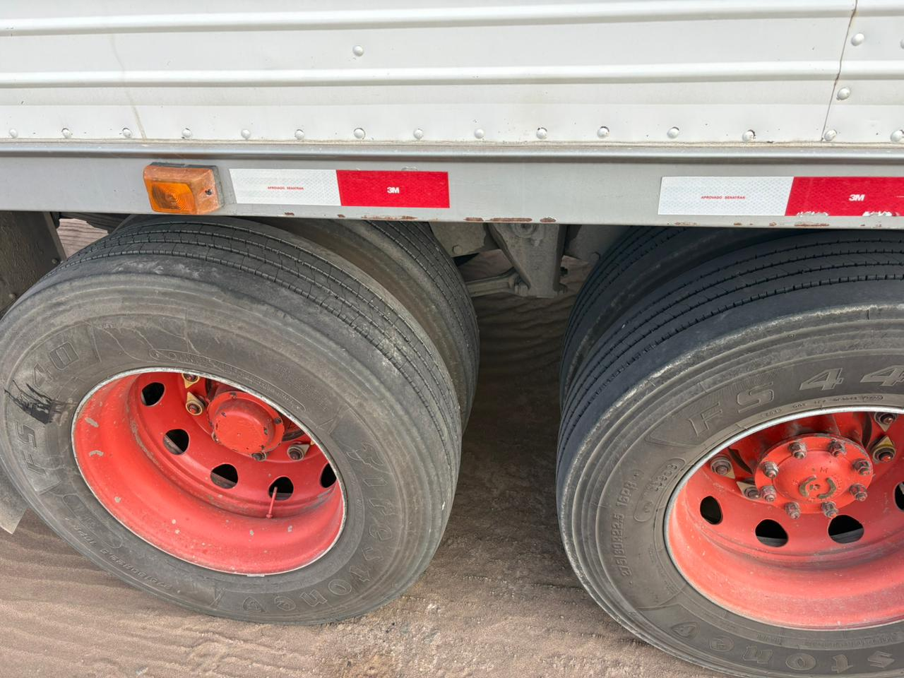 | 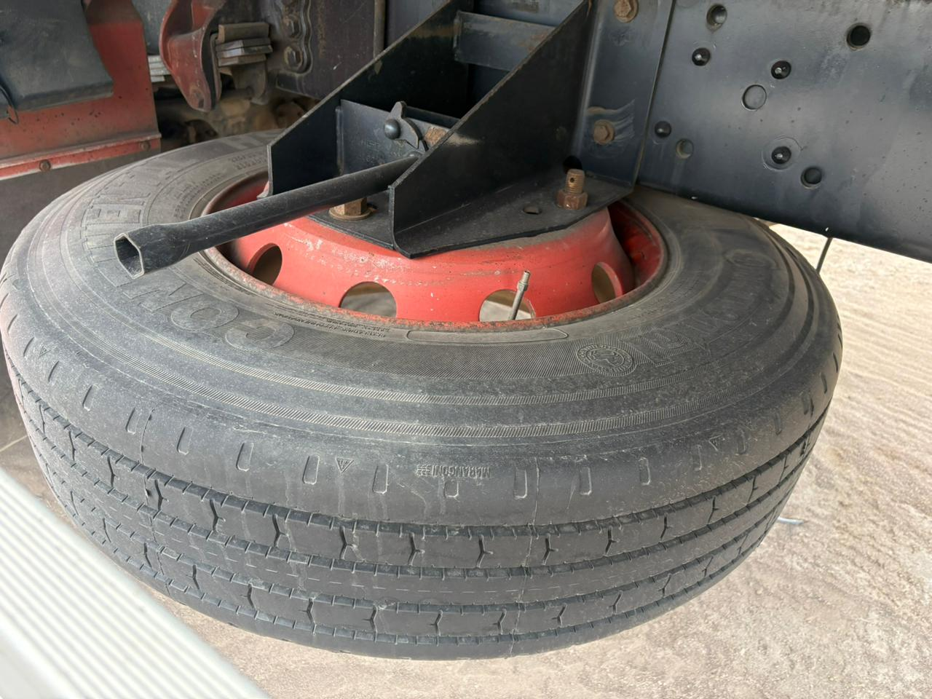
General view of tires conditions and spare tire.

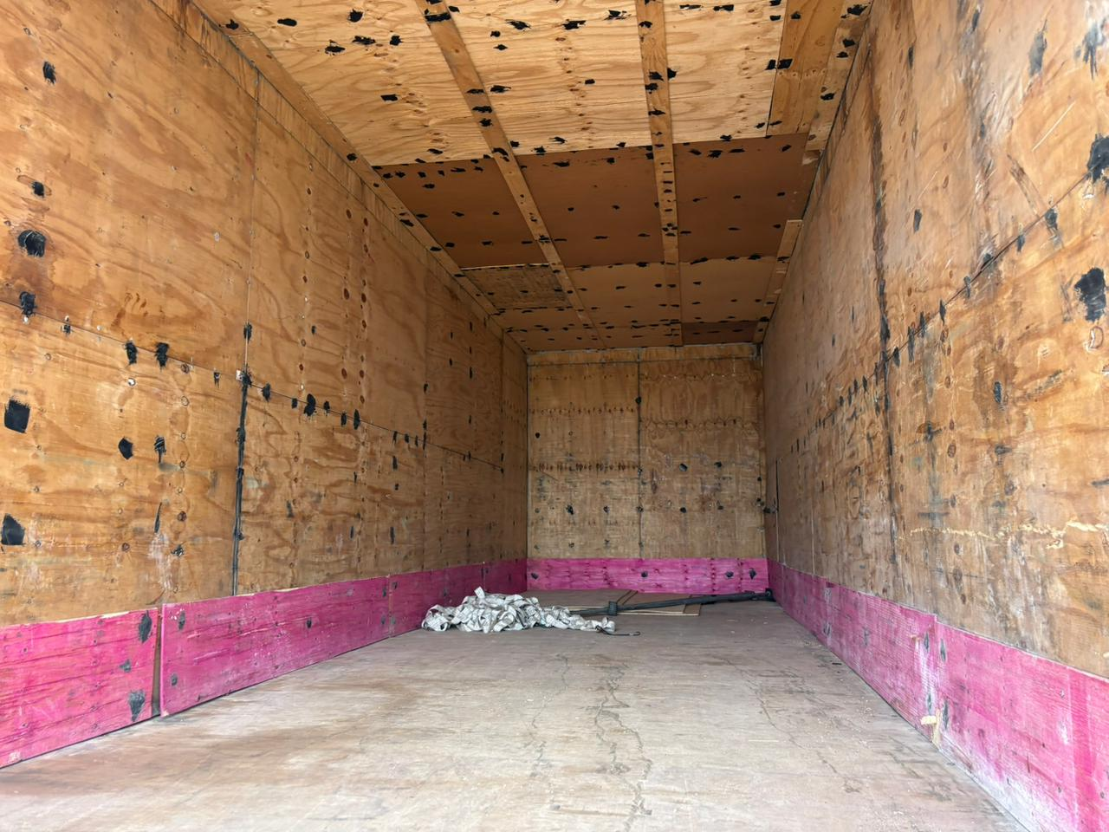 | 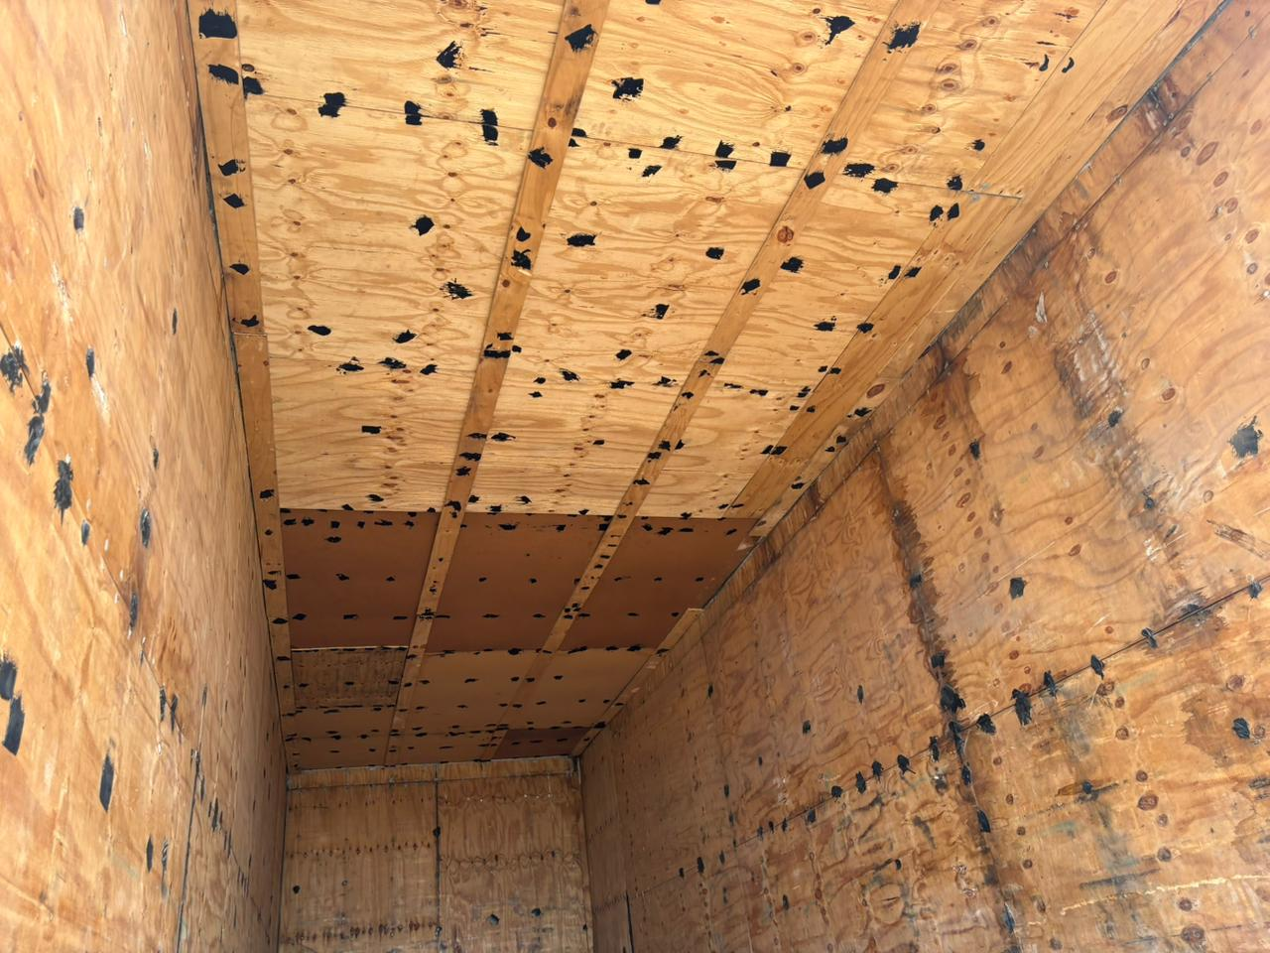
General view of receiver truck inner lining.

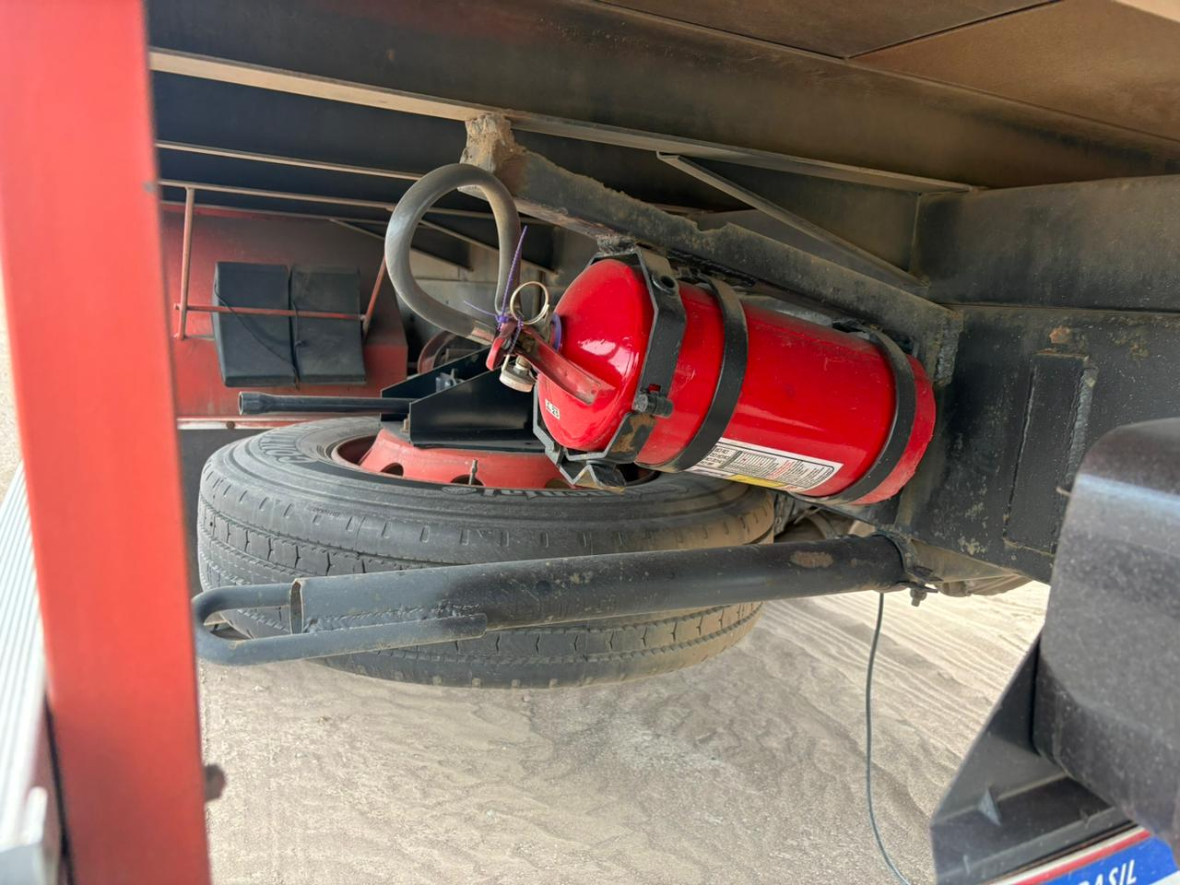 | 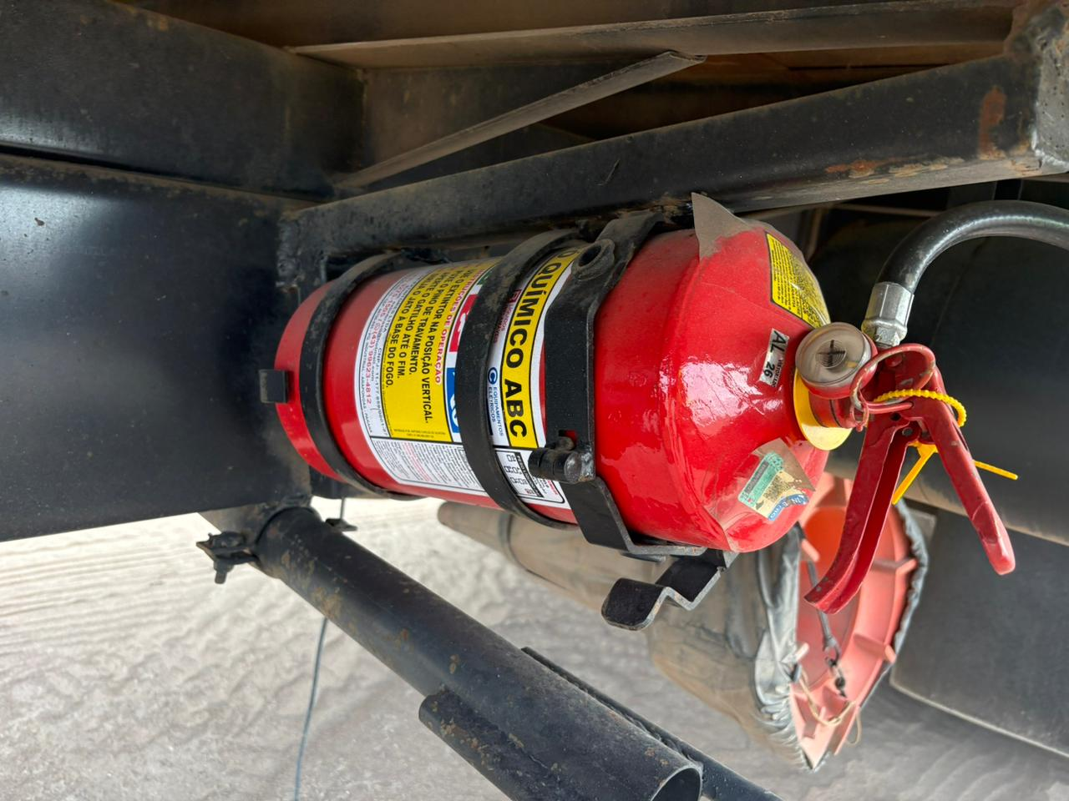
Positions of extinguisher´s.

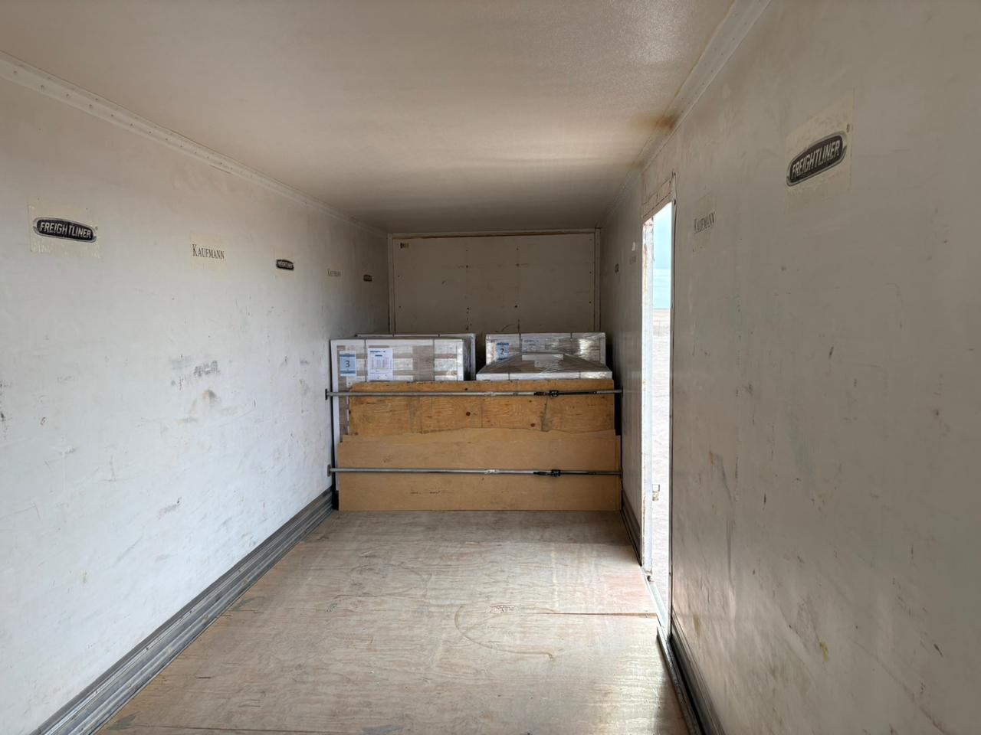 | 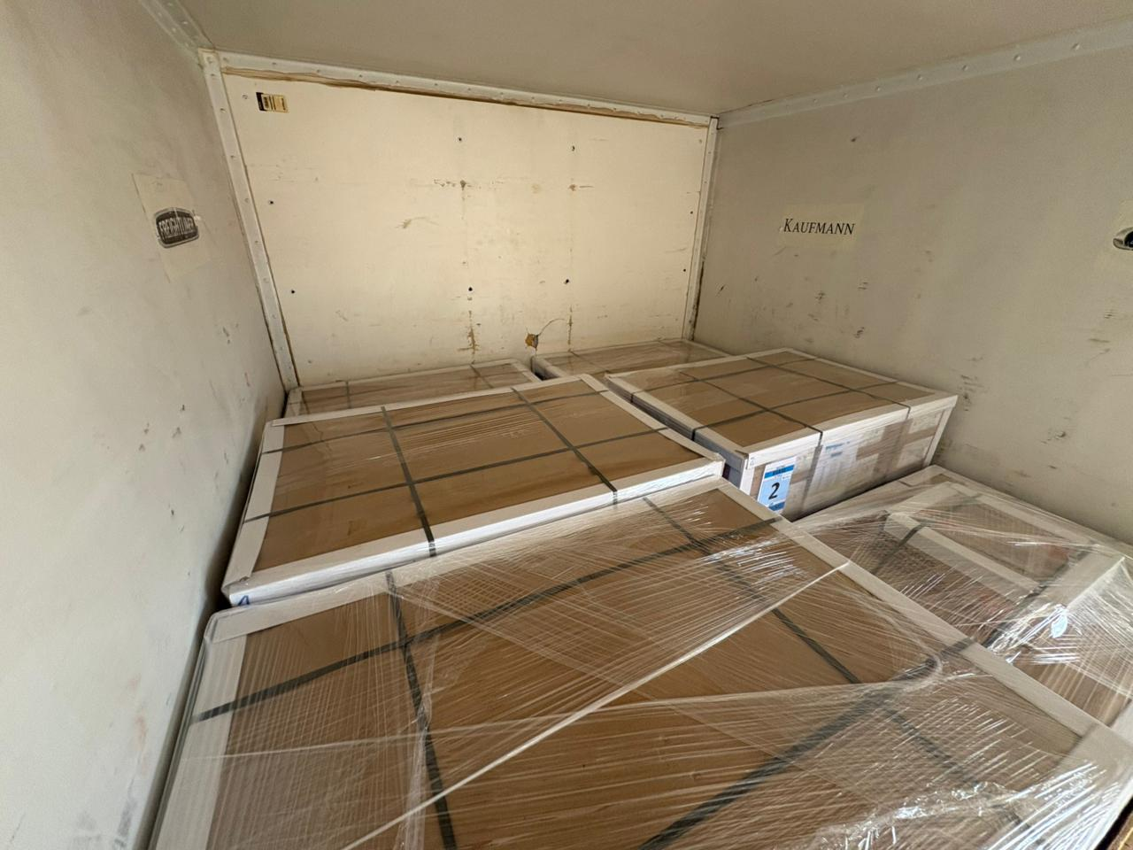
Cargo stowage conditions into emitter truck.

 | 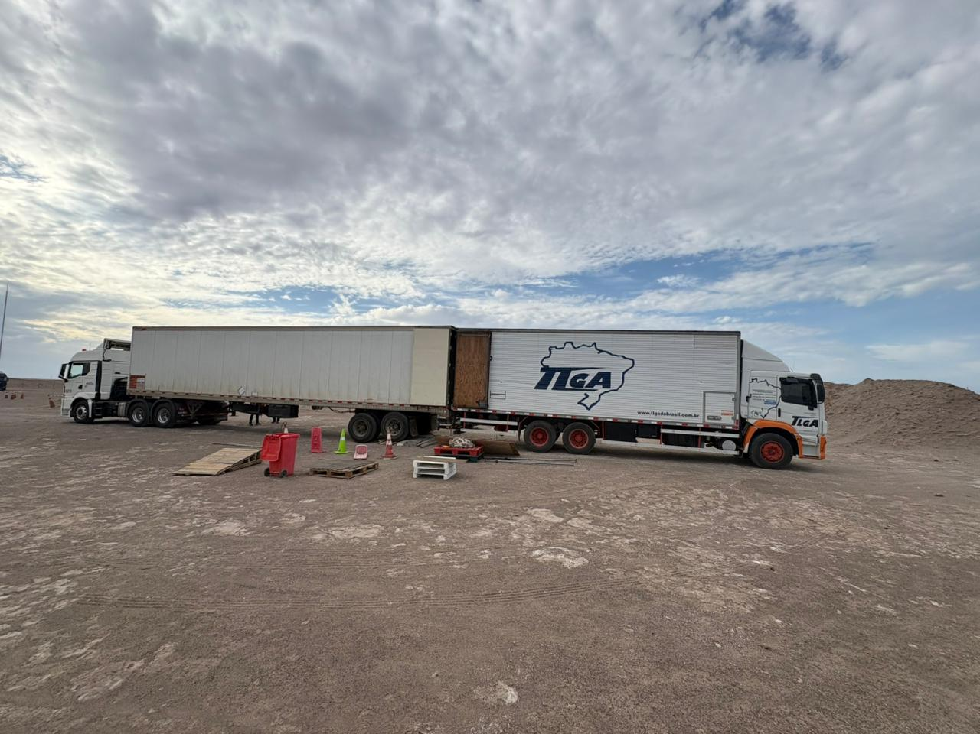
Truck driver license and cargo transference truck by truck.

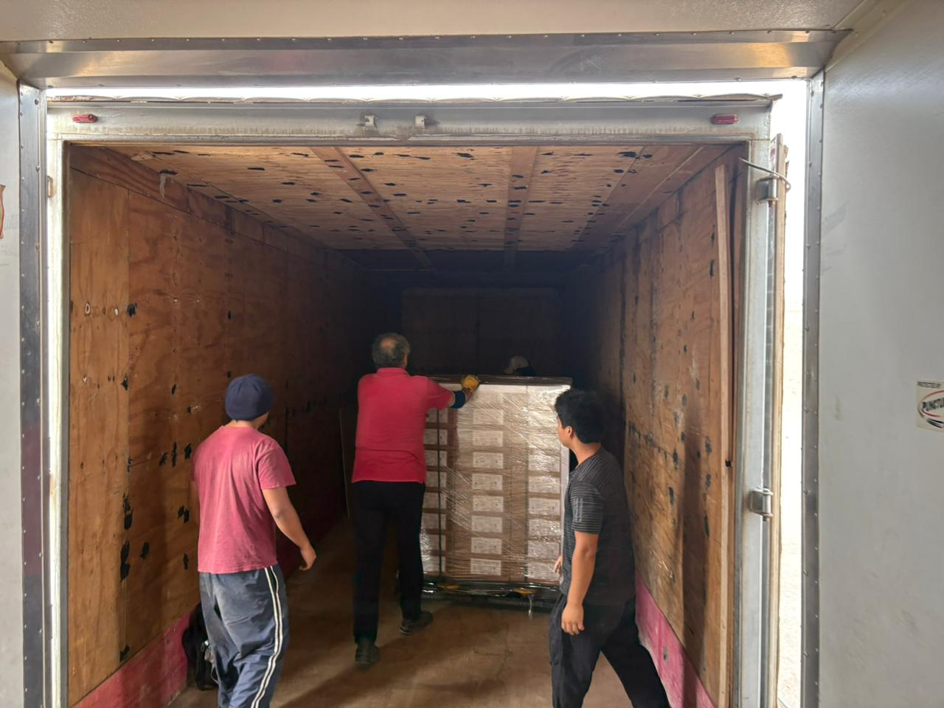 | 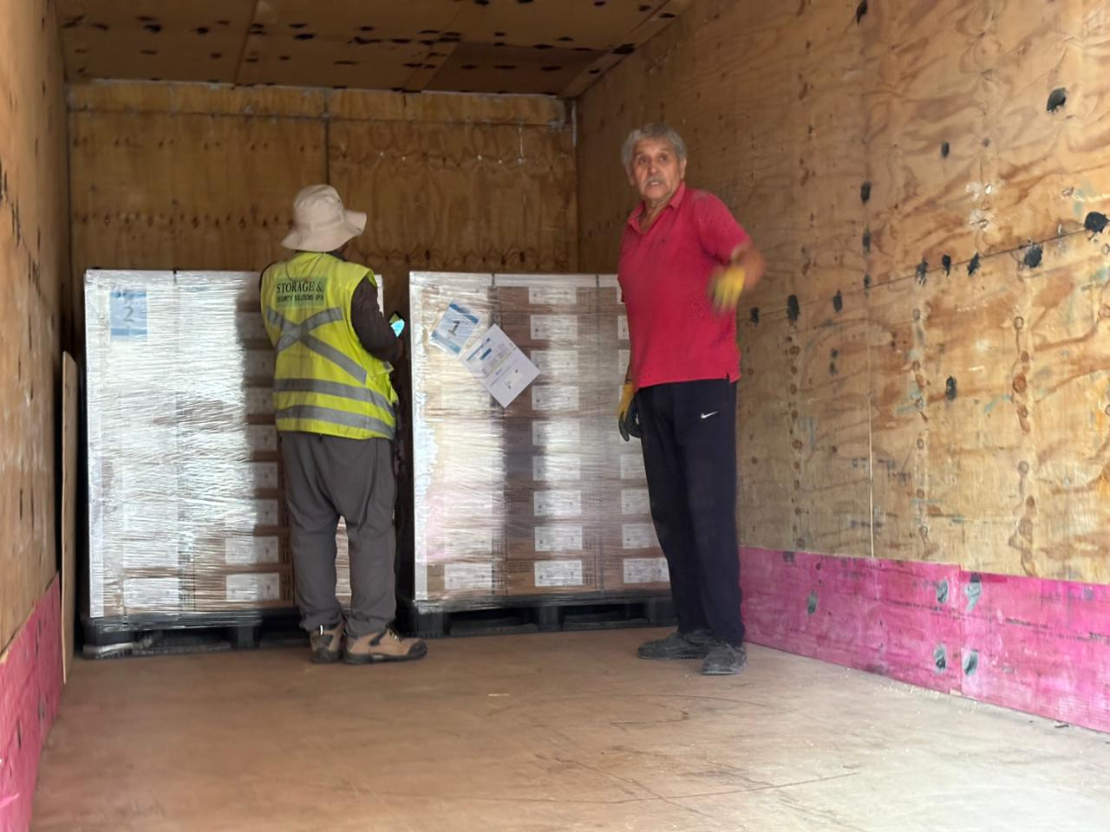
Transference operation of pallets carried out by STORAGE & SECURITY SOLUTION personnel.

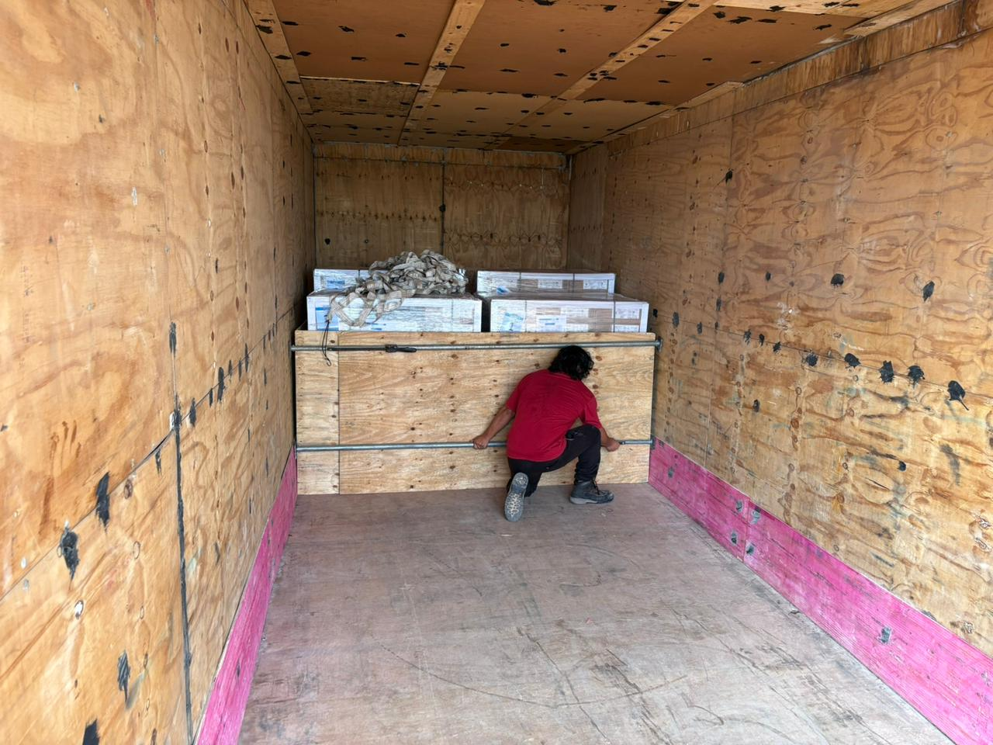 | 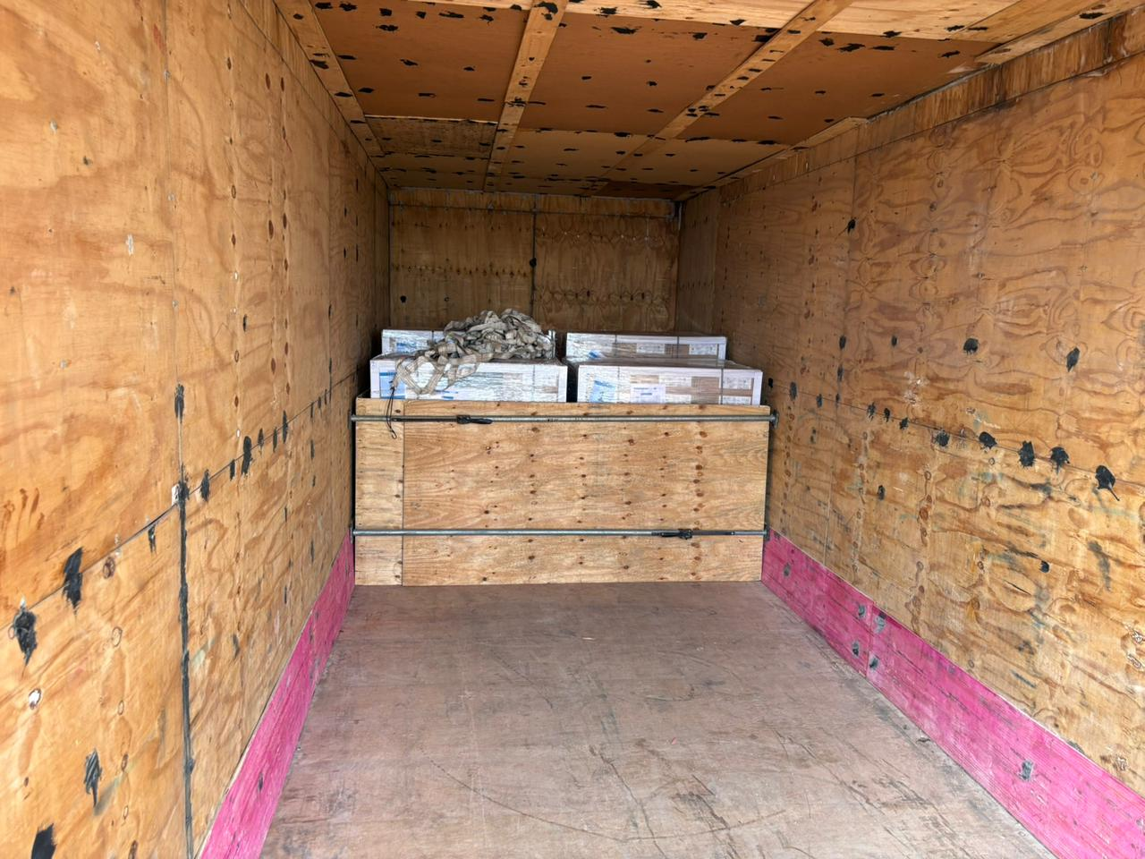
Final stowage of cargo inside truck with steel bars and wooden sheet in horizontal position.

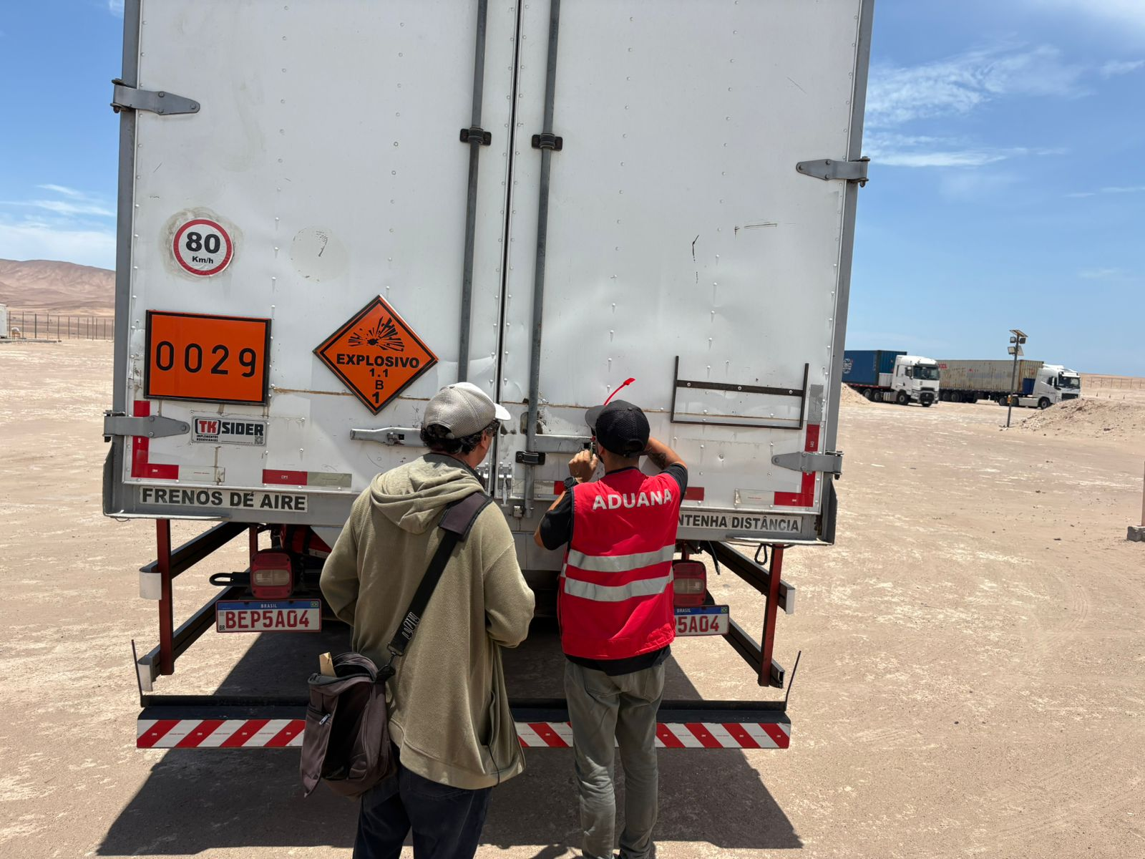 | 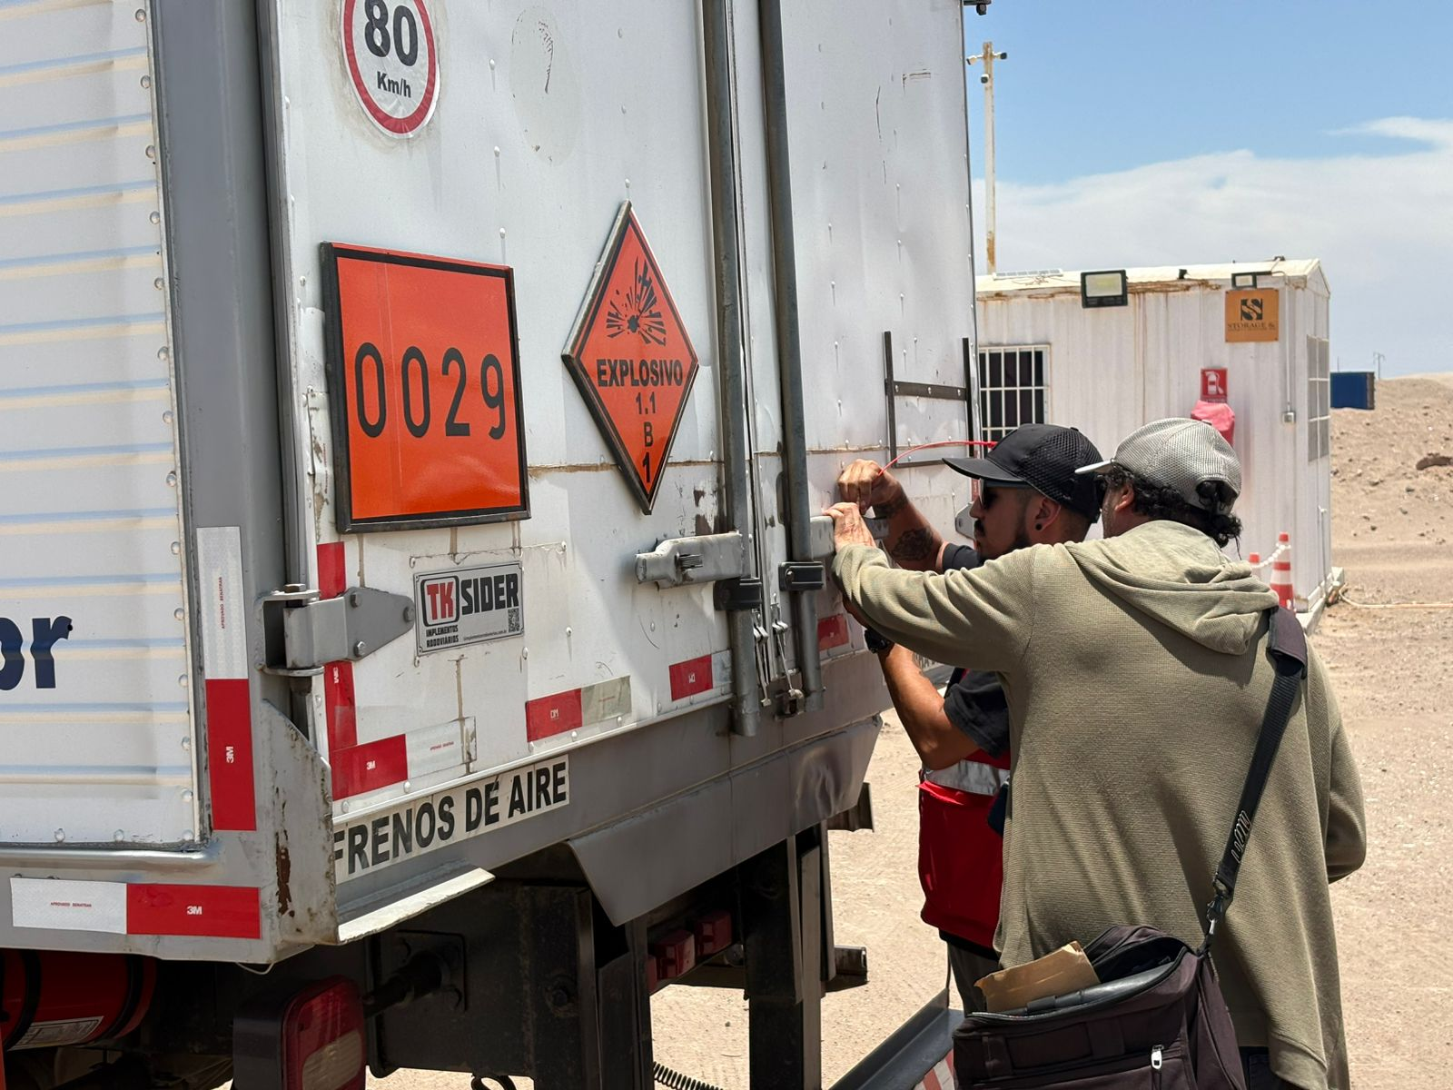
Sealing of truck by customs personnel.

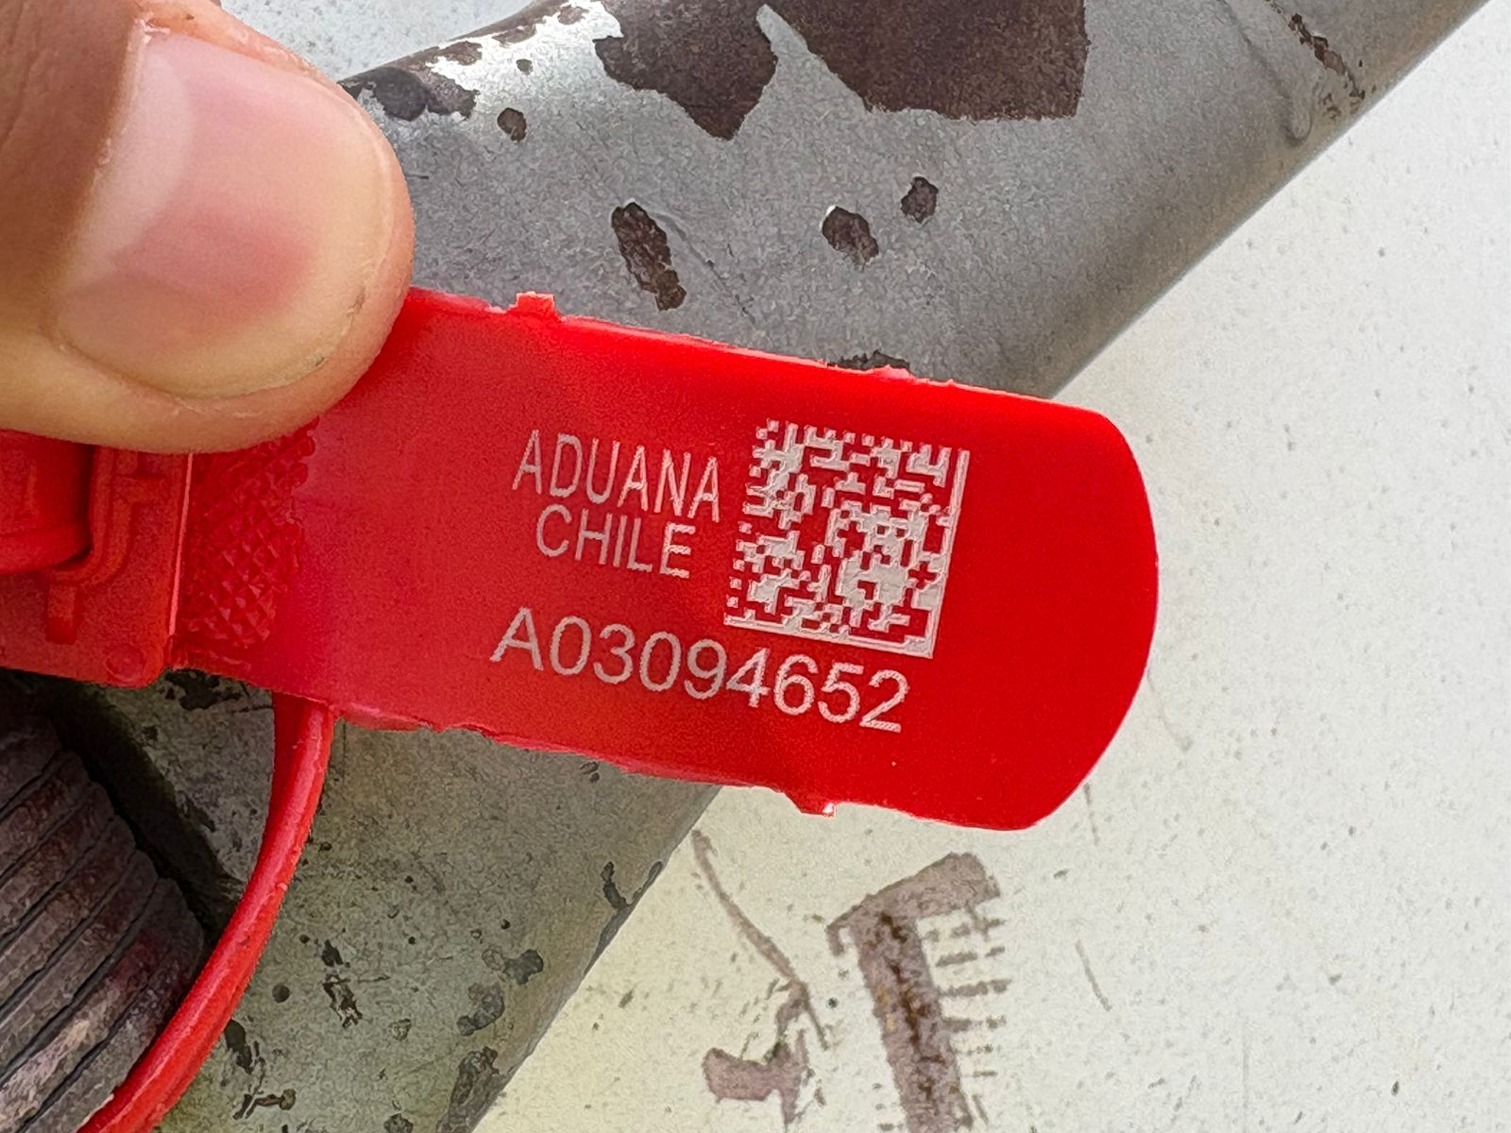 | 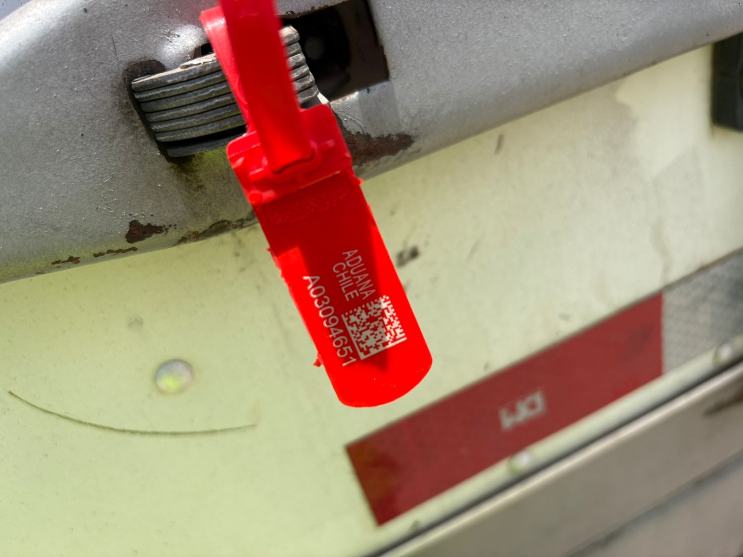
Seals applied Nr. A03094652 / A03094651 and final sealing.

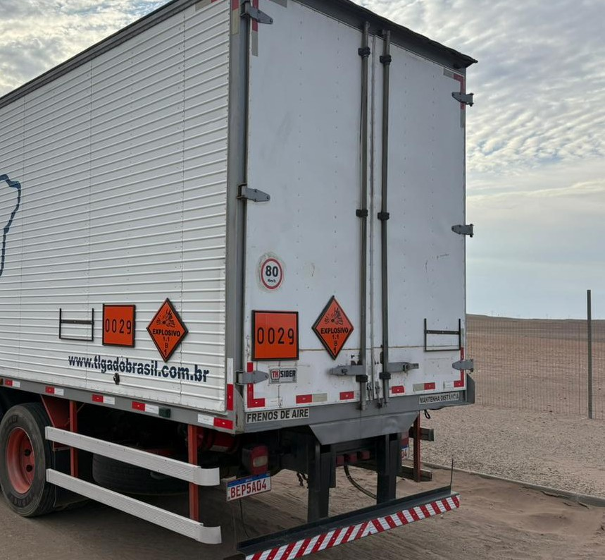 | 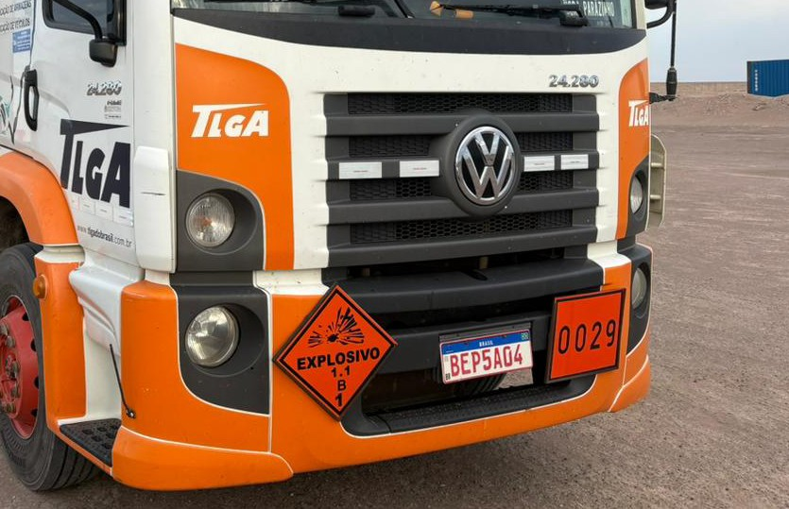
Expeditor signal and Rhomb class.

