TRUCK CERTIFICATION FOR EXPLOSIVES TRANSPORTATION

ALS REFERENCE
ANF – 2605 - 1845

INSPECTION ON BEHALF OF
ORICA Chile S.A.

REQUESTED BY
Ms. Maria Fernanda Poblete

TRUCK MODEL / PLATE
MAN KZ XL - 60

PLACE
Arica - Chile

ALS INSPECTION SURVEYOR
Yesenia Quispe B.

PLACE OF INSPECTION
Planta EHM, Antofagasta chile.

REFERENCE
CAPS PO 4800077188 //4800077326

ATTENDANCE DATE
May 25, 2026
1.-Truck certification for explosives transportation
Truck model: | MAN
Carrier: | TRANSPORTES TAPIA
Name of driver: | William Hernando Marin Garcia
License expiration date: | 22.01.2029

2.- General overview of unit subsystems
2.1.- Load ramp | Compliance
2.2.- Load gangway | Compliance
2.3.- Interior lining | Compliance
2.4.- Tires condition | Compliance
2.5.- Suspention condition | Compliance
2.6.- Wheeling system | Compliance
2.7.- Brake system | Compliance
2.8.- Electric system | Compliance
2.9.- King Pin | Compliance
2.10.- Chasis subsystems | Compliance
2.11.- Truck | Compliance
3.- General overview of safety accessories
3.1.- Extinguishers | Compliance
3.2.- Exhaust spark arrest | Compliance
3.3.- Exhaust thermal insulator | Compliance
3.4.- Battery cover | Compliance
3.5.- Ground Chains (2) | Compliance
3.6.- Elect. Handles Static | Compliance
3.7.- Flags | Compliance
3.8.- Signage | Compliance
3.9.- Rhomb class | Compliance
3.10.- Explosive’s sign | Compliance
3.11.- Safety cones | Compliance
Remark: This certificate will be considered only as reporting of the unit in particular
4.- Through this document ALS INSPECTION CHILE SPA., CERTIFIES that
4.1.- The equipment for explosives transportation is SUITABLE to operate | YES
4.2.- The safety accessories of the equipment are adequate and sufficient | YES
5.- ALS INSPECTION CHILE S.P.A concludes that
NIL

Date & Time of Survey | May 25, 2026 / 11:00 to 12:00 hrs.

This survey was carried out without prejudice and in the interest of whom it may concern.
SURVEYOR ALS INSPECTION CHILE SPA. | Yesenia Quispe B.

FACTURA ELECTRONICA

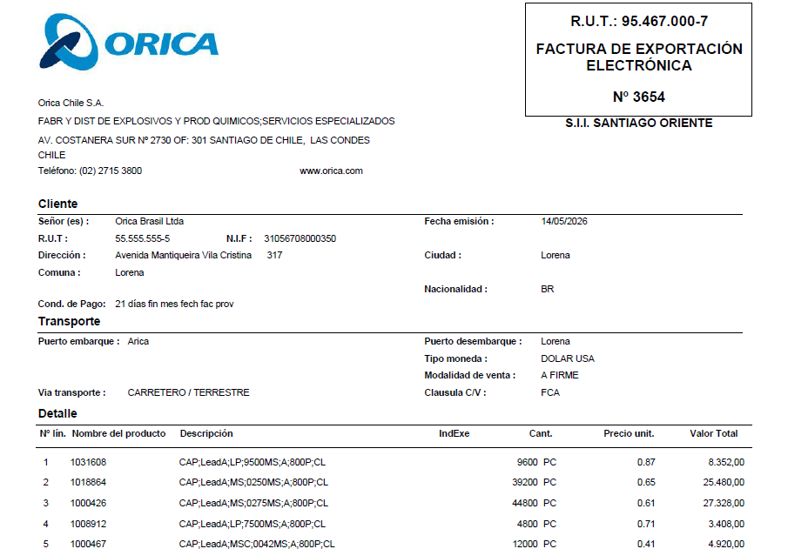
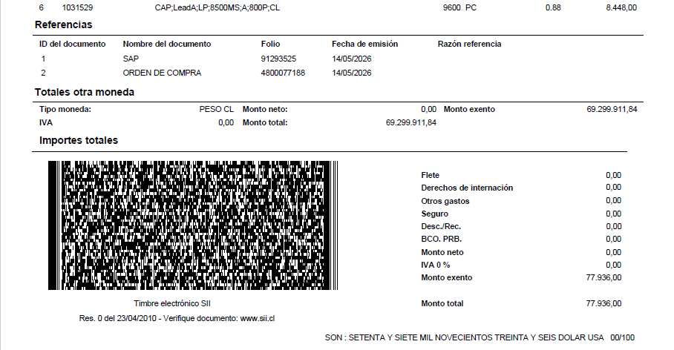

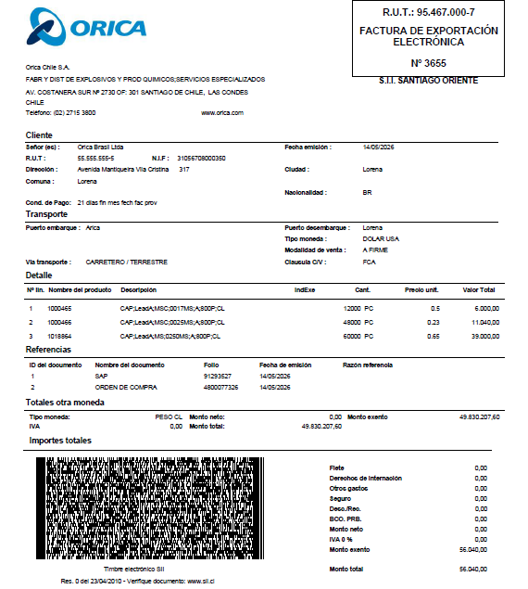

PACKING LIST

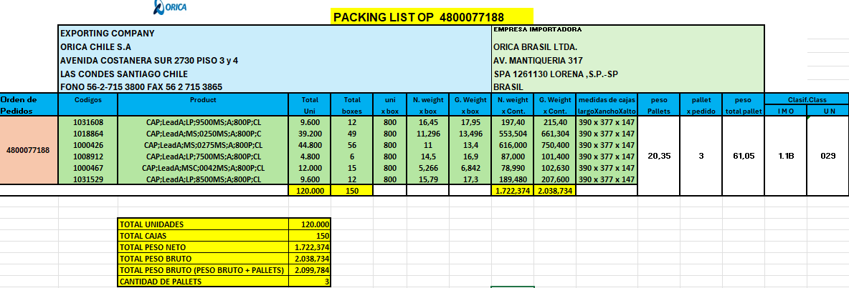

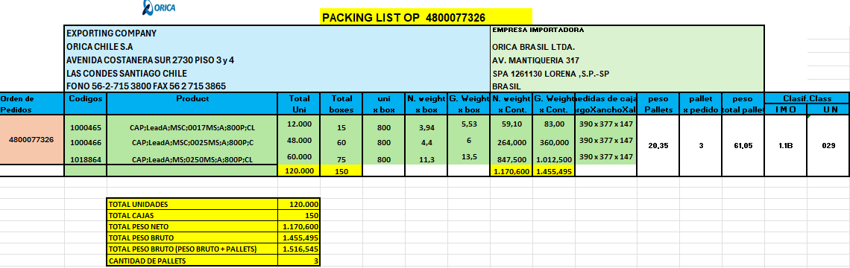

PHOTOGRAFIC SET

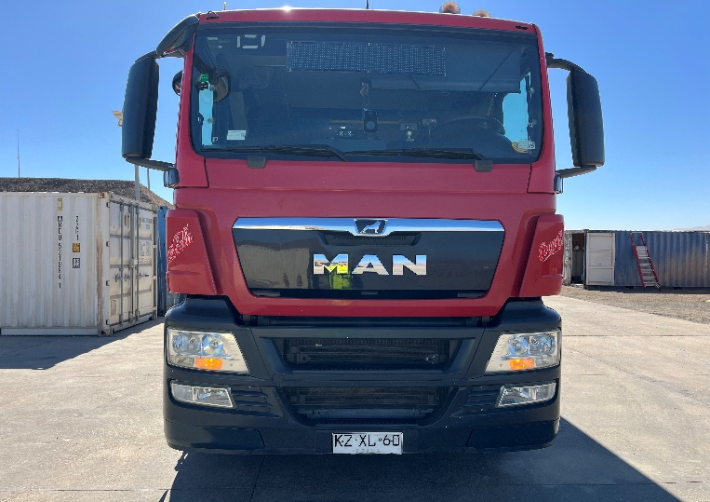 | 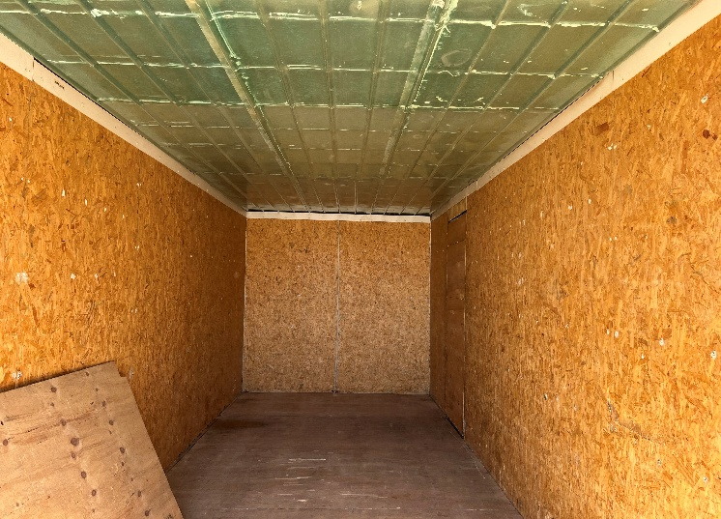
- Principal view of truck previous at stripping operations. | - General view of receiver truck inner lining.

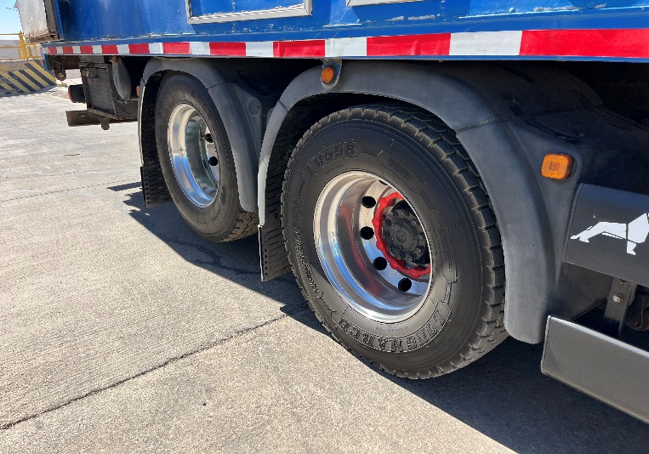 | 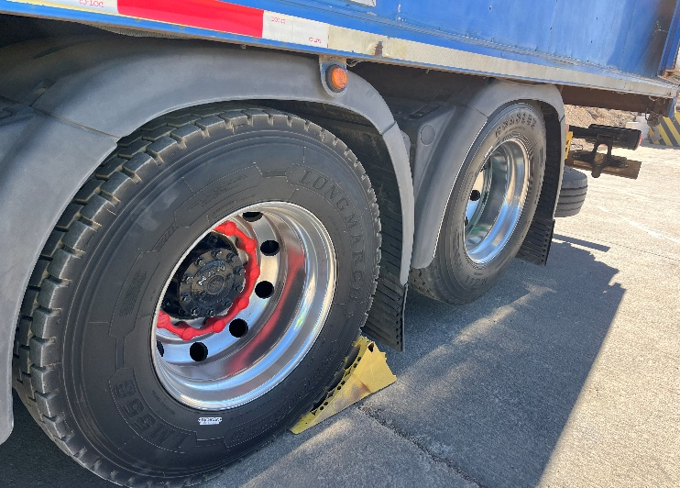
- General view of tires conditions and spare tire. | - Other view.

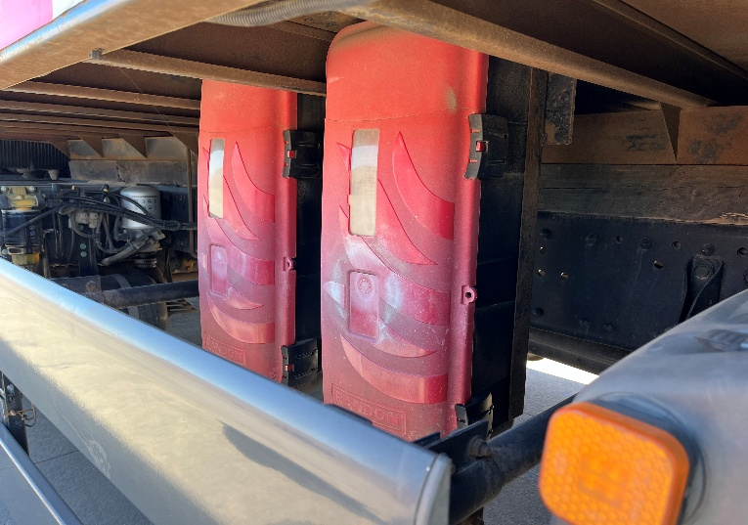 | 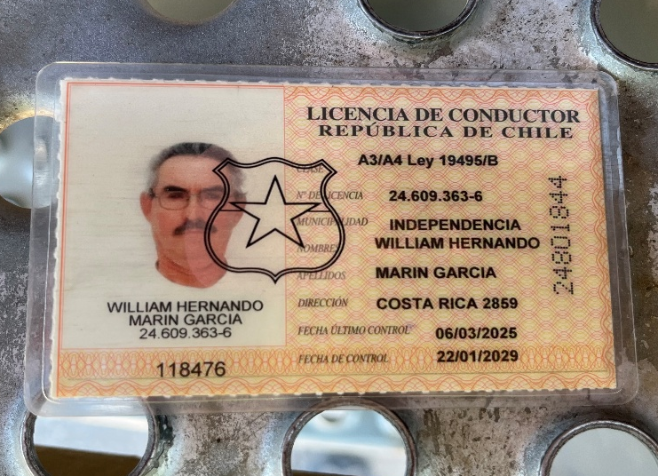
- Front view and rear positions of extinguisher´s. | - View of truck driver license.

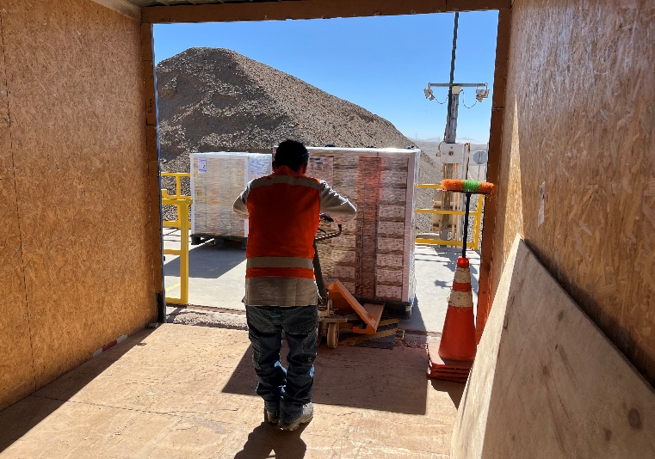 | 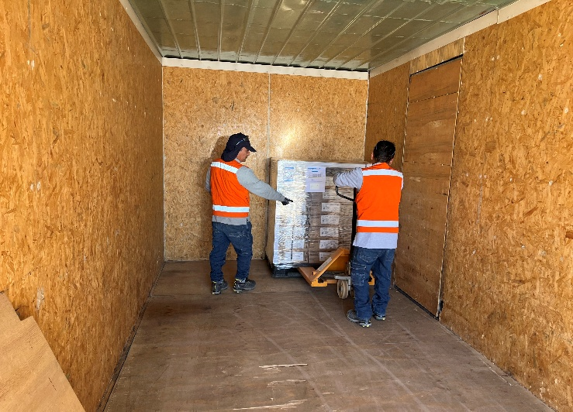
- View of stuffing operation. | - Other view.

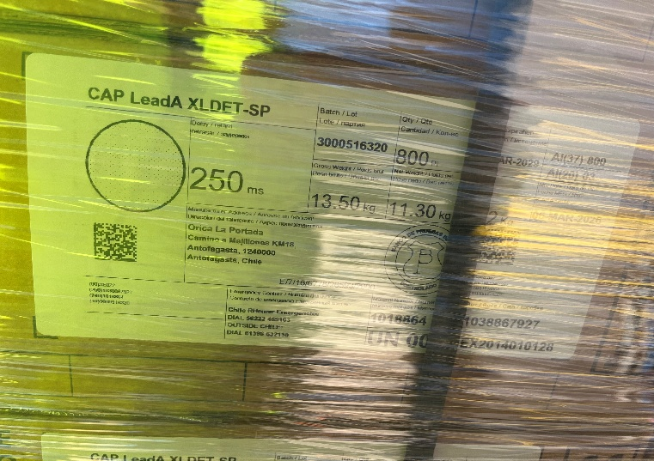 | 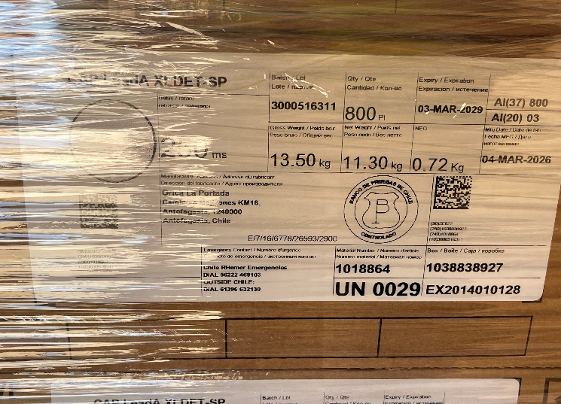
- View of cargo identification | - View of cargo identification

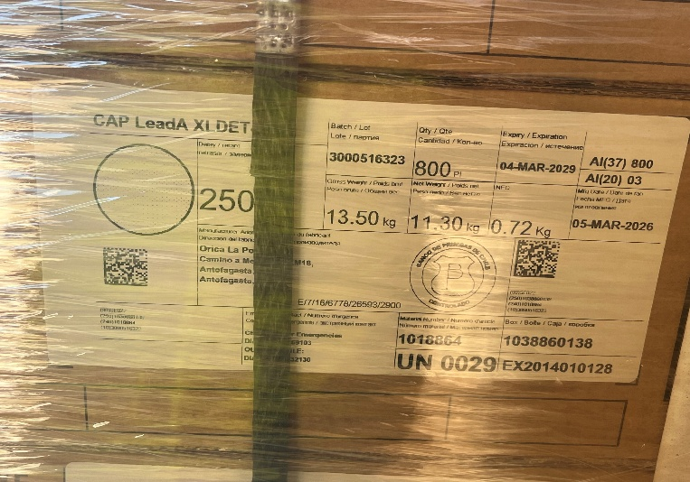 | 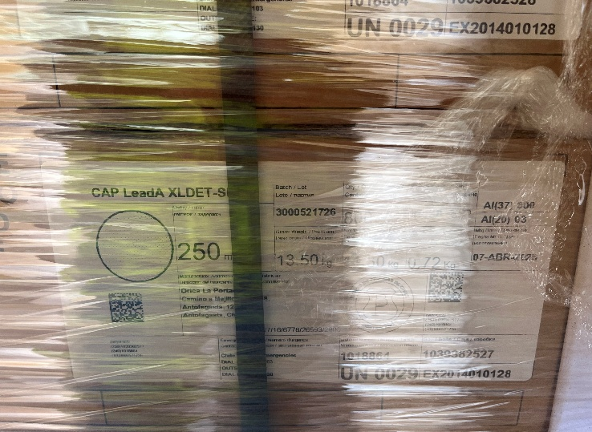
- View of cargo identification | - View of cargo identification

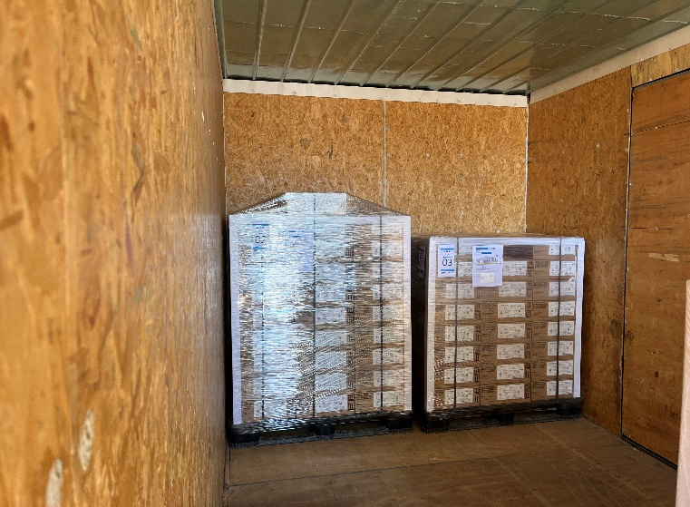 | 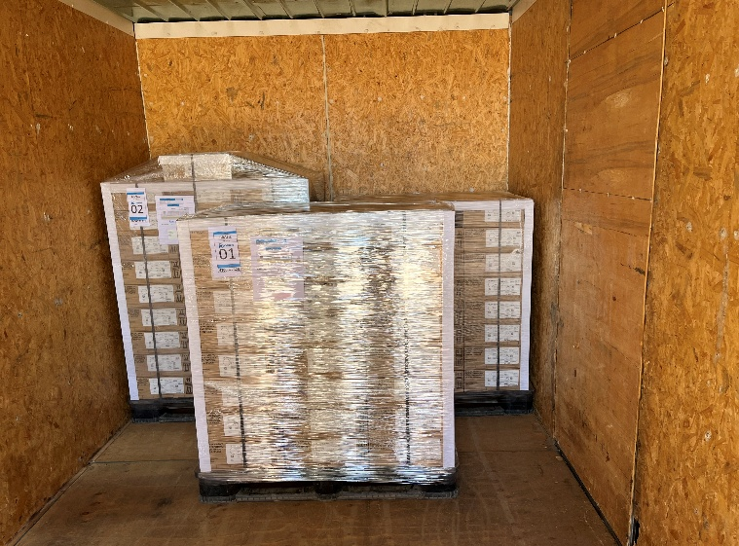
- View of stowage condition during stuffing operation 25 % | - View of stowage condition during stuffing operation 50 %

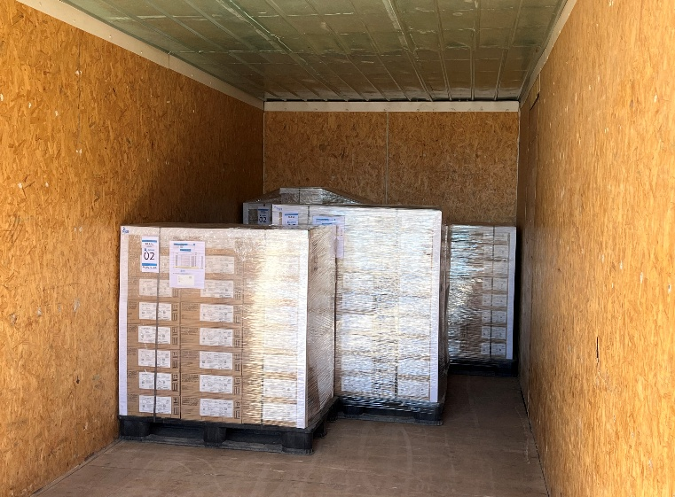 | 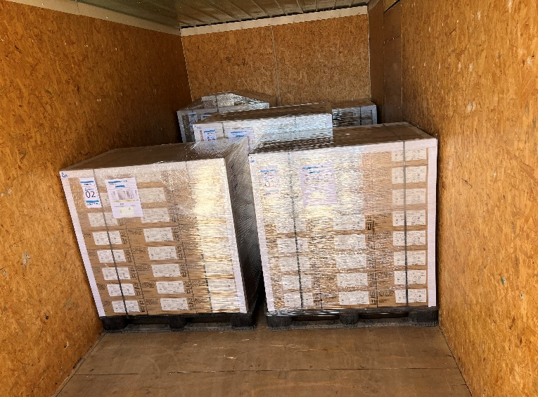
- View of stowage condition during stuffing operation 75 % | - View of stowage condition during stuffing operation 100 %

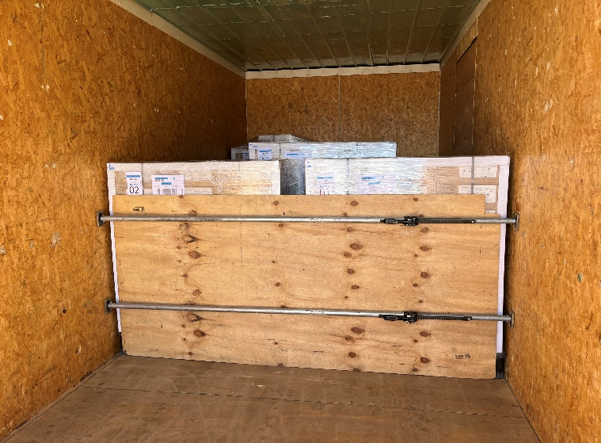 | 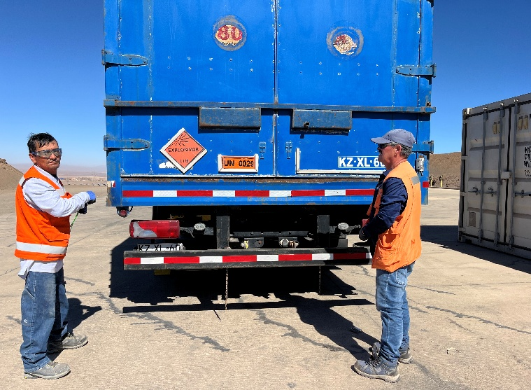
- View of lashing. | - cargo safety operation.

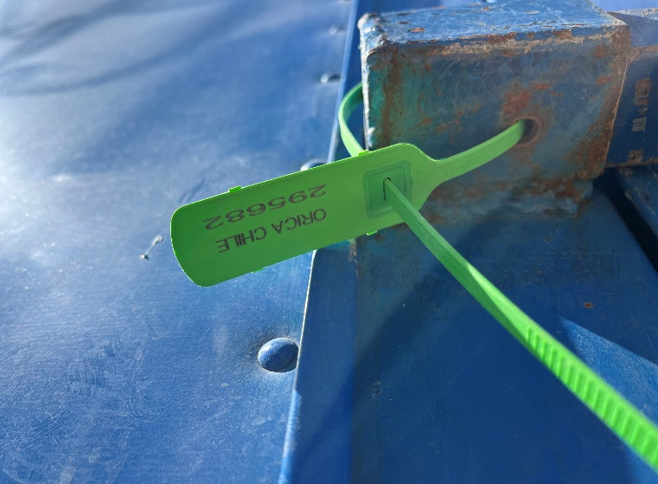 | 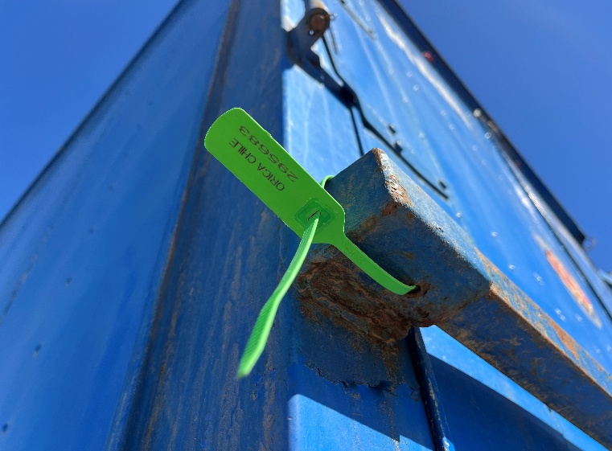
- Seal of Orica (295682) | - Seal of Orica (295683)

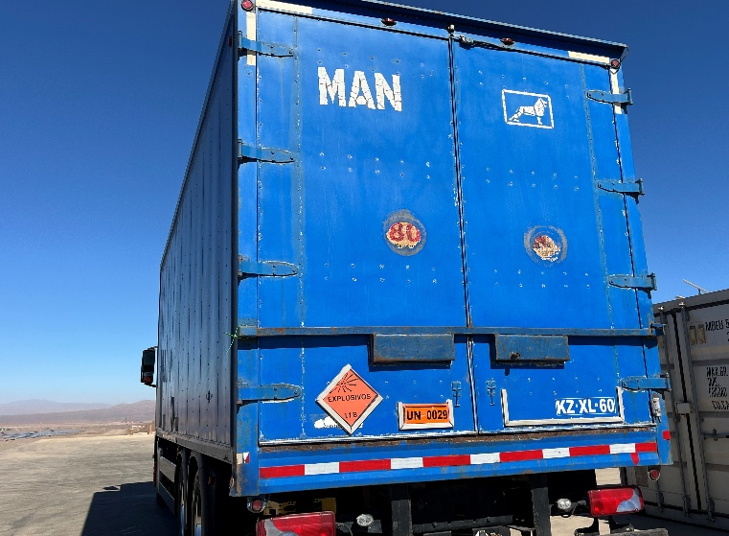 | 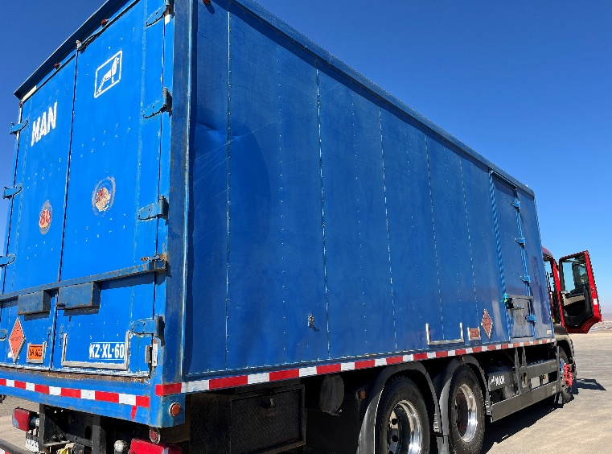
- View of security box locked | - Other view

Yesenia Quispe B.
ALS Inspection Chile SpA

