Your Ref: ALS UK 2612803
Our Ref: MIG ALS 2603-1283 D Date: April 22, 2026

Below you will find the details of a material described as “Quellaveco Copper Concentrates”, which was weighed, loaded, and sampled in the presence of our representative.
General Details:

Material | Copper Concentrates in Bulk
Advised Weight | 10,500 WMT
Vessel | GREEBA MANX
Stowed | Hold N°5
Supplier | IXM
Buyer | END RECEIVER:TONGLONG NONFERROUS
Load Port | ILO-Engie Port, Peru
Discharge Port | Jingjiang, China
Vessel arrival, Ilo Port | April, 08 th 2026 at 15:12 h
Vessel berthed, Pier Ilo - Engie Port | April, 22th 2026 form 06:06 h to 08:06 h
Loading commenced | April, 23th 2026 at 00:42 h
Loading completed | April, 23th 2026 at 10:15 h
Commenced moisture determination | April, 23th 2026 at 06:40 h  Dry Equipment No. LPI-EST-001  1st group of 11 samples  April, 23th 2026 at 12:15 h  Dry Equipment No. LPI-EST-002  2nd group of 09 samples
Finish moisture determination | April 23 th, 2026 at 18:52 h – 1rst group  April, 24th 2026 at 00:15 h - 2nd group  April, 24th 2026 at 14:03 h, Shipment Weight Certificate- SGS. (Client Ref. 184106, SGS Ref.  OL245044-06) TP Engie Ilo, Perú.

Commenced Quality Sample Preparation | April, 24 th, 2026 at 01:00 h app
Finish Quality Sample Preparation | April, 24 th 2026 at 02:08 h app
Commenced Sample Sealing | April, 24th 2026 at 12:17 h app
Finish Sample Sealing | April, 24 th 2026 at 19:09 h

Outturn Weights:

Net Wet Weight (Scale) | 10,002.810 WMT
Moisture (%) | 7.81397 %
Net Dry Weight (Scale) | 9,221.193 DMT

1.- CARGO CONDITION
Prior to loading operations commenced, our surveyor attended at the shipper’s stockpile Engie Port warehouse” which is a sheltered warehouse owned by AAQ, located at approximately 2,000 meters away from the loading pier, and observed that the cargo consisting of copper concentrates was in bulk form and ready for loading, presented in stack (T-010) with a total of 10,000.000 WMT app, directly over the warehouse concrete floor in a separate way.

No apparent contamination or impurities were observed as far as visually accessible. Neither lumps nor agglomeration were observed in the cargo during loading operations. Also, our surveyor visited the mentioned stockpile during loading operations to check that there was no mixing of material. The color of the material was grey and consisted of fine material.

It is worth to mention that we were authorized by the Shipper (AAQ) to enter to the stockpile to take photographs.

2.- LOADING OF THE VESSEL:

2.1 Vessel’s Particulars

Flag & Register Port | Douglas / Douglas
Owners | Greeba Marine Limited, c/o Mx Bulk Management Limited
Year Built | 2022
NRT | 21,466 mt
GRT | 35,610 mt
Type of ship | Bulk Carrier

2.2 Dates & Times of loading operations
Date | Time | Description
2026/04/08 | 15:12 | Vessel arrived to Ilo Port, Peru
2026/04/08 | 16:45 | Authorities on board
2026/04/08 | 17:05 | Free Practique
2026/4/22 | 02:00 | Pilot on board (POB)
2026/4/22 | 02:00 | Surveyors on Board
2026/4/22 | 2:30 – 5:30 | Transit Through TSS with Reduced Speed
2026/4/22 | 6:06-8:06 | Mooring operation
2026/4/22 | 8:50-9:00 | Inspection of Hold N°5 by SGS, ALS and Bureau Veritas (BV) Surveyors.  The holds were found in acceptable condition for receiving mineral concentrate.
 | 8:54 | Initial Draft Survery carried out by 1st Official of the vessel
2026/4/23 | 00:10 | Opening of cargo hold N°5
2026/4/23 | 00:25 | Ship loader being placed in Hold N°5
2026/4/23 | 00:42 | Starting of loading operation in Hold N°5
2026/4/23 | 01:00 | 478.63 wmt / 1007.63 mt/h
2026/4/23 | 02:02 | 1,567.40 wmt / 1092.0 mt/h
2026/4/23 | 03:00 | 3,722 wmt / 1087 mt/h
2026/4/23 | 06:06 | 5,009 wmt / 1084 mt/h
2026/4/23 | 06:20 | 6,020 wmt / 1082 mt/h
2026/4/23 | 07:29 | 7,003 wmt/ 1083 mt/h
2026/4/23 | 09:04 | 9,005 wmt/ 1050 mt/h
2026/4/23 | 10:15 | Completion of loading operation in Hold N°5:  10,002.810 wmt
2026/4/23 | 14:15-14:25 | Sealing manholes and hatch cover from Hold Nº5 by AIVEPET

Remarks:
Referential weight by AAQ shore scale: 10,002.810 WMT

2.3 Hold and Hatch condition

Our surveyor, jointly with shipper’s and end receiver surveyors inspected hold N°5, before loading:
HOLD N°1 | GOOD | FAIR | POOR
Hatch covers
Hatch coatings
Rubber packing, draining holes
Acting cleats, compression bars
Non-return valves
Hydraulic Systems
Forward and aft bulkhead
Side/shell plating (port and stb)
Frames, brackets and bracket connection
Tank top plating
Hopper tank plating
Ventilation, void spaces
Bilges, suctions
Air vents Sounding pipes
Cleaning Condition
Observation: The cargo Hold N°5 was found dry, clean, and suitable to receive cargo.
It is restricted to access to cargo holds for security, therefore it is only possible to take pictures from hatch coamings.

Previous cargo:
- CORN
- COPPER CONCENTRATE
- CEMENT CLINKER (LAST CARGO)

- SHORE SCALE WEIGHING AND LOADING:

  - Brief description of weighing system to be used:

The shipment weight was ascertained at time of loading on a dynamic electronic weight shore scale located within of AAQ warehouse, connected to the belt conveyor system that loads directly into vessel holds at rate of 1,000 – 1,100 wmt approx per hour. As the loading system of the copper concentrates is by means a closed system, there are not losses of material.

The weighing system to be used during loading operation corresponded to weight scale belonged to AAQ (Ilo -Engie ILO Port), according to following details:

Shore Scale Brand | THERMO FISHER SCIENTIFIC.
Type | ELECTRONIC (Automatic weighing instrument with continuous totalization)
Serial | 19442384J
ID | 5830-CV-002-SC1
Model | MT9301F
Capacity | 1,320 t/h
Minimum Division | 0.01 t.
Testing Company | LO JUSTO SAC.
Verification Certificate N° | E203-A2-0380-2026-1a
Last Testing | FEBRUARY 04TH – 06 TH, 2026
Condition | OPERATIVE

According to AAQ staff, prior to loading operations was performed Zero check.
*SGS surveyor (Shipper) before loading supervised zero check into shore scale room.

Attached Checklist Scale Calibration 5830-CV-002-SC1

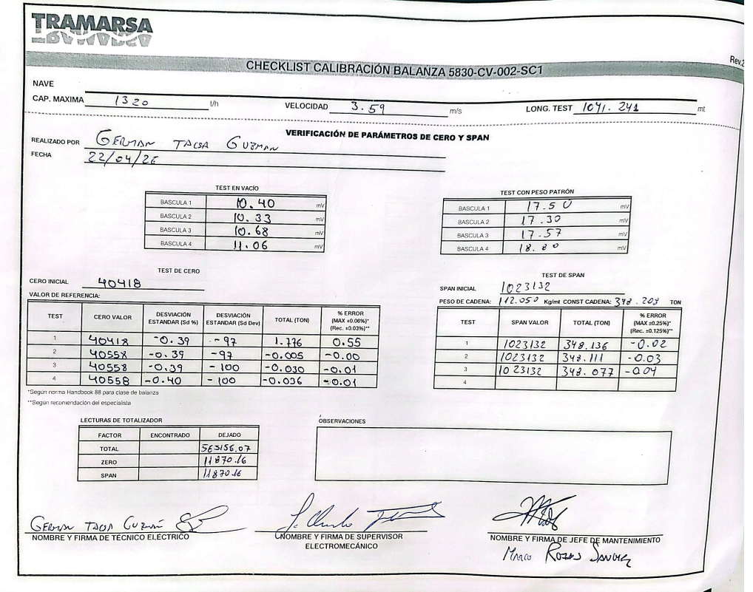

  - Loading operation and conveyor details:

The mineral concentrate loading commenced under supervision and proceeded in a continuous and controlled flow.

Loading operations were carried out using a fully enclosed belt conveyor system originating from the closed warehouse. The material was transferred directly from the AAQ storage facility through an encapsulated conveyor system to the movable ship loader, which discharged the cargo directly into the vessel’s designated holds.

No intermediate rehandling equipment was used during normal operations, as the system is designed for continuous enclosed transfer.

The loading and trimming operations inside the cargo holds were performed using the ship loader only, through controlled positioning (slewing, luffing, and telescopic chute adjustment).

Weather conditions during loading operations in Hold No. 5 were reported as good.

The cargo was stowed in good condition, with even distribution and no visible signs of contamination or excess moisture.

Regarding conveyor parameters, ALS Surveyor, on behalf of IXM, obtained Calibration Certificate No. E203-A2-0380A-2026-1a from AAQ, indicating the following:

Belt Capacity | Belt Length | Belt Speed
1320 T/H | 1039.904 m | 3.59 m/s

- SAMPLING FOR MOISTURE DETERMINATION AND QUALITY PREPARATION:

4.1.- Sampling:

The sampling scheme is obtained based on the procedure established in chapter 5 of the standard ISO 12743-2021.

Sampling scheme
- Batch size: The batch for this procedure consists of stacks in the concentrate warehouse whose mass can vary between 10, 20, 30, or 40 thousand metric tons.
- Sub-batch size: The sub-batch has been defined in increments of 500 metric tons, the value of which must be programmed into the sampler's control panel.

Manual sampling during transfer
This involves sampling concentrate flows during transfer using a metal probe with the following dimensions:

- The design allows for obtaining a mass per increment of approximately 2.00 kg.
- Each increment is taken at a frequency of approximately 40 metric tons. which, at a flow rate of 1000 t/h to 1100 t/h, would be a frequency of approximately 120 seconds, obtaining a total of 12 increments with the mechanical probe.
- For every 500 t/h, approximately a 24 kg sample was obtained.
- The samples are correctly labeled, sealed and recorded.

Transfer of samples from the transfer area to the laboratory
- Upon collection, each subsample remained in a container awaiting transfer to the port laboratory.
- Once the samples were in the laboratory, it was verified that they are properly sealed (without exposure to contamination or moisture loss) and that they have the correct label and information. Finally, the sample was weighed.

5. MOISTURE DETERMINATION – SGS QUELLAVECO LABORATORY

Prior to moisture determination, laboratory personnel explained the procedure and presented the equipment used (drying oven, weighing scale), including calibration status and certification.

For safety reasons (noise, dust, vibration), the inspection was conducted through an observation window.

Sample Division

Sample preparation was carried out as quickly as possible to minimize moisture loss, in accordance with ISO 12743:2021, Section 15.4.7 (manual incremental division).

The procedure was as follows:

The primary sample (~24–25 kg) was placed on the preparation table. Lumps were broken, the sample homogenized, and spread into a rectangular layer of uniform thickness (approximately 20–35 mm).

The sample was divided into 20 equal sections (5 × 4 grid).

Approximately 20 increments (~70 g each, total ~1.4 kg) were collected using a JIS No. 5R scoop and placed into trays for drying.

Tray dimensions: Length (31.5 cm), Width (18 cm), Height (3.5 cm)

Sample Drying Procedure

Two trays per sample were prepared, labeled, and lined with Kraft paper.

Empty tray weight was recorded (m1).

Wet sample was added and recorded (m2).

The sample layer was evenly distributed to ensure proper drying conditions.

Drying Process

Samples were dried in a forced ventilation oven at 105 ± 5 °C:

First stage: 8 hours

Second stage: additional 4 hours

Weighing Procedure

After the first drying stage, trays were removed and weighed immediately (m3).

After the second drying stage, trays were weighed again (m4).

All values were recorded in Excel templates or STARLIMS.

Moisture Calculation

Moisture content for each 500 wmt lot was determined based on the mass loss between wet and خشک weights, expressed as a percentage of the original sample mass.

No re-testing of moisture samples was required, as all determinations were completed successfully on the first analysis.

Equipment for Moisture Determination:

Oven Dry Brand | FLSMIDTH
Model | Essa DO1
Serial | Q761100-001
ID | AAQ-LPI-EST-001
Temperature | 105 °C +/- 5°C
Testing Company | LO JUSTO SAC
Last Testing | 2026-03-12
Certificate N° | E405-A2-0487A-2026-1
Max. Cap / Minimum Division | 1300 °C / 1 °C
Condition | OPERATIVE

Oven Dry Brand | FLSMIDTH
Model | Essa DO1
Serial | Q761100-002
ID | AAQ-LPI-EST-002
Temperature | 105 °C +/- 5°C
Testing Company | LO JUSTO SAC
Last Testing | 2026-03-12
Certificate N° | E405-A2-0487A-2026-2
Max. Cap / Minimum Division | 1300 °C / 1 °C
Condition | OPERATIVE

Weighing details:

Shipper Contract Nº ALS UK 2612803//MIG ALS-2603-1283// Hold N°5

Lot number | Net Wet Wight (MT) | Moisture |  | Net Dry Weight (MT) | Hold number
Lot number | Net Wet Wight (MT) | % | MT | Net Dry Weight (MT) | Hold number
1 | 500.000 | 7.820 | 39.100 | 460.900 | 5
2 | 500.000 | 7.800 | 39.000 | 461.000 | 5
3 | 500.000 | 7.750 | 38.750 | 461.250 | 5
4 | 500.000 | 7.910 | 39.550 | 460.450 | 5
5 | 500.000 | 7.870 | 39.350 | 460.650 | 5
6 | 500.000 | 7.900 | 39.500 | 460.500 | 5
7 | 500.000 | 7.830 | 39.150 | 460.850 | 5
8 | 500.000 | 7.770 | 38.850 | 461.150 | 5
9 | 500.000 | 7.850 | 39.250 | 460.750 | 5
10 | 500.000 | 7.770 | 38.850 | 461.150 | 5
11 | 500.000 | 7.810 | 39.050 | 460.950 | 5
12 | 500.000 | 7.860 | 39.300 | 460.700 | 5
13 | 500.000 | 7.890 | 39.450 | 460.550 | 5
14 | 500.000 | 7.880 | 39.400 | 460.600 | 5
15 | 500.000 | 7.760 | 38.800 | 461.200 | 5
16 | 500.000 | 7.720 | 38.600 | 461.400 | 5
17 | 500.000 | 7.720 | 38.600 | 461.400 | 5
18 | 500.000 | 7.800 | 39.000 | 461.000 | 5
19 | 500.000 | 7.850 | 39.250 | 460.750 | 5
20 | 502.810 | 7.720 | 38.817 | 463.993 | 5
Total | 10002.810 | 7.81397 | 781.617 | 9221.193

Total average moisture content calculation:
Total H20 MT/ Total wet weight x 100 = 781.617 / 10,002.810 X 100 = 7.81397 %

Total dry net weight: 9,221.193 mt

Nine thousand two hundred twenty - one point one nine three mt

6.- QUALITY SAMPLE PREPARATION IN LABORATORY:

Sample sorting
Once the moisture determination process is complete, the trays are placed with their respective pairs and transferred to the sample preparation room.

Sieve control
For the sample separated for sieve control, perform the following steps:

Select two test trays in their natural state and pass them through the rotary divider. Select one basket, weigh it, and pass it through a #140 sieve for approximately 2 minutes (the sieve must be cleaned beforehand, and the base and lid must be placed on it). Weigh the retained material.

If the retained weight is less than 5% of the initial weight, combine the sample from all the baskets and pulverize for 30 seconds. Pass the pulverized sample through the rotary divider, select one basket at random, record its weight, and pass it through a #140 mesh screen. A pulverizing time of 30 seconds should be considered for the samples from all sub-batches.

If the retained weight is greater than 5% of the initial weight, combine the sample from all the baskets and pulverize for 30 seconds. Pass the pulverized sample through the rotary divider, select one basket at random, record its weight, and pass it through a #140 mesh screen. If the retained weight does not exceed 5% of the initial mass, consider the pulverizing time (30 seconds) for the preparation of all sub-batches. If the retained weight exceeds 5% of the initial weight, combine the sample from all the baskets and spray for a longer time.

Repeat step 3 until the optimal spraying time is found (Retained weight < 5% of initial weight).

Preparation of envelopes and formation of the general compound
- After verifying the optimal time for particle size comminution of the sample to be prepared, the pulverizer settings are confirmed for the established time.
- The dry sample from tray A is pulverized for the programmed time and poured into a properly labeled and identified plastic bag.
- Similarly, the dry sample from tray B is pulverized for the programmed time and poured into the same bag as tray A.
- The mixture is then homogenized using a balloon for 1 minute and subsequently poured into the Rotary Divider.
- Of the 12 sample bags obtained, the following distribution will be made: 9 will go directly into paper envelopes, which will then be placed inside aluminum envelopes. These envelopes will be sealed (each paper and aluminum envelope must have sufficient information about the shipment and lot number on its label). The remaining sample bags will be used to prepare the general composite and, if necessary, the SUNAT composite.
- Repeat all the previous steps for each of the lots obtained from the shipment.
- For the preparation of the general (weighted) composite, the information must be entered into STARLIMS and/or an Excel template. This program must display the sub-lots included in the composite and the weight assigned to each sub-lot to ensure a minimum weight of 2500g (12 sample envelopes greater than 200g).

Sealing of samples:
Ten (10) sets of samples obtained of the 20 lots. Each envelope identified and labeled agreement contract specifications using ALS stamp and SGS del Peru S.A. adhesive self-label.

ALS Surveyor representing to IXM, Bureau Veritas (BV) on behalf of end receiver (Tonglong Nonferrous) and SGS Surveyor representing to Minera Quellaveco supervised above-mentioned process.

Instructions of sample´s distribution:
2 sets for Shipper (AAQ) – retained by Shipper
2 sets for IXM – retained by IXM’s surveyor ALS
2 sets for end receiver – retained by end receiver’s surveyor BV
2 sets for reserve/umpire between Shipper and IXM – retained by Shipper
2 sets for reserve/umpire between IXM and end receiver – retained by IXM’s surveyor ALS (*)

(*) Quellaveco informed us that they do not have any aditional instruction about this samples. The samples for BV on behalf of the end receiver were deliver to them

7.- DRAFT SURVEY:
Draft Survey was not carried out by ALS Surveyor as per instructions

8.- CONCLUSION:

The present report reflects our findings at the time and place of the inspection only and does not refer to any other matters.
The inspection has been performed to the best of our knowledge and ability within the scope of the instructions we have received.
This report does not relieve buyers and sellers from their contractual obligations.
- Cargo did not present contamination.
- Sampling and moisture determination of cargo were conducted according to SGS procedures and international standards. SGS is the surveyor of AAQ.
- Official quantity of cargo loaded is according to AAQ Shore Scale.
- Draft survey was not carried out by ALS Surveyor
- Loading operation was carried out under good weather.

- Upon completion of loading operations in vessel’s cargo hold N°5 it was sealed as follow:
Surveyor | Manhole F | Hatch cover | Manhole A
AIVEPET-ALS | 0006410 | 0006407-0006408-0006409 | 0006405
SGS | 4190385 | 1393827 | 4190386
Bureau Veritas (BV) | 2604933 | 2604931 | 2604932

9.-ATTENDING PARTIES:
Name | Position | On behalf of
Mr. Rolly S. Adobo | Vessel’s Master | Owners
Mr. Alexander Tique | SGS Surveyor on board | AAQ
Miss Yubela | Bureau Veritas Surveyor on board | End receiver  Tonglong Nonferrous
Miss Cinthia Palacios | ALS -AIVEPET Surveyor on board | IXM
Mr. Carlos Funes Flores | ALS – AIVEPET Surveyor at AAQ facilities | IXM
10.-ATTACHMENTS:
- Hold Inspection Certificate.
- Certificate of Sealing Holds.
- Shipment Weight Certificate.
- AAQ Shore Scale Calibration Certificate.
- Calibrations certificates (AAQ-SGS Lab Equipment´s),
- Set photografic

This survey was carried out without prejudice and in the interest of whom it may concern.

ALS INSPECTION

Prepared by: M.Orejuela/C.Funes
Reviewed by: A. Vilchez
Validated by: J. Alvarez

HOLD INSPECTION CERTIFICATE

CERTIFICATE OF SEALING HOLDS

SHIPMENT WEIGHT CERTIFICATE PORT

Shore Scale calibration certificate

Certificate of Calibration – Oven Dry – E405-A2-0487A-2026-1

Certificate of Calibration – Oven Dry – E405-A2-0487A-2026-2

Statement of samples delivery of copper concentrates

