INSPECTION OF STRUCTURAL CONDITION, LINED WITH PLYWOOD AND STUFFING OPERATION ON CONTAINER

ALS REFERENCE
ANF-2604-1419

INSPECTION ON BEHALF OF
ENAEX Chile

REQUESTED BY
Mr. Diego Olivares

MATERIAL
Pentex Duo

CONTAINER 20” Nr.
TCIU 400248 – 0

DATE MANUFACTURED
08/2024

ALS SURVEYOR
Roxana Segovia B.

PLACE OF INSPECTION
Rio Loa Plant, Calama / Chile

ATTENDANCE DATE

Between April 13, 2026 and April 30, 2026.

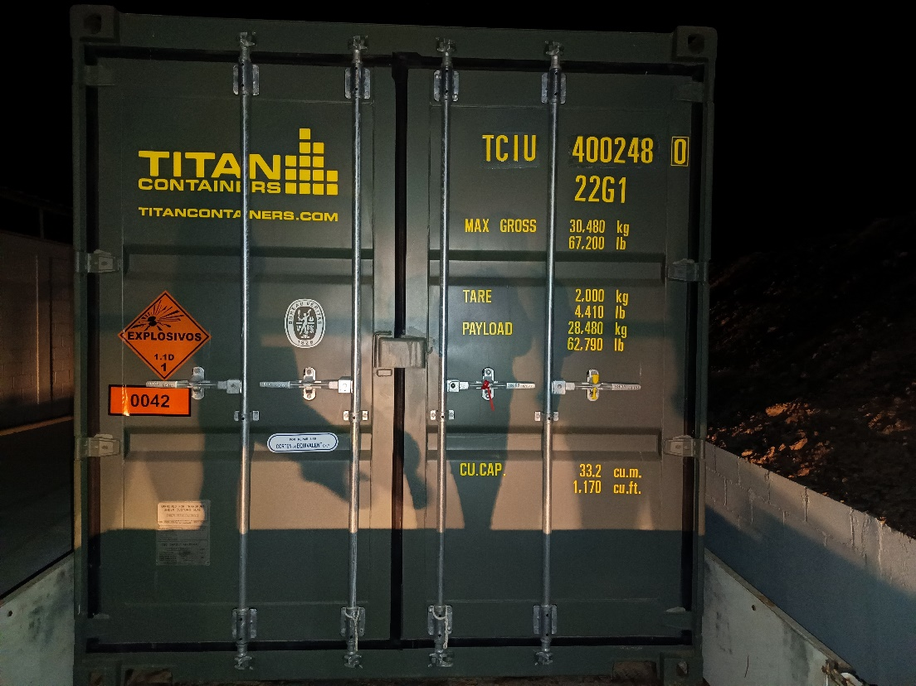
Container TCIU 400248-0 at Enaex Rio Loa Plant, Calama, Chile.

- Description of Goods
1.1.- Cargo | PENTEX DUO
1.2.- Total Units | 17.550
1.3.- Total caja | 1.170 cajas
1.3.- Total peso neto | 15.795,00 kg.
1.5.- Total peso bruto | 16.368,30 kg
1.6.- Valid CSC approval plated fitted or equivalent (ACEP No. legible) | Compliance

CSC PLATE

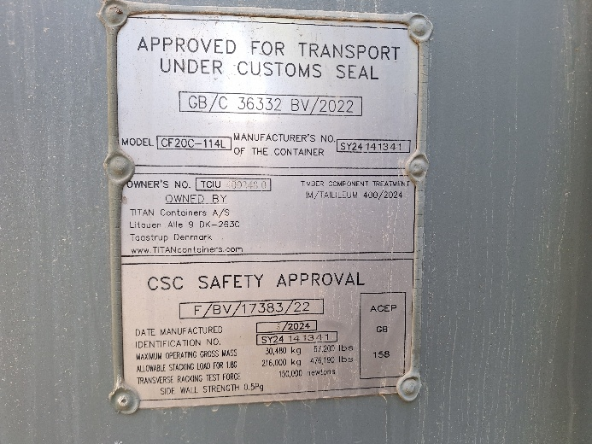

PACKING LIST

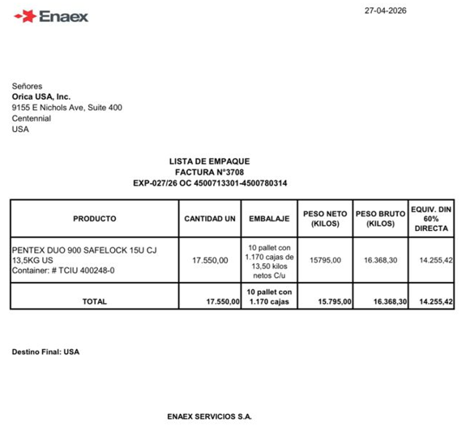

VERIFIED GROSS MASS

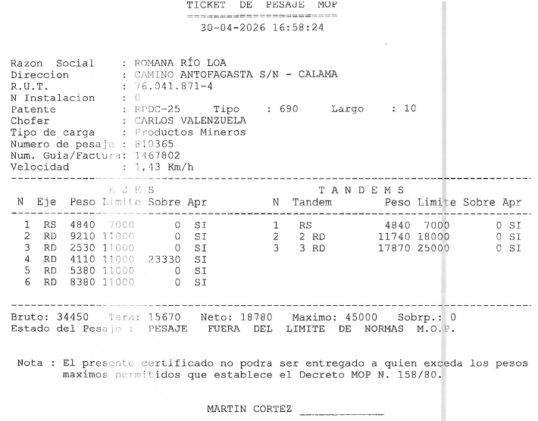

2.- Container Compliance Check list por Import/Export of Explosives
Container Selection | - | Lined with plywood | X | Stuffing Operation | X | Sealing | X

A.- General Requirements
A.1.- Non-vented general-purpose ISO container | Compliance
A.2.- Valid CSC approval plated fitted or equivalent (ACEP No. legible) | -
A.3.- Owners Serial No. | Compliance
A.4.- Appropriate UN hazard classification code (ie. 1.1D) and subsidiary risk label | Compliance

B.- Doors
B.1.- Only two openings | Compliance
B.2.- Each door with two locking bars (ie. 4) | Compliance
B.3.- Door hinges serviceable and operative | Compliance
B.4.- Doors capable of being locked | Compliance
B.5.- Door hinges serviceable and operative | Compliance
B.6.- Doors capable of being locked | Compliance
B.7.- Gaskets and seals in good condition | Compliance
B.8.- Weather tight | -

C.- External
C.1.- Top and bottom side rails | Compliance
C.2.- Top and bottom end rails | Compliance
C.3.- Door sill and header | Compliance
C.4.- Floor cross members | Compliance
C.5.- Corner posts | Compliance
C.6.- Corner fittings | Compliance
C.7.- Side and end walls weathertight | Compliance
C.8.- Tine pockets rendered inoperative (blanks fitted) | Compliance

D.- Internal
D.1.- Free of residue from previous cargo | Compliance
D.2.- Free from rust and scale | Compliance
D.3.- Clean condition | Compliance
D.4.- Free of projections or protrusions | Compliance
D.5.- Floor in sound condition, sift proof and free from cracks | Compliance
D.6.- Lined with either plywood 12mm thick, other timber 17mm thick, aluminium sheet 0.8mm thick | Compliance
D.7.- A 25mm gap between lining and container inner wall line | Compliance
D.8.- Lining extends 300 mm above cargo | Compliance
D.9.- Cargo is 300 mm below roof of container | Compliance
References: IMDG Section 7.4.6.4.2, CSC Code, Australian Explosives Code Section 6.3.

3.- Summary of Stuffing

Prefix | N° Container | United | Product | Custom Seal | Orica Seal
TCIU | 400248-0 | 17.550 | Pentex Duo | A14074718 | 107997

CONCLUSION | Approved

Date & Time of Survey (Selection) | April 02, 2026 / 16:30 Hrs.
Date & Time of Survey (Lined) | April 13, 2026 / 10:30 to 11:30 Hrs.
Date & Time of Survey (Stuffing) | April 30, 2026 / 11:00 to 12:00 Hrs.
Date & Time of Survey (Sealed) | April 30, 2026 / 19:30 Hrs.

This survey was carried out without prejudice and in the interest of whom it may concern.
SURVEYOR ALS | Roxana Segovia B. | 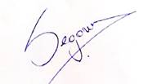
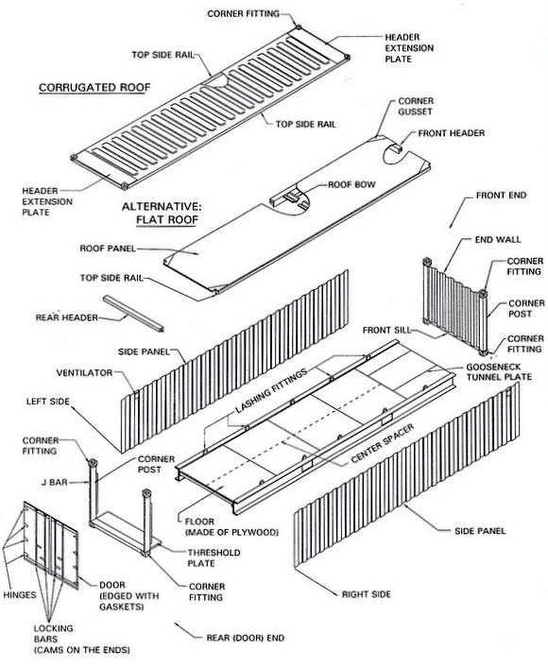
4. - PHOTOGRAFIC SET

4.1. – CONTAINER SELECTION

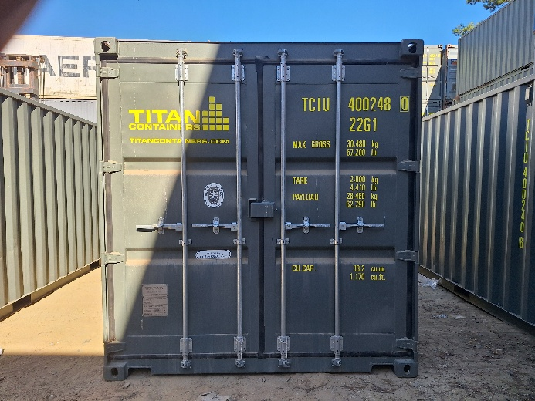
- General view of container | - CSC Plate

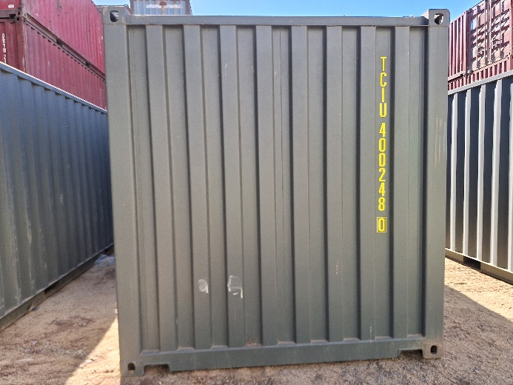 | 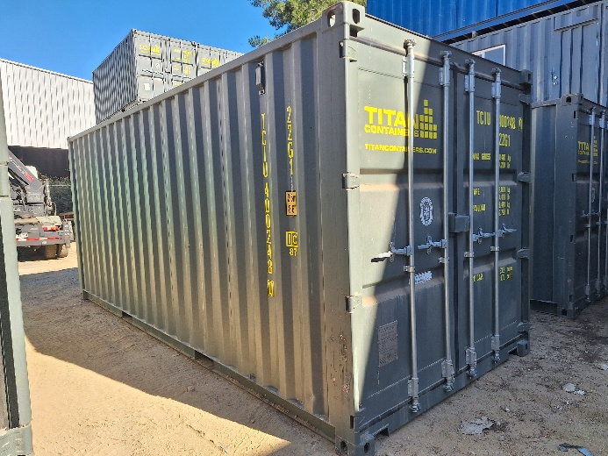
- Top riel and front panel in good condition. | - Side panel in good condition.

 | 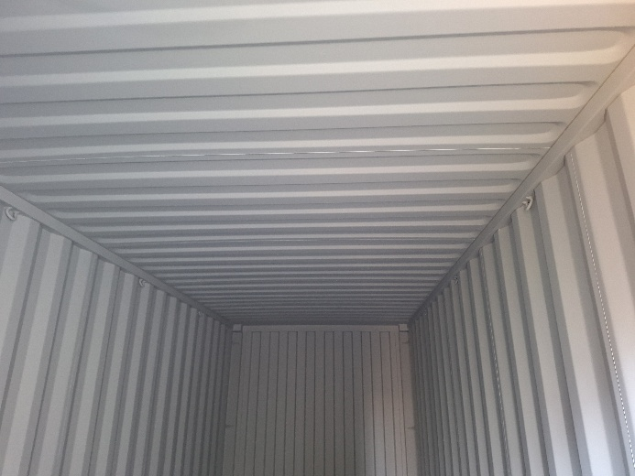
- Tight test. | - Inside panels in good condition.

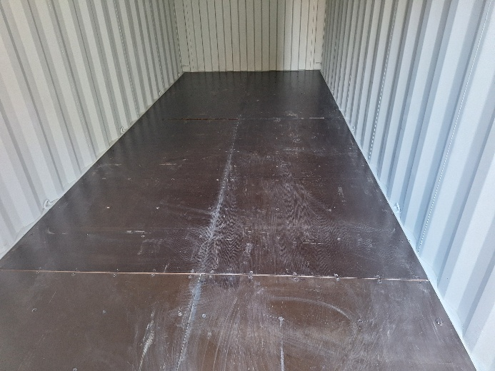 | 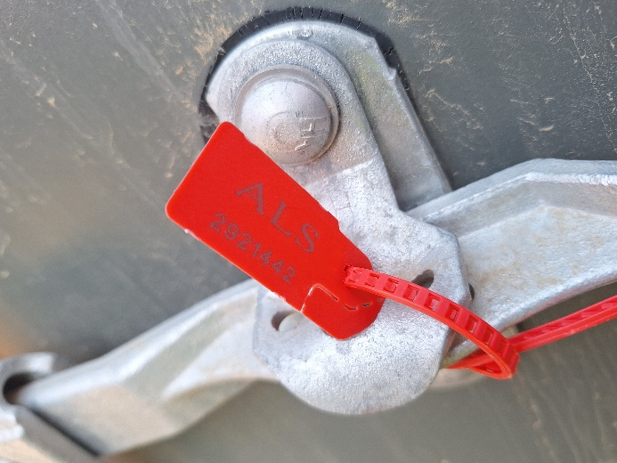
- Container floor in good condition. | - Bottom Red seal of approval:  Nr. ALS 2921442.

4.2. - LINED

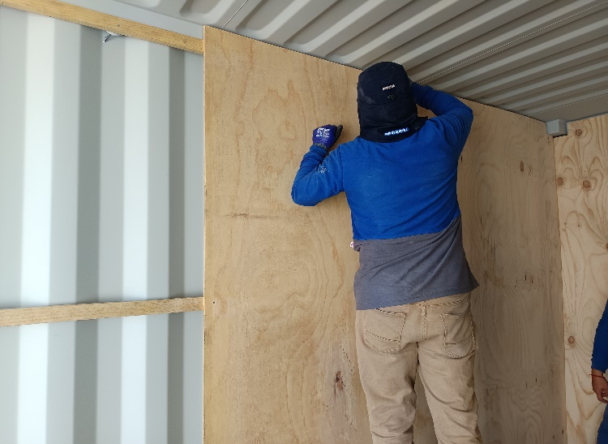
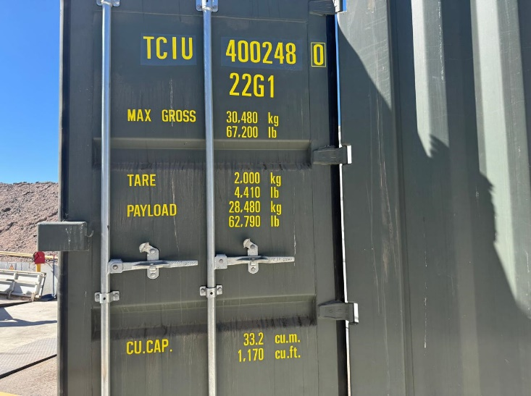
- View of Container TCIU 400248-0 | - Wooden used in the lined.

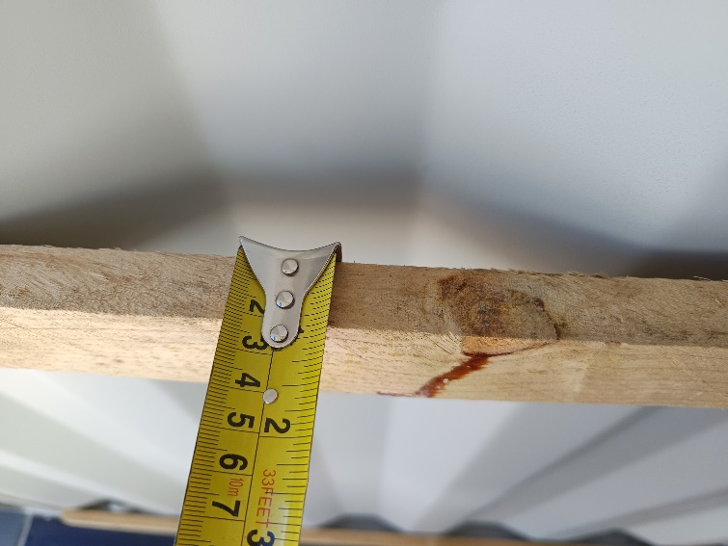
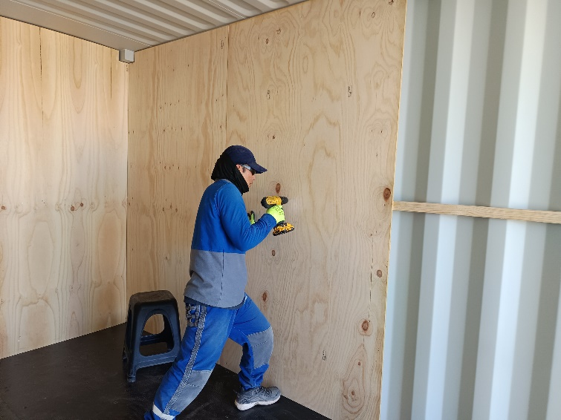

- Lined operation. | - Wooden used in the lined.

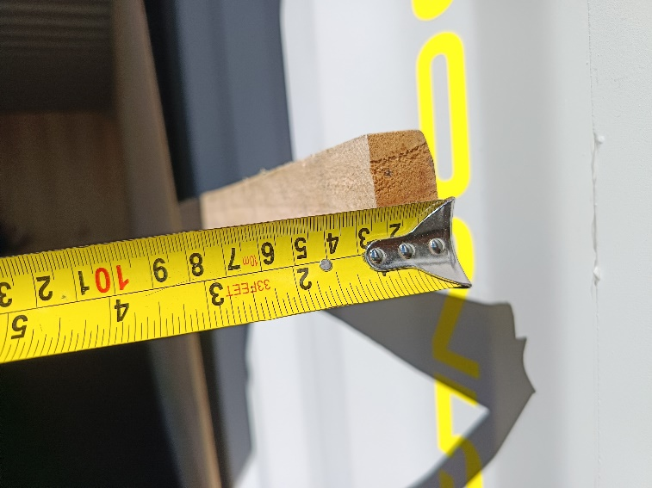
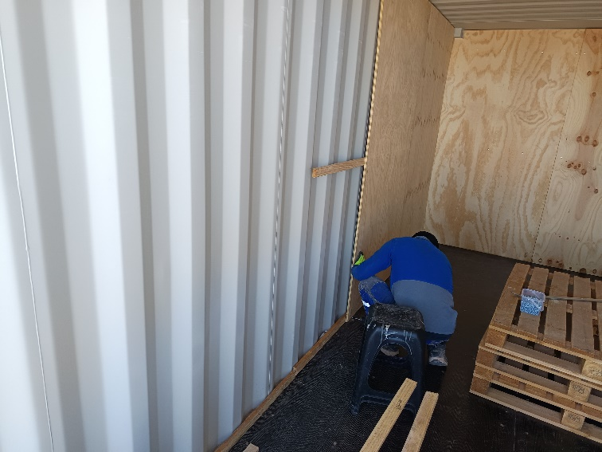
- Wooden used in the lined. | - Lined operation.

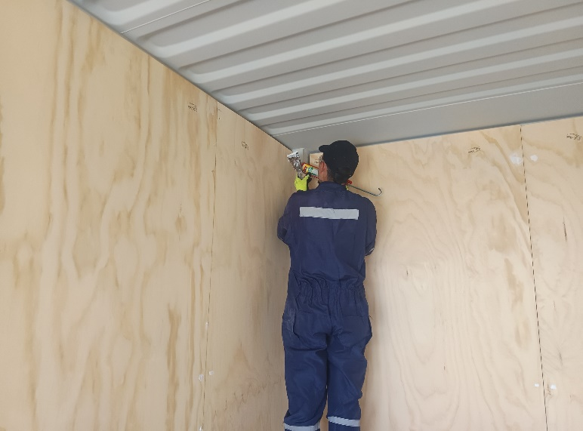 | 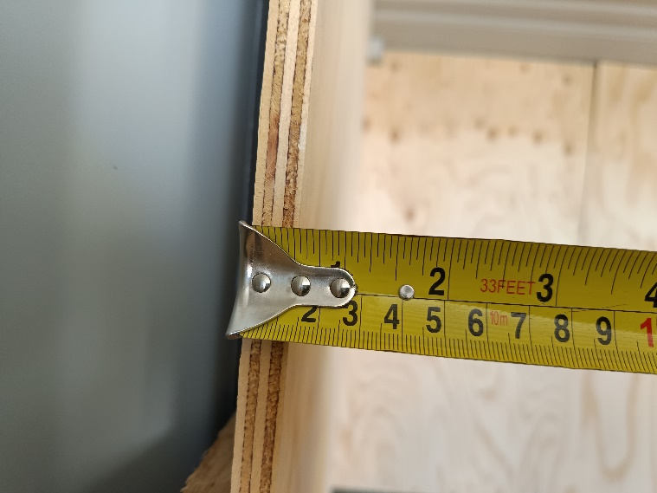
- Silicone to isolate nails. | - Measure of wood 12 mm.

4.3. - STUFFING

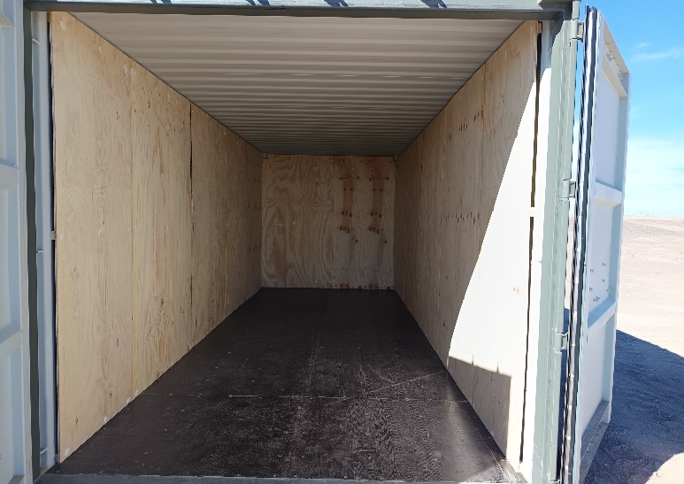 | 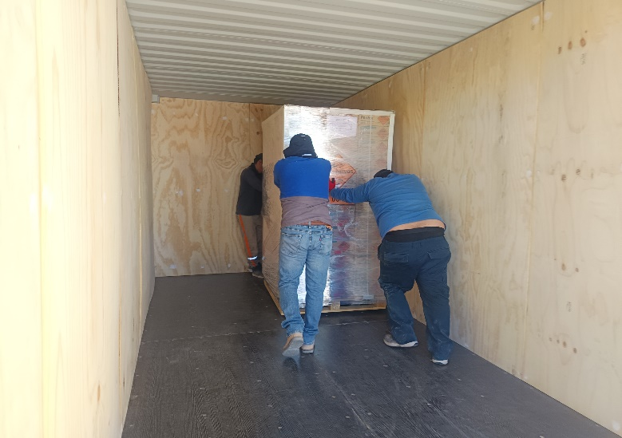
- Stuffing operation. | - Stuffing operation.

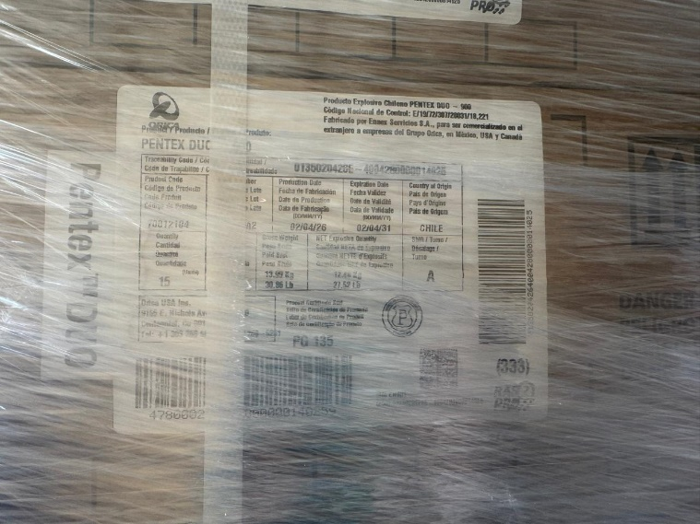 | 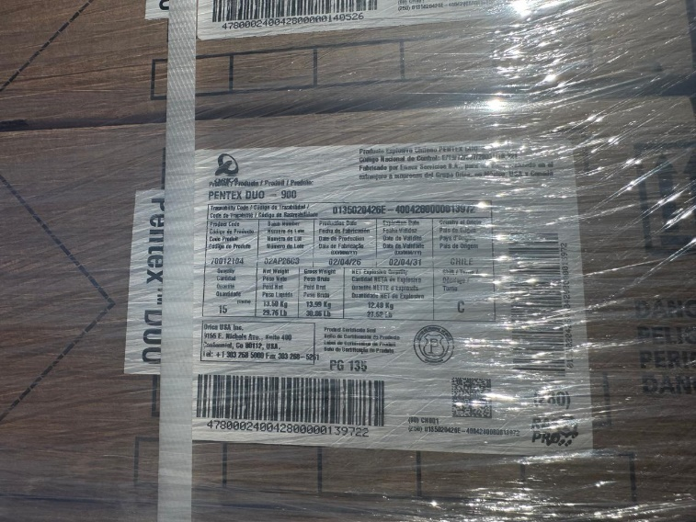
- View of cargo identification | - View of cargo identification

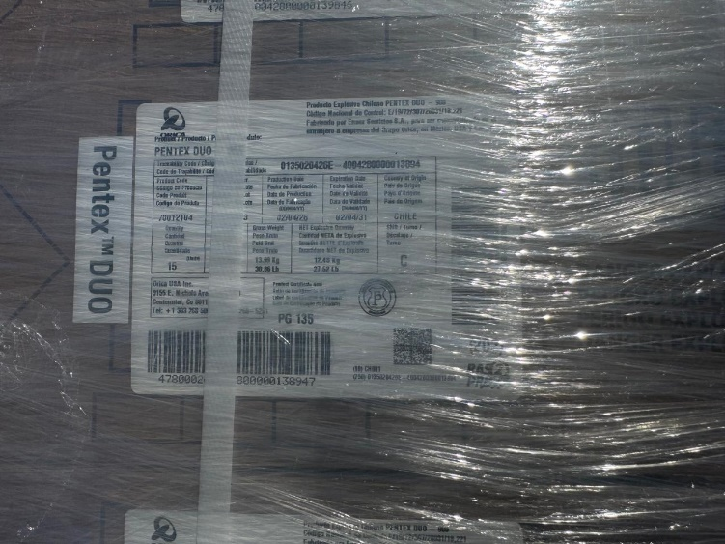 | 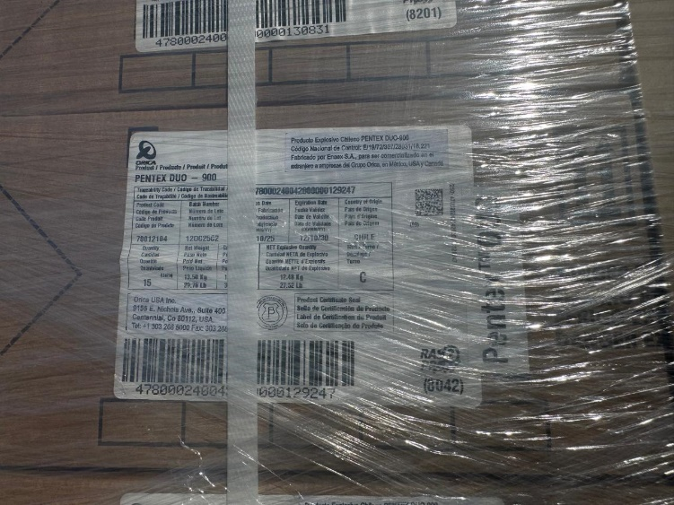
- View of cargo identification | - View of cargo identification

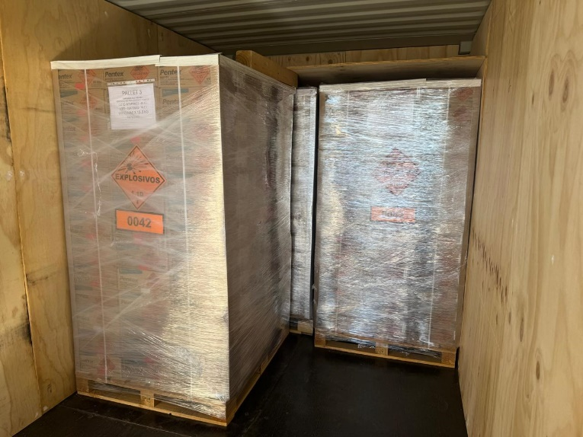
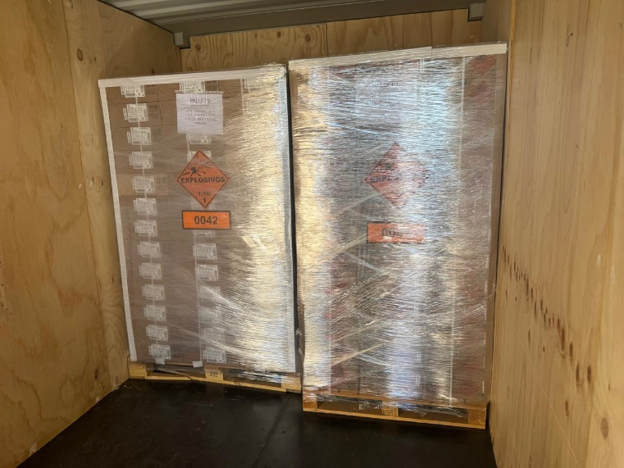

- View of stowage condition during stuffing operation 25 % | - View of stowage condition during stuffing operation 50 %

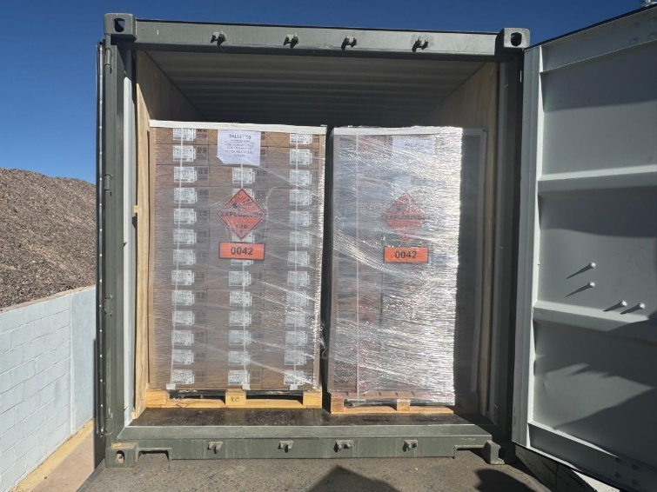
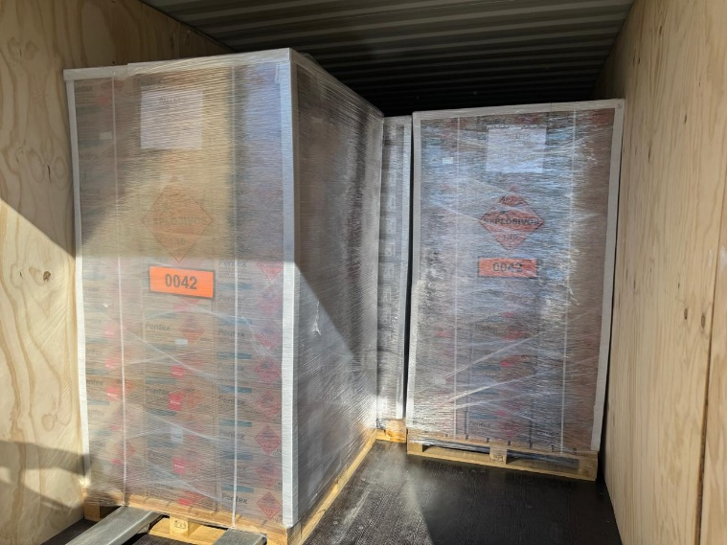
- View of stowage condition during stuffing operation 75 % | - View of cargo identification

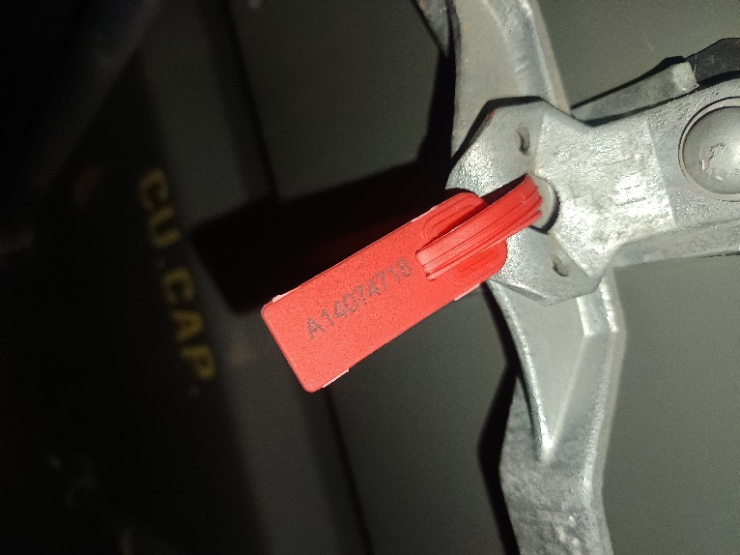
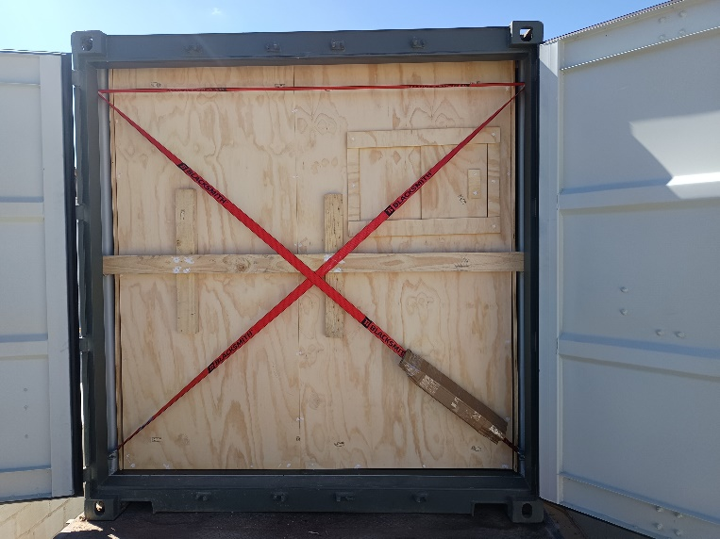

- View of lashing of container using polypropylene sling and wooden | - Seal of customs (A14074718)

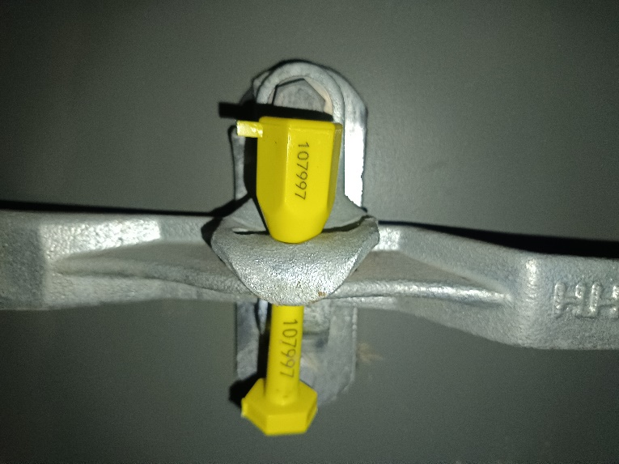 | 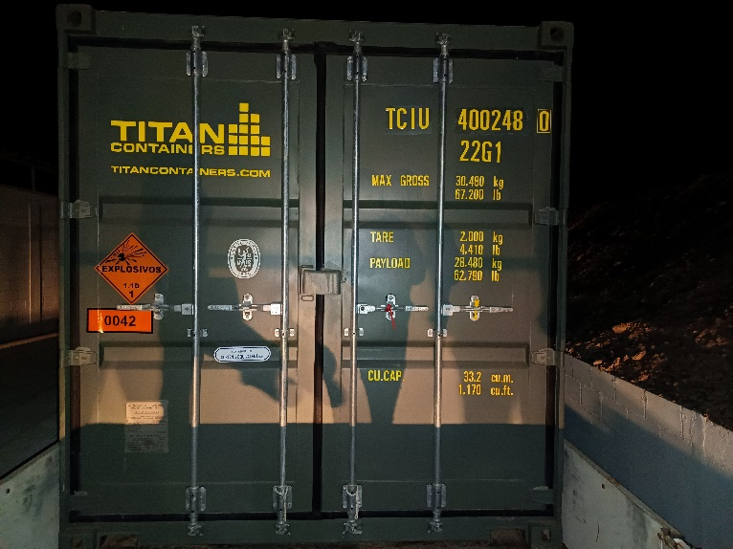
- Seal of Orica (107997). | - View of container with IMO labels.

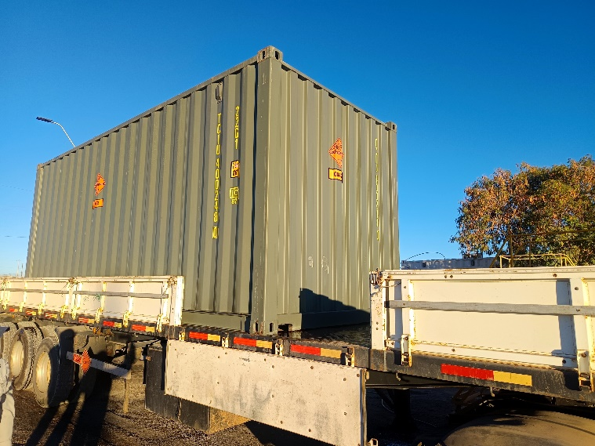
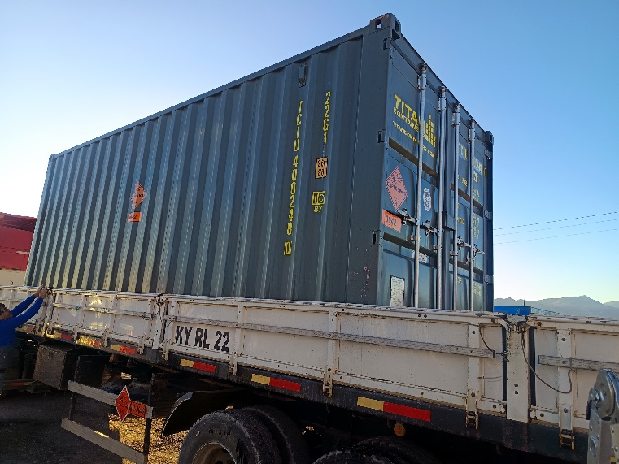

.

- View of container with IMO labels. | - View of container with IMO labels.

