VEHICLES SURVEY REPORT

VESSEL | : Ro/Ro “MORNING PILOT” | VOYAGE | : S610
PORT OF LOADING | : Shanghai / China | DISCHARGE PORT | : Iquique / Chile
UNITS INSPECTED | : 14 Ford Units (Vehicles) | ATTENDANCE DATE | : May 04, 2026

INSPECTED ON BEHALF OF | : EUKOR Car Carriers Inc.

CONTENT:
1.- | SCOPE OF SURVEY | 5.- | ON BOARD ATTENDANCE
2.- | PERTINENT DATA | 6.- | DISCHARGE SUPERVISION
3.- | TIMES | 7.- | POST-DISCHARGE DAMAGE SURVEY
4.- | CARGO IDENTIFICATION | 8.- | ATTENDING PARTIES

1.- SCOPE OF SURVEY
The present survey was conducted according to instructions received from Mr. Adolfo Liewald report upon:

- Stowage and lashing of 14 units on board vessel.
- General condition of vehicles on board vessel.
- Discharge operation of vehicles.
- Damages/observations noted on vehicles during post-discharge inspection alongside vessel.

All relevant surveys were performed in accordance with procedures agreed with client.
Having carried out all relevant surveys and attendance, we report as follows:

Report submitted to
Ian Taylor | : kmunoz@iantaylor.com
Submission date | : May 07, 2026

2.- PERTINENT DATA

Vessel | : MORNING PILOT
Voyage | : 610
Port of registry | : Majuro
Type of ship | : Pure Car & Truck Carrier
Operators | : EUKOR Car Carriers Inc.
Operators Agent | : Ian Taylor
Stevedores | : Ecos Muellaje

3.- TIMES

Date | Hour | Observations
May 04, 2026 | 14:30 | : ALS Surveyors arrived at the inspection site N° 2 EPI Port
May 04, 2026 | 15:30 | : ALS Surveyors on board vessel
May 04, 2026 | 15:40 | : Inspection on board commenced
May 04, 2026 | 18:20 | : Inspection on board finished
May 04, 2026 | 20:20 | : Inspection alongside vessel completed
May 04, 2026 | 20:30 | : ALS Surveyors left the inspection site N° 2 EPI Port

4.- CARGO IDENTIFICATION

Quantity | P.O.L. | Type of vehicle | Mark
14 | Shanghai / China | New Car | FORD
TOTAL: 14 Units

5.- ONBOARD ATTENDANCE

ALS surveyors attended on board vessel prior to commencement of unlashing and discharge operations and requested voyage information to Chief Officer, who reported:

 |  | YES | NO
 | Damage reports from loading ports issued by the ship |  | X

The condition of the hold’s car covers was noted to be, generally, good; The decks were clean and dry, and the lighting was satisfactory.

The vehicles arrived duly stowed; the lashing of the cars consisted of palms polypropylene bands.

The presence of important dust on vehicles was observed.

The general condition of the vehicle was found to be satisfactory.

6.- DISCHARGE SUPERVISION

The cargo was stowed with 14 vehicles on deck #07 / hold Nr. 1 and The cargo was stowed
Discharge operation of vehicles commenced on deck #5, following top levels. Six (6) stevedores removed lashings from vehicles; this operation was coordinated by ship’s crew and command. No damages were caused to vehicles during unlashing.

Vehicles were driven off the ship through her aft ramp; twelve (10) drivers from Ecos Muellaje performed the discharge operation of all units.

7.- POST DISCHARGE DAMAGE SURVEY

All vehicles were inspected by ALS surveyors, as detailed hereunder.

No vehicles found with damage and/or observations are included in the following damage list, while the following abbreviations are applied to classify the damage and deficiencies according to their origin:

TMD | = | - Transport marine damage.  - Damage attributable to marine transport.
TPLD | = | - Transport pre-load damage.  - A damage or deficiency originated before vehicle was loaded on board vessel.
OTTD | = | - Other than transport damage.  - Factory/manufacturing damages and deficiencies, deterioration, fall out or paint failure, which are not caused by transport impact at any transport system neither ashore nor at sea.
OTMD | = | - Other than marine damage.  - Any impact damage caused during transportation ashore prior to commencement of marine transport.
STEV | = | - Stevedore damage.  - A damage caused by stevedores on board or ashore.
IHM | = | - Item Hardware Missing.  - Apply to accessories such as radio, spare tires, ashtray, and so on, which must be replaced.

Vehicles found with observations and inspected by ALS Surveyors:

Upon discharging time, there was no presence of Ford representative to carry out the inspection jointly; after completing the discharge operations, the vehicles were parked inside EPI Terminal.

 | Mark | Damages (d) |  | TMD |  | OTMD |  | TPLD |  | STEV |  | OTTD
 | Mark | by their Origin
 | Mark | Ttl | % | # | % | # | % | # | % | # | % | # | %
 | FORD | 0 d | . % | d | . % | d | . % | d | . % | d | . % | d | . %
 | TOTAL | 0 | 100 | 0 | 0 | 0 | 0 | 0 | 0 | 0 | 0 | 0 | 0

8.- ATTENDING PARTIES

- Ecos Muellaje, personnel carried out vehicle’s discharge operation.
- Mr. Josue Espinosa, Vessel Operator o/b Ecos Muellaje stevedores.

On board inspection was carried out by:

- Mr. Gonzalo Bacian V. ALS Inspection Surveyor on behalf of EUKOR Cars Carriers Inc.

Post-discharge damage survey was carried out by:

- Mr. Gonzalo Bacian V. ALS Inspection Surveyor on behalf of EUKOR Cars Carriers Inc.

Attached to this report:

- Stowage cargo plan
- Cargo manifest

This survey was carried out without prejudice and in the interest of whom it may concern.

Surveyor
ALS INSPECTION CHILE SpA

Prepared by : G. Bacian
Reviewed by : M.J. Palma
Validated by : J. Lopez

SET OF PHOTOGRAPHS

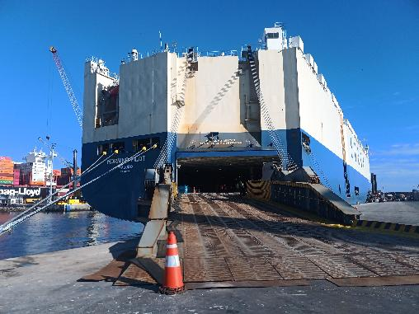 | 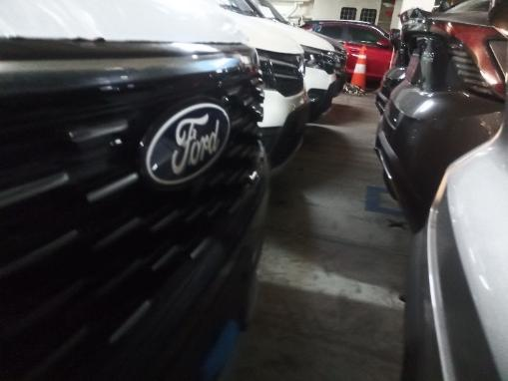
- M/V MORNING PILOT, berthed at  Pier N° 2 Terminal EPI, Iquique. | - Onboard view.
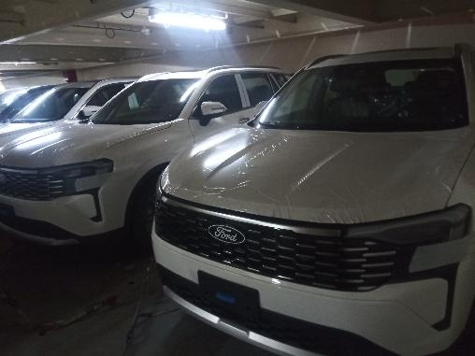 | 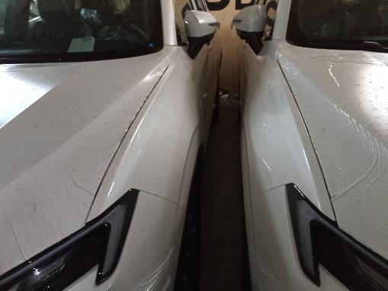
- View vehicles on board. | - Stowage separation between Ford vehicles.

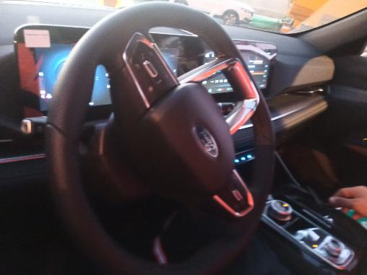 | 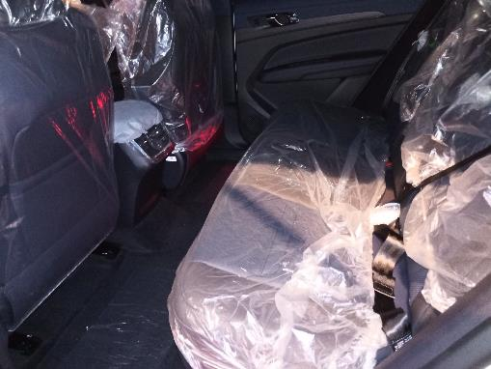
- Main view of vehicle inner side. | - Inner view of vehicle.
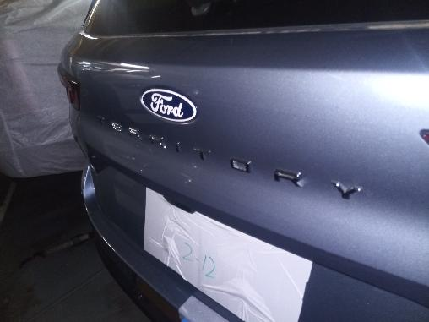 | 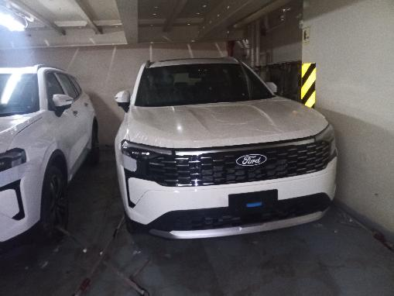
- Rear view of vehicles on board. | - General view of Ford vehicles.

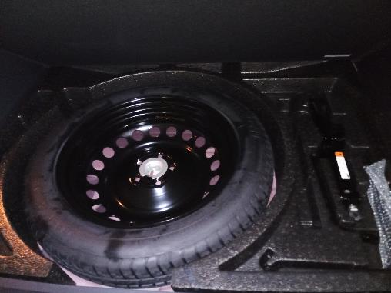 | 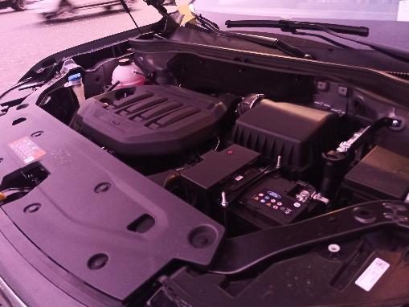
- Spare tire inside vehicle. | - Ford vehicle engine.
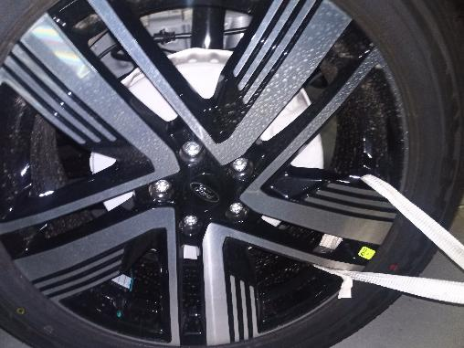 | 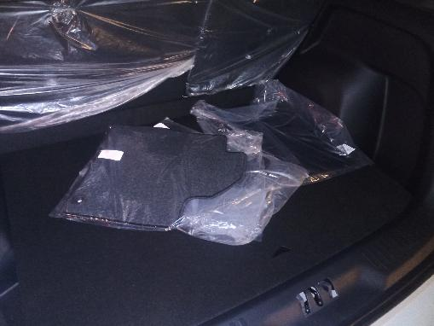
- Tire condition. | - View of bags inside trunk.

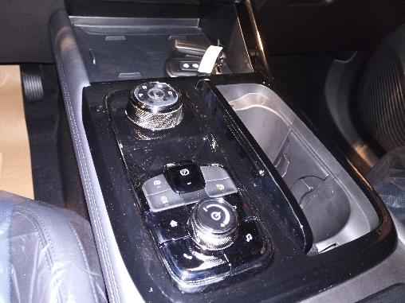 | 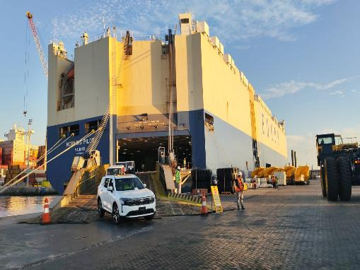
- Controls inside. | - View of vehicle being unloaded from main ramp.
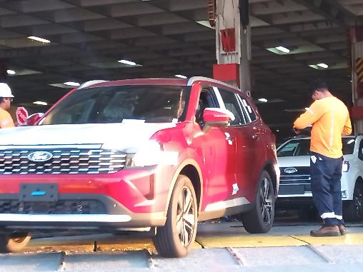 | 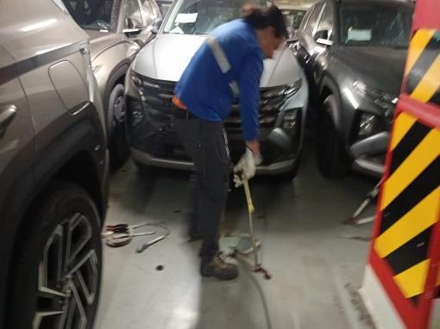
- Sink control, before being unloaded by main ramp. | - Vehicles being unlashed on boar.

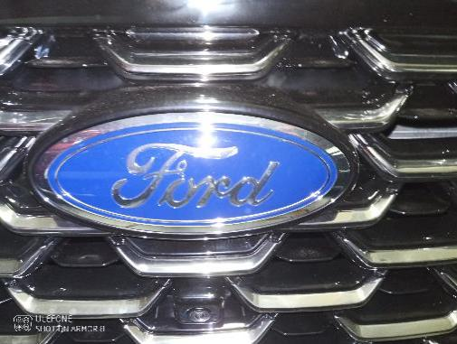 | 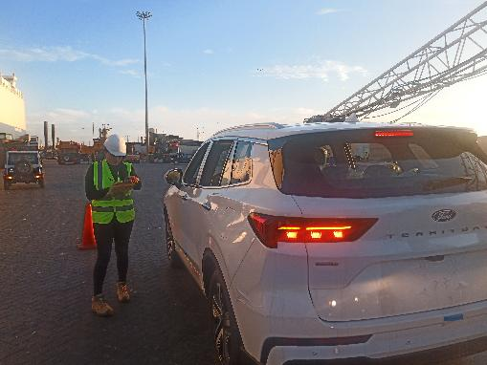
- View of Ford brand. | - View of vehicles alongside vessel.

