This is to certify that we ALS INSPECTION CHILE SPA., at the request of TRANS PACIFIC FIBRE S.A. and with the consent of Captain, the undersigned surveyor attended onboard MV:

“CANADA EXPRESS V.26005”

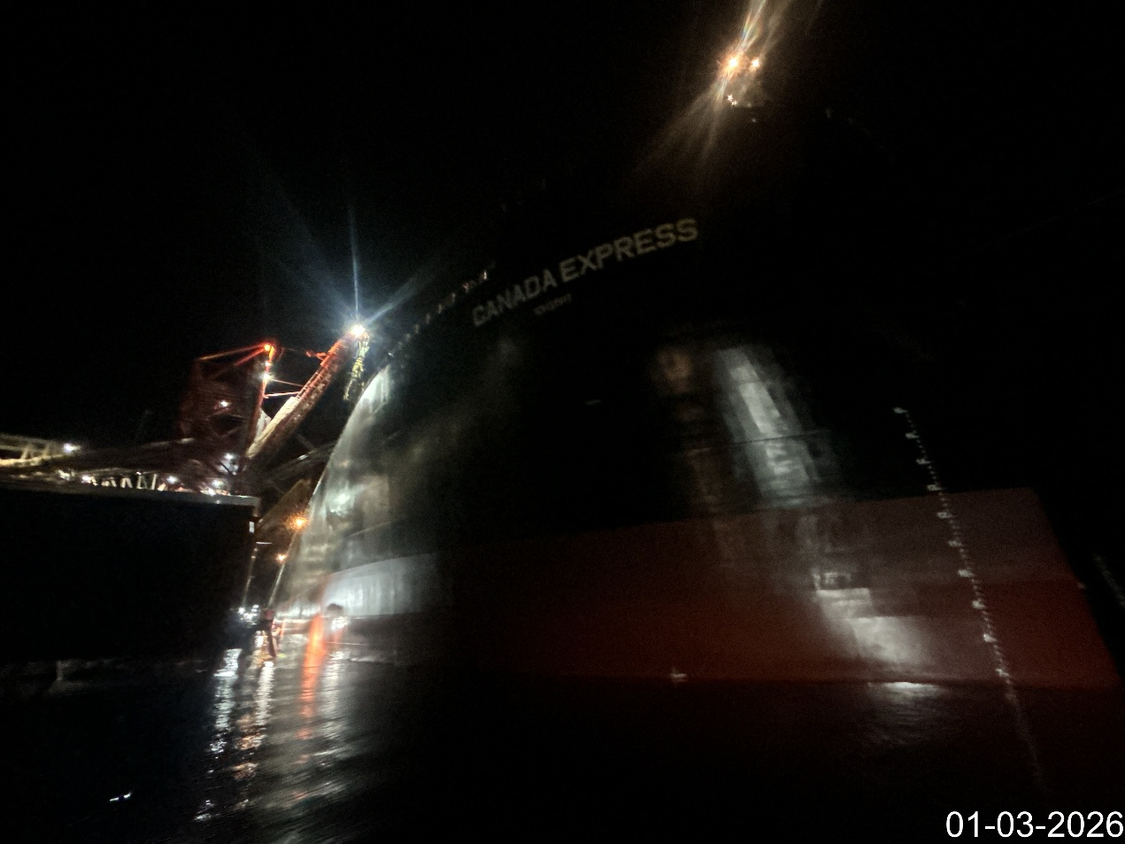

From the following dates: March 01, to 07, 2026, with the purpose to perform a:

“DRAUGHT SURVEY”

And we report as follows:

1. SCOPE OF THE SURVEY

The present inspection was conducted according to the request of Mr. Rodrigo Castro, from TRANS PACIFIC FIBRE S.A., with the purpose of carrying out a draught survey to determine the quantity of Woodchips loaded onto MV CANADA EXPRESS at Terminal San Jose – Calbuco Port, Chile.

2. SHIP’S PARTICULARS

Name | CANADA EXPRESS
IMO | 9861251
Call sign | 9V6333
Type | Wood Chip Carrier
Port of Registry | Singapore
Flag | Singapore
Deadweight | 69,742.00 MT
Gross Tonnage | 57,934.00 MT
Nett Tonnage | 19,727.00 MT
Class | ABS
L.O.A. | 215.40 mt
Depth | 25.20 mt
Master Name | Mr. Guoyong Zhang.
Chief Officer Name | Mr. Cuishan Yang.

3. WEATHER CONDITIONS

- The weather condition upon initial draught survey was good.
- The weather condition upon intermediate draught survey was good.
- weather condition upon final draught survey was good.

4. DATE & TIMES

DATE | HOURS | REMARKS
March 01, 2026 | 01:30 | Initial draught survey commenced.
March 01, 2026 | 03:30 | Initial draught survey completed.

DATE | HOURS | REMARKS
March 05, 2026 | 14:00 | Final draught survey commenced.
March 05, 2026 | 14:30 | Final draught survey completed.

DATE | HOURS | REMARKS
March 07, 2026 | 09:40 | Final draught survey commenced.
March 07, 2026 | 10:00 | Final draught survey completed.

5. RELEVANT FIGURES

5.1. First intermediate Draught Survey

5.2. Draught Survey results

We hereby certify that according to vessel’s displacement scales (draught survey); MV CANADA EXPRESS loaded the following quantity of EUCALYPTUS NITENS WOODCHIPS:

46,608.19 MT.

5.3. Final Draught Survey

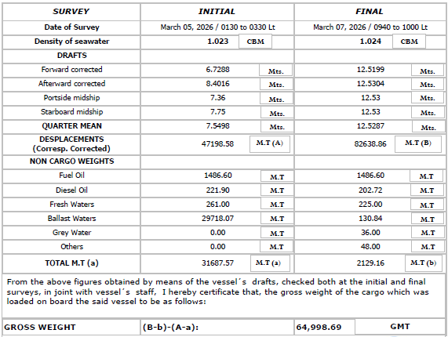

5.4. Draught Survey results

We hereby certify that according to vessel’s displacement scales (draught survey); MV CANADA EXPRESS loaded the following quantity of EUCALYPTUS NITENS WOODCHIPS:

64,998.69 MT.

- ATTACHMENTS

- Draught Certificate signed by ALS Inspection Chile SpA. surveyor and Chief Officer

- ATTENDING PARTIES

- Mr. Cuishan Yang., Chief Officer M/V “SCANADA EXPRESS”.
- Mr. Aaron Bustos A., ALS Inspection Chile SpA. on behalf of Trans Pacific Fibre S.A.

- BIBLIOGRAPHY

- Draught survey, Code of Practice, IIMS, UK
- Int’l UN code for Draught Surveys.

This survey report was carried out without prejudice and in the interest of whom it may concern.

Surveyor
ALS Inspection Chile SpA

Prepared by : A. Bustos
Reviewed by : J. Lopez

Approved by : J. Lopez

PHOTOGRAPIC SET

Initial draught survey:

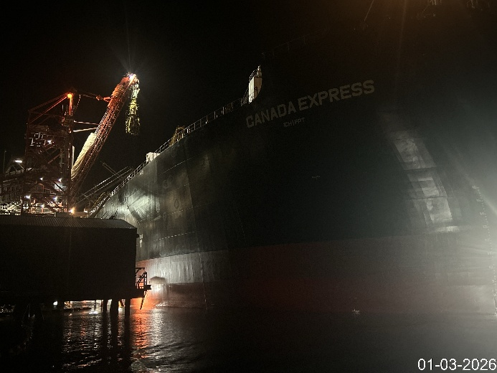 | 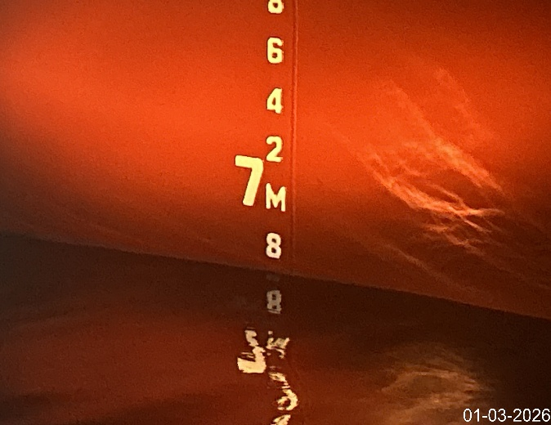
- MV berthed to Terminal San Jose. | - P/S Forward draft.

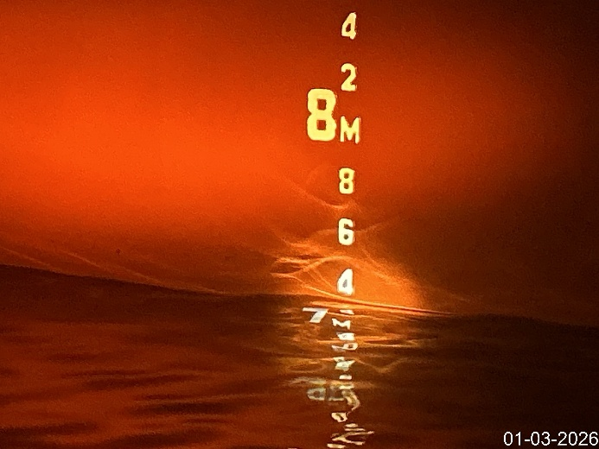 | 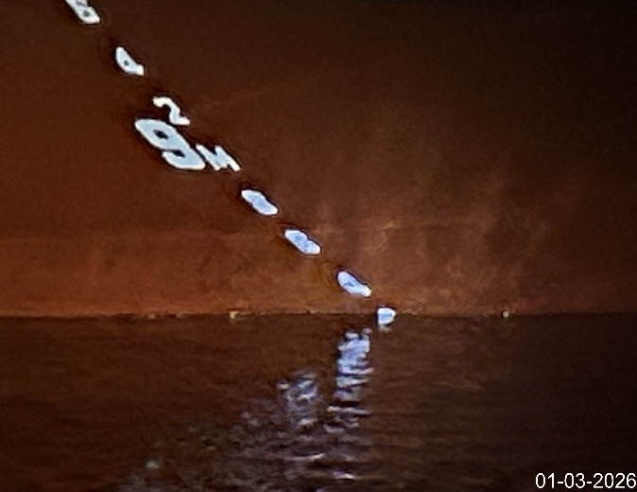
- P/S Mid ship draft mark. | - P/S Aft reading draft.

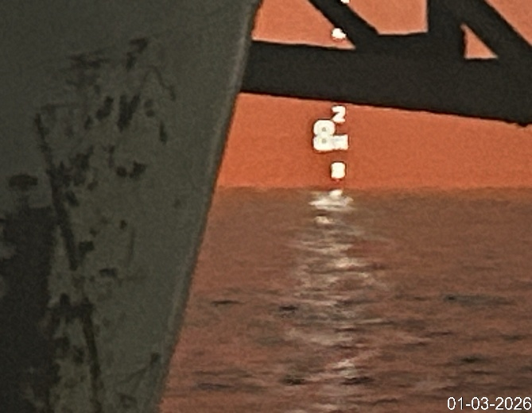 | 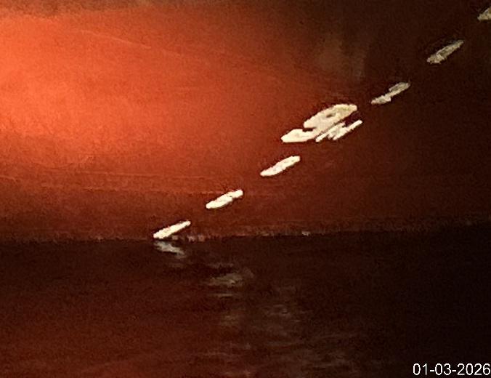
- S/S Mid ship draft mark. | - S/S Aft reading draft.

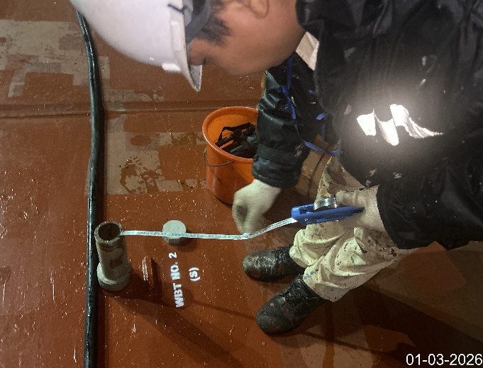 | 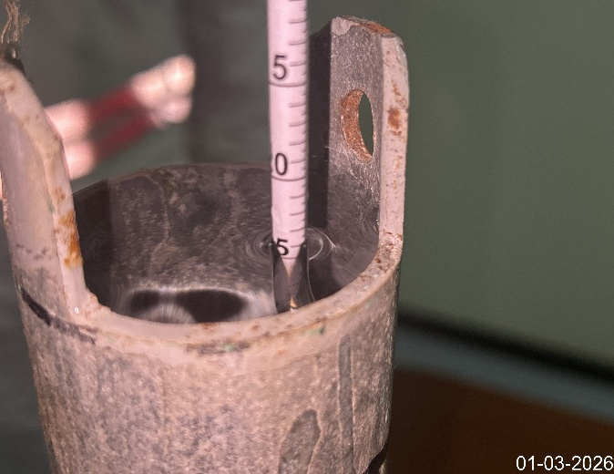
- Painting ruler before sounding ballast. | - Checking density of the sea water.

Intermediate draught survey:

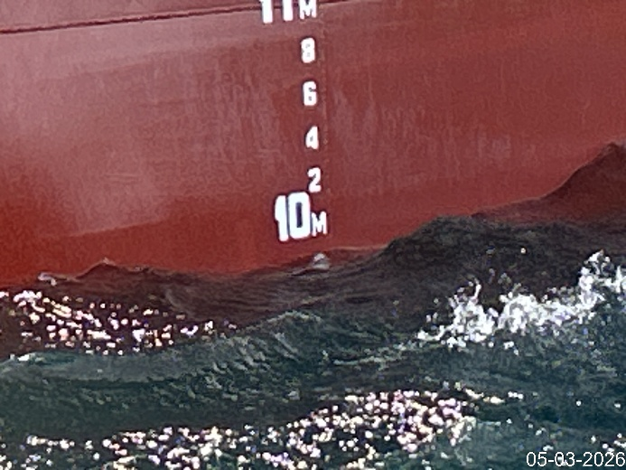 | 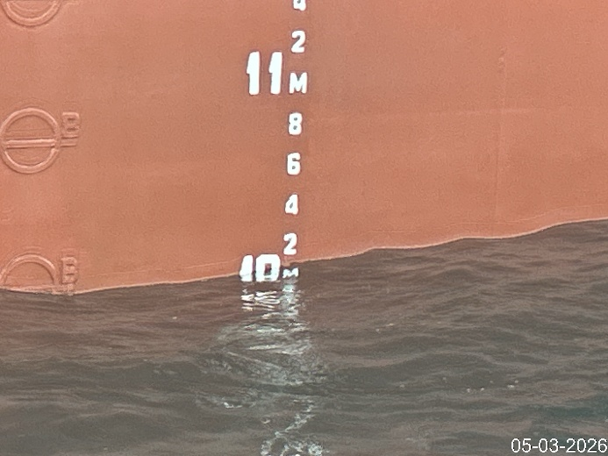
- P/S Forward draft. | - P/S Mid ship draft.

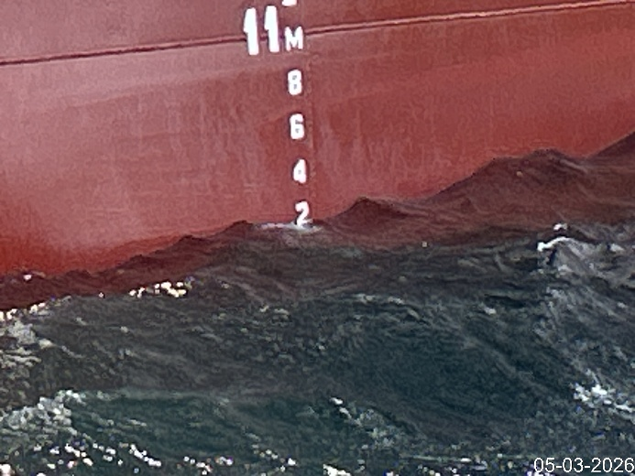 | 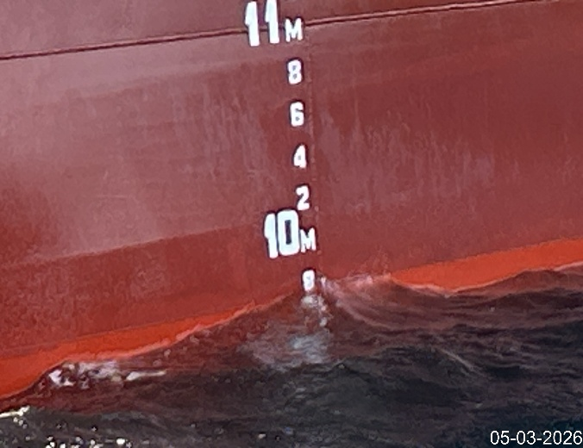
- P/S Aft draft. | - S/S Forward draft.

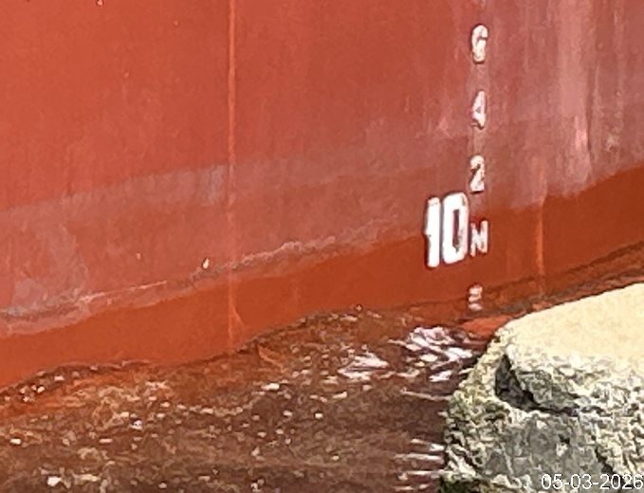 | 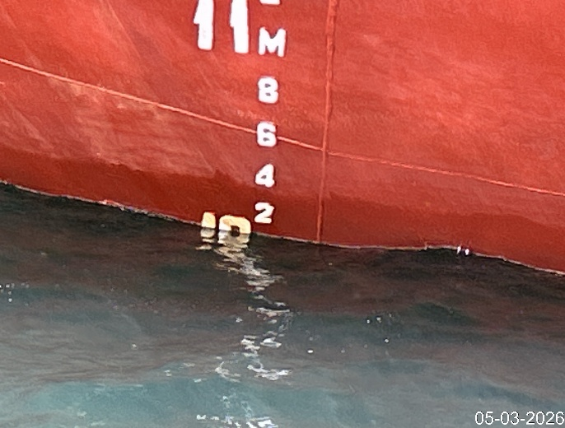
- S/S Mid ship draft. | - S/S Aft draft.

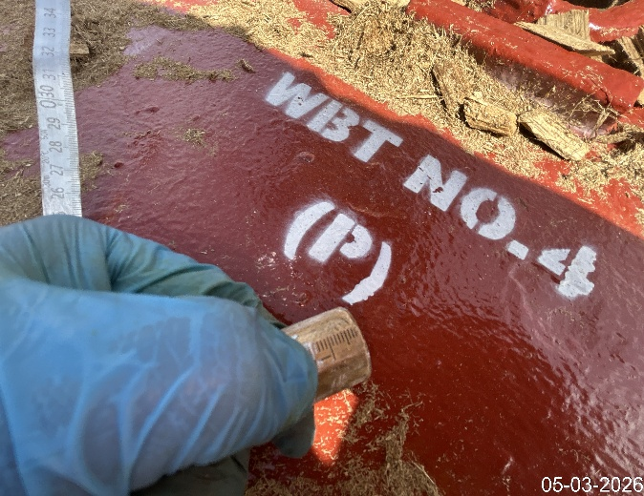 | 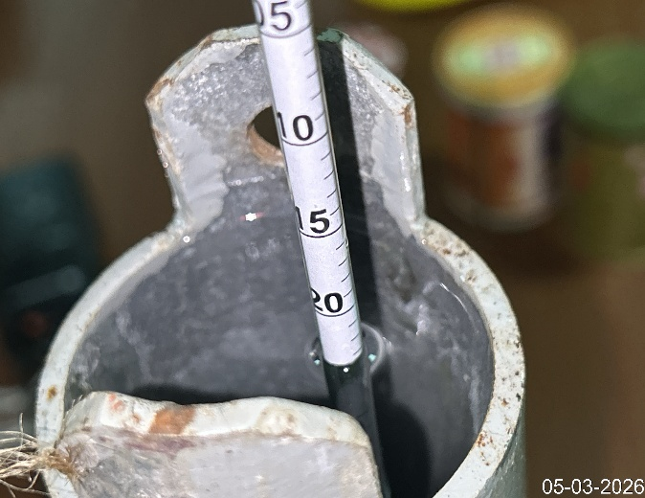
- Painting ruler before sounding ballast. | - Final density of the sea water.

Final draught survey:

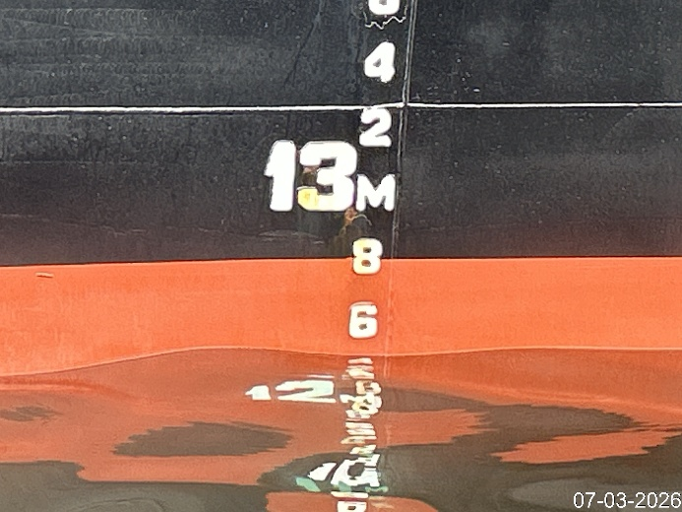 | 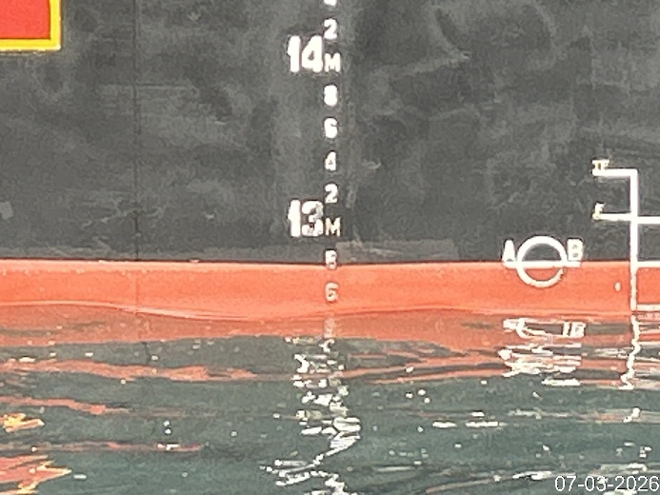
- P/S Forward draft. | 18. P/S Mid ship draft.

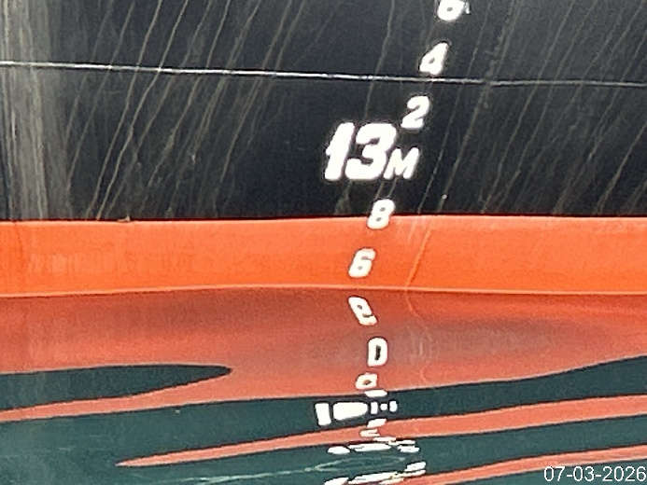 | 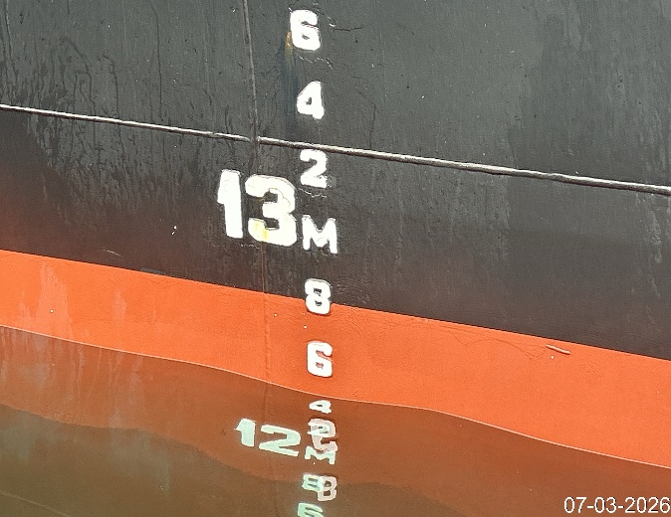
- P/S Aft draft. | - S/S Forward draft.

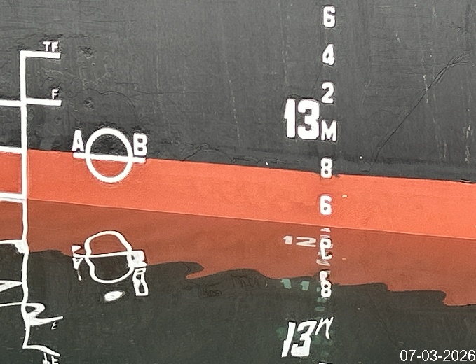 | 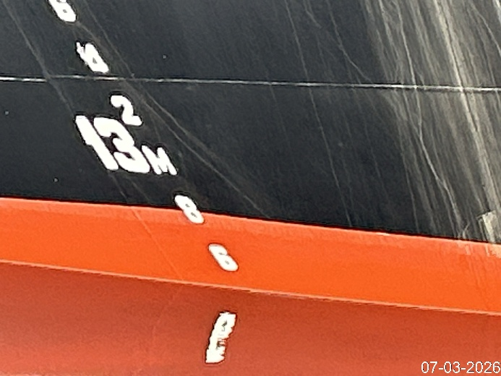
- S/S Mid ship draft. | - S/S Aft draft.

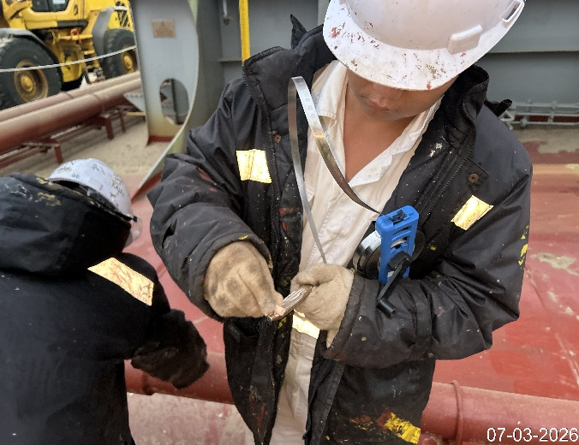 | 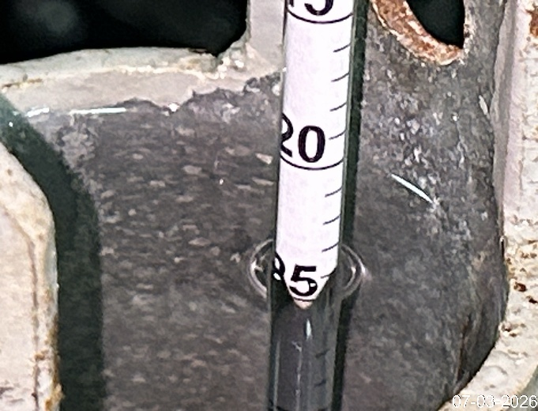
- Ballast tank description. | - Final density of the sea water.

