INSPECTION ON  BEHALF OF | Fresh On Time Seafood
REQUESTED BY | Ms. Yulan Indah Permatasari
SCOPE OF SURVEY | Inspect the cargo condition, container stuffing and sealing.

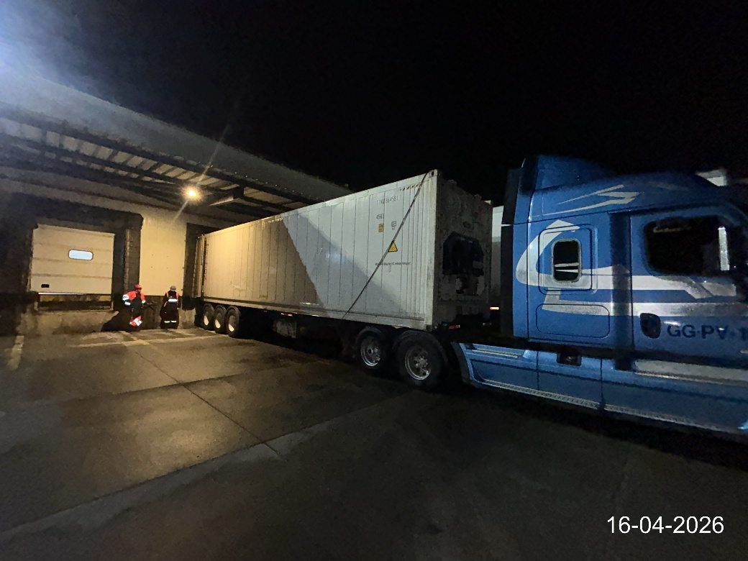
Reefer container TTNU 864581-1 located on the platform of the chamber
"Emergent" Puerto Varas - Puerto Montt /Chile.
CONTAINER | TTNU 864581-1  Reefer x 40 ft | PLACE OF INSPECTION | Chamber: Emergent  Ruta Panamericana Sur Km-1012 Puerto Varas - Puerto Montt, Chile
TYPE OF CARGO | Centolla  Congelado, Cocido bloque, Pinzas/Patas con cascara.  (Lithodes Santolla) | ATTENDANCE DATE | April 16, 2026,

- –DATE & TIMES

March 16, 2026 | 18:00 | ALS Surveyor arrives at the reefer chamber in Emergent.
March 16, 2026 | 18:15 – 18:30 | Meeting with the personnel of the reefer chamber Maersk.
March 16, 2026 | 19:10 | Commenced inspection of the condition cargo.
March 16, 2026 | 20:05 | Commenced stuffing.
March 16, 2026 | 21:10 | Completed inspection of the condition cargo.
March 16, 2026 | 22:40 | Completed stuffing.
March 16, 2026 | 23:00 | Sealing of the container.
March 16, 2026 | 23:20 | ALS Surveyor left the reefer chamber in Emergent.

2. – SURVEY DETAILS

2.1 General details of the survey
ALS CARGO INSPECTION AND CERTIFICATION
CERTIFICATE Nº | PMO-2602-0752
CLIENT | FRESH ON TIME SEAFOOD
PLACE OF SURVEY | REEFER CHAMBER EMERGENT
PRODUCT | STONE KING CRAB CLUSTER
Nº TERMOGRAPH | ZYS1798
CONTAINER NUMBER | TTNU 864581 1
PRODUCTION DATE | May, August, September, October, November y December 2025
QUANTITY OF CARGO | 961 BOXES
NET CARGO | 11.395,96 KG
ALS CARGO INSPECTION AND CERTIFICATION
GROSS CARGO | 12.886,50 KG
SEAL CHAMBER EMERGENT | 3579
SEAL LINE | 29633432
CHAMBER N°1 SET POINT | -18 °C
CLEAN, DRY AND ODOR FREE | YES
DISPATCH TEMPERATURE | -3.4 °C
OBSERVATION: NO OBSERVATION

2.2 Cargo condition and quantity of the pieces per box:

The king crab cluster was observed, with its body, legs and without shells.

• The cargo is in good frozen conditions.
• Color, odor and normal texture.
• Boxes inspected are dry.

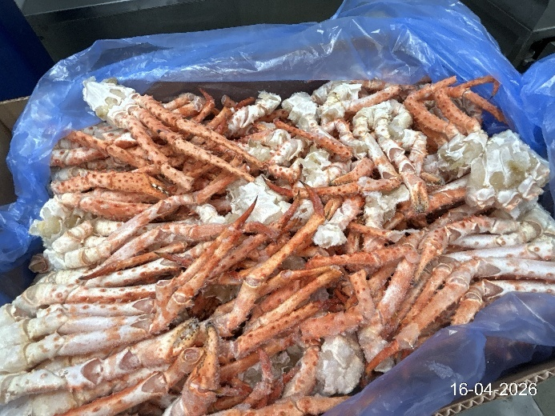 | 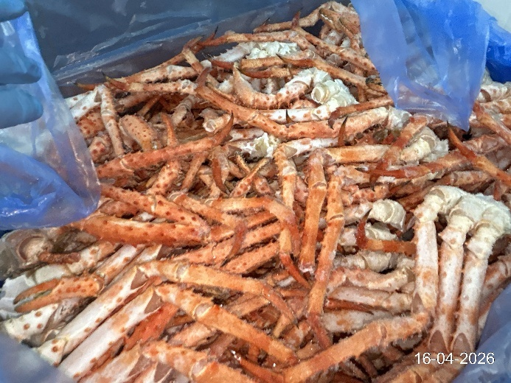

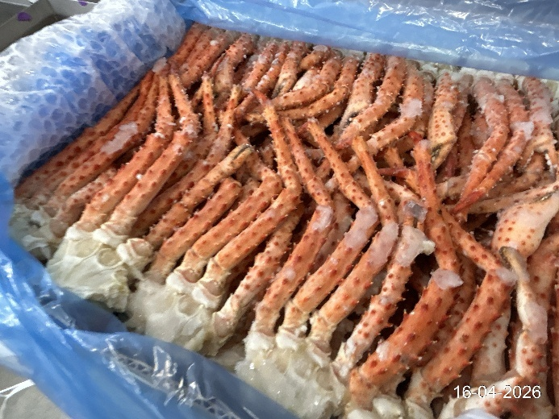 | 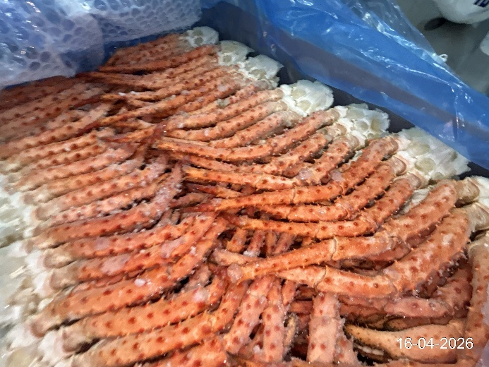

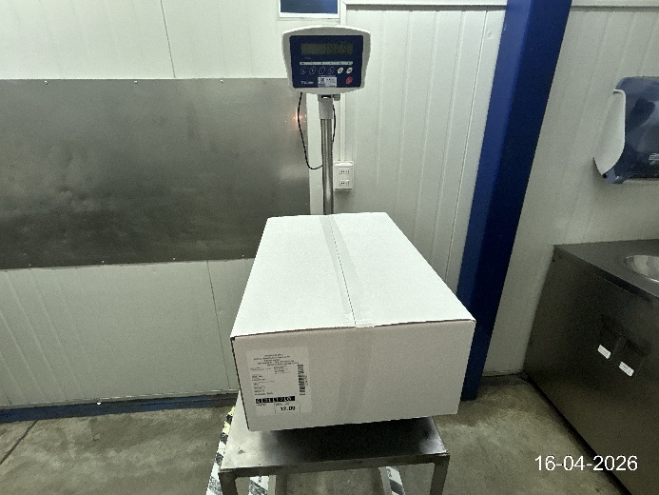 | 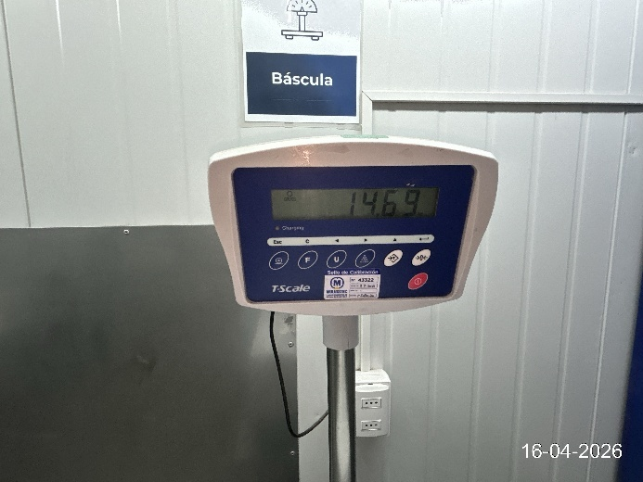

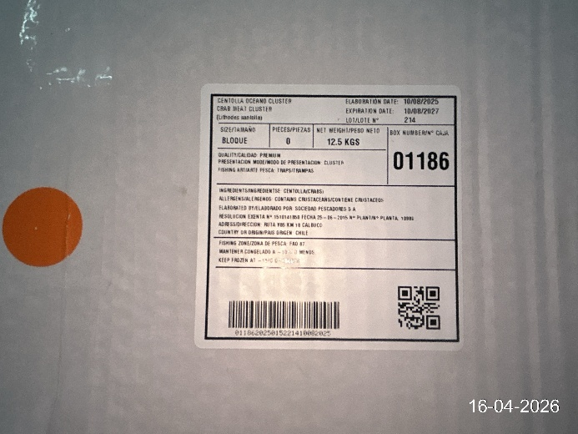 | 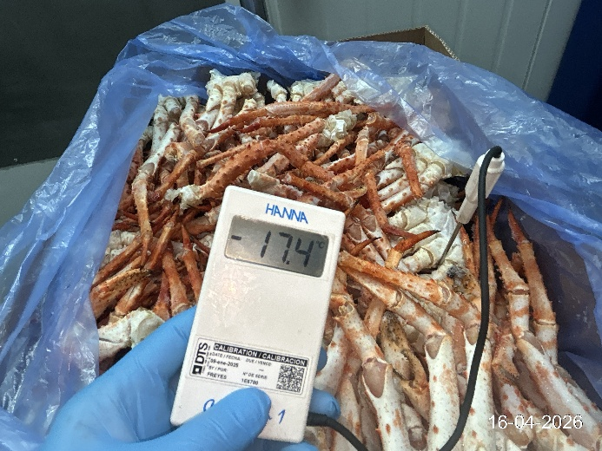

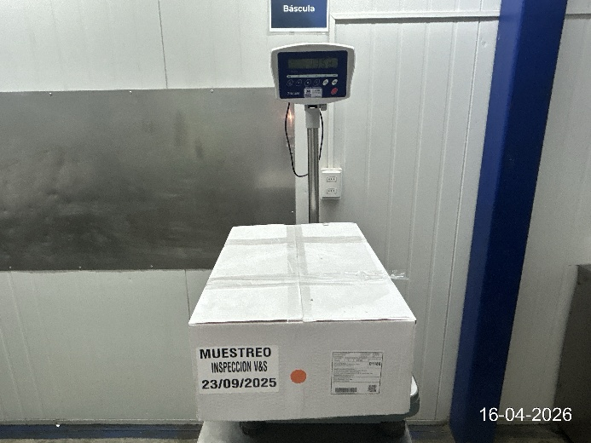 | 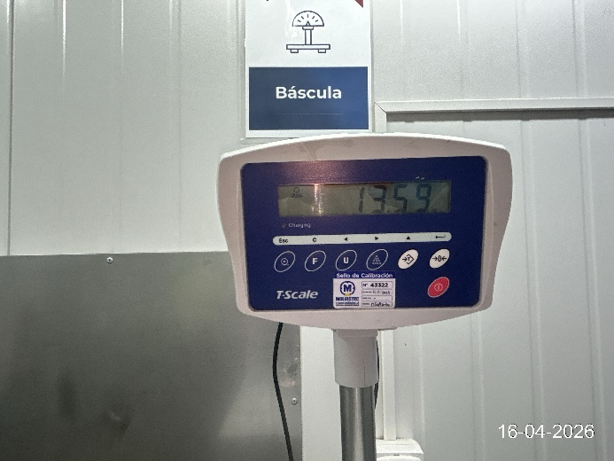

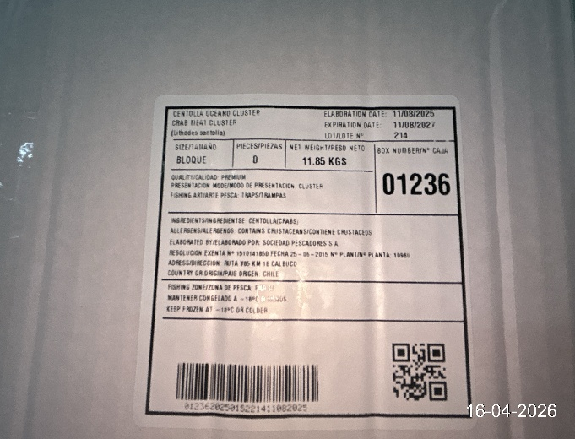 | 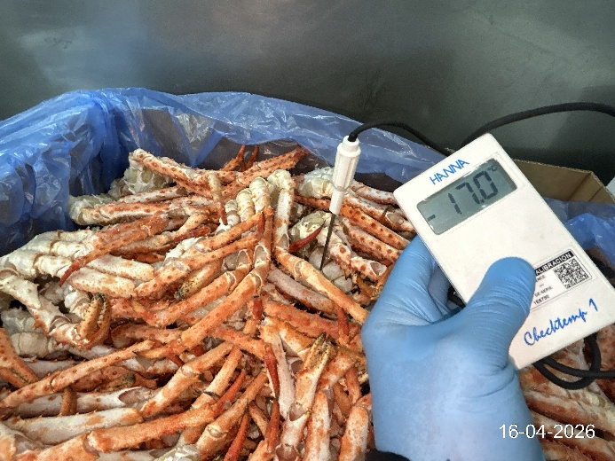

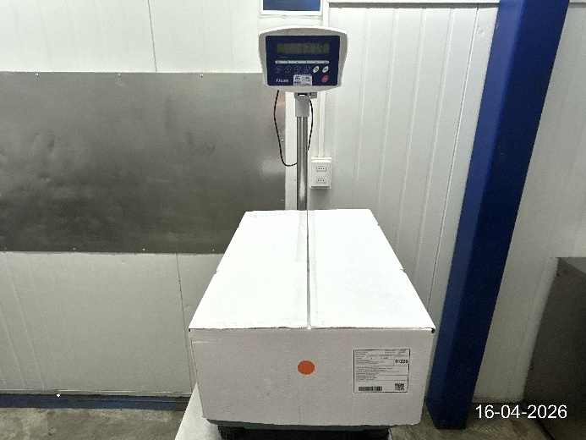 | 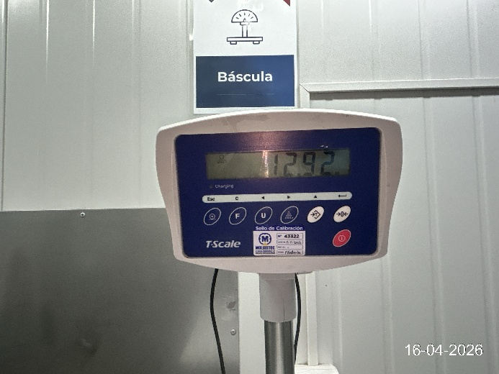

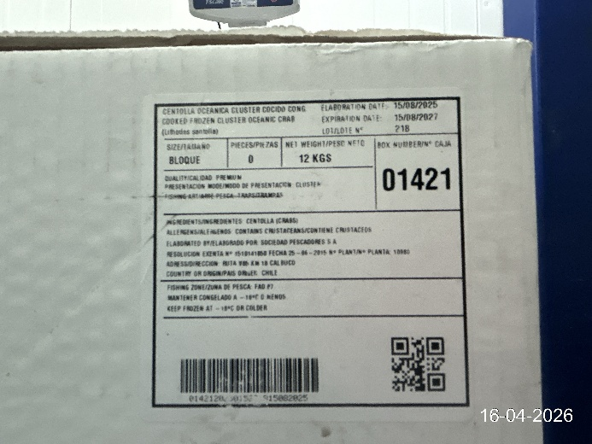 | 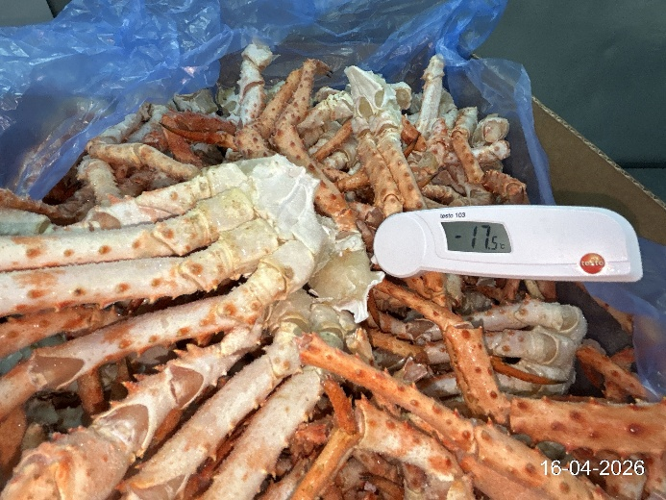

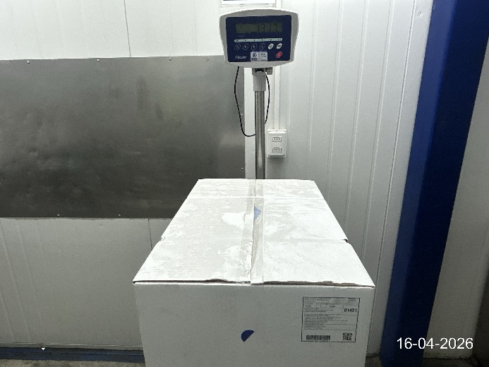 | 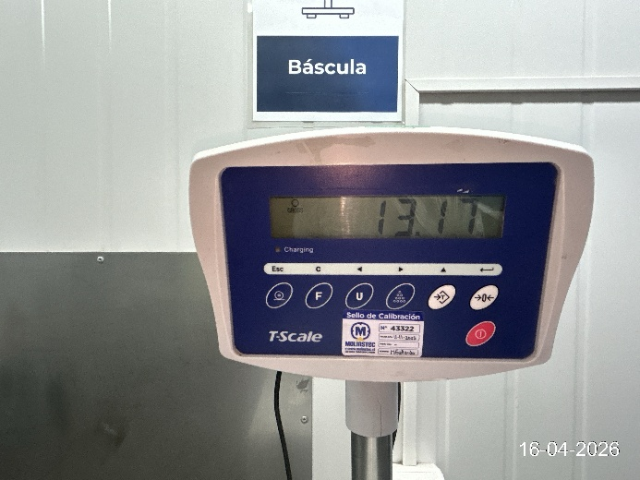

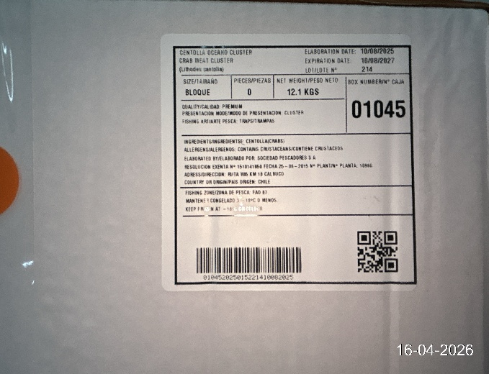 | 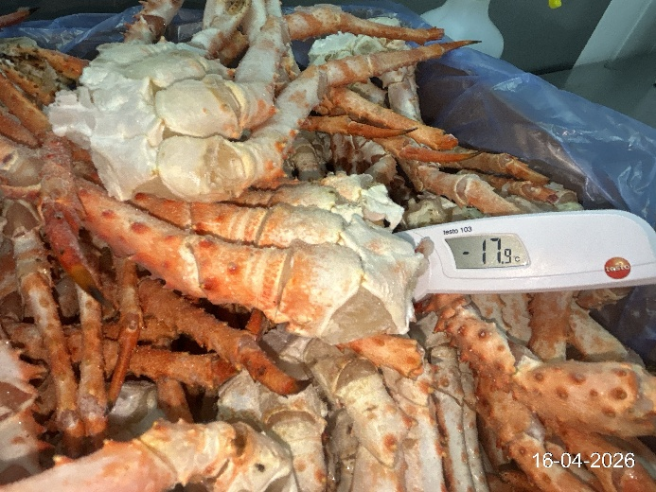

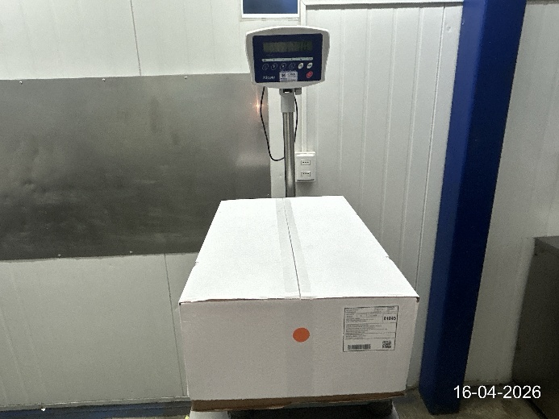 | 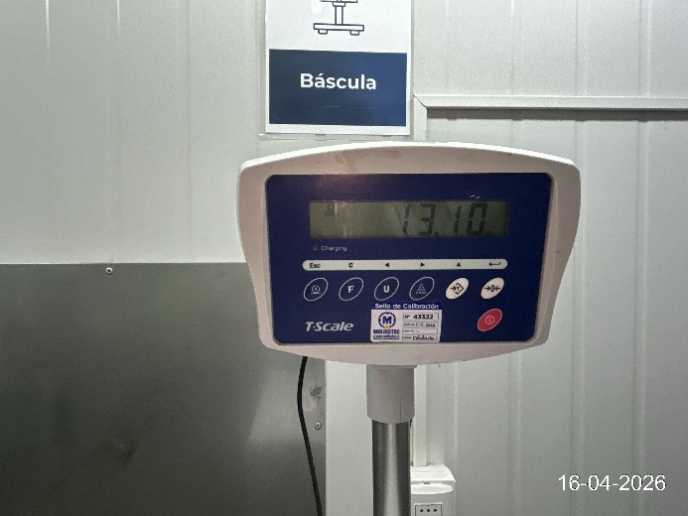

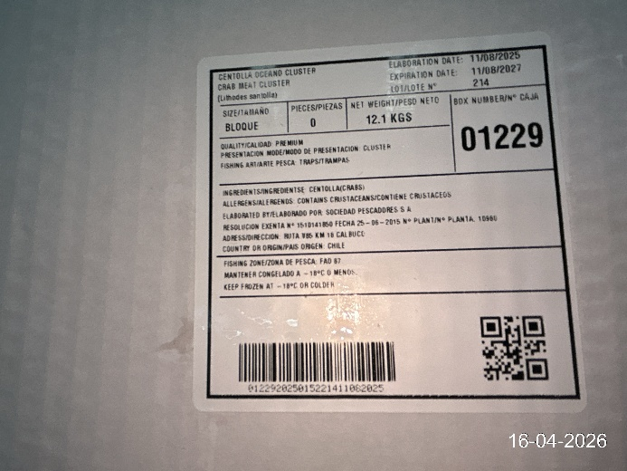 | 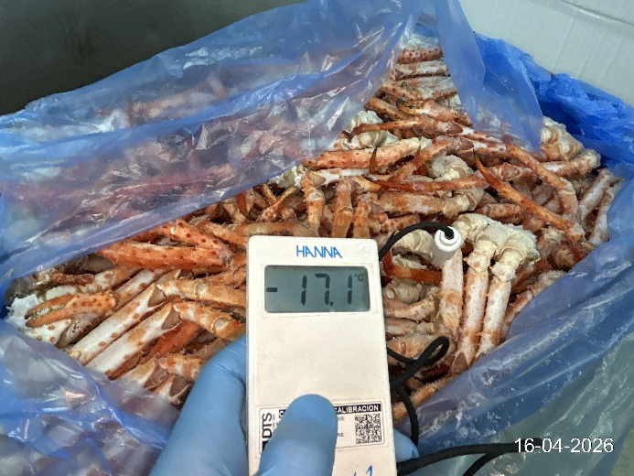

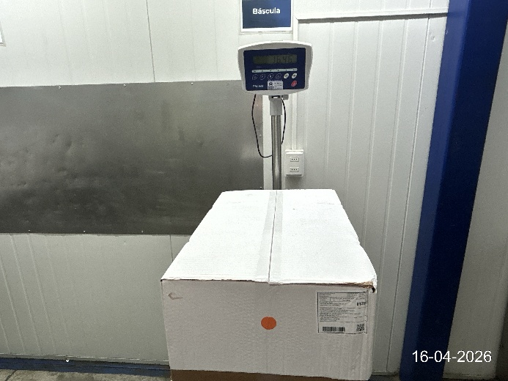 | 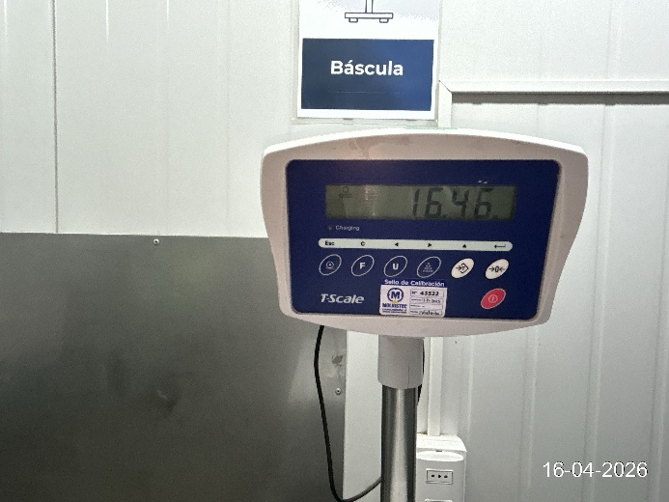

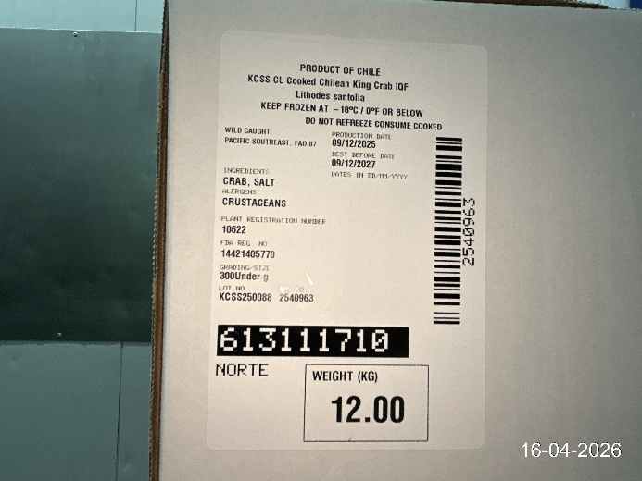 | 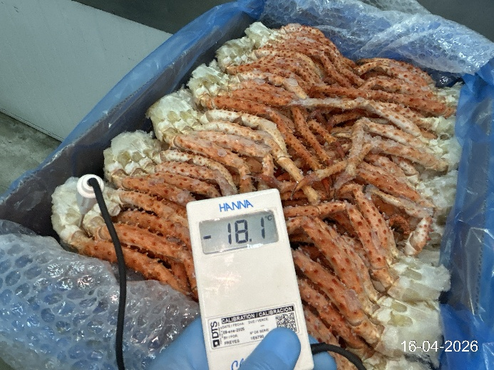

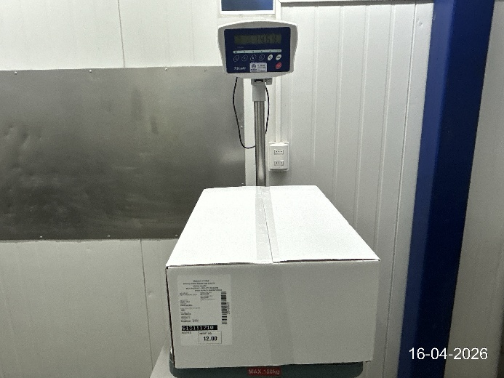 | 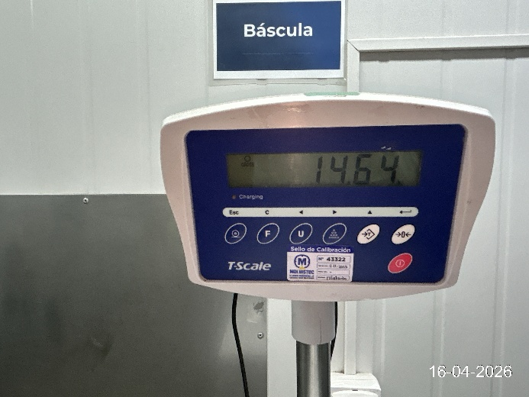

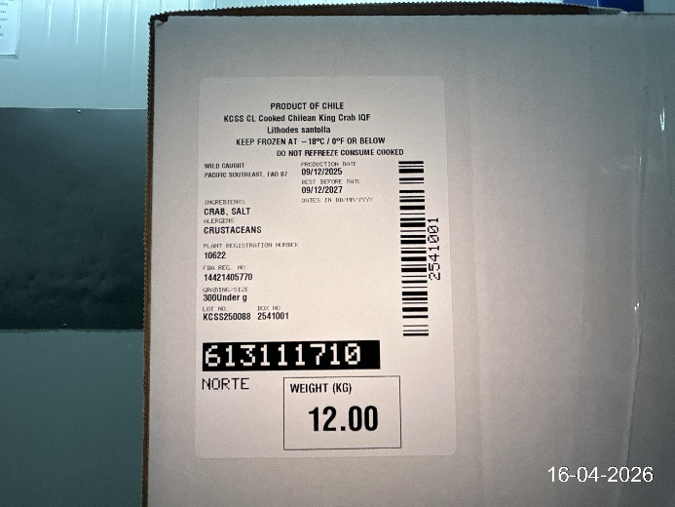 | 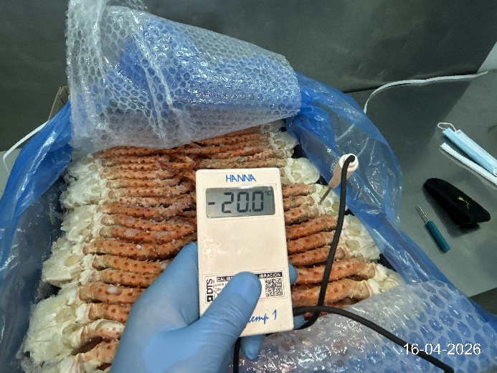

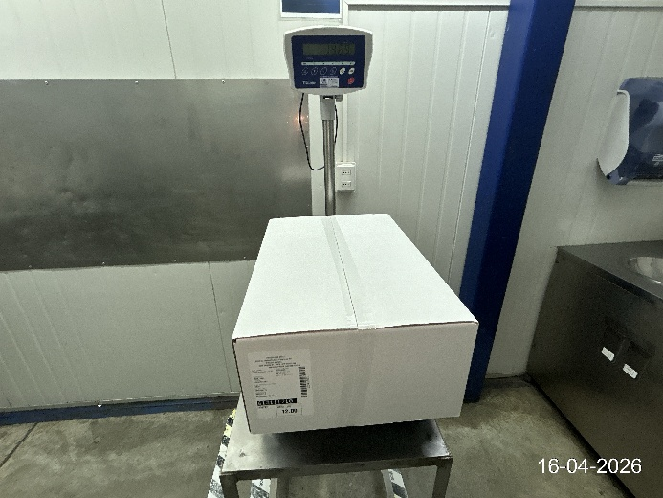 | 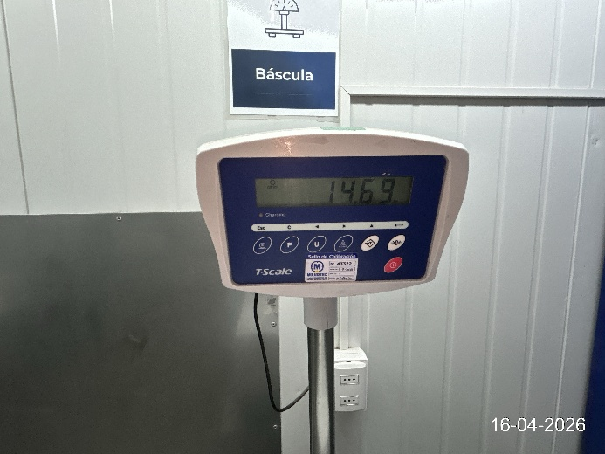

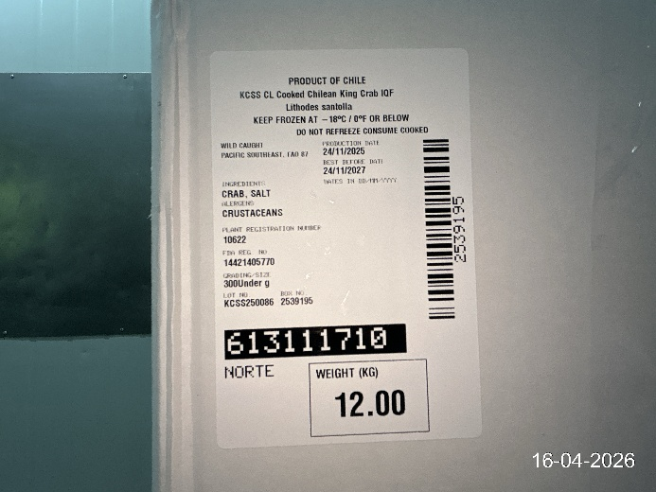 | 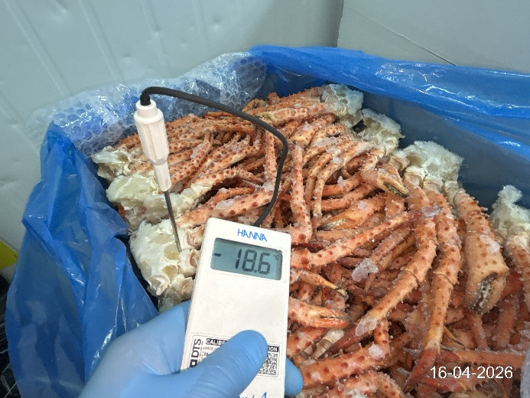

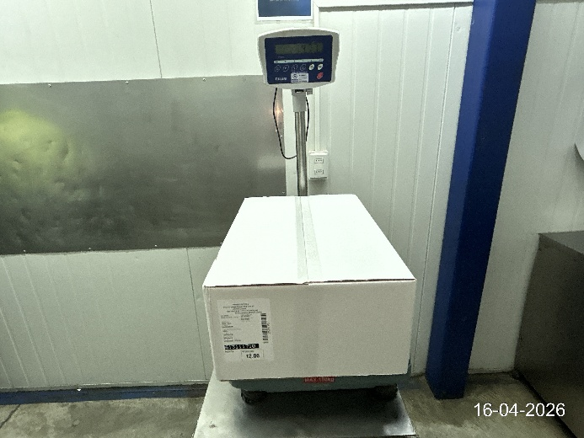 | 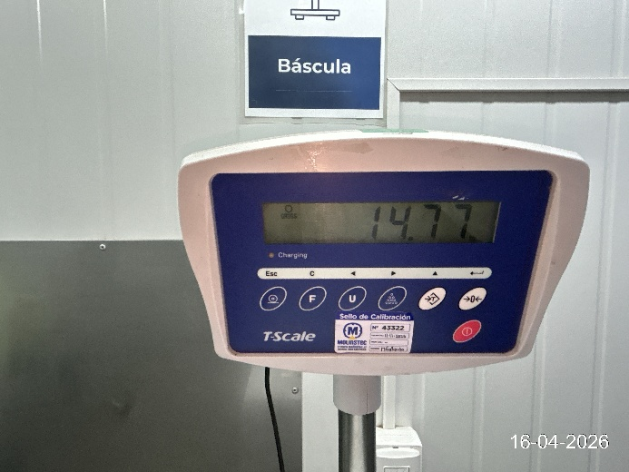

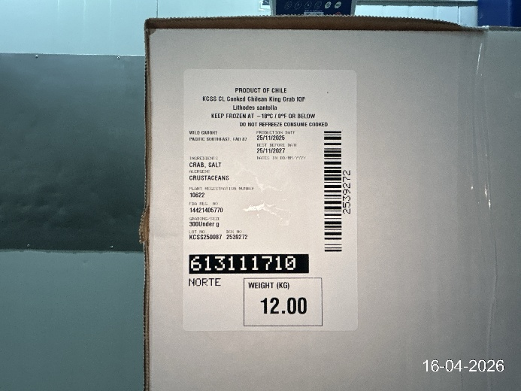 | 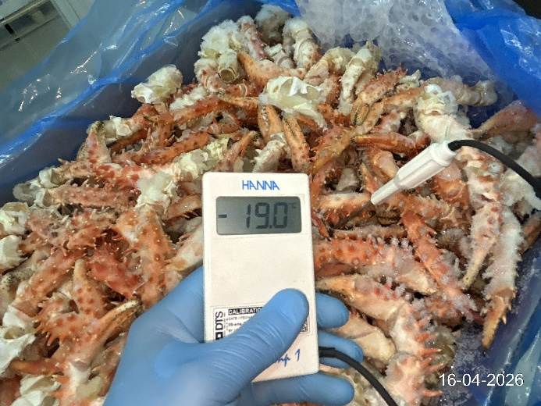

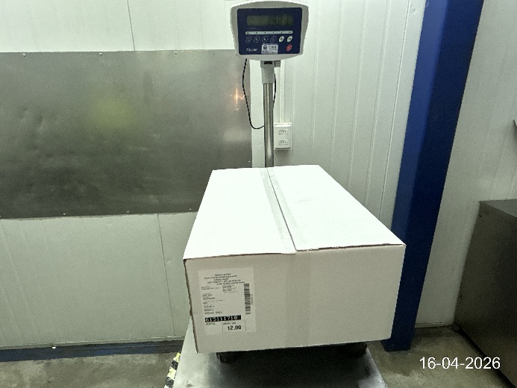 | 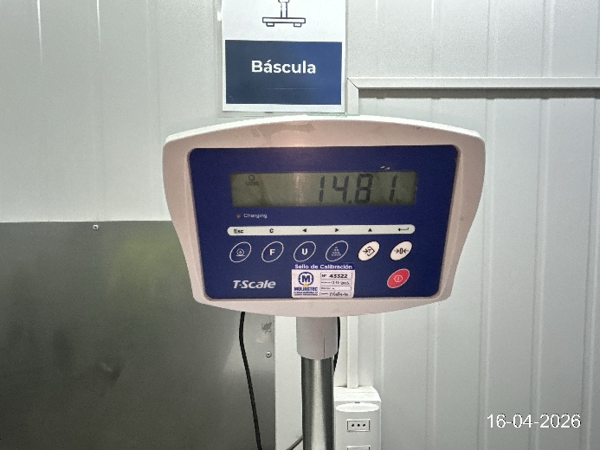

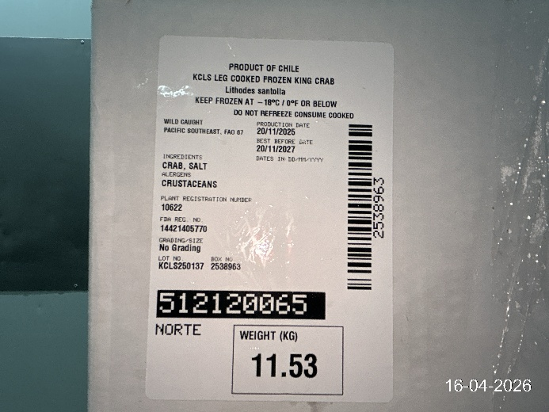 | 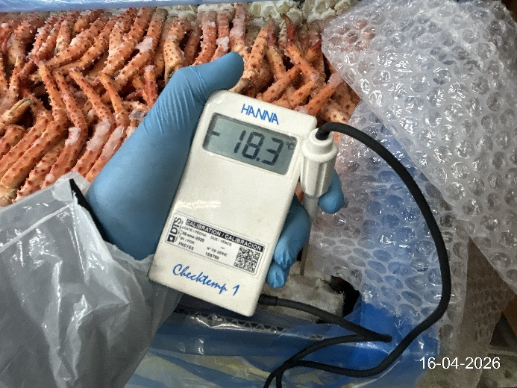

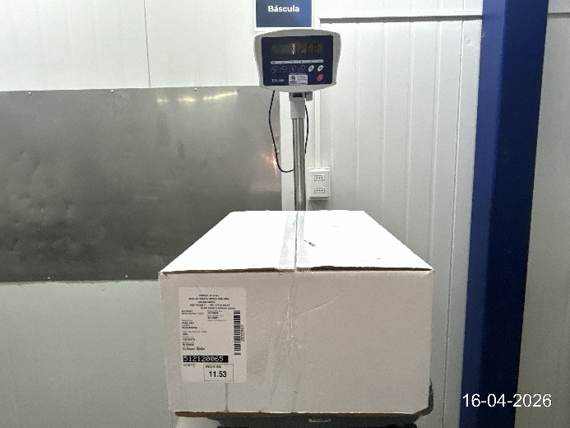 | 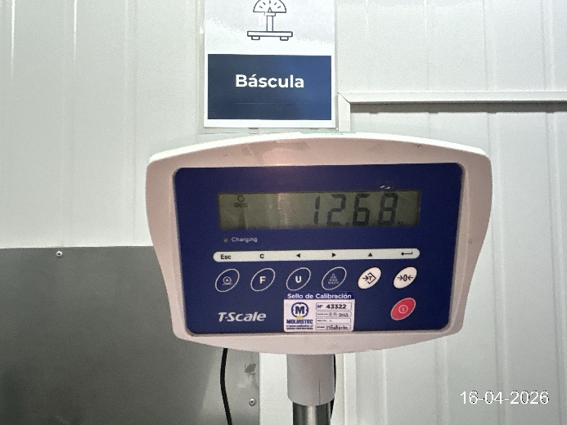

2.3 Temperature of the container prior to the stuffing:
- Container is presented off at room temperature.
- The panels externally have some dents and repairs.
- The panels internally are in good condition. (clean, dry and odor-free)

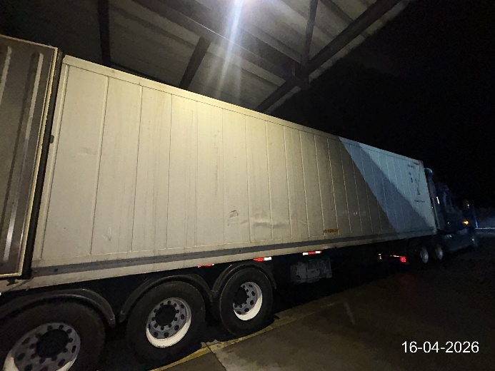 | 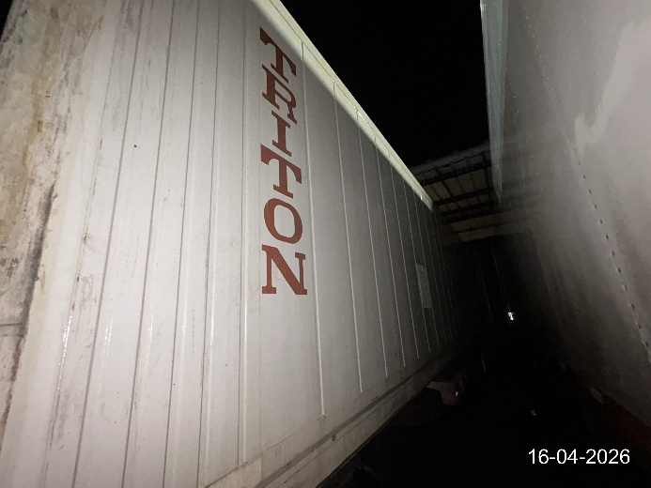

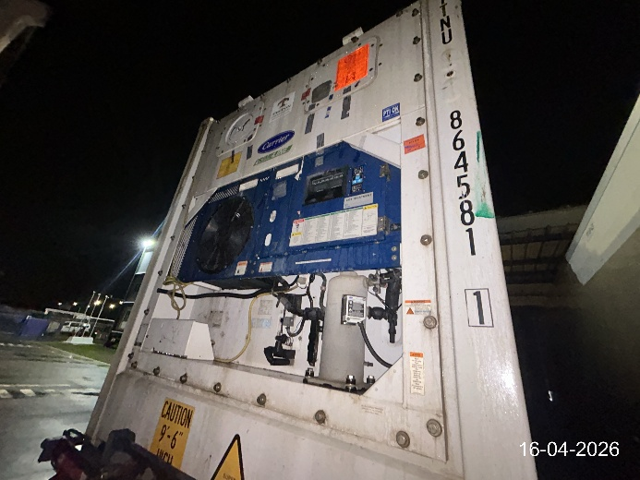 | 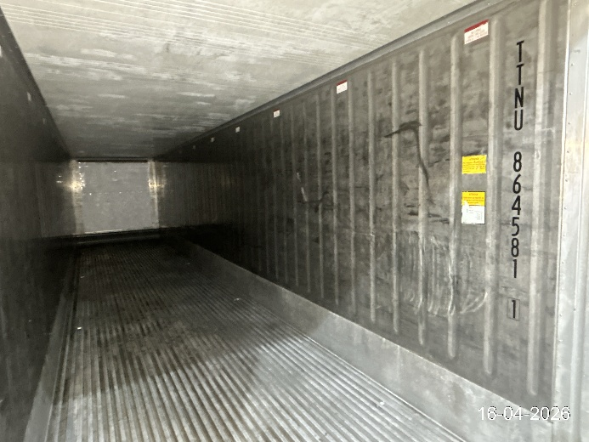

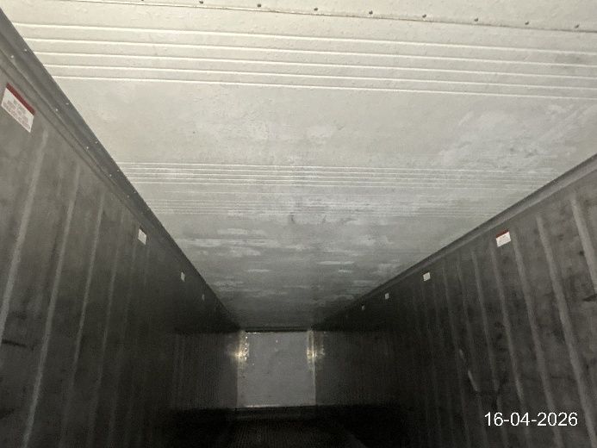 | 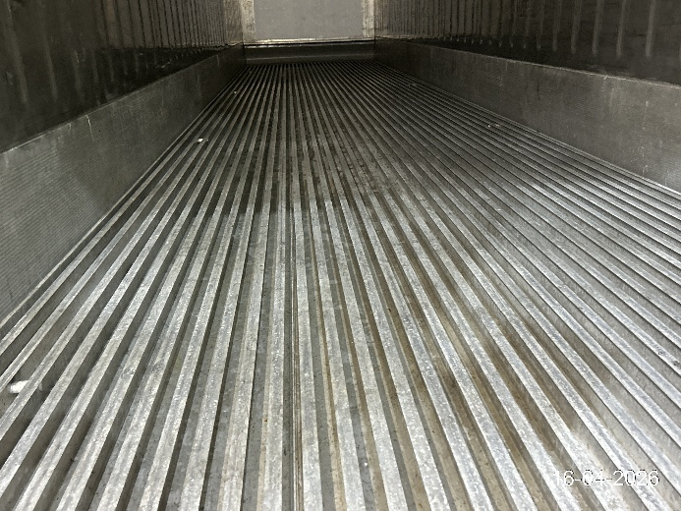

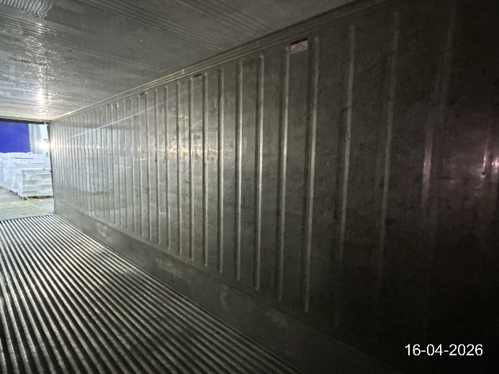 | 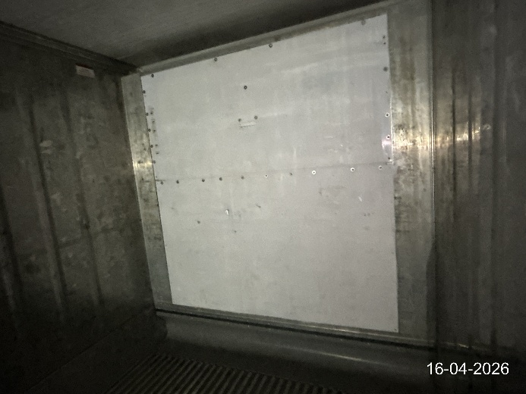

2.4 Stuffing of the cargo in the container (Photo per row):
- 07 rows were made of 54 boxes.
- 11 rows were made of 53 boxes.
- From the 18 rows, a grand total of 961 boxes were made.
- The packing of the cargo consists of high-density cardboard boxes; all are in good condition and duly labeled.
- The temperature of the products was taken prior to loading.
- The cargo was stored in the chamber N°1 at a temperature of -18.00 °C.
- The cargo was stacking in the antechamber at a temperature of 0.8 °C.

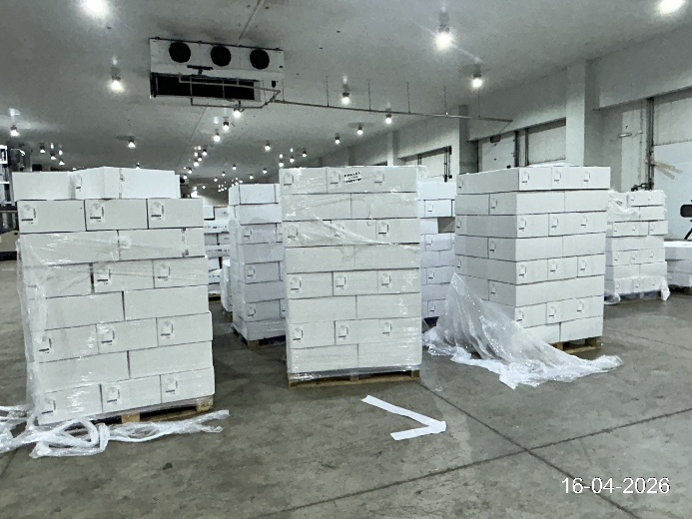 | 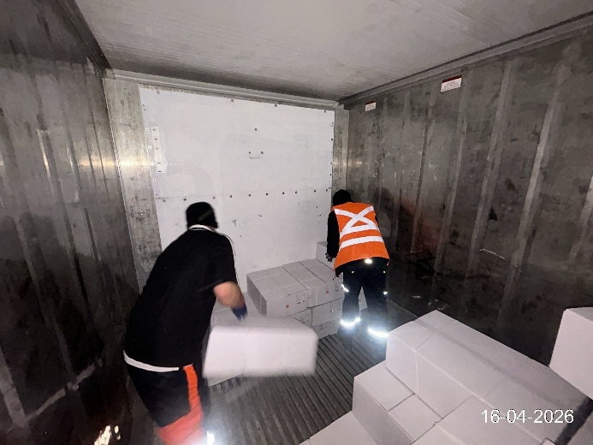

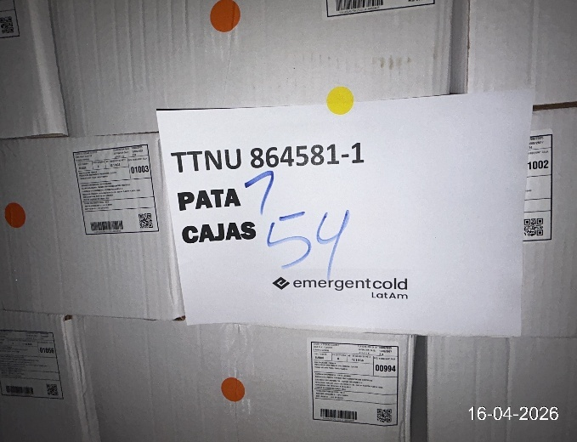 | 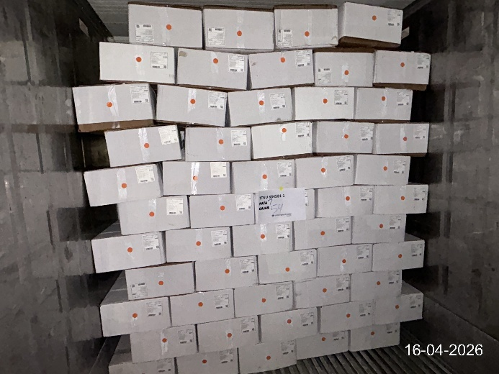

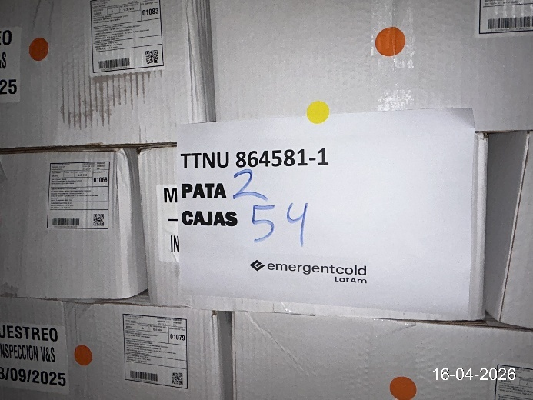 | 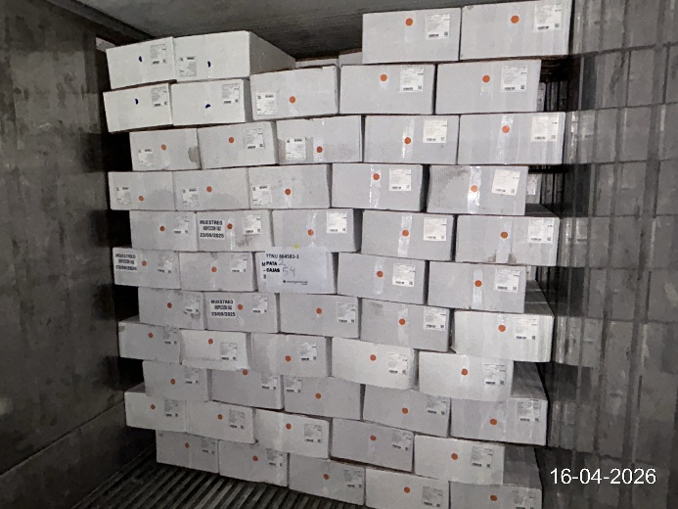

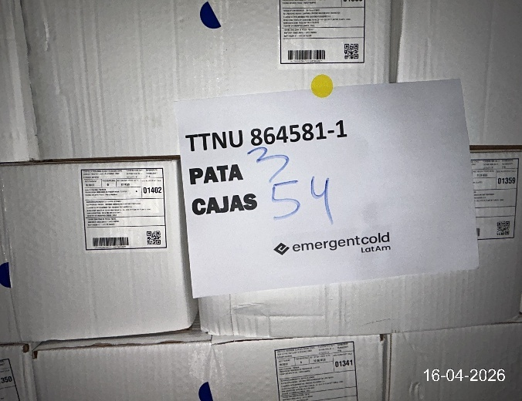 | 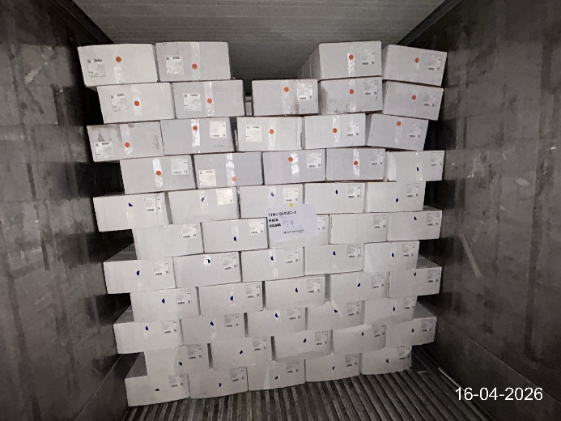

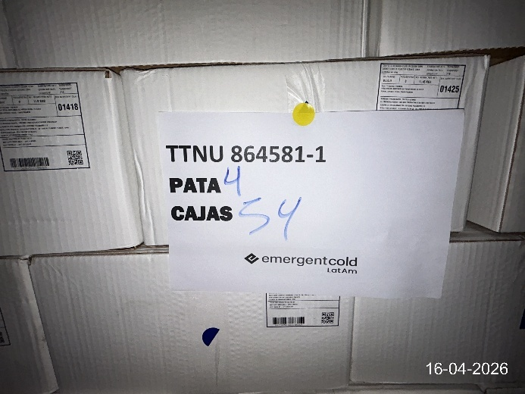 | 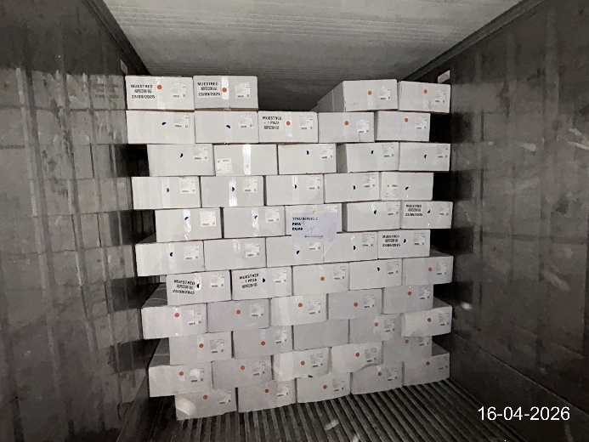

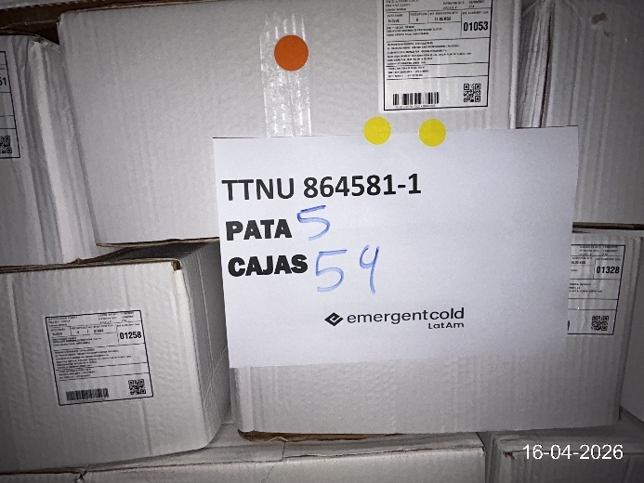 | 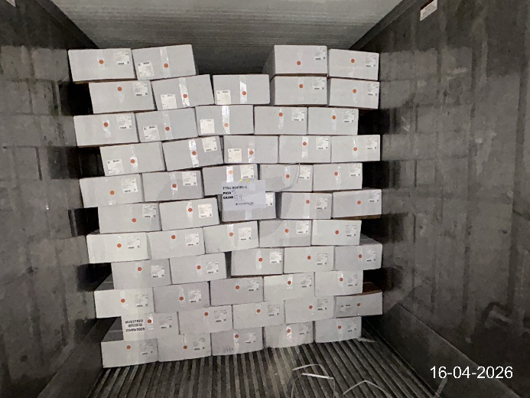

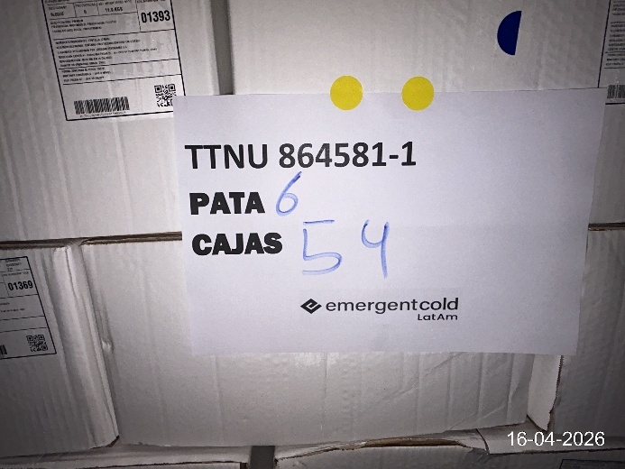 | 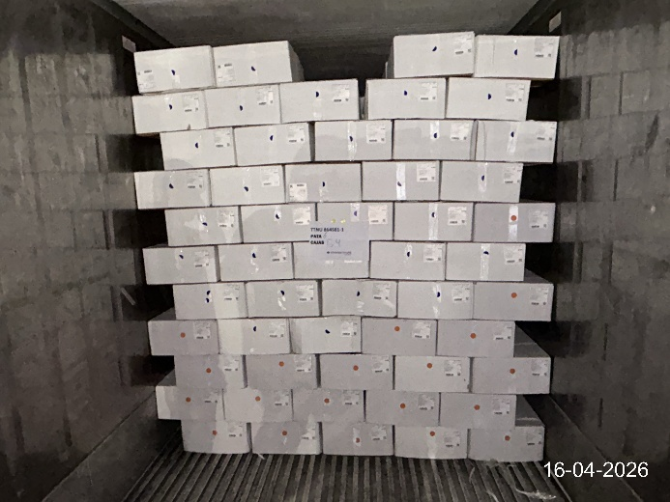

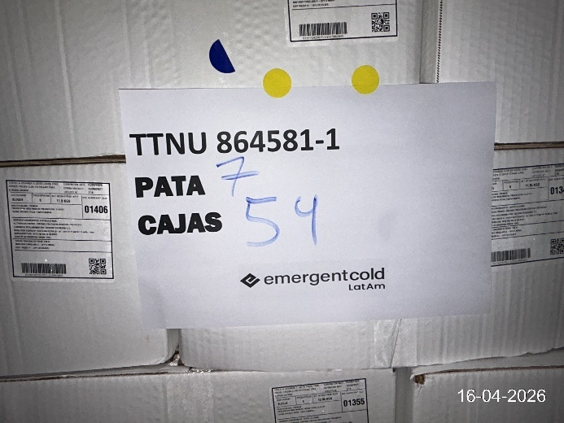 | 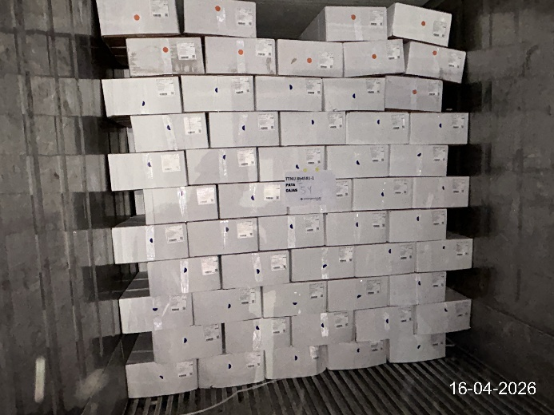

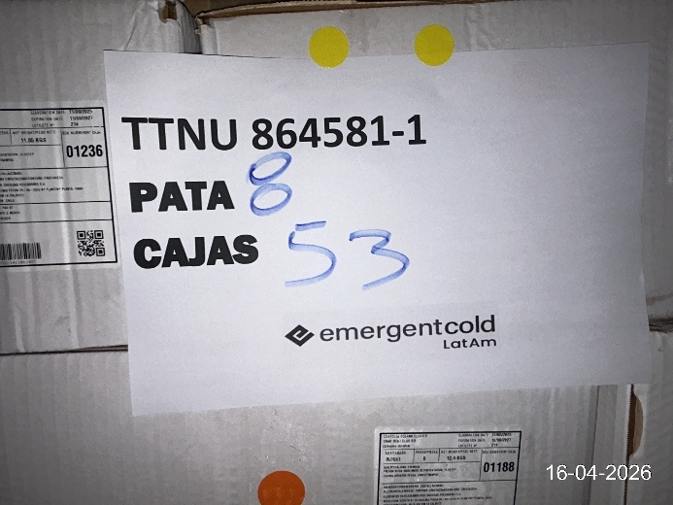 | 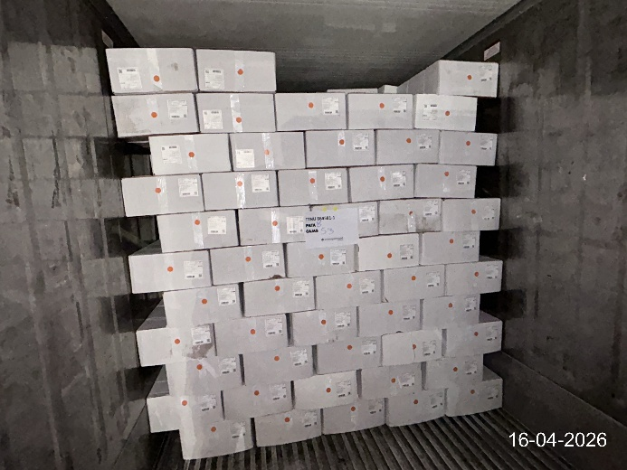

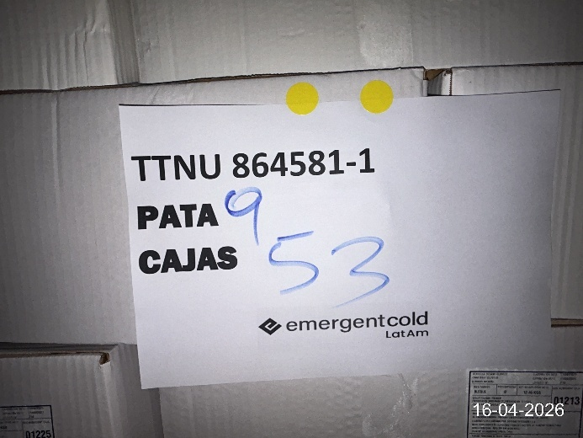 | 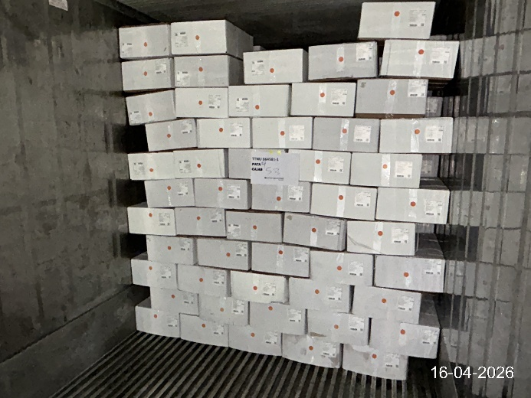

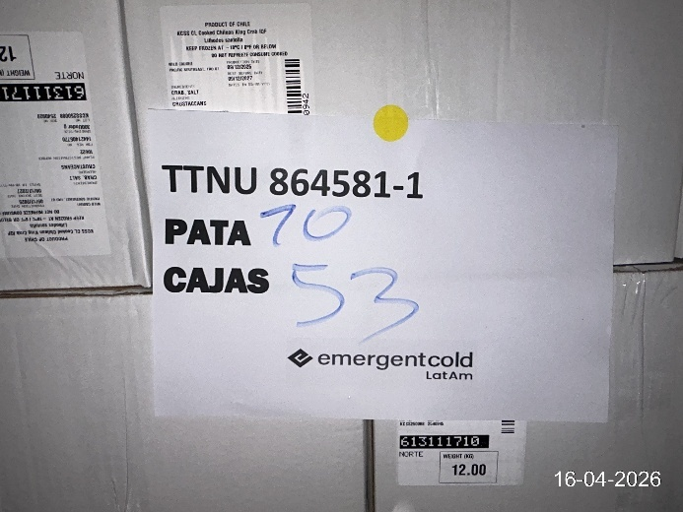 | 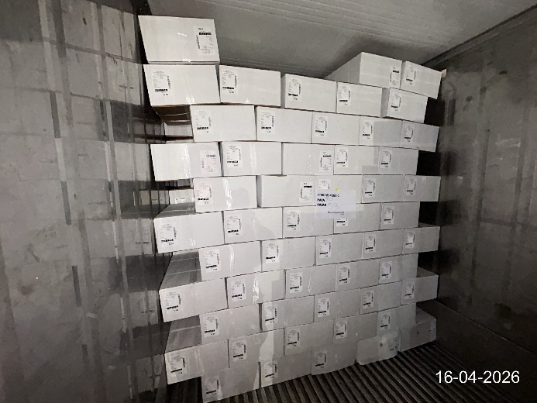

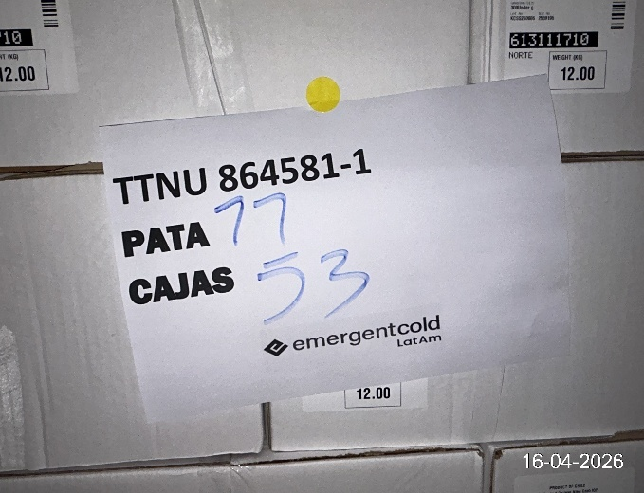 | 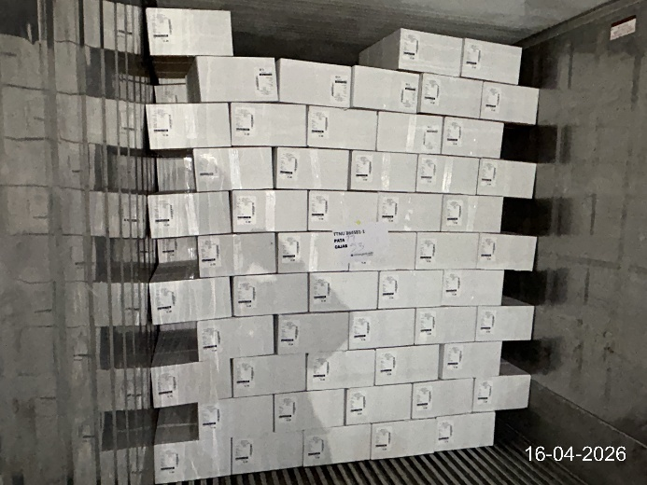

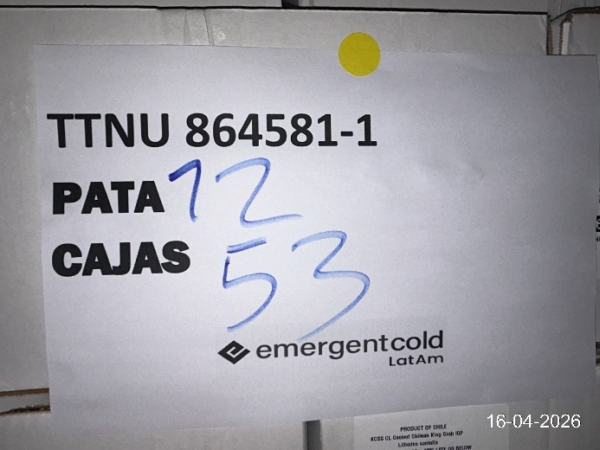 | 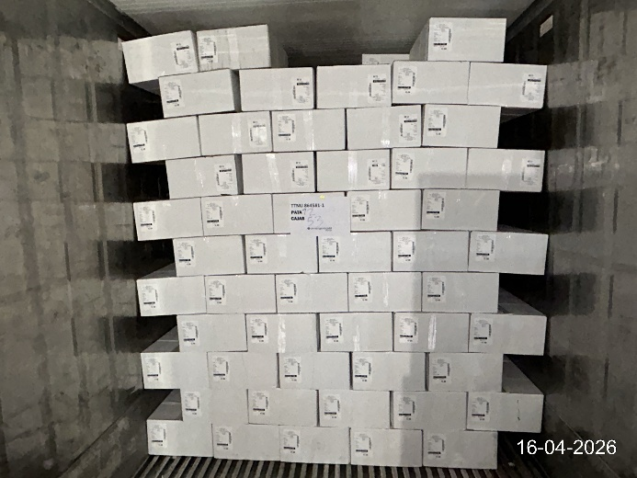

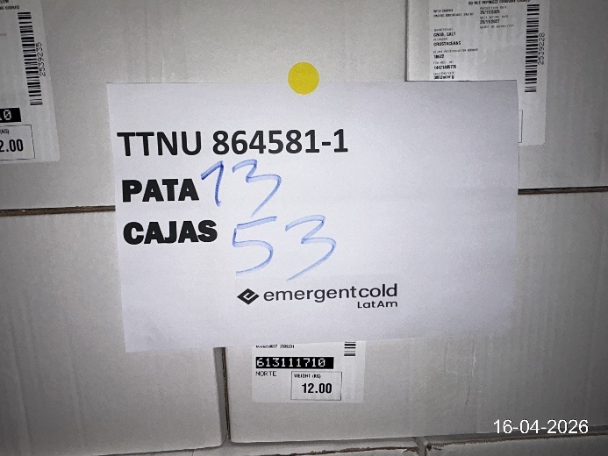 | 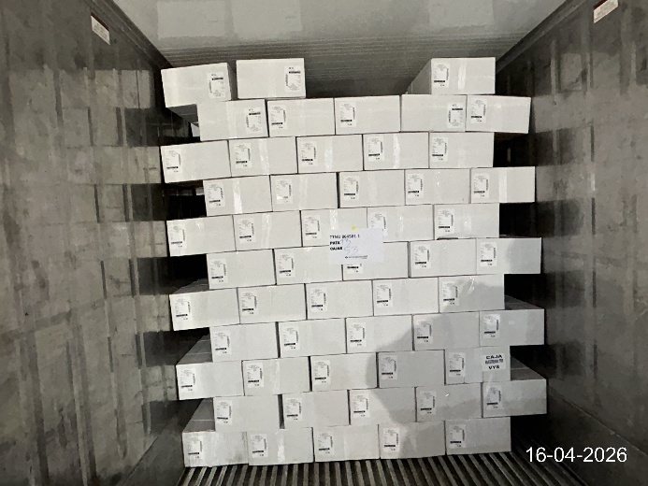

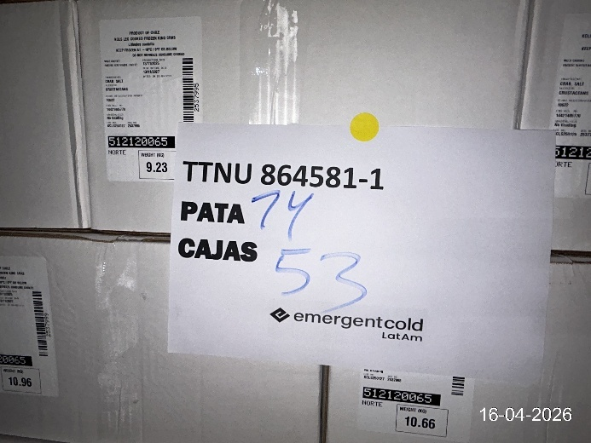 | 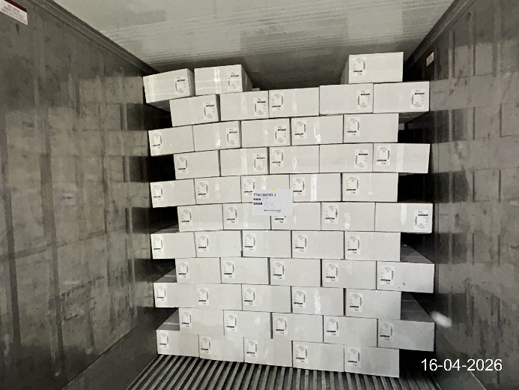

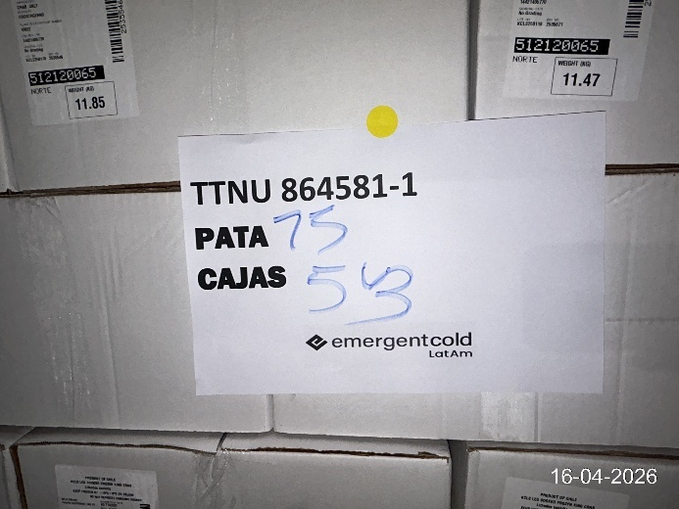 | 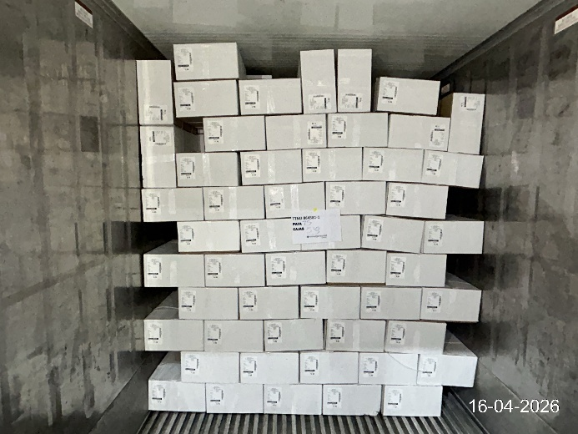

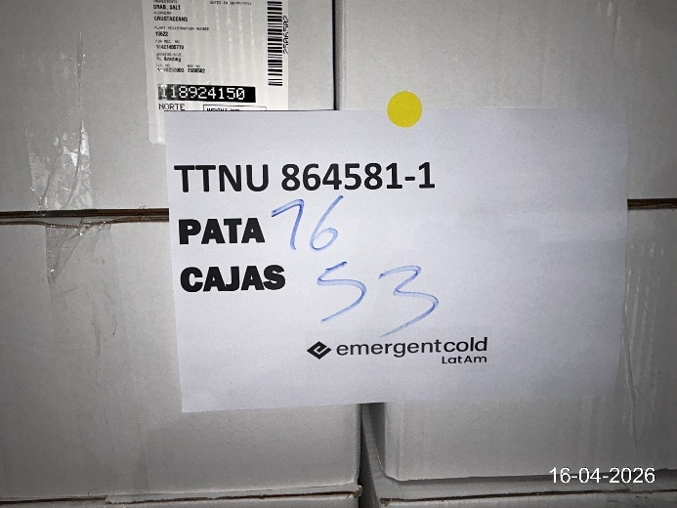 | 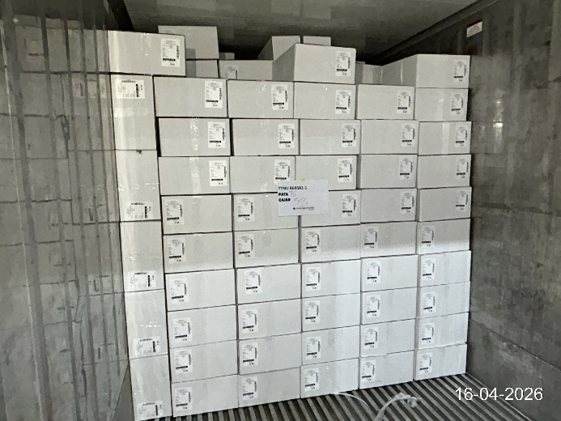

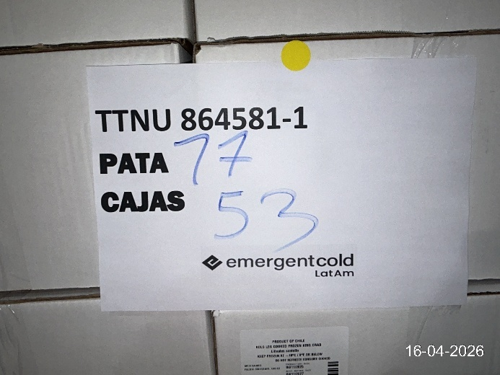 | 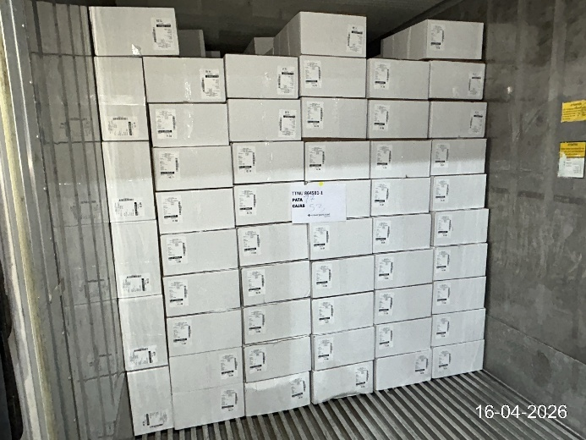

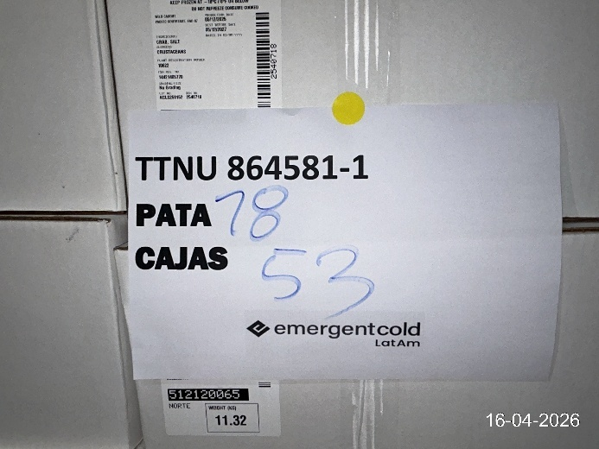 | 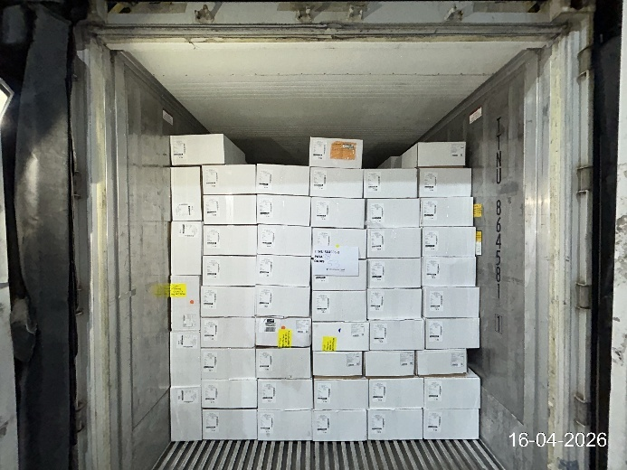

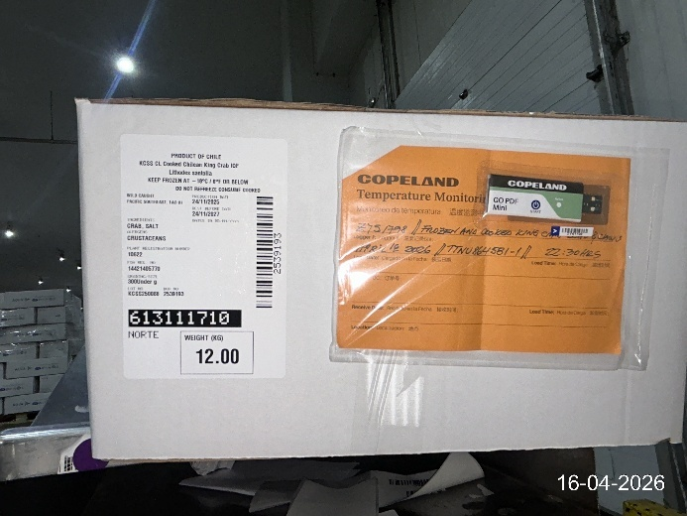 | 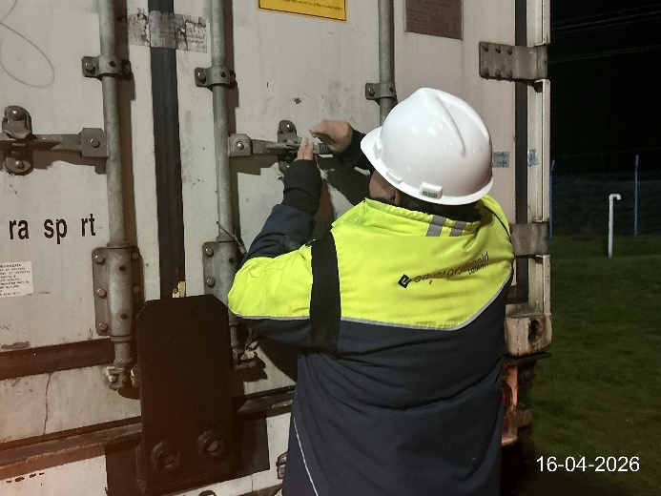

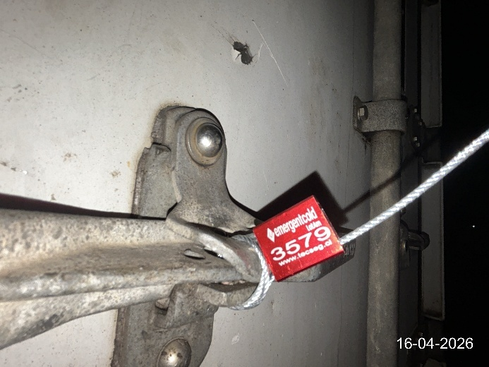 | 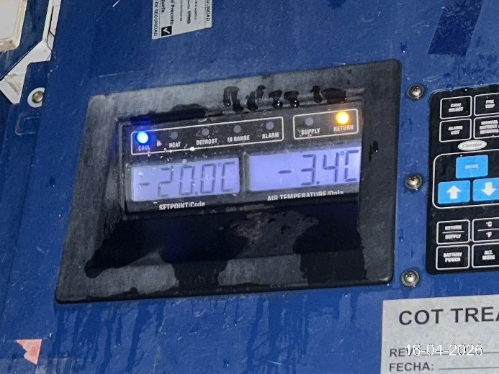

2.5 Attachments:
- Bill Dispatch N° 9651

2.6 Comments:
- Defrost pieces aren’t (weren´t) requested
- Odor: odorless.
- The container is not dispatched upon completion of the consolidation process; it remains pending approval from the local authority Sernapesca. The container is subsequently sealed with a wire seal by the cold storage facility.

This survey was carried out without prejudice and in the interest of whom it may concern.

Prepared by : A. Bustos
Reviewed by : J. Lopez

Approved by : J. Lopez

