This is to certify that we ALS INSPECTION CHILE SPA., at the request of Messrs MELON S.A. and with the consent of Captain, the undersigned surveyor attended onboard MV:

“MN GLOBAL FANFARE V.18”

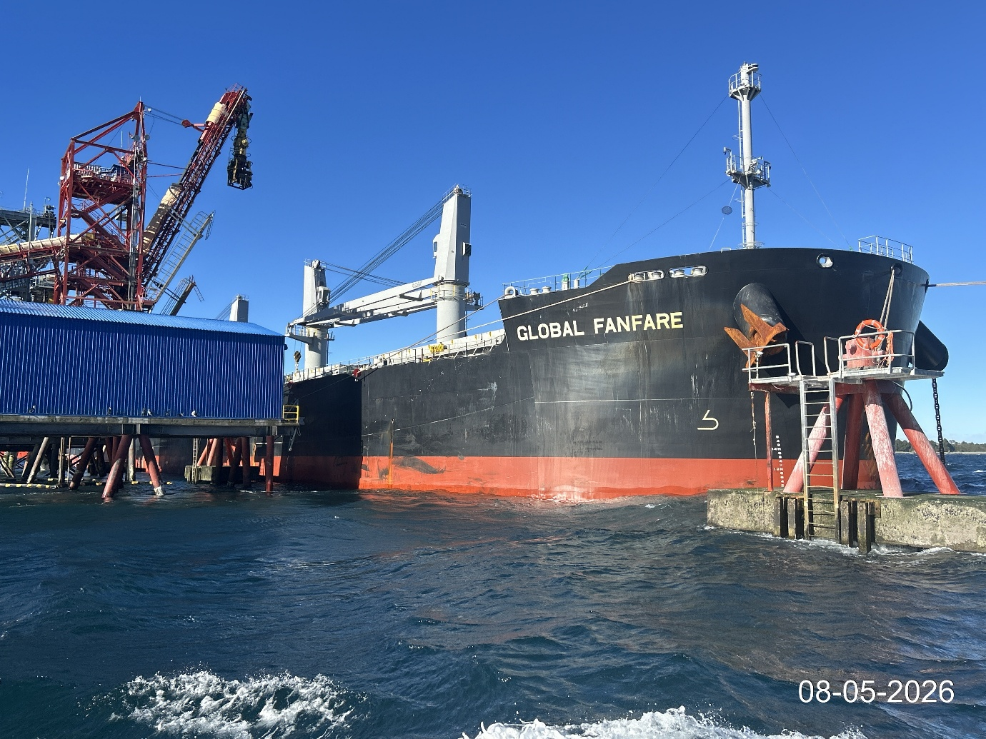

From the following dates: May 08 to 13, 2026, with the purpose to perform a:

“DRAUGHT SURVEY”
And we do report as follows:

1.- SCOPE OF SURVEY

The present inspection was conducted according to the request of Mr. Martin Llancafil, from MELON S.A., with the purpose of carrying out a draught survey to determine the quantity of Clinker discharged onto MV GLOBAL FANFARE at Muelle San Jose Port / Calbuco, Chile.

2. - SHIP’S PARTICULARS

Name | GLOBAL FANFARE
IMO | 9969027
Call sign | 3E6037
Type | BULK CARRIER
Port of Registry | Panama
Flag | Panama
Class | NK
Deadweight | 63,734.00 MT
Gross Tonnage | 36,139.00 MT
Net Tonnage | 21,173.00 MT
L.O.A. | 199.98 mt
Depth | 19.30 mt
Master Name | Mr. Felix Bacus B.
Chief Officer Name | Mr. Hermes Solera M.

3. - WEATHER CONDITIONS

- The weather condition upon initial draught survey was good.
- The weather condition upon final draught survey was good.

4. - DATE & TIMES

DATE | HOURS | REMARKS
May 08, 2026 | 14:50 | Initial draught survey commenced
May 08, 2026 | 15:20 | Initial draught survey completed

DATE | HOURS | REMARKS
May 13, 2026 | 19:05 | Final draught survey commenced
May 13, 2026 | 19:35 | Final draught survey completed

5. - RELEVANT FIGURES

5.1. - Final Draught Survey:

5.2. - Draught Survey results

We hereby certify that according to vessel’s displacement scales (draught survey); MV GLOBAL FANFARE discharged the following quantity of Clinker.

49,522.37 MT

- ATTACHMENTS:

Draught Certificate signed by ALS Inspection Chile SpA. surveyor and Chief Officer

- ATTENDING PARTIES:

- Mr. Hermes Solera M., Chief Officer M/V “GLOBAL FANFARE”.
- Mr. Aaron Bustos., ALS Inspection Chile SpA. on behalf of Melon S.A.

- BIBLIOGRAPHY:

- Draught survey, Code of Practice, IIMS, UK
- Int’l UN code for Draught Surveys.

This survey report was carried out without prejudice and in the interest of whom it may concern.

ALS Inspection Chile SPA.

Prepared by : A. Bustos
Reviewed by : J. Lopez
Approved by : J. Lopez

PHOTOGRAPIC SET

Initial draught survey:

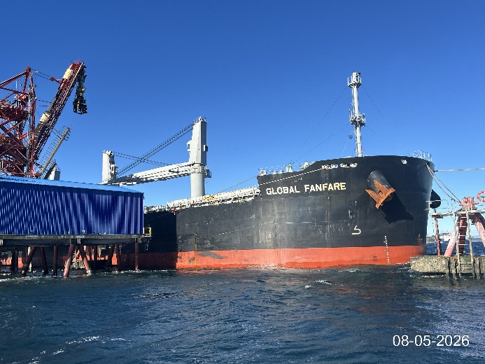 | 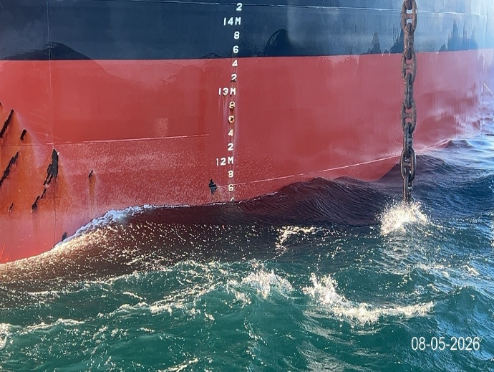
- Vessel mooring to Muelle San Jose Port. | - P/S forward draft.

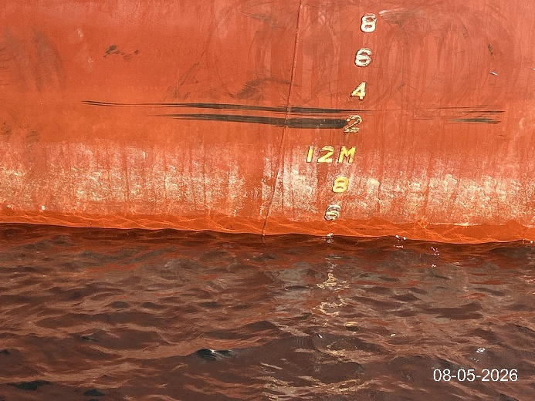 | 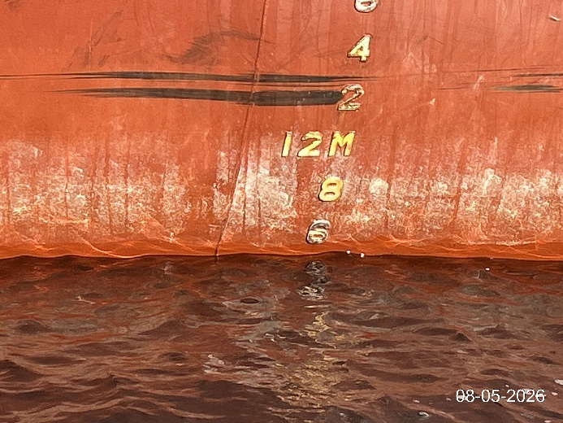
- P/S mid ship draft mark. | - S/S Aft draft mark.

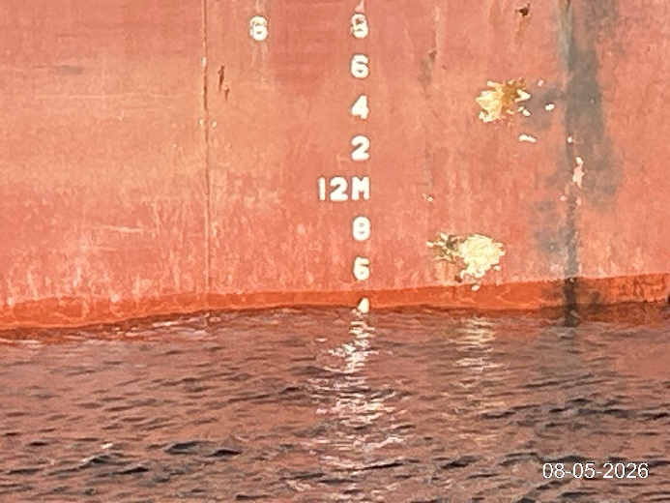 | 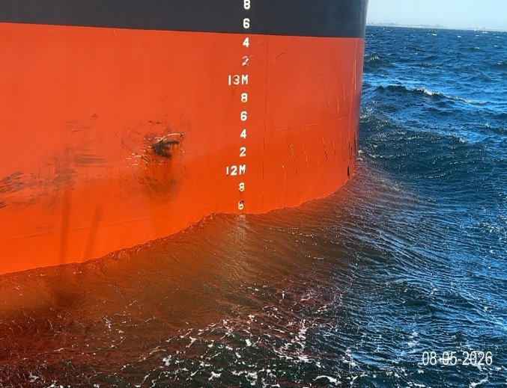
- S/S Mid draft mark. | - S/S Forward draft.

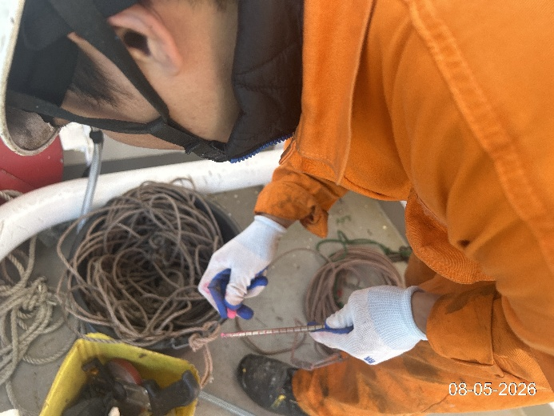 | 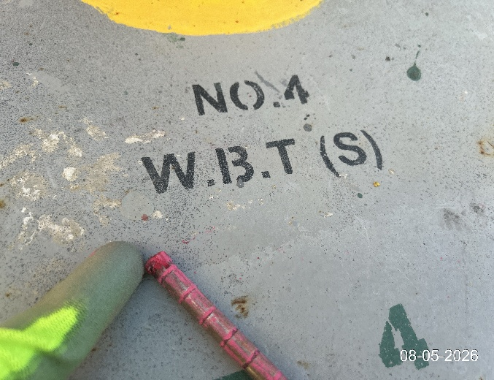
- Painting ruler before sounding ballast. | - Checking ballast.

Final draught survey:

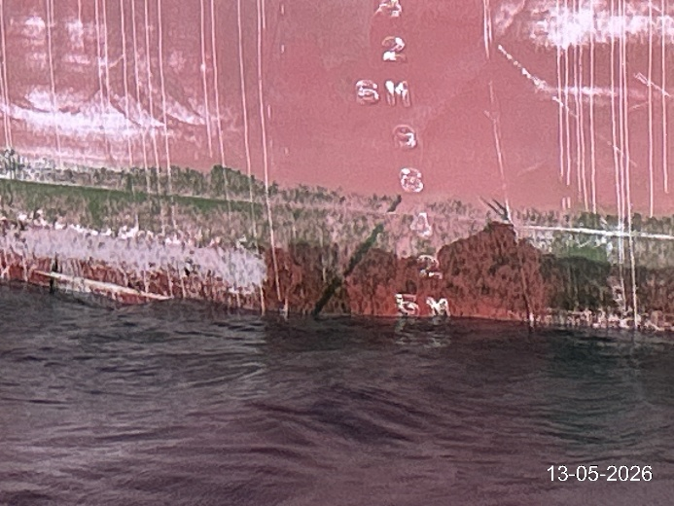 | 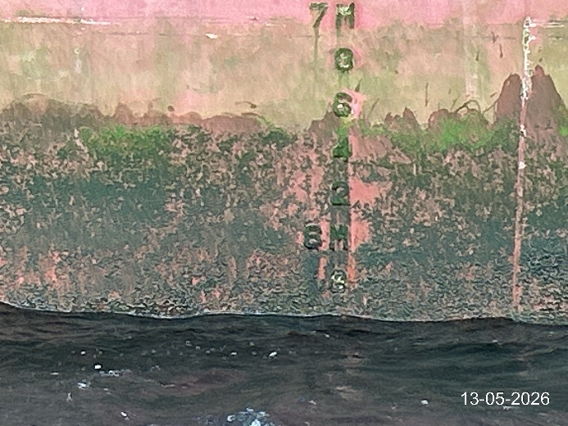
- P/S forward draft. | - P/S mid ship checking draft.

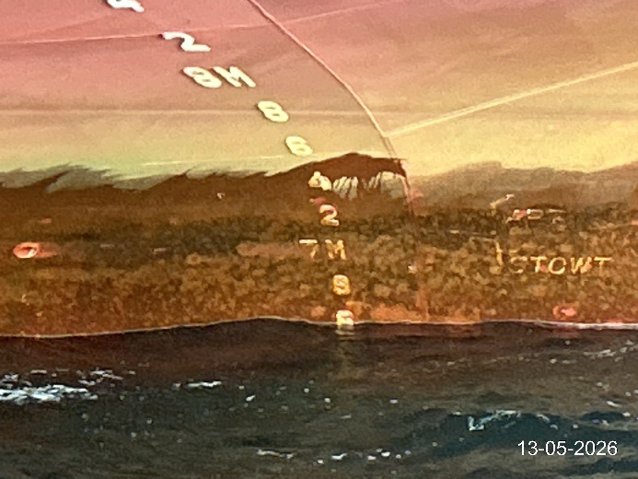 | 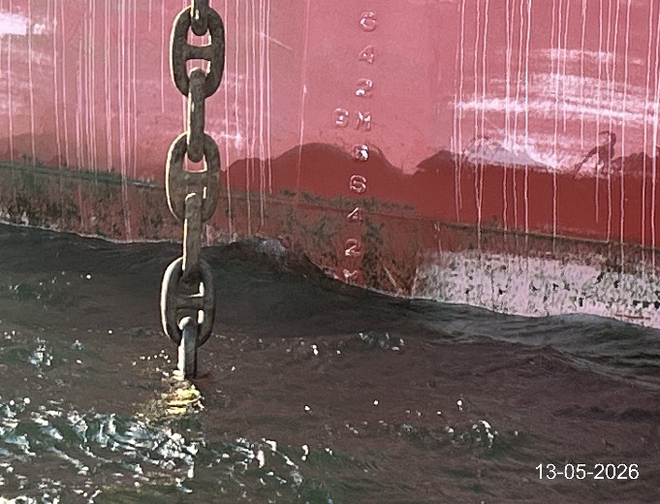
- P/S aft reading draft. | - S/S forward draft.

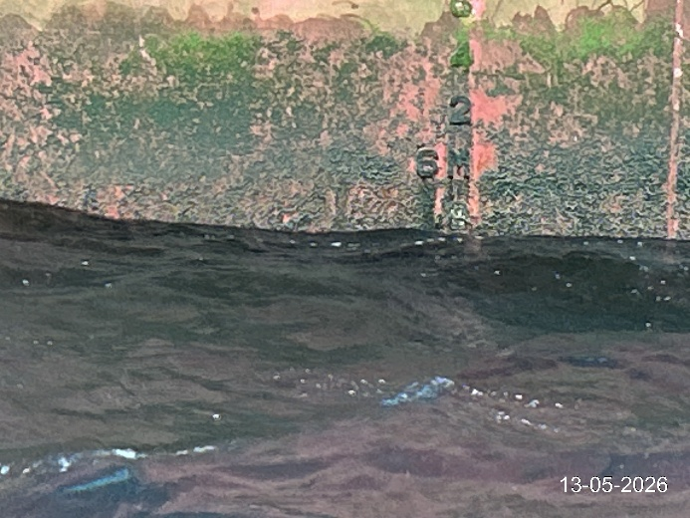 | 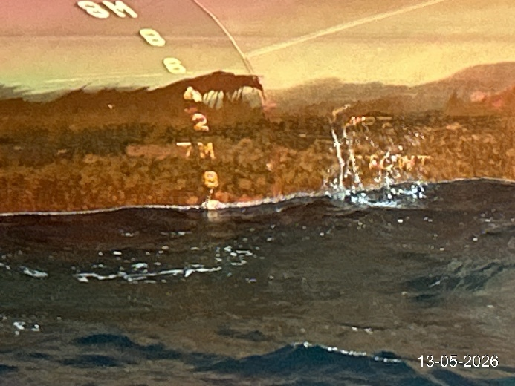
- S/S mid ship draft. | - S/S aft draft reading.

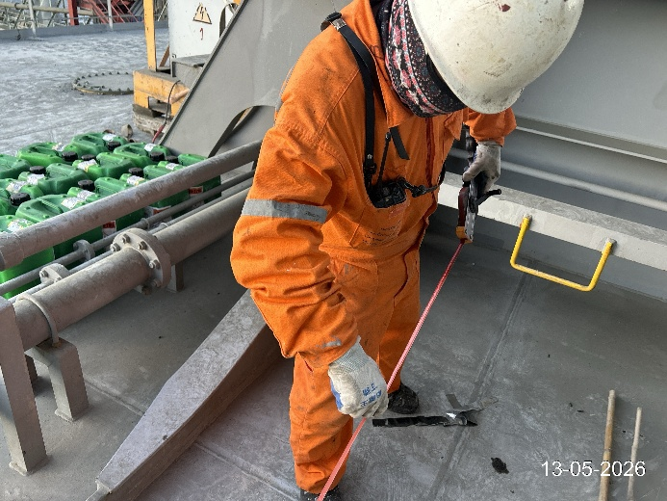 | 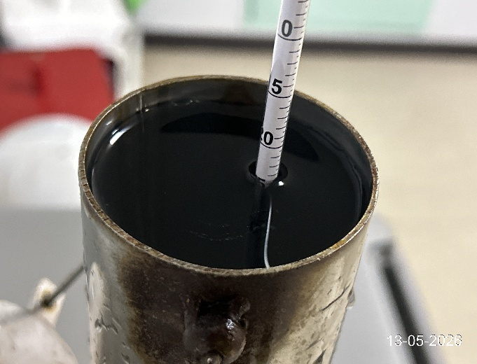
- Commenced souding ballast. | - Final density sea water.

