This is to certify that we ALS INSPECTION CHILE SPA., at the request of GRANELES DE CHILE S.A. and with the consent of Captain, the undersigned surveyor attended onboard MV:

“SAGITTARIUS V.098A”

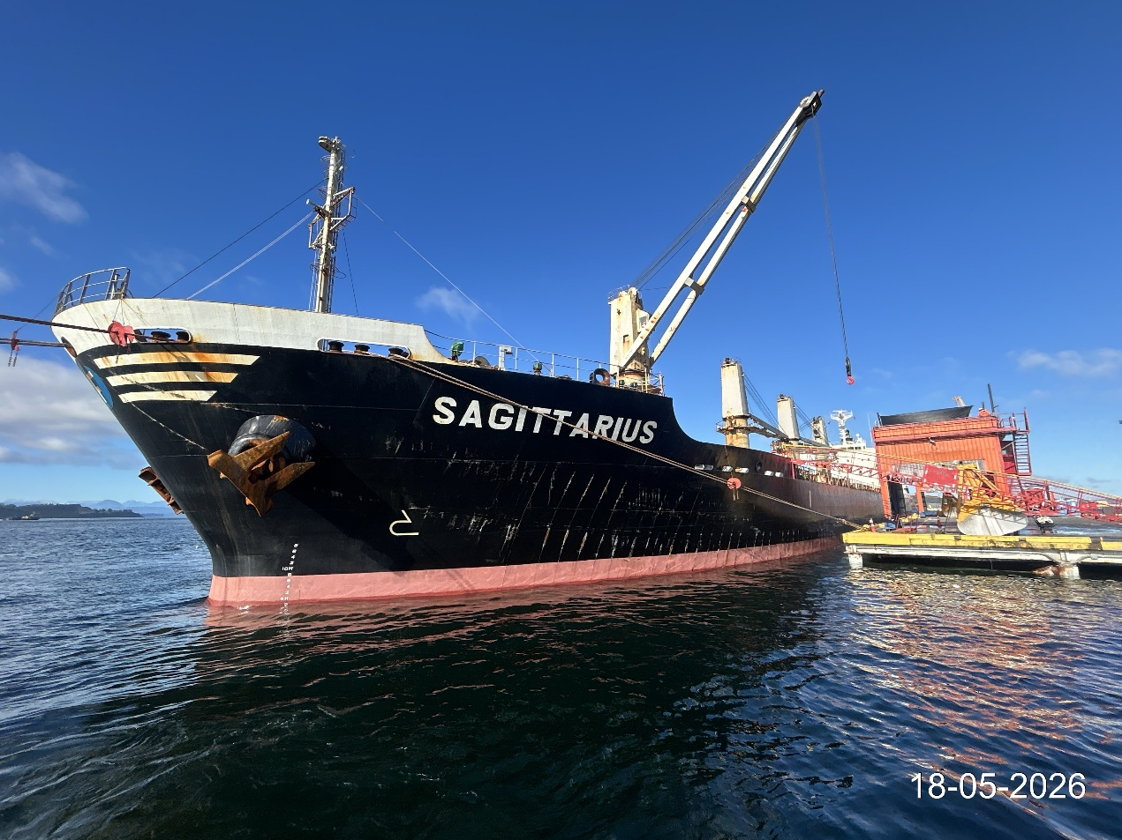

From the following dates: May 18to 24, 2026, with the purpose to perform a:

“DRAUGHT SURVEY”

And we report as follows:

1. SCOPE OF THE SURVEY

The present inspection was conducted according to the request of Ms. Maria Clara Frittayon, from GRANELES DE CHILE S.A., with the purpose of carrying out a draught survey to determine the quantity of Corn and Corn Gluten Meal discharged from MV SAGITTARIUS at TMP Chincui Port, / Puerto Montt, Chile.

2. SHIP’S PARTICULARS

Name | SAGITTARIUS
IMO | 9550254
Call sign | V7IF9
Type | BULK CARRIER
Port of Registry | Majuro
Flag | Marshall Islands
Deadweight | 17,025.00 MT
Gross Tonnage | 10,108.00 MT
Class | NKK
L.O.A. | 169.37 mt
Depth | 13.60 mt
Master Name | Mr. Osman Kivircik.
Chief Officer Name | Mr. Jyan Torrento.

3. WEATHER CONDITIONS

- The weather condition upon initial draught survey was good.
- The weather condition upon final draught survey was good.

4. DATE & TIMES

DATE | HOURS | REMARKS
May 18, 2026 | 14:20 | Initial draught survey commenced.
May 18, 2026 | 14:50 | Initial draught survey completed.

DATE | HOURS | REMARKS
May 24, 2026 | 04:15 | Final draught survey commenced.
May 24, 2026 | 04:45 | Final draught survey completed.

5. RELEVANT FIGURES

5.1. Final Draught Survey

5.2. Draught Survey results

We hereby certify that according to vessel’s displacement scales (draught survey); MV SAGITTARIUS discharged the following quantity of Corn & Corn Gluten Meal:

24,101.25 MT.

- ATTACHMENTS

- Draught Certificate signed by ALS Inspection Chile SpA. surveyor and Chief Officer

- ATTENDING PARTIES

- Mr. Jyan Torrento., Chief Officer M/V “SAGITTARIUS”.
- Mr. Aaron Bustos A., ALS Inspection Chile SpA. on behalf of Graneles de Chile S.A.

- BIBLIOGRAPHY

- Draught survey, Code of Practice, IIMS, UK
- Int’l UN code for Draught Surveys.

This survey report was carried out without prejudice and in the interest of whom it may concern.

Surveyor
ALS Inspection Chile SpA

Prepared by : A. Bustos
Reviewed by : J. Lopez

Approved by : J. Lopez

PHOTOGRAPIC SET

Initial draught survey:

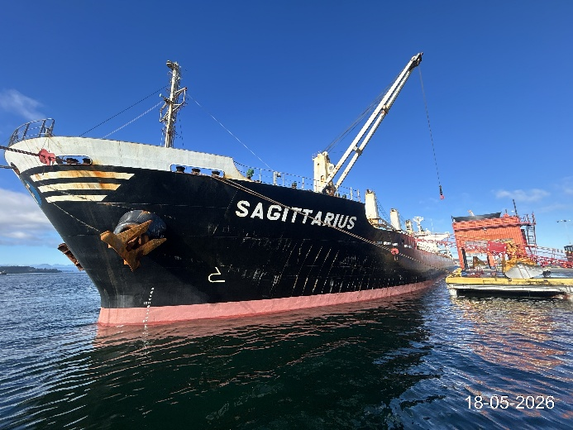 | 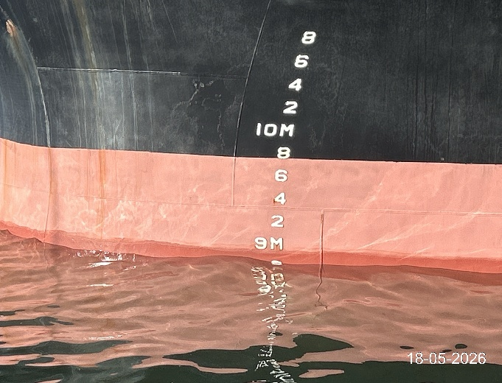
- MV Federal Indiana berthed to TMP Chincui. | - P/S Forward draft.

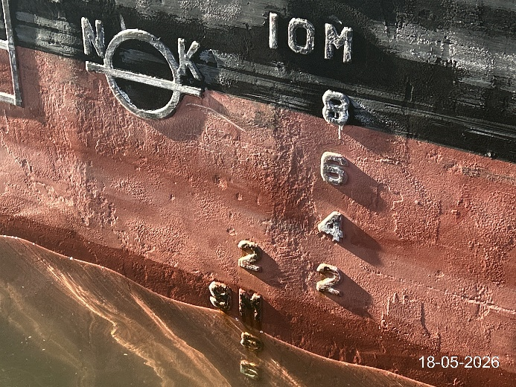 | 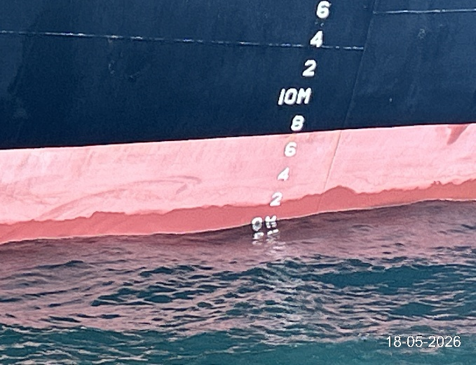
- P/S Mid ship draft mark. | - P/S Aft reading draft.

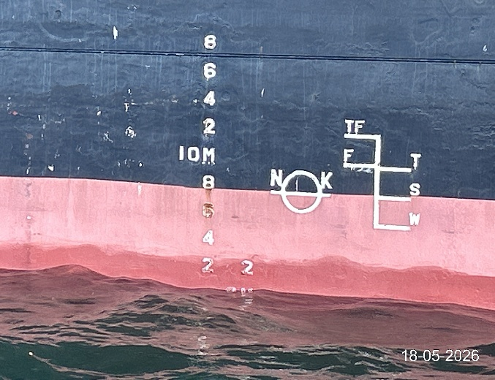 | 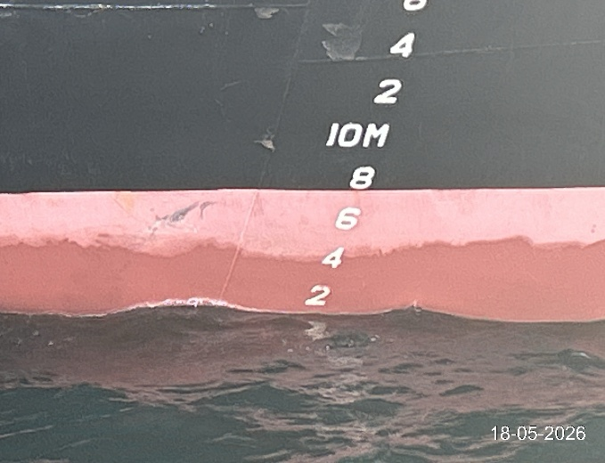
- S/S Mid ship draft mark. | - S/S Aft reading draft.

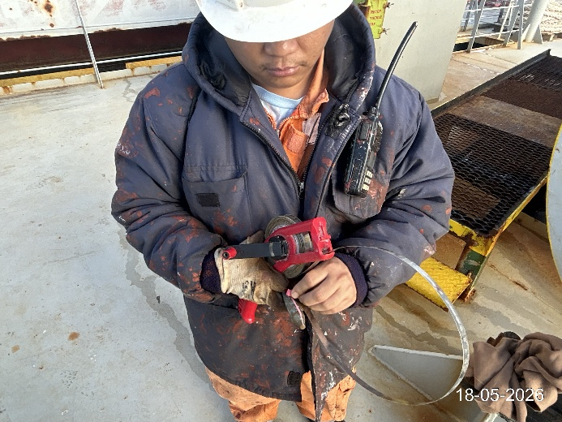 | 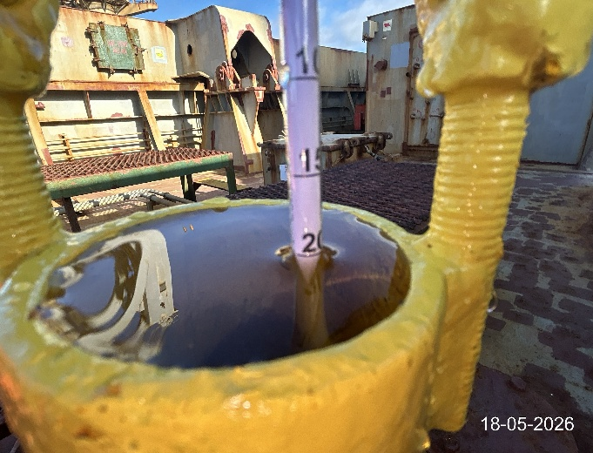
- Painting ruler before sounding ballast. | - Checking density of the sea water.

Final draught survey:

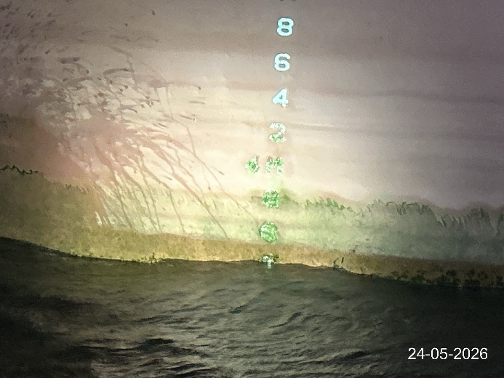 | 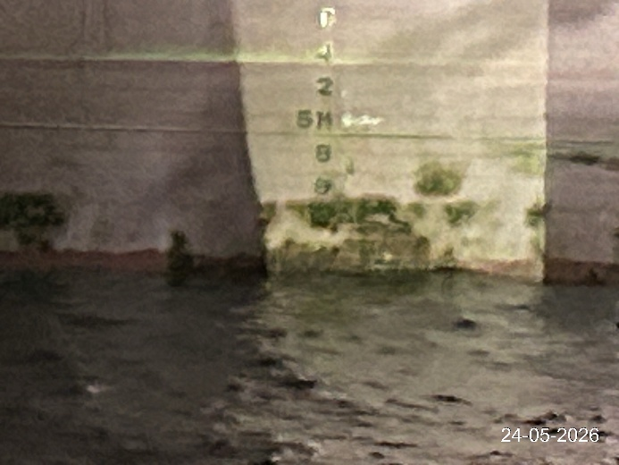
- P/S Forward draft. | 26. P/S Mid ship draft.

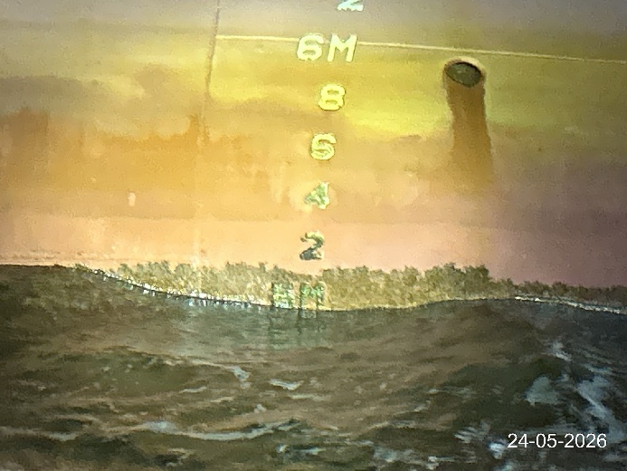 | 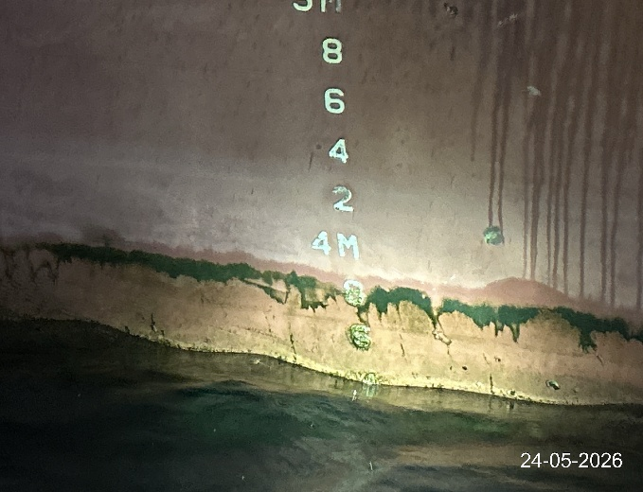
- P/S Aft draft. | - S/S Forward draft.

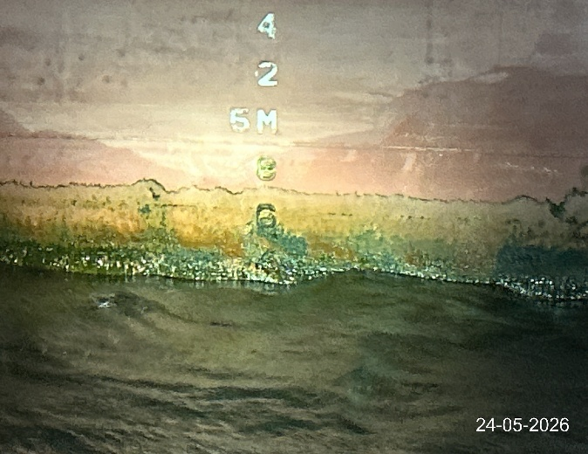 | 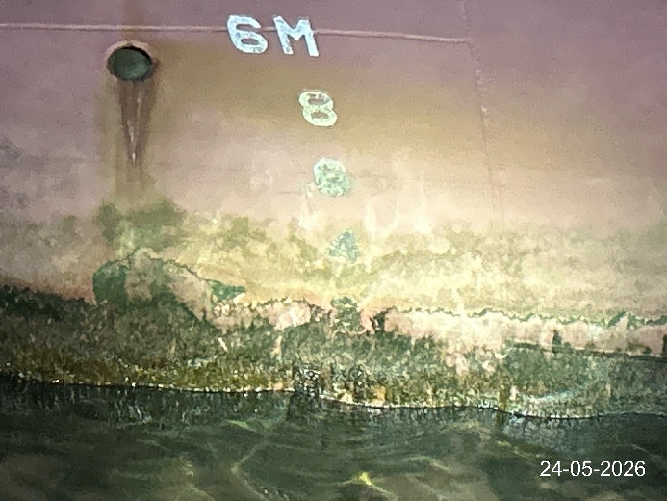
- S/S Mid ship draft. | - S/S Aft draft.

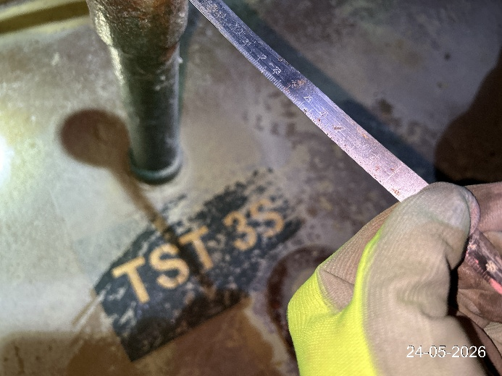 | 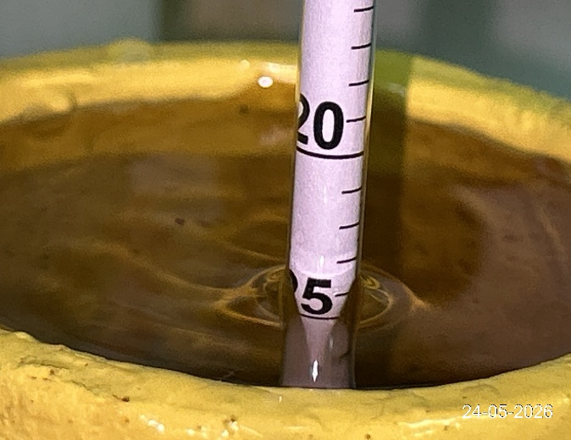
- Ballast tank description. | - Final density of the sea water.

