ROUTE STUDY (ROUTE 5 NORTH-A653) POWER EQUIPMENT TRANSPORT FROM IQUIQUE PORT TO “PHOTOVOLTAIC PARK” PROJECT RAOD TO MAMIÑA.

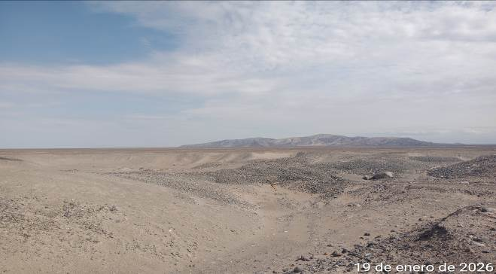
PHOTOVOLTAIC PARK

Made for:


ISSUE DATE: January 2026

CONTENT

1. Introduction
2. Objetives
3. Brief Description
4. Field Inspection
4.1 Loading capacity of port cranes, daily port discharge rate and permissible storage time in port.
4.1.1. Loading capacity of port cranes.
4.1.2. Daily discharge rate at port.
  - 4.1.3. Allowable storage time at port.
  - 4.1.4. Availability of storage site.
  - 4.2. Define the distances in kilometers between the ports and the project facilities.
  - 4.3. Define estimated transportation times.
  - 4.4. Mark, the physical characteristics of the route.
  - 4.5. Identify the presence of low and medium voltage cables, indicating minimum permitted distances.
  - 4.6. Identify bridges on the route.
  - 4.7. Identify the presence of tunnels on the route and their technical capacities for traffic.
  - 4.8. Identify any other obstacles (traffic signs, advertising, private property, etc.) that difficult of free transit.
  - 4.9. Establish a calendar of weather seasonality that affects safety transportation on the routes (rain season, intense heat, fog, snow, ice, as well as light times per season).
  - 4.10. Identify water crossings (dry or wet) on the route that could affect travel, nothing the following: maximum axle weight allowed, official strength specifications, physical attributes, and visual conditions, as well as by-pass or reinforcement alternatives if possible.
  - 4.11. Identify possible resting and parking areas in safe conditions for the driver and cargo.
4.12. Current legislation.
5. Route evaluation (photographs)
6. Conclusions and recommendations.

1. INTRODUCTION

In response to the request made by Messrs. “DELFIN GROUP”, a route study is presented below for the transportation of POWER EQUIPMENT to PHOTOVOLTAIC PARK, PROJECT ROAD TO MAMIÑA, located at Pozo Almonte, Iquique Region, Chile

2. OBJETIVES:

1. To have information regarding the loading capacity of port cranes, daily port discharge rate and admissible storage time in port, availability of storage facilities in port or close to it.
2. Allow us to identify the route involved in the transfer of components, and it will serve as a reference for a subsequent definition and assessment of the improvement in the existing road infrastructure, if necessary.
3. Define the distances in kilometers between the ports and the Project facilities.
4. Define estimated transportation times.
5. Indicate the physical characteristics of the route; pavement condition, type of surface, number of lanes, gradients, condition of the shoulder.
6. Presence of low, medium, and high voltage cables, indicating the minimum distance allowed by law to transit.
7. Identify the presence of bridges on the route.
8. Identify the presence of tunnels on the route and their technical capacities for transit.
9. Identify any other obstacles (traffic signs, advertising, private property, etc.) that are difficult of free transit
  - 10. Establish a calendar of weather seasonality that affects safety transportation on the routes (rain season, intense heat, fog, snow, ice, as well as light times per season).
11. Identify water crossings (dry or wet) on the route that could affect travel, nothing the following: maximum axle weight allowed, official strength specifications, physical attributes, and visual conditions, as well as by-pass or reinforcement alternatives if possible.
12. Identify possible rest and parking areas in safe conditions for the driver and cargo.
  - 13. Formulate relevant recommendations on the routes such as possible improvements, and use of special equipment for transporting oversized and/or overweight cargo.

  - 3. BRIEF DESCRIPTION: PHOTOVOLTAIC PARK, PROJECT ROAD TO MAMIÑA

The Project presented in this route study will be located south of the City of Iquique, in the district of Pozo Almonte province, Iquique region, approximately 98 km away (considering the location of photovoltaic panels).

The altitude varies between 1170 m to 1200 m throughout the area.

Our study of routes, not included, details of photovoltaic park due to don’t have information about as.

Main route from Iquique Port to the Project.

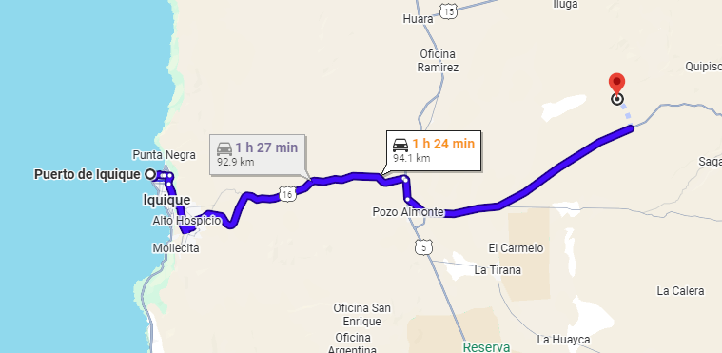
Main route from IQQ port to destination: Google maps.

4. FIELD INSPECTION:

Field inspections were carried out based on all defined routes, to carry out reference surveys of obstacles and singular points, photographic capture, clearance measurements, inspection of bridges and verification of general conditions of each route, critical points with insufficient maneuvering area, bridges with restrictions, among others, were photographed and inspected thoroughly.

Following our study, carried out in the field, we can define the following points:

4.1. LOADING CAPACITY OF PORT CRANES, DAILY PORT DISCHARGE RATE AND PERMISSIBLE STORAGE TIME IN PORT.

Through the following report we can inform you that the Iquique Port consists of 2 terminals:

1.- Iquique Port Company
2.- Iquique International Terminal

For which only Iquique International Terminal has cranes to discharge the power equipment, so the following can be verified:

Main Area to Iquique international Terminal. (ITI.

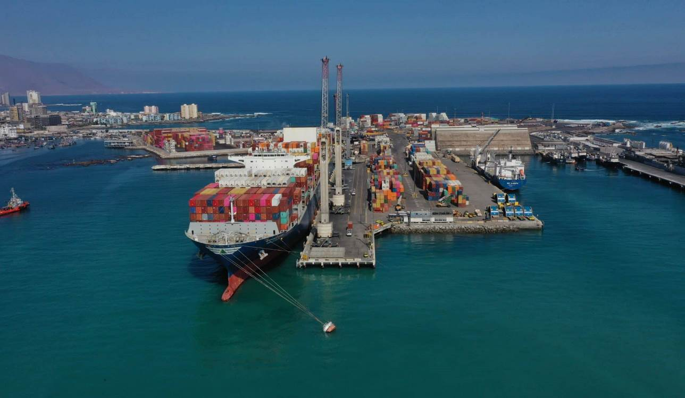
Source: Logistica Press, https://logisticapress.com/puerto-iquique-terminal-internacional-alcanzo-un-hito-historico-en-carga/

Satellite Image of Iquique International Terminal

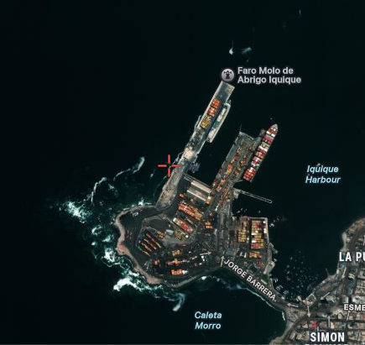
Souce: Google maps

4.1.1. LOADING CAPACITY OF PORT CRANES:

Iquique International Terminal has Dock Equipment with a safe working load of 100 tons and Yard Equipment with a working load of 45 tons.

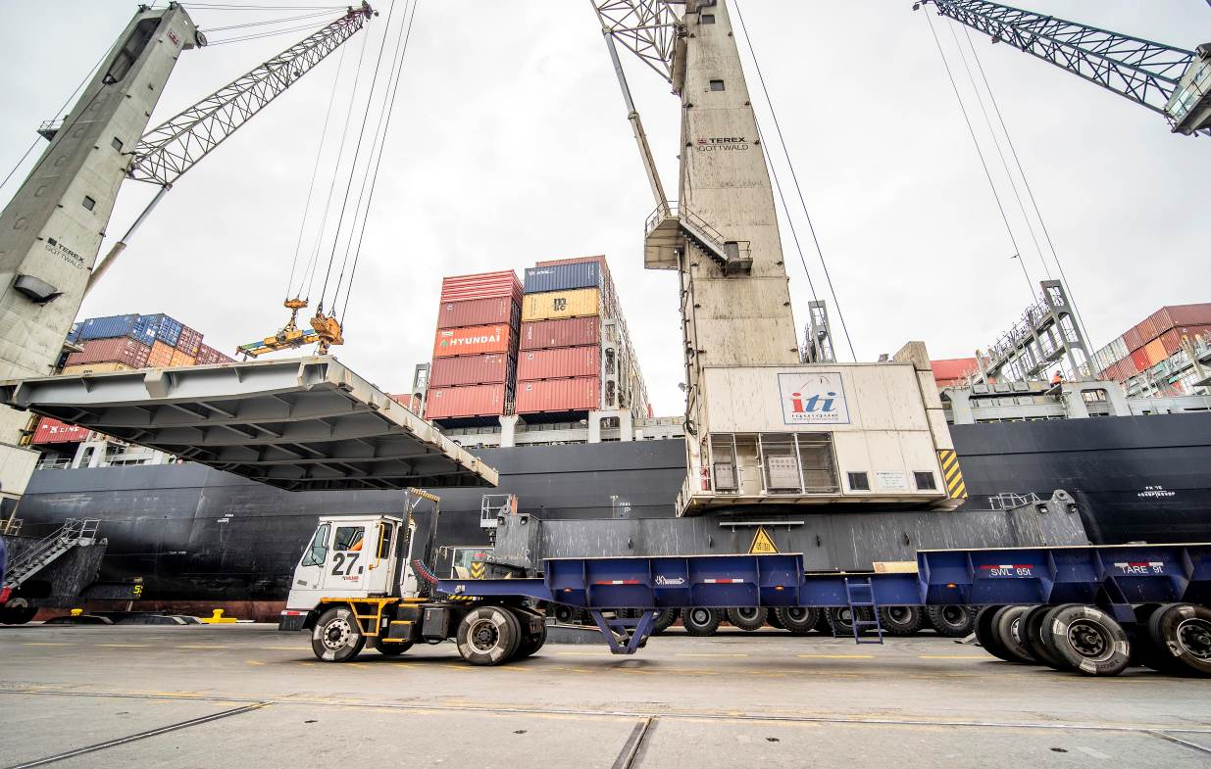
Source: Iquique International Terminal.

4.1.2. DAILY DISCHARGE RATE AT ITI

At Iquique International Terminal, cargo productivity is like handling 20' containers, from 80 to 100 units. per shift (3 shifts per day).

4.1.3. ALLOWABLE STORAGE TIME AT ITI:

At Iquique International Terminal, cargo such as power equipment is classified as IMO 9 / UN 3536, with a maximum stay in port of 7 days. After this time, the units must be moved to the storage areas, where the spaces in m2 will be charged. The values ​​were not provided; these were classified as reserved information. However, you can find prices on the terminal's website (public tariff) Page 10, Tar 305.

4.1.4 AVAILABILITY OF STORAGE SITE AT ITI:

At Iquique International Terminal, cargoes such as power equipment, classified as IMO 9, must be stored inside the controlled area for dangerous cargo.

Likewise, if the client has other warehouses outside the terminal, such as primary areas authorized by the National Customs Service as storage areas, in both cases the clients can choose that alternative.

It should be noted that the stay in ITI is subject to storage charges. For this, you can see the public tariff at the following link:
https://www.iti.cl/wp-content/uploads/2024/09/Anexo_Tarifas_11_septiembre_2024.pdf

4.2. DEFINE THE DISTANCES IN KILOMETERS BETWEEN THE PORTS AND THE PROJECT FACILITIES.

Access to the Photovoltaic Park Project is via the main national roads that connect the cities of Iquique, Pozo Almonte, Mamiña.

However, not all these accesses are enabled for the transit of cargo trucks, so there is only 1 defined route that allows the passage for cargo transport of 3.5 tons or more.

The route was made from the port of discharge to a few kilometers before its destination according to the coordinates provided (20°06'16.9"S 69°29'02.8"W), with a length of 98 kilometers.

This was because the A-653 highway did not have any roads leading to the photovoltaic park.

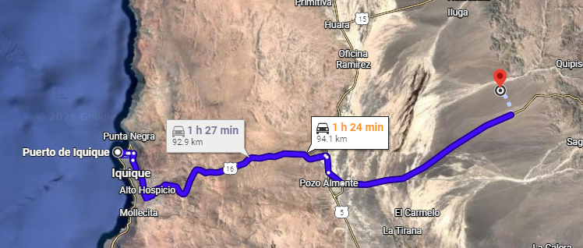
FSource: Google maps
Iquique-Mamiña (20°06'16.9"S 69°29'02.8"W)

Below are the distances in kilometers by sections:

START | FINAL DESTINATION | DISTANCE (km)
Iquique Port | Road “Pampa Perdiz” Toll | 41
Road “Pampa Perdiz” Toll | Pozo Almonte | 57
Pozo Almonte | Road A-653 (FVP Mamiña) | 98

4.3. DEFINE ESTIMATED TRANSPORTATION TIMES.

According to the route study carried out, from the Port of Discharge to the Photovoltaic Park, the travel time of the route was 01 hours and 10 minutes, respecting the speed limits stipulated during the route, which were very well signposted.

Speed ​​limits:

Road : 70 to 100 Km/Hr.
Urban and rural areas : 30 to 50 Km/Hr.

Considering the speeds, determined by the land carrier, as a safety speed for the transport of cargo, we can consider a change in the number of hours considering that variable.

Note that the travel distance includes waiting time at Quillagua Customs, since, being a mixed transport route, it has high traffic congestion.

Speed ​​limits, for other projects with cargo up to 45 tons.

Road : 50 to 60 Km/Hr.
Urban and rural areas : 20 to 40 Km/Hr.

4.4. IDENTIFY THE PHYSICAL CHARACTERISTICS OF THE ROUTE, PAVEMENT CONDITION, TYPE OF SURFACE, NUMBER OF LANES, GRADIENTS, CONDITION OF THE SHOULDER.

According to the study carried out, from the Iquique Port to the Tocopilla Photovoltaic Park Project, the physical characteristics of the routes traveled are detailed below:
ROUTE | ORIGIN | FINAL DESTINATION | TYPE OF SURFACE | NR. OF LANES | STATUS AND SIGNALING | TYPE OF ROUTE | CONDITION OF SHOULDER
S/R | IQQ PORT | ALTO HOSPICIO | Pavement/  Asphalt | One way | Good | Winding | Good
16 | ALTO HOSPICIO | TOLL | Asphalt | Bidirectional | Good | Winding/  Dangerous | Good
16 / 5 NORTH | TOLL | POZO ALMONTE | Asphalt | Bidirectional | Good | Winding | Good
5 NORTH / A 65 | POZO ALMONTE | BYPASS COLLAHUASI - UJINA | Asphalt | One way | Good | Winding | Good
A65 / A653 | BYPASS | MAMIÑA | Asphalt /Dirt | One way | Good | Winding/  Dangerous | Good

4.5. PRESENCE OF LOW, MEDIUM AND HIGH VOLTAGE CABLES, INDICATING THE MINIMUM DISTANCE ALLOWED BY LAW TO TRANSIT.

According to the study carried out, by Iquique Port, towards the Photovoltaic Park Project, medium voltage cables were seen at the following intersections of Avenida Arturo Prat / Sotomayor Street, which, depending on the height of the transport and its cargo, may make the journey difficult.

In Chile, the minimum height of telecommunications cables at street and road crossings is 5.5 meters above the ground; this height applies to voltages up to 1000 volts.

ROUTE | DESCRIPTION | COORDINATES
S/R | Medium Voltage Cables | Av. Prat - Sotomayor

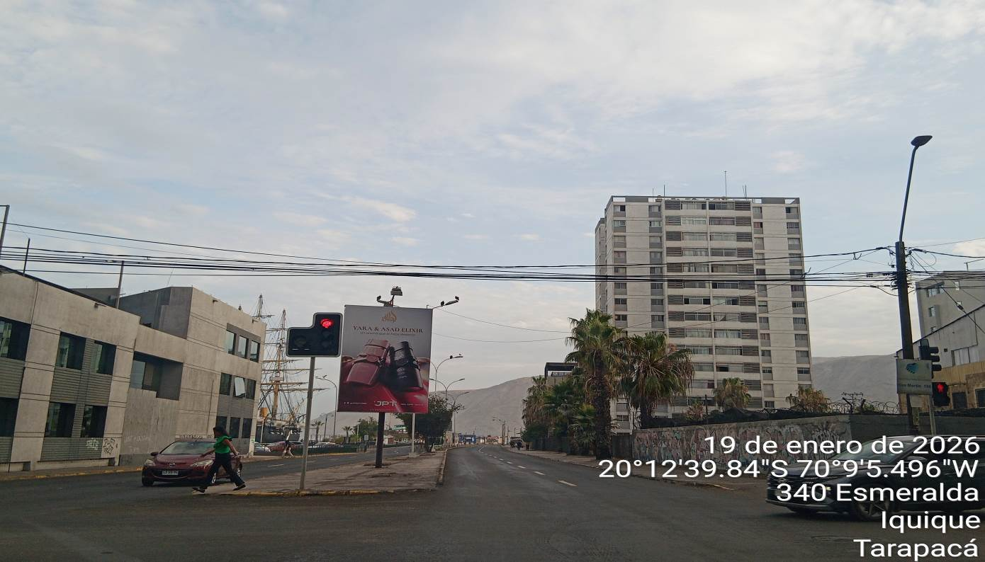

4.6. IDENTIFY THE PRESENCE OF BRIDGES ON THE ROUTE.

According to the study carried out by Iquique Port, towards the Photovoltaic Park Project, bridges and pedestrian walkways were identified on the route, which are detailed below.:

Summary table of dimensional restrictions on route to Photovoltaic Park

ROUTE | DESCRIPTION | COORDINATES | LENGTH (M) | WIDTH (M) | HEIGHT (M)
16 | BRIDGE | 20°16'49.482''S, 70°6'14.562''W |  |  | 4,2
16 | BRIDGE | 2016'47.712''S, 70°6'4.254''W |  |  | 4,2
16 | BRIDGE | 20°16'29.916''S, 70°5'43.2''W |  |  | 4,2
16 | BRIDGE | 2016.296’S, 70°5'36.09''W |  |  | 4,2
16 | PEDESTRIAN BRIDGE TO HOSPICIO | 20°16'4.752’S, 70°5'20.292''W |  |  | 5,82
16 | PEDESTRIAN BRIDGE SANTUARIOS | 20°12'53.19''S, 69°53'49.398''W |  |  | 5,80
16 | PEDESTRIAN BRIDGE HUMBERSTONE | 20°12'48.096''S, 69°47'51.906''W |  |  | 5,82

Photographs of bridges on route.

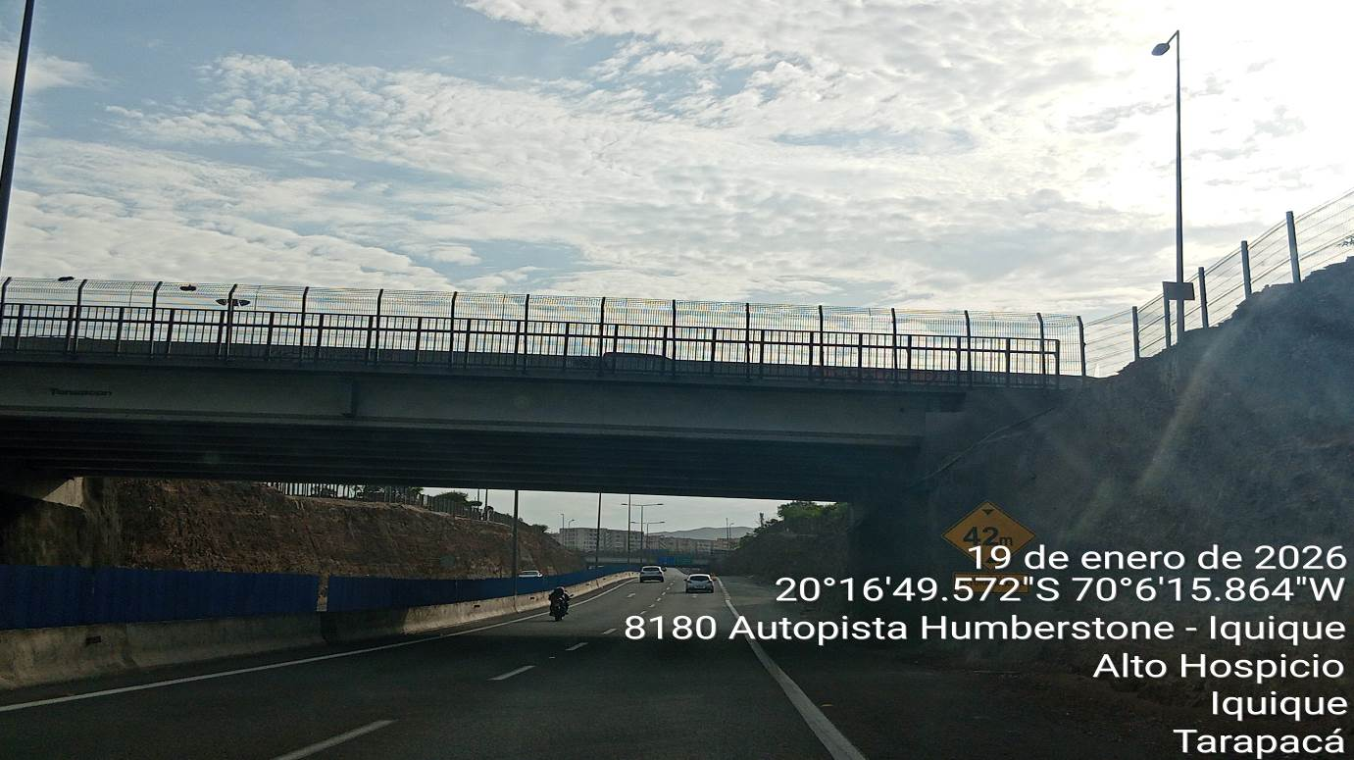

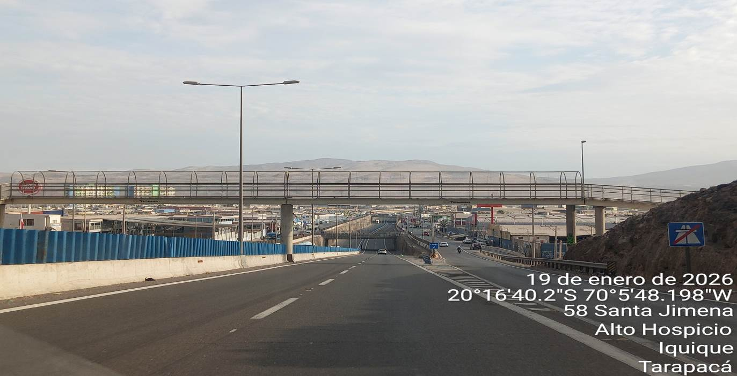

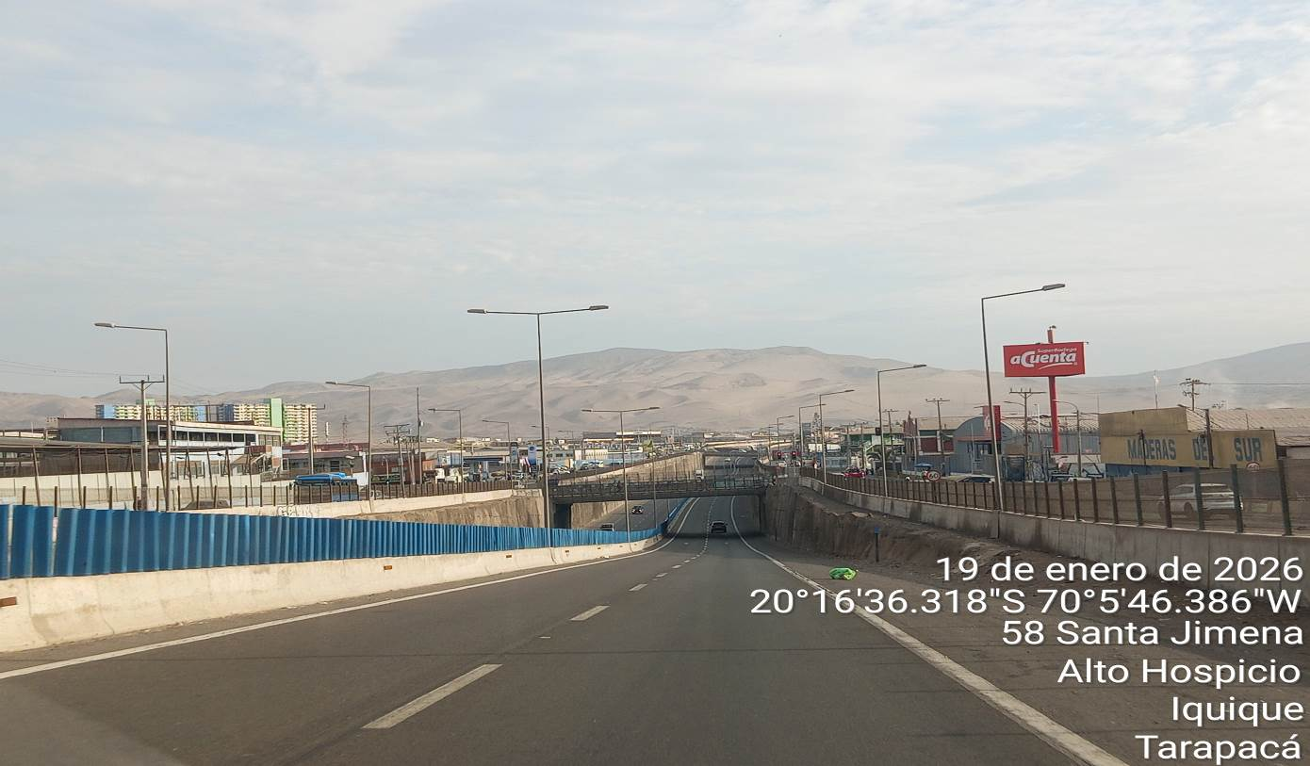

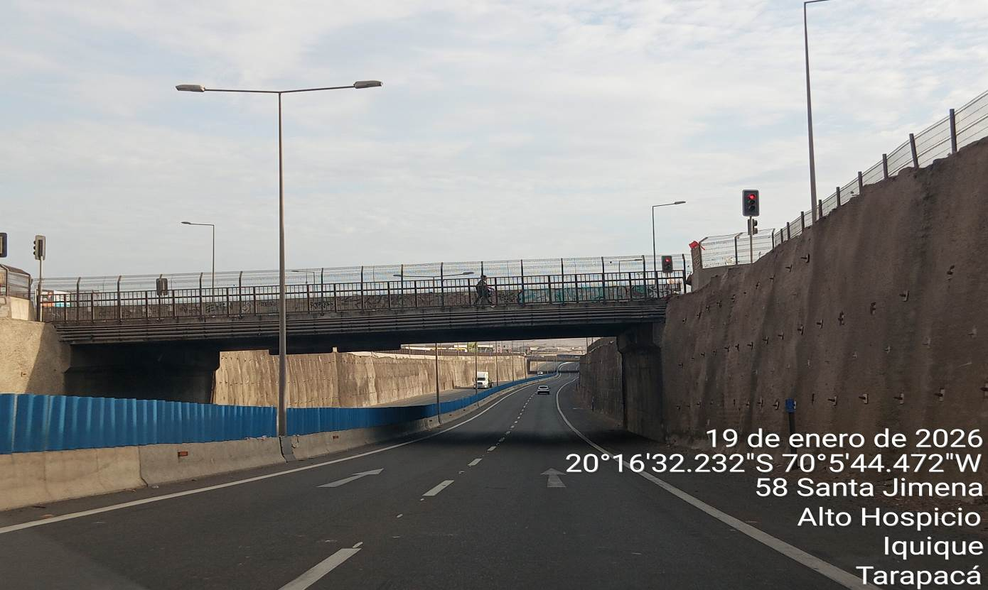

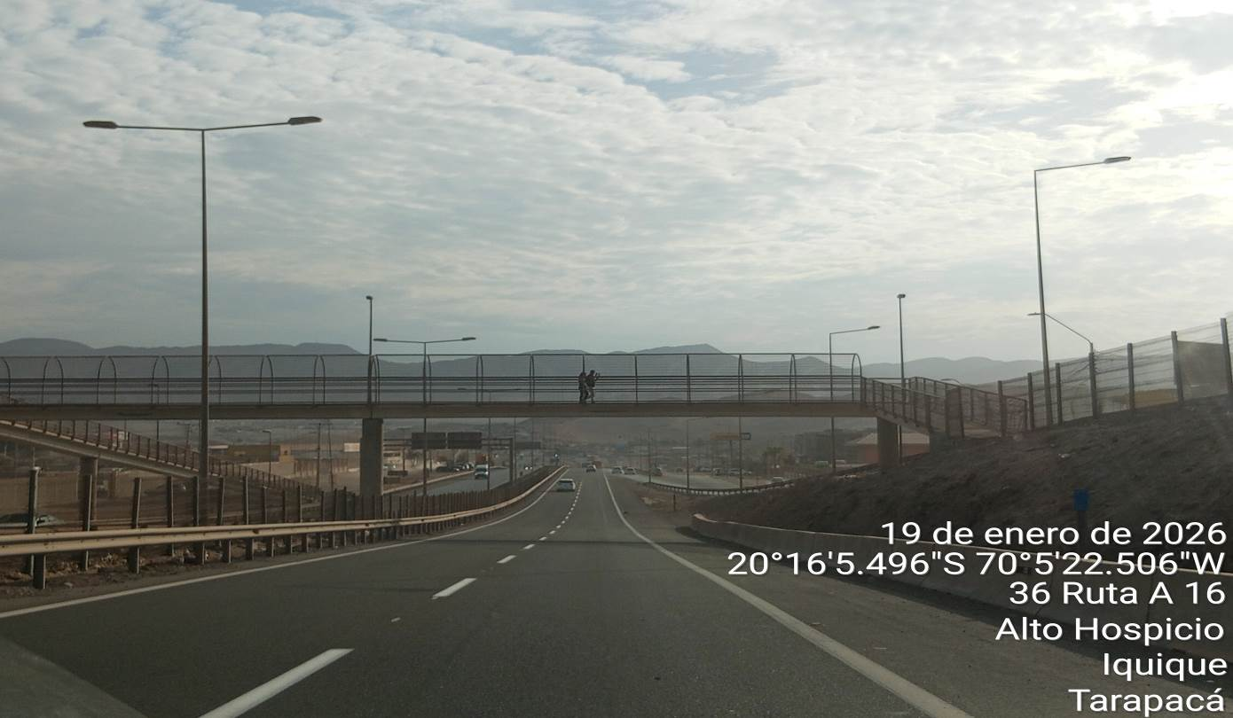

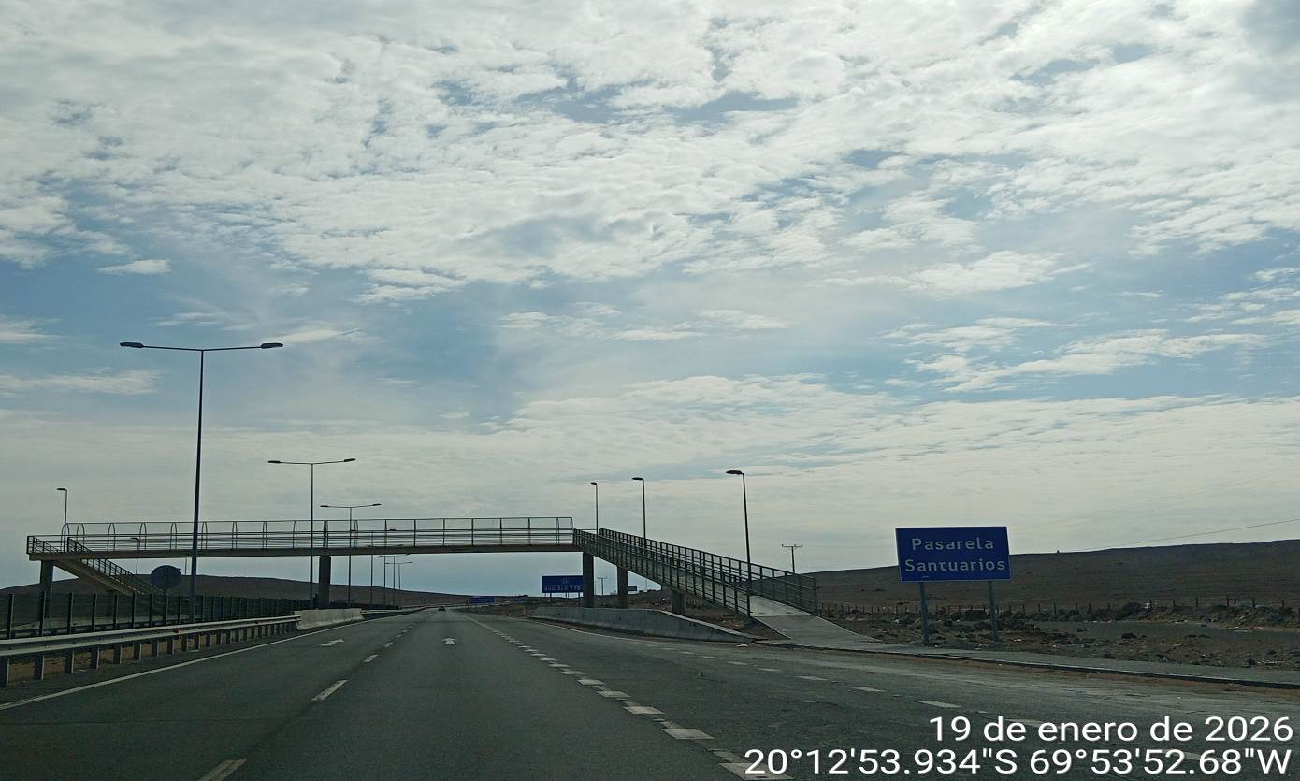

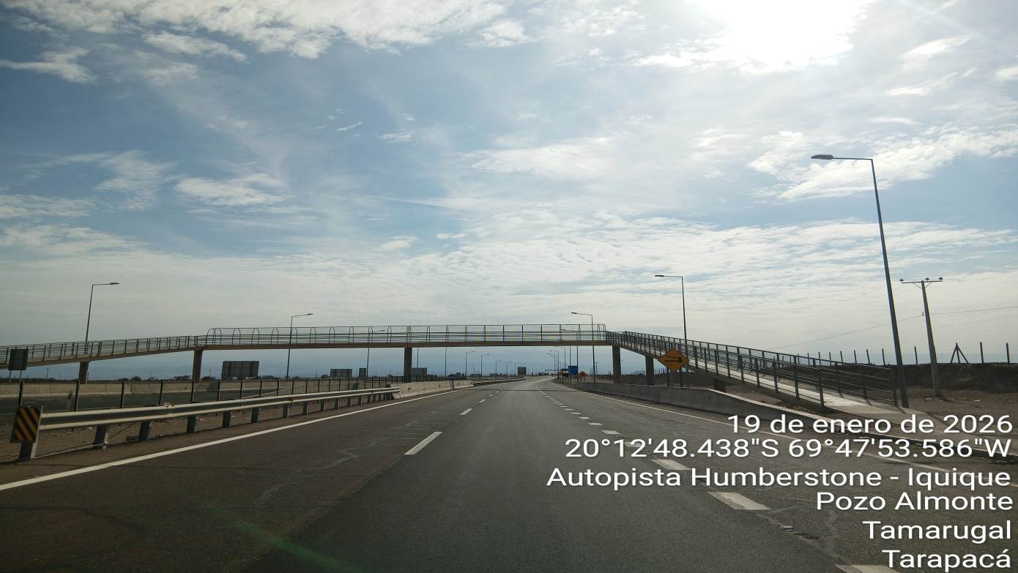

4.7. IDENTIFY THE PRESENCE OF TUNNELS ON THE ROUTE AND THEIR TECHNICAL CAPACITIES FOR TRANSIT

According to the route study carried out, from Iquique port to Photovoltaic Park Project, NO tunnels were observed.

4.8. IDENTIFY ANY OTHER OBSTACLE (TRAFFIC SIGNS, ADVERTISING, PRIVATE PROPERTY, ECT) THAT DIFFICULT OF FREE TRANSIT

According to the route study carried out from Iquique port to Photovoltaic Park Project, the traffic signs were observed in good condition, in order and duly identified, such as stopped, speed limits, bypass, detours and advertising, being easily access to the determined areas.

In the rural and urbanized places, the traffic is reduced according to speed limits established, since the route is found in the middle of urbanized areas, but this is not an obstacle to the free transportation.

In general, the route was observed without obstacles, without risk areas, that prevent free transit.

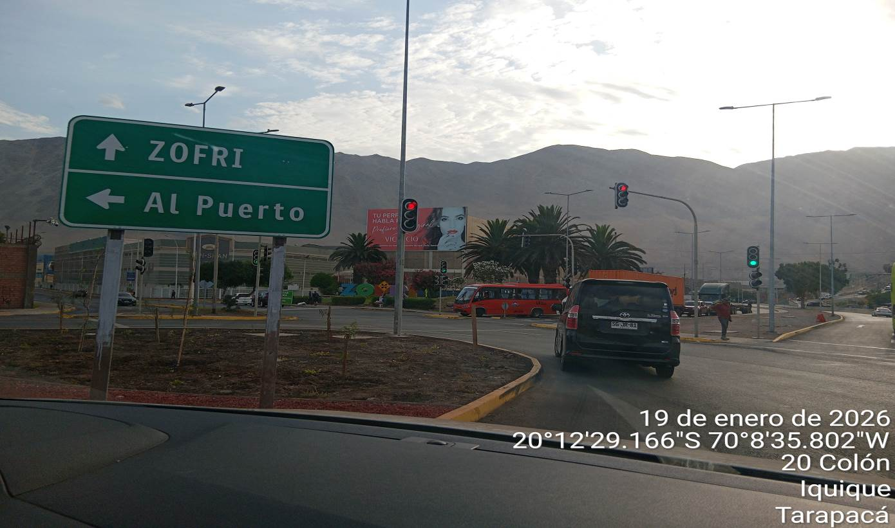

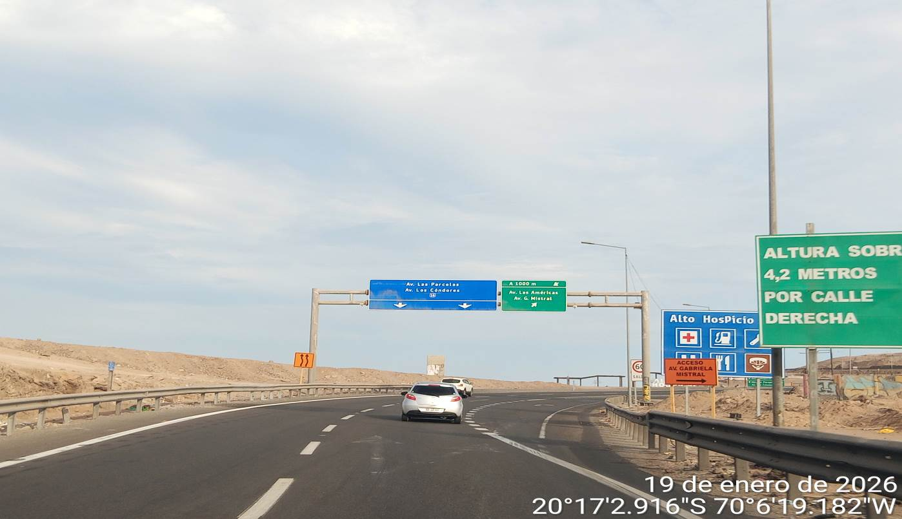

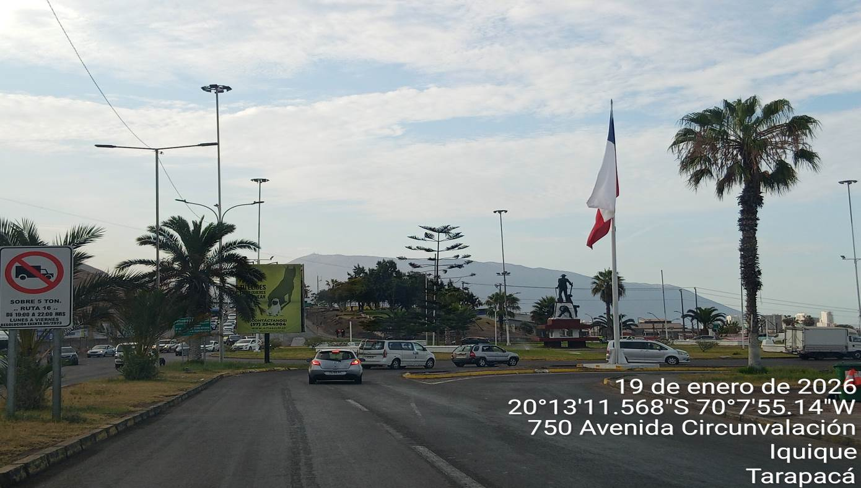

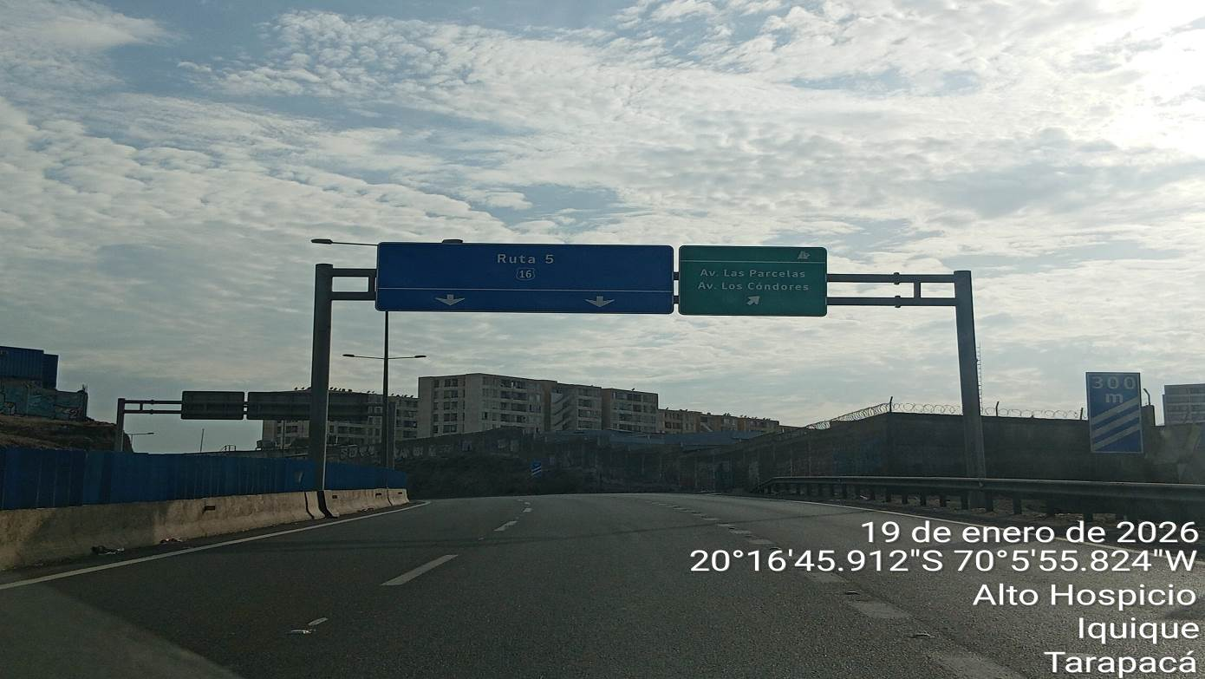
MPS Height: 5.73m

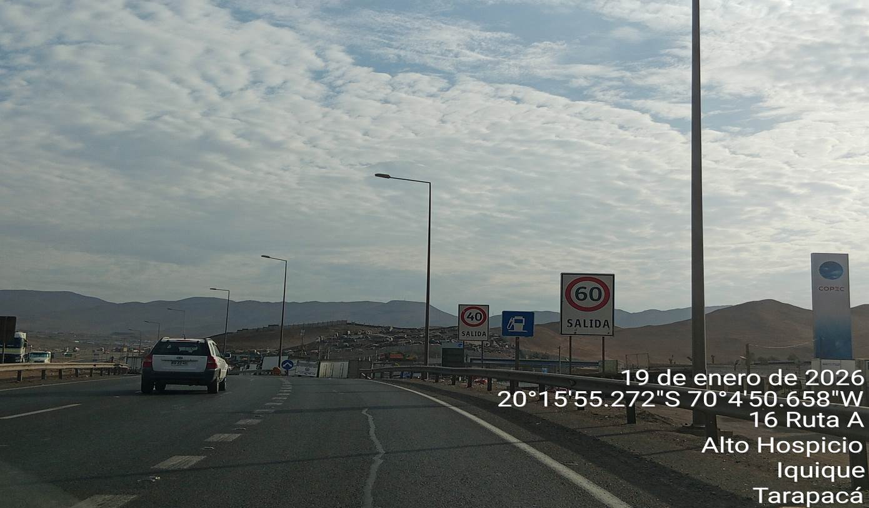

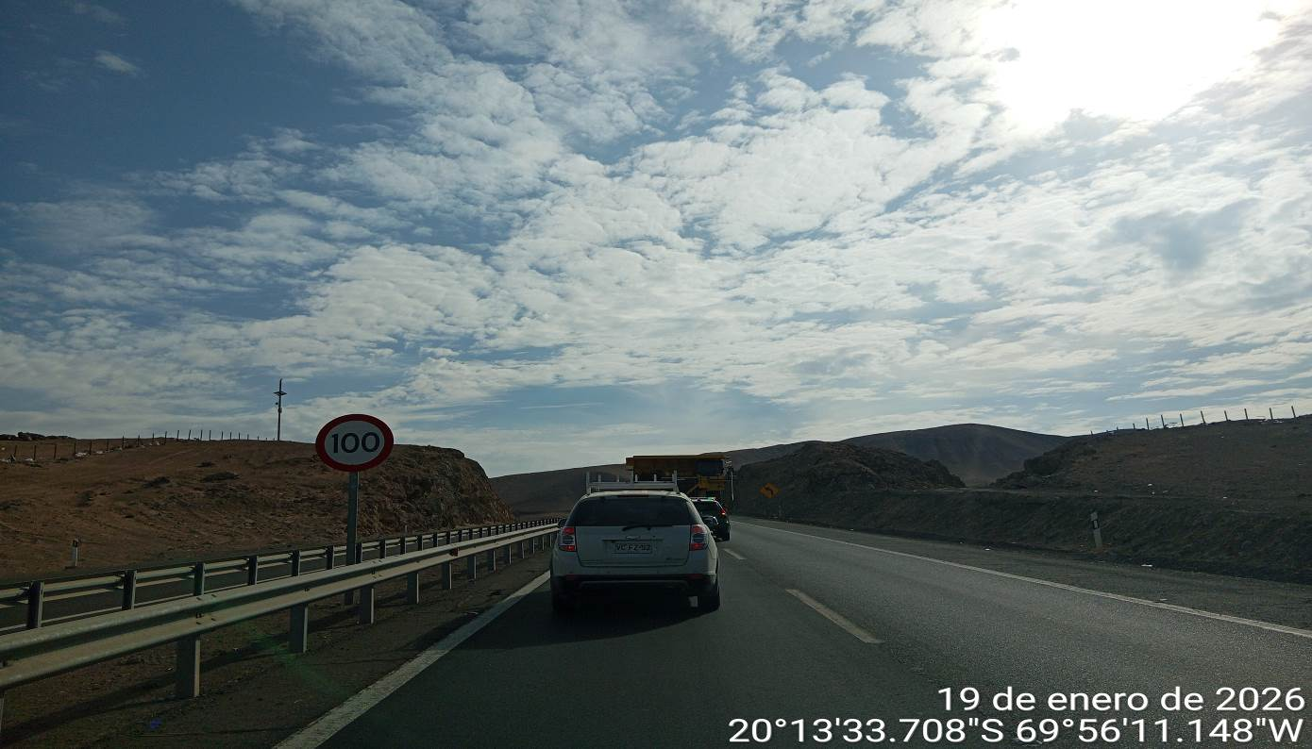

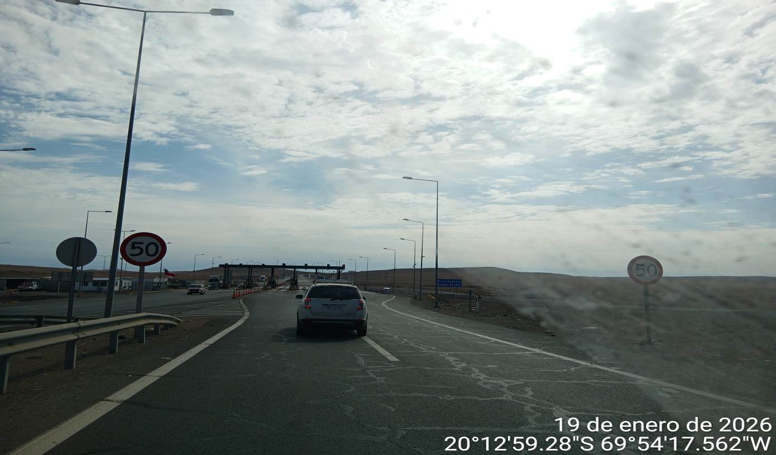

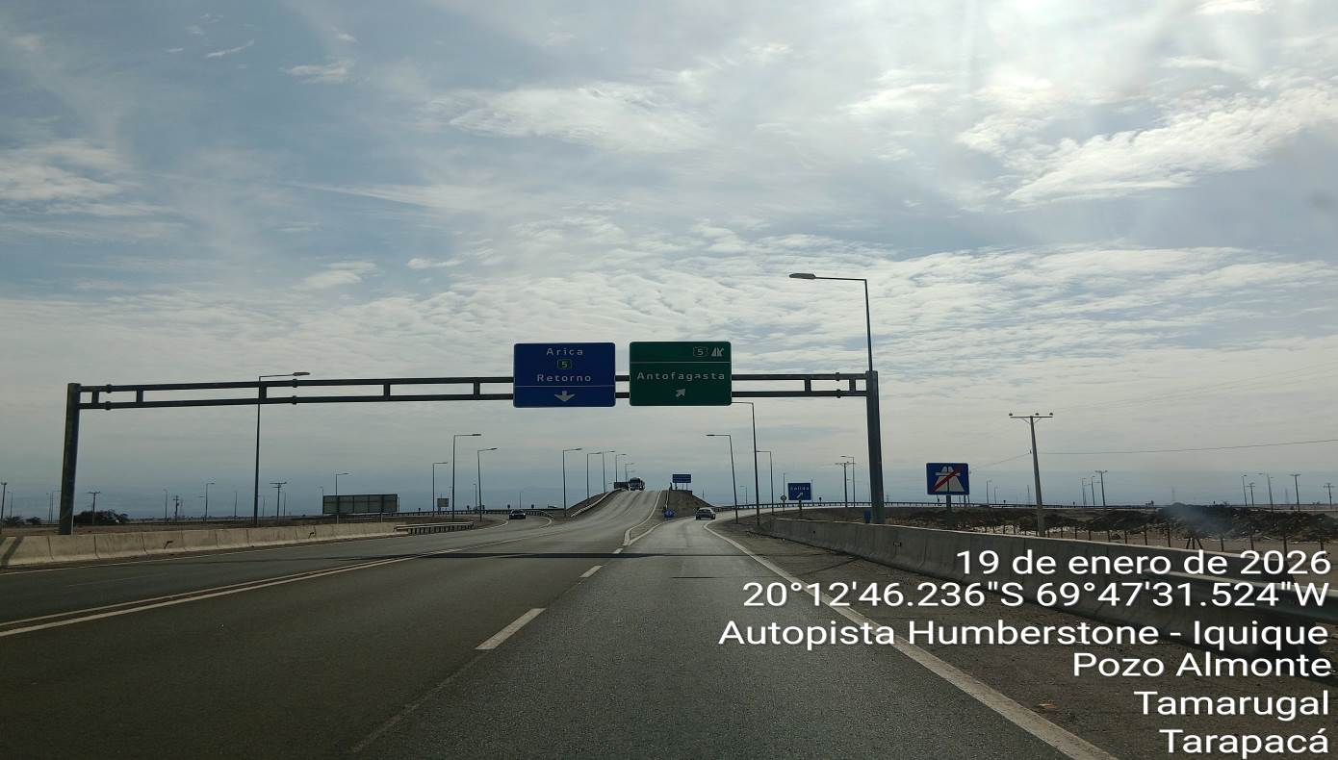
MPS Height: 5.73m

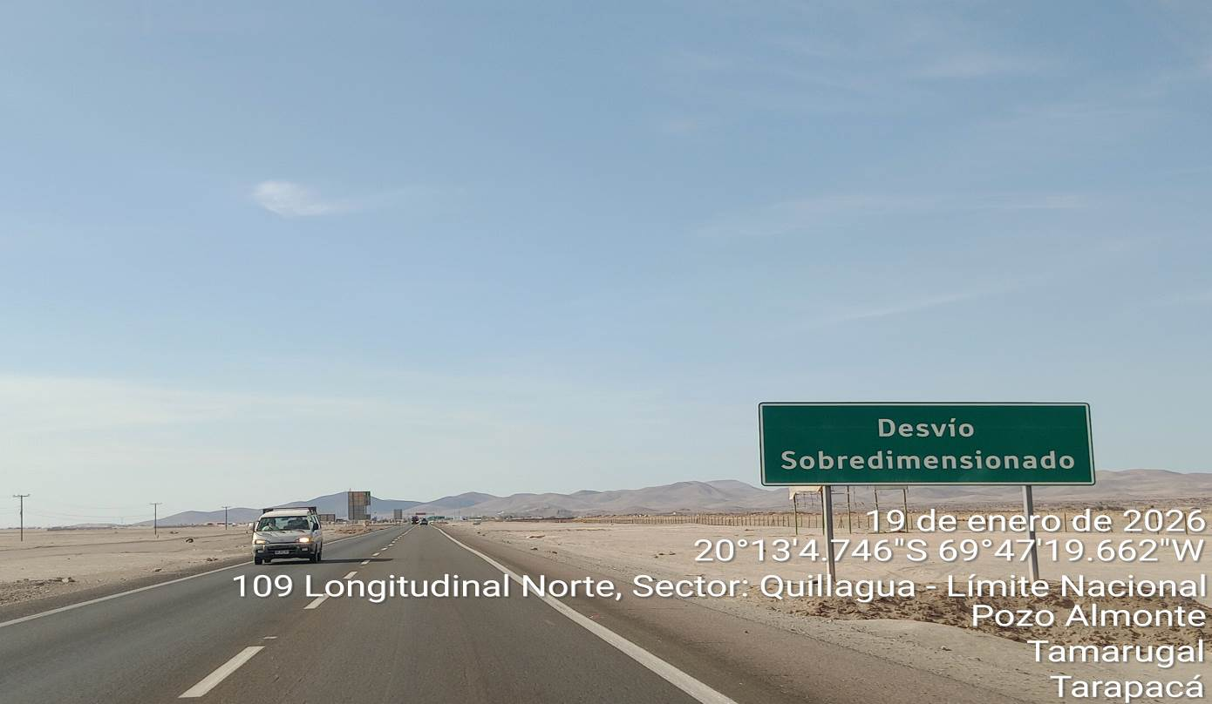

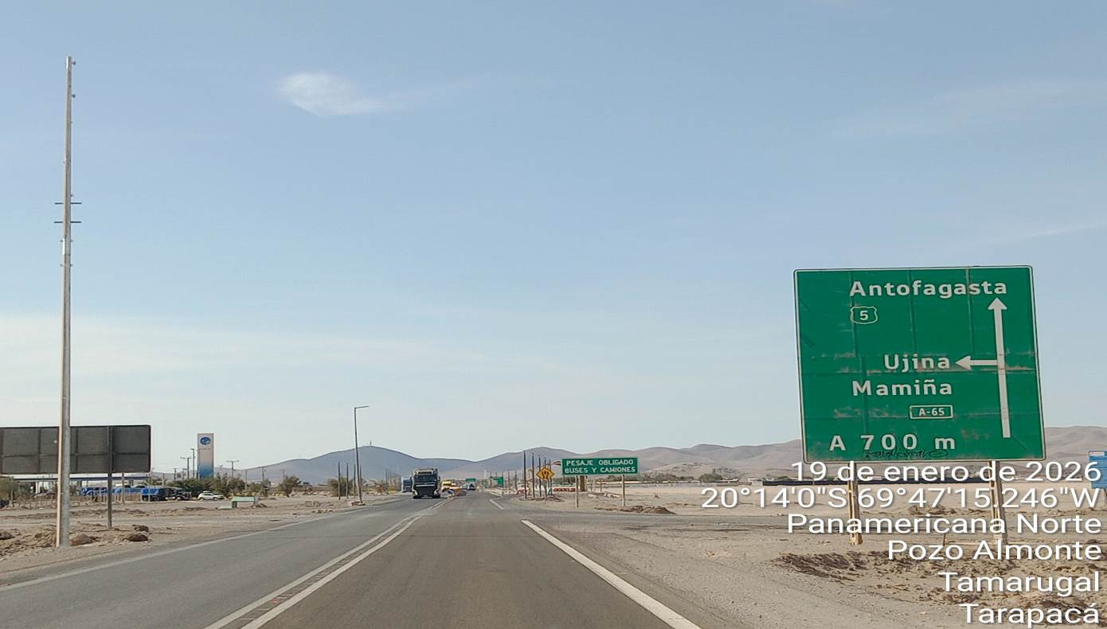

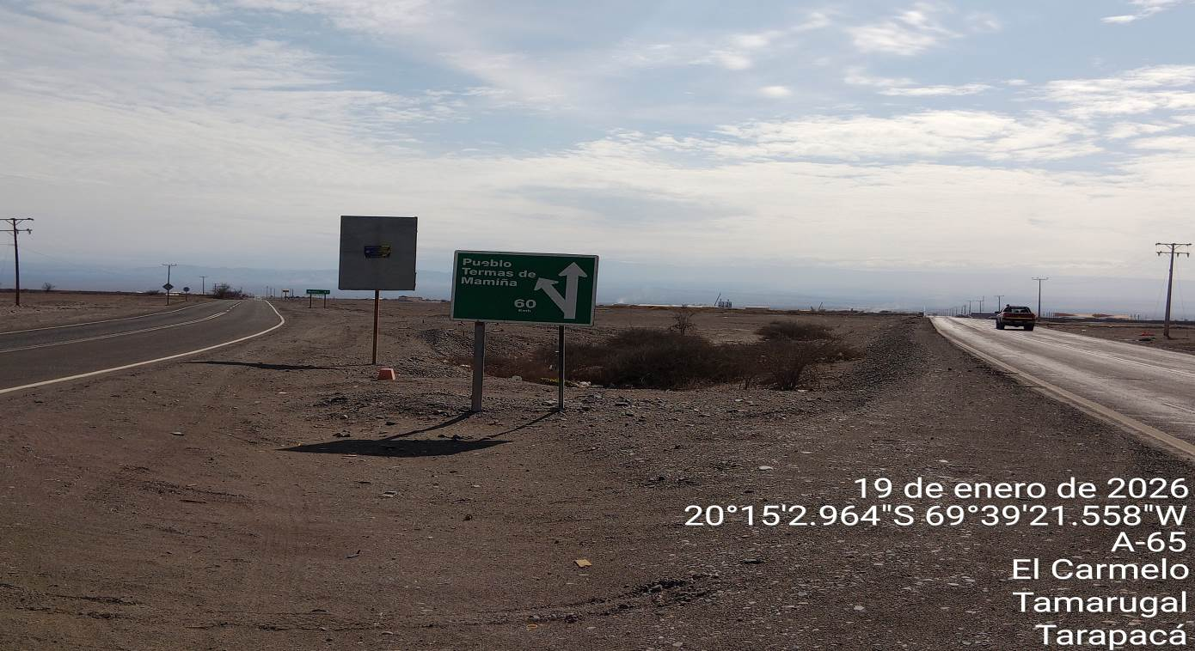

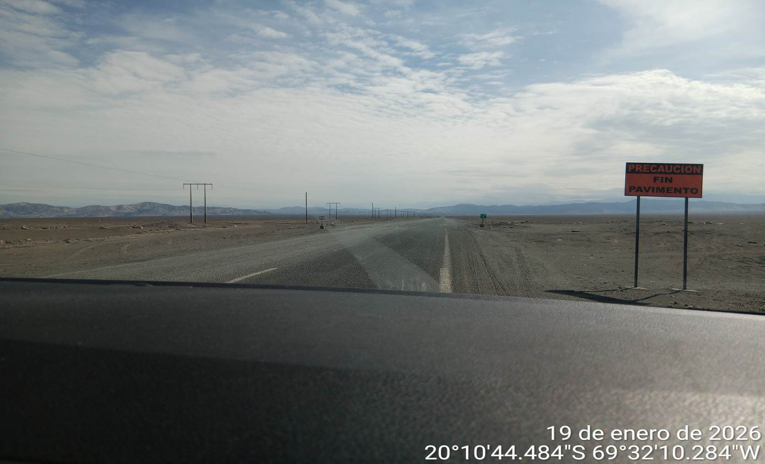

4.9. ESTABLISH A CALENDAR OF WHEATHER SEASONALITY THAT AFFECTS SAFETY TRANSPORTATION ON THE ROUTES (RAIN SEASON, INTENSE HEAT, FOG, SNOW, ICE, AS WELL AS LIGHT TIMES PER SEASON)
AD PRIVADA, ETC.) QUE DIFICULTE
The route study was developed during summer with an average temperature between 24° to 26 °C.
LIBRE TRÁNSITO.

The weather condition noted from Pozo Almonte, way to Mamiña, is a desert climate, which is characterized by high temperatures, low rainfalls, high humidity and fog at nights, during all seasons.

The weather conditions during the year, as per the following details:

 | WEATHER
SUMMER |  | AUTUMN |  | WINTER | SPRING
Intense heat- Sunshine-  Humidity- Fog |  | Sunshine - Wind - Humidity - Fog |  | Humidity-wind-  Average rain - Fog | Sunshine - Wind - Humidity - Average rain - Fog

- 4.10. IDENTIFY WATER CROSSINGS (DRY OR WET) ON ROUTE THAT COULD AFFECT TRAVEL, NOTING THE FOLLOWING: MAXIMUM AXLE WEIGHT ALLOWED, OFFICIAL STRENGTH SPECIFICATIONS, PHYSICAL ATTRIBUTES AND VISUAL CONDITIONS, AS WELL AS BY-PASS OR REINFORCEMENT ALTERNATIVES IF POSSIBLE.

According to the study, no water crossings were observed.

4.11. IDENTIFY POSSIBLE RESTING AND PARKING AREAS IN SAFE CONDITIONS FOR THE DRIVER AND CARGO, FORMULATE RELEVANT RECOMMENDATIONS TO THE ROUTES SUCH AS POSSIBLE IMPROVEMENTS, USE OF SPECIAL EQUIPMENT FOR TRANSPORTING OVERSIZED AND/OR OVERWEIGHT CARGO.

According to the study, one (1) resting areas and eighteen (5) parking areas were identified.

Resting areas:

Name | Location | City | Region
Copec Pozo Almonte | -20.236697, -69.786627 | Pozo Almonte | Tarapacá

Photographs of resting and parking areas

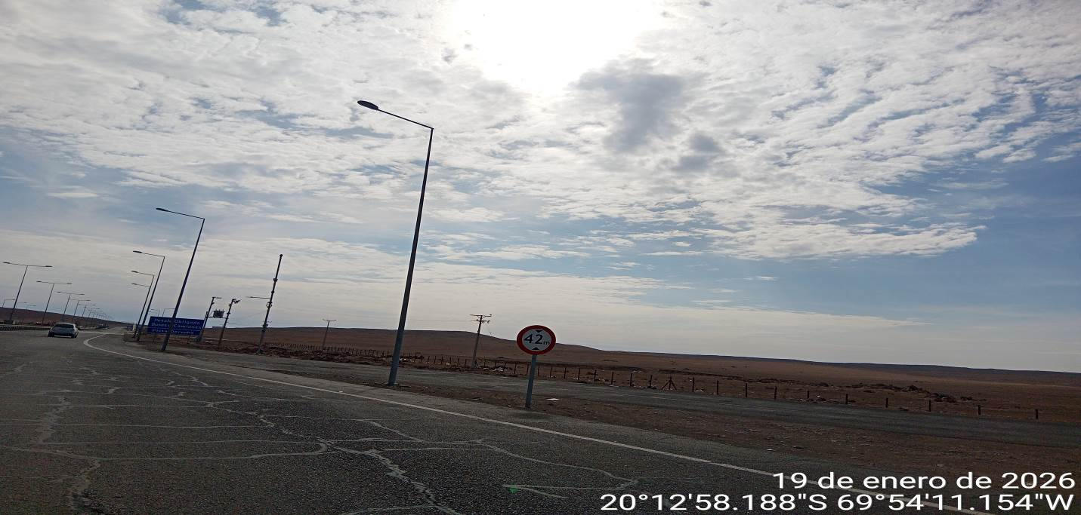

- 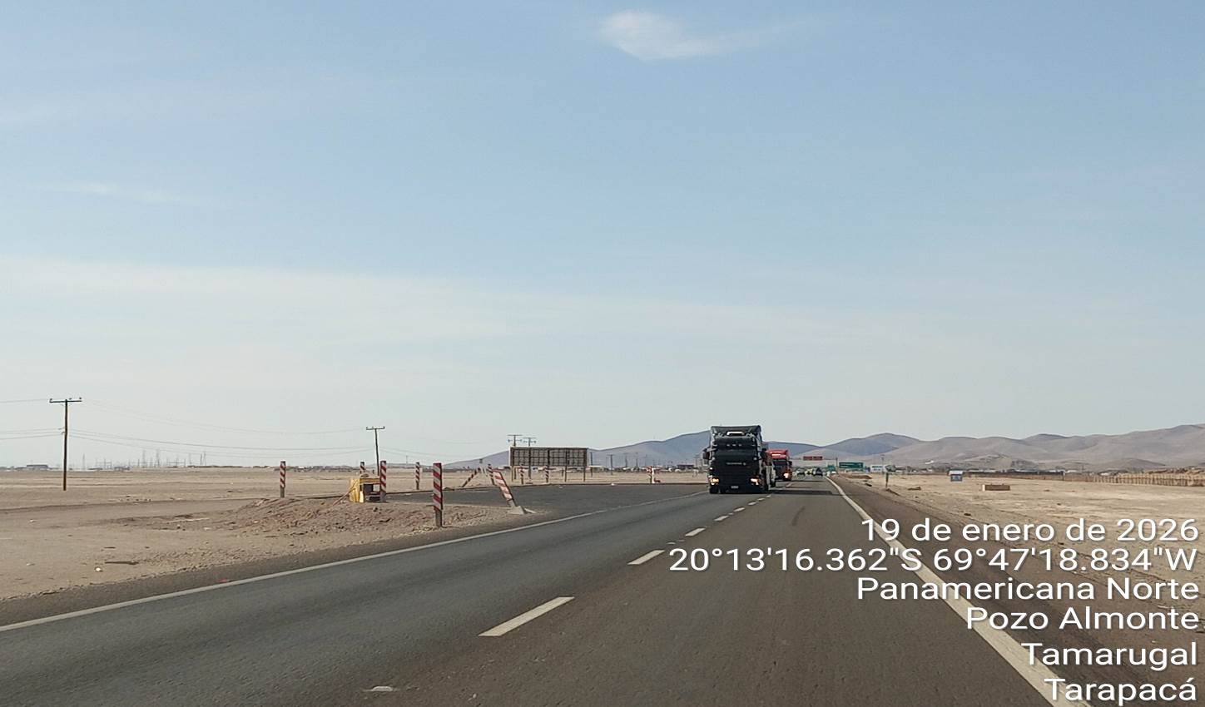
- 4.12. CURRENT LEGISLATION:

4.13 ROAD PROCEDURES (Ministerio de Obras Públicas de Chile)

The authorization process for road procedures oversees “Ministerio de Obras Públicas de Chile”, through the “MANUAL OF AUTHORIZATIONS FOR SPECIAL TRANSPORTATION” of the “Ministerio de Obras Públicas” (M.O.P.), updated on September 21, 2023, and which, in turn, refers to the following regulatory framework:
    - Traffic Law 18.290
    - Law 19.171 de 1992
    - Supreme Decree MOP N° 158 / 1980
    - Supreme Decree MOP N° 19 / 1984
    - Supreme Decree MOP N° 414 / 2015
    - DFL N°1 de 2007 (Article 63)
    - DFL MOP N°850 de 1997
    - Resolution N°1 de 1995 / “Ministerio de Transportes y Telecomunicaciones”
    - Resolution N° 1600 de 2008 / “Contraloría General de la República”
    - Resolution D.V. (affect) N° 60 del 2018
    - Resolution D.V. (exempt) N° 5168 de 2018
    - Resolution D.V. (exempt) N° 2547 de 2020
    - Resolution D.V. (exempt) N°3995 de 2023
    - Resolution C.G.R. N°7 de 2019
    - Resolution C.G.R. N°14 de 2022

In accordance with the above, any truck that meets at least one of the following conditions must apply to the M.O.P. for a special authorization to travel with oversize cargo:

    - Total length bigger than 18.60 mts
    - Total width bigger than 2.60 mts
    - Total high is bigger than 4.20 mts

Additionally, any truck exceeding 45 tons of Total Gross Weight must request to M.O.P. a special authorization for travelling with overweight cargo; M.O.P. may request complementary “Route Studies”, elaborated by engineers specialized in Road Safety, for those special transport requests that present the following minimum conditions:

    - Length equal to or bigger than 36 mts
    - Width bigger than 4,5 mts
    - High equal to or bigger than 5,5 mts
    - Total gross weight (TGW) equal to or bigger than 100 tons

Considering that the cargo to be transported complies with the established width, height and length indicated by the law, the information is only as reference.

5.- EVALUATION OF THE ROUTE.

The following route is considered from Iquique Port to PFV, along the routes A16 / 5 Norte / A65/ and route A 653

- Distance: 98 km

Destination:
- Photovoltaic Power Park

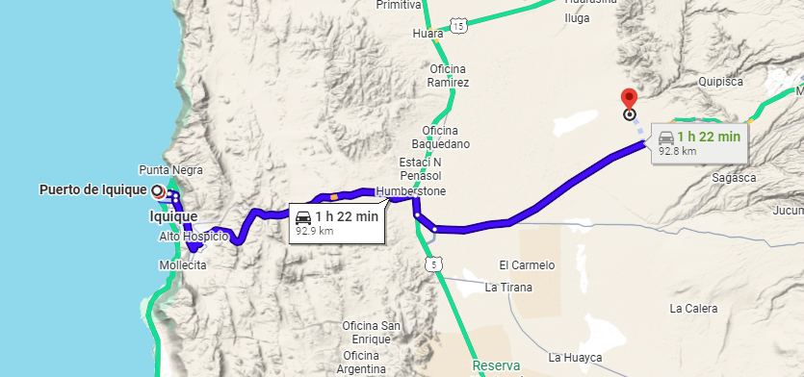

The study of this report starts from the maritime terminal entrance, through Jorge Barrera Street:

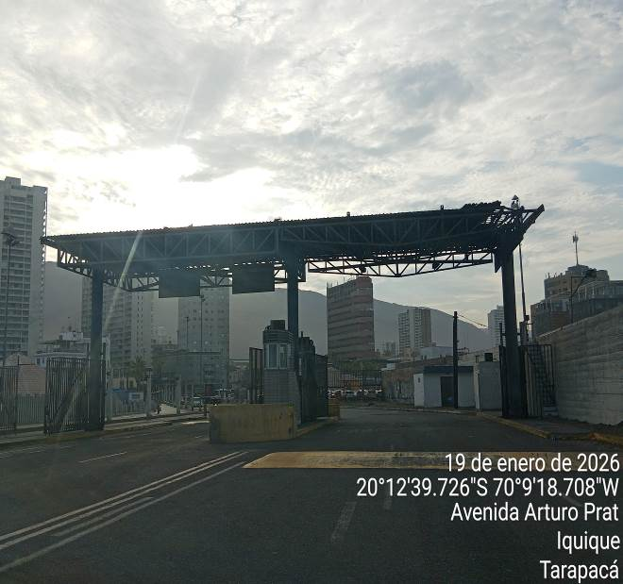 | 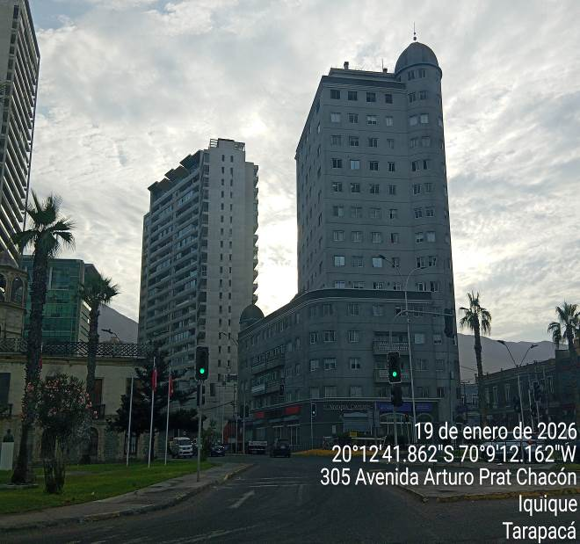
- Exit of Iquique Port; maximum height: 6,65m. | - Exit in front of Arturo Prat Av.

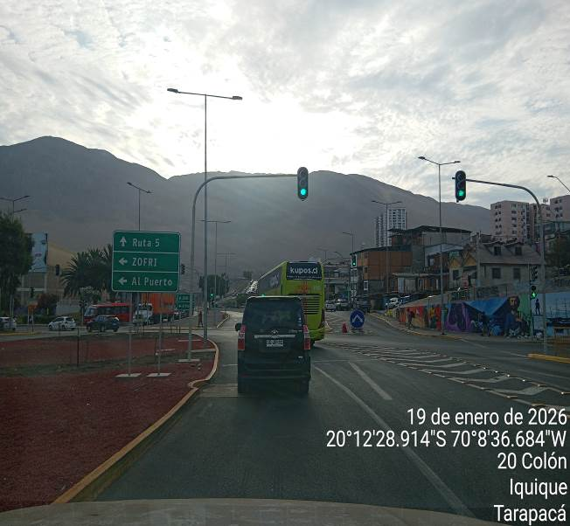 | 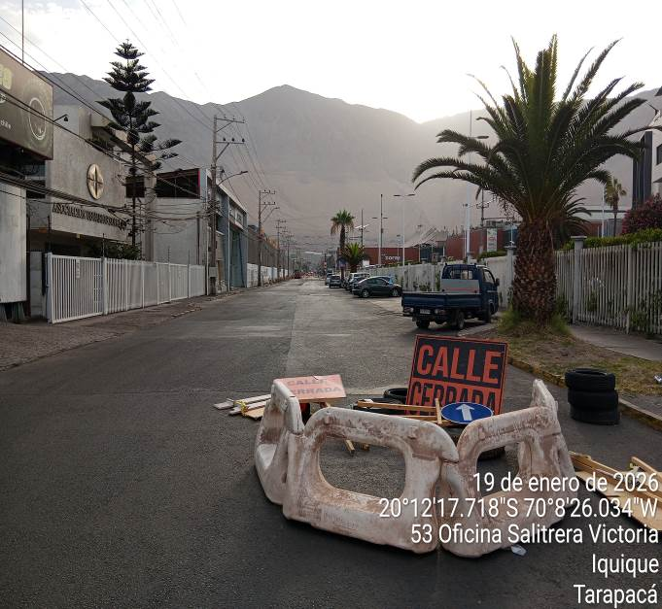
- Street closed for working in route, detour to Z(commencing the route to las cabras / L. Jaspar). | - Route door Nr.4 of Zofri closed due to roadworks, so you must turn left.

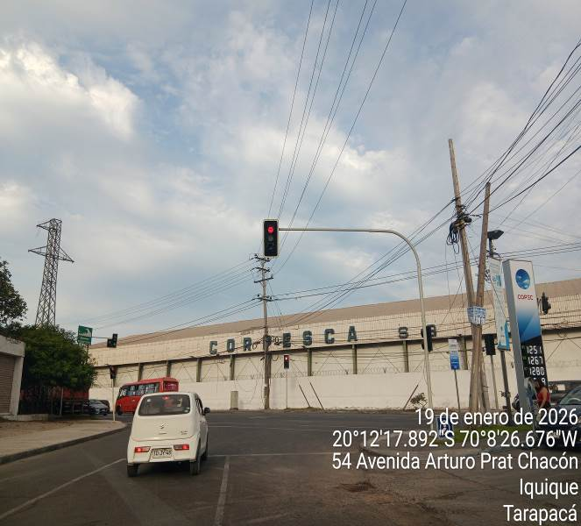 | 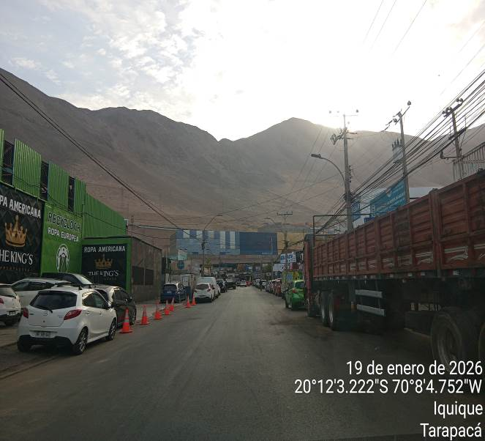
- Take avenue AArturo Prat, turn to right. | - Take avenue Santa Rosa of Huara.

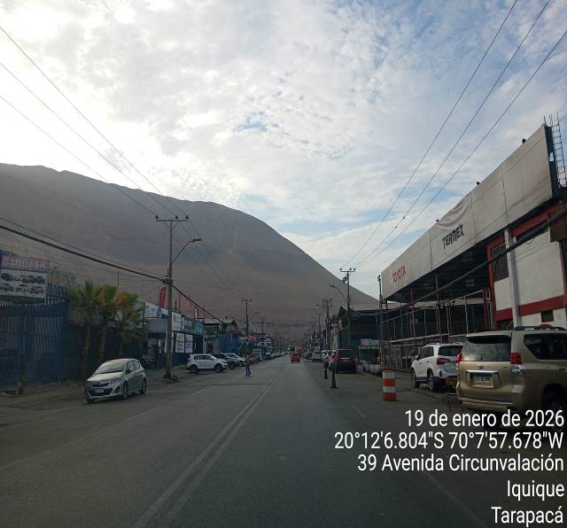 | 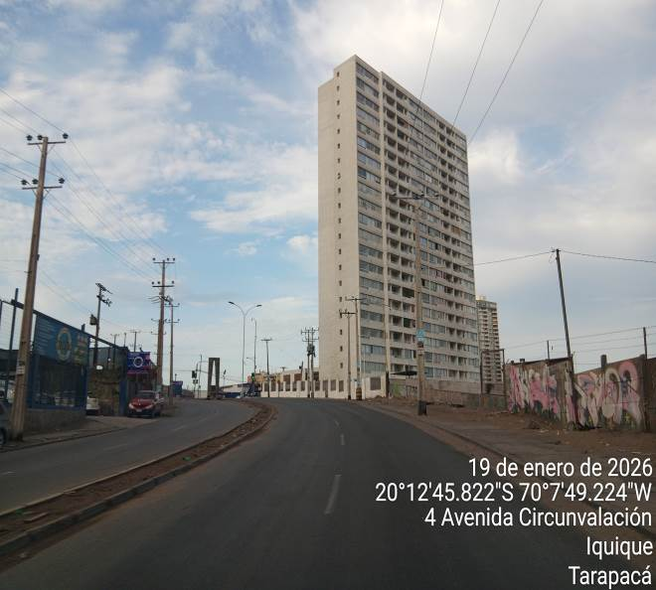
- Route to the right, Av. Circunvalacion. | - Av. Circunvalacion, straight road until arriving at “Rotonda Pampino”.

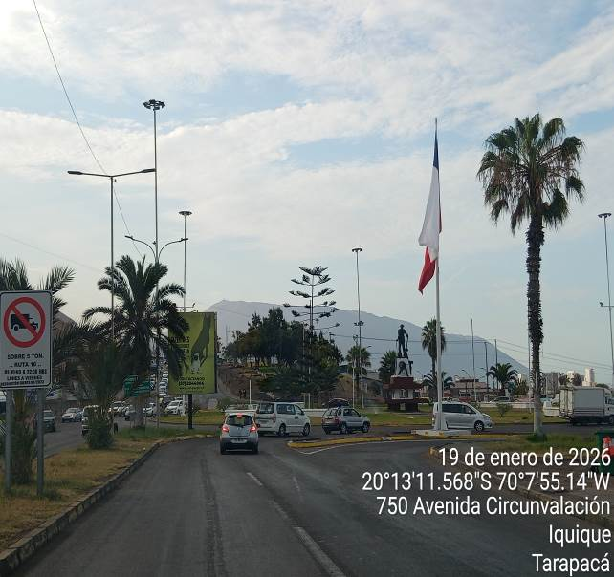 | 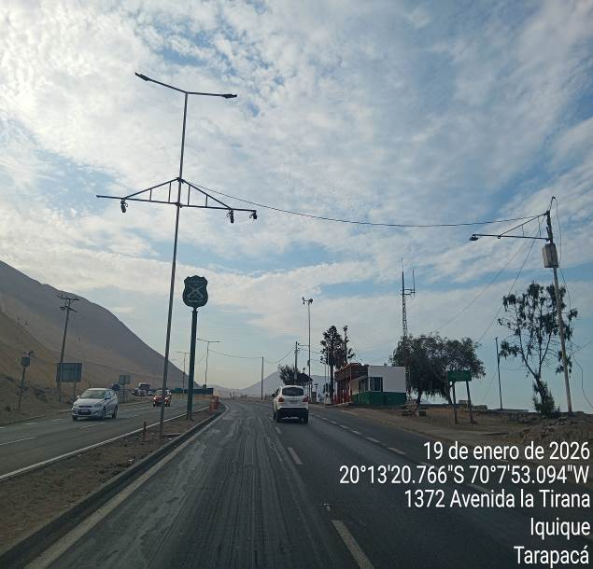
- Route El Pampino takes route A16, to Alto Hospicio. | - Route A 16.

 | 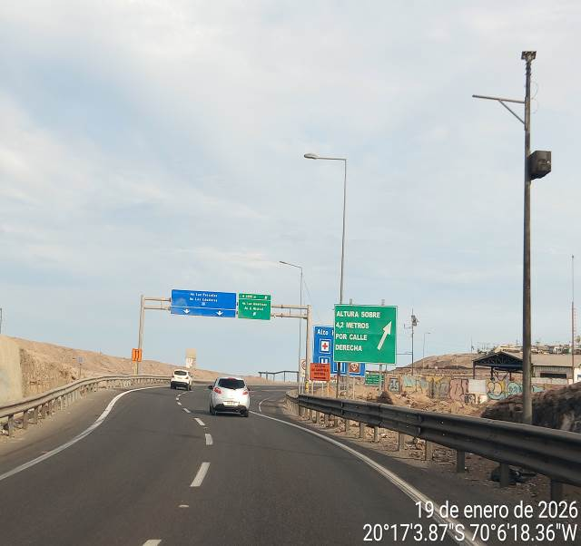
- Bend at KM-40, to arrive in Alto Hospicio. | - Entrance to Alto Hospicio (rural zone).

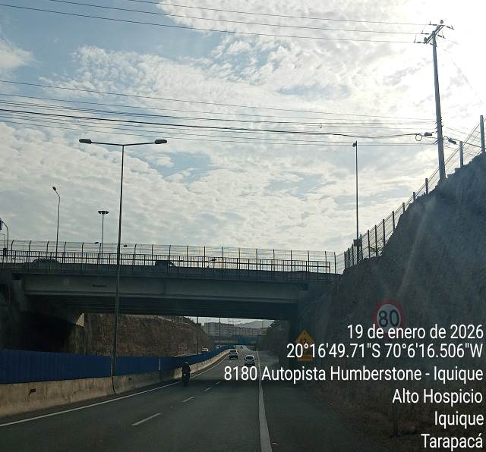 | 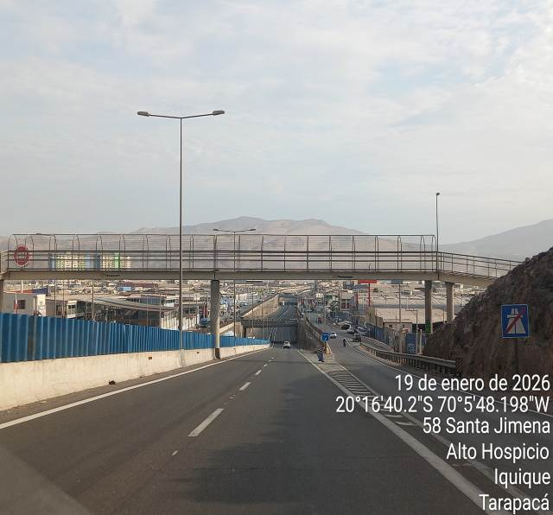
- Bridge (route 16). | - Footbridge (route 16).

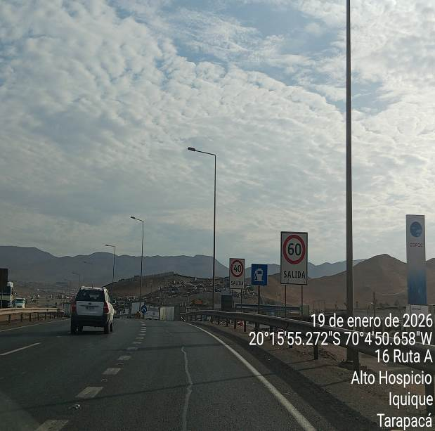 | 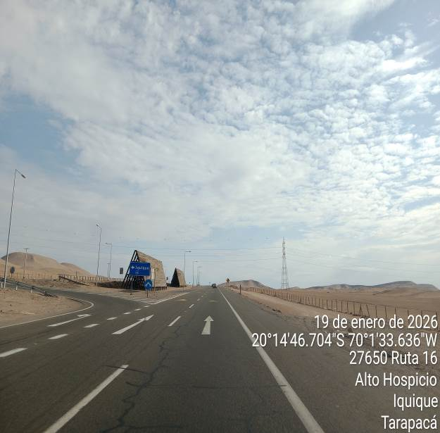
- Exit of Alto Hospicio  (bidirectional). | - Route 16, to tollbooth (bidirectional).

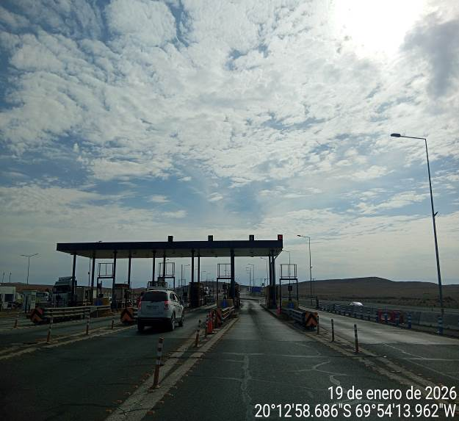 | 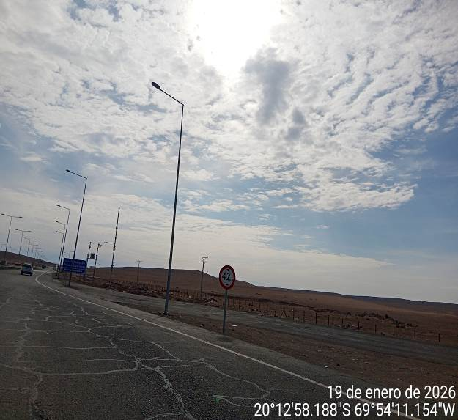
- Tollbooth. | - Rest zone (tollbooth).

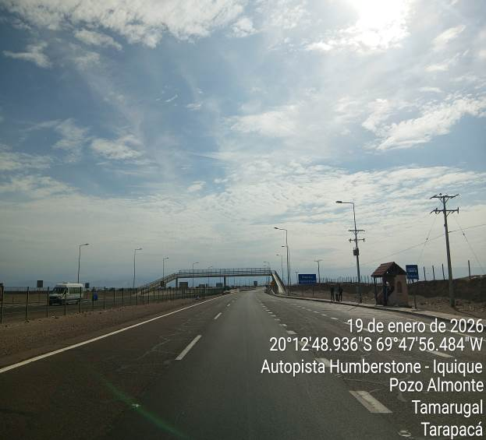 | 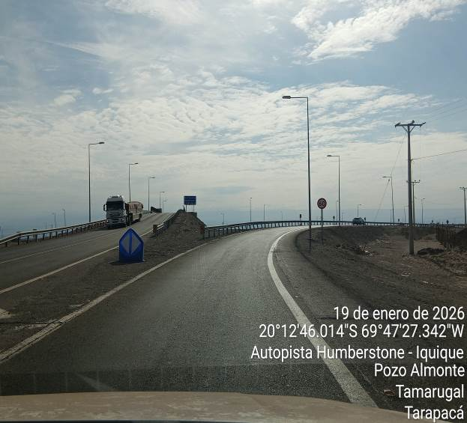
- Humberstone Footbridge. | - Detour to route 5 Norte.

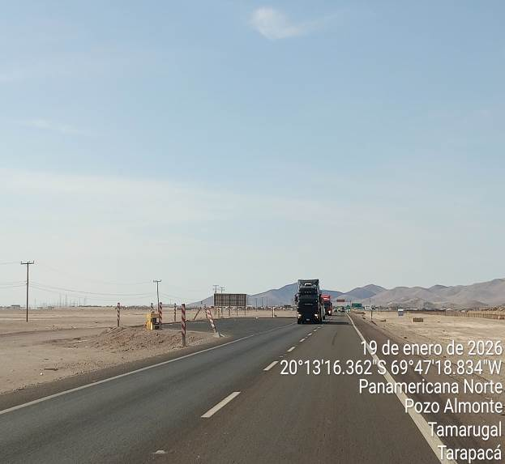
- Rest zone, Copec Pozo Almonte (working in route). | - Detour bypass Pozo Almonte, to route A65.

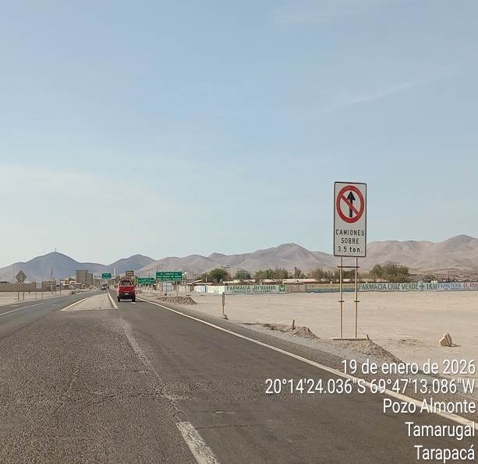 | 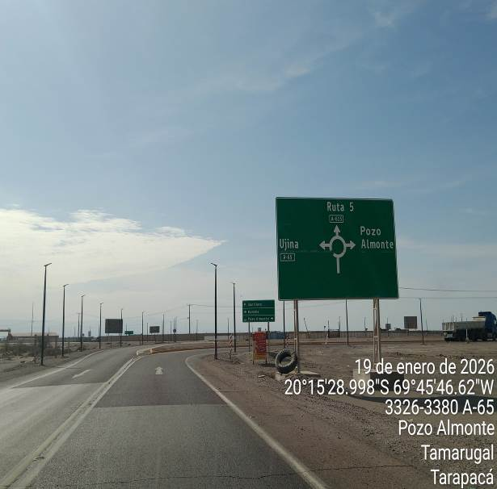
- Route A65. | - Route A65 bypass with route A653.

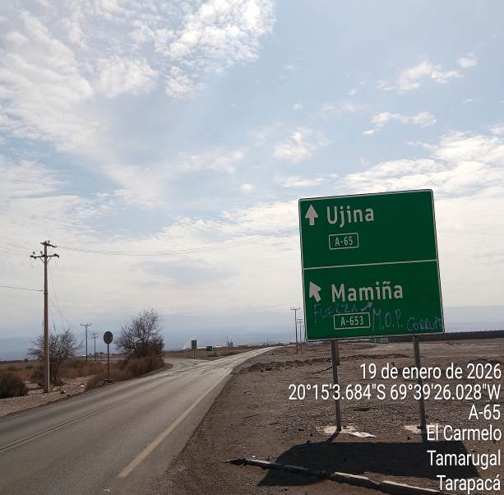 | 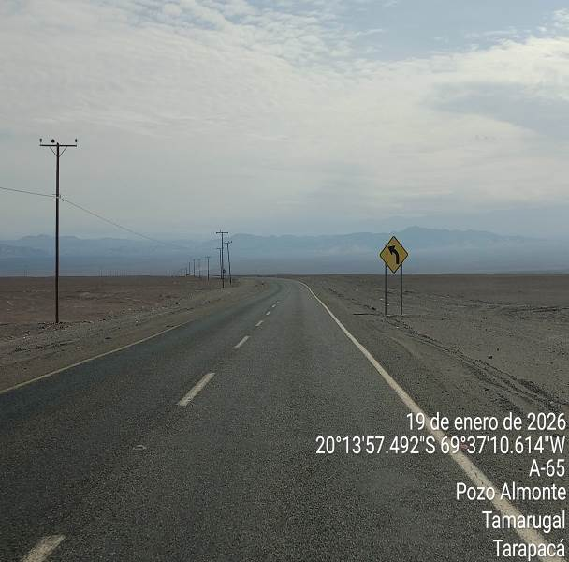
- Take route Mamiña (A653). | - Route A653 in good maintenance.

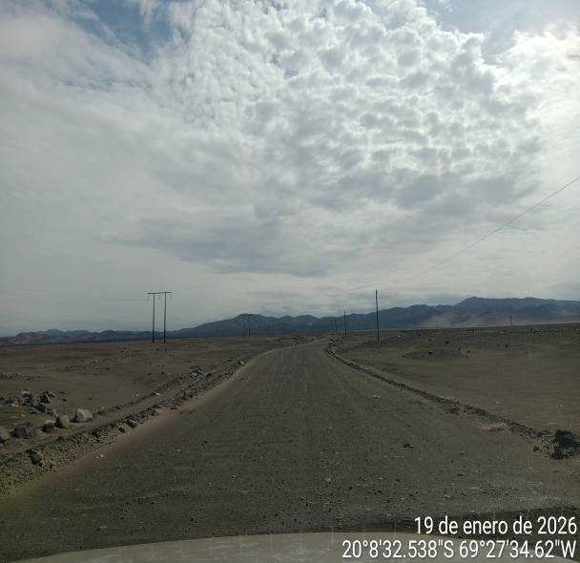 | 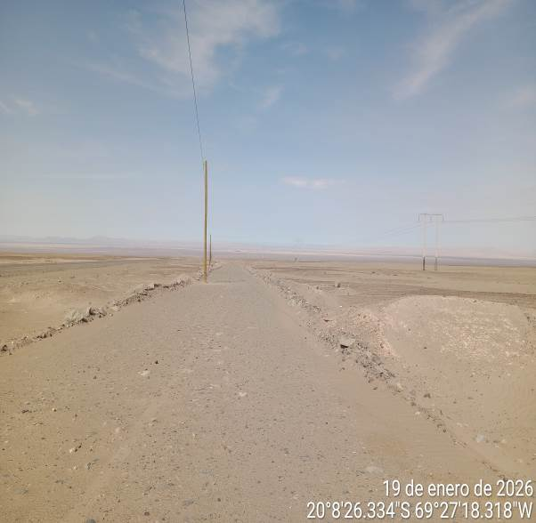
- Dirt road A-653, kilometer 15, by 2 kilometers. | - Dirt road turn to left kilometer 4 of route A-653.

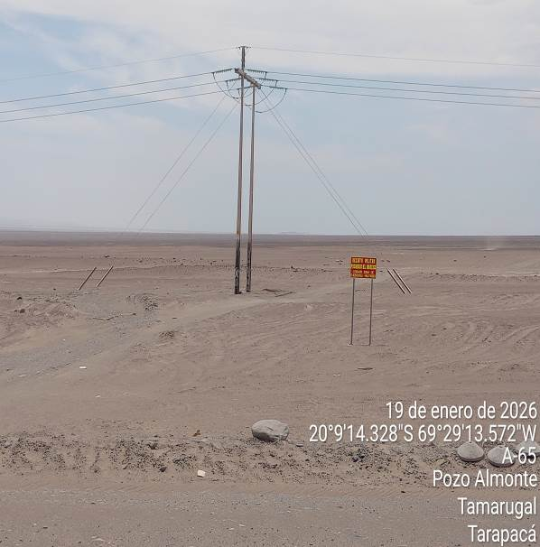 | 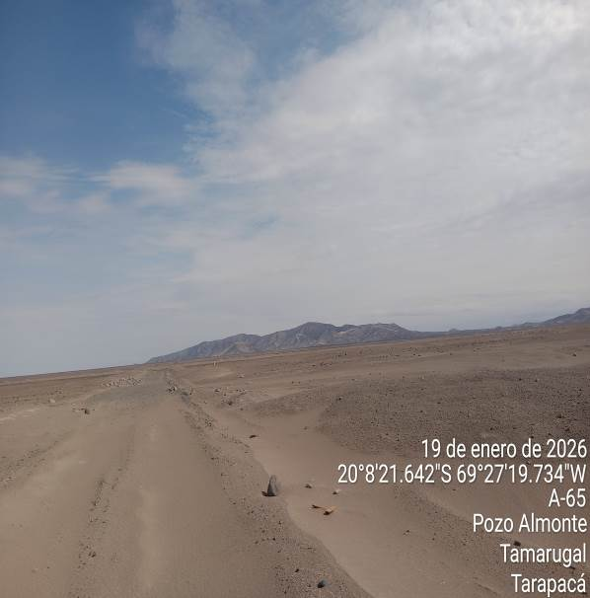
- Military complex, prohibited ingress. | - Road, not enabled for transport access.

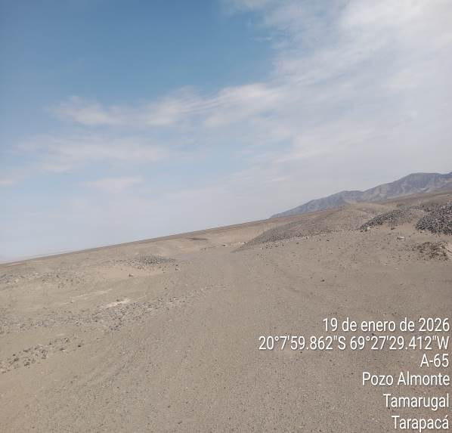 | 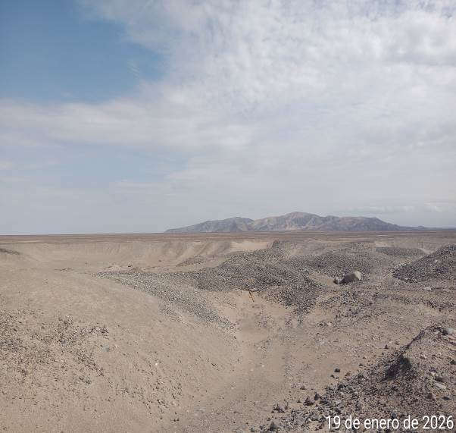
- Road, not enabled for transport access. | - Final route study, without access to place.

- 6.- CONCLUSIONS AND RECOMMENDATIONS:

Based on the route analysis carried out, ALS recommends the route from Iquique Port to Photovoltaic Park Project, considering the sections Route A16 / 5 Norte / A65/ and route A 653, for the following:

- The route from Iquique Port Photovoltaic Park Project covers a total of 98 km of travel: being the only direct route to reach the destination.

- Iquique Port gives a connection to the urban sector of Iquique city, through Arturo Prat Avenue, so transportation must cross the city to connect with the specified routes.

- Since there are no traffic zones on Route 16 up to Alto Hospicio, it is recommended that the departure on Route 16 to destination begins at night.

- Upon arriving in Pozo Almonte, a detour should be taken because trucks over 3.5 tons cannot enter the urban area.

- Regarding the characteristics of the main route from Iquique to the Project, 90% of the route is asphalted and/or paved, the 95% is properly signaled and 10% of the route has U-turns or dangerous curves; with these percentages, we may say that this is a route with positive characteristics for the transportation of regular and oversized cargo.

- It has 1 rest area and 5 park areas along the route.

• On route A-653, no detours, paths and or roads were found to reach the project, according to coordinates (20°06'16.9"S 69°29'02.8"W), so the route study had to stop in front of the road that led us horizontally to the place.

• The 2 routes and/or roads, properly signposted and where vehicles can travel, corresponded to military premises, where access is prohibited.

If cargo is oversized, the following must be considered:
- In general, the route 5 Norte does not present complications for transport, taking into consideration the observations that “MOP” could have upon processing the road permits.

- It should be coordinated with the concessionary company of route 16 Humberstone/Iquique, the transportation of the oversized cargo, so that, in case of works on the route, they could coordinate properly. The transportation from Iquique Port to the destination is feasible, considering the adjustments proposed in this report and in accordance with the configuration of the cargo considered for transport.

