INSPECTION CERTIFICATE
(FCL)

Shipper : IANSAGRO S.A.
Product description : OF CHILEAN DRIED SUGAR BEET PULP PELLETS (BPP) IN BIG BAGS OF 1.1 MT, ON PALLETS.
Tonnage : 104,50 M/T.
Port of discharge : OAKLAND-USA
Port of Loading : PORT SAN VICENTE, SVTI, CHILE.
Date of Stuffing : MARCH 20, 2026.
Vessel : HOOGE V.613N
Place of Stuffing : IANSA PLANT IN CHILLAN, CHILE.
Quantity of Containers : 05 CONTAINERS.
Supervisor : RODRIGO HERNÁNDEZ.
Surveyor : RODRIGO HERNÁNDEZ
Bill of lading : HLCUSCLQC04649AA
BL date : MARCH 30, 2026
1. Generalities:

Product was found stockpiled at Iansa Plant, located at Chillan, Chile. Cargo was stored in maxi bags to be stuffed into containers.

Stuffing Start : On March 20, 2026, at 09:00 Hrs.
Stuffing Term : On March 20, 2026, at 15:00 Hrs.

2. Product Inspection:

Cargo visual inspection and warehouse supervision were carried out prior to commence stuffing operation into container, cargo was noted clean and free of contaminants of any kind.

3. Stuffing of product:

Stuffing Operation was carried out in the PACKING warehouse at the location designated place for the activity.
Cargo loading and stuffing into container was carried out assisted by an equipment previously inspected to rule out dirt, humidity, or leaks of any kind.

Visual inspection of the containers was carried out to check their cleanliness and physical condition, where no observations were recorded.

After weighing each container in the shore scale, each one was sealed, installing the seal assigned by carrier and the ALS seal on the door.

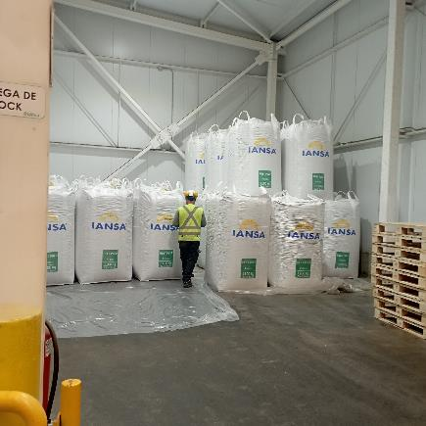 | 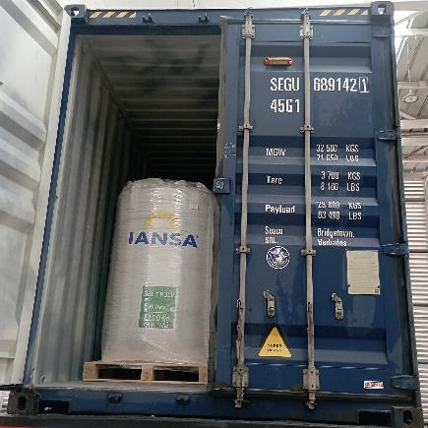
- View of product stored in the warehouse. | - View of cargo stuffed into container.

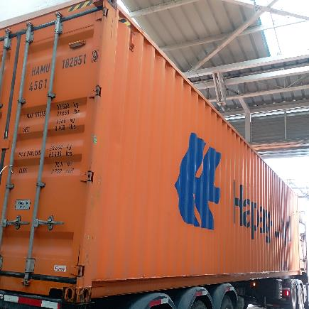 | 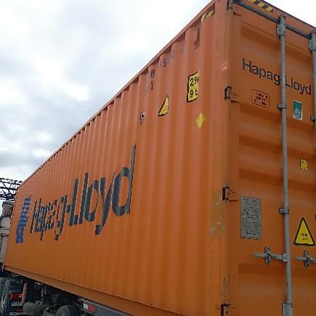
- View container lateral side, in inspection process. | - Another view lateral panel in inspection process.
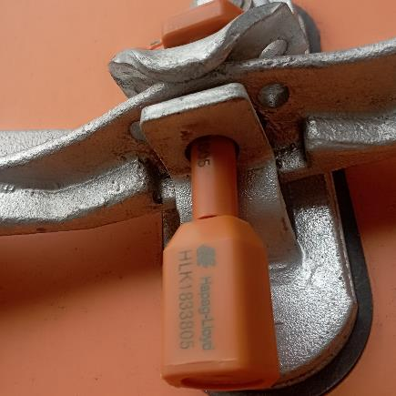 | 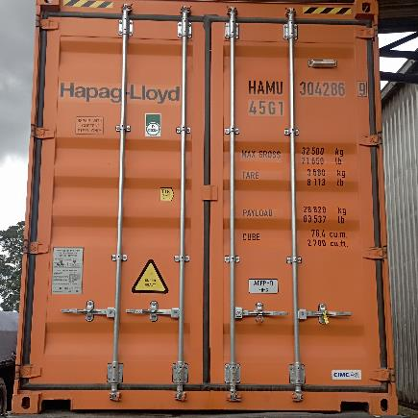
5. View Carrier seal Nr. HLK1833805 on container. | 6. General view of sealed container.

4. Product Weighing:

To weigh the cargo, the container loaded on the truck was weighed at the shore scale property of Iansa S.A (located in Iansa S. A facilities). The net weight of the cargo was calculated by weighing difference.
Shore Scale calibration date is reviewed, which data from April 09, 2025, carried out by company CESMEC S.A.

  - Weighing details:

N° | CONTAINER | GROSS WEIGHT KG | TARE KG | NET WEIGHT KG | TARE FCL KG
1 | SEGU 689142-1 | 39.680 | 18.410 | 20.900 | 3.700
2 | HAMU 182851-9 | 40.170 | 18.890 | 20.900 | 3.700
3 | FANU 155062-5 | 40.460 | 19.210 | 20.900 | 3.680
4 | FANU 321588-4 | 39.970 | 18.740 | 20.900 | 3.750
5 | HAMU 304286-9 | 39.390 | 18.120 | 20.900 | 3.680
 |  | GRAND | TOTAL | 104.500

5. Container sealing details:

N° | CONTAINER | SHIPPING LINE SEAL | ALS SEAL
1 | SEGU 689142-1 | HLK1833782 | 80161
2 | HAMU 182851-9 | HLK1833808 | 80162
3 | FANU 155062-5 | HLK1833807 | 80163
4 | FANU 321588-4 | HLK1833837 | 80164
5 | HAMU 304286-9 | HLK1833805 | 80165

6. Observations:

- - Containers shipped to PORT SAN VICENTE, SVTI, CHILE., on March 20, 2026.
- - Containers shipped on board the M/V HOOGE V.613N
- -Last destination to OAKLAND-USA
- - During stuffing operation, a composite sample is extracted from the shipped batch for analysis.
- - The weather was optimal for carrying out the stuffing operation.

7. Present Persons:

Name | Company | On Behalf of
Sr. Camilo Parra | IANSAGRO S. A | IANSAGRO S. A
Sr. Rodrigo Hernandez | ALS INSPECTION CHILE SPA | IANSAGRO S. A

This survey was carried out without prejudice and in the interest of whom it may concern.

Surveyor
ALS Inspection Chile SpA.

Prepared by : Rodrigo Hernández.
Reviewed by : Héctor Campos.
Validated by : Jaime López.

