FINAL REPORT

SURVEY | MOORING ROPES INSPECTION
TO | GUAYACAN TERMINAL
FROM | ALS INSPECTION CHILE SPA.
CLIENT REF | N/A
ALS REF | VAP-2601-0183
SCOPE OF SURVEY | INSPECTION OF 18 MOORING LINES.
VESSEL NAME | NORD AURUM
OWNER | NORDEN ASSET MANAGEMENT A/S
DISPONENT OWNER | CLASSIC MARITIME
CHARTERERS | CMP
PLACE OF SURVEY | COQUIMBO BAY
DATE OF SURVEY | JANUARY 15, 2026
TIME OF SURVEY | FROM 08:25 HRS TO 15:30 HRS

SUMMARY
From a total of 18 mooring lines inspected:

- All of them COMPLY with the length and visual condition for use.

Definitions:

Good : Unimpaired condition without significant wear or deviation from original strength and operating efficiency.
Fair : Condition in which wear and tear and other deficiencies of minor nature not requiring correction or repair.
Poor : Condition in which the adequacy of strength and/or operational efficiency is marginally below acceptable limits or is in doubt.

1.- SURVEY FINDINGS

1.1.- CHECK LIST OF MOORING ROPE N° 1

ALS REFERENCE | VAP-2601-0183 |  | Date/Time | 15/01/2026
CLIENT | ULTRAMAR
VESSEL/PLACE | NORD AURUM / COQUIMBO, CHILE.
MOORING ROPE NOMINAL LENGHT | 220 METERS | SEAL APPLIED |  |  | 0000002

According OCIMF standard, letter D.2 / Cordage Institute DIRSOMAR-PROINSP/200/011/2016

DAMAGE  ITEM | GOOD | FAIR | POOR
Ext. Abrasion (max 25%) |  |  | Over 25%
Int. Abrasion
Cut strands
Burn/ heated parts / fusion
Sun degradation /discoloration
Fiber broken
Black stains / dirty
Inconsistent diameter
Inconsistent flexibility
Number of splices | (0) | (1- 2) | Discard 3

Length measured by surveyor: 227.7 meters.

Remarks: N/A

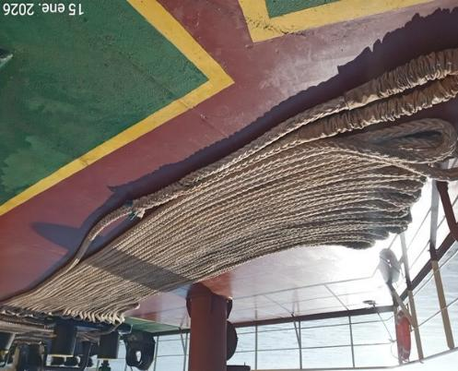 | 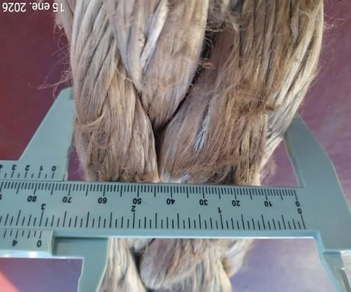
- General view of rope. | - Diameter of Rope.
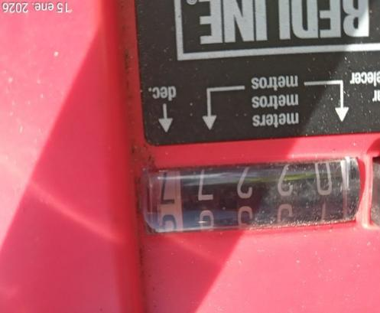 | 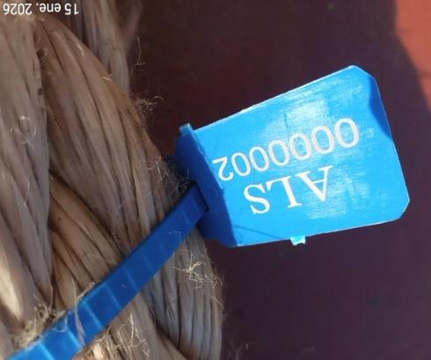
- Measure of Rope, 227.7 meters. | - Seal Nr. 0000002

1.2.- CHECK LIST OF MOORING ROPE N° 2

ALS REFERENCE | VAP-2601-1083 |  | Date/Time | 15/01/2026
CLIENT | ULTRAMAR
VESSEL/PLACE | NORD AURUM / COQUIMBO, CHILE
MOORING ROPE NOMINAL LENGHT | 220 METERS | SEAL APPLIED |  |  | 0000003

According OCIMF standard, letter D.2 / Cordage Institute DIRSOMAR-PROINSP/200/011/2016

DAMAGE  ITEM | GOOD | FAIR | POOR
Ext. Abrasion (max 25%) |  |  | Over 25%
Int. Abrasion
Cut strands
Burn/ heated parts / fusion
Sun degradation /discoloration
Fiber broken
Black stains / dirty
Inconsistent diameter
Inconsistent flexibility
Number of splices | (0) | (1- 2) | Discard 3

Length measured by surveyor: 220.2 meters.

Remarks: N/A

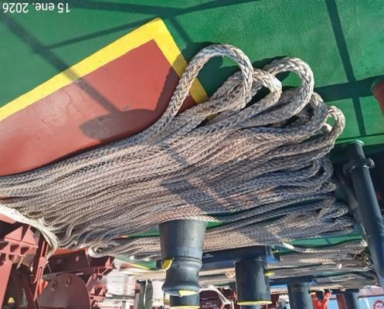 | 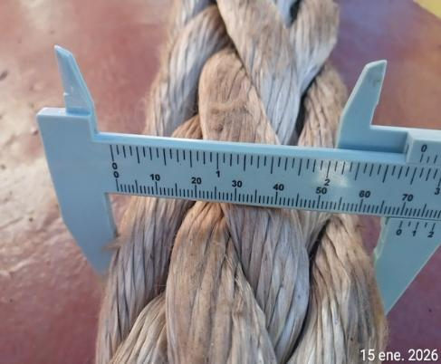
- General view of rope. | - Diameter of Rope.
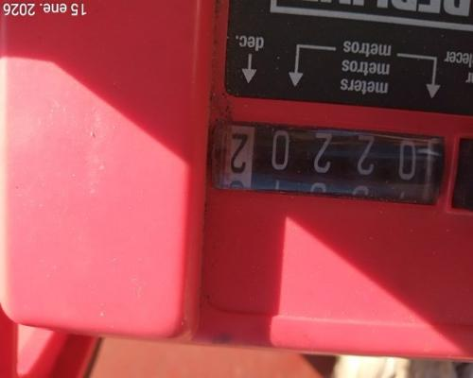 | 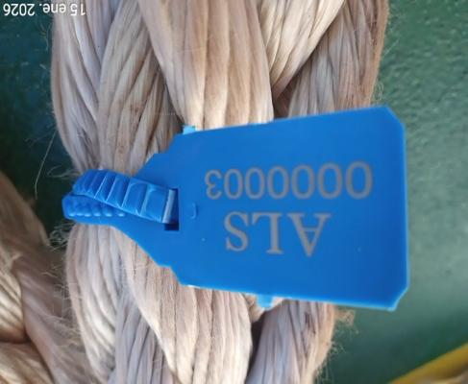
- Measure of Rope, 220.2 meters. | - Seal N° 0000003

1.3.- CHECK LIST OF MOORING ROPE N° 3

ALS REFERENCE | VAP-2601-0183 |  | Date/Time | 15/01/2026
CLIENT | ULTRAMAR
VESSEL/PLACE | NORD AURUM / COQUIMBO, CHILE.
MOORING ROPE NOMINAL LENGHT | 220 METERS | SEAL APPLIED |  |  | 0000004

According OCIMF standard, letter D.2 / Cordage Institute DIRSOMAR-PROINSP/200/011/2016

DAMAGE  ITEM | GOOD | FAIR | POOR
Ext. Abrasion (max 25%) |  |  | Over 25%
Int. Abrasion
Cut strands
Burn/ heated parts / fusion
Sun degradation /discoloration
Fiber broken
Black stains / dirty
Inconsistent diameter
Inconsistent flexibility
Number of splices | (0) | (1- 2) | Discard 3

Length measured by surveyor: 229.8 meters.

Remarks: N/A

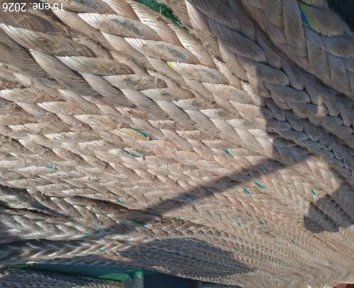 | 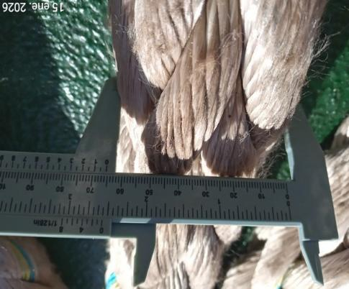
- General view of rope. | - Diameter of Rope
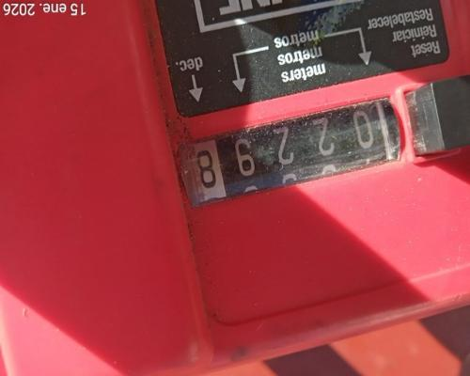 | 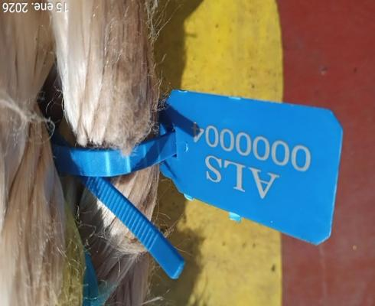
- Measure of Rope, 229.8 meters. | - Seal N° 0000004

1.4.- CHECK LIST OF MOORING ROPE N° 4

ALS REFERENCE | VAP-2601-0183 |  | Date/Time | 15/01/2026
CLIENT | ULTRAMAR
VESSEL/PLACE | NORD AURUM / COQUIMBO, CHILE.
MOORING ROPE NOMINAL LENGHT | 220 METERS | SEAL APPLIED |  |  | 0000005

According OCIMF standard, letter D.2 / Cordage Institute DIRSOMAR-PROINSP/200/011/2016

DAMAGE  ITEM | GOOD | FAIR | POOR
Ext. Abrasion (max 25%) |  |  | Over 25%
Int. Abrasion
Cut strands
Burn/ heated parts / fusion
Sun degradation /discoloration
Fiber broken
Black stains / dirty
Inconsistent diameter
Inconsistent flexibility
Number of splices | (0) | (1- 2) | Discard 3

Length measured by surveyor: 227.0 meters.

Remarks: N/A

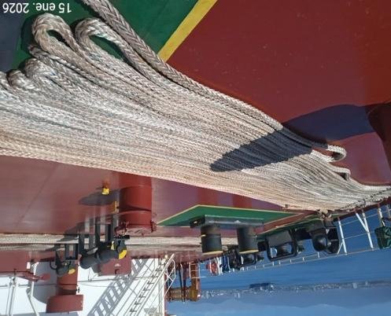 | 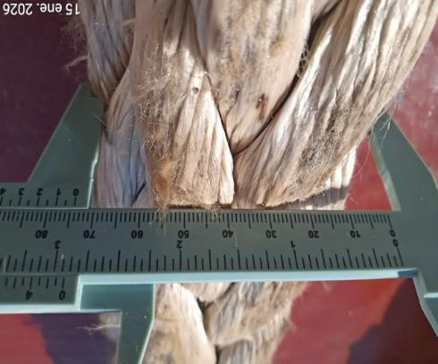
- General view of rope. | - Diameter of Rope
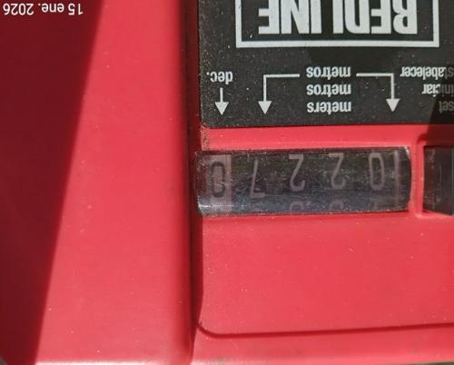 | 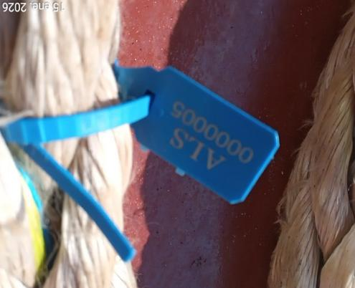
- Measure of Rope, 227.0 meters. | - Seal N° 0000005

1.5.- CHECK LIST OF MOORING ROPE N° 5

ALS REFERENCE | VAP-2601-0183 |  | Date/Time | 15/01/2026
CLIENT | ULTRAMAR
VESSEL/PLACE | NORD AURUM / COQUIMBO, CHILE.
MOORING ROPE NOMINAL LENGHT | 220 METERS | SEAL APPLIED |  |  | 0000006

According OCIMF standard, letter D.2 / Cordage Institute DIRSOMAR-PROINSP/200/011/2016

DAMAGE  ITEM | GOOD | FAIR | POOR
Ext. Abrasion (max 25%) |  |  | Over 25%
Int. Abrasion
Cut strands
Burn/ heated parts / fusion
Sun degradation /discoloration
Fiber broken
Black stains / dirty
Inconsistent diameter
Inconsistent flexibility
Number of splices | (0) | (1- 2) | Discard 3

Length measured by surveyor: 228.5 meters.

Remarks: N/A

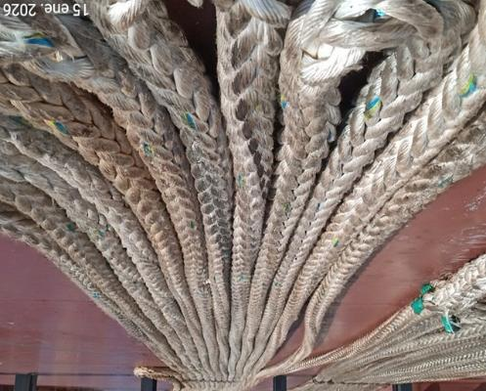 | 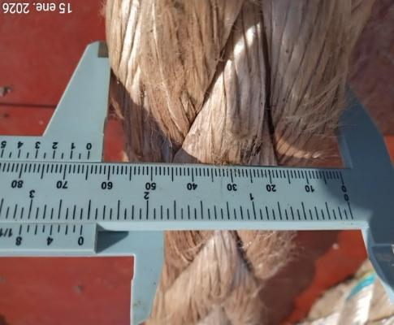
- General view of rope. | - Diameter of Rope
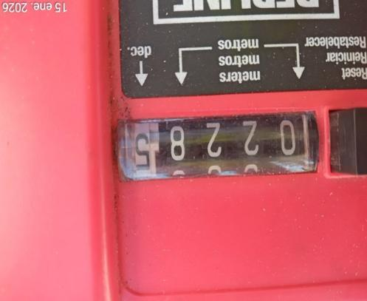 | 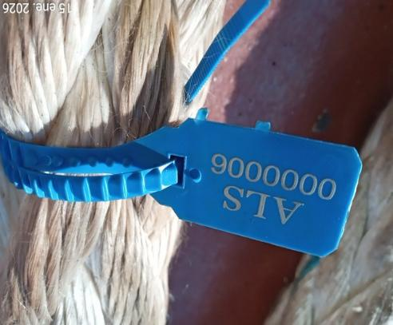
- Measure of Rope, 228.5 meters. | - Seal N° 0000006

1.6.- CHECK LIST OF MOORING ROPE N° 6

ALS REFERENCE | VAP-2601-0183 |  | Date/Time | 15/01/2026
CLIENT | ULTRAMAR
VESSEL/PLACE | NORD AURUM / COQUIMBO, CHILE.
MOORING ROPE NOMINAL LENGHT | 220 METERS | SEAL APPLIED |  |  | 0000007

According OCIMF standard, letter D.2 / Cordage Institute DIRSOMAR-PROINSP/200/011/2016

DAMAGE  ITEM | GOOD | FAIR | POOR
Ext. Abrasion (max 25%) |  |  | Over 25%
Int. Abrasion
Cut strands
Burn/ heated parts / fusion
Sun degradation /discoloration
Fiber broken
Black stains / dirty
Inconsistent diameter
Inconsistent flexibility
Number of splices | (0) | (1- 2) | Discard 3

Length measured by surveyor: 236.7 meters.

Remarks: N/A

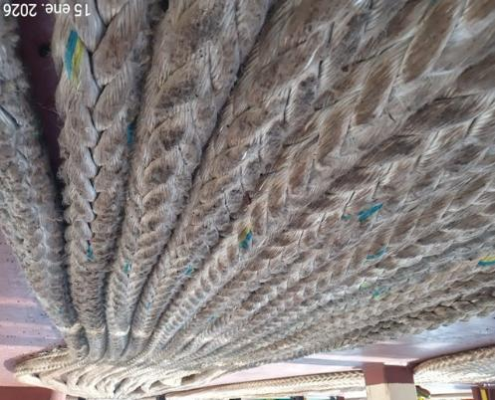 | 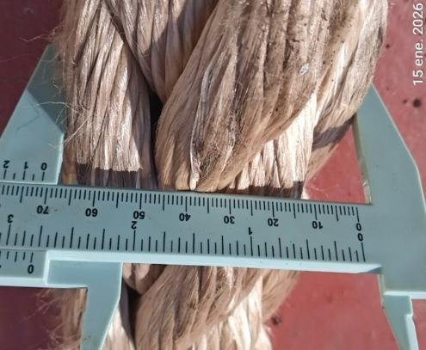
- General view of rope. | - Diameter of Rope
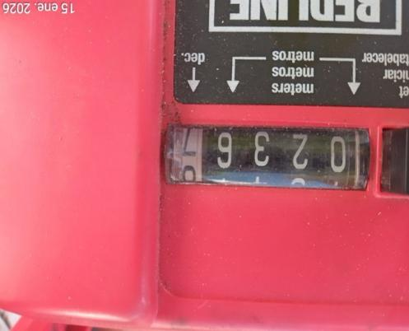 | 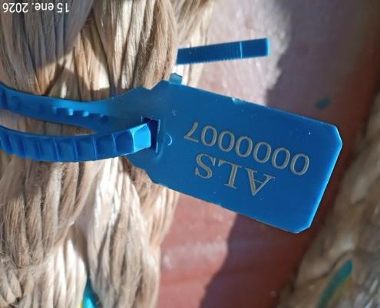
- Measure of Rope, 236.7 meters. | - Seal N° 0000007

1.7.- CHECK LIST OF MOORING ROPE N° 7

ALS REFERENCE | VAP-2601-0183 |  | Date/Time | 15/01/2026
CLIENT | ULTRAMAR
VESSEL/PLACE | NORD AURUM / COQUIMBO, CHILE.
MOORING ROPE NOMINAL LENGHT | 220 METERS | SEAL APPLIED |  |  | 0000008

According OCIMF standard, letter D.2 / Cordage Institute DIRSOMAR-PROINSP/200/011/2016

DAMAGE  ITEM | GOOD | FAIR | POOR
Ext. Abrasion (max 25%) |  |  | Over 25%
Int. Abrasion
Cut strands
Burn/ heated parts / fusion
Sun degradation /discoloration
Fiber broken
Black stains / dirty
Inconsistent diameter
Inconsistent flexibility
Number of splices | (0) | (1- 2) | Discard 3

Length measured by surveyor: 220.1 meters.

Remarks: N/A

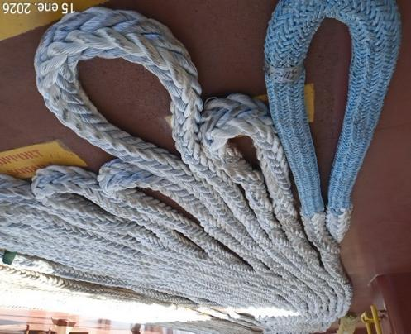 | 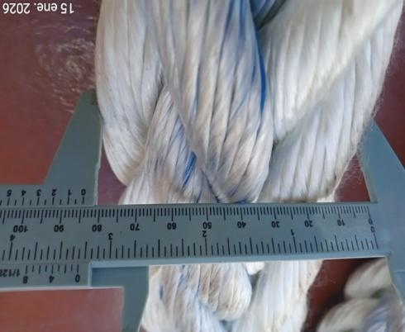
- General view of rope. | - Diameter of Rope
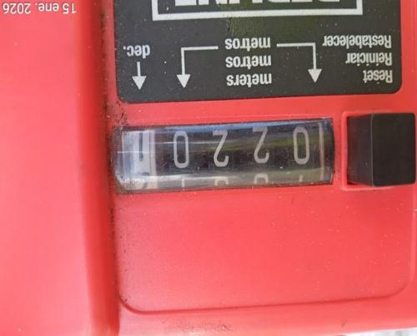 | 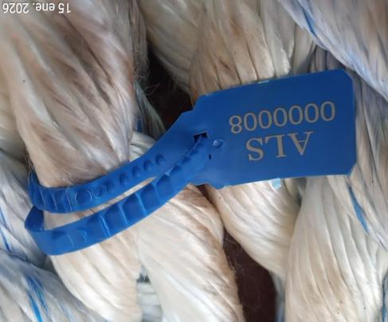
- Measure of Rope, 220.1 meters. | - Seal N° 0000008

1.8.- CHECK LIST OF MOORING ROPE N° 8

ALS REFERENCE | VAP-2601-0183 |  | Date/Time | 15/01/2026
CLIENT | ULTRAMAR
VESSEL/PLACE | NORD AURUM / COQUIMBO, CHILE.
MOORING ROPE NOMINAL LENGHT | 220 METERS | SEAL APPLIED |  |  | 0000009

According OCIMF standard, letter D.2 / Cordage Institute DIRSOMAR-PROINSP/200/011/2016

DAMAGE  ITEM | GOOD | FAIR | POOR
Ext. Abrasion (max 25%) |  |  | Over 25%
Int. Abrasion
Cut strands
Burn/ heated parts / fusion
Sun degradation /discoloration
Fiber broken
Black stains / dirty
Inconsistent diameter
Inconsistent flexibility
Number of splices | (0) | (1- 2) | Discard 3

Length measured by surveyor: 220.2 meters.

Remarks: N/A

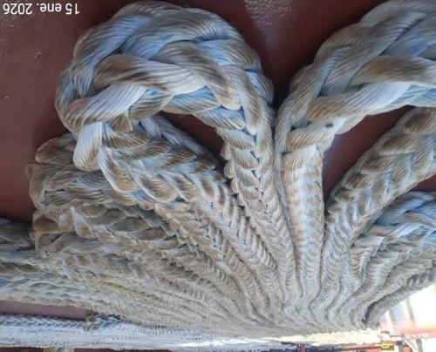 | 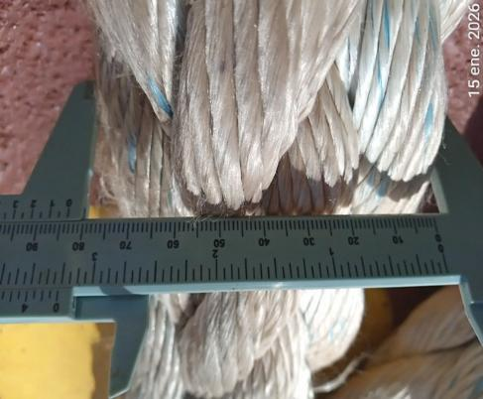
- General view of rope. | - Diameter of Rope
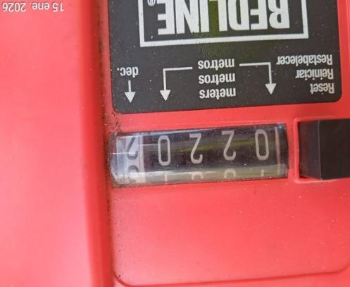 | 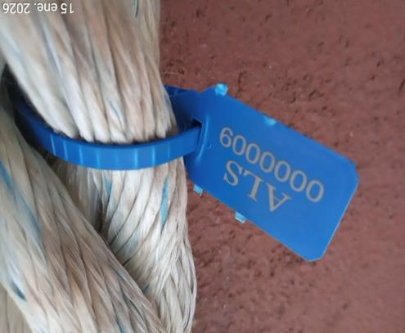
- Measure of Rope, 220.2 meters. | - Seal N° 0000009

1.9.- CHECK LIST OF MOORING ROPE N° 9

ALS REFERENCE | VAP-2601-0183 |  | Date/Time | 15/01/2026
CLIENT | ULTRAMAR
VESSEL/PLACE | NORD AURUM / COQUIMBO, CHILE.
MOORING ROPE NOMINAL LENGHT | 220 METERS | SEAL APPLIED |  |  | 0000010

According OCIMF standard, letter D.2 / Cordage Institute DIRSOMAR-PROINSP/200/011/2016

DAMAGE  ITEM | GOOD | FAIR | POOR
Ext. Abrasion (max 25%) |  |  | Over 25%
Int. Abrasion
Cut strands
Burn/ heated parts / fusion
Sun degradation /discoloration
Fiber broken
Black stains / dirty
Inconsistent diameter
Inconsistent flexibility
Number of splices | (0) | (1- 2) | Discard 3

Length measured by surveyor: 220.1 meters.

Remarks: N/A

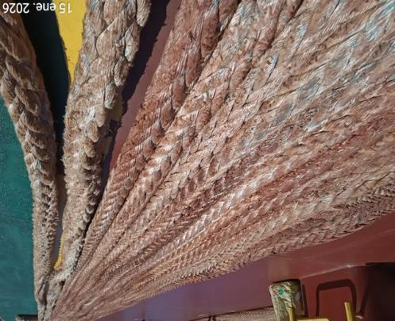 | 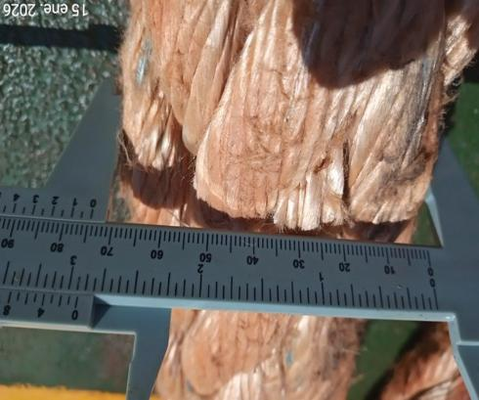
- General view of rope. | - Diameter of Rope
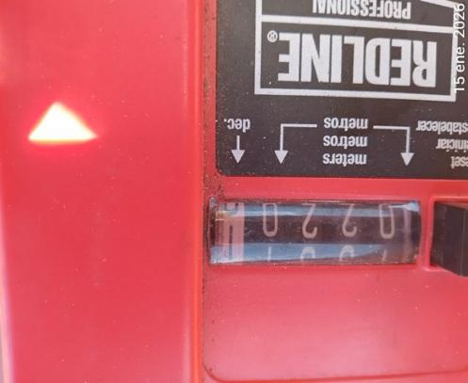 | 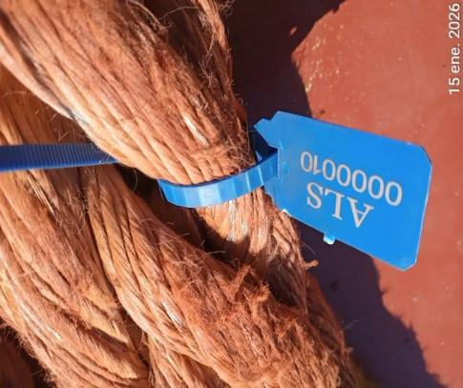
- Measure of Rope, 220.1 meters. | - Seal N° 0000010

1.10.- CHECK LIST OF MOORING ROPE N° 10

ALS REFERENCE | VAP-2601-0183 |  | Date/Time | 15/01/2026
CLIENT | ULTRAMAR
VESSEL/PLACE | NORD AURUM / COQUIMBO, CHILE.
MOORING ROPE NOMINAL LENGHT | 220 METERS | SEAL APPLIED |  |  | 0000806

According OCIMF standard, letter D.2 / Cordage Institute DIRSOMAR-PROINSP/200/011/2016

DAMAGE  ITEM | GOOD | FAIR | POOR
Ext. Abrasion (max 25%) |  |  | Over 25%
Int. Abrasion
Cut strands
Burn/ heated parts / fusion
Sun degradation /discoloration
Fiber broken
Black stains / dirty
Inconsistent diameter
Inconsistent flexibility
Number of splices | (0) | (1- 2) | Discard 3

Length measured by surveyor: 220.6 meters.

Remarks: N/A

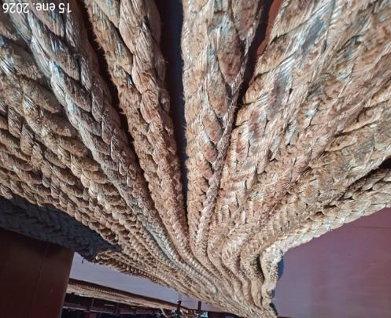 | 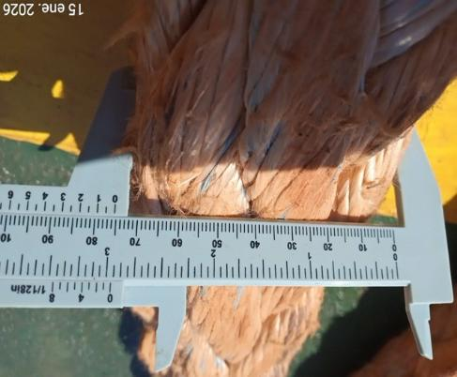
- General view of rope. | - Diameter of Rope
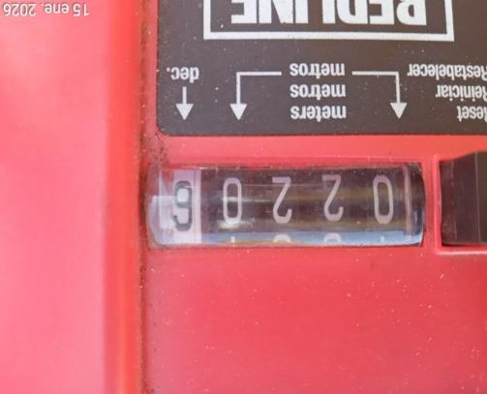 | 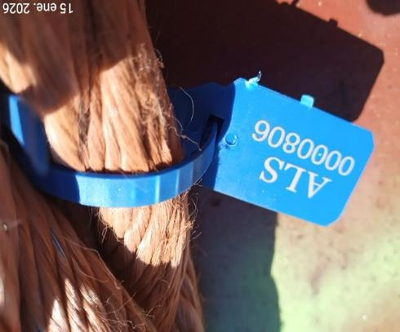
- Measure of Rope, 220.6 meters. | - Seal N° 0000806

1.11.- CHECK LIST OF MOORING ROPE N° 11

ALS REFERENCE | VAP-2601-0183 |  | Date/Time | 15/01/2026
CLIENT | ULTRAMAR
VESSEL/PLACE | NORD AURUM / COQUIMBO, CHILE.
MOORING ROPE NOMINAL LENGHT | 220 METERS | SEAL APPLIED |  |  | 0000807

According OCIMF standard, letter D.2 / Cordage Institute DIRSOMAR-PROINSP/200/011/2016

DAMAGE  ITEM | GOOD | FAIR | POOR
Ext. Abrasion (max 25%) |  |  | Over 25%
Int. Abrasion
Cut strands
Burn/ heated parts / fusion
Sun degradation /discoloration
Fiber broken
Black stains / dirty
Inconsistent diameter
Inconsistent flexibility
Number of splices | (0) | (1- 2) | Discard 3

Length measured by surveyor: 221.1 meters.

Remarks: N/A

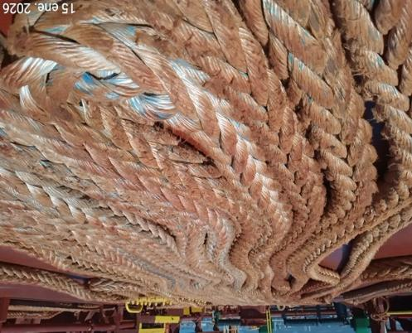 | 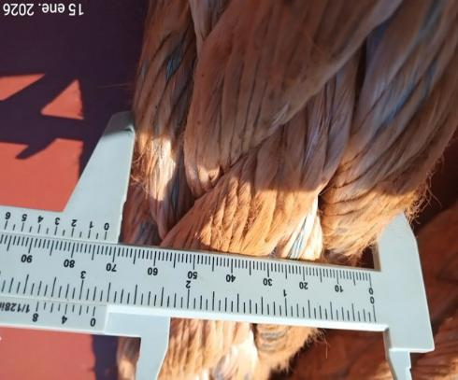
- General view of rope. | - Diameter of Rope
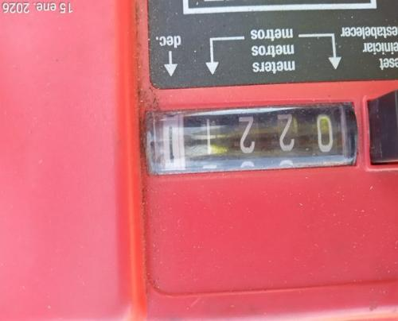 | 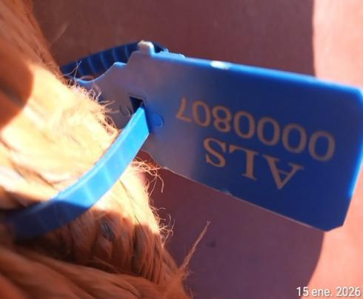
- Measure of Rope, 221.1 meters. | - Seal N° 0000807

1.12.- CHECK LIST OF MOORING ROPE N° 12

ALS REFERENCE | VAP-2601-0183 |  | Date/Time | 15/01/2026
CLIENT | ULTRAMAR
VESSEL/PLACE | NORD AURUM / COQUIMBO, CHILE.
MOORING ROPE NOMINAL LENGHT | 220 METERS | SEAL APPLIED |  |  | 0000808

According OCIMF standard, letter D.2 / Cordage Institute DIRSOMAR-PROINSP/200/011/2016

DAMAGE  ITEM | GOOD | FAIR | POOR
Ext. Abrasion (max 25%) |  |  | Over 25%
Int. Abrasion
Cut strands
Burn/ heated parts / fusion
Sun degradation /discoloration
Fiber broken
Black stains / dirty
Inconsistent diameter
Inconsistent flexibility
Number of splices | (0) | (1- 2) | Discard 3

Length measured by surveyor: 221.3 meters.

Remarks: N/A

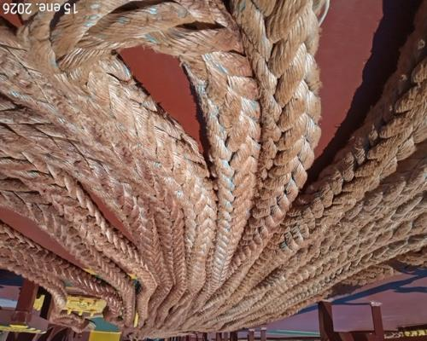 | 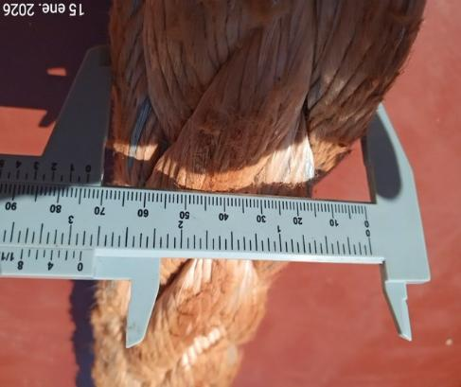
- General view of rope. | - Diameter of Rope
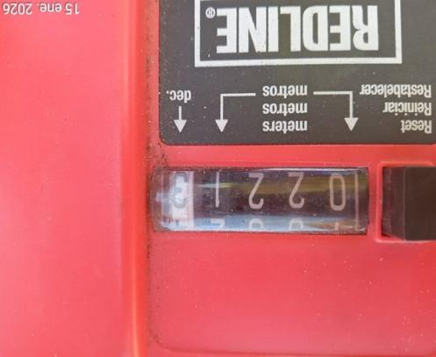 | 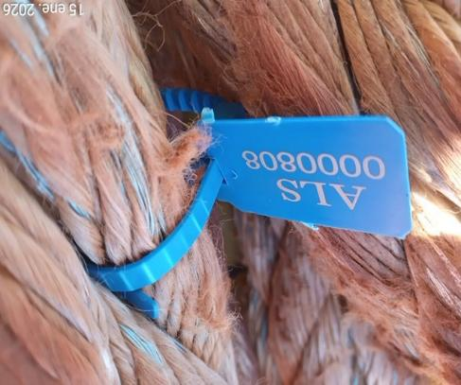
- Measure of Rope, 221.3 meters. | - Seal N° 0000808

1.13.- CHECK LIST OF MOORING ROPE N° 13

ALS REFERENCE | VAP-2601-0183 |  | Date/Time | 15/01/2026
CLIENT | ULTRAMAR
VESSEL/PLACE | NORD AURUM / COQUIMBO, CHILE.
MOORING ROPE NOMINAL LENGHT | 220 METERS | SEAL APPLIED |  |  | 0000809

According OCIMF standard, letter D.2 / Cordage Institute & DIRSOMAR-PROINSP/200/011/2016
DAMAGE  ITEM | GOOD | FAIR | POOR
Ext. Abrasion (max 25%) |  |  | Over 25%
Int. Abrasion
Cut strands
Burn/ heated parts / fusion
Sun degradation /discoloration
Fiber broken
Black stains / dirty
Inconsistent diameter
Inconsistent flexibility
Number of splices | (0) | (1- 2) | Discard 3

Length measured by surveyor: 221.2 meters.

Remarks: N/A

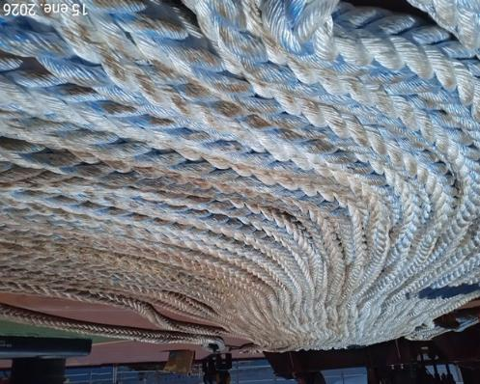 | 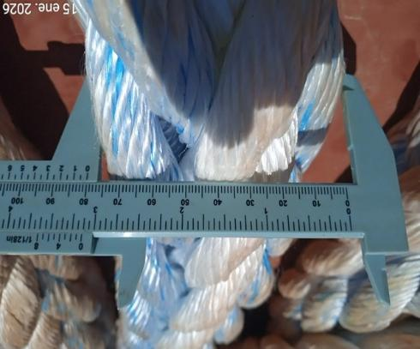
- General view of rope. | - Diameter of Rope
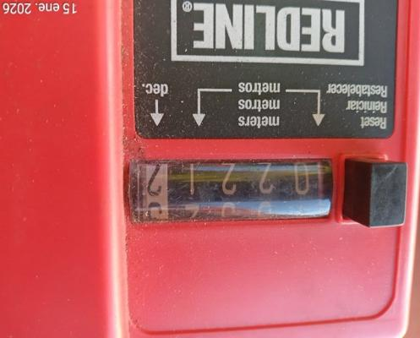 | 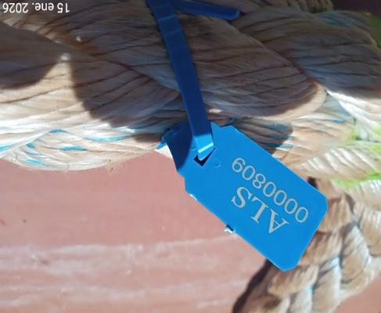
- Measure of Rope, 221.2 meters. | - Seal N° 0000809

1.14.- CHECK LIST OF MOORING ROPE N° 14

ALS REFERENCE | VAP-2601-0183 |  | Date/Time | 15/01/2026
CLIENT | ULTRAMAR
VESSEL/PLACE | NORD AURUM / COQUIMBO, CHILE.
MOORING ROPE NOMINAL LENGHT | 220 METERS | SEAL APPLIED |  |  | 0000810

According OCIMF standard, letter D.2 / Cordage Institute & DIRSOMAR-PROINSP/200/011/2016
DAMAGE  ITEM | GOOD | FAIR | POOR
Ext. Abrasion (max 25%) |  |  | Over 25%
Int. Abrasion
Cut strands
Burn/ heated parts / fusion
Sun degradation /discoloration
Fiber broken
Black stains / dirty
Inconsistent diameter
Inconsistent flexibility
Number of splices | (0) | (1- 2) | Discard 3

Length measured by surveyor: 221.4 meters.

Remarks: N/A

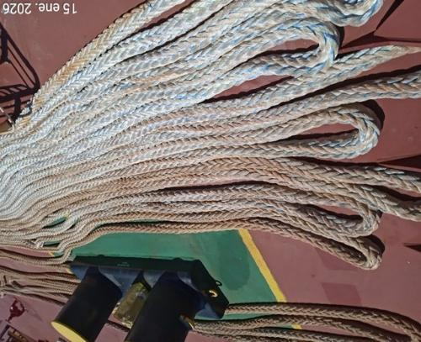 | 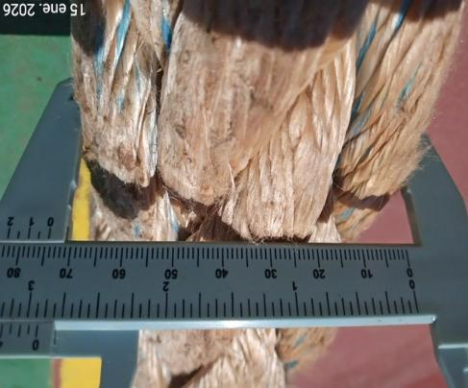
- General view of rope. | - Diameter of Rope
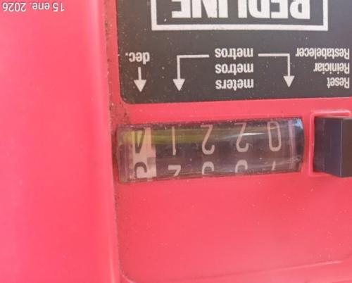 | 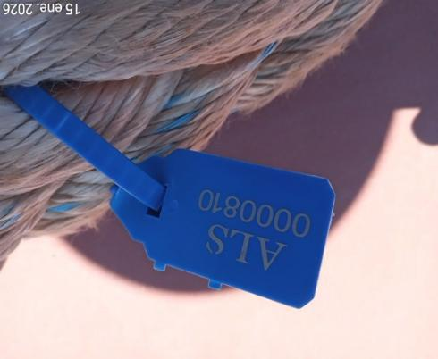
- Measure of Rope, 221.4 meters. | - Seal N° 0000810

1.15.- CHECK LIST OF MOORING ROPE N° 15

ALS REFERENCE | VAP-2601-0183 |  | Date/Time | 15/01/2026
CLIENT | ULTRAMAR
VESSEL/PLACE | NORD AURUM / COQUIMBO, CHILE.
MOORING ROPE NOMINAL LENGHT | 220 METERS | SEAL APPLIED |  |  | 0000801

According OCIMF standard, letter D.2 / Cordage Institute & DIRSOMAR-PROINSP/200/011/2016
DAMAGE  ITEM | GOOD | FAIR | POOR
Ext. Abrasion (max 25%) |  |  | Over 25%
Int. Abrasion
Cut strands
Burn/ heated parts / fusion
Sun degradation /discoloration
Fiber broken
Black stains / dirty
Inconsistent diameter
Inconsistent flexibility
Number of splices | (0) | (1- 2) | Discard 3

Length measured by surveyor: 222.8 meters.

Remarks: N/A

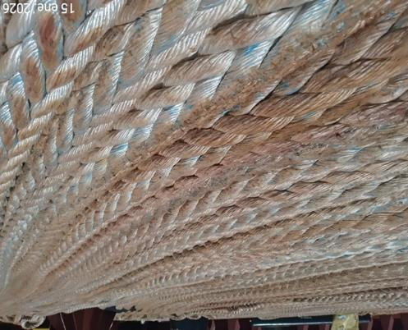 | 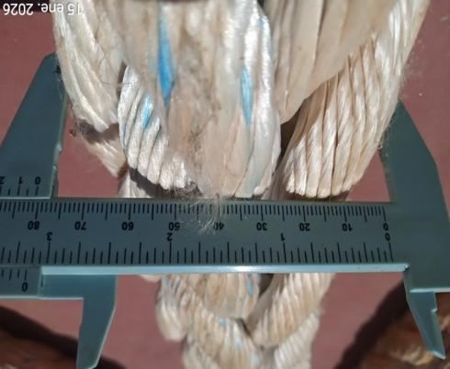
- General view of rope. | - Diameter of Rope
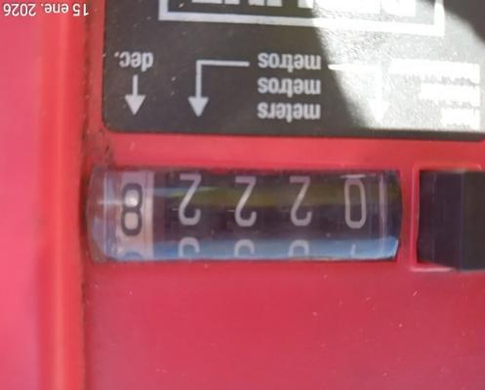 | 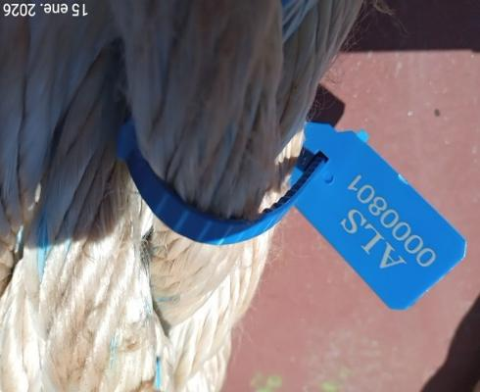
- Measure of Rope, 222.8 meters. | - Seal N° 0000801

1.16.- CHECK LIST OF MOORING ROPE N° 16

ALS REFERENCE | VAP-2601-0183 |  | Date/Time | 15/01/2026
CLIENT | ULTRAMAR
VESSEL/PLACE | NORD AURUM / COQUIMBO, CHILE.
MOORING ROPE NOMINAL LENGHT | 220 METERS | SEAL APPLIED |  |  | 0000802

According OCIMF standard, letter D.2 / Cordage Institute & DIRSOMAR-PROINSP/200/011/2016
DAMAGE  ITEM | GOOD | FAIR | POOR
Ext. Abrasion (max 25%) |  |  | Over 25%
Int. Abrasion
Cut strands
Burn/ heated parts / fusion
Sun degradation /discoloration
Fiber broken
Black stains / dirty
Inconsistent diameter
Inconsistent flexibility
Number of splices | (0) | (1- 2) | Discard 3

Length measured by surveyor: 223.1 meters.

Remarks: N/A

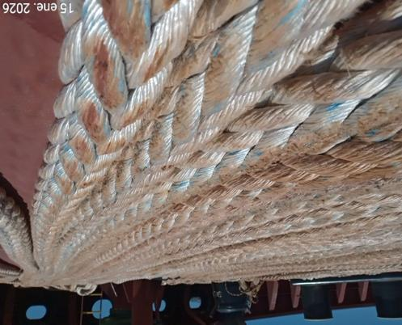 | 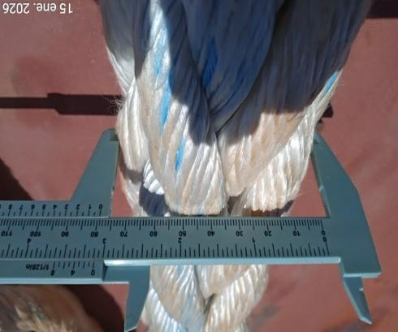
- General view of rope. | - Diameter of Rope
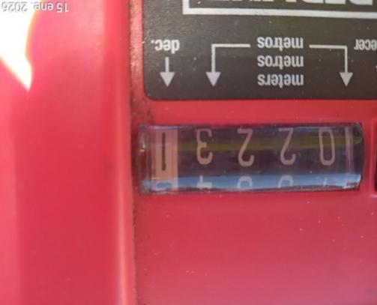 | 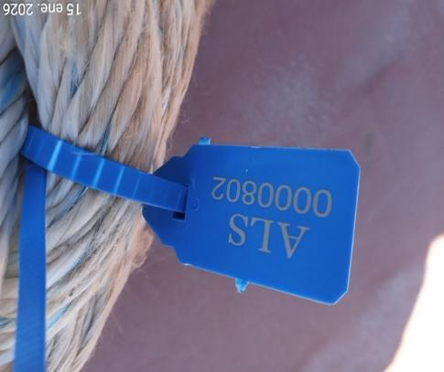
- Measure of Rope, 223.1 meters. | - Seal N° 0000802

1.17.- CHECK LIST OF MOORING ROPE N° 17

ALS REFERENCE | VAP-2601-0183 |  | Date/Time | 15/01/2026
CLIENT | ULTRAMAR
VESSEL/PLACE | NORD AURUM / COQUIMBO, CHILE.
MOORING ROPE NOMINAL LENGHT | 220 METERS | SEAL APPLIED |  |  | 0000803

According OCIMF standard, letter D.2 / Cordage Institute & DIRSOMAR-PROINSP/200/011/2016
DAMAGE  ITEM | GOOD | FAIR | POOR
Ext. Abrasion (max 25%) |  |  | Over 25%
Int. Abrasion
Cut strands
Burn/ heated parts / fusion
Sun degradation /discoloration
Fiber broken
Black stains / dirty
Inconsistent diameter
Inconsistent flexibility
Number of splices | (0) | (1- 2) | Discard 3

Length measured by surveyor: 221.4 meters.

Remarks: N/A

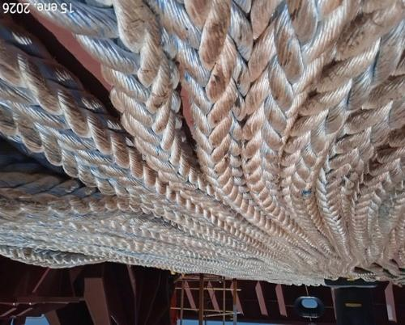 | 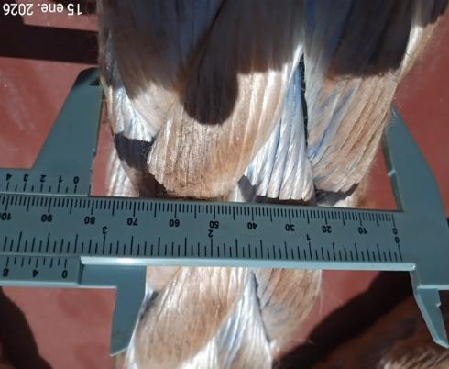
- General view of rope. | - Diameter of Rope
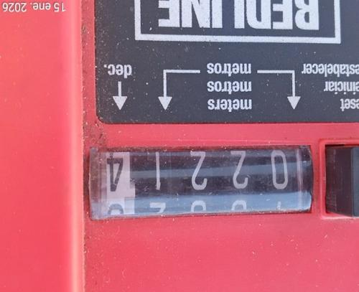 | 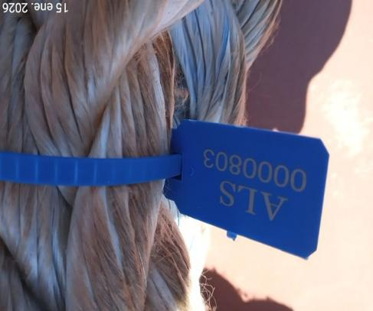
- Measure of Rope, 221.4 meters. | - Seal N° 0000803

1.18.- CHECK LIST OF MOORING ROPE N° 18

ALS REFERENCE | VAP-2601-0183 |  | Date/Time | 15/01/2026
CLIENT | ULTRAMAR
VESSEL/PLACE | NORD AURUM / COQUIMBO, CHILE.
MOORING ROPE NOMINAL LENGHT | 220 METERS | SEAL APPLIED |  |  | 0000804

According OCIMF standard, letter D.2 / Cordage Institute & DIRSOMAR-PROINSP/200/011/2016
DAMAGE  ITEM | GOOD | FAIR | POOR
Ext. Abrasion (max 25%) |  |  | Over 25%
Int. Abrasion
Cut strands
Burn/ heated parts / fusion
Sun degradation /discoloration
Fiber broken
Black stains / dirty
Inconsistent diameter
Inconsistent flexibility
Number of splices | (0) | (1- 2) | Discard 3

Length measured by surveyor: 223.0 meters.

Remarks: N/A

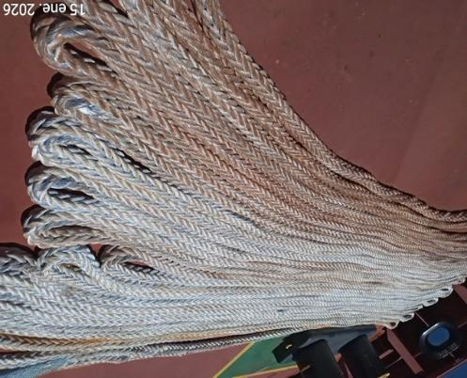 | 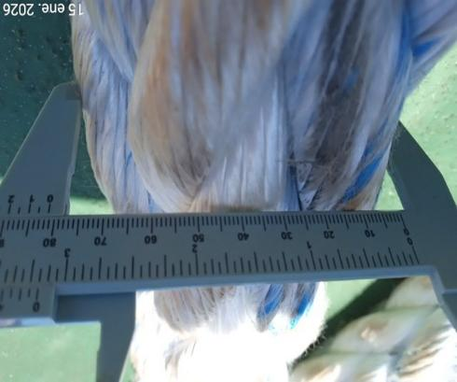
- General view of rope. | - Diameter of Rope
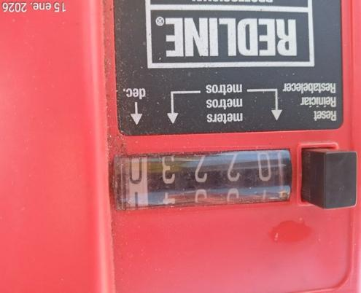 | 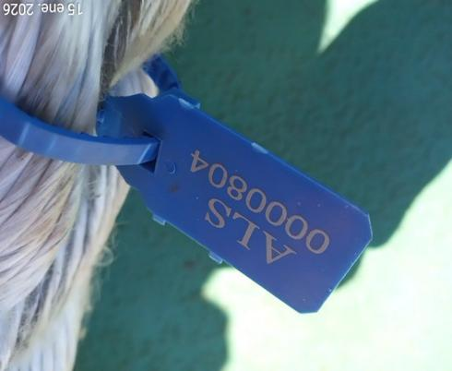
- Measure of Rope, 223.0 meters. | - Seal N° 0000804

2.- COMMENTS

It is important to mention that upon our inspection of the mooring lines, these were not arranged in their entire length, even that, they were measured 2 times to achieve an average measurement.

No records of history of previous inspections of the mooring lines were shown, not did the units possess visible or recognizable identification such as plates, sleeves, seals, or permanent marks.

The mooring ropes corresponding to standard ropes. According to information received from Vessel Chief officer the vessel does not use mooring tails.

Visual inspection of mooring ropes was carried out with natural light.

The inspected mooring lines were also properly marked with a color, green for accepted lines.

From a total of 18 mooring lines inspected, all of them comply with the conditions for use.

This survey was carried out without prejudice and in the interest of whom it may concern.

Surveyor
ALS INSPECTION CHILE SPA

Prepared by : V. Alfaro
Reviewed by : C. Alvear
Validated by : J. Lopez

