Our Ref : VAP-2601-0333
Your Ref : 2612052
Date : February 04, 2026

Supervision Report

We give below details of a material described as “Los Pelambres Copper Concentrates”, which was weighed, loaded, sampled, determined for moisture, and prepared in the presence of our representative.

General Details

Advised Material | Los Pelambres Copper Concentrate
Advised Weight | 10,000.000 WMT
Vessel | ARIES MIZUKI
Stowed | Hold Nr. 1
Supplier | Antofagasta Minerals
Loading Port | Punta Chungo, Los Vilos - Chile
Discharge Port | Nanjing, China
Vessel Arrival | 08:00 Hrs. // 27 – 01 – 2026
Vessel Berthed | 09:42 Hrs. // 27 – 01 – 2026
Loading Hold Nr. 1 Commenced | 07:31 Hrs. // 28 – 01 – 2026
Loading Hold Nr. 1 Completed | 04:25 Hrs. // 29 – 01 – 2026

Outturn Weights

 | Total Vessel
Net Wet Weight (Scale) | 10,700.10
Moisture (%) | 7.9538
Net Dry Weight (Scale) | 9, 849.033

Cargo Condition:

The material was found stockpiled in Los Pelambres warehouse located at Punta Chungo port Terminal which is 860 meters away from the berth. This warehouse has a full capacity of 150.000 MT.

The date of stockpile of the material was from January 21, 2026. Our parcel belonged to one stockpile.

Our surveyor was authorized to ingress and take photographs inside stockpile Port by the Shipper.

Our surveyor attended at the shipper’s stockpile prior to the loading operations and observed that the cargo was in bulk form and ready for loading. No apparent contamination or impurities were observed as far as visibly accessible. Neither lumps nor agglomerations were observed in the cargo during the loading operations.

The material was grey in colour and consisted of fine material.

Remark: ALS surveyor was authorized to ingress and take photographs inside stockpile Port, but only before commencing with loading operation and only for this time after complete loading operation due to safety procedures and operational reazons (according to shipper Minera Los Pelambres instruction).

Loading of Vessel

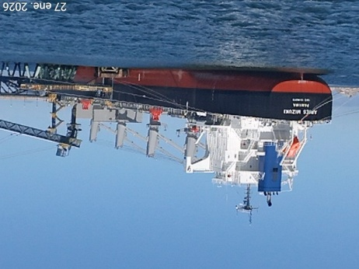
Vessel’s Particulars:

Flag & Register Port | Panama / Panama
Owners | Cassiopeia Marine S.A.
Year Built | 2025
NET | 21,291
GRT | 36,372
Type of ship | Bulk Carrier

Dates & Times:

Date | Time | Description
January 27, 2026 | 08:00 | Vessel arrived at Punta Chungo Port
January 27, 2026 | 08:06 | POB for berthing maneuvers
January 27, 2026 | 08:42 – 09:42 | First line / Vessel berthed
January 27, 2026 | 10:46 | ALS Surveyor & Shipper Surveyor on board
January 27, 2026 | 10:54 – 11:11 | Inspection of hold Nr. 1 by Shipper (AHK) and ALS Surveyors
January 27, 2026 | 11:50 – 12:00 | Meeting with Chief Officer
January 27, 2026 | 12:13 | ALS surveyor disembarked from vessel
January 27, 2026 | 14:20 | Loading operation commenced in other hold
January 28, 2026 | 00:00 – 06:57 | Loading operation continued in other hold
January 28, 2026 | 07:31 | Loading operation commenced in hold Nr. 1
January 28, 2026 | 11:45 – 20:34 | Loading operation continued in other hold
January 28, 2026 | 20:20 | ALS surveyor on board vessel
January 28, 2026 | 21:15 – 23:55 | Resume loading operation in hold Nr. 1
January 29, 2026 | 00:42 – 03:05 | Loading operation continued in other hold
January 29, 2026 | 03:39 | Resume loading operation in hold Nr. 1
January 29, 2026 | 04:25 | Loading operation completed in hold Nr.1. Total Loaded according to Shore scale: 10,700.10 WMT
January 29, 2026 | 04:35 – 04:40 | Hold Nr.1 being closed by the crew
January 29, 2026 | 04:40 – 04:45 | Sealing of hatch covers and stevedore’s access hold Nr. 1 by ALS surveyor
January 29, 2026 | 04:50 | Hold sealing certificate being signed by C/O
January 29, 2026 | 05:10 | ALS surveyor disembarked from vessel
January 29, 2026 | 05:10 – 06:25 | Inspection of equipment and surrounding area upon completion loading operation (*)
January 29, 2026 | 06:30 | POB for unberthing maneuvers
January 29, 2026 | 07:47 | Vessel departed to the next port Coquimbo, Chile
February 02, 2026 | 10:20 | Samples sealed by ALS surveyor and delivered by AHK lab. in Punta Chungo – Los Vilos
Remarks: (*) According to the informed by Punta Chungo Port with the request about inspect all equipment and surrounding area upon completion of loading operation, this was authorized only for this time.

Hold Inspection:

Our surveyor, jointly with shipper’s surveyor, inspected the hold N° 1 before loading:

HOLD N° 1 | GOOD | FAIR | POOR
Hatch covers
Hatch coatings
Rubber packing, draining holes
Acting cleats, compression bars
Non return valves
Hydraulic Systems
Forward and aft bulkhead
Side/shell plating (port and stb)
Frames, brackets and bracket connection
Tank top plating
Hopper tank plating
Ventilation, void spaces
Bilges, suctions
Air vents Sounding pipes
Cleaning Condition
Observation: Cargo hold Nr. 1 was found dry, clean and suitable to receive the intended cargo.

Previous cargo:

- Cement
- Copper Concentrate
- Wheat

According to vessel Chief Officer, the watertight test (hose test) in holds was carried out on January 26, 2026.

Loading sequence:

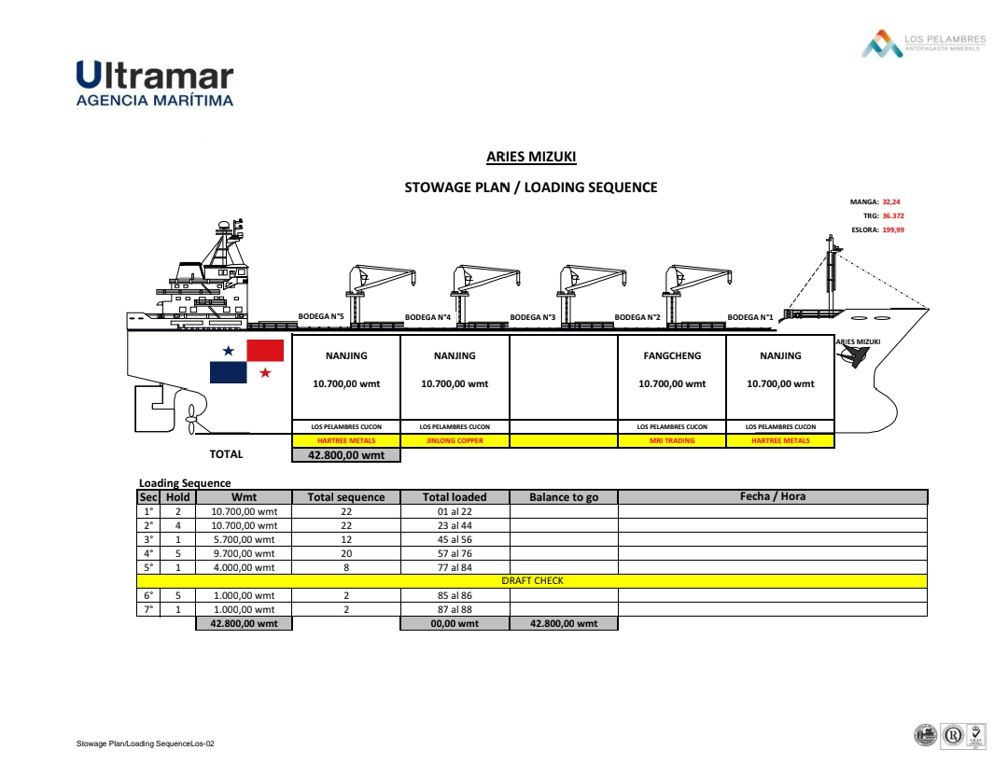

Shore Scale Weighing and Loading

Description of the weighing system used:

At this port, the official weight of cargo loaded on board vessel is ascertained by means of shore scale, which has the following details:

Mark | : RAMSEY
Model | : MICROTECH 9301
Serial Number | : 14489739
Location | : Belt CV-120
Maximum Capacity | : 1900 t/h
Last Calibration | : August 28, 2025 by World Survey Services S.A. (WSS)
Belt speed (Average) | : 1,395.06 WMT/Hour
Belt length | : 860 m

Remark: Official weight according to Shore Scale.

A zero check was performed prior to loading commencement (once, before start loading into vessel’s hold). The result was positive: no increase in the shore scale during idle running.

The shore scale was observed before the start of the loading operations in order to record the initial and final readings. According to readings, the total quantity loaded in hold Nr. 1 of MV “ARIES MIZUKI” was 10,700.10 WMT.

The official weight was ascertained by shore scale, which is located in belt CV-120 and the calibration is every 6 months and/or two times in the year. The company in charge of calibration is World Survey Services S.A. (WSS).

Loading operation and conveyor details:

Material was transported from the warehouse (stockpile) by means of a digger that fed the belt conveyor up to the transference tower where the material was transferred to a belt conveyor up to the system which loads the material directly into the vessel´s hold at a speed of 1,395.06 WMT / Hour average.

We were authorized by vessel’s Chief Officer to take pictures on board during the loading operations, and to remain on board checking the material condition and possible contamination.

During loading operation in hold Nr. 1, weather conditions were partly cloudy, clear sky and windy.

During loading operation in hold Nr. 1, following stoppages was registered:
- Loading operation in other hold

Conveyor system CV-120:

Belt Capacity | Belt Length | Belt Speed (Average)
1,900 T/H | 860 meters | 1,395.06 T/H

**ALS surveyor was authorized to take photographs of conveyor area. The entire loading operation of this parcel was carried out through the conveyor belt (CV-120) and weight meter system.

Sealing of hatch covers and stevedores’ access:

According to what was requested, the hatch covers and stevedores’ access of hold Nr. 1 were sealed by ALS surveyor and a hold sealing certificate was issued to Chief Officer (attached), seal numbers as per following detail:

Hold Nr. | 1
Hatch covers | ALS 00224
Stevedores access Fwd | ALS 00225
Stevedores access Aft | ALS 00226

Sampling for moisture determination and quality preparation

Sampling:

To determine the moisture content of cargo loaded, the samples increments were drawn automatic by AHK personnel from transference tower belts 112 and 120; the loading rate was 1,395.06 WMT / Hour on average.

At the sampling point, for each 500 WMT, a material portion is taken from conveyor Nr. 120 by primary sampler (app. 20 kg) and sent through a square channel into a secondary sampler (app. 10 kg). The remaining product from the primary sample was returned into conveyor Nr. 120 by means of small conveyor located under secondary sampler.

Once this is completed, a sample of app. 10 kg is obtained which are collected in a polyethylene bag sealed with tape, labeled, and taken to the lab at approximately 300 meters from the sampling site. Samples are transported from the sampling site to the lab by means of a bike.

During sampling operations, we checked that there was no mixing of material.

Moisture determination:

Before weighing the sample, the empty trays were weighed. One bag with samples corresponding to 500 WMT is homogenized and poured over a plastic sheet. Afterwards, this homogenized sample is divided into squares (5x4= 20 portions). Twenty (20) increments are taken randomly with the use of a JIS scoop Nr. 3, filling one tray, and the other 20 increments are also taken randomly to fill another tray reaching a weight of 1Kg (app) per tray. These 2 trays are then placed into the oven for drying.

The balance material remained as witness in laboratory.

Trays dimensions are:

- Length: 23 cms
- Width: 30 cms
- Height: 4 cms
- Sample thickness in the tray: 1.5 cm to 2.5 cms.

Prior to use, the oven temperature is set at 105 ºC, and its temperature is controlled by means of a thermometer. This control is carried out at 08:00 hours, 12:00 hours and 16:00 hours. Further controls can be conducted if the operator deems necessary but those mentioned are mandatory.

The trays were put into the oven without continuous circulation at 105 ºC +/- 5 ºC, for five hours plus one hour until constant weight was achieved. Each tray-sample was weighed before and after drying in the oven. Upon completion of the drying process, the moisture percentage of each tray-sample was obtained by calculating the difference between the wet and dry weight.

The average of the samples was applied per lot. The samples were weighed whilst hot with the tray after being taken directly from oven. All the trays are placed in the same oven, therefore, there is a mix of wet and dry samples (on their respective trays), in the oven during the drying process as they are not put into the oven at once.

The final moisture of 500 WMT lot-samples were calculated by averaging the moistures from the 2 trays.

Remark: according to the new regulation of AHK laboratory “it is forbidden enter to the sample drying area when local personnel put or remove samples from the oven”; about this matter, at the entrance of this area, an informative poster reads “Restricted area authorized personnel only”.

Remark: No process was repeated; all samples obtained constant weight in the second control.

Equipment for moisture determination

DRYING OVEN | LABTECH HEBRO
MODEL | DO1ME
SERIAL NUMBER | 5701-M-01-13
MEASUREMENT RANGE | 22°C TO 105°C
TESTING COMPANY | Servicio de Metrología Integral (SMI SpA)
STATUS | OPERATIVE
LAST TEST | *January 07, 2026
* The certification is carried out every 3 years.

ELECTRONIC SCALE | TOMS
MODEL | TM-STC60001
SERIAL NUMBER | 230302035
MINIMUM GRADUATION | 0.1 g.
TESTING COMPANY | Servicio de Metrología Integral (SMI SpA)
LAST TESTING | March 01, 2025

STANDARD WEIGHT | SARTORIOUS
MODEL (SHAPE) | TE6101 (CYLINDRIC)
CERTIFICATE | SMA - 100228
NOMINAL NUMBER | 1 Kg.
INTERNAL NUMBER | IN-LAB-MU033 / AHK-MLP-004
TESTING COMPANY | CESMEC S.A.
TESTING DATE | February 27, 2025

STANDARD WEIGHT | SARTORIOUS
MODEL (SHAPE) | YCW623-00 (CYLINDRIC)
CERTIFICATE | SMA - 98873
NOMINAL NUMBER | 2 Kg.
INTERNAL NUMBER | IN-LAB-MU034 / AHK-MLP-005
TESTING COMPANY | CESMEC S.A.
TESTING DATE | February 27, 2025

Weighing details: Shipper Contract: MLPL-CC218-2026-TR-03

LOT | HOLD | WMT (DRAFT) | % H2O | DMT (DRAFT) | Date & Time Start drying |  | Date & Time Finish drying |  | Date of samples sealed with tape by ALS Surveyor
45 | 1 | 500,00 | 7,88 | 460,600 | 28-Jan-26 | 9:05 | 28-Jan-26 | 15:05 | 2-Feb-2026
46 | 1 | 500,00 | 7,90 | 460,500 | 28-Jan-26 | 9:05 | 28-Jan-26 | 15:05 | 2-Feb-2026
47 | 1 | 500,00 | 7,92 | 460,400 | 28-Jan-26 | 9:05 | 28-Jan-26 | 15:05 | 2-Feb-2026
48 | 1 | 500,00 | 7,91 | 460,450 | 28-Jan-26 | 9:05 | 28-Jan-26 | 15:05 | 2-Feb-2026
49 | 1 | 500,00 | 7,72 | 461,400 | 28-Jan-26 | 11:15 | 28-Jan-26 | 17:15 | 2-Feb-2026
50 | 1 | 500,00 | 7,78 | 461,100 | 28-Jan-26 | 11:15 | 28-Jan-26 | 17:15 | 2-Feb-2026
51 | 1 | 500,00 | 7,72 | 461,400 | 28-Jan-26 | 11:15 | 28-Jan-26 | 17:15 | 2-Feb-2026
52 | 1 | 500,00 | 7,88 | 460,600 | 28-Jan-26 | 11:15 | 28-Jan-26 | 17:15 | 2-Feb-2026
53 | 1 | 500,00 | 7,90 | 460,500 | 28-Jan-26 | 11:15 | 28-Jan-26 | 17:15 | 2-Feb-2026
54 | 1 | 500,00 | 7,98 | 460,100 | 28-Jan-26 | 11:15 | 28-Jan-26 | 17:15 | 2-Feb-2026
55 | 1 | 500,00 | 7,87 | 460,650 | 28-Jan-26 | 15:15 | 28-Jan-26 | 21:15 | 2-Feb-2026
56 | 1 | 196,71 | 7,96 | 181,052 | 28-Jan-26 | 15:15 | 28-Jan-26 | 21:15 | 2-Feb-2026
77 | 1 | 500,00 | 8,10 | 459,500 | 28-Jan-26 | 22:10 | 29-Jan-26 | 4:10 | 2-Feb-2026
78 | 1 | 500,00 | 8,04 | 459,800 | 28-Jan-26 | 22:10 | 29-Jan-26 | 4:10 | 2-Feb-2026
79 | 1 | 500,00 | 7,80 | 461,000 | 29-Jan-26 | 0:10 | 29-Jan-26 | 6:10 | 2-Feb-2026
80 | 1 | 500,00 | 7,96 | 460,200 | 29-Jan-26 | 0:10 | 29-Jan-26 | 6:10 | 2-Feb-2026
81 | 1 | 500,00 | 8,16 | 459,200 | 29-Jan-26 | 0:10 | 29-Jan-26 | 6:10 | 2-Feb-2026
82 | 1 | 500,00 | 8,02 | 459,900 | 29-Jan-26 | 0:10 | 29-Jan-26 | 6:10 | 2-Feb-2026
83 | 1 | 500,00 | 8,14 | 459,300 | 29-Jan-26 | 0:10 | 29-Jan-26 | 6:10 | 2-Feb-2026
84 | 1 | 479,27 | 7,90 | 441,408 | 29-Jan-26 | 0:10 | 29-Jan-26 | 6:10 | 2-Feb-2026
87 | 1 | 500,00 | 8,15 | 459,250 | 29-Jan-26 | 4:45 | 29-Jan-26 | 10:45 | 2-Feb-2026
88 | 1 | 524,12 | 8,28 | 480,723 | 29-Jan-26 | 4:45 | 29-Jan-26 | 10:45 | 2-Feb-2026
Total |  | 10.700,10 | 7,9538 | 9.849,033

REMARKS | Samples were delivered by AHK Lab. Punta Chungo on February 02, 2026 at 10:20 hrs (LT)

Total average moisture content calculation:

Total H2O MT/ Total wet weight x100= (10,700.100 – 9,849.033) / 10,700.100 x 100 = 7.9538% Total dry net weight: Nine thousand eight hundred forty-nine point zero thirty-tree.

Quality Sample Preparation:

Dried moisture samples were used for quality purpose. Once moisture process finished, the material of the two trays passed through a Nr. 170 sieve and then submitted to grinding process for 1 minute to be completely pulverized. then, the sample is placed onto a plastic carpet to homogenize; after that, sample was put in rotatory divider to be automatically and equally separated to then be dropped into 8 metallic containers; then, these samples are put into aluminum bags with 150 g (app) to be finally sealed.

Subsequent to the samples drying and the ascertaining of the constant weight per lot, a composite is prepared by reserving a portion of samples taken per lot, which is mixed with other portions from the other lots of the shipment. This portion is calculated on the basis of the total shipment and quantity of lots. Partial and general composites are formed.

The lot-samples were distributed in 8 portions as follows:

1 set of samples to be dispatched to Alex Stewart International Corporation Ltd.
1 set of samples to be dispatched to SGS-CSTC Standards Technical Services (Qingdao) Co., Ltd.
1 set of samples to be dispatched to ALS UK
2 sets of samples for the seller, Minera Los Pelambres (witness)
1 sets of samples for AHK laboratory (shipper’s lab)
1 sets of samples for AHK laboratory, Chacay Salamanca
1 set of samples for the Chilean Custom

1 composite to be dispatched to ALS UK
2 composites for the seller, Minera Los Pelambres (witness)
1 composite for AHK laboratory (shipper’s lab)
1 composite for AHK laboratory, Chacay Salamanca
1 composite for the Chilean Custom

Sealing of Samples:

A total of 8 portions x 22 lots of samples and 6 general composites were packed into aluminum bags with adhesive labels and sealed with plastic adhesive tape from AHK. All samples and composites were also labeled with ALS tape.

Special requirement:

Upon completion of loading operation was request inspect all equipments and surrounding area to ensure all material has been recovered and swept clean. About this special request the Punta Chungo terminal informed us that it was authorized only for this time, and in the future won't be authorized due to operational and safety reazons.

Conclusion:

The following observations were found out of ISO Standard during sampling activity and moisture determination process:

- Samples were dried in oven for 5 hours + 1 at 105ºC+/- 5ºC degrees for constant mass (as per ISO 10251, page 5, suggests that “The initial drying time has to be determined empirically. Sixteen hours is sufficient for most cases and can be taken as a guide”).

- The oven for drying is not sealed, due to samples are placed inside each time they are prepared, because of this there is a mixture of trays with samples in different phases of drying process. One single oven is used for keeping all samples and it is very frequently opened for keeping and taking out the samples.

- According to the new regulation of AHK laboratory “it is forbidden enter to the sample drying area when local personnel put or remove samples from the oven”.

- As per informed of Minera Los Pelambres Terminal Punta Chungo, the inspection carried out to all equipments and surrounding area upon completion of loading operation, only was authorized for this time.

The above report reflects our findings at the time and place of the inspection only and does not refer to any other matters.

The inspection has been performed to the best of our knowledge and ability within the scope of the instructions we have received and in accordance with accepted international standards. This report does not relieve buyers and sellers from their contractual obligations.

