- VESSEL

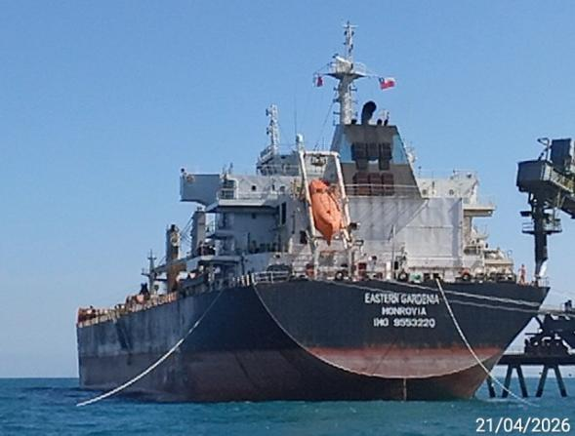
- M/V EASTERN GARDENIA berthed at Punta Chungo port.

- HOLD CONDITION

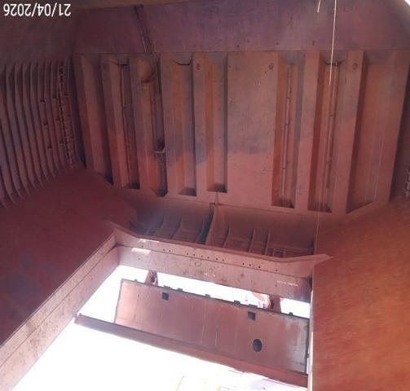 | 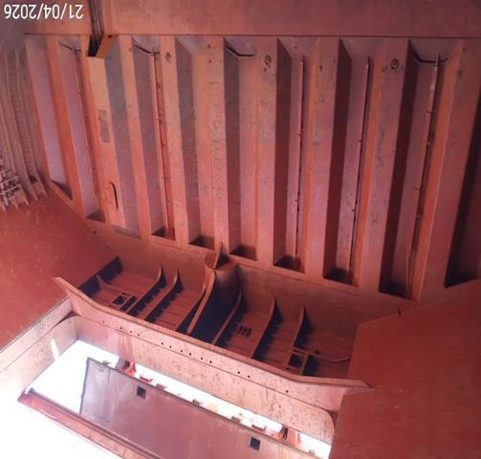
- Hold Nr. 2, general condition of bulkhead/Fwd. | - Hold Nr. 2, general condition of bulkhead/Aft.
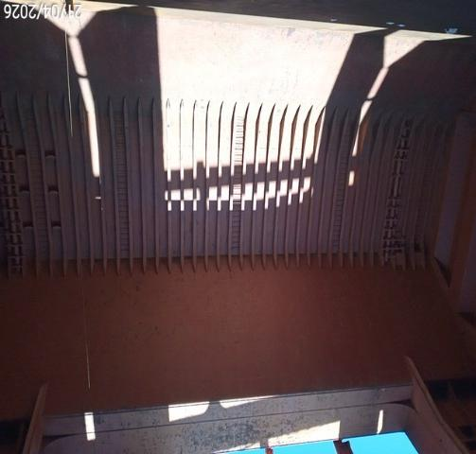 | 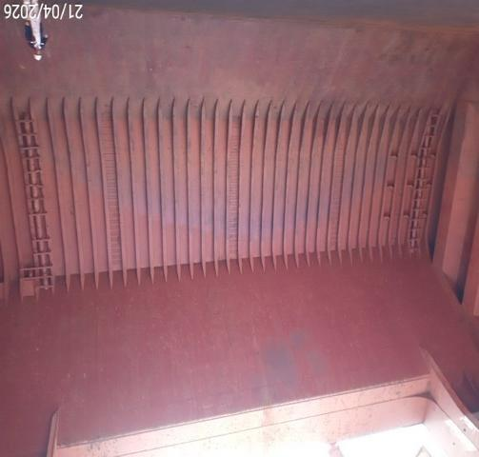
- Hold Nr. 2/Ps, shell plating condition. | - Hold Nr. 2/Ss, shell plating condition.
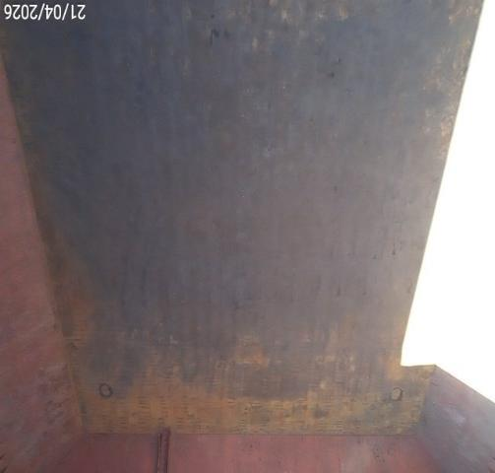 | 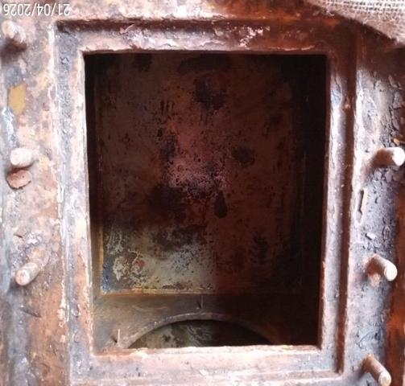
- Hold Nr. 2, general condition of tank top plating. | - Hold Nr. 2, bilge/Ps clean and dry.
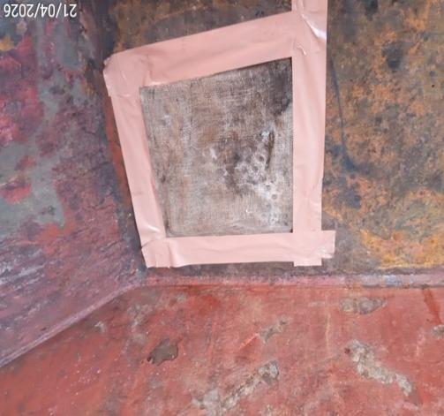 | 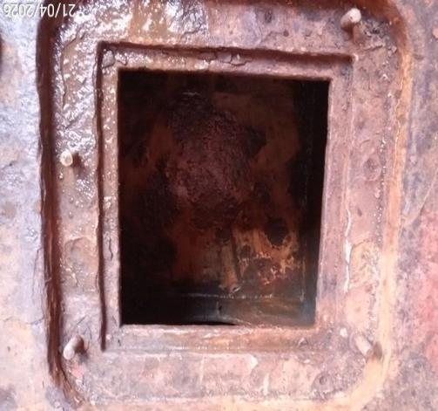
- Hold Nr. 2, bilge/Ps covered with burlap and sealed with tape. | - Hold Nr. 2, bilge/Ss clean and dry.
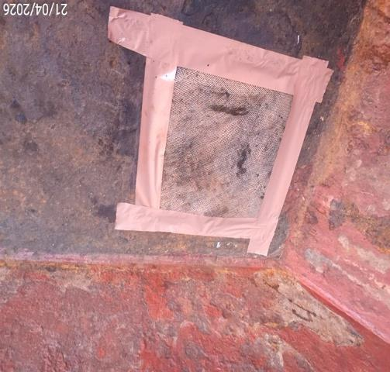 | 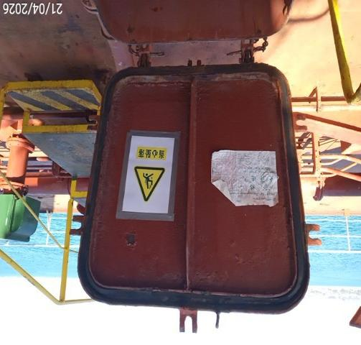
- Hold Nr. 2, bilge/Ss covered with burlap and sealed with tape. | - Hold Nr. 2, stevedores’ access with rubber packing in good conditions.
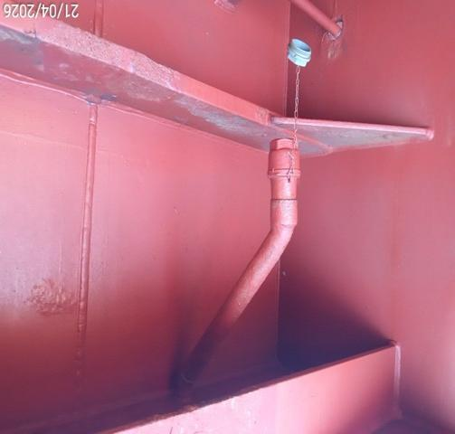 | 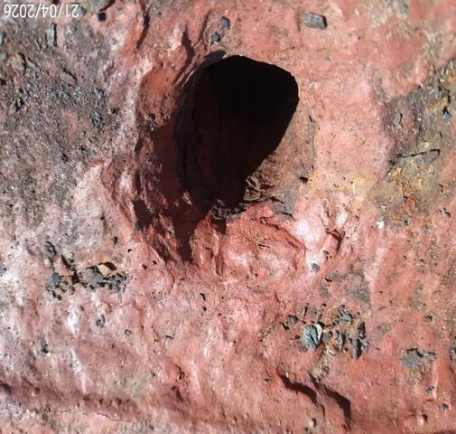
- Hold Nr. 2, non-return valve. | - Hold Nr. 2, drain hole condition.
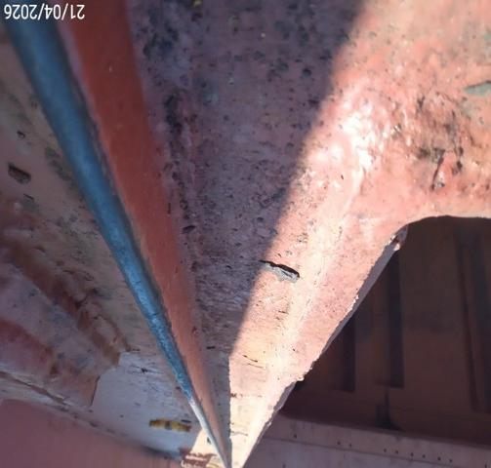 | 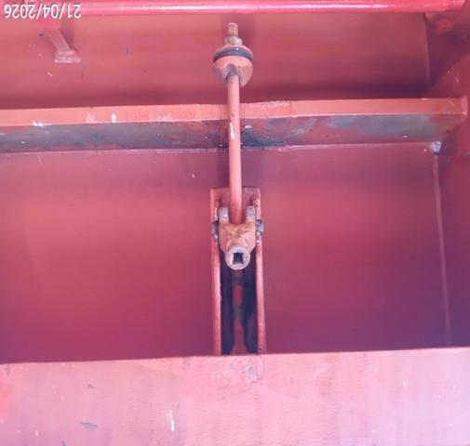
- Hold Nr. 2, compression bar in good condition. | - Hold Nr. 2, acting cleat.
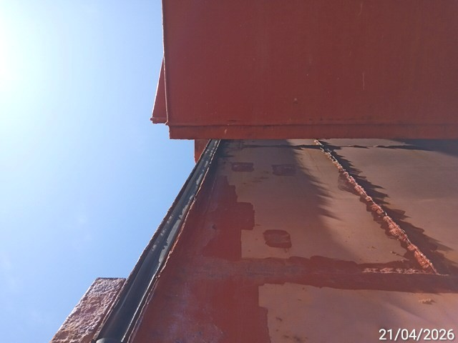 | 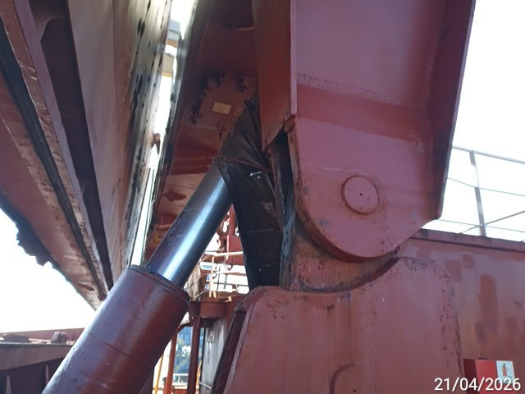
- Hatch cover hold Nr. 2, rubber packing condition. | - Hold Nr. 2, hydraulic system without leaking.

- CONDITION OF CARGO

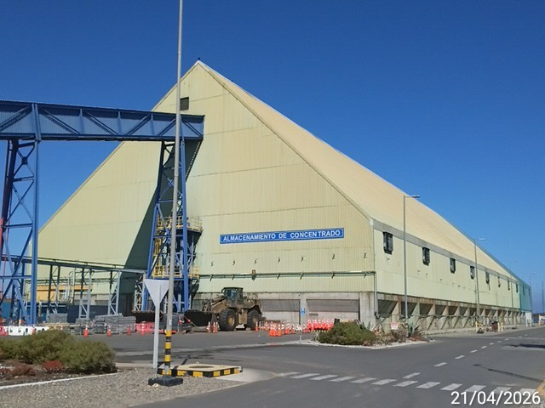 | 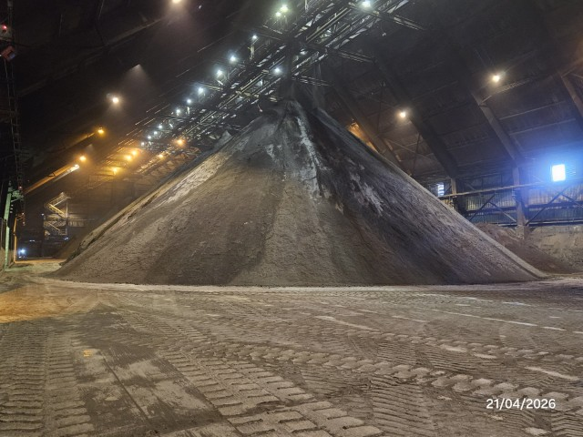
- View of stockpile warehouse. | - Copper concentrate inside stockpile prior commencement of loading operation.

- LOADING OPERATION

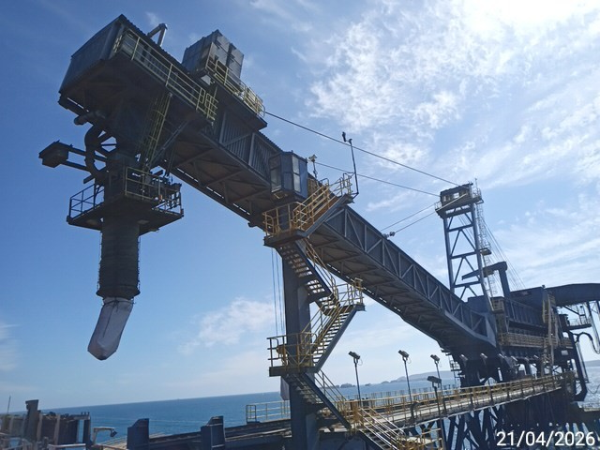 | 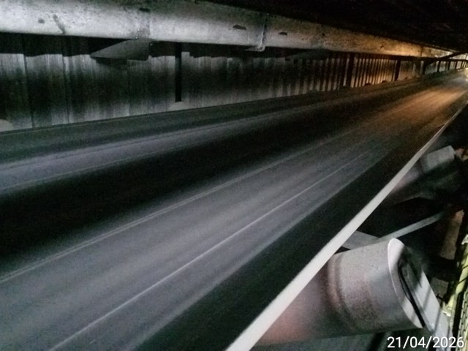
- Ship loader system. | - Conveyor belt.
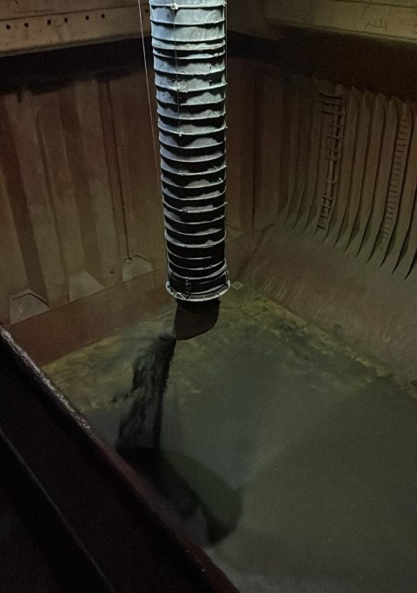 | 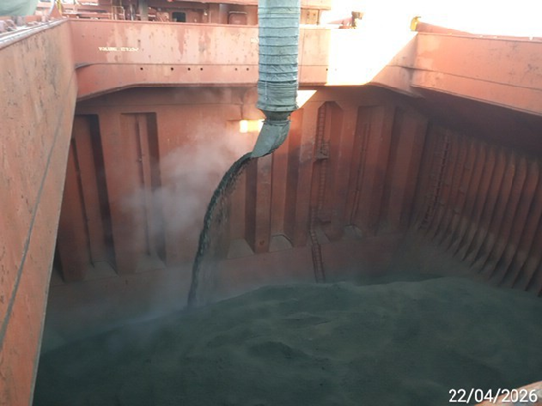
- Loading operation of copper concentrate in hold Nr. 2 commenced. | - Loading operation in process in hold Nr. 2.
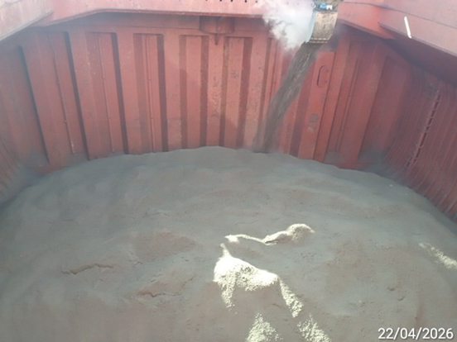 | 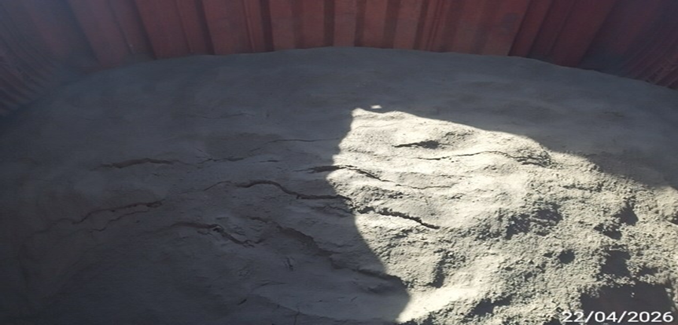
- Loading operation in process in hold Nr. 2. | - Loading operation completed in hold Nr. 2.

- SEALING OF HOLDS AND STEVEDORES’ ACCESS

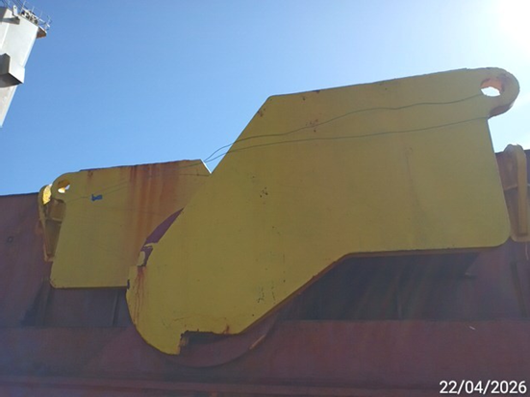 | 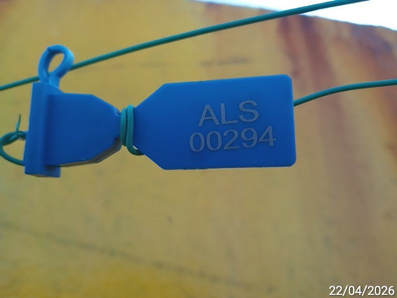
- Hold Nr. 2, general view of hatch covers sealed. | - Hold Nr. 2, hatch cover with seal  Nr. ALS 00294.
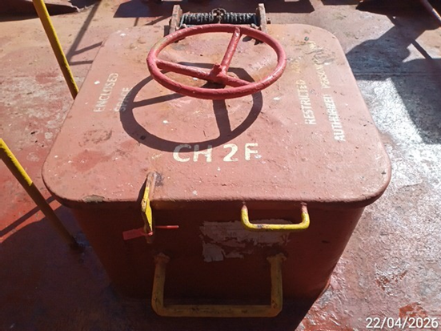 | 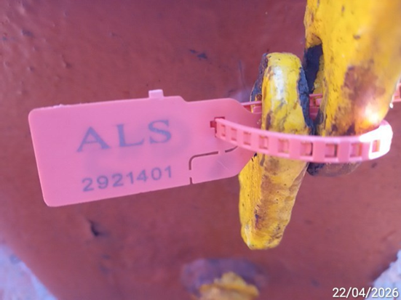
- Hold Nr. 2, general view of stevedores’ access Fwd sealed. | - Hold Nr. 2, stevedores’ access Fwd with seal Nr. ALS 2921401.
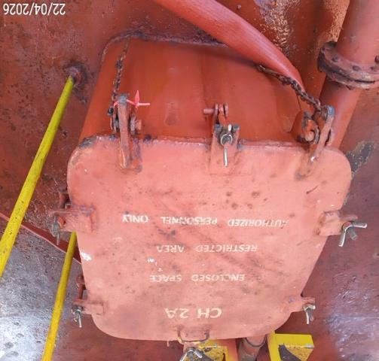 | 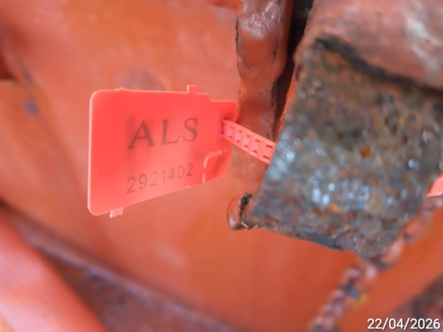
- Hold Nr. 2, general view of stevedores’ access Aft sealed. | - Hold Nr. 2, stevedores’ access Aft with seal Nr. ALS 2921402.

- SHORE SCALE

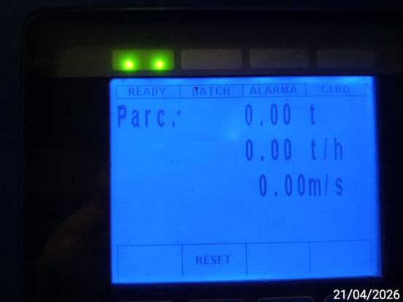 | 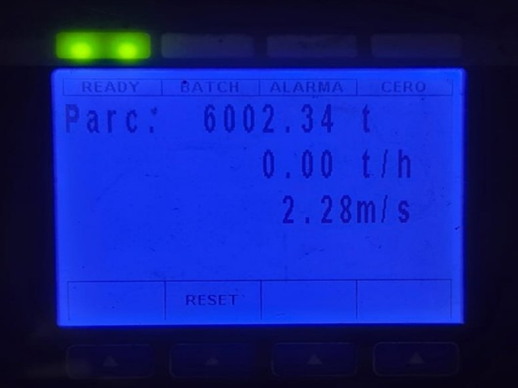
- Shore scale in zero check (prior to start loading operation). | - Weighing scale before of loading operation in hold Nr. 2  (first part).
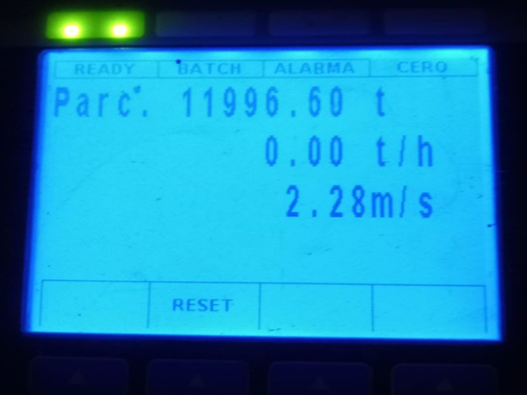 | 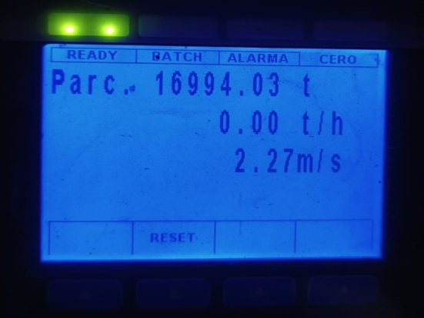
- Weighing scale after finishing loading operation in hold Nr. 2 (first part). | - Weighing scale before resume loading operation in hold Nr. 2  (second part)
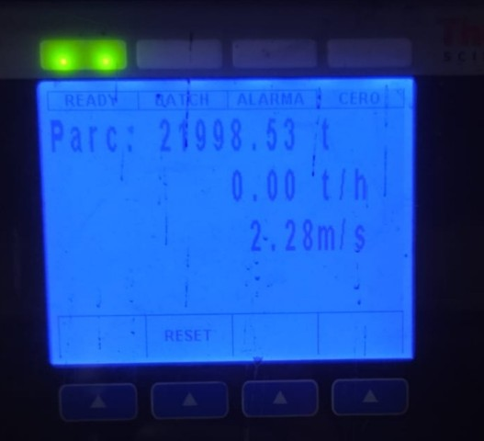
- Weighing scale after finishing loading operation in hold Nr. 2 (second part).

- SAMPLING OPERATION

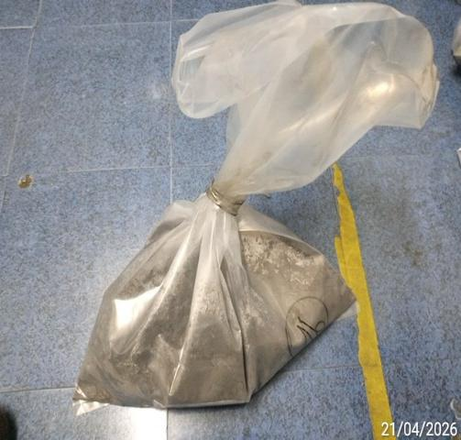 | 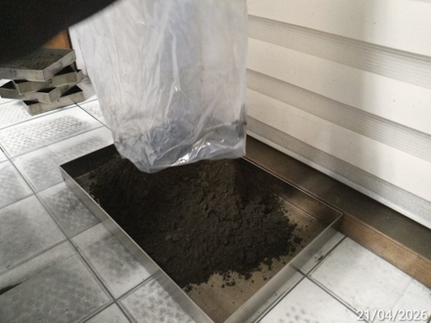
- Sample in plastic bags duly sealed by AHK personnel. | - Sample in laboratory being poured into a tray of 52 x 60cm.
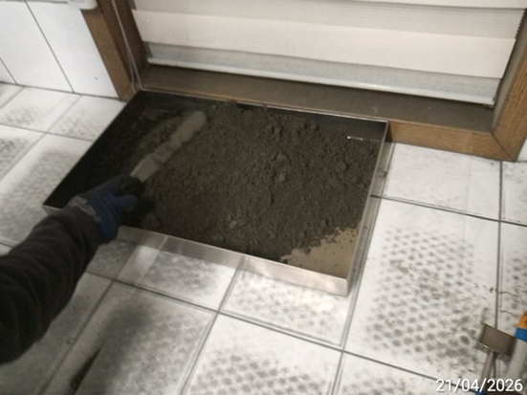 | 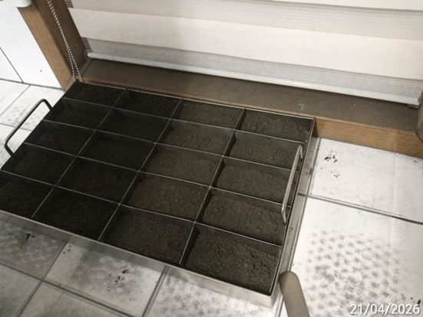
- Sample being divided by AHK Lab personnel. | - Sample divided in 20 square portions for filling the tray.
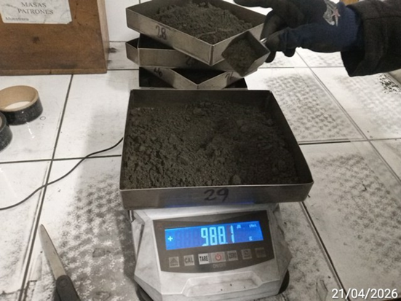 | 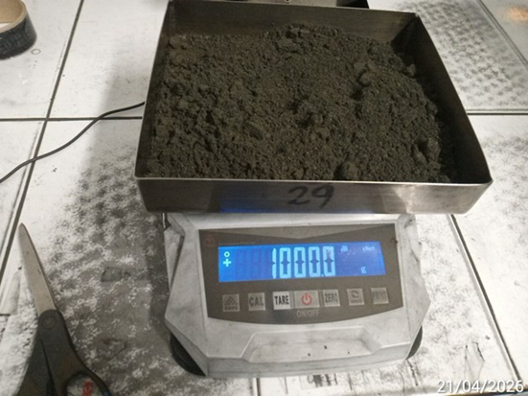
- Sample being placed into tray. | - Weighing tray with the sample.
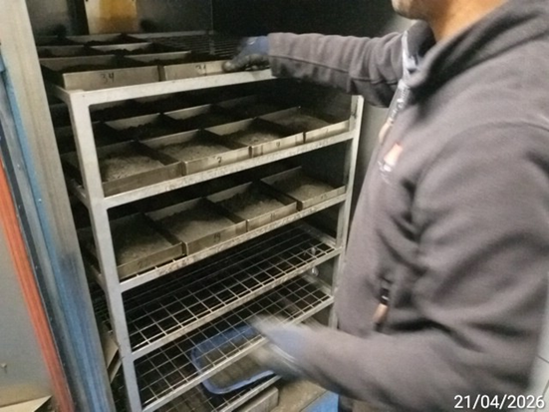 | 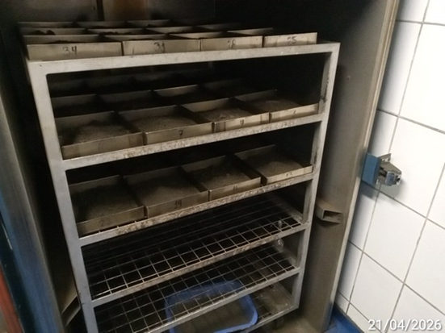
- Trays being placed into the oven for 5 hours plus 1 hour. | - View of trays with samples into the oven.
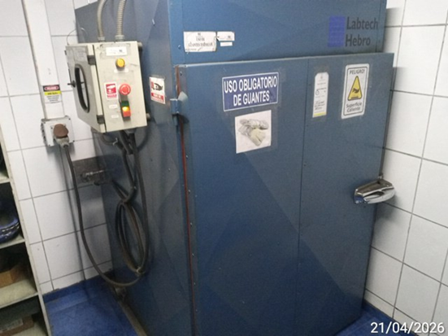 | 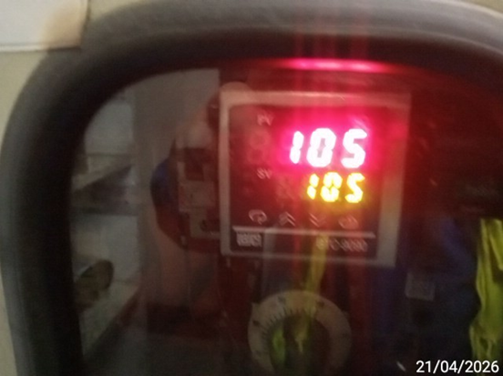
- Oven closed by AHK lab personnel. | - Oven temperature of 105.0 ºC.
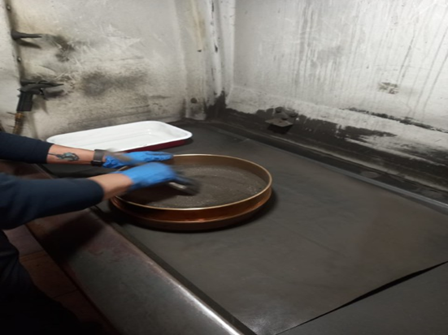 | 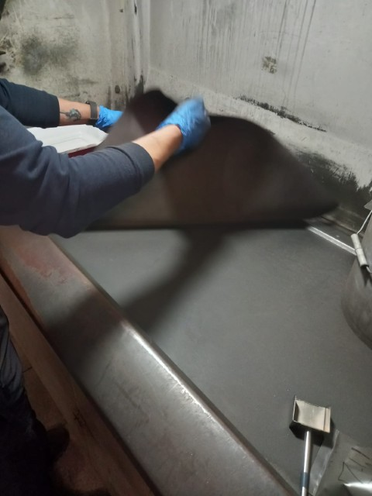
- Sieve in process. | - Sample being homogenized onto a carpet by AHK lab personnel.
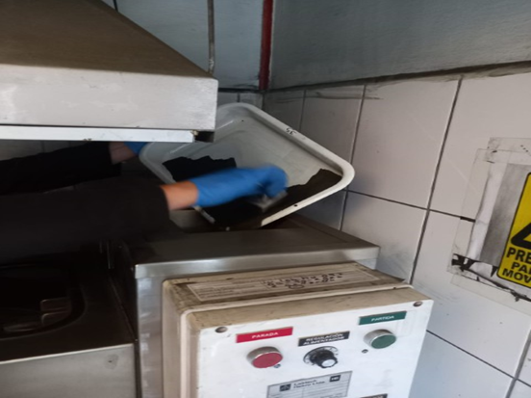 | 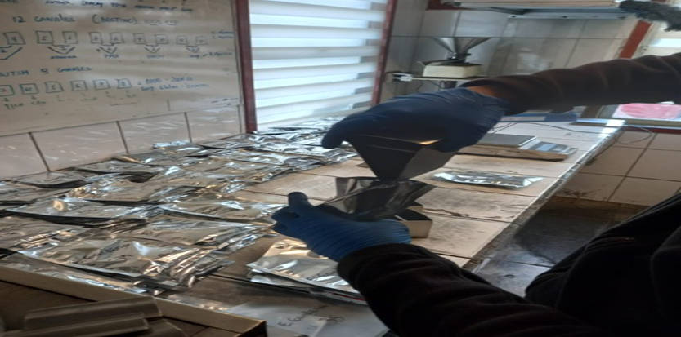
- Dried sample being divided into automatic divider. | - Sample being put into aluminium bag.
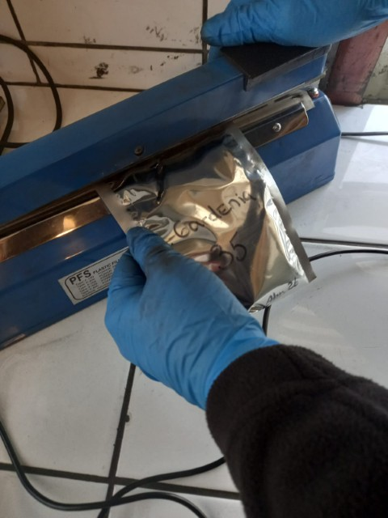 | 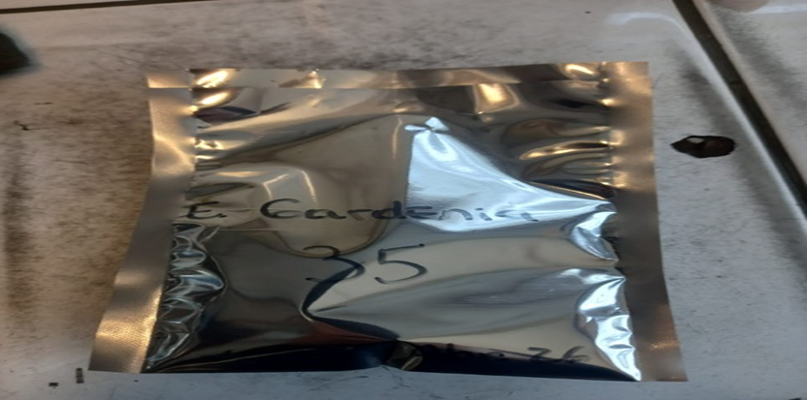
- Sample being sealed by AHK personnel. | - Sample bag duly sealed by AHK lab personnel.
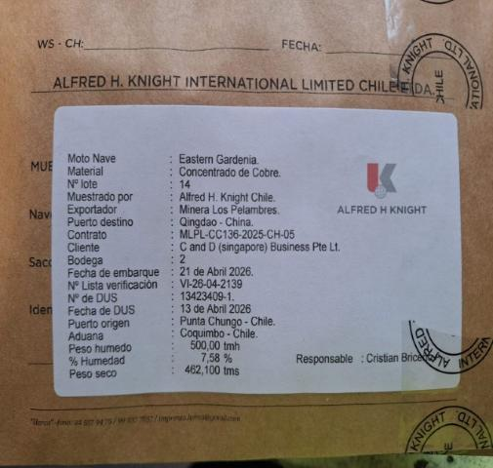 | 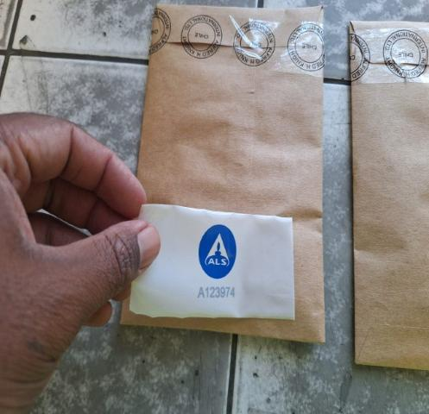
- Close up view of bag duly sealed/labeled by AHK personnel. | - Sample bags being sealed with ALS tape by ALS Surveyor.
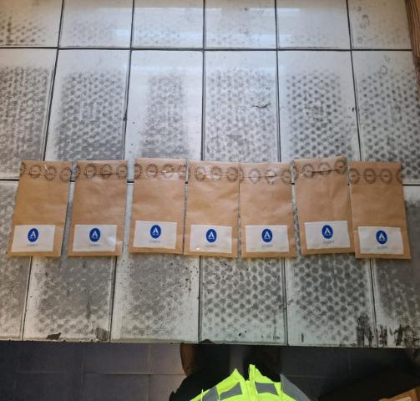 | 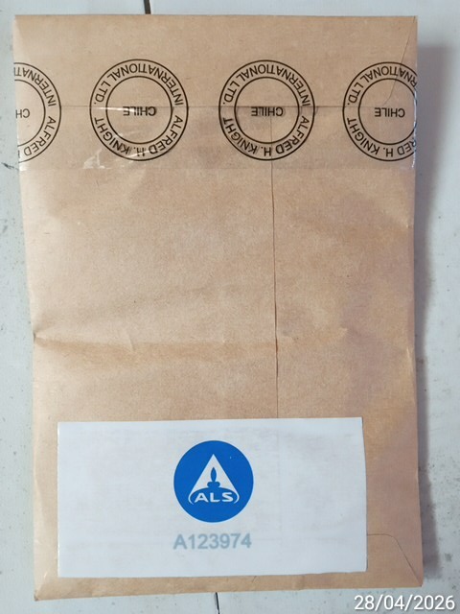
- General view of samples with ALS tape. | - Close up view of bag duly sealed with ALS tape.

- DISPATCHING OF SAMPLES

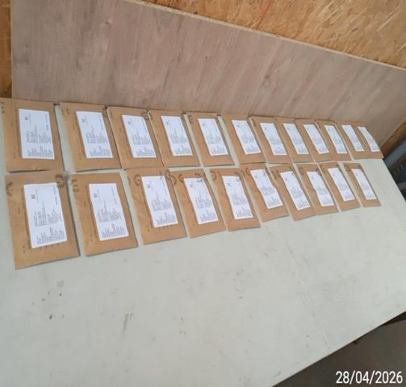 | 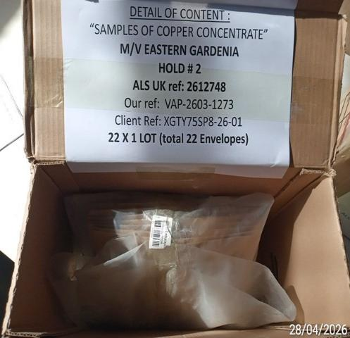
- Sample bags being prepared to be placed inside carton box for ALS Inspection UK Ltd. | - Sample bags packaged inside carton box and Label with detail inside box to be dispatched to ALS Inspection UK Ltd.
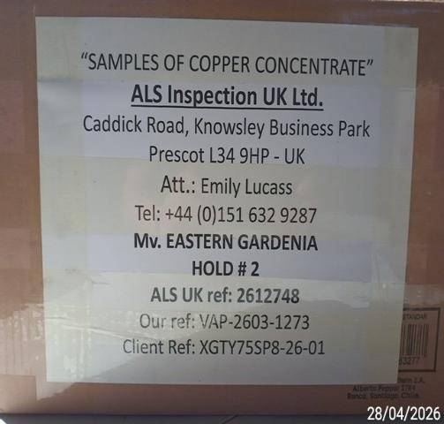 | 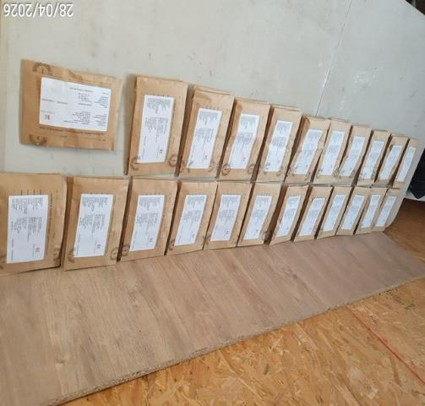
- Carton box duly labeled & closed to be dispatched to ALS Inspection UK Ltd. | - Sample bags being prepared to be placed inside carton box for Yanggu Xiangguang Copper Co. Ltd.
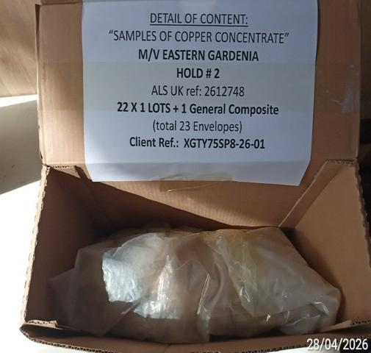 | 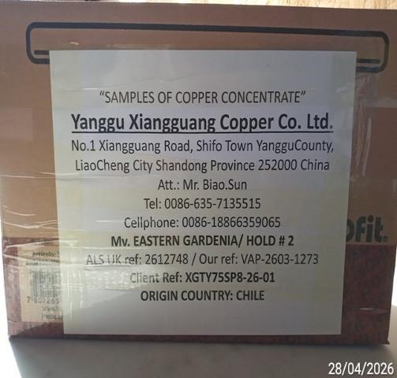
- Sample bags packaged inside carton box and Label with detail inside box to be dispatched to Yanggu Xiangguang Copper Co. Ltd. | - Carton box duly labeled & closed to be dispatched to Yanggu Xiangguang Copper Co. Ltd.

