INSPECTION OF CONTAINER STRUCTURAL CONDITION BEFORE STUFFING OPERATION

ALS INSPECTION REFERENCE
VAP-2604-1325

INSPECTION ON BEHALF OF
Bertling Logistics Chile S.A.
REQUESTED BY
Mr. Ariel Valdenegro

CONTAINER 20” Nr.
TCIU 400248-0

DATE MANUFACTURED
August 2024

ALS SURVEYOR
Alexander Luzardo I.

PLACE OF INSPECTION
Servicontainers S.A., Placilla, Valparaiso - Chile

ATTENDANCE DATE
April 02, 2026

 | Question |  | Answer
 | CONTAINER COMPLIANCE CHECKLIST FOR IMPORT/EXPORT OF EXPLOSIVES |  | Container Selection
 | 1.- General Requirements
 | 1.1.- Non-vented general purpose ISO container |  | Compliance
 | 1.2.- Valid CSC approval plated fitted or equivalent (ACEP No. legible) |  | Compliance
 | 1.3.- Owners serial No. On CSC plate and container |  | Compliance
 | 2.- Doors
 | 2.1.- Only two openings |  | Compliance
 | 2.2.- Each door with two locking bars (ie. 4) |  | Compliance
 | 2.3.- Door hinges serviceable and operative |  | Compliance
 | 2.4.- Doors capable of being locked |  | Compliance
 | 2.5.- Gaskets and seals in good condition |  | Compliance
 | 2.6.- Weather tight |  | Compliance
 | 3.- External
 | 3.1.- Top and bottom side rails |  | Compliance
 | 3.2.- Top and bottom end rails |  | Compliance
 | 3.3.- Door sill and header |  | Compliance
 | 3.4.- Corner posts |  | Compliance
 | 3.5.- Corner fittings |  | Compliance
 | 3.6.- Side and end walls weathertight |  | Compliance
 | 4.- Internal
 | 4.1.- Free of residue from previous cargo |  | Compliance
 | 4.2.- Free from rust and scale |  | Compliance
 | 4.3.- In clean condition |  | Compliance
 | 4.4.- Free of projections or protrusions |  | Compliance
 | Remark: The lining specified is not required where all of the explosives in the container are in packaging’s having substantial wooden outside surfaces or all the explosives are of Blasting Type E (UN0241, UN0332), in which case non lined steel containers may be used
 | References: IMDG Section 7.4.6.4.2, CSC Code, Australian Explosives Code Section 6.3.
 | CONCLUSION |  | APPROVED
 | CONTAINER SEAL |  | ALS 2921442
 | Date & Time of Survey |  | April 02, 2026 – 16:33 to 16:40 Hrs.
 | This survey was carried out without prejudice and in the interest of whom it may concern.
 | SURVEYOR | Alexander Luzardo I. |  | April 02, 2026
  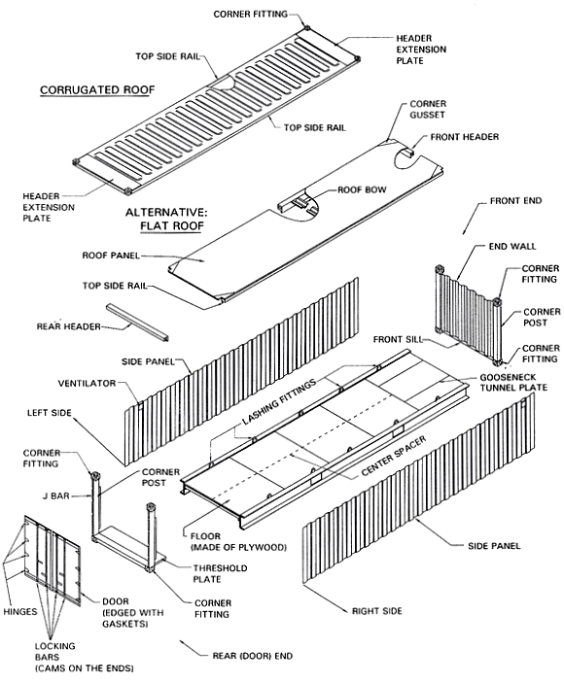

PHOTOGRAPHIC SET

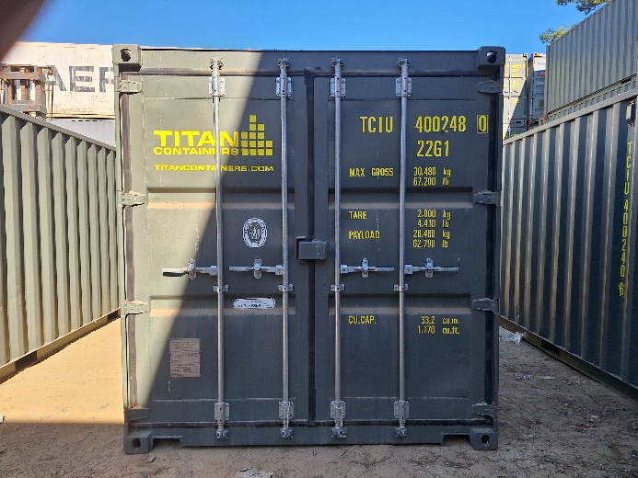 | 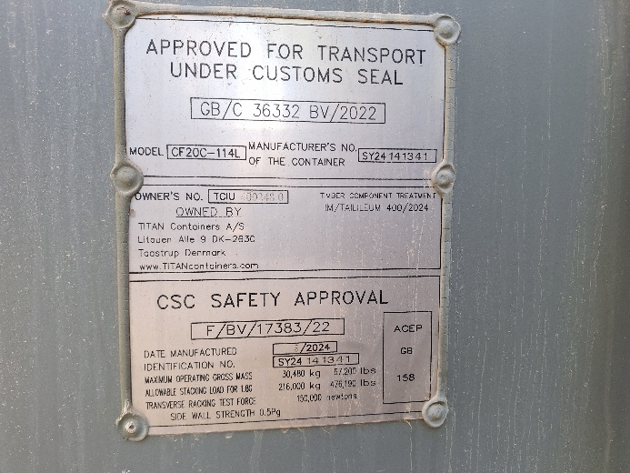
- General view of unit 20´ | - CSC plate

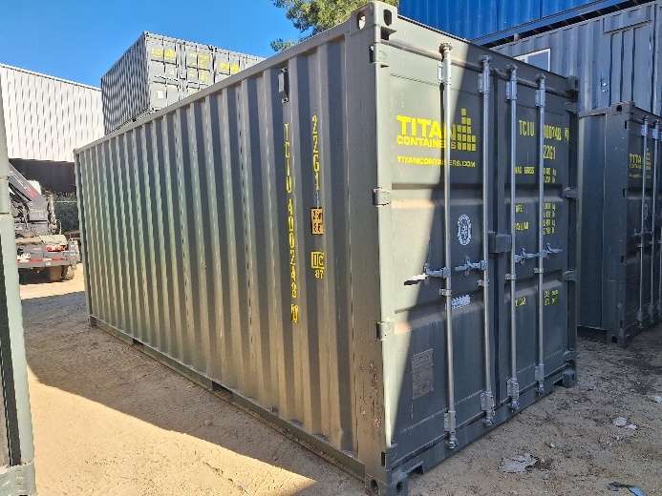 | 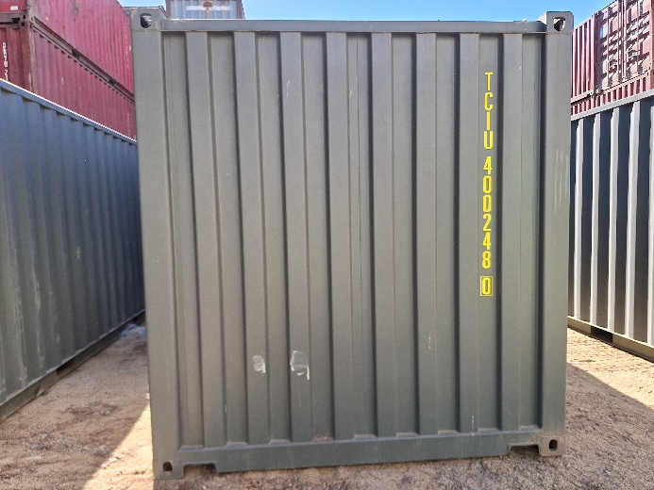
- Side panel in good condition. | - Top riel and front panel in good condition.

 | 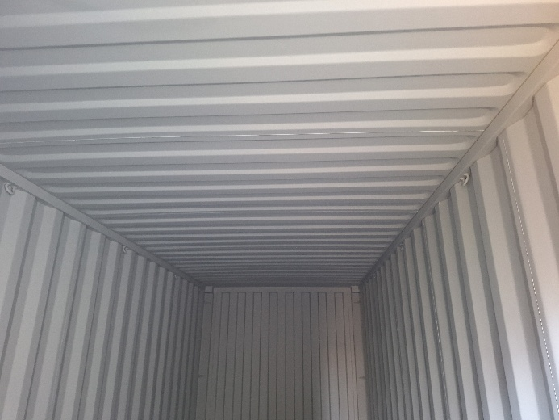
- Tight test. | - Inside without damage.

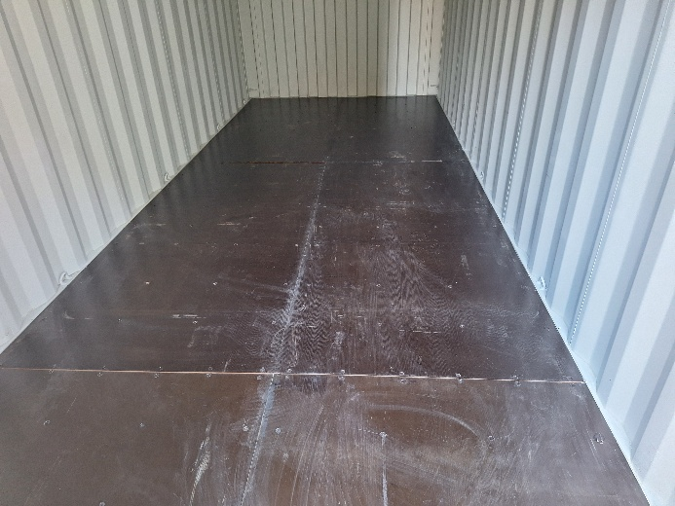 | 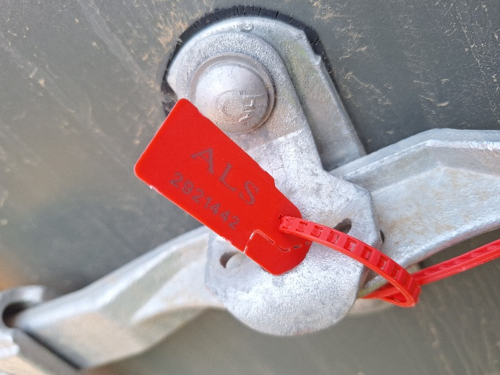
- Container floor in good conditions. | - Seal employed N° ALS 2921442 approved.

